Dr. George Antal

3D Click Limited

c/o Suite 431, 28 Old Brompton Road, London SW7 3SS

**Beta of GameChanger Stocks**

**Motivation** **1**

**Background** **2**

What is Beta? 2

What's the relationship between R-squared and beta? 4

What is NOT the Beta? 5

Optimal Return Interval and Length of Lookback Period 6

**Results** **8**

Impact of Lookback Period and Return Interval on Estimated Beta 8

Estimating Beta for the Entire GameChanger Portfolio 22

Monte-Carlo Analysis to Select the Optimal Daily Beta ‘Monthly-izing’ Multiplicator 28

Optimal Beta for Individual GameChanger Stocks? 36

**Conclusions** **40**

# Motivation

A significant part of our total real life portfolio consists of **GameChanger stocks[1]**. Recently, this is **very profitable** but **could very easily turn into huge losses**, for example during a **market panic** or when the long-awaited **bears finally arrive**. As a **risk-averse investor**, someone would want to **reduce the risk** of this sub-portfolio with some kind of **protection without limiting or significantly reducing expected profit**. It is well known that **every insurance has a price**, but it is not all the same that this cost is 10% or even 50% of the profit. Common practice among investors is the use of **stop-losses or hedging with a related security**. As our GameChanger portfolio contains **13 technology companies**, constantly setting stop-loss limits or buying stock specific put options would be very time consuming. Instead, someone may want to **treat them together**, and since almost each of these companies is a member of the **Nasdaq 100**, they could be hedged together with **QQQ put options**. In one of our previous studies (*‘*[***QQQ Put Option Insurance Strategy***](https://docs.google.com/document/d/1vEedC2qeI3zhBr5sfi2c1i-GhzwgxJoUH5rW_zuAIKw/edit?usp=sharing)*’*), it has been concluded that the ***‘QQQ Put Option Insurance Strategy’* could be very profitable using long QQQ** (as a proxy of GameChanger portfolio) stock and **long ATM QQQ put options with monthly rebalancing 1-month maturity options**. But it is not exactly the same as we would like playing in real life, as our goal is protecting our GameChanger stocks with this kind of QQQ put option strategy instead of the QQQ ETF. And these stocks have **some kind of betas compared to the QQQ, thus our GameChanger portfolio could be hedged with different amounts of QQQ put options from time to time.**

In this study, our main goal is to **determine how this beta** (and thus the required number of QQQ put options) **should be calculated.**

Adjusted daily, weekly and monthly close prices were used from 2004-01-01 to 2018-12-31.

# Background

## What is Beta?[2]

*“What is Beta?*

*Beta is a measure of the* ***volatility, or systematic risk****, of a security or a portfolio in comparison to the entire market or a benchmark. Beta is used in the capital asset pricing model (CAPM), which calculates the expected return of an asset based on its beta and expected market returns. Beta is also known as the beta coefficient.*

*Calculating Beta*

*Beta reflects the tendency of a security's returns to respond to swings in the market. A security's beta is calculated by dividing the product of the covariance of the security's returns and the benchmark's returns by the product of the variance of the benchmark's returns over a specified period. The most common formula for beta is as follows:*

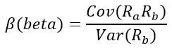

*Cov(RaRb): Covariance of asset and market  
Var(Rb): Variance of market*

*The above calculation is designed to (a) help investors understand* ***whether a stock moves in the same direction as the rest of the market*** *and (b)* ***how volatile it is compared to the market****. For beta to provide any insight, the “market” is used as a benchmark and should be related to the stock. For example, calculating a bond ETF’s beta by using the S&P 500 as the benchmark isn’t helpful because bonds and stocks are too dissimilar.  
  
The benchmark used in the calculation should be related to the stock because an investor is trying to gauge how much risk a stock is adding to a portfolio. A stock that deviates very little from the market doesn’t add a lot of risk to a portfolio, but it also doesn’t increase the theoretical potential for greater returns.*

*Using R-Squared to Validate Beta*

***In order to make sure a stock is being compared to the right benchmark it should have a high R-squared value in relation to the benchmark****. The* ***R-squared measures the percentage of a security's historical price movements that could be explained by movements in a benchmark index****. For example, a gold exchange-traded fund (ETF), such as the SPDR Gold Shares (GLD), is tied to the performance of gold bullion. Consequently, a gold ETF would have a low beta and* low *R-squared in relation to the S&P 500, for example.* ***When using beta to determine the degree of systematic risk, a security with a high R-squared value, in relation to its benchmark, would increase the accuracy of the beta measurement.***

*Interpreting Beta*

*One way for a stock investor to think about risk is to split it into two categories. The first category is called* ***“systemic risk”*** *which is the risk of the entire market declining. The financial crisis in 2008 is an example of a systemic risk event when no amount of diversification could prevent investors from losing value in their stock portfolios. Systemic risk is also known as “undiversifiable risk”.* ***Unsystemic risk or idiosyncratic risks*** *are associated with an individual stock. The surprise announcement that Lumber Liquidators (LL) had been selling hardwood flooring with dangerous levels of formaldehyde in 2015 is an example of unsystemic risk. Unsystemic risk can be partially mitigated through diversification.  
  
If a stock has a* ***beta of 1.00, it indicates that its price is correlated with the market****. A stock like that has systemic risk, but the beta calculation can’t detect any unsystemic risk. Adding a stock to a portfolio with a beta of 1.00 doesn’t add any risk to the portfolio, but it also doesn’t increase the likelihood that the portfolio will provide excess return.  
  
A* ***beta of less than 1.00 means that the security is theoretically less volatile than the market*** *which means the portfolio is less risky with the stock included than without it. For example, utility stocks often have low betas because they tend to move more slowly than market averages.  
  
A beta that is* ***greater than 1.00 indicates that the security's price is theoretically more volatile than the market****. For example, if a stock's beta is 1.20, it is assumed to be 20% more volatile than the market. Technology stocks and small caps tend to have higher betas than the market benchmark. This indicates that adding the stock to a portfolio will increase the portfolio’s risk, but also increase its expected return.  
  
Some stocks even have negative betas. A* ***beta of -1.00 means that the stock is inversely correlated to the market benchmark as if it were a mirror image of the benchmark’s trends****. Put options or inverse ETFs are designed to have negative betas but there are a few industry groups – like gold miners –* or bonds *where a negative beta is also common.*

*Beta in Theory vs. Beta in Practice*

*The beta coefficient assumes that* ***stock returns are normally distributed*** *from a statistical perspective. However, financial markets are prone to large surprises, so we know that* ***returns aren’t normally distributed****. Therefore, what* ***beta might predict about a stock’s movement isn’t always true****.****A stock with a very low beta could have smaller price swings and yet still be in a long-term downtrend. In this case adding a down trending stock with a low beta only decreases risk in a portfolio if we define risk as a function of volatility rather than the potential for losses. From a practical perspective, a low beta stock in a downtrend isn’t likely to improve a portfolio’s performance.  
  
Similarly, a high beta stock that is volatile in a mostly upward direction will increase the risk of a portfolio but add gains as well. Investors using beta to evaluate a stock will need to evaluate it from other perspectives—such as fundamental or technical factors—before assuming it will add or remove risk from a portfolio.***

*Beta in Theory vs. Beta in Practice*

***A stock’s beta or beta coefficient is a measure of the stock’s level of systemic and unsystemic risk based on in its prior performance. The beta of an individual stock only tells an investor theoretically how much risk the stock will add (or potentially subtract) from a diversified portfolio. For beta to be meaningful, the stock and the benchmark used in the calculation should be related.”***

## What's the relationship between R-squared and beta?[3]

*“****Beta and R-squared are two related, but different, measures.*** *A mutual fund with a high R-squared correlates highly with a ‘*[*benchmark*](https://www.investopedia.com/terms/b/benchmark.asp)*’. If the beta is also high, it may produce higher returns than the benchmark, particularly in* [*bull markets*](https://www.investopedia.com/terms/b/bullmarket.asp)*.* ***R-squared measures how closely each change in the price of an asset is correlated to a benchmark.******Beta measures how large those price changes are in relation to a benchmark.******Used together, R-squared and beta give investors a thorough picture of the performance of asset managers.***

*R-Squared Measures How Performance Matches a Benchmark*

*‘*[*R-squared*](https://www.investopedia.com/terms/r/r-squared.asp)*’ is a measure of the percentage of an asset or fund's performance as a result of a benchmark. It is reported as a number between 0 and 100. A hypothetical mutual fund with an R-squared of 0 has no correlation to its benchmark at all. A mutual fund with an R-squared of 100 matches the performance of its benchmark precisely.*

[*Beta*](https://www.investopedia.com/terms/b/beta.asp) *is a measure of a fund or asset's sensitivity to the correlated moves of a benchmark. A mutual fund with a beta of 1.0 is exactly as sensitive, or volatile, as its benchmark. A fund with a beta of 0.80 is 20% less sensitive or volatile, and a fund with a beta of 1.20 is 20% more sensitive or volatile.*

*‘*[***Alpha***](https://www.investopedia.com/terms/a/alpha.asp)*’***- referred to as “excess return” or “abnormal rate of return” - *is a third measure, which measures asset managers' ability to capture profit when a benchmark is also profiting.*** *Alpha is reported as a number less than, equal to, or greater than 0.* It is interpreted as percentage how the stock performed compared to the benchmark (such as 2.4% better or -1.5% worse). *The higher a manager's alpha, the greater his or her ability to profit from moves in the underlying benchmark. Some top-performing* [*hedge fund managers*](https://www.investopedia.com/terms/h/hedge-fund-manager.asp) *have achieved short-term alphas as high as 5 or more using the Standard & Poor's 500 Index as a benchmark.*

***The alpha and beta of assets with R-squared figures below 50 are thought to be unreliable because the assets are not correlated enough to make a worthwhile comparison.*** *A low R-squared or beta does not necessarily make an investment a poor choice, it merely means its performance is statistically unrelated to its benchmark.”*

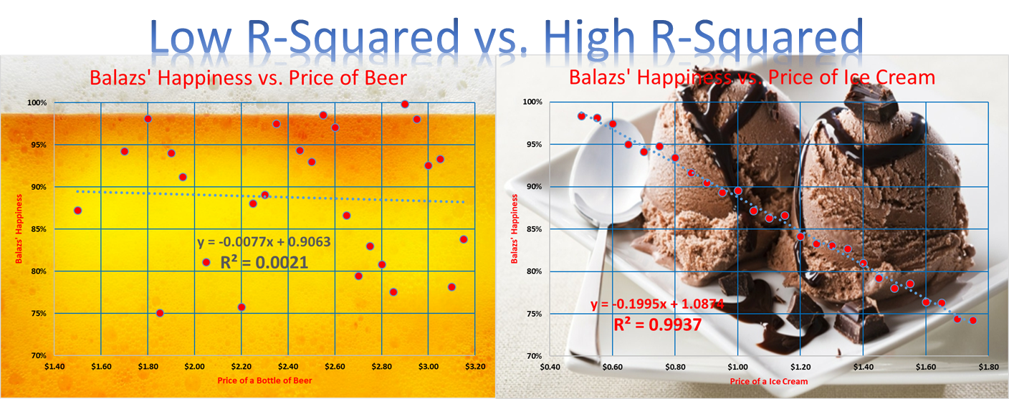

Caution! High correlation in itself can be misleading: [*Spurious correlations*](http://tylervigen.com/spurious-correlations)😉

## What is NOT the Beta?

Most of the investors believe that when a stock moves +5% in a given time period while its benchmark (e.g. SP500 or Nasdaq) only changes +2.5% during this time, the beta is exactly 2 (+5%/2.5%). **But - generally - this is not the case**.

*“****A statistical estimate of beta is calculated by a regression method****. For a given asset and a benchmark, the goal is to find an approximate formula*



*where ra is the return of the asset,* [*alpha*](https://en.wikipedia.org/wiki/Alpha_(finance)) *(α) is the active return, and rb is return of the benchmark.*

*Since practical data are typically available as a discrete ‘*[*time series*](https://en.wikipedia.org/wiki/Time_series)*’ of samples, the statistical model is*



*where εt is an error term (the unexplained return).* ***The best (in the sense of least squared error) estimates for α and β are those such that Σεt2 is as small as possible****.”[4]*

That is, as we can see, there is an **alpha** in the equation as well. This can be **considered as zero in the very short term if there are no events affecting the company** (e.g. earnings report or product release). But in the **long run** (weeks, months, years) **this effect must be taken into account**.

Furthermore, in longer term, the **cumulative effects** of daily or monthly returns should also be considered.

Thus, especially when the R2 of the regression (the squared value of the correlation as there is only two variables in the equation) is low, **it can easily happen that although the 'daily beta' or the 'monthly beta' of a stock is +1.6, and while the entire market rose by 10% during the last year, the price of the stock fell -20%. This is a surprise knowing that the 'daily beta' was positive, but it can easily be true.**

Last but not least, it is worth emphasizing that “***past price movement is a poor predictor of the future.*** *Betas are merely rear-view mirrors, reflecting very little of what lies ahead. Furthermore,* ***the beta measure on a single stock tends to flip around over time, which makes it unreliable****. Granted, for traders looking to* ***buy and sell stocks within short time periods, beta is a fairly good risk metric****. However, for investors with* ***long-term horizons, it's less useful.****”[5]*

## Optimal Return Interval and Length of Lookback Period

Attentive readers might notice that **neither the return interval, data sampling frequency (daily, weekly, monthly, yearly) nor the length of the lookback period (x-day, -month or -year ) is clearly defined in the above cited definition of beta**. This is not surprising as there is **no generally accepted rule** on this issue. However, as it will be seen, this is the **alpha and omega of the whole subject** and there is **no generally optimal choice**. For example, Yahoo Finance shows beta using monthly return interval with 3 years lookback period. It might be a good choice for “Buy&Hold” traders who are long-term thinking about a given stock. Nevertheless, the situation is quite different for daily traders, whose best choice could be daily (or even intraday) returns with short term lookback period.

In the following, some **research results from the literature** of this subject will be presented.

*Estimating Systematic Risk: The Choice Of Return Interval And Estimation Period[6]*

*(Phillip R. Daves, Michael C. Ehrhardt and Robert A. Kunkel)*

*“Financial managers can estimate the cost of equity via the CAPM approach. If the financial manager estimates the firm’s beta via regression analysis, then the financial manager* ***must select both the return interval and the estimation period****. Regarding return interval, this study finds that the* ***financial manager should always select daily returns*** *because daily returns result in the smallest standard error of beta or greatest precision of the beta estimate.  
However, regarding estimation period, the financial manager faces a dilemma. While* ***a longer estimation period results in a tighter standard error for the estimate of beta, a longer estimation period also results in a higher likelihood that there will be a significant change in the beta****. Thus, the beta estimated over longer estimation periods is more likely to be biased and of little use to the financial manager. The results show that an* ***estimation period of three years captures most of the maximum reduction in the standard error of the estimated beta from a one-year estimation period to an eight-year estimation period.*** *Additionally, less than fifty percent of the firms experience a significant shift in beta over a three-year period.“*

*How to Estimate Beta?[7]*

*(Fabian Hollstein, Marcel Prokopczuk and Chardin Wese Simen)*

*“Researchers and practitioners face many choices when estimating an asset’s sensitivities toward risk factors, i.e., betas. We study the effect of different data sampling frequencies, forecast adjustments, and model combinations for beta estimation. Using the entire U.S. stock universe and a sample period of more than 50 years, we find that…* ***using daily data over a 12-month horizon generally yields lower prediction errors than alternative historical windows and estimators based on low-frequency data.****”*

*Monthly Beta Forecasting with Low, Medium and High Frequency Stock Returns[8]*

*(Tolga Cenesizoglu, Qianqiu Liu, Jonathan J. Reeves and Haifeng Wu)*

*“Generating* ***one-month-ahead systematic (beta) risk forecasts*** *is common place in financial management. This paper evaluates the accuracy of these beta forecasts in three return measurement settings; monthly, daily and 30 minutes. It is found that the popular Fama-MacBeth* ***beta from 5 years of monthly returns*** *generates the most accurate beta forecast among estimators based on monthly returns. A realized beta estimator from* ***daily returns over the prior year****, generates the most accurate beta forecast among estimators based on daily returns. A realized beta estimator from* ***30 minute returns over the prior 2 months****, generates the most accurate beta forecast among estimators based on 30 minute returns.* ***In environments where low, medium and high frequency returns are accurately available, beta forecasting with low frequency returns are the least accurate and beta forecasting with high frequency returns are the most accurate.”***

*Why Beta Shifts as the Return Interval Changes[9]*

*(Gabriel Hawawini)*

*“A security's* ***beta may vary substantially depending upon whether it is estimated on the basis of daily, weekly or monthly returns****. For instance, for the four-year period January 1970 to December 1973, Eastman Kodak had a beta of 1.25 based on daily returns, but a beta of 0.93 based on monthly returns.* ***In general, the betas of securities with a smaller market value than the average of all securities outstanding (the market) will decrease as the return interval is shortened, whereas the betas of securities with a large market value relative to the market will increase. This suggests that betas measured over return intervals of arbitrary length will tend to be biased. In particular, securities with relatively small market values may appear to be less risky than they truly are, whereas securities with relatively large market values may appear to be more risky than they truly are.****”*

# 

# Results

## Impact of Lookback Period and Return Interval on Estimated Beta[10]

As it could be seen at the calculation of the beta, **it is not too difficult to “estimate” it**. However, **it has to be emphasized that - depending on the data used in the estimation - different estimations of beta can arise in connection with the same stock and market.** It was mentioned in the previous section that **two parameters have significant impact on the estimated beta coefficient: the lookback period and the return interval**. In this section the effects of these factors will be examined more deeply.

At first, focus on the **lookback period**. During this examination, daily-, weekly- and monthly close prices were used to calculate the betas of the **~500 companies of S&P500 index in comparison to the SPY** **on 2018-12-31** using **2- and 5-year lookback periods**. The distribution of these estimated betas can be seen in Chart 1a-c. Based on these charts and Table 1 it can be concluded that **the length of the lookback period really affects the value of the beta coefficient and in case of the longer period, the betas are less scattered** (**more data is used**, thus there are less outlier and lower standard deviation).

Secondly, let us see the effect of the **return interval**. Chart 2a and 2b show the distribution of the estimated betas in case of different return intervals: **daily-, weekly- or monthly returns** with the same lookback period (2- or 5-year). Using these charts and Table 1 it can be concluded that: **(1) the longer the interval, the higher the beta and (2) the shorter the interval (more samples are used in the beta estimator), the ‘narrower’ the distribution (less scattered, less outliers, a less random, more reliable estimator).**

Based on these findings someone may suppose that **using more frequent data (i.e. daily returns) gives us more stable and maybe more useful beta**.

Chart 1a: Distribution of Estimated Betas of S&P500 Companies using Daily Returns - different lookback period

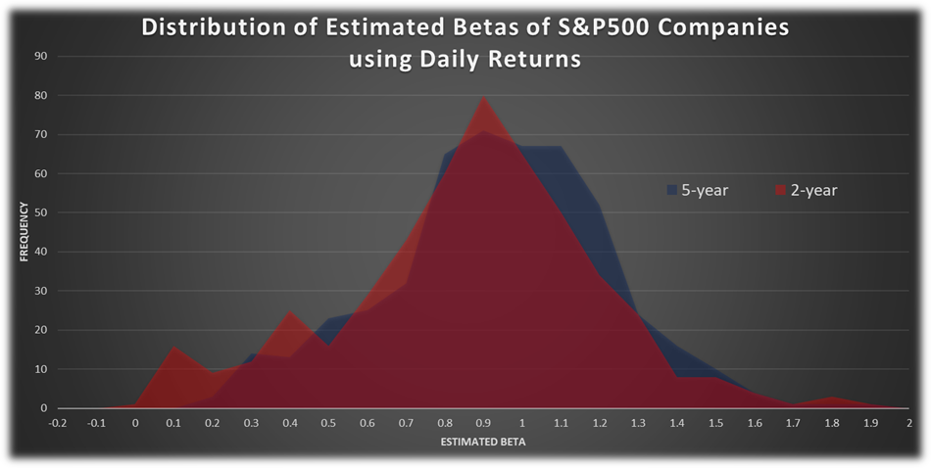

Chart 1b: Distribution of Estimated Betas of S&P500 Companies using Weekly Returns - different lookback period

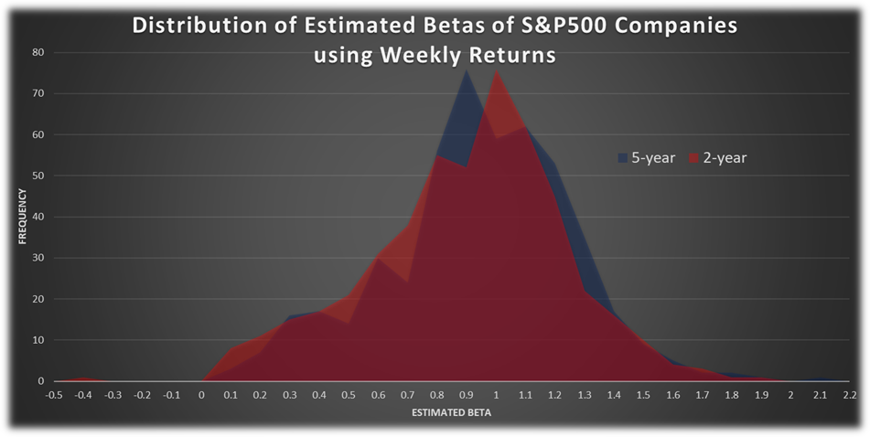

Chart 1c: Distribution of Estimated Betas of S&P500 Companies using Monthly Returns - different lookback period

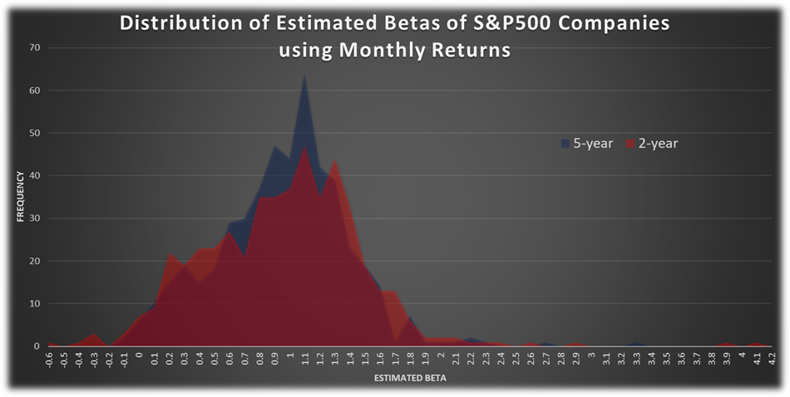

Chart 2a: Distribution of Estimated Betas of S&P500 Companies using 5-Year Lookback Period - different return interval

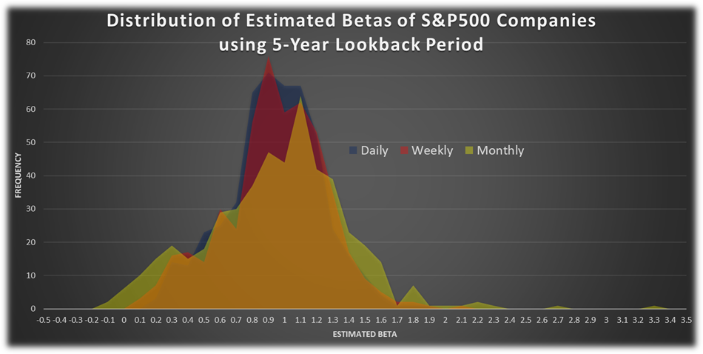

Chart 2b: Distribution of Estimated Betas of S&P500 Companies using 2-Year Lookback Period - different return interval

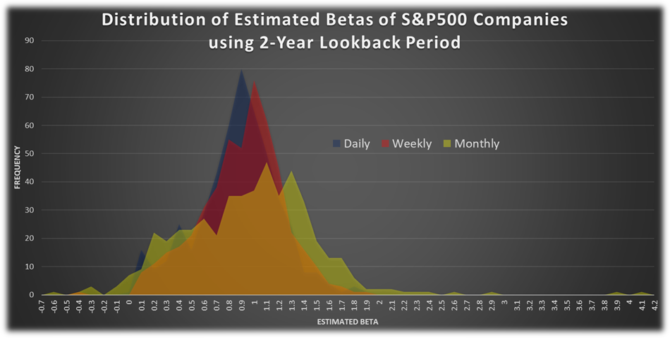

Table 1: Estimated Betas of S&P500 Companies by Lookback Period and Return Interval

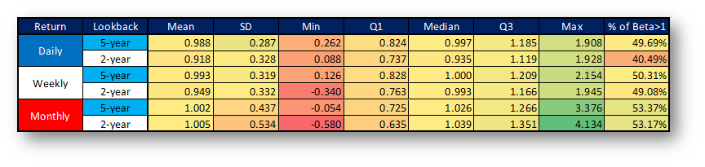

As a next step, instead of the nearly 500 S&P500 companies, we have **focused on our 13 GameChanger stocks**. In this part of this section, we calculated their betas **not only for a given day (e.g. 2018-12-31 as above) but for every day between 2004 and 2018** and not only in comparison to the SPY but to the QQQ (their better benchmark) as well - using daily-, weekly- and monthly returns and 2- and 5-year lookback periods again. The distributions of these beta coefficients can be seen in Chart 3a-f and Chart 4a-d - similar to the previous ones.

Based on these charts, **daily betas seem more stable (less volatile) and slightly lower than weekly- or monthly betas**. At this point, **no clear relationship can be found between the distribution of betas and these (2- and 5-year) lookback periods** (other periods may have significant effect).

Chart 3a: Distribution of Estimated Betas of GameChangers using Daily Returns in Comparison to QQQ - different lookback period

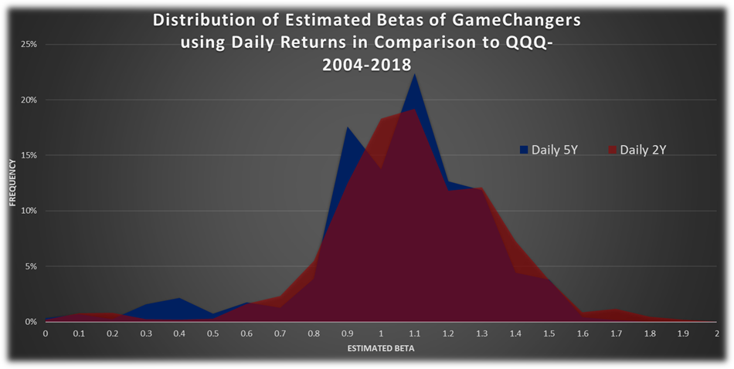

Chart 3b: Distribution of Estimated Betas of GameChangers using Daily Returns in Comparison to SPY - different lookback period

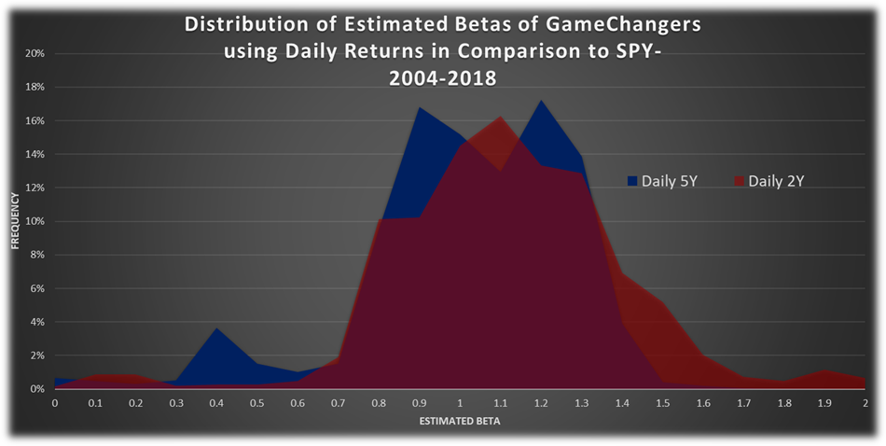

Chart 3c: Distribution of Estimated Betas of GameChangers using Weekly Returns in Comparison to QQQ - different lookback period

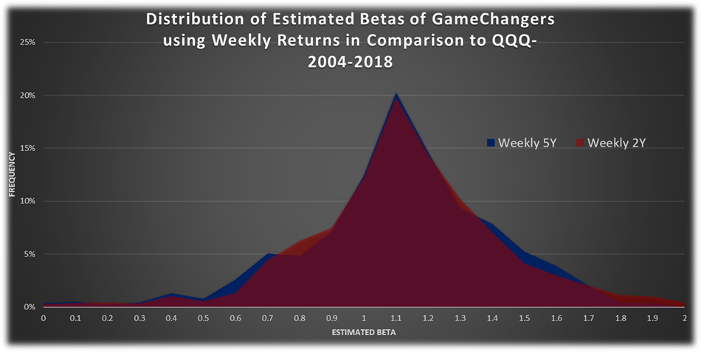

Chart 3d: Distribution of Estimated Betas of GameChangers using Weekly Returns in Comparison to SPY - different lookback period

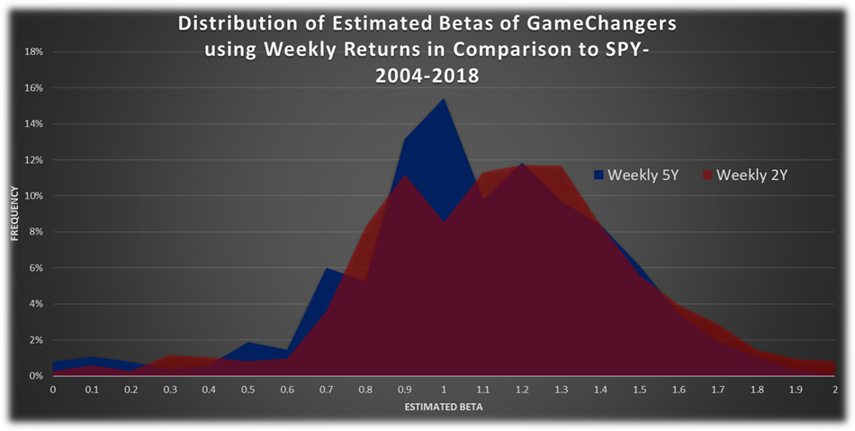

Chart 3e: Distribution of Estimated Betas of GameChangers using Monthly Returns in Comparison to QQQ - different lookback period

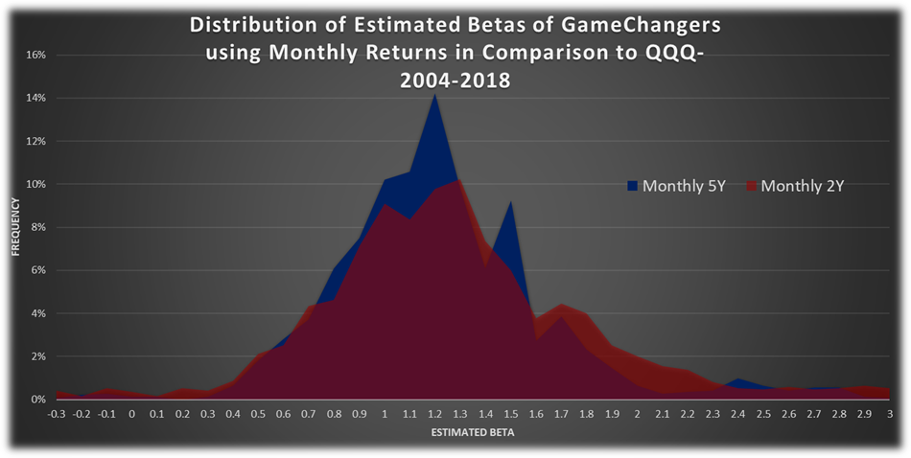

Chart 3f: Distribution of Estimated Betas of GameChangers using Monthly Returns in Comparison to SPY - different lookback period

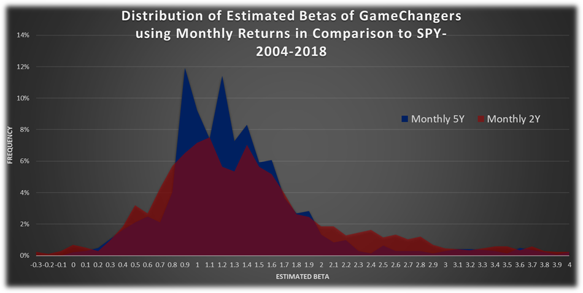

Chart 4a: Distribution of Estimated Betas of GameChangers using 5-Year Lookback Period in Comparison to QQQ - different return interval

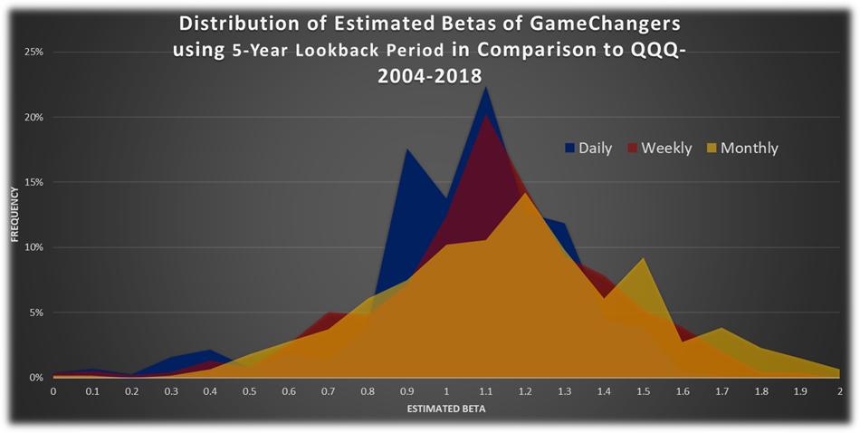

Chart 4b: Distribution of Estimated Betas of GameChangers using 5-Year Lookback Period in Comparison to SPY - different return interval

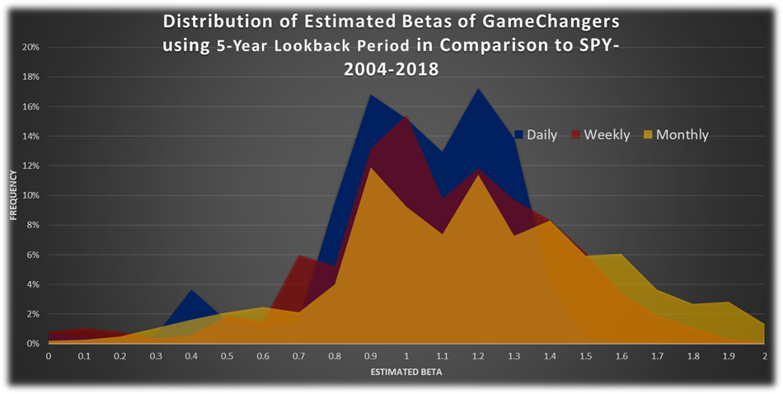

Chart 4c: Distribution of Estimated Betas of GameChangers using 2-Year Lookback Period in Comparison to QQQ - different return interval

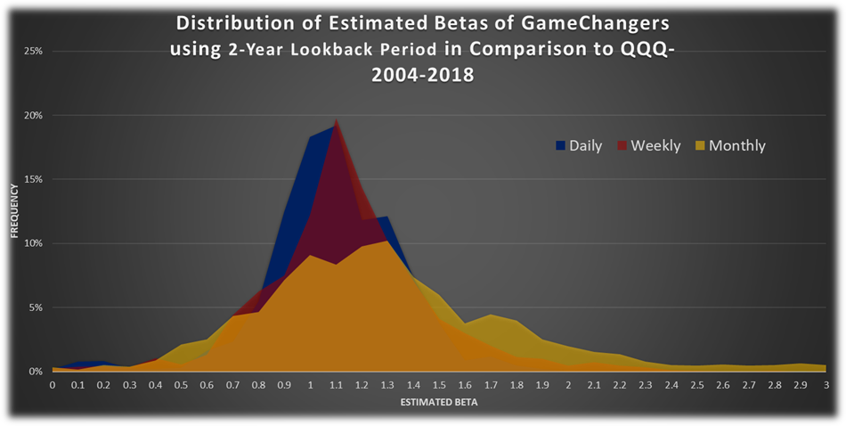

Chart 4d: Distribution of Estimated Betas of GameChangers using 2-Year Lookback Period in Comparison to SPY - different return interval

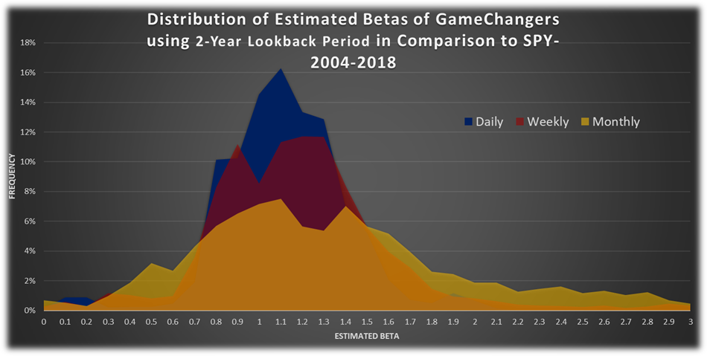

**To summarize the above findings it seems that the use of daily betas could be recommended the most.** We also see why the fact that YahooFinance uses monthly beta is a poor choice: it gives more random, more scattered beta estimators. But, until now, we did not deal with the reliability of these betas. As it could be read in the Background chapter, the [**coefficient of determination**](https://en.wikipedia.org/wiki/Coefficient_of_determination) **(R2 or R-squared)** can help us to **validate the estimated beta and it tells us how 'useful' the calculated beta is in practice for prediction purposes.** In this case, as there is only one dependent (return of the stock) and one independent variable (return of the market), this is **simply the square of the sample correlation coefficient (i.e. *r*)** between the returns of the stock and the returns of the market. Why could be this R-squared (its value is between 0 and 1 or 0% and 100%) help us? When its **value is high (e.g. above 64%), it means that the past returns of the stock and the market are highly correlated (above 0.8), thus it can be expected (with limitations) that these returns will move almost together in the near future as well**. So the **estimated beta could be really useful**. At the other extreme, when **R-squared is really low (e.g. below 25%), it means that the past returns of the stock and the market do not correlate enough (below 0.5 which is not sufficient in case of time series), thus the estimated beta could be useless.**

Chart 5a-f and Chart 6a-d contain the **distributions of these R-squared values** - exactly as beta coefficients were shown in Chart 3a-f and Chart 4a-d above. Based on these charts, someone can conclude that in case of **GameChanger stocks**:

* **daily- and weekly betas have higher R2 on average and their distributions are less “flat”;**
* **R2 is higher using longer lookback period**;
* **R2 is higher if QQQ is the benchmark rather than SPY. Therefore, the QQQ-beta number is more useful than the SPY-beta. We should use that. This is expected because the GameChanger stocks are in technology sector. Note that YahooFinance only calculates the SPY-beta.**
* **For individual GameChanger stocks, the R2s are generally less than 0.5. Even in the QQQ case. This means the stocks and the QQQ do not correlate enough. Pessimists can say that the calculated beta could be useless. Nevertheless, this is what can be calculated from the past. That is the best it is possible to do. Even though the R2s are not very high, we can use these betas, but do not expect very precise future stock %change estimation compared to the benchmark %change. Note that, if instead of individual GameChanger stocks, we aggregate the GameChangers into a portfolio, the situation will be much better. More about it later.**

Actually, **every time we calculate the beta number, we should show the R2 value as wel**l to the user next to the beta. It would show how reliable is the calculated beta.

Chart 5a: Distribution of R-Squared of GameChangers using Daily Returns in Comparison to QQQ - different lookback period

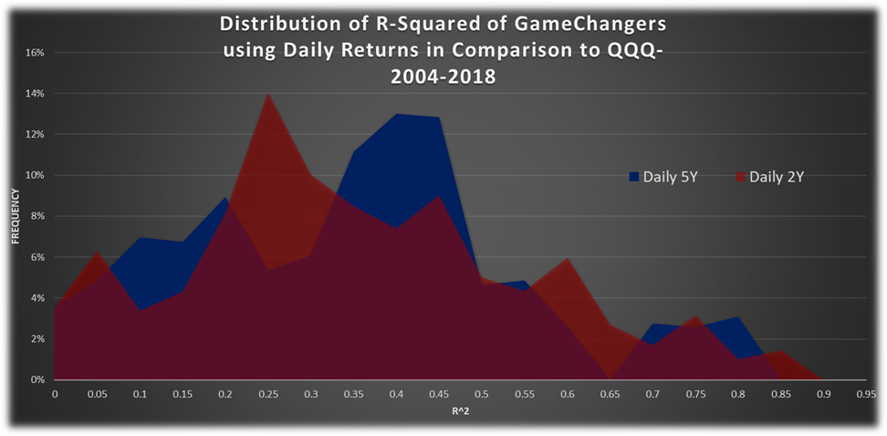

Chart 5b: Distribution of R-Squared of GameChangers using Daily Returns in Comparison to SPY - different lookback period

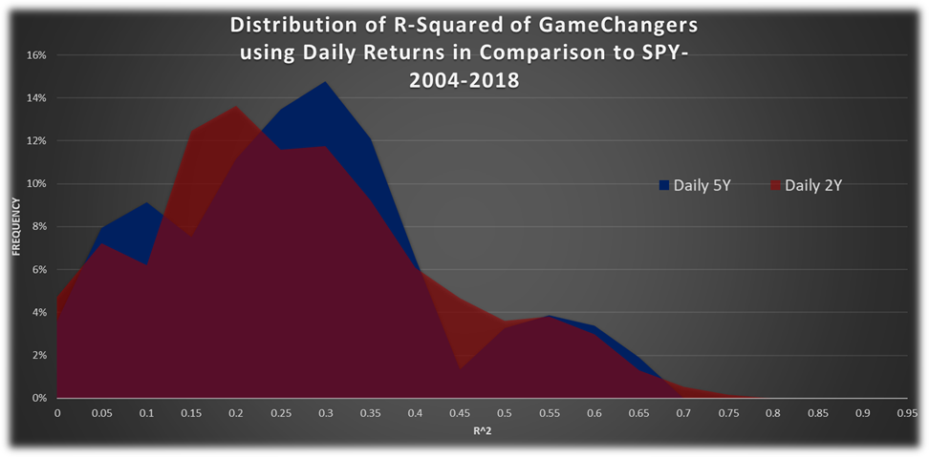

Chart 5c: Distribution of R-Squared of GameChangers using Weekly Returns in Comparison to QQQ - different lookback period

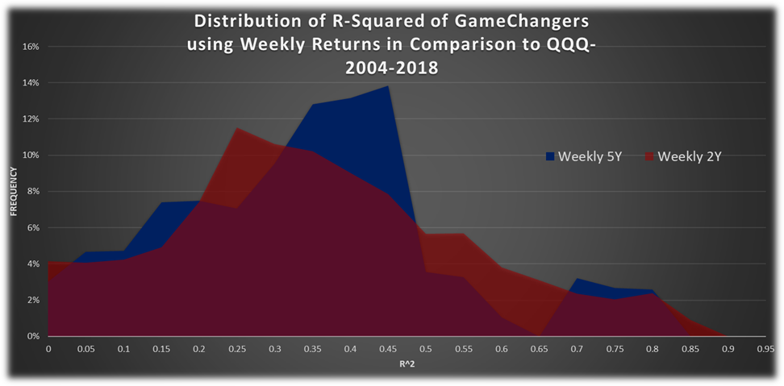

Chart 5d: Distribution of R-Squared of GameChangers using Weekly Returns in Comparison to SPY - different lookback period

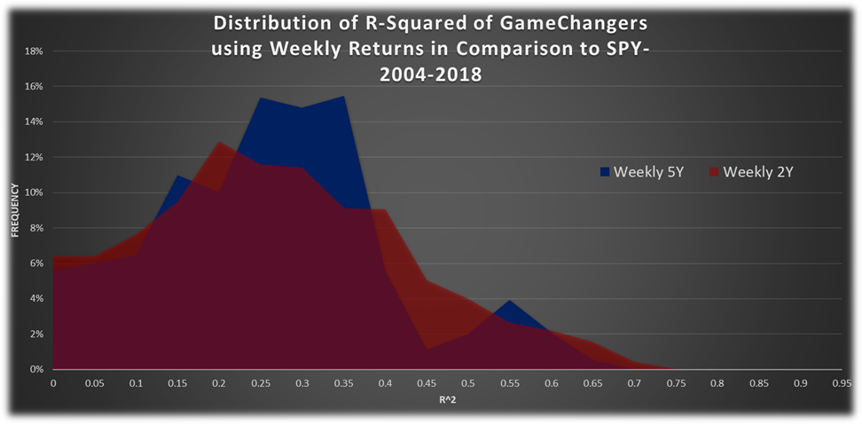

Chart 5e: Distribution of R-Squared of GameChangers using Monthly Returns in Comparison to QQQ - different lookback period

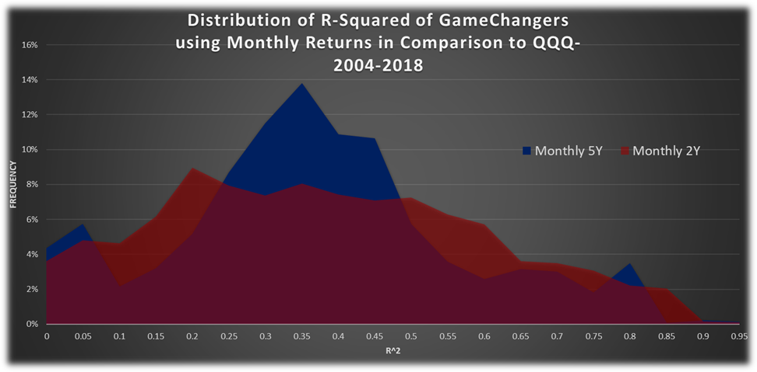

Chart 5f: Distribution of R-Squared of GameChangers using Monthly Returns in Comparison to SPY - different lookback period

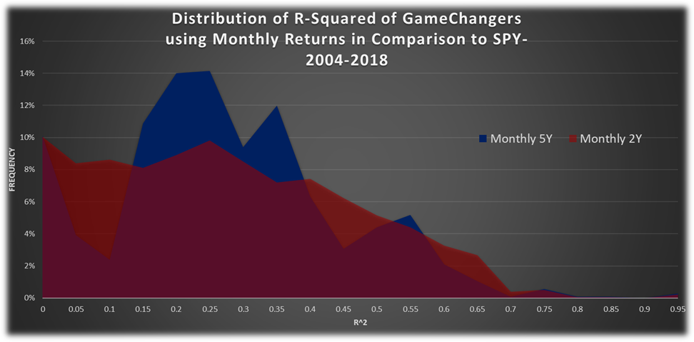

Chart 6a: Distribution of R-Squared of GameChangers using 5-Year Lookback Period in Comparison to QQQ - different return interval

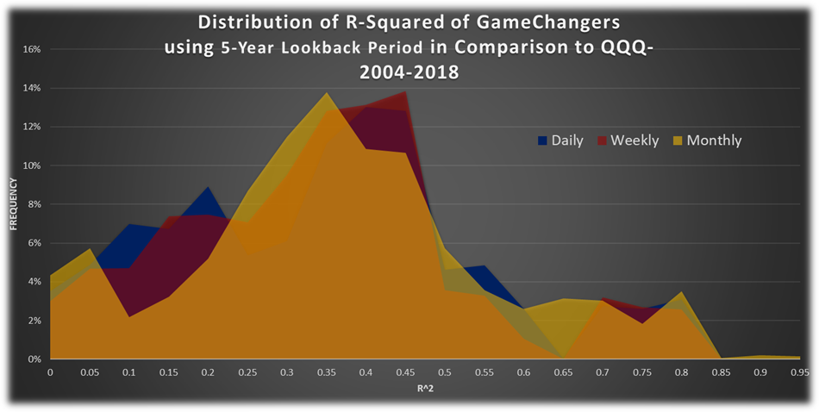

Chart 6b: Distribution of R-Squared of GameChangers using 5-Year Lookback Period in Comparison to SPY - different return interval

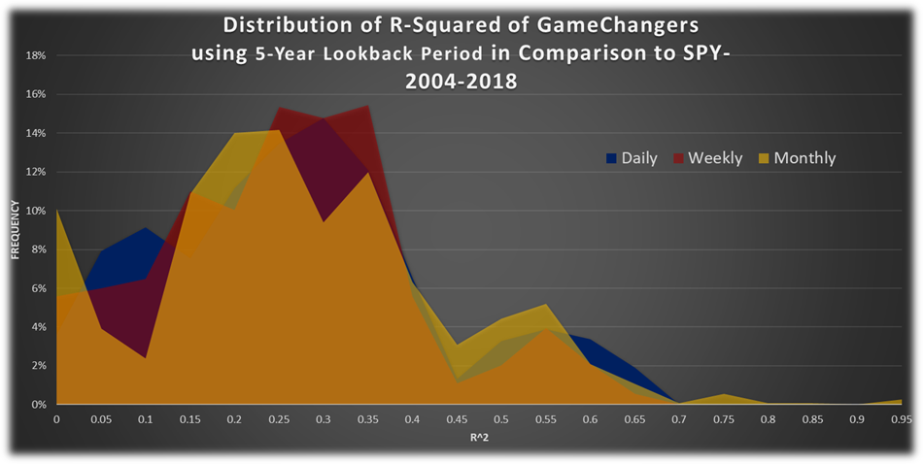

Chart 6c: Distribution of R-Squared of GameChangers using 2-Year Lookback Period in Comparison to QQQ - different return interval

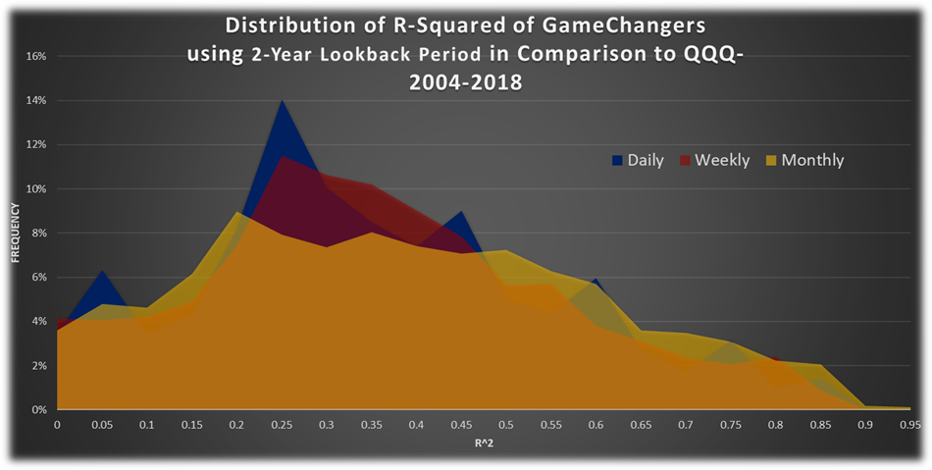

Chart 6d: Distribution of R-Squared of GameChangers using 2-Year Lookback Period in Comparison to SPY - different return interval

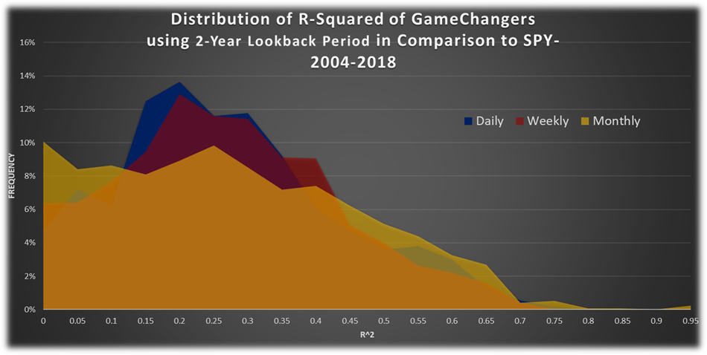

## Estimating Beta for the Entire GameChanger Portfolio

Until now, we have treated the **individual GameChanger stocks separately**. But our main goal is **to hedge the entire GameChanger portfolio with QQQ put options**. That’s why we should **deal with them together** and to do this, we have made a **virtual stock**, in which all GameChanger companies have **equal weight**: **EqualWeighted GameChanger stock (EWGCh)**. In the following, we are dealing with this virtual stock.

What do we expect from this virtual stock? As our GameChanger stocks - because they have large market cap - have **more than 50% total weight in QQQ**, the virtual EqualWeighted GameChanger stock must have a **much closer relationship (higher correlation)** with the QQQ. Thus, its beta can be considered **more reliable** than looking at company betas separately.

Table 2a-b contain statistical indicators of estimated beta of the virtual EWGCh and its R-squared by benchmark (QQQ or SPY), return interval (daily, weekly or monthly) and lookback period (2- and 5-year).

Based on these tables it can be concluded that:

* **the virtual EWGCh stock (and thus our GameChanger portfolio) should not be hedged with SPY put options as the reliability of betas in comparison to SPY is significantly lower than in comparison to QQQ;**
* **the longer the lookback period, the lower the beta, but the difference is not significant;**
* **the longer the lookback period, the more reliable the beta, as more data is used. But this difference is also not significant.;**
* **beta of the virtual EWGCh stock is obviously higher than 1, so our GameChangers are more volatile than the Nasdaq.;**
* **The daily QQQ-R2 is 0.78. Its value is high enough that the beta of the EWGCh can be reliable used. The calculated beta is useful.**

In our opinion, based on these figures, **our GameChanger portfolio (actually EWGCh stock) correlates well with QQQ, thus - based on our above mentioned QQQ put option insurance study - it could be effectively hedged with QQQ put options with some beta coefficient**.

Table 2a: Statistical Indicators of Estimated Beta of EWGCh by Benchmark, Return Interval and Lookback Period - from 2004 to 2018

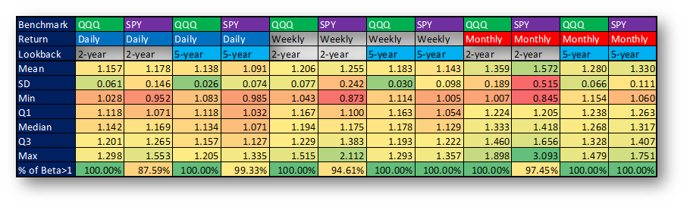

Table 2b: Statistical Indicators of R-Squared of EWGCh by Benchmark, Return Interval and Lookback Period - from 2004 to 2018

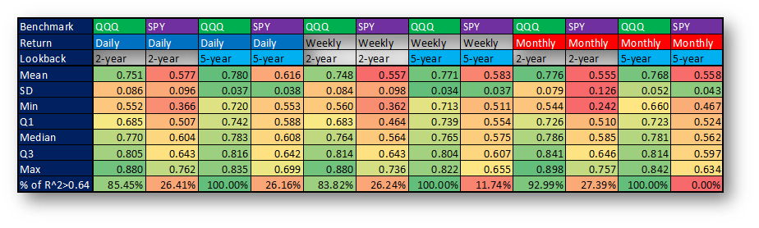

Furthermore, neither the lookback period nor the return interval seem to be a significant factor in terms of beta - for now. If this were really the case, we could safely use any of the betas for the QQQ put option insurance strategy. Unfortunately, however, the situation is not so simple. Chart 7a-b show the scatter plot of **daily vs. monthly EWGCh betas in comparison to QQQ and SPY using 1 year lookback period. Surprisingly, it can be seen that the daily betas vs. the monthly betas: they are almost independent (very low R2), thus they can not easily be substituted for each other**. For instance, there are **examples in Chart 7a**, when the daily beta is 1.8, while the monthly beta is 0.8. Or the other extreme: the daily beta is 0.8, while the monthly beta is 1.6. Monthly beta calculations can be affected much more by big outlier values. Imagine Netflix daily %change values. Furthermore, imagine that over a year, Netflix stock mostly moved with the QQQ, but on the earnings report day, it fell -50%, but price come back to 0% over the next month. If daily beta calculation is used, that outlier value is averaged with another 259 other trading day samples, so its effect will be smoothed. However, if monthly beta is calculated (over 1 year, using 12 samples) then two things can happen. Either that -50% daily drawdown is either totally skipped by those 12 monthly data samples (because price came back to breakeven later), or that -50% drawdown is in the 12 monthly samples. But in that case, that outlier is only averaged with another 11 other monthly samples, so its effect will be huge. It is easy to see why monthly beta calculation is so random and unreliable. And it is a major problem with regard to the QQQ put option insurance strategy, as it buys and holds the options for a month. Because our investment horizon in this case is a month, we ought to use the monthly betas. But assuming that daily betas are more robust and reliable, as we see, monthly beta calculation gives quite random values. We have a choice here. We **either use the monthly betas (but it uses less data) or try to ‘monthly-izing’ the daily betas (more data → more reliable) with a multiplicator**.

Chart 7a: Scatter Plot of EWGCh Betas in Comparison to QQQ - daily vs. monthly return interval

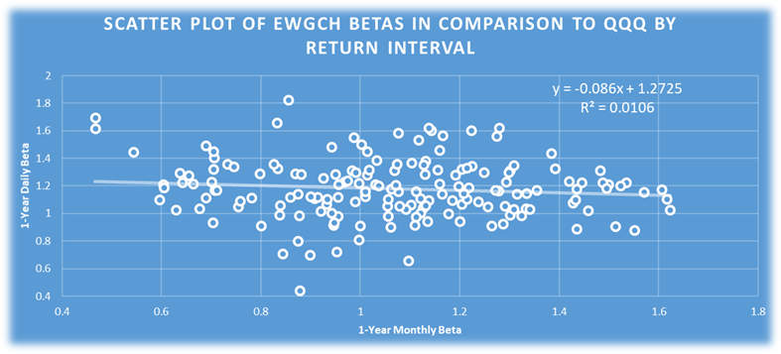

Chart 7b: Scatter Plot of EWGCh Betas in Comparison to SPY - daily vs. monthly return interval

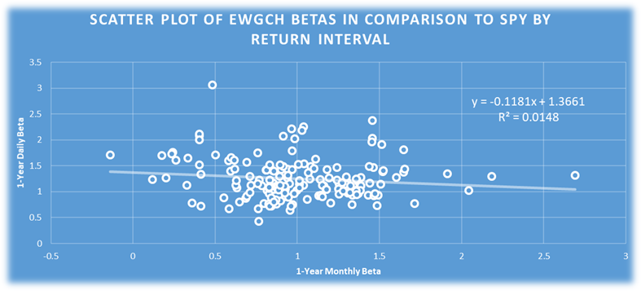

In the following, we will analyse the beta coefficient further with the help of a simple strategy - let us call it ‘Beta Tester strategy’.

***Beta Tester strategy***:

* **calculate daily, weekly or monthly betas with some lookback period in comparison to the QQQ once in a month (generally EOM);**
* **use some multiplicator for betas to get the appropriate monthly leverage for QQQ;**
* **buy&hold EWGCh stock with QQQ hedge: long EWGCh stock and short multiplicator*beta QQQ;**
* **rebalance it monthly (when the new beta is calculated).**

This strategy is close to the strategy we would like playing in real life with QQQ put option instead of short QQQ stock.

Our goal is twofold with this ‘Beta Tester strategy’: **finding the appropriate lookback period, return interval and multiplicator to get the best performance (CAGR, Sharpe ratio, maximum drawdown), while the difference between the monthly return of the EWGCh and leveraged (multiplicator*beta) QQQ is the closest to zero (perfect hedge)**. In case of the latter, the sum of absolute deviations and sum of squared deviations will help us. These indicators are almost equivalent to the standard deviation.

Based on our market experience, we **would not think that data older than 3 years should be used if we think about monthly time frame (1-month maturity put options with monthly rebalancing)**. Because of this, Table 3 and Table 4 contain statistical indicators of **estimated betas** and **performance indicators** of the ‘Beta Tester strategy’ using **daily-, weekly and monthly betas with 1-, 2- and 3-year lookback period and with 100% multiplicator (no leverage)**. Actually, **really significant differences can not be found among the performance** of the strategies using these scenarios.

**We think (and it is recommended in** [**‘How to Estimate Beta’ - Hollstein et al.**](https://pdfs.semanticscholar.org/a83b/d033252f311d3a40c3c20fb52b03d6a6f5df.pdf)**) that daily beta using 1-year lookback period with some multiplicator would be the most appropriate choice for our real life QQQ put option insurance strategy.**

Someone might think that *‘All right, let us use daily beta with 1 year lookback period. But* ***do not we want to use an extra multiplier for bearish periods****?’* **Many traders may have the impression that these GameChanger stocks lose much more than QQQ on bearish days and win slightly more on bullish days, so different betas should be used in bearish and bullish days**. But after taking a look at Chart 8a-c, it can be seen that **there is no reason to use different multipliers (betas) in bearish and bullish times**. These linear regression charts show that there is **no significant difference in daily betas** (using data from 2004 to 2018) on extreme bullish (beta=1.135 and R2=0.6466 when daily %change of QQQ is more than 1%) and on extreme bearish (beta=1.1269 and R2=0.599 when daily %change of QQQ is less than -1%) days compared to all days (beta=1.1642 and R2=0.771).

Table 3: Statistical Indicators of Estimated Beta of EWGCh in Comparison to QQQ by Return Interval and Lookback Period - 2006-2018

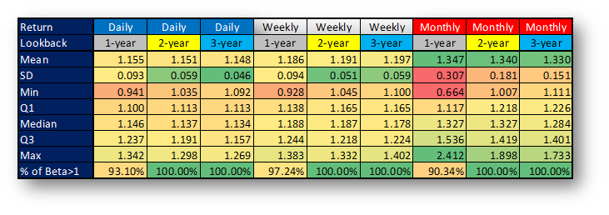

Table 4: Performance Indicators of PVs by Return Interval and Lookback Period - 2006-2018

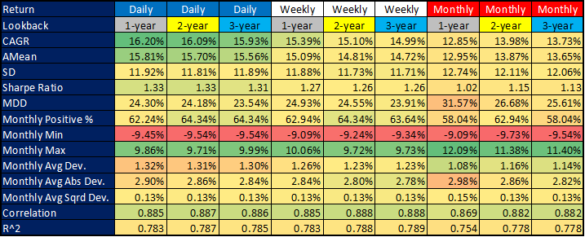

Chart 8a: Linear Regression Chart - EWGCh vs. QQQ using Daily Returns from 2004 to 2018 - All Days

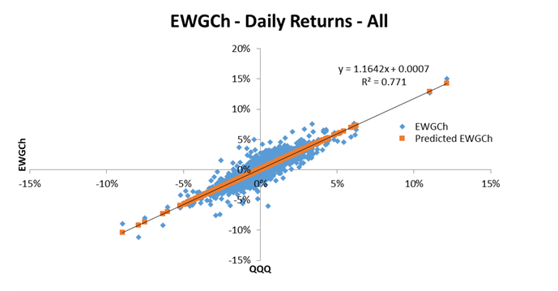

Chart 8b: Linear Regression Chart - EWGCh vs. QQQ using Daily Returns from 2004 to 2018 - When QQQ Daily % Change >=1%

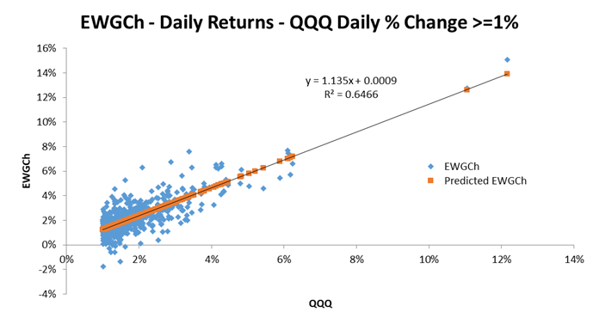

Chart 8c: Linear Regression Chart - EWGCh vs. QQQ using Daily Returns from 2004 to 2018 - When QQQ Daily % Change <-1%

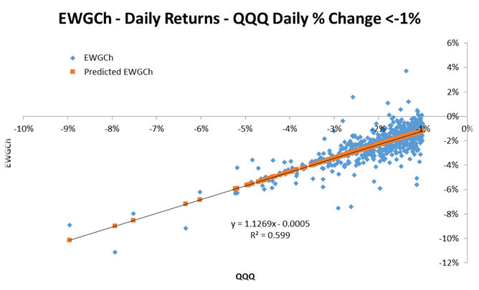

## 

## Monte-Carlo Analysis to Select the Optimal Daily Beta ‘Monthly-izing’ Multiplicator

In the previous section we concluded that daily beta using 1-year lookback period with some multiplicator would be the most appropriate choice us. We essentially estimate the monthly beta from the daily beta with this multiplier. In this section, we try to determine its **optimal value**.

Table 5a contains performance indicators of the **‘Beta Tester strategy’ using daily betas, while the same can be found in Table 5b but using monthly betas**. The **lookback period is 1-year** in both cases for the sake of comparability. **0% multiplicator means the pure buy&hold EWGCh stock without QQQ hedge**. **Surprisingly, in case of daily betas, we get the best performance (highest Sharpe ratio and lowest maximum drawdown) with 80-85% multiplicators, while the lowest deviation belongs to the 115-125% multiplicators**. It means, that **we are the closest to perfect hedge when daily beta was increased by 15-25%**, but we get the **best Sharpe, maxDD results when beta is decreased by 15-20%**. This difference can largely be attributed to the fact that the **virtual EWGCh stock itself has performed well in the past**. If it was **loss-making or neutral, it would have achieved the best result with a larger multiplier**. The same can be concluded based on Table 5b: **the lower leverage (lower multiplier) for the QQQ hedge is used, the better performance we get - thanks to the well performed virtual EWGCh stock. A remarkable achievement that the maxDD, which is -50% without hedging could have been brought down to -23% with the 70-75% multiplier. It is far from the 0% maxDD of a perfect hedge, but it is a big advantage.**

Table 5a:Performance Indicators of PVs by Multiplicators from 2004 to 2018 - Using Daily Beta

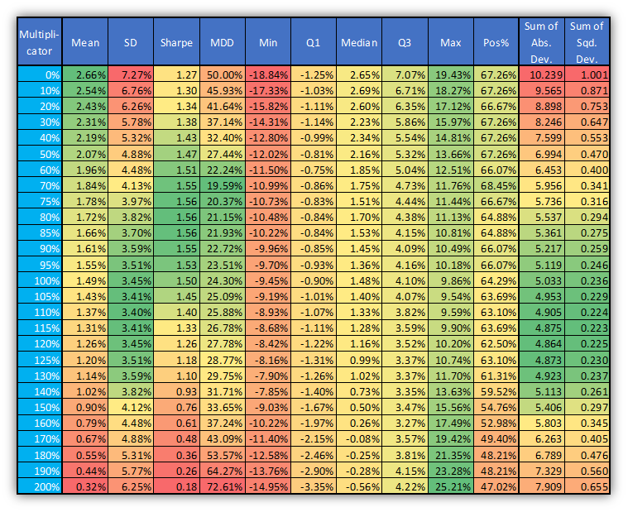

Table 5b: Performance Indicators of PVs by Multiplicators from 2004 to 2018 - Using Monthly Beta

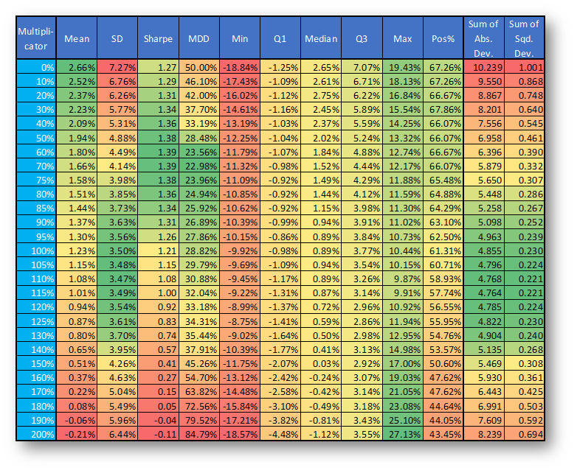

But how would the strategy perform if the **GameChanger stocks did not perform so well** (e.g. in a bear market)? In the following, we are analysing **three scenarios with Monte Carlo simulations using 100,000-100,000 simulated return path for QQQ and EWGCh to analyse the performance of the** **‘Beta Tester strategy’**:

* **Realistic:** using real average daily returns, standard deviations and correlation coefficient - **all day** from 2004 to 2018;
* **Bearish:** using real average daily returns, standard deviations and correlation coefficient - **bearish periods** (QQQ decreased more than -15% within months) from 2004 to 2018;
* **Bullish:** using real average daily returns, standard deviations and correlation coefficient - **bullish periods** (QQQ increased more than 15% within months) from 2004 to 2018.

The exact parameters of these scenarios can be seen in Table 6.

Table 6: Parameters of Simulated Daily Returns

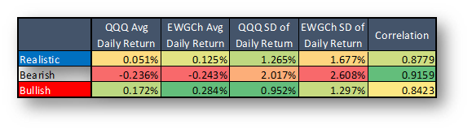

For all three scenarios, we show the density of **CAGRs, Sharpe ratios and maximum drawdowns** of the **‘Beta Tester strategy’ using daily betas with the following multipliers: 0% (without hedge), 85%, 100% (pure beta), 125% and 150%.** These density functions can be seen in Chart 9a-c - Chart 11a-c. The averages of these performance indicators can be found in Table 7.

**As it might be supposed, a lower multiplier (even 0%, no hedge) would be the most appropriate in bullish periods, while the opposite is true in bearish periods (even 150%). In our opinion, the optimal value of the multiplicator should be around 85% for risk lover and around 110-125% for risk averse investors. Note that the 150% multiplier brought down CAGR significantly (from 33% to 8.24%) in the 'Realistic' case, so we probably shouldn't hedge that much amount. The 85% multiplier decreased the CAGR to 20%, which is still fine.**

Chart 9a: Density of CAGRs using Simulated Returns - Realistic Returns

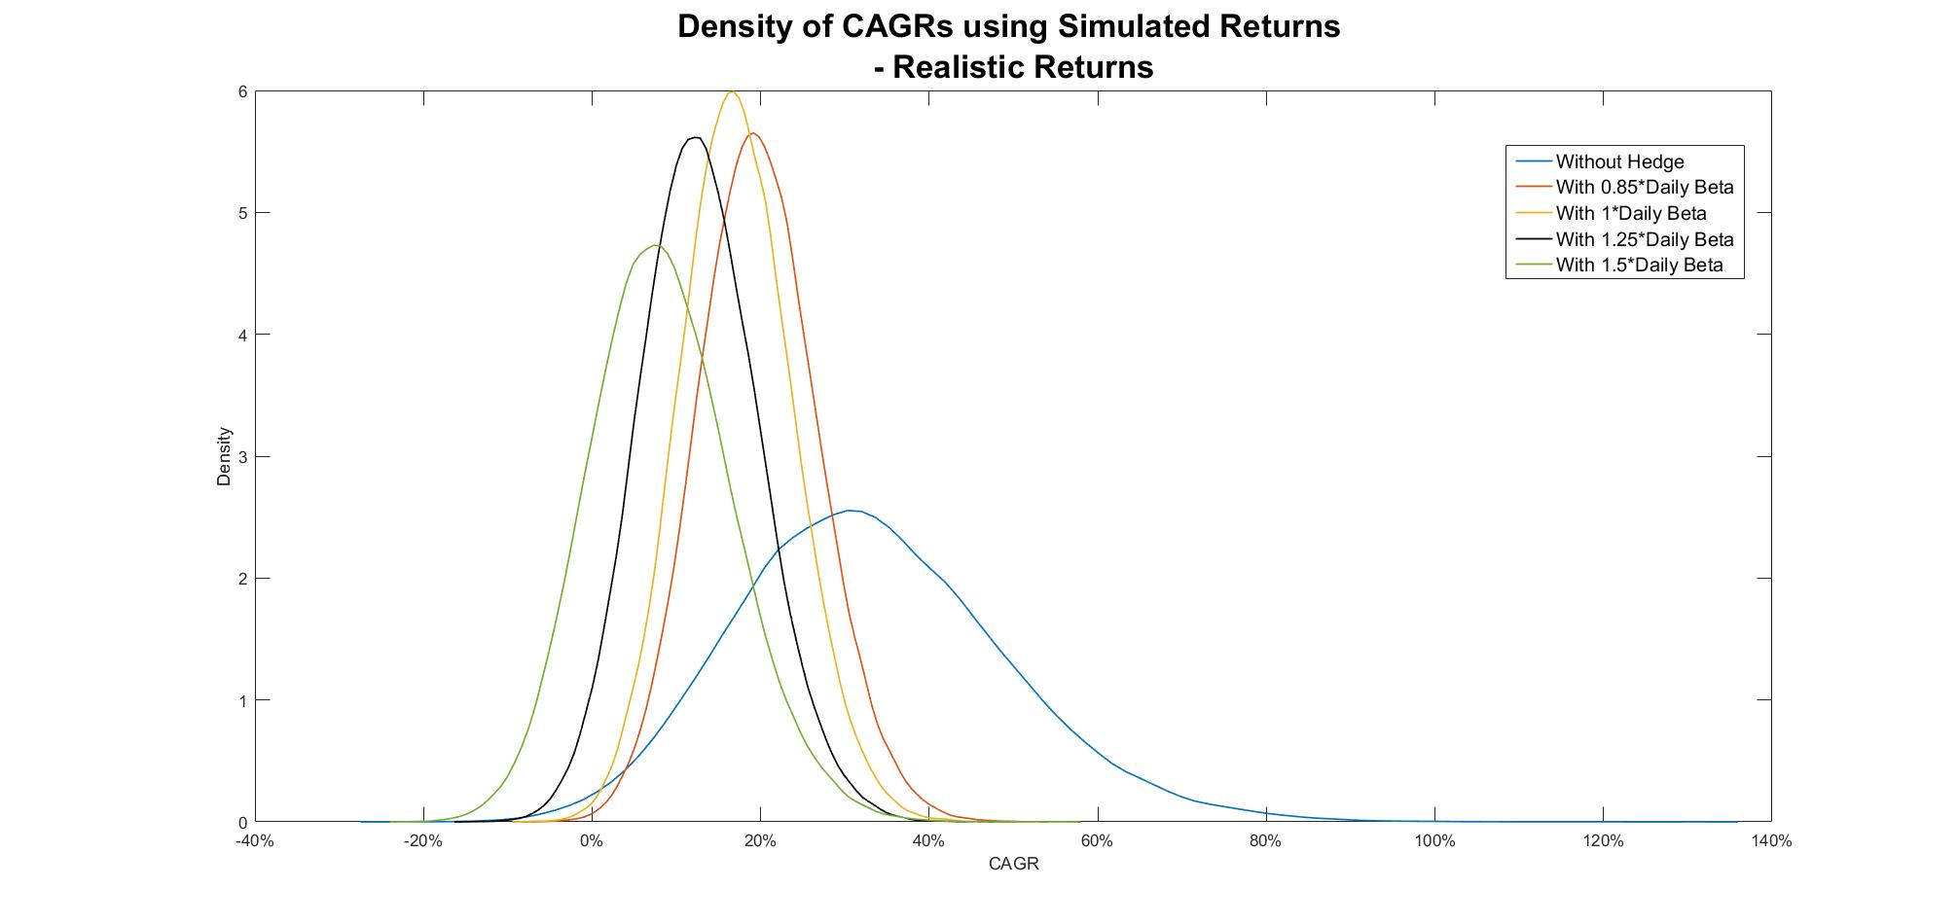

Chart 9b: Density of Sharpe Ratios using Simulated Returns - Realistic Returns

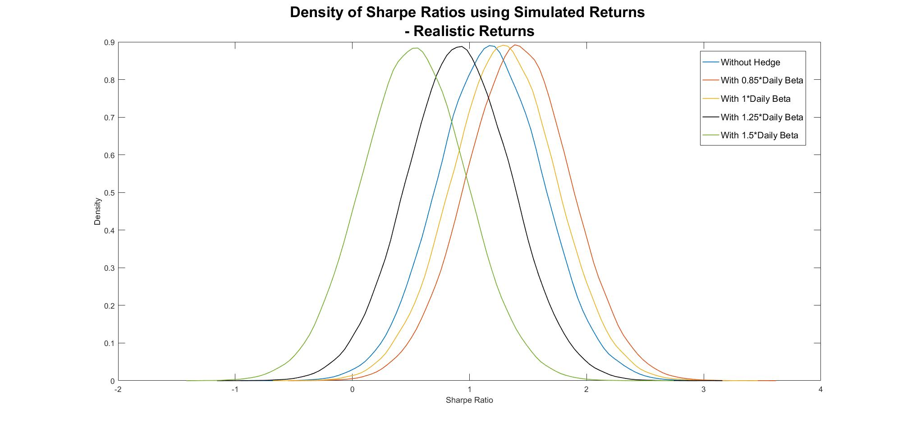

Chart 9c: Density of Maximum Drawdowns using Simulated Returns - Realistic Returns

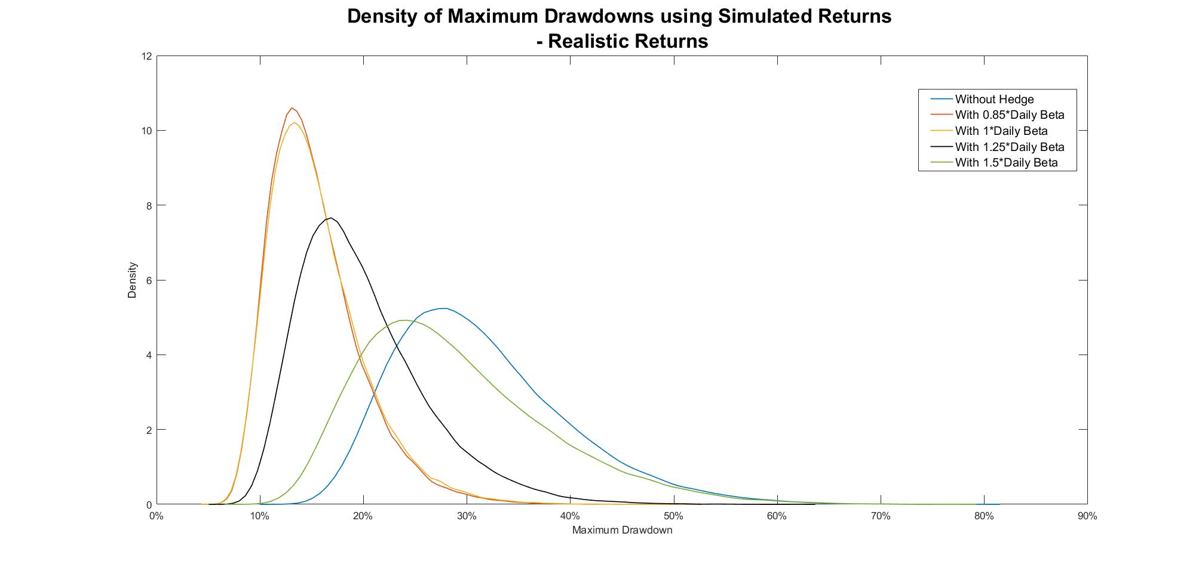

Chart 10a: Density of CAGRs using Simulated Returns - Bearish Regime

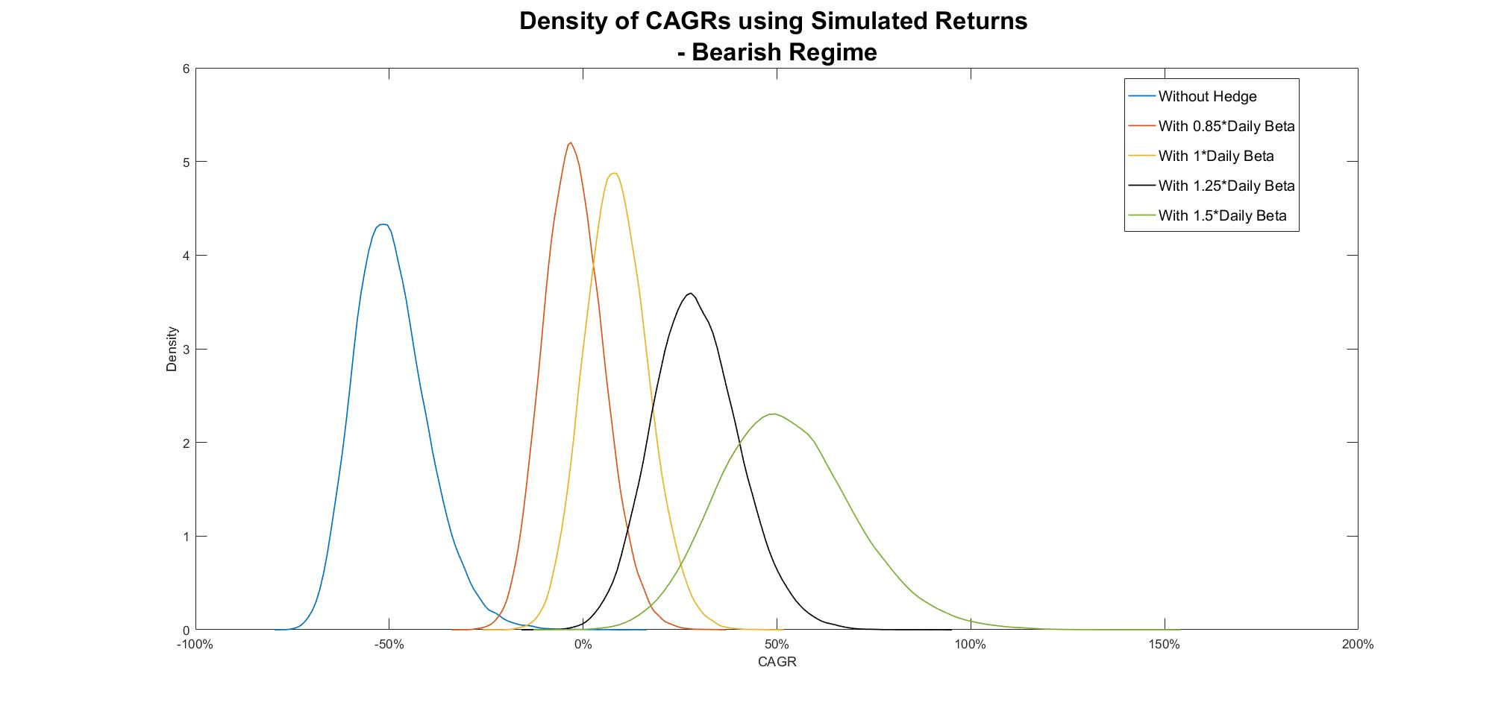

Chart 10b: Density of Sharpe Ratios using Simulated Returns - Bearish Regime

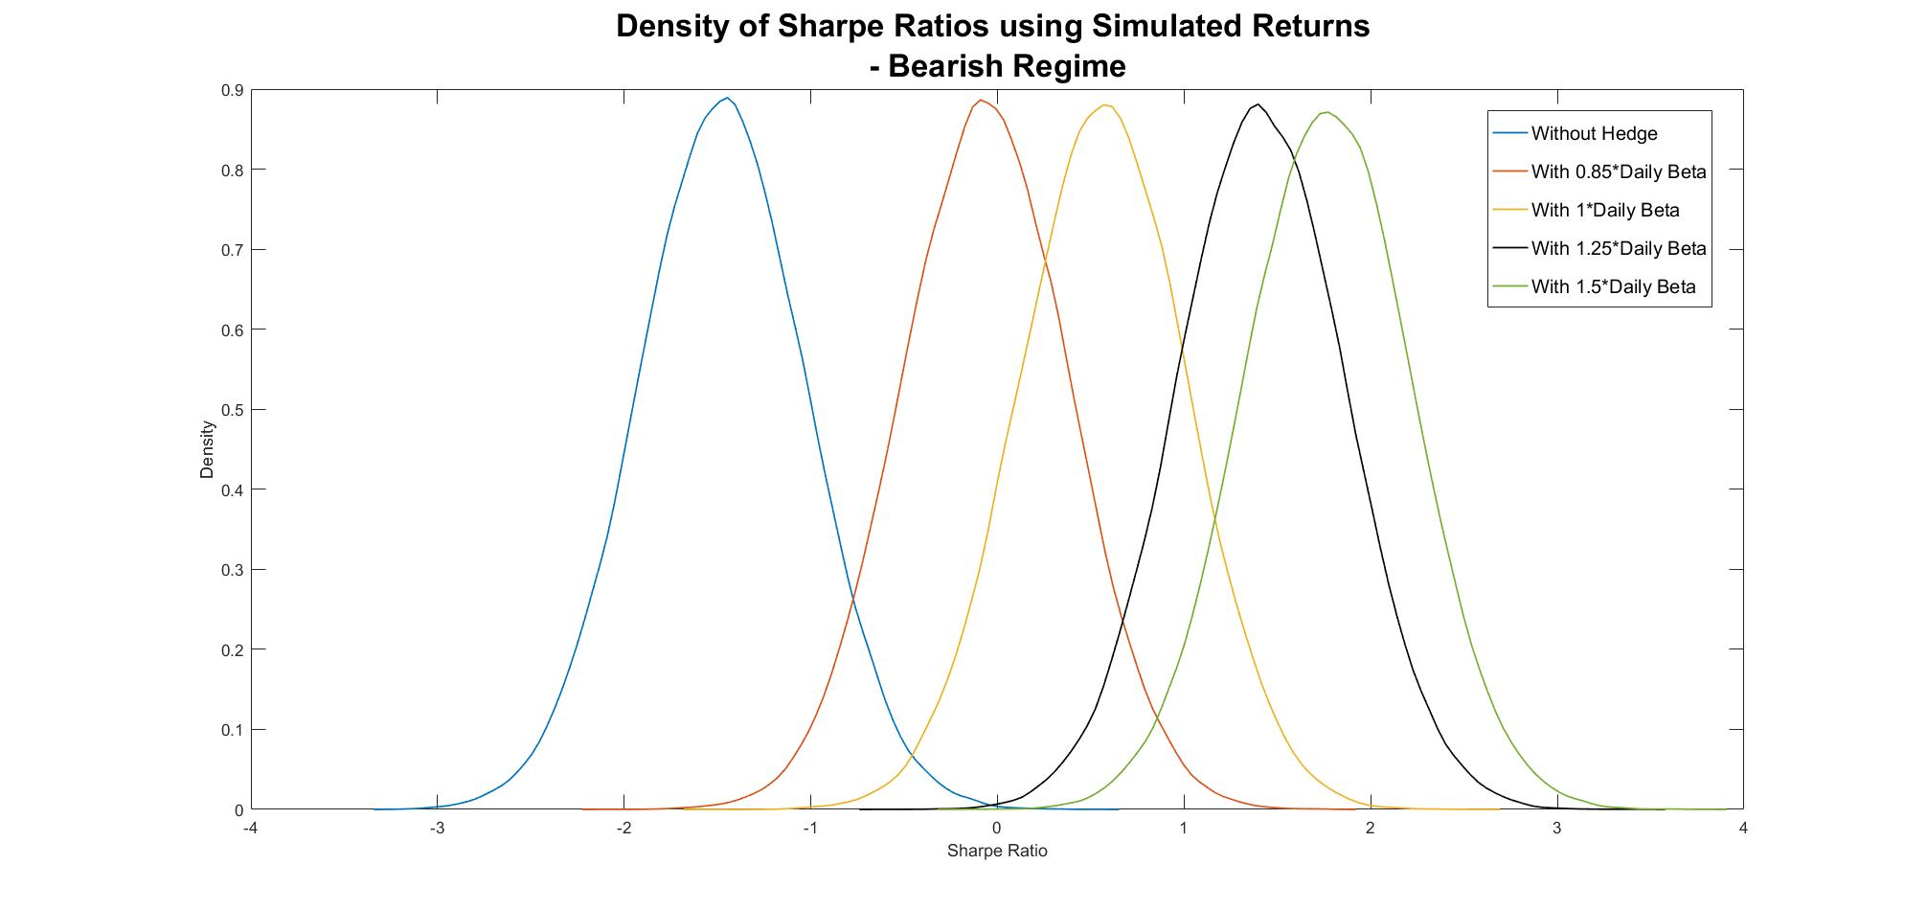

Chart 10c: Density of Maximum Drawdowns using Simulated Returns - Bearish Regime

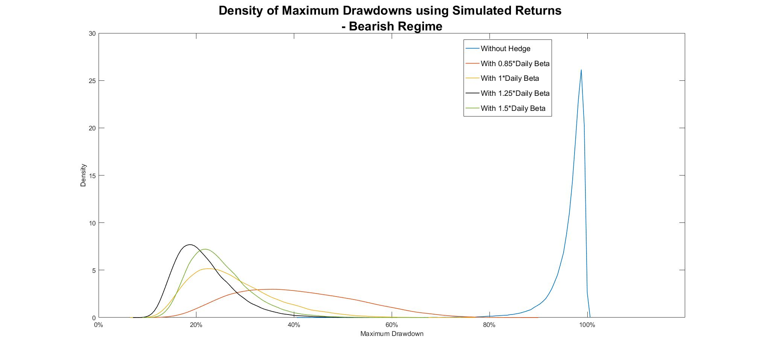

Chart 11a: Density of CAGRs using Simulated Returns - Bullish Regime

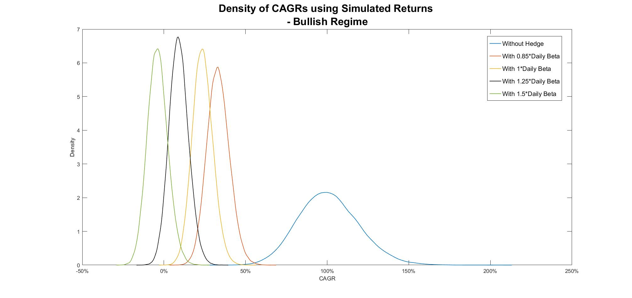

Chart 11b: Density of Sharpe Ratios using Simulated Returns - Bullish Regime

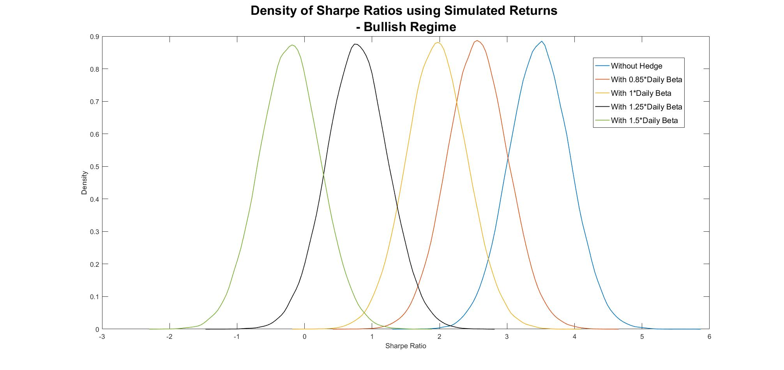

Chart 11c: Density of Maximum Drawdowns using Simulated Returns - Bullish Regime

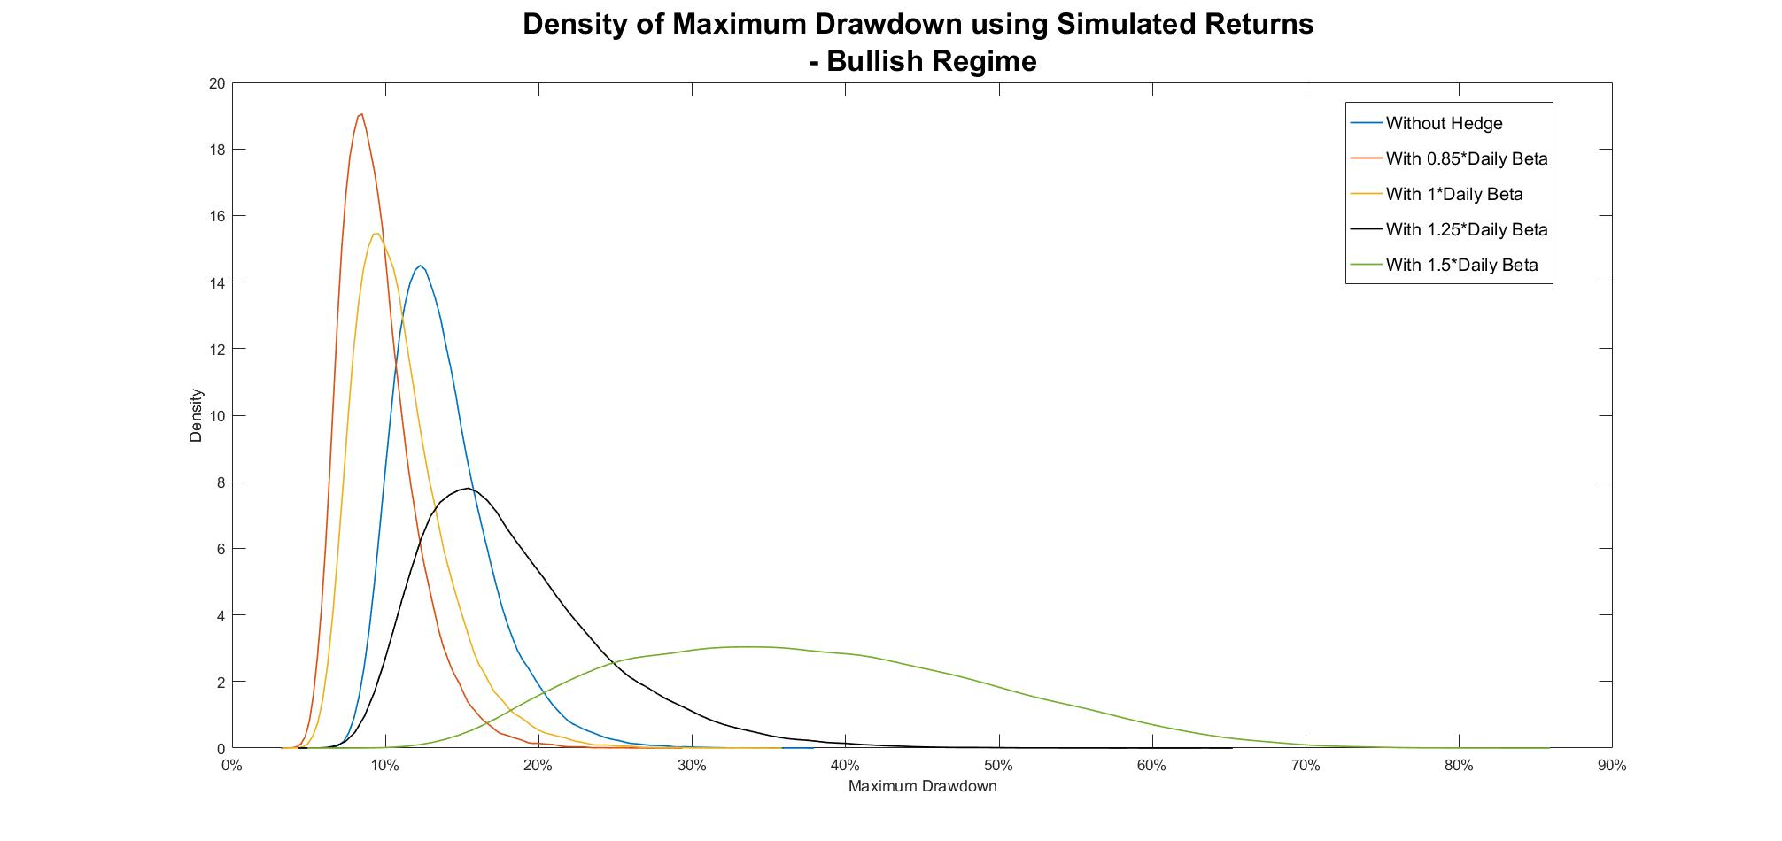

Table 7: Average Performance Indicators using Simulated Daily Returns, Daily Betas and 1-Year Lookback Period

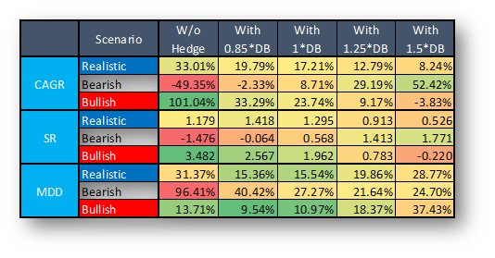

## 

## Optimal Beta for Individual GameChanger Stocks?

In the previous sections we have dealt with the virtual **EqualWeighted GameChanger (EWGCh) stock** (as a proxy of our real life GameChanger portfolio) and we have found that this is a **better way to hedge, as if we were doing it separately for each stock** (e.g. with stock specific put options). But what if we want to **hedge only one or two stocks** (for example we would like holding only AAPL and AMZN)? Can these QQQ betas be used then?

Table 8a-c show betas of GameChanger stocks and their reliability using **daily, ‘End-of-Month’ monthly and ‘Mid-Month’ monthly betas in comparison to QQQ using all available data from 2004 to 2018**. In these tables, not only **‘Total’ days/months** but also **extreme bullish and bearish QQQ days/months** are shown separately. Based on these figures it can be concluded that while **in case of the virtual EWGCh stock these numbers are close to each other and reliability (R2) is high, in case of some companies this is not always the case**. **Reliability is much lower for every stocks than for the virtual EWGCh aggregate**. Furthermore, it is also interesting to see that while **in case of the EWGCh stock the numbers in Table 8b and 8c are almost the same (and in Table 8a as well), this is not entirely true for individual stocks, although they use monthly returns as well with just 2 weeks of difference**. For example, in case of the FB, End-of-Month (EOM) betas are positive in extreme bullish/bearish months, while negative(!) in case of Mid-Month (MM) betas. **These differences are caused by some stock specific outliers (e.g. earnings report, product release etc.) which are ‘balanced’ in case of EWGCh and daily betas but not in case of individual stocks and monthly betas, which is exactly what YahooFinance provides.** These outliers and their effects can be clearly seen in Chart 12-13.

All in all, we **do not recommend using QQQ (and thus these betas) for hedging one or two individual stocks. In this case, stock specific put options are much more appropriate.**

Table 8a: Betas of GCh Stocks and their Reliability using Daily Beta and all data (Maximum Lookback) from 2004 to 2018

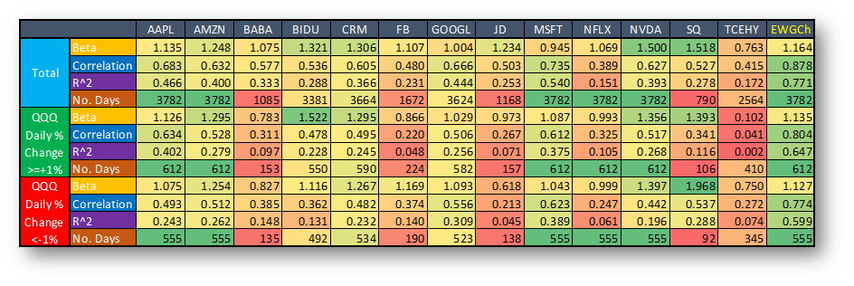

Table 8b: Betas of GCh Stocks and their Reliability using Monthly Beta (EOM) and all data (Maximum Lookback) from 2004 to 2018

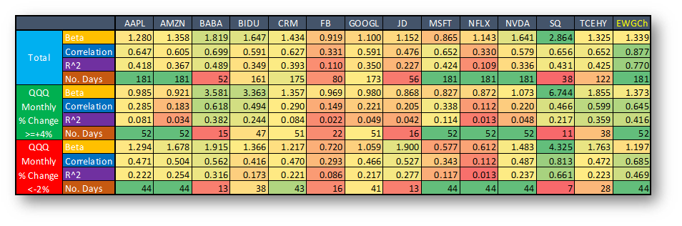

Table 8c: Betas of GCh Stocks and their Reliability using Monthly Beta (Mid-Month) and all data (Maximum Lookback) from 2004 to 2018

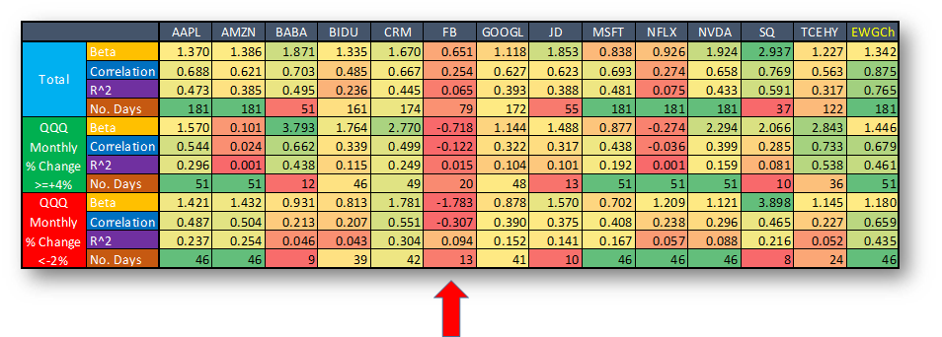

Chart 12: Linear Regression Chart - FB vs. QQQ using Monthly Returns (Mid-Month) from 2004 to 2018 - When QQQ Monthly % Change >=4%

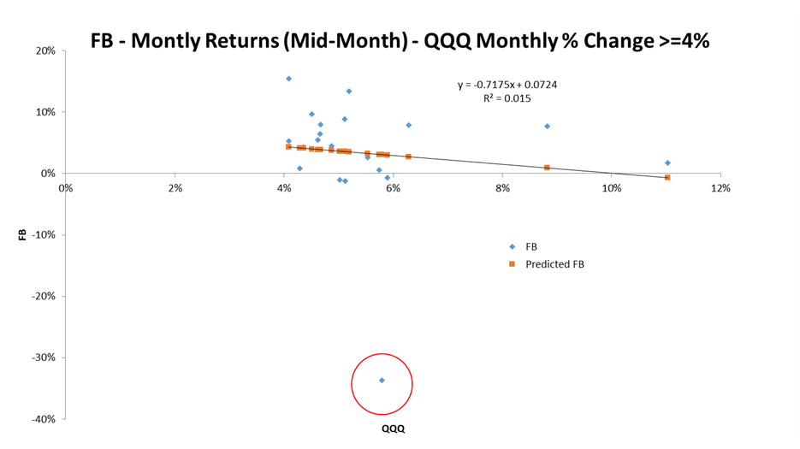

Chart 13: Linear Regression Chart - NFLX vs. QQQ using Daily Returns in 2018 - All Days

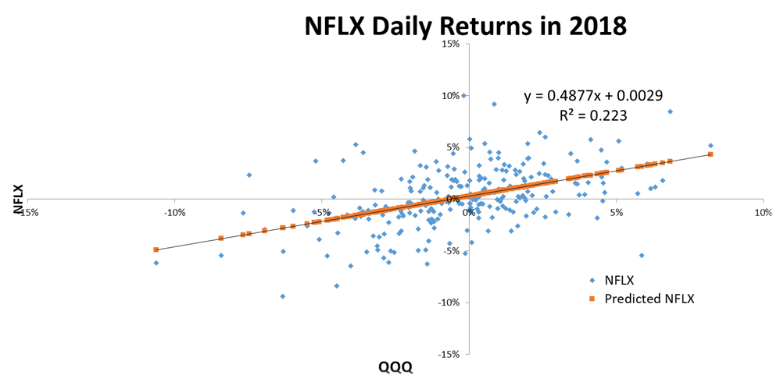

Finally, let us see **how useful the betas shown by Yahoo Finance are**. These are betas **in** **comparison to SPY** (it was shown above that these are less useful for GameChanger stocks than betas in comparison to QQQ). They use **monthly return** with **3-year lookback period** (only 36 data points). These returns are based on the close prices on the **first trading day of each month** (interestingly, for Yahoo Finance, not the close price on the last trading day is the close price of a month).[11] Table 9 contains daily, EOM (End-of-Month) monthly (as we used) and BOM (Beginning-of-Month) monthly (as YF use) betas of GameChanger stocks in comparison to SPY on 2018-12-31. It should be noted that **we managed to perfectly reproduce the betas shown in YF** (last row in table). However, it can be clearly seen from the figures in this table that these BOM monthly betas in comparison to SPY are far from the betas that are desirable for us (daily betas in comparison to QQQ) in many cases (e.g. in case of FB, YF says: 0.556 vs. we say: 1.13, or JD, YF says: 0.614 vs. we say: 1.261). All in all, **we do not recommend using YF betas in order to hedging GameChanger stocks.**

As YF betas are not useful for us and we did not find any appropriate online beta calculator for our GameChanger stocks, **we have developed our own version which can be found** [**here**](https://www.snifferquant.net/GameChangerBetaCalculator).

Table 9: Betas of GCh Stocks in comparison to SPY on 2018-12-31 using 3-year lookback period

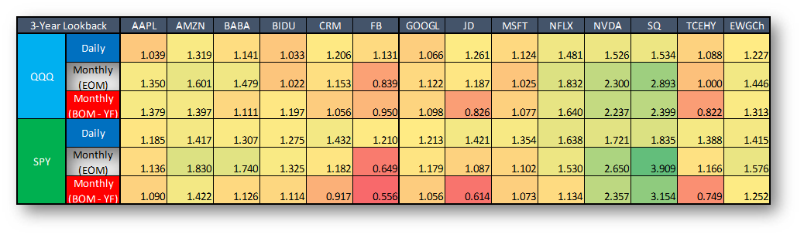

# Conclusions

In this study we dealt with the beta of our GameChanger stocks. Previously we have developed a **QQQ put option insurance strategy which could be appropriate for hedging our GameChanger portfolio**. However, we have to know **how many options we need to buy for almost perfect hedging**. That’s why we need to determine an **‘appropriate beta’.**

At first, we introduced what the beta is: **how to calculate it, how many ‘parameters’ it has (Beta has 3 parameters, benchmark: SPY or QQQ; return interval, data sampling frequency: daily, weekly, monthly, annual; lookback period: 1-5 years), what is written in the literature etc**.

In the first section of the next chapter we dealt with the **optimal return interval and lookback period**. It is not a simple task at all, because **it depends on the purpose for which we want to use the beta**. For short-term holdings, daily returns with shorter lookback period is obviously more appropriate than monthly returns with longer lookback. But the latter could be more desirable for traders who want to hold a stock in the long run (for years).

Based on our examination in this section we found that:

* **only QQQ put options should be used as a hedge for our GameChanger portfolio, SPY is not good enough;**
* **the more data we use (e.g. daily returns instead of monthly returns), the more reliable the beta will be;**
* **daily beta using 1-year lookback period with some ‘monthly-izer’ multiplicator would be the most appropriate choice for our real life QQQ put option insurance strategy;**
* **there is no significant differences between betas in extreme bearish or bullish periods.**

After that we tried to optimize the ‘monthly-izer’ multiplicator which makes daily betas suitable for monthly use. Using Monte-Carlo simulations we have found that **the optimal value of this ‘monthly-izer’ daily beta-multiplicator should be around 85% for risk lover and around 110-125% for risk averse investors.**

In the last section we concluded that **using QQQ (and thus these betas) for hedging one or two individual stocks is not recommended. In this case, stock specific put options are much more appropriate.**

Finally, as YF betas are not useful for us and we did not find any appropriate online beta calculator for our GameChanger stocks, **we have developed our own version which can be found** [**here**](https://www.snifferquant.net/GameChangerBetaCalculator).

1. As on 2019-03-31: AAPL, AMZN, BABA, BIDU, CRM, FB, GOOGL, JD, MSFT, NFLX, NVDA, SQ and TCEHY.
2. https://www.investopedia.com/terms/b/beta.asp
3. <https://www.investopedia.com/ask/answers/012915/whats-relationship-between-r-squared-and-beta.asp>
4. <https://en.wikipedia.org/wiki/Beta_(finance)#Statistical_estimation>
5. <https://www.investopedia.com/investing/beta-know-risk/>
6. <http://www.studyfinance.com/jfsd/pdffiles/v13n1/daves.pdf>
7. <https://pdfs.semanticscholar.org/a83b/d033252f311d3a40c3c20fb52b03d6a6f5df.pdf>
8. <https://pdfs.semanticscholar.org/e6ed/174cb2e0dfe24dc450acf10570da1138626b.pdf>
9. <https://www.jstor.org/stable/4478650?seq=1#page_scan_tab_contents>
10. Some ideas came from: <http://p-s.com/news/impact-of-estimation-period-and-return-interval-on-estimated-beta/>
11. <http://investexcel.net/how-does-yahoo-finance-calculate-beta/>