Dr. George Antal

3D Click Limited

c/o Suite 431, 28 Old Brompton Road, London SW7 3SS

**Revisiting the IPO shorting strategy**

**Motivation** **1**

**Used data** **2**

**Methodology** **2**

**Usual IPOs** **4**

**Short-term** **5**

Short-term behavior after IPO 5

Short-term walk-forward behavior 12

Short-term behavior by IPO calendar month 15

Short-term behavior by sectors 16

**Mid-term** **18**

Mid-term behavior 18

Mid-term behavior by IPO calendar month 29

Mid-term behavior by sectors 34

**Conclusion** **37**

# 

# 

# Motivation

After an IPO starts trading, investment banks begin a **quiet-period**, during which they can’t publish any research on the company. The end of the quiet period is important because the underwriters all launch their coverage on the IPO on that day and it can have a large impact on the stock.

Most investment banks observe a 25-day rule for a quiet period. On the coverage day analysts will issue their full reports on the company including earnings, estimates and price targets. These reports are usually positive; underwriters vetted these companies before going public, so it makes sense that the underwriter would remain optimistic about the company in their research coverage.

For company executives, there is also a SEC-mandated period of 40 days in which they are prohibited from offering new information that isn’t already available to the public. So after these dates we expect a bullish period.

Another trading date to note is the expiration of the **lock-up period**. When a company goes public, the underwriters make company insiders sign a lock-up agreement. These lock-ups are legally binding contracts, prohibiting insiders from selling any shares of stock for a specified period of time, usually lasting 90 to 180 days.

When lock-ups expire, all the insiders are permitted to sell their stock. This can result in a rush of people trying to sell their stock to realize their profit. You can expect the stock price to go down if everyone tries to sell at once. This is a good opportunity to pick up these shares at a lower price.

Beside these short- and mid-term periods IPOs can be interesting on long term as well. In practice many of the IPOs are bankrupt after 3 years. They had a great idea, but the business world is cruel, so the 100% of them cannot survive. They run out of money, etc. Many of the IPO company owners just did the IPO to collect a lot of money from “investors”. After being rich, they don’t cultivate the company or the original idea.

Because these dates all can be important milestones in a company’s life therefore in this study we examine whether we can find any bullish/bearish pattern around these (or any other) dates of the IPOs. We are looking for such patterns not only in general but splitting on sector or date (monthly, quarterly) level as well.

# Used data

In our database there are nearly 4000 IPOs from January 2000 until April 2019. However many of them miss some basic information (1276 of them miss even Day_0 data) so after cleaning our dataset I was able to use only about ⅔ of them (2680 IPOs). Out of these 2680 actually 2153 started at least three years before the ending date (2019-04-26) of our database. 1932 (89.7%) of them were still traded after 3 years - the remaining 10.3% stopped trading after 3 years. The most likely reason is bankruptcy.

For calculating returns I used original and adjusted daily closing prices from 2000-01-05 until 2019-04-26. Day_0 target price and original Day_0 closing price were also important inputs.

# Methodology

This document is divided basicly in 2x3 sections:

* I analysed the dataset on short- (first 10 days) and mid-term (from around the end of quiet-period up to 9 months) level as well
* For each term I also analysed on total-, calendar date- and sector level

Mid-term in this document has two meanings:

* An absolute number of calendar days, because the end of quiet period is generally linked to the 40th calendar day (although there can be a lot of exemptions and moreover there isn’t an absolute exact and strict rule about the length of this period)[1]. However this period can be modeled with an absolute length but it means that its length is relative in trading days (because it depends on weekends, holidays). In practice until the 40th calendar day after IPO there can be 24-30 trading days. Therefore during this kind of analysis I calculated the exact trading day for each stock that is closest to its 40th calendar day after IPO[2] and denoted that day by Q (as end of quiet period). After that I checked the performance for the 5, 10, 15 consecutive trading days right before Day_Q.
* Of course mid-term can also mean an absolute number of trading days, so therefore I checked the results (beside the first 1, 5, 10 again) for the first 20, 25, 40, 50, 63 (stands for the average length of a quarter), 126 (stands for the average length of two quarters), 180 and 189 (stands for the average length of 3 quarters) days as well.

I also grouped the results according to the performance of Day_0 and/or Day_1.

Some of the data (out of the above mentioned 2680) at some point of the analysis were omitted because they were either too fresh (so I didn’t have mid- and long-term experience for them) or had an extreme outlier performance (in this latter category there was about 1-2% of the data).

At sector analysis - because lack of reliable data - I used only 2301 IPOs (86% of 2680 and 58% of all IPOs in our database).

# Usual IPOs

Before going into details let’s see some overall results about the “average” IPOs. Table 0.a-b shows the average arithmetic mean for the first 10 days (including Day_0 as well) separately and for the first n days (without Day_0) cumulative. Chart 0.c shows the average cumulative price change for the first 189 trading days. Here we can see that there is a big drop between Day_114 and Day_125 which might be the result of the lock-up period selling (in following chapters we will analyse these days in more details).

Table 0.a-b





Chart 0.c

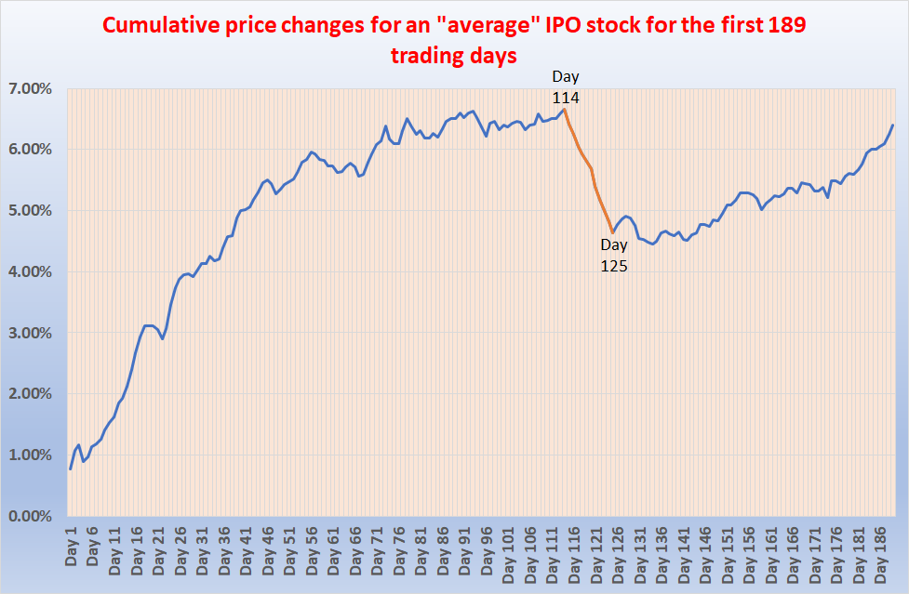

## 

# Short-term

## Short-term behavior after IPO

First I checked the short term performance after IPO dates. Short-term here means the first 2 weeks, i.e. 10 trading days. I didn’t just simply analyzed each days result but I was curious whether previous days result could tell something about the subsequent days. So I grouped the IPO stocks into 5 quintiles (again and again) according to the performance of Day_n (where n can be 0, 1, …, 9)[3] and checked the daily %changes of the following days. Results can be found in Table 1a-b.

Table 1a. Arithmetic mean of the following days by the quintiles of the previous day

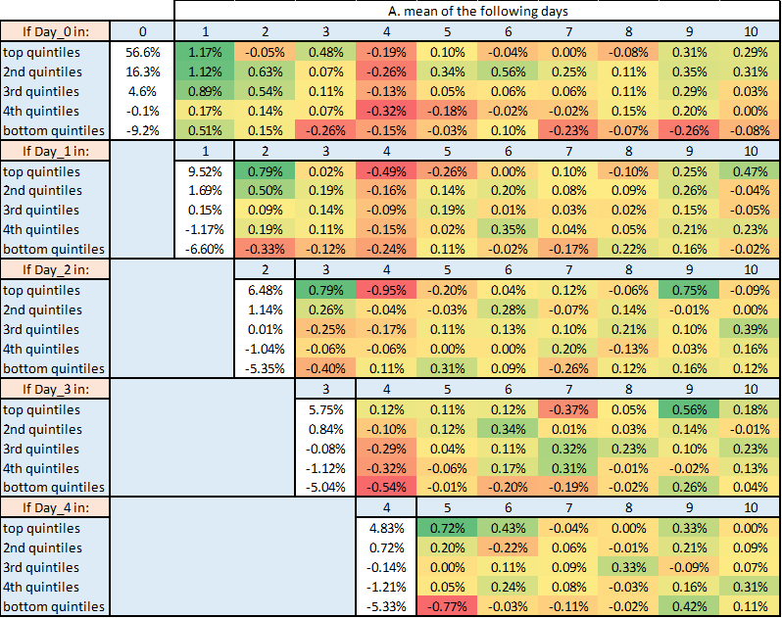

Table 1b.

Table 1b. Arithmetic mean of the following days by the quintiles of the previous day (cont)

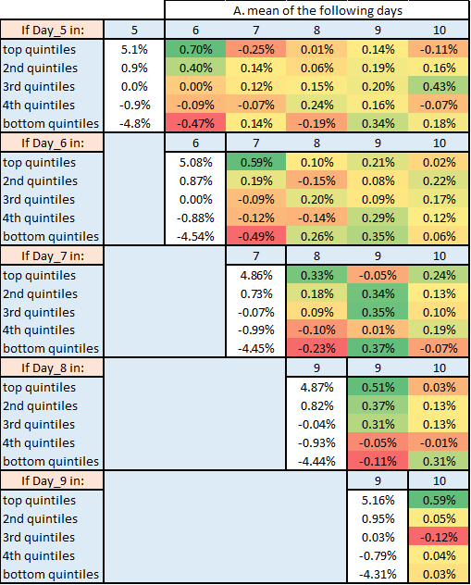

We can see that Day_0 results have the widest range: top quintiles’ average is extremely high (which means that target prices are very often/largely underestimated) and bottom quintiles has the lowest average as well.

What we can also derive from these tables that the results of the **first 10 days are very volatile** - however there seems to be some pattern in it:

* **If Day_n result was in the top quintiles than Day_(n+1) seems to be a positive one** (average of these days are typically in the 0.5%-0.8% range).
* **Day_4 is weak (bearish) in general** (actually Day_4 has the worst average in every quintiles (except in the bottom quintiles where Day_0, Day_1 and Day_2 are worse))

Let’s see the main performance indicators of a strategy that **plays long Day_(n+1) if Day_n was in top quintile**. This momentum-style strategy has an extraordinary CAGR but unfortunately its MDD also very high[4]:

Table 1c. Performance indicators for Day_(n+1) strategy

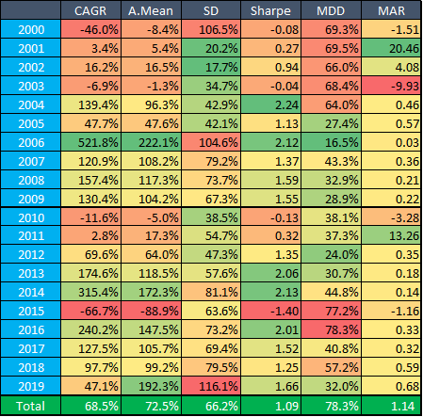

In the following section I extended this analysis and checked daily returns not only according to the results of Day_0 but Day_1 as well. Results can be found in Table 2a-b.

Table 2a. Arithmetic mean of the following days by the quintiles of Day_0 and Day_1

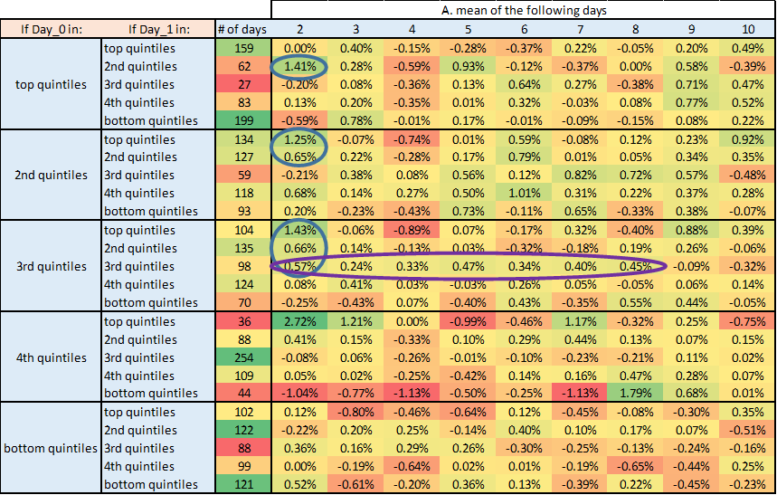

Table 2b. p-values of the following days by the quintiles of Day_0 and Day_1

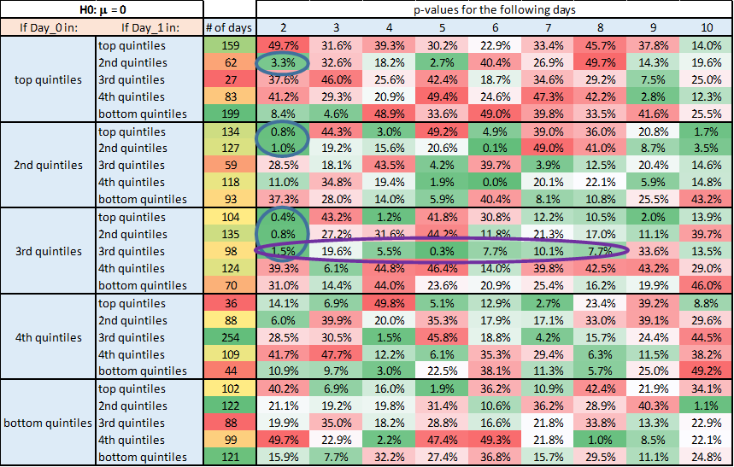

According to these results it seems that **if Day_0 was in the top3** (either top, 2nd, 3rd) **quintiles and Day_1 in the second one** - **then Day_2 will be a positive** one (see the blue-circled related p-values in Table 2b. which are lower than 5% and therefore indicate that these days’ average significantly differ from zero). However we can extend this selection with Day_1 top quintiles days as well - so a tradable strategy can be the following:

* Play long Day_2 if Day_0 was in top3 quintiles and Day_1 was in the top2.

Although p-values are somehow higher (and therefore not so significant for all days) in the purple-circled area **in the absolute middle** - it seems that during these consecutive days **there is a chance to capture nearly 3% profit** in total with a long position (although in the previous tables we saw that Day_4 is weak in general - however we have the highest value still at this subgroup (0.33%)).

At first sight selecting these days can be strange but there can be some rationality behind this: these days can be the golden mean because if Day_0 and/or Day_1 were too extreme than following days could also be dangerous.

**Beside these** values **no contiguous pattern** can be found during the first 10 trading days.

Based on the above findings I calculated the PV and main performance indicators for the following strategies:

* Strategy1: play long all Day_(1, 2, 3, 5, 6, 7, 8, 9, 10) and play short all Day_4
* Strategy2: play long Day_2 only if Day_0 was in top3 and Day_1 was in top 2 quintiles
* Strategy3: play long all Day_2 and play short all Day_4
* Strategy4: play long Day_(2, 3, 4, 5, 6, 7, 8) only if Day_0 and Day_1 were in their respective middle quintiles

Table 3a. Performance indicators of Strategy1

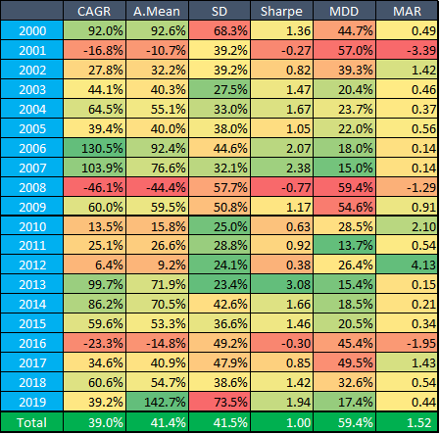

Table 3b. Performance indicators of Strategy2

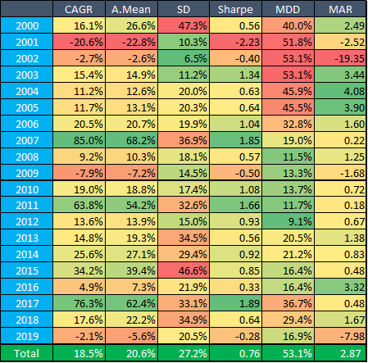

Table 3c. Performance indicators of Strategy3

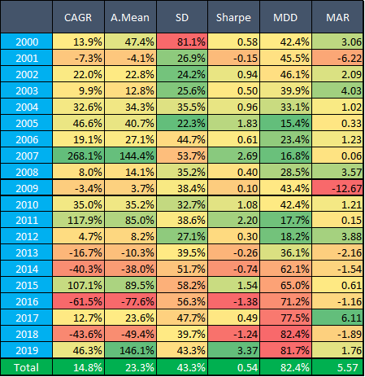

Table 3d. Performance indicators of Strategy4

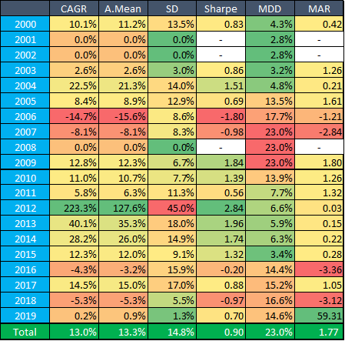

Chart 3e. PV of different strategies during first 10 days after IPOs

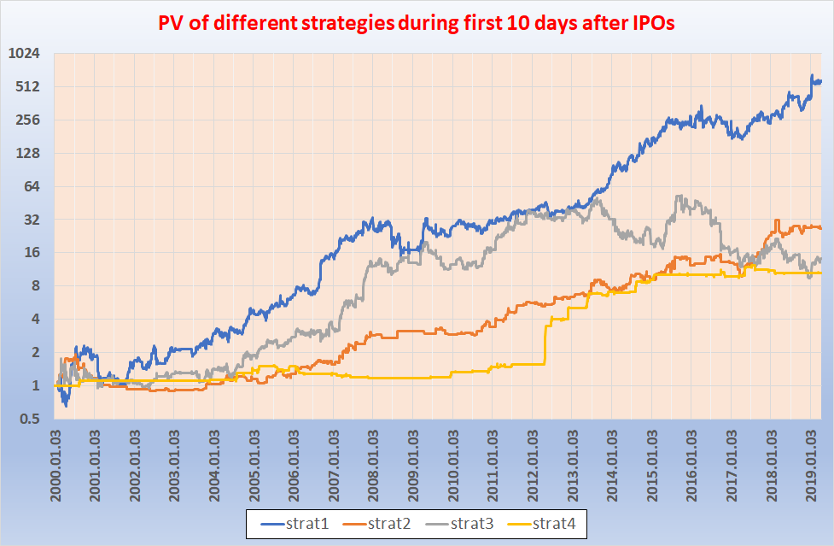

According to Table 3a-d and Chart 3e it seems that the far best strategy is the first one, where we play long all first ten days except Day_4 when we play short. This strategy has 39% CAGR and 1.00 Sharpe Ratio beside 59% MDD.

Strat4 (“catching the absolute middle”) has the second best SR (0.90) with the lowest MDD - but the main reason behind it that this strategy had an outstanding year in 2012 and according to that one rather “boring” results in other years.

Although Strat2 has only about half CAGR (18.5%) of Strat1 and only ¾ of that one’s SR (0.76) however it also has somewhat lower MDD (53%) and was under 20% for 10 consecutive years.

Strat3 during the last 6 years produced terrible results 4 times.

## Short-term walk-forward behavior

However there is a general problem with the above strategies: we created our quintiles AFTER April 2019 when we already knew all results of the 19+ years. In practice we cannot determine the respected quintile of a given day in advance - only up to that date. So therefore I also prepared the so called “walk-forward version” of the above tables where every Day_0 and Day_1 day’s result was categorized only based on the information (e.g. quantile thresholds) that was available until that given day.

Maybe it’s a little bit surprising but these walk-forward tables look very similar to Table2a-b (please note that the total number of days in each Day_0 quintiles in this case are not equal to each other (462, 462, 534, 616, 606) - because of the walk-forward categorization):

Table 4a. Arithmetic mean of the following days by the quintiles of Day_0 and Day_1

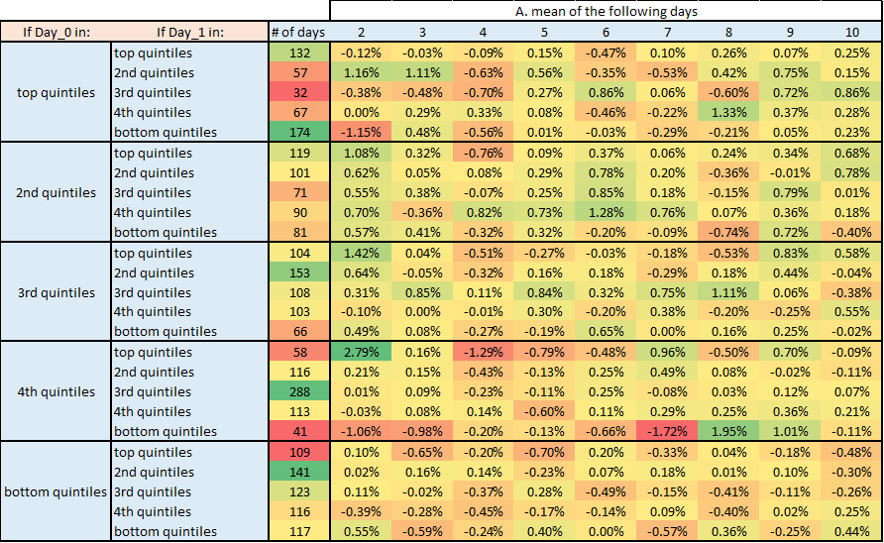

Table 4b. p-values of the following days by the quintiles of Day_0 and Day_1

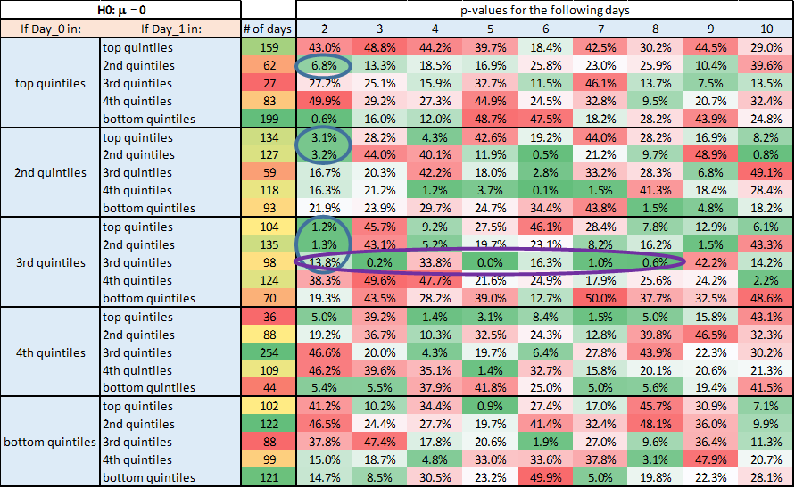

Because Table 4a and Table 2a are very similar I calculated performance indicators and PVs for the same 4 walk-forward strategies as above (actually Strat1 and Strat3 are not sensitive to the categorization because they play all days).

Table 5a. Performance indicators of walk-forward Strategy2

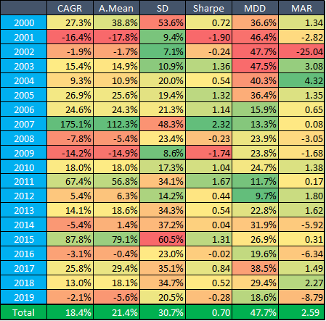

Table 5b. Performance indicators of walk-forward Strategy4

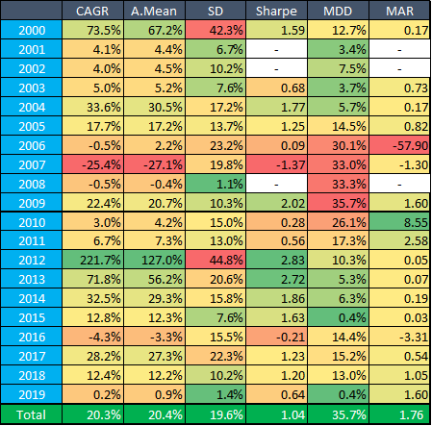

Chart 5c. PV of different strategies during first 10 days after IPOs

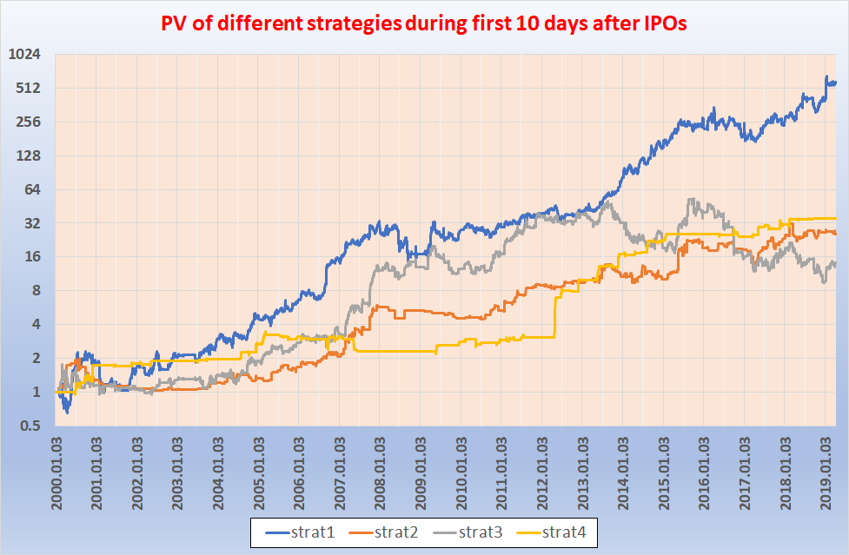

What we can see here that results of Strat2 has slightly decreased while Strat4 has improved. **The walk-forward Strat4 (“catching the absolute middle”) now has a CAGR of 20.3% with an SR of 1.04 and MDD of 35.7%.**

## Short-term behavior by IPO calendar month

This time I grouped the results according to the calendar month of the IPO. Results can be found in Table 6a-c.

Table 6a. Arithmetic mean of the first 10 days by the calendar month of Day_0

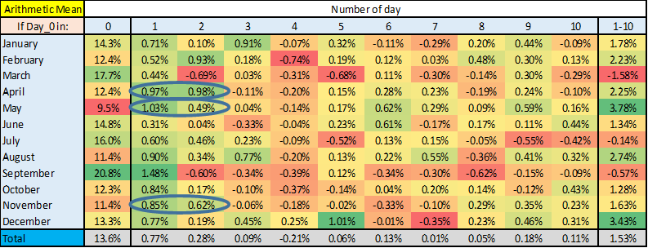

Table 6b. p-values of the first 10 days by the calendar month of Day_0

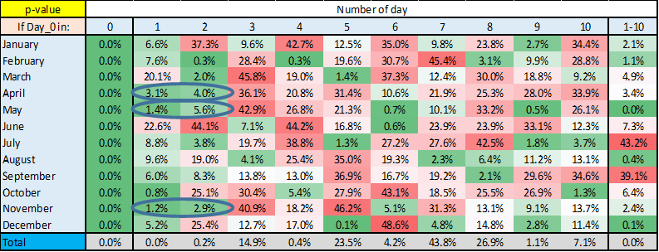

Table 6c. Number of IPOs by the calendar month of Day_0



By monthly split the **general weakness of Day_4 is confirmed again** (except in December - although only February and October are statistically significant).

**Bullish first two days** are also present (even compared with low enough p-value) **in April, May and November**.

## Short-term behavior by sectors

After splitting by calendar months I also grouped our IPOs according to their sectors. I had to skip nearly 400 stocks (14% of all analysed IPOs) because of lack of data. Results can be found in Table 7a-c.

Table 7a. Arithmetic mean of the first 10 days by sectors

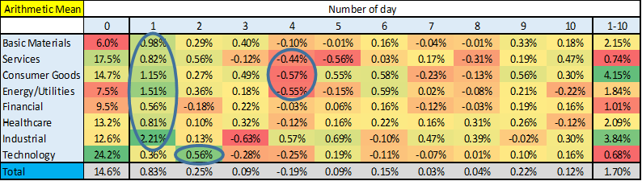

Table 7b. p-value of the first 10 days by sectors

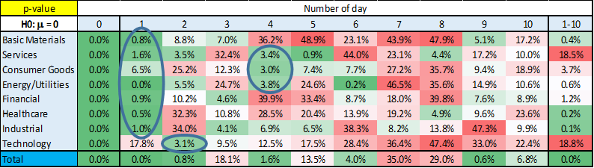

Table 7c. Number of IPOs by sectors



Although Technology sector has in general the strongest Day_0 however **Day_1** is still not **significantly positive** **fo**r it - despite the fact that for **all the other sectors** they are. Actually **Technology** sector has a **strong Day_2**.

**General weakness of Day_4** is confirmed again - especially at **Services, Consumer Goods and Energy/Utilities** sectors.

According to Table 7d and Chart 7e a “play long all Day_1 except for Technology where play long all Day_2” strategy has an extreme high 55% CAGR - however it’s SR is only 1.03 and MDD is also very high (69%).

Table 7d. Performance indicators for

“play long all Day_1 except for Technology where play long all Day_2” Strategy

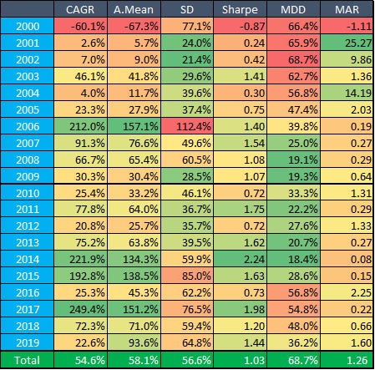

Chart 7e. PV of “play long all Day_1 except for Technology where play long all Day_2” Strategy

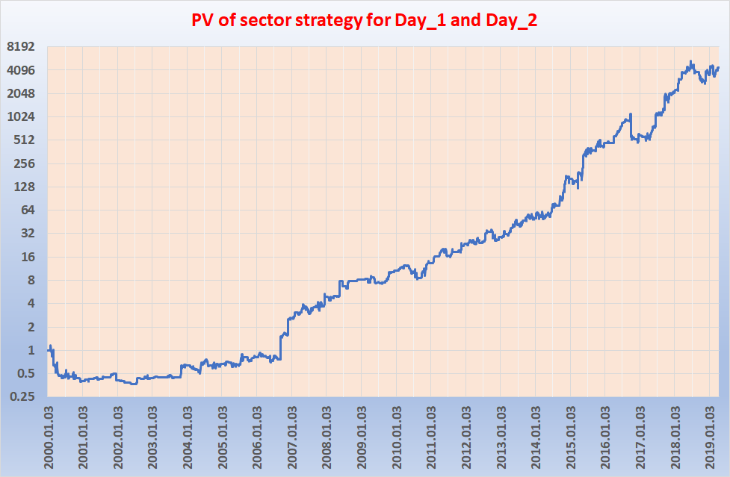

# Mid-term

## Mid-term behavior

Next step in our analysis is moving up to mid-term results. (For possible definitions of mid-term please check again the Methodology chapter).

First I checked the 15-, 10-, 5-day performance (i.e. I compared the closing price of Day_Q and Day_(Q-15) etc) just before the end of quiet period and grouped them according to the performance of Day_0 and Day_1. Result can be found in Table 8.

Table 8. Arithmetic mean and p-values for different periods before end of quiet-period

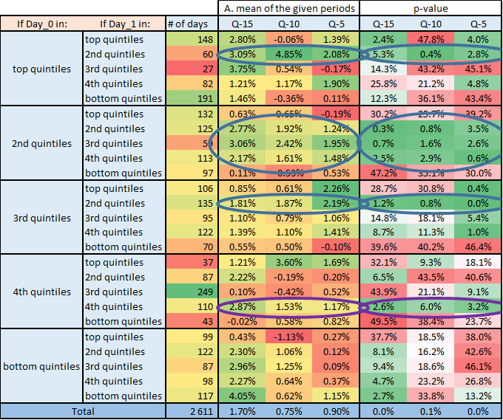

Here we can find a significant, **15 day long bullish pattern if Day_0 was in the top 60%** (i.e. in the top 3 quintiles) and **Day_1 was in the second quintiles**. These segments include 320 IPOs (1/9 of the analysed ones) and can be extended by two more quintiles if Day_0 was in the second quintiles (so the blue-circled segments all together cover ⅕ of the all IPOs).

A similar period can be also found at the purple-circled area if Day_0 and Day_1 were also in the 4th quintiles.

After all the last row shows that even on Total level the bullishness of these 15 days before the end of quiet period is confirmed.

Let’s check what would be the performance of the following strategies:

* Strategy1: play long for all 15 days before the end of quiet period
* Strategy2: play long for 15 days before the end of quiet period only if Day_0 was in the top3 quintiles and Day_1 was in the second quintile
* Strategy3: play long for 15 days before the end of quiet period only if Day_0 was in the top3 quintiles and Day_1 was in the first or second quintiles
* Strategy4: play long for 10 days before the end of quiet period only if Day_0 was in the top3 quintiles and Day_1 was in the second quintile
* Strategy5: play long for 5 days before the end of quiet period only if Day_0 was in the top3 quintiles and Day_1 was in the second quintile

Table 9a-b. Performance indicators for Strategy1 and Strategy2 (mid-term)

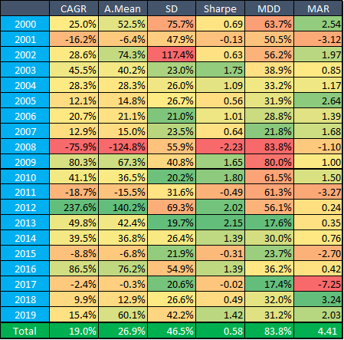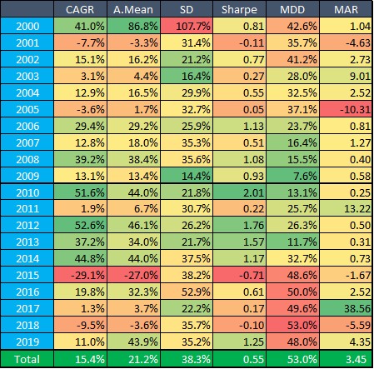

Table 9c-d. Performance indicators for Strategy3 and strategy4 (mid-term)

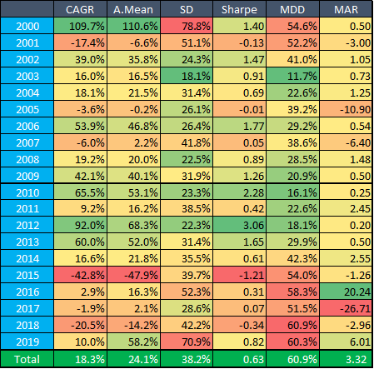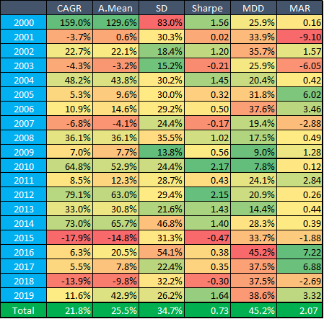

Table 9e. Performance indicators for Strategy5 (mid-term)

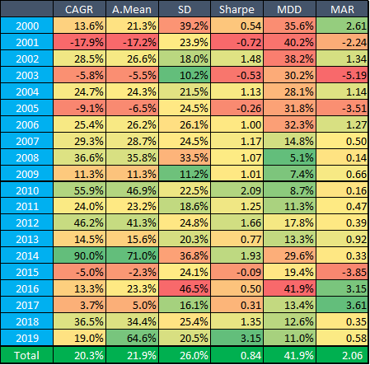

Chart 9f. PV of different strategies before end of quiet period

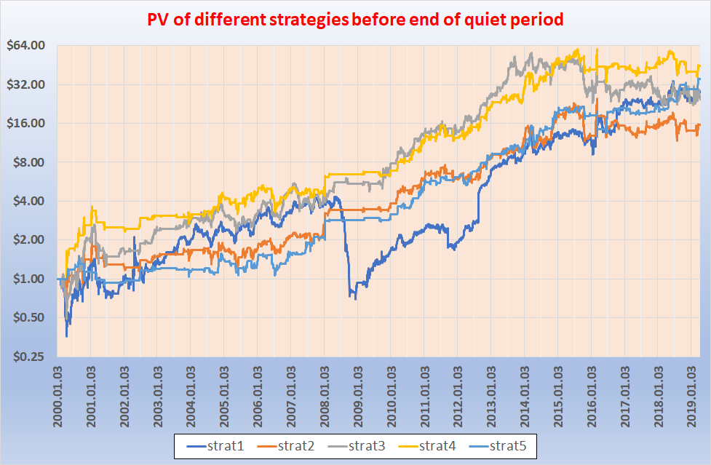

Although all the above strategies have a CAGR of 15-22% however SR is above 0.8 only at Strategy5 (last 5 days long before end of quiet period for some special quintiles) and its MDD is still above 40%. Before playing the given clusters may seem an unnatural selection we can extend it up to the following:

* Strategy6: play long for 5 days before the end of quiet period only if Day_0 was in the top3 quintiles and Day_1 was in the first or second quintiles

As we can see this extension improves only CAGR but SR and MDD unfortunately became worse.

Table 9g. Performance indicators for Strategy6 (mid-term)

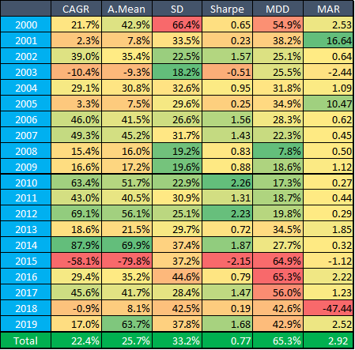

Beside the last days of quiet period I also checked other mid-term periods according to the number of trading days and the performance of Day_0. This time I compared (adjusted) closing price of Day_n with (adjusted) closing price of Day_0, so the results in Table 10. show the total yield that could have captured until the given day from Day_0[5].

Table 10. Arithmetic mean of the first 189 days by quintiles of Day_0

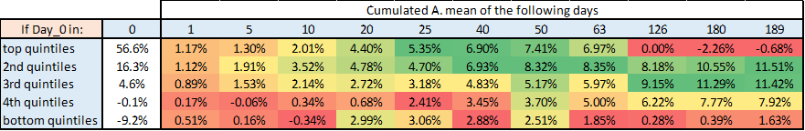

These results are very interesting because after 40-50 trading days there is **a longer bearish period at the top(!!!) and the bottom quintiles** that can last even until the 180th trading day. Meanwhile the middle 3 segments are continuously in a long period.

I wanted to check whether this strange result was caused by only some of the stocks. Therefore for each quintiles I did the following checking: I chose random 150 companies out of the given quintiles (each of them consists of ~530 companies) and calculated the above Table 10. with the chosen 150-150-150-150-150 random companies - then repeated it 100 times. So for each number in Table 10. I got 100 new different results and so a distribution for that value after this 100 random selections. The distribution of these results can be found in Chart 11a-e.

*For example the grey “candle” in Chart 11a at Day_126 means that the middle two quartiles of the 100 results (where so each result based on a random selection) were in the [+3.1%, -4.2%] range, while the maximum value was about 8.9% and the minimum was about -9.3.%. The arithmetic mean of the 100 results is denoted by a horizontal line within the “candle” (in this example it was about -1.2%).*

These charts strengthen the results of Table 10. - because we can see that either in Chart 11a and in Chart 11e the last 3 candles (and their arithmetic mean as well) are below the brownish candle of Day_63. **So it really seems** that **after 3 months** in general **there is a bearish 3 months at these two segments**.

Chart 11a. Distribution of average stock price changes for Day_0 top quintile stocks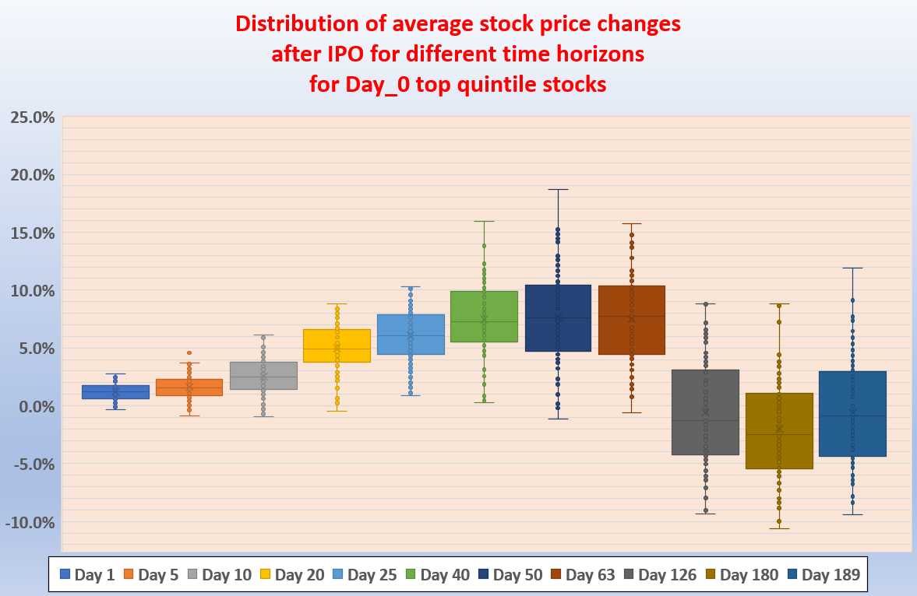

Chart 11b. Distribution of average stock price changes for Day_0 second quintile stocks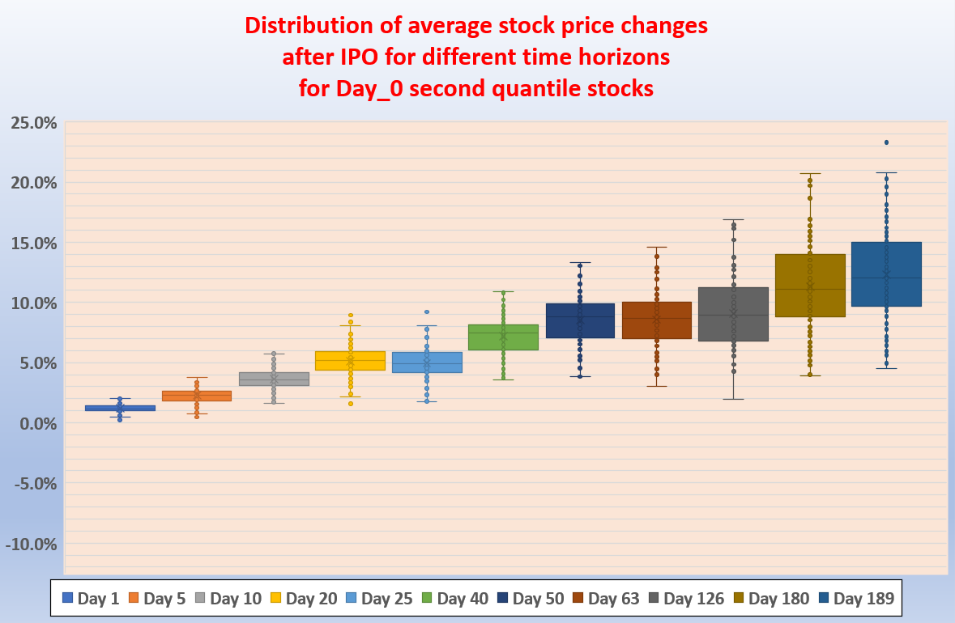

Chart 11c. Distribution of average stock price changes for Day_0 third quintile stocks

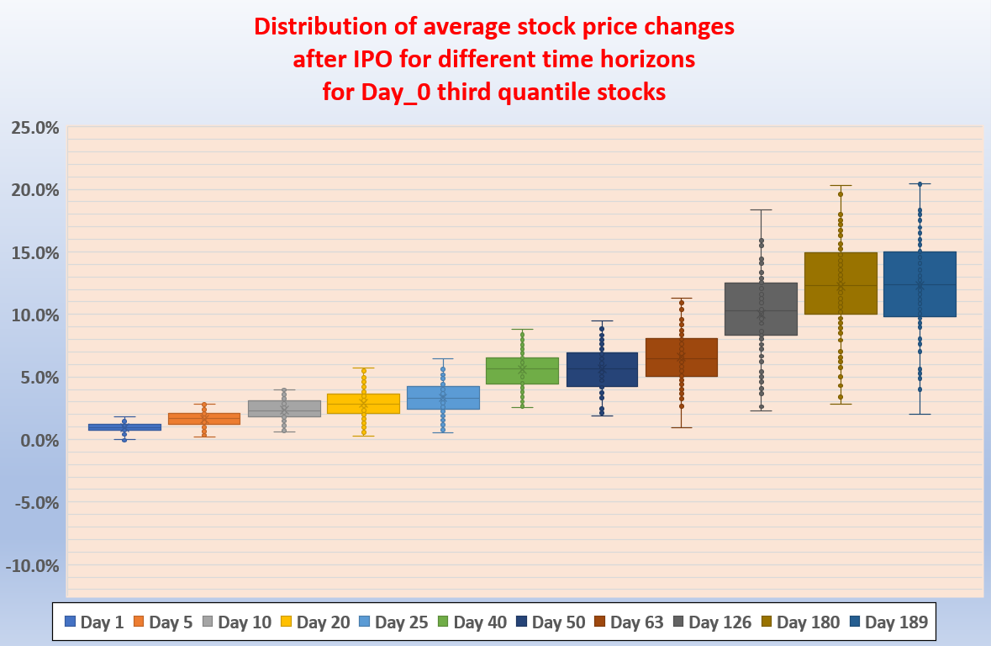

Chart 11d. Distribution of average stock price changes for Day_0 fourth quintile stocks

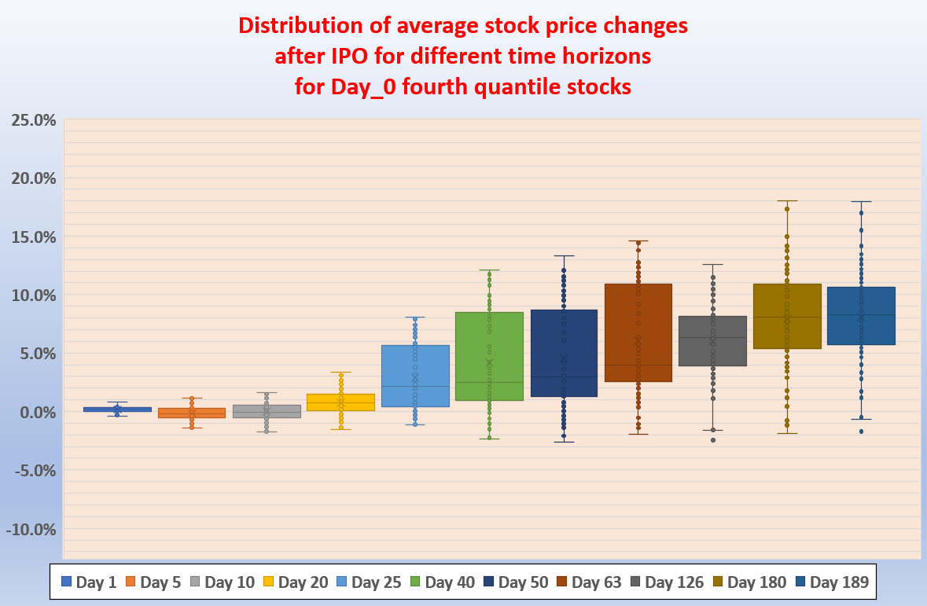

Chart 11e. Distribution of average stock price changes for Day_0 fifth quintile stocks

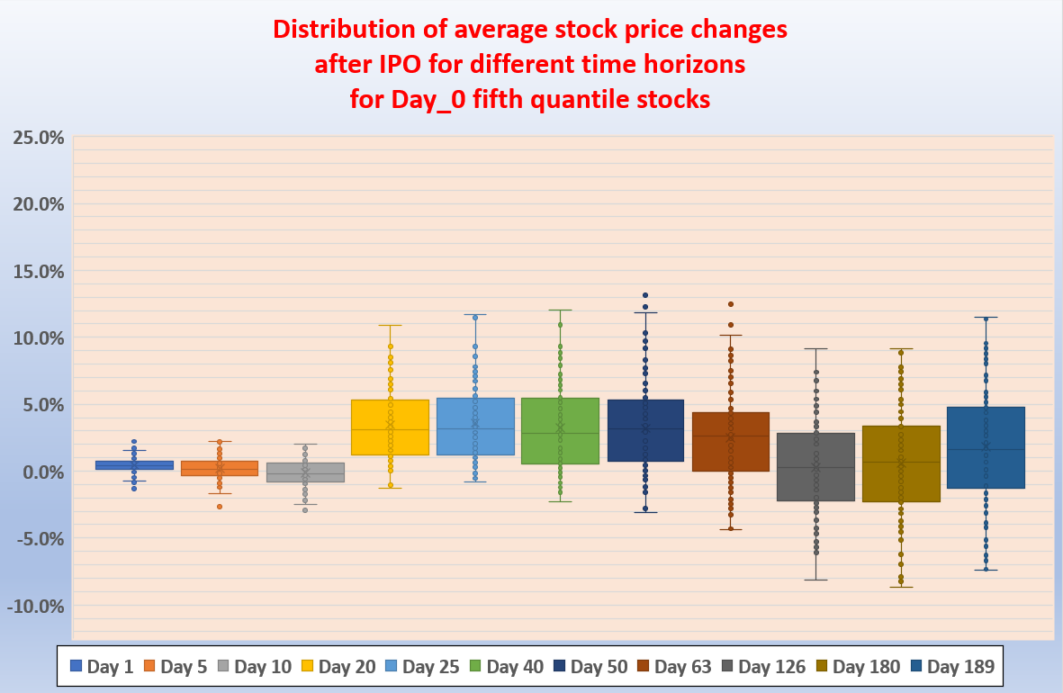

Based on the above findings I calculated performance indicators for the following strategies:

* Play short (with daily rebalance) for 4th, 5th and 6th months
* Play short for 5th and 6th months
* Play short for 6th month
* Play short for the last two weeks of 6th month
* Play short for the last week of 6th month

I did it both for Day_0 top quintile and bottom quintile stocks separately. Results can be found in Table 12a-e.

(Actually I prepared my calculations not only with short but long strategy as well - sometime long was better).

Best among all is “playing short for 6th month for Day_0 top quintile stocks” - although this one has still only 0.83 SR with 32.7% CAGR and 53.7% MDD. Other results are not so promising.

Table 12a-b. Performance indicators for the following strategies:

“Play short (with daily rebalance) for 4th, 5th and 6th months” and “Play short for 5th and 6th months” for Day_0 top quintile stocks

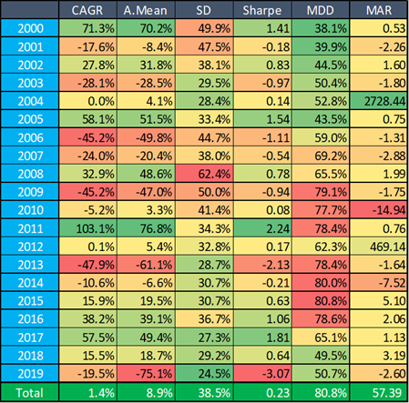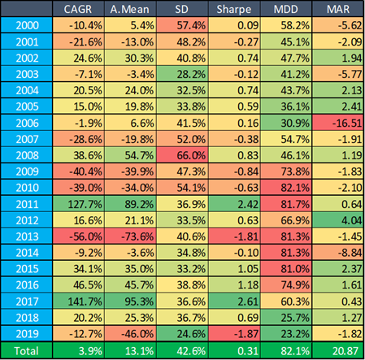

Table 12c-d. Performance indicators for the following strategies:

“Play short for 6th month” and “Play short for the last two weeks of 6th month” for Day_0 top quintile stocks

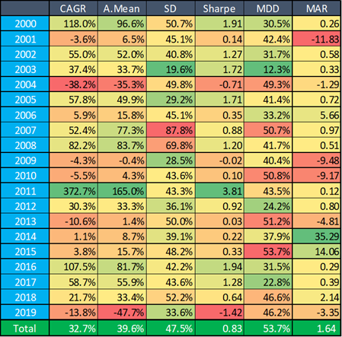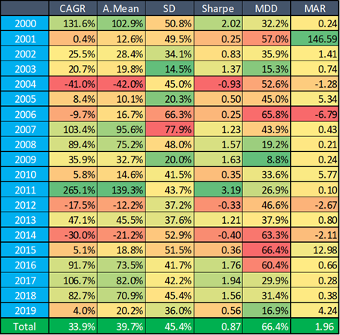

Table 12e. Performance indicators for the following strategy:

“Play LONG (with daily rebalance) for 4th, 5th and 6th months” for Day_0 bottom quintile stocks

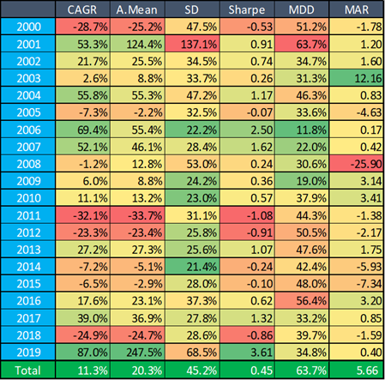

## 

## Mid-term behavior by IPO calendar month

Table 13a. collects the results of different IPO start months regarding different periods from the Quiet-period day Q: Q-15, Q-10 and Q-5. It also confirms that **bullishness of Q-15** period does exist - **typically from July to January**. However **in case of June IPOs** there is a **bearish** pattern for this period!

Table 13a. Arithmetic mean and p-values for different periods before end of quiet-period by calendar months

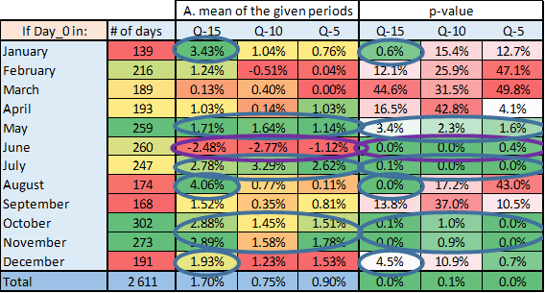

Let’s see the main performance indicators of the following strategies

* Strategy1 plays long for all 15 days before end of quiet period for the IPOs from July to January
* Strategy2 is Strategy1 extended by short all 15 days before end of quiet period for the IPOs of June

The situation is similar as above: **if we cherry-pick the best** periods then we may have a **high CAGR** but our **SR and MDD** tell us that these strategies are **not so attractive**.

Table 13b-c.Performance indicators for Strategy1 and Strategy2 (mid-term by calendar months)

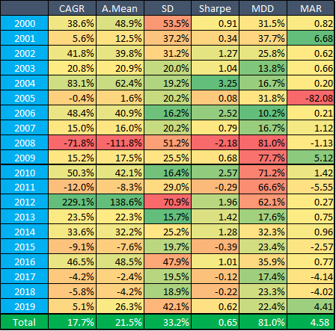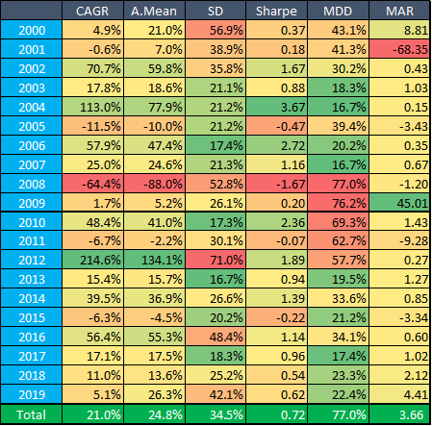

Looking around on a little bit longer time-horizon (Table 14.) we found again that in some segments there is a **bearish period after 3 months** - it seems to be present **from December until April** (i.e where Day_0 of the IPO was in these months).

A candle-chart for the same random results as in the above chapter can be seen in Chart 15a-b for February and March.

Table 14. Arithmetic mean for different periods after IPO by IPO calendar months

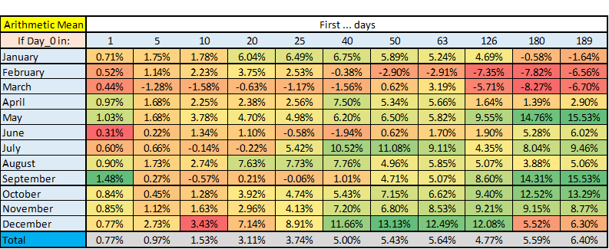

Chart 15a. Distribution of average stock price changes for February IPOs

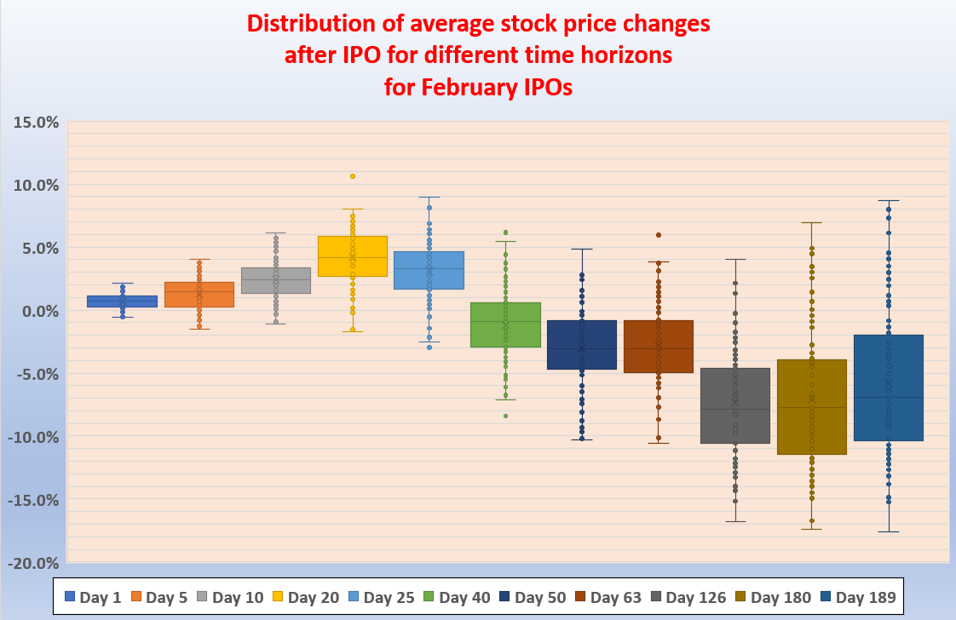

Chart 15b.Distribution of average stock price changes for March IPOs

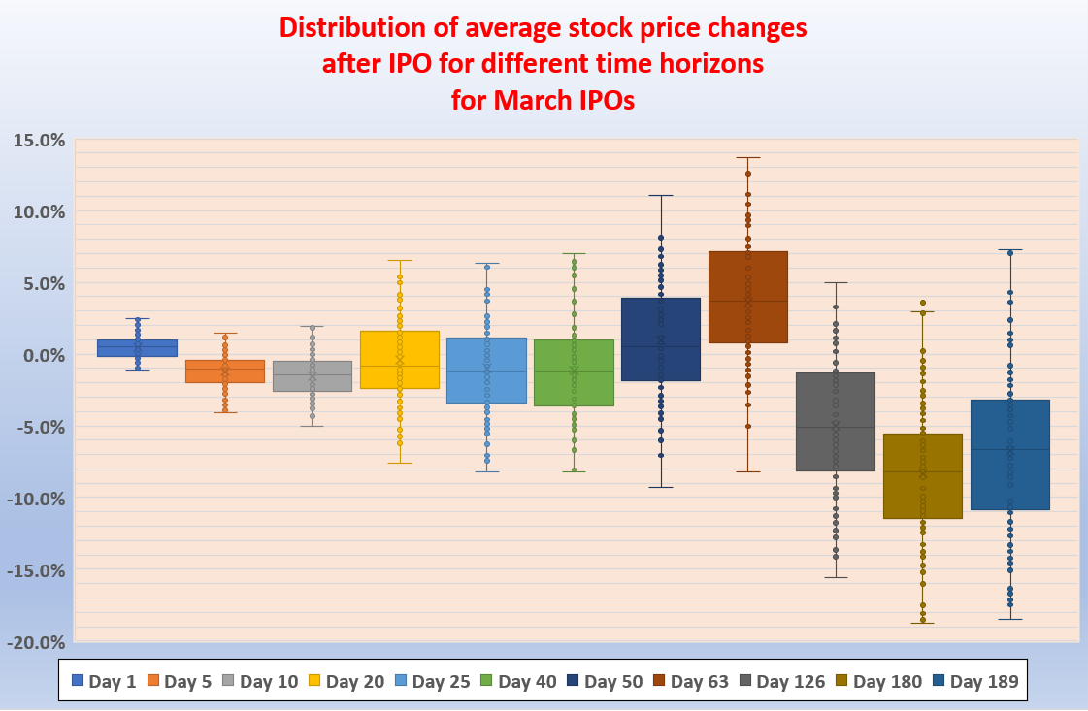

Similarly as above based on these findings I calculated performance indicators for the following strategies again:

* Play short (with daily rebalance) for 4th, 5th and 6th months
* Play short for 5th and 6th months
* Play short for 6th month
* Play short for the last two weeks of 6th month
* Play short for the last week of 6th month

I did it both for February and March IPOs separately. Some of the results can be found in Table 16a-d.

Among these results I couldn’t find any promising one, SRs were usually below 0.3, CAGRs below 5% and MDDs above 50%.

At first glance **these results seem to be in contradiction with the above candles**. A possible **explanation** can be - as usual - the **rebalancing frequency and the volatility drag**. For individual stocks the second 3 months (after IPO) can be profitable (or loss) but for a combination of them the overall result can be loss (or profitable). These results prove again the importance of timing.

Table 16a-b. Performance indicators for the following strategies:

“Play short (with daily rebalance) for 4th, 5th and 6th months” and “Play short for last two weeks of 6th month” for February IPOs

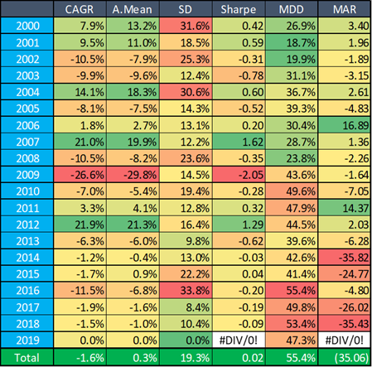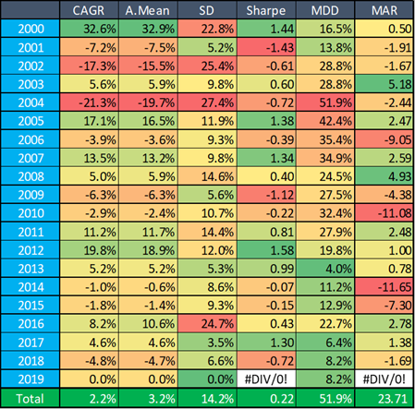

Table 16c-d. Performance indicators for the following strategies:

“Play short (with daily rebalance) for 4th, 5th and 6th months” and “Play short for 6th month” for March IPOs

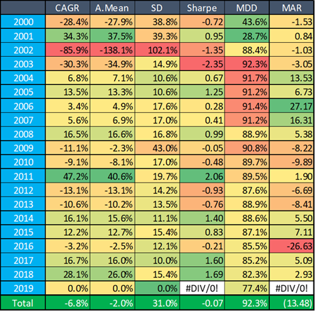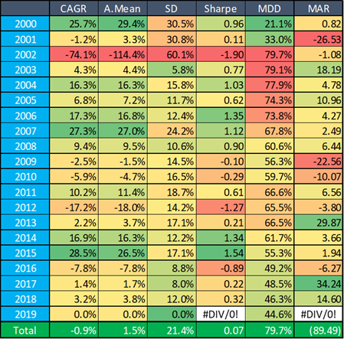

## 

## Mid-term behavior by sectors

When we check the 15 trading days just **before the end of quiet-period** on sector level then (beside the general bullishness of this period) we can realize that a **significant profit** can be captured mainly **at Basic Materials, Services, Energy/Utilities, Healthcare and Technology sectors**.

This significant bullish period is true (except for Healthcare) not only for the last 15, but for last 10 and 5 trading days as well (before Day_Q) - see Table 17a.

Table 17a. Arithmetic mean and p-values for different periods before end of quiet-period by calendar months

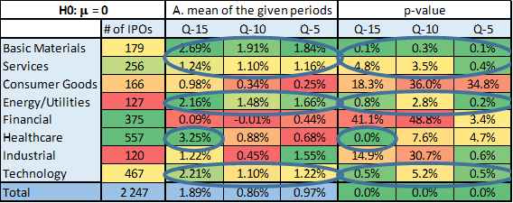

Let’s see the main performance indicators of a strategy that plays long for all 15 days before the end of quiet period for Basic Materials, Services, Energy/Utilities, Healthcare and Technology sectors only.

According to Table 17b although this strategy has an attractive CAGR, SR and maybe acceptable MDD during bull-markets however it has an extreme MDD at bear-markets.

Table 17b. Performance indicators of sector-based mid-term strategy

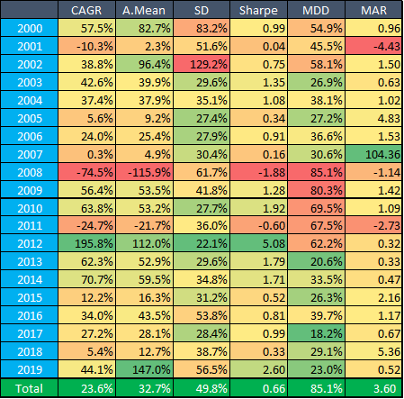

On sector level **after about 3 months** we can find again some **bearish periods** - just as we did it on quintiles and monthly level earlier. However similarly to those ones it is also **not a general pattern but** seems to be present only at **Services, Consumer Goods, Healthcare and Technology sectors**.

Table 18. Arithmetic mean for different periods after IPO by sectors

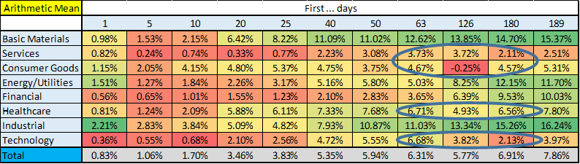

## 

Similarly as above based on these findings I calculated performance indicators for the following strategies again:

* Play short (with daily rebalance) for 4th, 5th and 6th months
* Play short for 5th and 6th months
* Play short for 6th month
* Play short for the last two weeks of 6th month
* Play short for the last week of 6th month

I did it both for **Consumer Goods** and **Technology** separately. Some of the results can be found in Table 19a-d.

According to these results Consumer Goods cannot produce a profitable short strategy during any of the sub-periods of the second 3 months of the stocks.

However, in Technology sector there is a chance for such a strategy: shorting the last 2 weeks of the 6th month (in practice it means the [Day_117, Day_126] period) gives us nearly 28% CAGR with 0.75 SR and 59% MDD.

Table 19a-b. Performance indicators for the following strategies:

“Play short (with daily rebalance) for 6th month” and “Play short for last two weeks of 6th month” for Consumer Goods IPOs

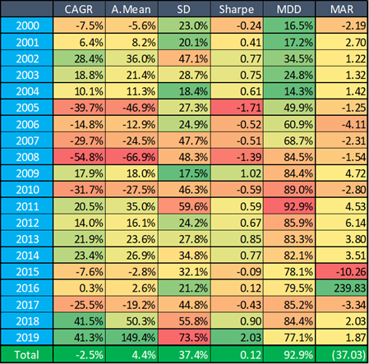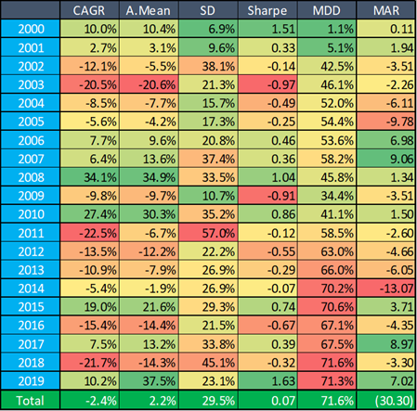

Table 19c-d. Performance indicators for the following strategies:

“Play short 6th month” and “Play short for last two weeks of 6th month” for Technology IPOs

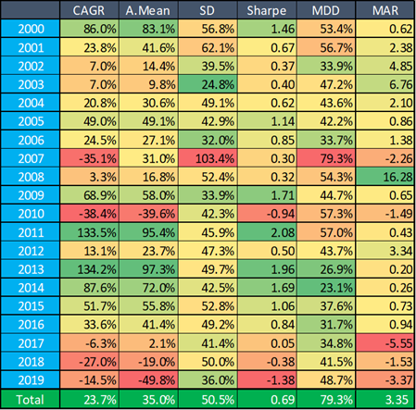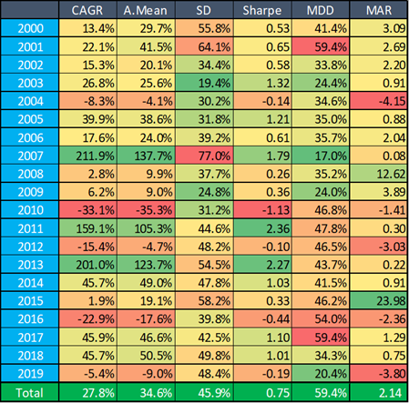

# 

# Conclusion

The purpose of this study was to find significant bullish/bearish periods related to IPOs.

After an IPO usually there is so called quiet-period, during which investment banks can’t publish any research on the company. Therefore the end of this period can be important because then a lot of new (usually positive) reports reach and impact the market.

It makes sense that the underwriter would remain optimistic about the company in their research coverage.

While most investment banks quiet-period last for 25 day then for company executives, there is also a SEC-mandated period of 40 days in which they are prohibited from offering new information that isn’t already available to the public.

Around these dates we expect a bullish period.

The expiration of the so called lock-up period (usually lasting 90 to 180 (calendar) days [which is about 62-124 trading days]) can also be important. Around the end of this period we expecting a bearish sub-period.

According to the results of this study we met some of our expectations - at least at some segments of the IPOs.

On very short term (first 10 trading days) we found that if we group the results of a given day into quintiles then:

* **If Day_n result was in the top quintiles than Day_(n+1) seems to be a positive one**
* **Day_4 is weak (bearish) in general** (this general weakness of Day_4 was confirmed on sector level [especially at **Services, Consumer Goods and Energy/Utilities** sectors] and on monthly level [**except in December** - **although only February and October are statistically significant**] too).

Looking around on monthly level we found that **bullish first two days** are also present (even compared with low enough p-value) **in April, May and November**.

A larger contiguous group were found at **Day_0’s top3 quintiles**: if their Day_1 were in the second quintiles - then **Day_2** were significantly **positive**.

Finally (according to quintiles groups) **in the absolute middle** we found 7 consecutive (trading) days where there **is a chance to capture nearly 3% profit**.

However strategies built on these findings may have high CAGRs but typically they are accompanied by relatively low SRs and high MDDs. Among the analyzed strategies maybe the best one is the last one mentioned above, i.e.: **play long Day_(2, 3, 4, 5, 6, 7, 8)** only if Day_0 and Day_1 were **in** their respective **middle quintiles.** This strategy have a CAGR of 20% with an SR of 1.04 and MDD of 36%.

On mid-term, **right before** the **end of** 40 (calendar) day long **quiet-period** we found several **5-10-15 trading day long bullish periods**, namely at:

* **if Day_0 was in the top3 quintiles and Day_1 in the second one** (these segments include 1/9 of the all analysed ones and can be extended by two more quintiles of Day_1 if Day_0 was in the second quintiles)
* **if Day_0 and Day_1 were also in the 4th quintiles**
* [Q-15, Q] period is generally positive for **January, May, July, August, October, November and December IPOs** (but bearish for June IPOs (!))
* **Basic Materials, Services, Energy/Utilities, Healthcare and Technology sectors**

However these findings lead again to such strategies which have relatively high CAGR (15-22%) but low SR (0.58-0.84) and high MDD (42-65%).

Still on mid-term, but about after 3 months we found longer bearish periods (which can be explained by the termination of 90 day long lock-up periods) at:

* **top** and bottom quintiles according to the results **of Day_0**
* January, February, March, April and December IPOs
* Services, Consumer Goods, Healthcare and **Technology sectors**

However after going into details we found that only 2 of them are really profitable (other ones were not so attractive probably because of the result of volatility drag):

* **shorting** the 6th month (or **the last 2 weeks of the 6th month**) of **Day_0 top quintile stocks** (33-34% CAGR, 0.83-0.87 SR, 54-66% MDD)
* **shorting the the last 2 weeks of the 6th month** of **Technology stocks** (28% CAGR, 0.75 SR, 59% MDD)

Although these **strategies have high MDDs** with an **under-leverage** (for example 0.35-0.4 times) we still can earn 10-14% CAGR with 0.75-0.87 SR and 19-26% MDD

1. <https://www.sec.gov/fast-answers/answersquiethtm.html>
2. closest means that if the 40th calendar day was a trading day then I chose that one; if not then the I chose the first trading day after that
3. It is important to note that %change of Day_0 is a special item - because here we don’t compare a closing price to a closing price, but the (original) closing price of Day_0 to the target price of the IPO.
4. However a risk-averse investor still can play such a strategy with an under-leverage. For example playing this strategy only with 1/5 PV we still can earn nearly 14% CAGR with about 16% MDD and 1.09 SR.
5. This dataset contains only those companies which were still alive on Day_189