Dr. George Antal
3D Click Limited
c/o Suite 431, 28 Old Brompton Road, London SW7 3SS

Revisiting The Renewed Uber Strategy

Motivation 1
Background 2
The Renewed Uber Strategy 2
Real Life Performance of The Renewed Uber Strategy (2018-05-14 – 2019-05-24) 4
Results 8
The Bullish UberMix Basket 8
Trading Signals and Performance of The Revisited Renewed Uber Strategy 17
Possible Modifications of The Revisited Renewed Uber Strategy 21
Conclusions 29
Remark 30
Appendix 31
Appendix 2 - Real Life Performance 2019-07-18 - 2020-02-05 33
Appendix 3 - VIX Based Leverage Indicator - 2020-03-18 36

Motivation

In real life, we played an FOMC meeting based live VXX strategy from 2014-01-22 to 2018-02-05. The name of the strategy was changed to UberVXX Live Strategy in December, 2014, as it had several parts: FOMC meetings (from the beginning), holidays (since September, 2014), option expiration days (OPEX - since October, 2014), turn of the month (ToTM - since October, 2014), VIX futures expiration days (VIXFUTEX - since January, 2015), turn of the mid-month (ToTMM - since April, 2015) and ‘VIX-based MIX’ (volatility indicators (contango indicator, VIX/VXV ratio, etc.) based sub-strategy - from the beginning) sub-strategies. In addition, Winter-Summer seasonality filters were applied as well. Since January, 2015, we did not play the ‘VIX-based MIX’ part, only events and seasonalities. These parts were revised and modified several times in the past.

Unfortunately, on Monday, 2018-02-05, there was a big volatility market panic, which was exacerbated in the 15 minutes after market close. This panic almost killed our UberVXX Live portfolio as we were in long XIV position after market close and this ETF lost about 92.5% of its value within minutes. It is worth noting that if we had been in ‘riskier’ short VXX position (instead of the ‘equivalent’ long XIV), our loss would have been only 2.41%. The explanation of this event can be read here: ‘2018-02-05 VIX Panic: What Happened’.

After this event, the UberVXX Live strategy has been halted. Although the strategy was incredibly successful before, it was decided not playing the strategy in its previous form anymore.

However, we did not want to completely eliminate the strategy because of its previous success. For this reason, we have developed our new Renewed Uber strategy, which is the recast of the previous one with the use of some new trading instruments (QQQ, SPY, hedges, etc.) and we started to trade it on 2018-05-14. Details of this strategy can be read in our ‘The Renewed Uber Strategy’ study.
In this study, a revision of our Renewed Uber strategy is presented. During the calculations, I have used daily adjusted close prices from 2004-03-26 to 2019-05-24.

Background

The Renewed Uber Strategy

Sub-strategies

The Renewed Uber Strategy contains six sub-strategies: FOMC, Holidays, OPEX, VIXFUTEX, Turn-of-the-Month and Turn-of-the-Mid-Month. Their hierarchy can be seen below:
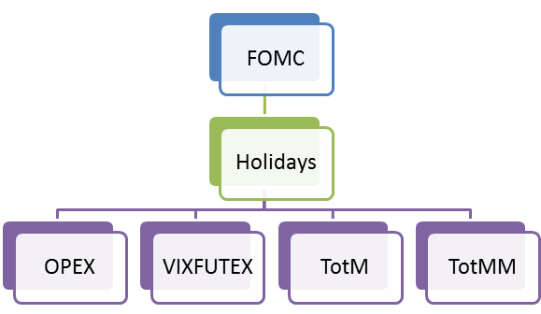

“It means that if there is a non-zero ‘FOMC signal’, play it. Otherwise, if there is a nonzero ‘Holidays signal’, play it. If there is neither non-zero ‘FOMC signal’ nor non-zero ‘Holidays signal’, play the resultant of the OPEX, VIXFUTEX, TotM and TotMM signals (the sign of their sum). If all of the signals are zero, stay in cash.”

Basic Ideas

“As it was mentioned in the Motivation chapter, we have found the base UberVXX strategy (trading only long VXX or long XIV) too risky. We would like avoiding huge daily moves (which is frequent in case of volatility ETFs) and reducing some kind of risks (e.g. liquidity, methodology, tracking error, counterparty, closure or hype risks). Thus, our main idea is diversification: instead of pure long VXX or long XIV trades, a cocktail of different ETPs should be traded. Furthermore, using hedges (e.g. bond or gold) would also be desirable.

In this Renewed Uber Strategy, three baskets are defined for bullish days:

- Short Volatility Basket:
  - long SVXY (which has only 0.5x leverage since March, 2018, thus it can be called SVXY-Light),
  - short VXX,
  - long ZIV;

- Long Market Basket:
  - long UPRO (ProShares UltraPro S&P500, 3x leverage),
  - long TQQQ (ProShares UltraPro QQQ, 3x leverage),
  - long FAS (Direxion Daily Financial Bull 3X ETF);

- SQ Hedge Basket:
  - short TMV (Direxion Daily 20+ Yr Trsy Bear 3X ETF) - equivalent to long 3x TLT,
  - short UGAZ (VelocityShares 3x Long Natural Gas ETN) - equivalent to short 3x UNG,
  - short UWT (VelocityShares 3x Long Crude Oil ETN) - equivalent to short 3x USO,
  - long UGLD (VelocityShares 3x Long Gold ETN) - equivalent to long 3x GLD.

It means, that on bullish days a mixture of these baskets are played: either only Short Volatility Basket or Short Volatility Basket + Long Market Basket is played with SQ Hedge Basket (hedges are always played on bullish days). Optimal weights and leverages of these baskets will be presented in The Renewed Uber Strategy chapter.

On bearish days, we play only long VXX with 100% leverage. On these days, this long VXX position can be considered as a hedge of our whole account.

In this study, winter (26th October - 1st May) and summer (2nd May - 25th October) seasons are distinguished in case of sub-strategies (except FOMC and Holiday).”

Weights of the Trading Instruments of The Renewed Uber Strategy

“Using the bullish and bearish signs and the hierarchy of sub-strategies from previous chapters, the position distribution of the Renewed Uber Strategy can be found in Table 1. As it can be seen, the strategy is in cash in the quarter of the trading days. In the fifth of days, bearish bet (ie. long VXX) is recommended. The almost 54% (39.4% + 14.45%) bullish proposal may seem like too much, but VXX is moving down in about 58% of days, while SPY climbed higher in about 55% of days in the examined period (2004-03-26 - 2018-03-23).

Table 1: Position distribution of the Renewed Uber Strategy
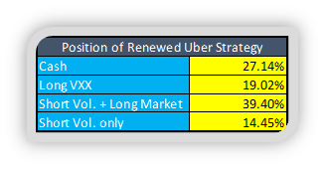
Using the ‘magical’ 60%/40% stock-bond weight rule, the following trading rules were defined for the Renewed Uber Strategy:
- On bearish days, go long VXX with 100% of PV;
- On bullish days, when
  - both Short Volatility and Long Market Baskets are played: 30% of PV for Short Volatility Basket, 30% for Long Market Basket and 40% for Hedges;
  - only Short Volatility Basket is played: 36% of PV for this basket and 24% for Hedges.

It is worth noting, that these allocations are not optimised as we would like avoiding additional overfitting.

Now, the next question is how to split the 30%-30%-40% weights within the basket. We want to avoid over-optimization again, thus weights within baskets are calculated in the proportion of the Sharpe ratios (in the past 14 years) of the ETPs. These calculated and rounded used weights can be seen in Table 2.”

Table 2: Calculated and used weights of ETPs on Bullish days (Bullish SQ Basket)
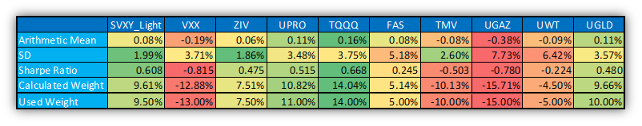

Real Life Performance of The Renewed Uber Strategy (2018-05-14 – 2019-05-24)

Based on the above cited study, ‘The Renewed Uber Strategy’ was started playing in real life with $500K on 2018-05-14. Nevertheless, some modifications and discretionary decisions have been influencing the strategy since the beginning. These can be found in this document:

“Remark (2018-05-14): New Uber Strategy portfolio is opened with $500K based on this study. At first, trade with halved leverage (50%) for a while.
Remark (2018-05-18): Hedges (UGLD, TMV, UGAZ, UWT) are removed from strategy after discretionary decision.
- In the Mixed basket (ShorVol + BullishMarket) case the hedges consumed 40% of PV, which is assigned to the ShortVol + BullisMarket baskets, increasing their weight from 30% / 30% to 50% / 50%.
- In case when only the ShortVol basket is played, the 50% basket is multiplied by 1.2, and it uses 60% weight after the decision of removing hedges.
Remark (2018-05-22): Stocks are replaced by options.
In general options are: ATM, more than 20 days expiration, equivalent Delta as the stock, assuming Delta of ATM option is 0.5 (e.g. 100 stock is replaced by 2x1=2 options, so we don’t do extra-leverage (yet))
- TQQQ and UPRO is replaced fully with the equivalent QQQ, SPY options that gives the same expected next day profit
- ShortVol basket: half of the basket stays as it is with a combined SVXY,VXX,ZIV stocks, other half is replaced by VXX only Put options.
- LongVol basket: half is long VXX stock, other half is VXX Call options
Remark (2018-06-08): Stocks are replaced by options, part 2
- TQQQ and UPRO is replaced fully with the equivalent QQQ, SPY options that gives the same expected next day profit. Keep FAS for a while, but we will think about replacing it with options as well.
- ShortVol basket: half of SVXY,ZIV stocks are kept. All other is replaced by VXX Put options. (which is the full VXX and half of the SVXY, ZIV position)
- LongVol basket: only long VXX stock, no VXX Call options
Remark (2018-06-12): On Uber Bullish days we only trade 50% TQQQ, 50% UPRO (converted to options having the same exposure). No hedges. And until that study will be made which will show the VXX vs. TQQQ for different Uber Events, we skip the ShortVol basket totally. (Later, we may play 50% shortVol basket on Volatility events like VixFutex or Opex, we will see). On Bearish Uber days we trade long VXX stocks (not options) for a while.
Remark (2018-06-27): No changes, only a note here. The UberRenewed portfolio PV is 500K, but so far we trade it with 50% PV. Now that we play it with options, it is safer, so theoretically we could go 100% PV, instead of 50%, but we defer it and will probably do it in September only. We prefer trading lightly in summer as market is more skittish and we may not be able to monitor it all the time. We don't want too much excitement when everyone is travelling. Let’s discuss the same in September.
Remark (2018-07-04): Based on the latest document, there are 4 different decision categories for BullishMarket days:
1. Using hedges or not or only partially?
2. Leverage is 30%+30%=60% or 100% or something else?
3. Which trading instrument combinations (VXX, ZIV, SVXY (Opex, VixFutex, deep contango), TQQQ, UPRO, FAS)?
4. Options or not or partial usage?
We would like the following at this stage.
- Long VXX days: 100% long VXX stock. Don't trade options. This is a good hedge for the GameChanger portfolios.
- We try to minimize the chance of having 50% maxDD in the future. Actually, we target 10% maxDD, although we admit it will be more in the unknown future. The UberRenewed strategy (with hedges, but without long VXX days) has a maxDD of 14.5%, let's say 15%. To reduce that to 10% maxDD, we have to decrease the leverage by 2/3. Let's do that. So, instead of the 30% ShortVol and 30% BullishMarket basket, we target 20% ShortVol + 20% BullishMarket exposure. Total exposure is 40% only.
- On Bullish days, we trade everything with options, not stocks. We hope options trading will decrease volatility even more compared to backtest, because of multi-day holding periods (if 2 losing days happen, the second day loses less if it is played by options).If ShortVol basket is also played on the Bullish day, we turn ZIV, SVXY exposure to VXX, and trade it with VXX Put options.
- The currently used 100% leverage on BullishDays is decreased very much because of the previous decision. To compensate for that, we will use the whole PV of the Uber portfolio. So, instead of the current $250K (50% exposure), let's use the $500K total PV (100%) on both Bullish and Bearish days.
- In the Opex, VixFutex, deep contango cases trade the ShortVol basket ‘too’ (together with the BullishMarket basket). On other bullish days, trade only the BullishMarket basket with 2x exposure to consume 40% PV instead of the 20%. We define deep contango with the threshold for the 7th decile (based on Table 56a, 56b) which is 7.23%. If the daily contango is bigger than this, we use ShortVol basket too in All events.
- FAS: it should be in the BullishMarket basket only on FOMC days, because conceptually FOMC days are interest-rate setting days, and it is good for the banks. On any other bullish days, trade only TQQQ and UPRO as the BullishMarket basket.
- Hedges: in the future, we will introduce back the hedges opportunistically. The 40% hedges exposure is also deleveraged by 2/3, which will give a total maximum hedge as 26.6%. In the long term we like TLT as a hedge, but not at the moment, still play half of the intended short TMV exposure. (10% decreased to ⅔ would be 6.66% as the target, but only half of it now: 3.3% short TMV now). However, we like short natural gas now. Let's use the intended amount, which is ⅔ of the 15% as 10% short UGAZ now. These half-TMV, full UGAZ hedges will go on until we specify otherwise. Ideally, we should re-evaluate which hedges we use at least once per month, or instantly react if there is a power event that affects our worldview.
Remark (2018-09-27): Because we see that trading bullish days with options decreases the risked capital so much, we would like to double the traded amounts. Let's use the $1M total PV (200%) on both Bullish and Bearish days.
Remark (2018-11-19): [planned until 1st January 2019] The market is too jittery now. On bullish days, if there is only 1 bullish signal which is weak, then don’t play that day as bullish, but stay in cash. Weak signals: Opex, ToM, ToMM, VixFutex. FOMC and Holidays are strong signals, therefore play them even if there is only 1 bullish signal on that day.
Remark (2018-11-20): [planned until 1st January 2019] The market is even more jittery now. Instead of the current 200% PV play, let's go back to 100% on both Bullish and Bearish days.”

Table 3 shows the ~1 year profit of the real life trading (based on above modifications) and the theoretical performance of the original ‘The Renewed Uber Strategy’ and its sub-strategies. It can be seen that our live portfolio lost about -15%, while it would be only about -6% using the original rules. As it can be concluded, all but the Short Volatility basket would suffer a slight loss.

Table 3: Performance of Renewed Uber and Sub-Strategies from 2018-05-14 until 2019-05-24
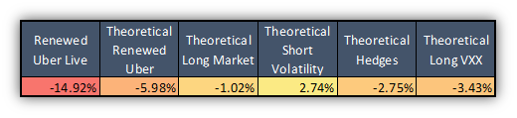

Based on these figures, someone may have two questions:
- Why was not profitable the Theoretical Renewed Uber Strategy?
- Where does the big difference between real and theoretical performance come from?

To answer these questions - at least partially-, look at Table 4 and Table 5.

In Table 4, the performance of really traded ETPs with 100% weight and the ‘Modified, Deleveraged Bullish Mix Basket’ (20% Short VXX + 10% Long TQQQ + 10% Long UPRO + 10% Short UGAZ + 3.3% Short TMV - as it was recommended in Remark (2018-07-04), without FAS) can be found playing on every bullish days (not only when Long Market Basket should be played). It can be seen that all of these ETPs but short UGAZ would be profitable playing them on every bullish days. Furthermore, the modified and deleveraged bullish mix basket would also be profitable. And the -3.43% loss on bearish days (Theoretical Long VXX) was compensated by this +6.8% theoretical profit. Thus, we believe that it is unnecessary to distinguish between ‘Only Short Volatility’ and ‘Short Volatility + Long Market Basket’ days. It is enough to separate bullish and bearish days (and all of the selected ETPs should be played on bullish days).

In Table 5, the real life performance of played ETPs and their options (call in case of QQQ and SPY, while put in case of VXX) can be found from 2018-05-24 (playing the strategy with options instead of stocks was decided on 2018-05-22 - Remark (2018-05-22)). These figures show what would have been the profit of stocks/options if the strategy would be played with only the given stock/option (with 100% PV). For example, playing the bullish days with only short VXX stock would have made 9.09% profit, while the same figure would be -12.63% loss using put options instead of short stock. It can be seen that the difference is significant in case of QQQ and SPY, while unacceptably high in case of short VXX. Based on figures, the strategy should not be played with options.

Naturally, these findings do not fully answer our questions (there were other discretionary decisions, etc.), but these should be taken into account when developing further the strategy.

Table 4: Performance of Traded ETPs of Renewed Uber from 2018-05-14 until 2019-05-24
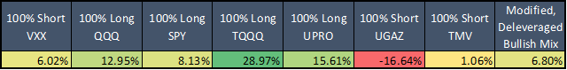

Table 5: Real Life Performance - Stock vs. Option from 2018-05-24 until 2019-05-24
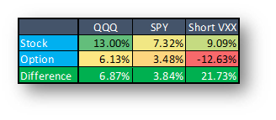

Results

The Bullish UberMix Basket

As it was concluded in the previous section, we believe that it is unnecessary to distinguish between ‘Only Short Volatility’ and ‘Short Volatility + Long Market Basket’ days. It is enough to separate bullish and bearish days (and all of the previously selected ETPs should be played on bullish days). Thus, it is needless to create both ‘Short Volatility’ and ‘Long Market’ basket separated. Our goal is to create a bullish ‘UberMix’ basket which contains short volatility, long market and hedge ETPs as well. It was observed in the previous chapter that trading options instead of stocks hindered the performance of the strategy. It would be better to trade stocks only. For that purpose, we intend to decrease the risk of the basket. Compared to the ETP allocations used in the current Uber strategy, our goal was decreasing the VXX weight while simultaneously increasing the weights of TQQQ, UPRO. Thus, making the basket safer for occasional volatility jumping days.

Our first recommendation is the following ‘UberMix’ basket for bullish days (100% long VXX has remained on bearish days):
- 30% long UPRO (3x long SPY);
- 30% long TQQQ (3x long QQQ);
- 20% short VXX (or the corresponding 40% long SVXY (0.5x short VXX) for even safer trading; or a mix of short VXX + SVXY);
- 10% short TMV (3x long TLT);
- 5% short UGAZ (3x short UNG) and
- 5% short UWT (3x short USO).

It is worth emphasizing that these are not optimized weights but are based on out trading experience.

The following charts and tables show the buy and hold performance of these ETPs (and their unleveraged versions - these tables can be found in Appendix) and the UberMix basket (with and without hedges). It can be clearly seen that the UberMix basket has the highest Sharpe- and MAR ratio. Before the big ‘Volmageddon’ panic on 2018-02-05, our previous UberVXX strategy was played with short VXX or long XIV on bullish days. As it can be seen in Table 6a and 6c, this new UberMix basket is much better trading instrument than the short VXX alone:
- UberMix is more diversified ⇒ lower volatility and risk (much lower concentration risk), much safer;
- CAGRs are almost the same: 26.93% (UberMix) vs. 29.28% (ShortVXX);
- both Sharpe- and MAR Ratio are slightly higher in case of UberMix (0.83 and 0.34 vs. 0.77 and 0.32);
- UberMix had only 2 losing years (2008 and 2018) out of the 16 examined years, while ShortVXX had 6;
- Maximum Drawdown is also better (lower) in case of UberMix.

In our opinion, based on the above findings, this UberMix basket should be played on bullish, while long VXX on bearish days.
Chart 1: PV of Buy&Hold Strategy Using Different ETFs
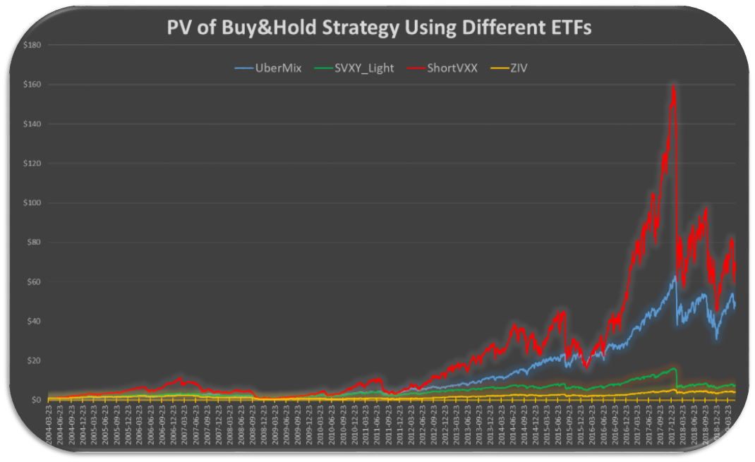

Chart 1a: PV of Buy&Hold Strategy Using Different ETFs - logarithmic scale
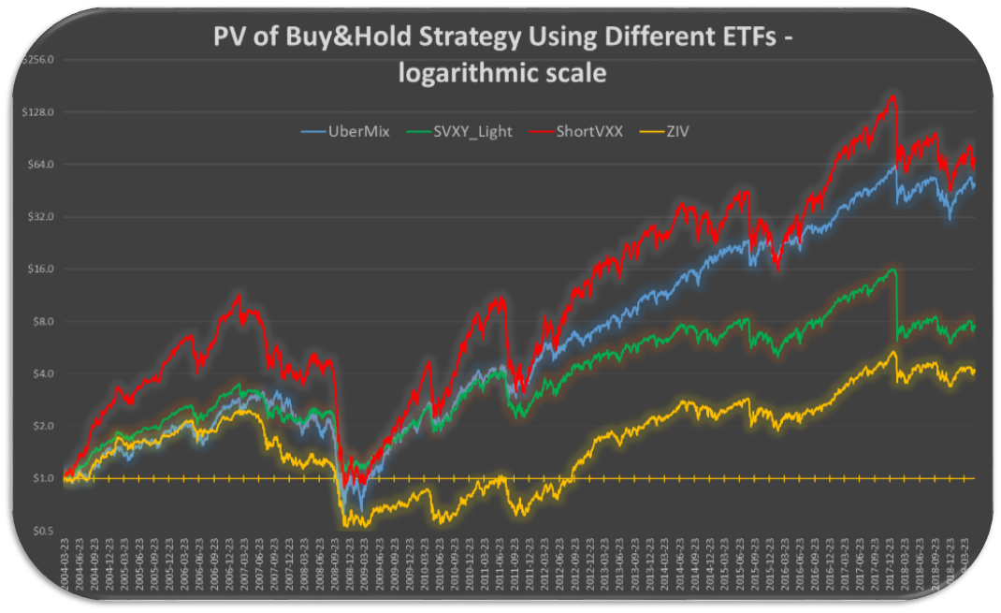
Chart 2: PV of Buy&Hold Strategy Using Different ETFs
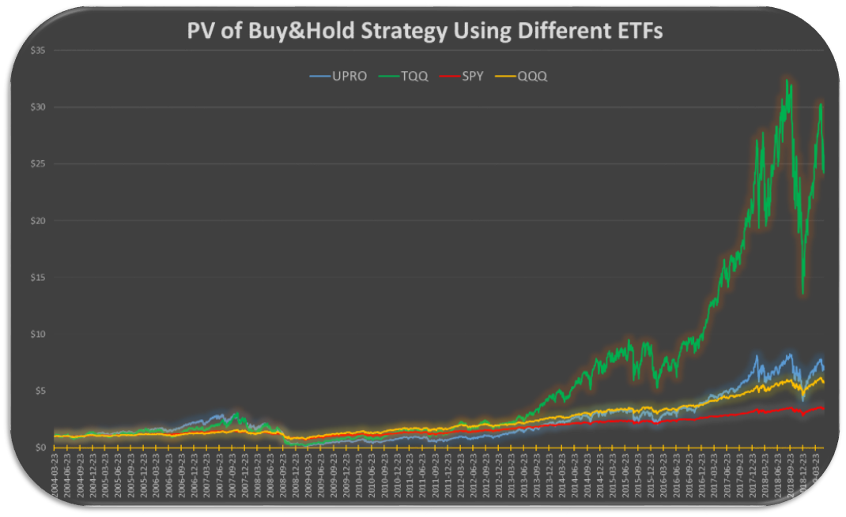

Chart 2a: PV of Buy&Hold Strategy Using Different ETFs - logarithmic scale
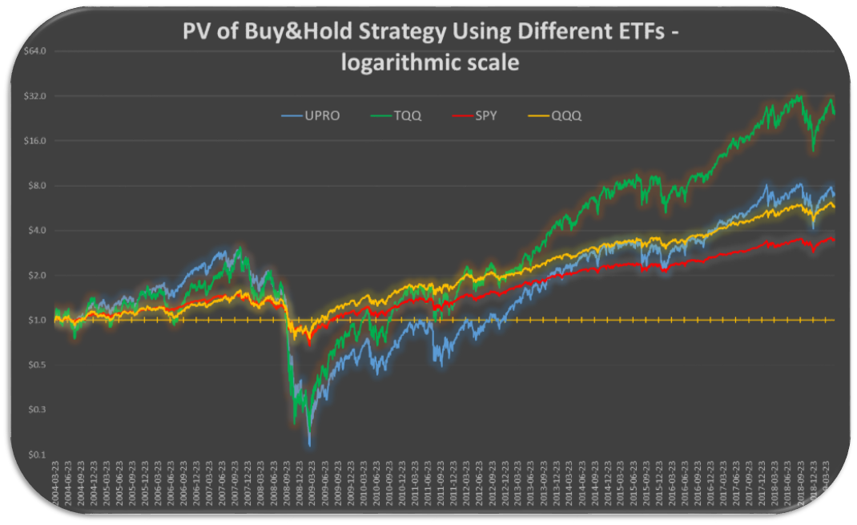
Chart 3: PV of Buy&Hold Strategy Using Different ETFs
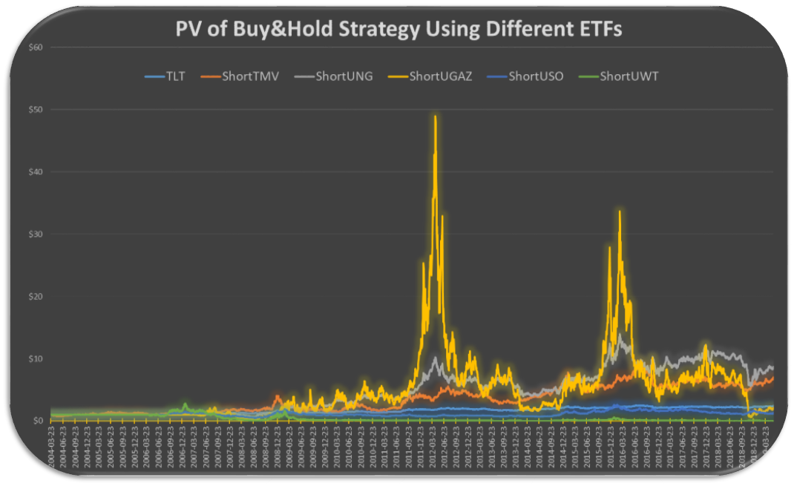

Chart 3a: PV of Buy&Hold Strategy Using Different ETFs - logarithmic scale
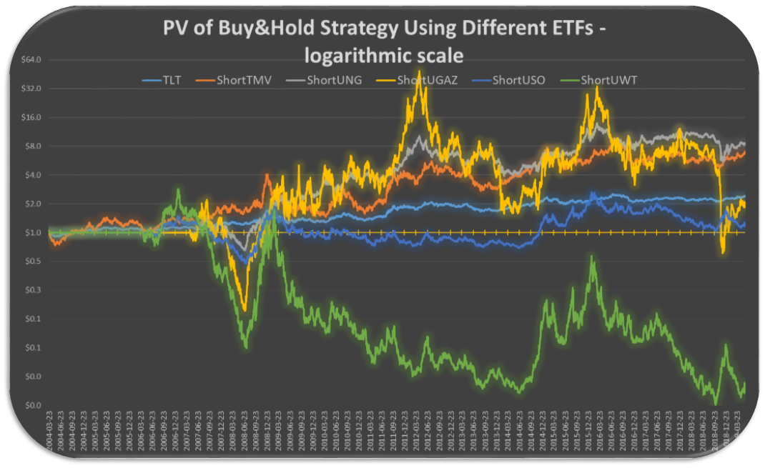
Table 6a: Performance indicators of Buy&Hold UberMix
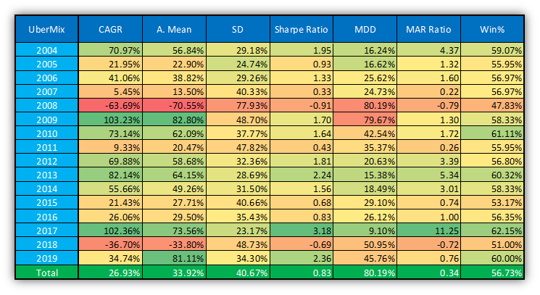

Table 6b: Performance indicators of Buy&Hold UberMix without Hedges
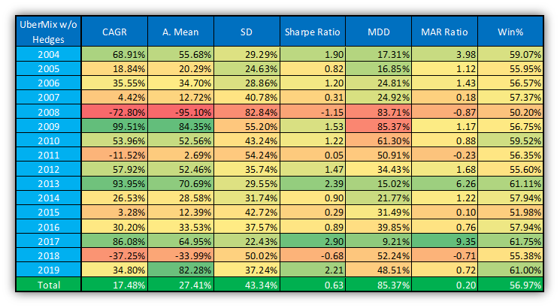

Table 6c: Performance indicators of Buy&Hold ShortVXX (i.e. Short&Rebalance VXX)
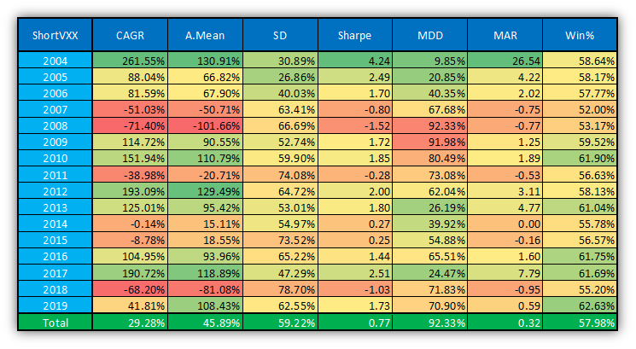

Table 6d: Performance indicators of Buy&Hold SVXY (0.5x short VXX)
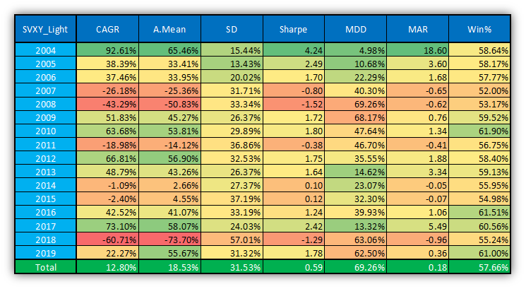

Table 6e: Performance indicators of Buy&Hold TQQQ
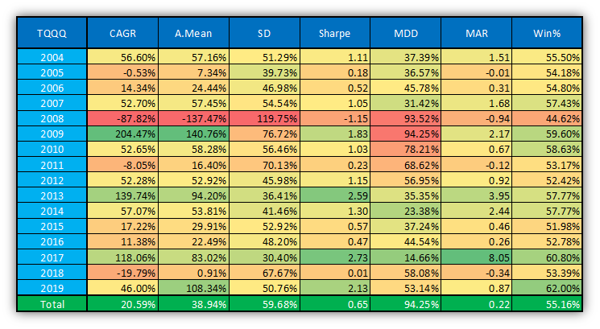

Table 6f: Performance indicators of Buy&Hold UPRO
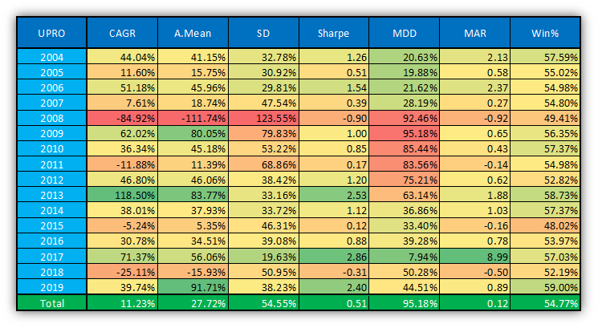

Table 6g: Performance indicators of Buy&Hold ShortTMV (i.e. Short&Rebalance TMV)
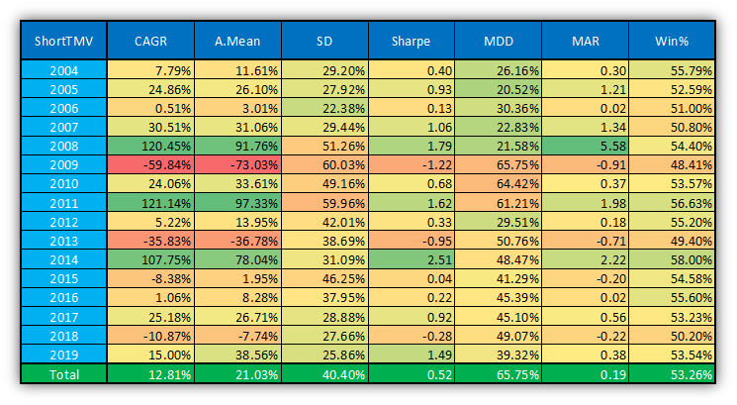

Table 6h: Performance indicators of Buy&Hold ShortUGAZ (i.e. Short&Rebalance UGAZ)
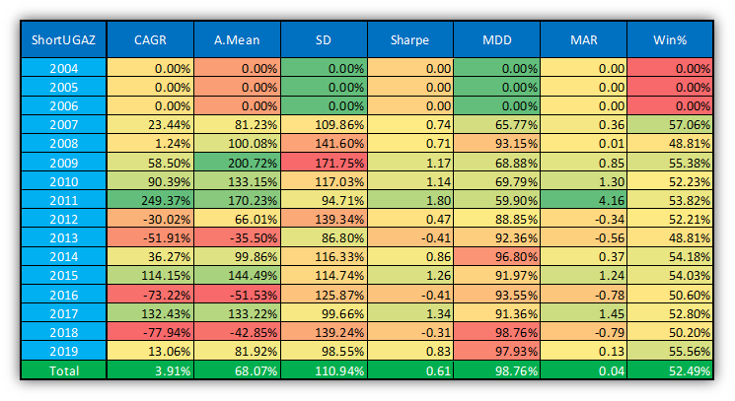

Table 6i: Performance indicators of Buy&Hold ShortUWT (i.e. Short&Rebalance UWT)
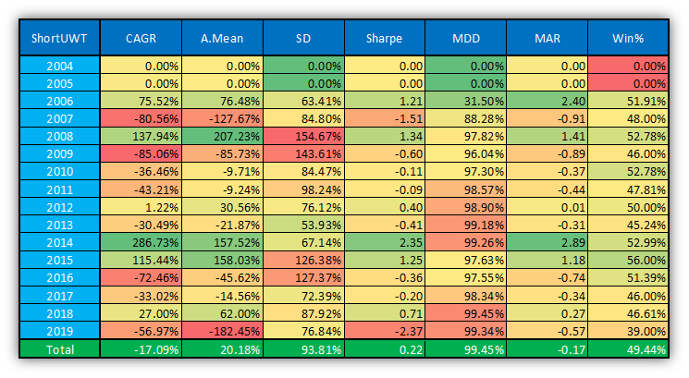

Trading Signals and Performance of The Revisited Renewed Uber Strategy

After the appropriate trading instruments (UberMix on bullish and long VXX on bearish days) were chosen in the previous section, our next task is to specify bullish and bearish days. In this section, these trading signals and the performance of this revisited Renewed Uber Strategy will be presented.

At first, it is worth noting that during the revision, the sub-strategies of the current Renewed Uber Strategy and their hierarchy will not be changed, only some bullish and bearish signals. The recommended new trading signals can be found in Table 7a, where ‘1’ indicates bullish, ‘-1’ bearish and ‘0’ neutral (when the strategy is in cash) days, while W/S indicates Winter/Summer. If someone is interested, Table 7b shows the changes (compared to the current rules) as well. In this table, green signals are the newly added and reds are the skipped. It can be seen that more bearish than bullish signals are added and less bearish are skipped, which means that the proportion of the bearish days is increased, while the bullish is decreased. This makes the strategy even safer. The position distribution of this revisited Renewed Uber Strategy can be seen in Table 8 (and can be compared to Table 1).

These trading signals came from significance analysis as previously (arithmetic mean, adjusted mean, geometric mean, Sharpe ratio, positive percentage and p-value (based on t-test)) but using UberMix basket instead of short VXX.

The past performance of this revisited Renewed Uber Strategy can be seen in Chart 4-4a and in Table 9. As expected, this performance is amazing (CAGR, Sharpe- and MAR ratios), but it has to be emphasized that this is a highly over-fitted strategy thus no such good future performance should be expected. Nevertheless, all of the sub-strategies have strong fundamental reasons, thus we continue to believe in the success of the strategy.
Table 7a: Trading signals of Revisited Renewed Uber Strategy
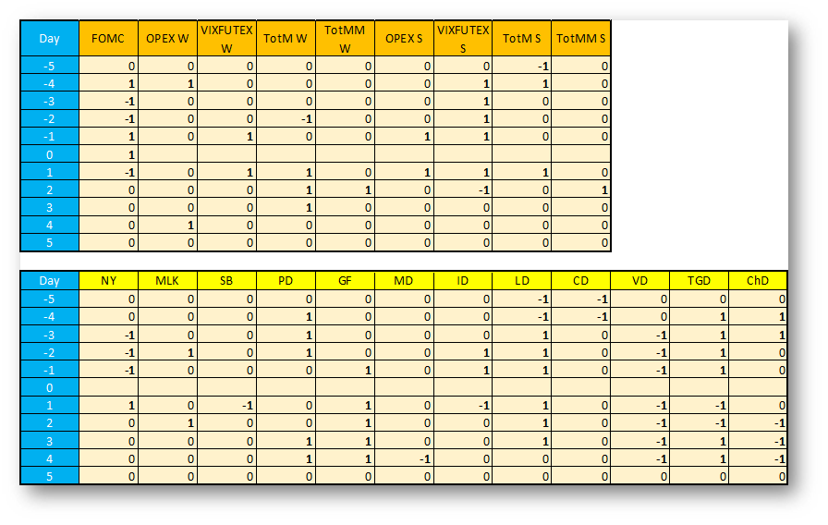
Table 7b: Trading signals of revisited Renewed Uber Strategy - with changes compared to the current rules
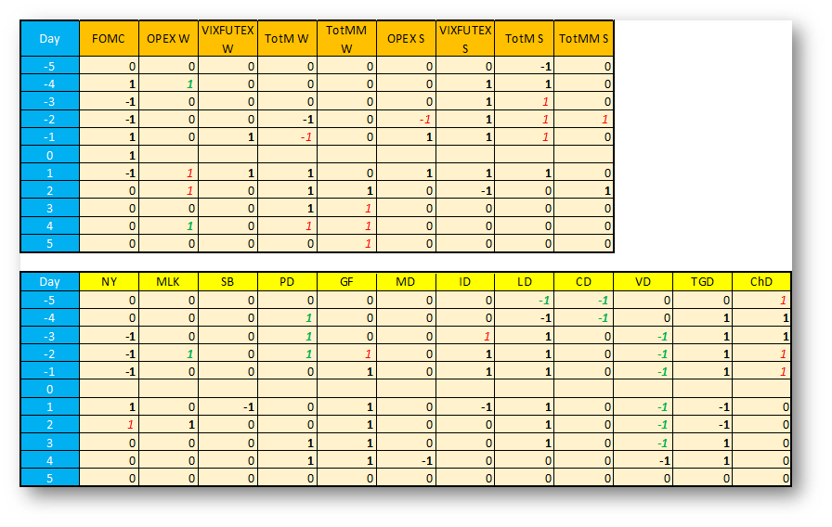

Table 8: Position distribution of the ‘new’ revisited Renewed Uber Strategy
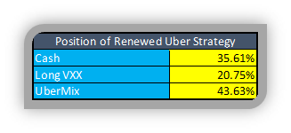
Table 1: Position distribution of the ‘old’ Renewed Uber Strategy

Chart 4: PV of the revisited Renewed Uber Strategy
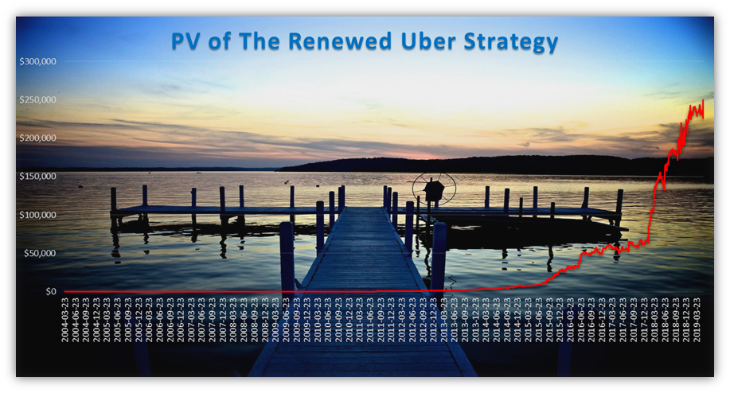

Chart 4a: PV of the revisited Renewed Uber Strategy - logarithmic scale


Table 9: Performance indicators of the revisited Renewed Uber Strategy
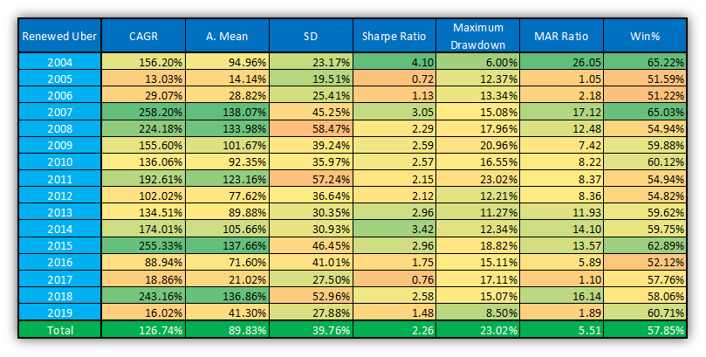

Possible Modifications of The Revisited Renewed Uber Strategy

Someone may wonder whether this amazing performance can even be improved. Numerous modifications and extension ideas were tested again (as previously), but in our opinion, this strategy should not be further burdened with additional overfitting. Nevertheless, it is worth considering using an indicator we know well: the Short-Term Contango Indicator.

Why? Our real life trading experience suggests that it is not necessarily profitable playing bullish bet in scary periods (when volatility is high and the term structure of the VIX futures is in backwardation). The same is true for bearish bets when VIX futures are in deep contango.

Chart 5 shows the evolution of the Short-Term Contango Indicator (second month VIX futures/front month VIX futures (with more than 5-days until exp.)-1).

Chart 5: Short-Term Contango Indicator
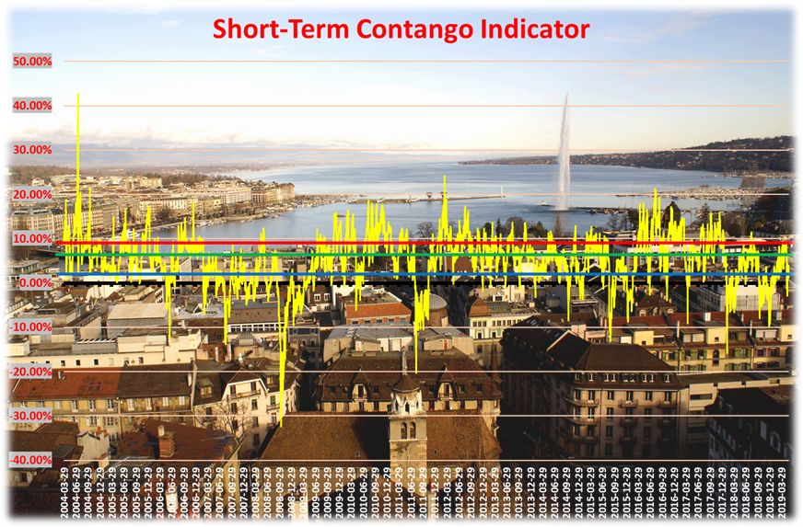

Our recommendation is to use this Short-Term Contango Indicator (STCI) in the following way:
- all of the FOMC and Holiday signals have to be played, regardless the STCI;
- on weaker bullish days (OPEX, VIXFUTEX, TotM and TotMM) play the UberMix basket if and only if the STCI closed above +2% contango (25th percentile, blue line in Chart 5) on previous day (so, stay in cash if contango is not big enough);
- on weaker bearish days (OPEX, VIXFUTEX, TotM and TotMM) play long VXX if and only if the STCI closed below +9% contango (75th percentile, red line in Chart 5) on previous day (so, stay in cash if the contango is too deep).

It is worth noting that these threshold are not optimised. Using this STCI, some trading signals should be changed. The newly recommended trading signals can be found in Table 10a (and changes compared to the currently used in Table 10b).

As it can be seen in Table 11, the proportion of played bullish days significantly decreased compared to the revisited Renewed Uber strategy without STCi (Table 8): 36.77% vs. 43.63%, while the same numbers for played bearish days are almost the same (20.44% vs. 20.75%). The proportion of cash days increased from 35.62% to 42.79%.

Table 10a: Trading signals of revisited Renewed Uber Strategy using Short-Term Contango Indicator
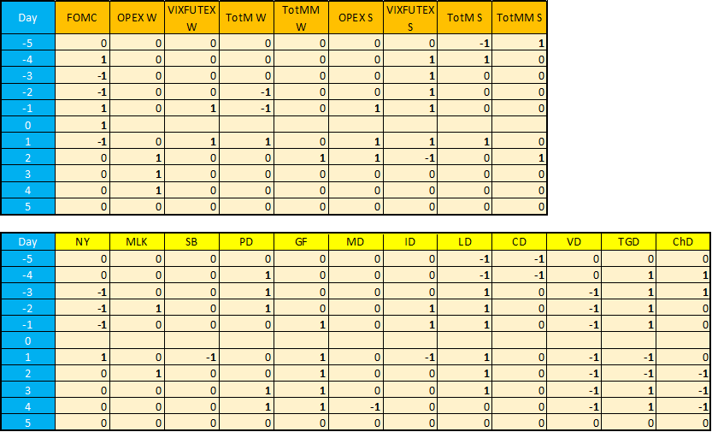

Table 10b: Trading signals of revisited Renewed Uber Strategy using Short-Term Contango Indicator - with changes compared to the current rules
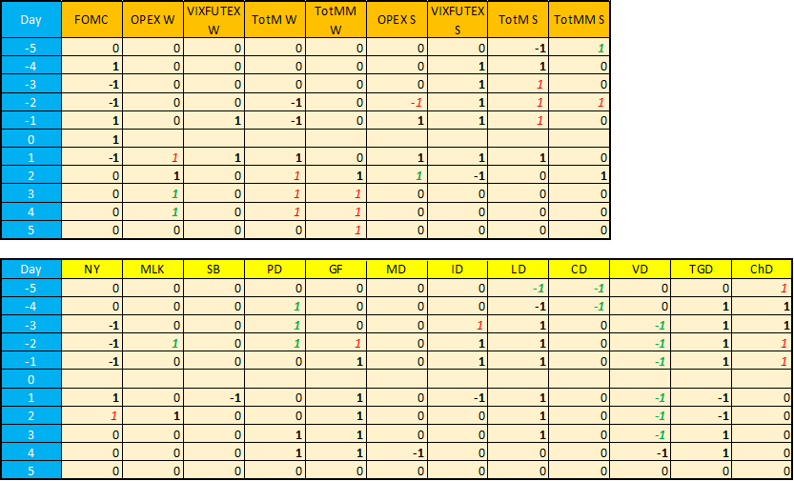

Table 11: Position distribution of the revisited Renewed Uber Strategy using Short-Term Contango Indicator
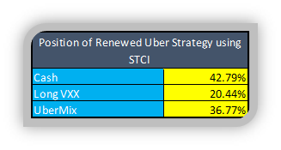

The performance of this Renewed Uber Strategy using Short-Term Contango Indicator can be found in Chart 6-6a and in Table 12. The figures are amazing again (as expected) and it is worth comparing them to the revisited strategy without STCI (Table 9): CAGRs are the same (125.9% vs. 126.74%), while Sharpe- and MAR ratios are better (2.31 and 6.69 vs. 2.26 and 5.51). Furthermore, maximum drawdown is reduced from 23.02% to 18.82%. Even better, it could achieve this by being in cash in almost half of the days (42% in particular, instead of the 27% cash days of the currently traded strategy).

In our opinion, this extension (using Short-Term Contango Indicator) should be used in real life trading.

Chart 6: PV of the revisited Renewed Uber Strategy using Short-Term Contango Indicator
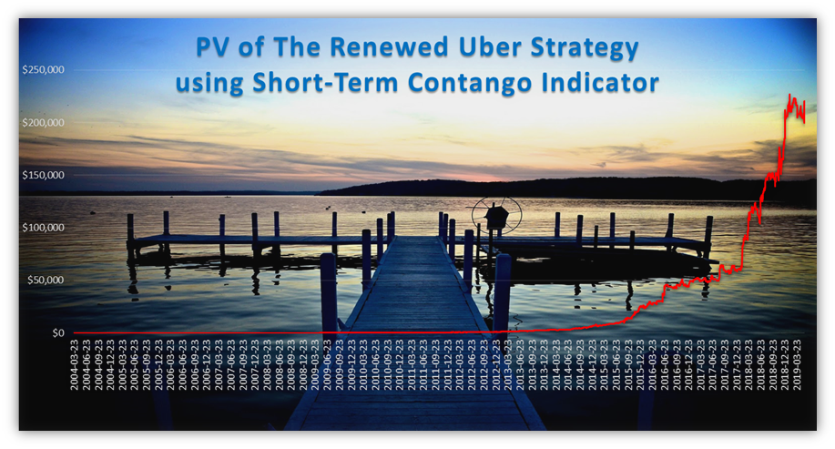

Chart 6a: PV of the revisited Renewed Uber Strategy using Short-Term Contango Indicator - logarithmic scale
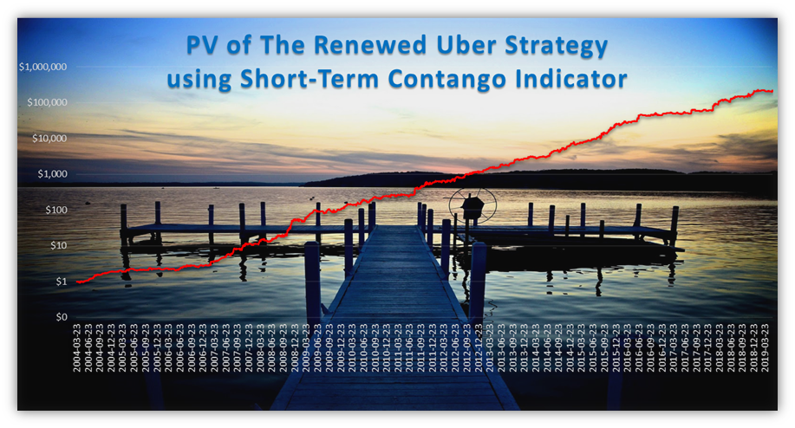

Table 12: Performance indicators of the revisited Renewed Uber Strategy using Short-Term Contango Indicator
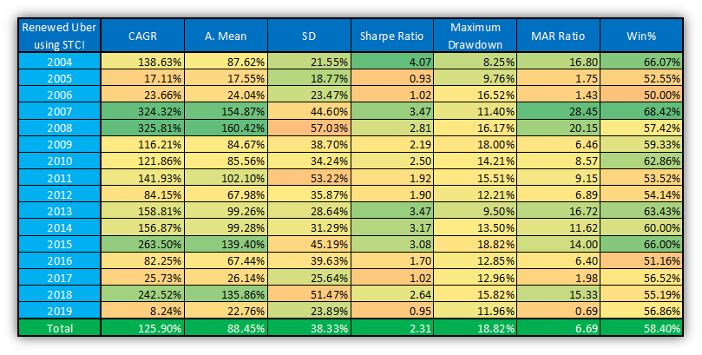

For risk-loving investors, another extension idea could be to play long UberMix basket not only on predefined days (ie. FOMC, Holidays, OPEX, VIXFUTEX, TotM and TotMM), but always when the value of the Short-Term Contango Indicator is higher than a given threshold (that is, in very bullish and calm regimes). Our recommended threshold is +7.5%, which is the 67th percentile of historical value of the STCI. Naturally, it increases the proportion of long UberMix basket days (from 35.77% to 57.78%) and decreases the number of days in cash from 42.79% to 21.78%. Thus, it is almost the same than in case of the currently played Renewed Uber Strategy (Table 1).

The performance of this extension (Extended Renewed Uber Strategy using STCI - where ‘Extended’ refers to the extended trading days when the well performing UberMix basket is in play) can be seen in Chart 7-7a and in Table 14.

Table 13: Position distribution of the Extended Renewed Uber Strategy using Short-Term Contango Indicator
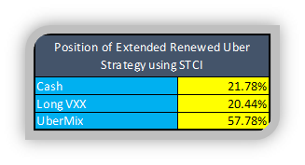

Table 1: Position distribution of the Renewed Uber Strategy

Chart 7: PV of the Extended Renewed Uber Strategy using Short-Term Contango Indicator
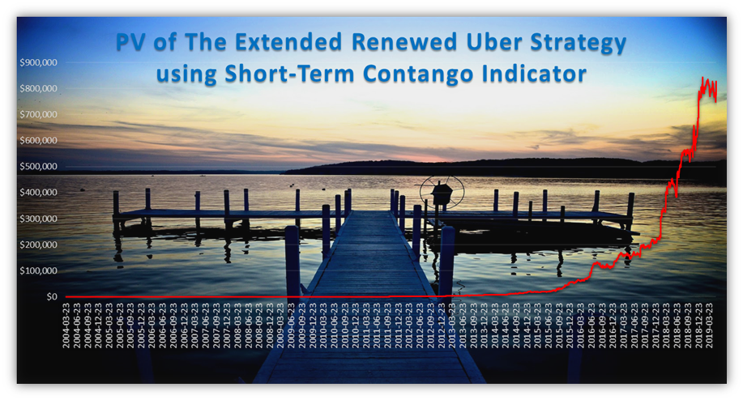
Chart 7a: PV of the Extended Renewed Uber Strategy using Short-Term Contango Indicator - logarithmic scale
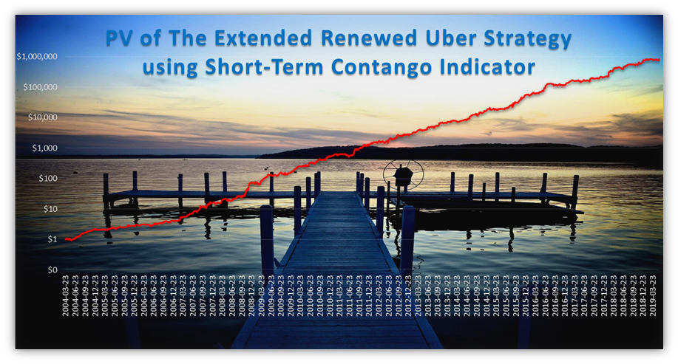

Table 14: Performance indicators of the Extended Renewed Uber Strategy using Short-Term Contango Indicator
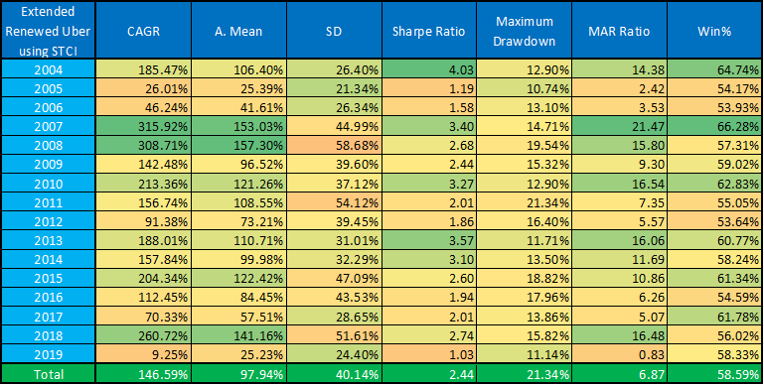

The following Table 15 and 16 compare the performance indicators and position distributions of the above presented three versions: revisited Renewed Uber, Renewed Uber using STCI and Extended Renewed Uber using STCI.

In our opinion, all the three strategy version should be played in real life trading, but the last one is the most recommended.

Table 15: Comparison of performance indicators
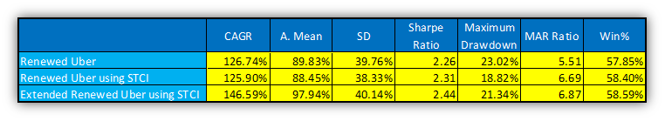
Table 16: Comparison of position distributions
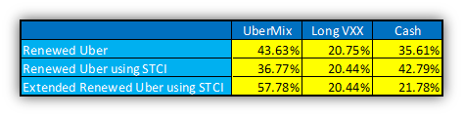

Conclusions

In this study, a revision of our beloved Renewed Uber strategy was presented.

At first, we checked its real life performance in last year. We found that our live portfolio lost about -15%, while it would have been only about -6% using the original rules. It was concluded that it is unnecessary to distinguish between ‘Only Short Volatility’ and ‘Short Volatility + Long Market Basket’ days. It is enough to separate bullish and bearish days (and all of the selected ETPs should be played on bullish days). Furthermore, using options for safety reasons dramatically decreased the performance, especially in case of short VXX vs. VXX put options. In our opinion, this strategy is not worth playing with options. Instead of this, other risk-reducing methods should be considered (e.g. portfolio-based stop-loss with rest period, reduced PV, long SVXY instead of short VXX, double leveraged ETPs instead of triple leveraged ones, etc.).

Secondly, a new bullish trading basket of the Renewed Uber Strategy were defined: the ‘UberMix’ basket (100% long VXX has remained on bearish days):
- 30% long UPRO (3x long SPY);
- 30% long TQQQ (3x long QQQ);
- 20% short VXX (or the corresponding 40% long SVXY (0.5x short VXX));
- 10% short TMV (3x short TLT);
- 5% short UGAZ (3x long UNG) and
- 5% short UWT (3x long USO).

After that, we re-analysed the significance of the played seasonality events using this UberMix basket instead of short VXX. Bullish and bearish market days were determined (with some changes compared to the currently played version) in that section. The performance of this revisited Renewed Uber Strategy (using the UberMix basket and new trading signals) is amazing, but somewhat overfitted.

As a realistic modification, we used the Short-Term Contango Indicator to determine when the hierarchically inferior sub-strategies (OPEX, VIXFUTEX, TotM and TotMM) should be played.
Our recommendation is to use this Short-Term Contango Indicator (STCI) in the following way:
- all of the FOMC and Holiday signals have to be played, regardless the STCI;
- on weaker bullish days (OPEX, VIXFUTEX, TotM and TotMM) play the UberMix basket if and only if the STCI closed above +2% contango (25th percentile) on previous day (so, stay in cash if contango is not big enough);
- on weaker bearish days (OPEX, VIXFUTEX, TotM and TotMM) play long VXX if and only if the STCI closed below +9% contango (75th percentile) on previous day (so, stay in cash if contango is too deep).
The strategy with this modification has even better past performance.
Finally, for risk-loving investors, we extended the number of played bullish days using this STCI (when market is calm and has positive outlook).
In our opinion, this revisited Renewed Uber Strategy using Short-Term Contango Indicator should be played in real life (but definitely without options).

Remark
On 2019-07-23 we started trading this strategy live. Compared to the backtested ‘Extended Renewed Uber Strategy using STCI’ (page 26), in real-life trading we aim to decrease leverage a bit for decreasing future StDev and maxDD. The following rules aim this under-leveraging:
Play with 100% of PV on FOMC days (as this is the strongest part of the strategy), with 85% on Holiday days, with 70% on VIXFUTEX, OPEX, TotM and TotMM days, while with only 50% of PV on pure bullish STCI days. These deleveraging percentages have to be played both on bullish and bearish days."

Appendix

Table 17a: Performance indicators of Buy&Hold ZIV
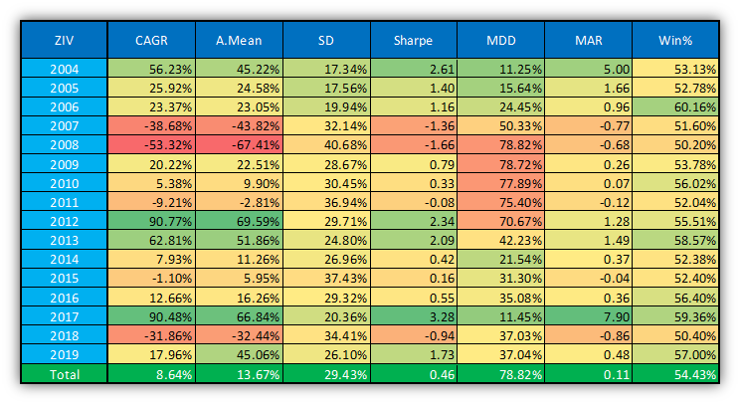
Table 17b: Performance indicators of Buy&Hold QQQ
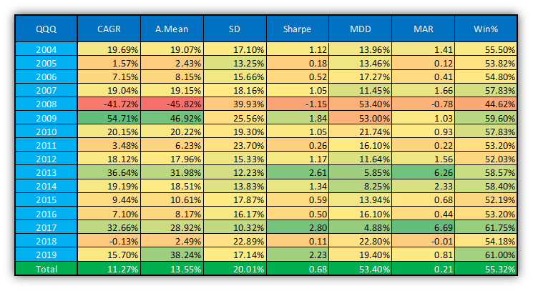
Table 17c: Performance indicators of Buy&Hold SPY
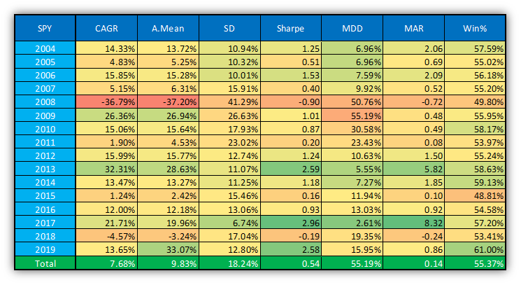
Table 17d: Performance indicators of Buy&Hold TLT
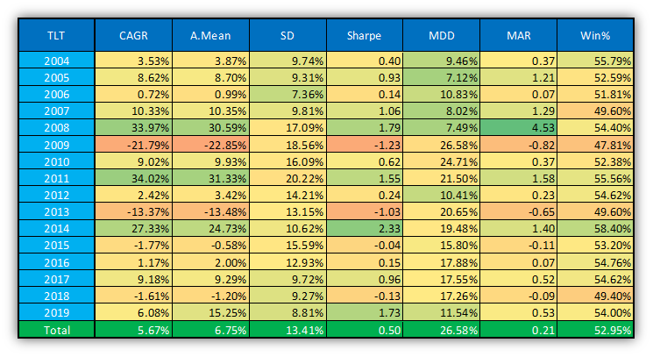

Appendix 2 - Real Life Performance 2019-07-18 - 2020-02-05

On 2019-07-23 we started trading this strategy live. Compared to the backtested ‘Extended Renewed Uber Strategy using STCI’ (page 26), in real-life trading we aim to decrease leverage a bit for decreasing future StDev and maxDD. The following rules aim this under-leveraging:
Play with 100% of PV on FOMC days (as this is the strongest part of the strategy), with 85% on Holiday days, with 70% on VIXFUTEX, OPEX, TotM and TotMM days, while with only 50% of PV on the 'STCI-extended' no-event days. These deleveraging percentages have to be played both on bullish and bearish days."

After half a year, the real life profit of the strategy is an incredible +73.4% with 8.76% maximum drawdown (right after the start). Sharpe ratio is 3.24, while win percentage is 63.64%. (Chart App2-1 and Table App2-1)

The distribution of profits between the sub-strategies (i.e. events) can be considered fairly even. Table App2-2 shows that the strategy has gained +17.39% on FOMC days, +24.74% on Holiday days, +12.76% on Other Event days and +5.04% on STCI days - using the above mentioned under-leverage percentages (Table App2-3 contains performance indicators without under-leverage - ie. using 100% leverage on every day). Furthermore, it can be seen that both bullish and bearish days are profitable: +34.29% and +29.15% respectively.

It has to be noted that both the win percentage and the distribution of days in different sub-strategies are also balanced: win percentage is above 60% in all cases (Table App2-4) and the strategy spends about 25% of its time in different sub-strategies (Table App2-5). The distribution of capital invested can be seen in Table App2-6.

All in all, all of the parts and events of the strategy was profitable in the last half year, the high profit was not only due to luck. No changes are recommended.

Chart App2-1: Real life PV of the Uber Extended Renewed using STCI Live strategy
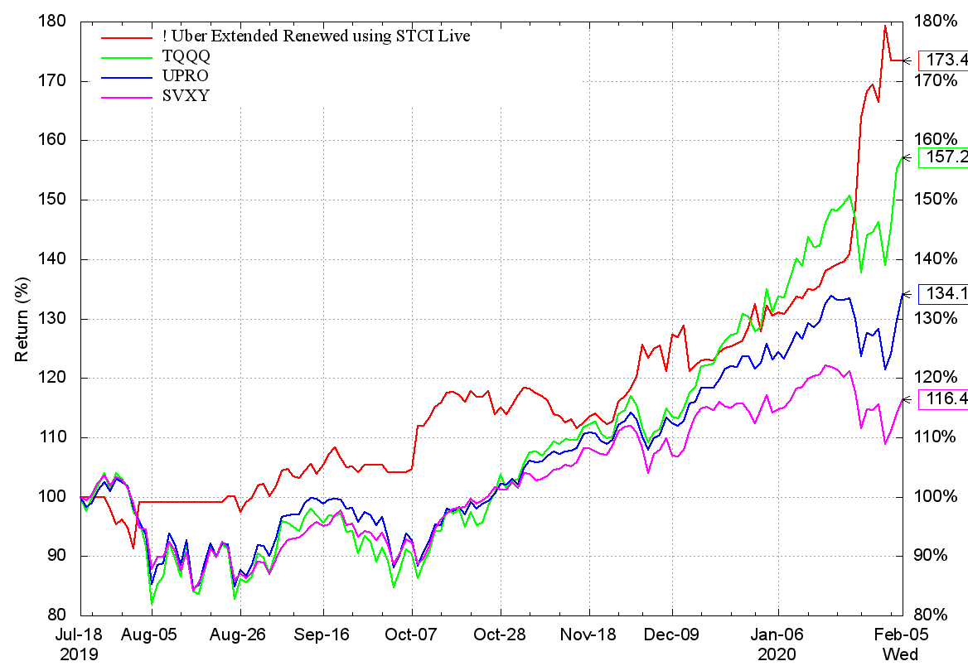
Table App2-1: Real life performance indicators
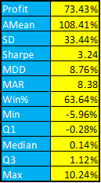
Table App2-2: Real life performance indicators
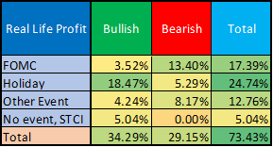
Table App2-3: Theoretical performance indicators - using 100% leverage on every day
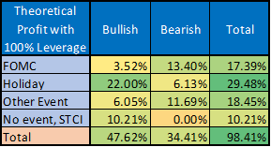
Table App2-4: Win percentage of different sub-strategies
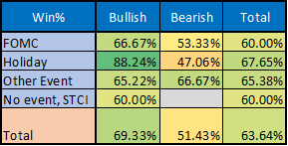
Table App2-5: Distribution of days in different sub-strategies
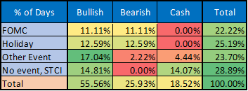

Table App2-6: Amount of capital invested in sub-strategies. (%Days * Leverage)
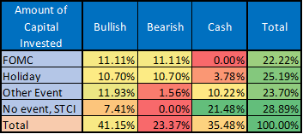

Appendix 3 - VIX Based Leverage Indicator - 2020-03-18

On 2020-03-16 (after the VIX index reached a record high 82.69 level during the coronavirus pandemic), it was decided to de-leverage the ‘Extended Renewed Uber using STCI Live Strategy’ when the expected volatility of the market is extremely high, i.e. when the VIX index is ‘too high’. In these periods, more prudent, safer investments can be more effective. The situation changes from moment to moment, so neither a mean-reversion nor a follow-through strategy can be recommended with absolute certainty. In other words, using a de-leverage indicator for our Renewed Uber strategy (both in case of bullish and bearish days) may be the most expedient decision (in addition to the currently used, event based leverage indicator: “Play with 100% of PV on FOMC days (as this is the strongest part of the strategy), with 85% on Holiday days, with 70% on VIXFUTEX, OPEX, TotM and TotMM days, while with only 50% of PV on pure bullish STCI days. These deleveraging percentages have to be played both on bullish and bearish days.”).
Based on the distribution of historical values of the VIX (Table App3-1), our recommendation is not to reduce the leverage (leverage=100%) while the VIX is below 21 (68th percentile). Furthermore, do not invest more than 10% of the PV when the VIX is above 30 (92th percentile) - but pausing the strategy is not advisable. When the VIX is between 21 and 30, a gradual reduction of leverage is proposed.
VIX Based Leverage Function:
- If VIX<21: leverage = 100%;
- If 21<=VIX<30: leverage = 100%-(VIX-21)*10%;
- If 30<=VIX: leverage = 10%.
The recommended VIX Based Leverage Function and the density- and cumulative distribution function of the VIX Index can be seen in Chart App3-1. The effect of this extension on the performance indicators of the played ‘Extended Renewed Uber using STCI Live Strategy’ in the backtested period (2004-2019H1) can be found in Table App3-2.
Table App3-1: Distribution of VIX level from 1990 to 2020
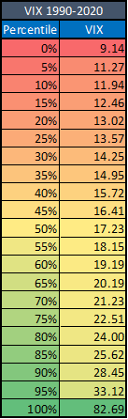

Chart App2-1: VIX based leverage and the density and cumulative distribution of VIX
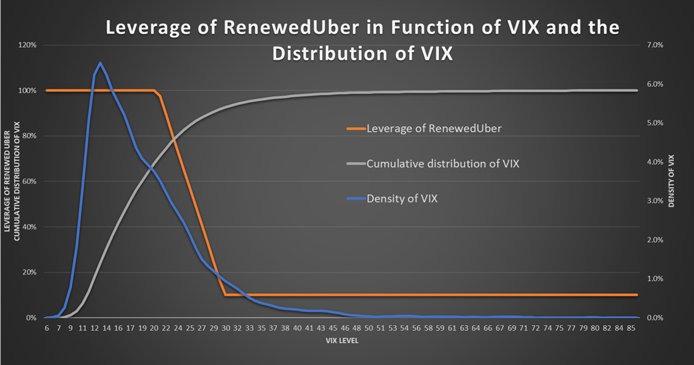

Table App3-2: Performance indicators
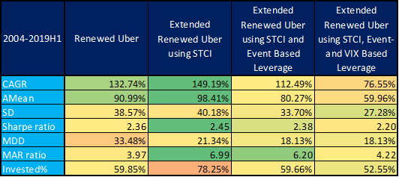

CURRENTLY
PLAYED

RECOMMENDED

Remark 1: It is interesting to see that all of the examined ETPs but short oil (short UWT) were lossmaking in 2018, while in 2019, just the opposite is true. Remark 2: UberMix basket should not be played in 2028 (2008, 2018 …) ☺
The green line indicates the 67th percentile, which is 7.5%.

