Dr. George Antal

3D Click Limited

c/o Suite 431, 28 Old Brompton Road, London SW7 3SS

Short Earnings Backtest 2019

# Goal

Check the recent Earnings Market Regime

# Test

Virtual portfolios have been created, the base portfolio has the following **trading rules**:

* **Buy** every stock from the stock universe (the S&P 500 stocks), which has an **earnings announcement** after the market close of the given day and before the market open of the next trading day. Buy **on market close**.
* **Close** every position on the **market open** of the next trading day.
* Initial deposit is $10.000. Starting date is 2010-01-01.
* If there are more stocks to buy on the given day, the portfolio value is divided equally. This gives a little unbalancement to the strategy, some positions are traded with 100% portfolio value, some just with 10%; like in real life trading.

## Test versions

* Repeat the tests with the stock universe of the **S&P 500 stocks (but not Nasdaq100) and the game changer stocks**. In the tests the S&P 500 stock universe is historically biased, the changes in the S&P 500 list are taken into account, every day the actually valid S&P 500 list is considered. The tests with the game changer stocks contain a fixed stock universe: the current 13 game changer stocks.
* In the base tests **all the earnings events** are traded. Then a portfolio is created with a “selected” subset of the stock universe. In that portfolio only the **“low-SHIR” stocks** are traded. Low SHIR stock means a stock with a SHIR percentile ranking below 0.33, with other words the stock’s SHIR value is in the first third among all the SHIR values (of the S&P 500 stocks). A third portfolio is also created for a fairer comparison: where **all the earnings events are traded with known SHIR value**. This portfolio will be very similar to the base portfolio with all the earnings events as we have a good SHIR database; on the other hand it should allow us a better comparison when checking our “selector’s” effectiveness.

# Test results

## The S&P 500 universe

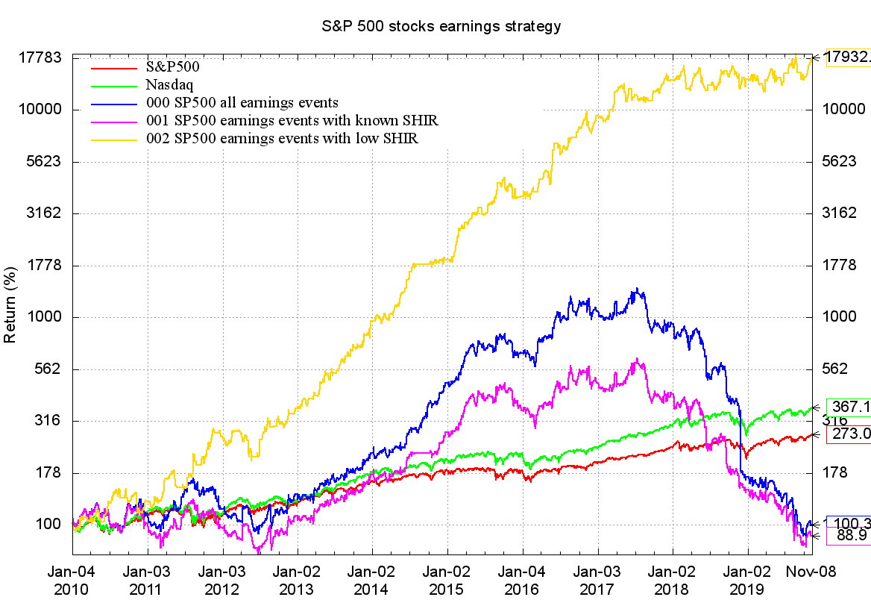

|  |  |  |  |  |  |  |  |  |
| --- | --- | --- | --- | --- | --- | --- | --- | --- |
|  | **final %gain** | **CAGR** | **Max DD** | **Average Number of Positions per Year** | **Average %Gain** | **Daily Std. Dev.** | **HQ Volatility** | **Sharpe** |
| 000 SP500 all earnings events | 0.32% | 0.03% | 93.71% | 1960.7 | 0.00% | 2.86% | 1.53 | 0.23 |
| 001 SP500 earnings events with known SHIR | -11.06% | -1.17% | 87.74% | 1896.3 | 0.00% | 2.54% | 1.47 | 0.17 |
| 002 SP500 earnings events with low SHIR | 17832.89% | 68.02% | 29.82% | 593 | 0.33% | 2.30% | 1.23 | 1.62 |

First we can focus on the blue line on the chart, it shows the “overall earnings regime”. In that portfolio every S&P 500 stock is traded. The most important thing is, that there is a big drawdown observable on the chart **from June 2017. The downtrend is still ongoing**. Currently holding all the S&P 500 stocks indiscriminately on their earnings announcement day generates losses. Currently we are still in a Bearish-Earnings-Regime cycle.

As for our SHIR based stock selector, we can see that it works quite effectively. Comparing the yellow line (“low-SHIR” stocks) with the pink line (all stocks with known SHIR value - which chart is very similar to the base chart as excepted) we can see that the chart goes horizontally with some oscillation instead of falling down. **The earnings strategy would not have produced profit since the Bearish-Earnings-Regime started in January 2017. It would have moved sideways. Maybe we start to observe some life in the strategy (yellow line) in the last quarter. We might have timed the live trading perfectly.**

## The Game Changer Stocks universe

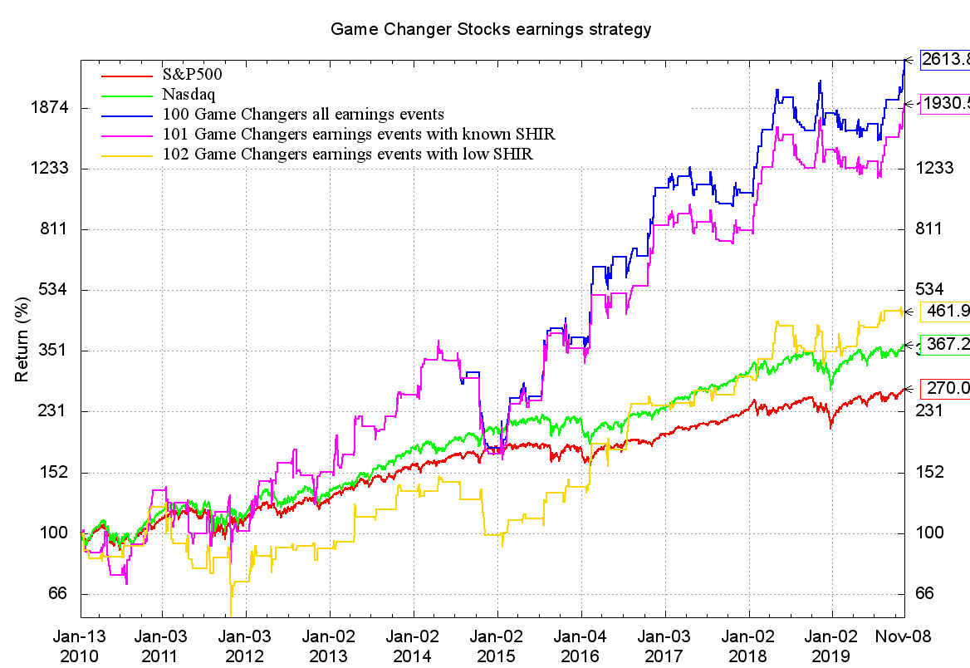

|  |  |  |  |  |  |  |  |  |
| --- | --- | --- | --- | --- | --- | --- | --- | --- |
|  | **final %gain** | **CAGR** | **Max DD** | **Average Number of Positions per Year** | **Average %Gain** | **Daily Std. Dev.** | **HQ Volatility** | **Sharpe** |
| 100 Game Changers all earnings events | 2513.75% | 38.59% | 54.19% | 60.9 | 1.08% | 2.89% | 1.06 | 0.97 |
| 101 Game Changers earnings events with known SHIR | 1830.52% | 34.45% | 55.96% | 59.9 | 1.04% | 2.86% | 1.02 | 0.9 |
| 102 Game Changers earnings events with low SHIR | 361.91% | 16.53% | 54.61% | 31.3 | 0.94% | 2.17% | 0.61 | 0.64 |

Focusing on the blue line, which contains all the game changer stocks’ earnings events we can see that it contains only minor local drawdowns. The overall regime is bullish: **it is profitable to hold the game changer stocks during their earnings announcement day.**

Our low SHIR based selector is not as relevant on the Game Changer stocks as on the S&P 500 stock universe. Using low SHIR filter on GC stocks reduces the number of positions as well as the overall profit. The GC stocks are too good to be skipped.

# Conclusion

**The current overall earnings-regime is still bearish. Although the chart shows that we might be at the inflexion point when the cycle changes and overall earnings days will be bullish.**

**If we had traded in real life, we would not have produced a big profit with the earnings strategy in recent years.**

Most probably, the current bearish earnings regime does not last forever. It should work in long-term cycles, like a rhythm. Periods when it is unsuccessful are followed by periods of profitability for 2-3 years. We very well might be in the transition period between these periods to profitability.