Dr. George Antal

3D Click Limited

c/o Suite 431, 28 Old Brompton Road, London SW7 3SS

**Simple technical bear market avoidance strategy**

**Motivation** **1**

**Used data** **1**

**Background** **3**

**Our Current Results** **7**

Reconciliation of study’s results 7

Analysis of SMA10 14

Using EMA instead of SMA 17

Comparison of SMA and EMA 19

**Conclusion** **21**

# 

# 

# Motivation

There is a Mojena market timing model, developed and maintained by professor Richard Mojena. It is a method for timing the broad U.S. stock market based on a combination of many monetary, fundamental, technical and sentiment indicators to predict changes in intermediate-term and long-term market trends. In an article at [cxoadvisory.com](https://www.cxoadvisory.com/2555/fundamental-valuation/mojena-market-timing-model/) Steve LeCompte compared the performance of this strategy for the last 25 years with the result of some simple strategies. In this study we try to reconcile his results and look deeper behind them.

# Used data

For calculating returns I used adjusted daily closing prices from 1993-01-03 until 2019-04-30 (which is 26.33 years) for SPY. For calculating daily yields for 13-week Treasury bills (T-bills) I used closing [**IRX**](https://finance.yahoo.com/quote/%5EIRX/history?p=%5EIRX) **values** from finance.yahoo.com. However please note that these values **are not prices but yearly interest rates** and as such match the corresponding data from [FRED database](https://fred.stlouisfed.org/series/DTB3).

So for daily yields I used the

daily yield for T-bills = closing ^IRX value / (100 x 252)[1]

formula.

Chart 1a. ^IRX (13 week treasury bill) closing values at [finance.yahoo.com](https://finance.yahoo.com/quote/%5EIRX/chart?p=%5EIRX), 2001-01-02-2019-04-01

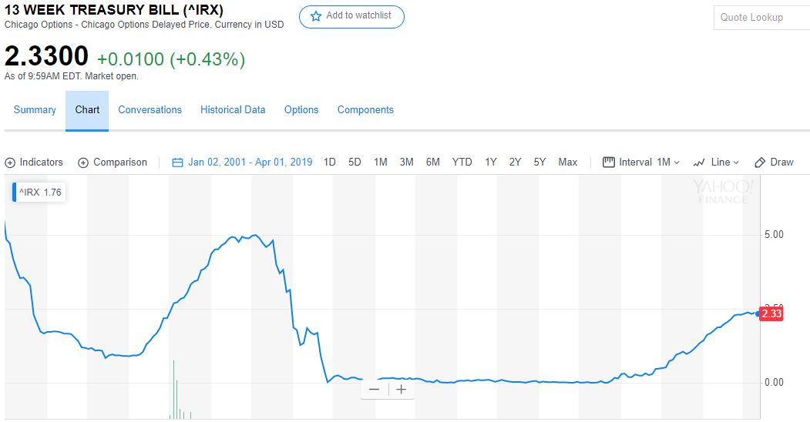

Chart 1b. 3-Month treasury bill at [fred.stlouisfed.org](https://fred.stlouisfed.org/series/DTB3), 2001-01-03-2019-04-30

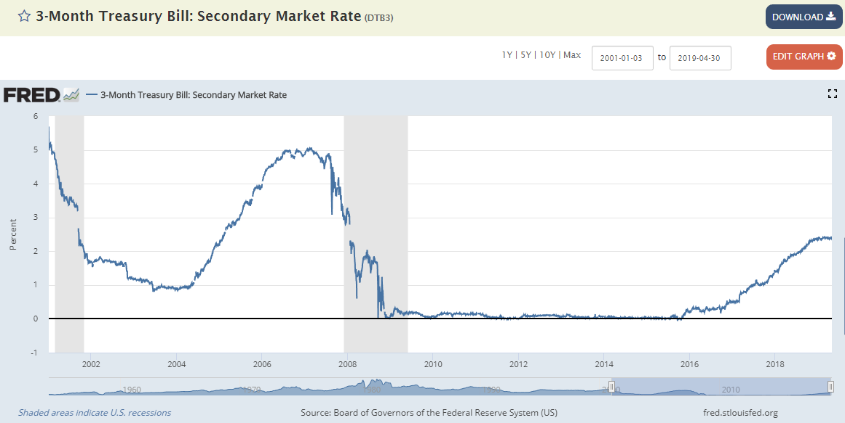

# Background

The above mentioned article says:

*“The* [*Mojena Market Timing*](http://www.mojena.com/) *strategy (Mojena), developed and maintained by professor* [*Richard Mojena*](http://www.mojena.com/about.htm)*, is a method for timing the broad U.S. stock market based on a combination of many monetary, fundamental, technical and sentiment indicators to predict changes in intermediate-term and long-term market trends. He adjusts the model annually to incorporate new data. Professor Mojena offers a* [*hypothetical backtest of the timing model since 1970*](http://www.mojena.com/model.htm) *and a* [*live investing test since 1990*](http://www.mojena.com/live.htm) *based on the S&P 500 Index (with dividends). To test the robustness of the strategy’s performance, we consider a sample period commencing with inception of SPDR S&P 500 (SPY) as a liquid, low-cost proxy for the S&P 500 Index. As benchmarks, we consider both buying and holding SPY (Buy-and-Hold) and trading SPY with crash protection based on the 10-month simple moving average of the S&P 500 Index (SMA10). Using the trade dates from the Mojena Market Timing live test, daily dividend-adjusted closes for* [*SPY*](http://finance.yahoo.com/q/hp?s=SPY) *and daily yields for* [*13-week Treasury bills*](http://finance.yahoo.com/q/hp?s=%5EIRX)*(T-bills) from the end of January 1993 through August 2018 (over 25 years), we find that:*

*Analyses assume the following:*

* *Initial investment size is $10,000.*
* *Use of dividend-adjusted values of SPY implies reinvestment of dividends.*
* *For Mojena, trade between SPY and cash at the close on the first trading day after the dates (Sundays) specified. Trading at the open is a feasible alternative.*
* *For SMA10, hold SPY (cash) when the S&P 500 Index is above (below) its SMA10 at the end of the prior month. There is slight anticipation of signals to trade at the same monthly close.*
* *Return on cash is the T-bill yield.*
* *One-way switching frictions are 0.1% of the balance for all switches (but zero for reinvestment of dividends).*
* *Ignore tax implications of trading.*

*The following chart compares on a logarithmic scale net cumulative values of $10,000 initial investments for Mojena, Buy-and-Hold and SMA10 over the full sample period. Mojena largely tracks Buy-and-Hold. SMA10 mostly outperforms both. Quantitatively:*

* *Net* [*compound annual growth rates*](https://en.wikipedia.org/wiki/Compound_annual_growth_rate) *(CAGR) for Mojena, Buy-and-Hold and SMA10 are 9.0%, 9.7% and 11.2%, respectively.*
* [*Maximum drawdowns*](https://en.wikipedia.org/wiki/Drawdown_(economics)) *(MaxDD) based on daily data are -42%, -55% and -19%, respectively.*
* *Mojena generates 47 switches, compared to 25 for SMA10, so the former is more sensitive to the assumption about switching frictions.*

*For another perspective, we look at returns by calendar year.*

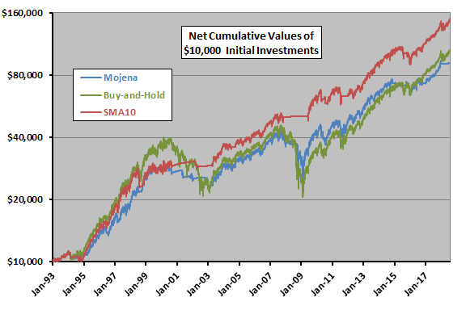

*The next chart compares net calendar year returns for Mojena, Buy-and-Hold and SMA10 during 1993 (partial) through 2018 (partial). Average net annual returns through 2017 are 9.9%, 11.1% and 11.6%, respectively, with standard deviations 12.7%, 17.8% and 12.1%. Using the average daily T-bill yield during a year as the risk-free rate for that year, net annual* [*Sharpe ratios*](http://en.wikipedia.org/wiki/Sharpe_ratio) *are 0.59, 0.49 and 0.76, respectively.*

*Mojena beats Buy-and-Hold (SMA10) for five (eight) of 24 years. Mojena’s best year relative to Buy-and-Hold is 2008.*

*For additional insight, we compare performances of Mojena and SMA10 relative to Buy-and-Hold.*

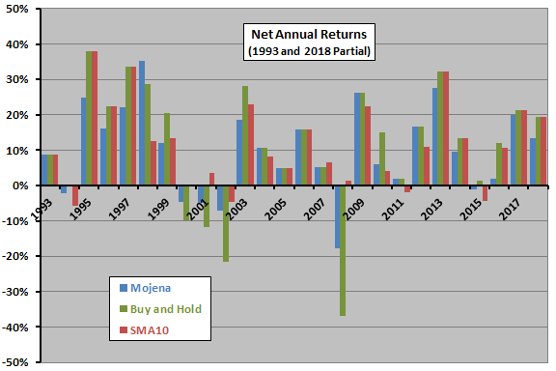

*The final chart compares Mojena and SMA10 annual returns minus those of SPY. The chart shows that both timing strategies tend to outperform Buy-and-Hold during equity bear markets and underperform during bull markets. Their overall performances therefore depend on the mix of bull and bear states in the sample. Neither timing strategy has beaten Buy-and-Hold since 2008.*

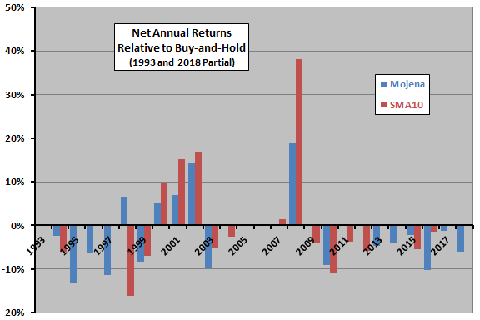

*The following table summarizes performance statistics mentioned above.*

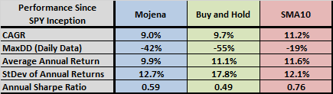

*In summary, evidence from simple tests over a 25+-year sample period suggests that Mojena Market Timing modestly outperforms buy-and-hold on a risk-adjusted basis, but substantially underperforms a simple and widely used technical bear market avoidance strategy.*

*Cautions regarding findings include:*

* *The sample period is not long in terms of number of bull and bear markets.*
* *As noted, Mojena outperforms Buy-and-Hold during only five of 24 calendar years, most strongly by avoidance of part of the market loss in 2008.”*

# 

# Our Current Results

## Reconciliation of study’s results

First of all I tried to rebuild the first chart from the above article.

**

Chart 2. Net cumulative values of $1 initial investments for different SPY and ^IRX related strategies, 1993-01-01 - 2018-08-31, logarithmic scale 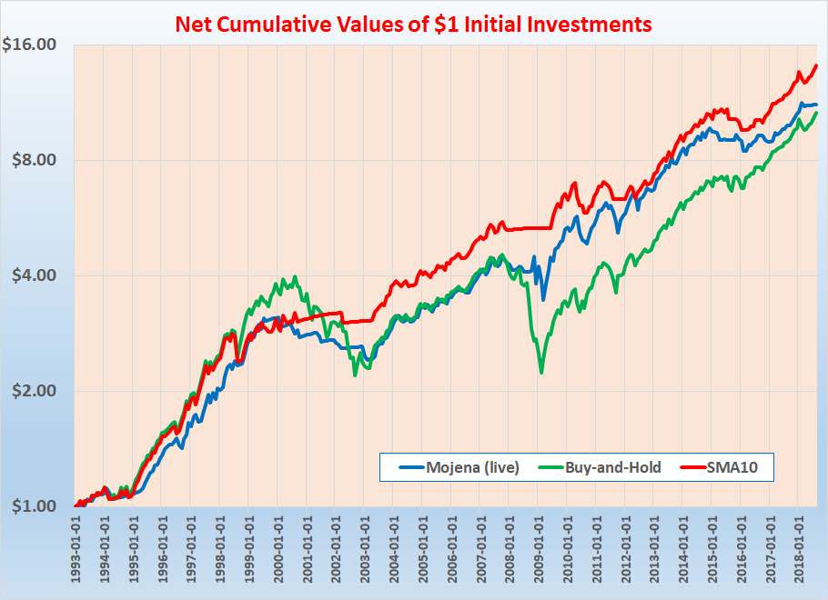

Although in my calculation I didn’t use switching friction cost at all - basically I think I succeed. However Mojena curve is higher in my reconciliation from 2008 than in the article. The reason behind it is that **my backtest didn’t suffer such a significant loss in October 2008**.

Professor Mojena provided 2 sets of Buy/Sell signals (both only until the end of 2018): a (back)tested and a live one. The above (and all my later) calculation was **based on the live signal-set**. In the next two charts we can compare the two different sets:

Chart 3. Mojena Market Timing signals, 1993-01-01 - 2018-12-31

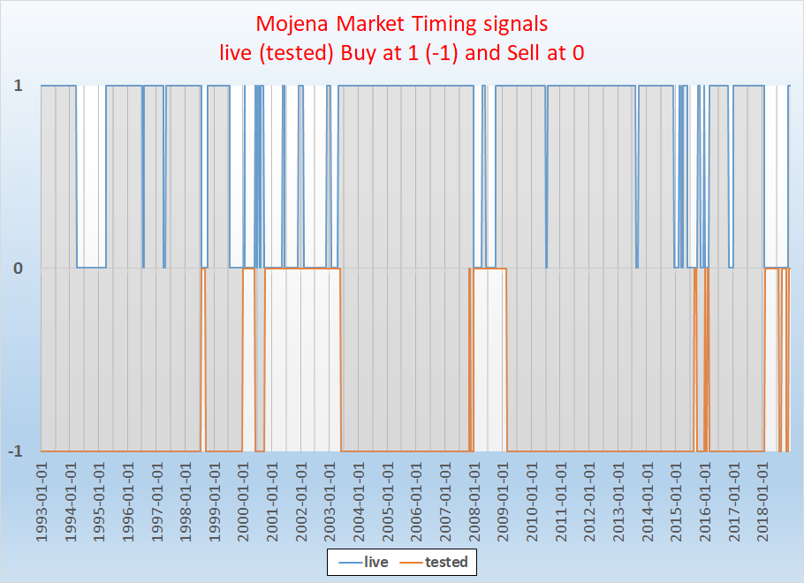

Chart 4. Net cumulative values of $1 initial investments for different SPY and ^IRX related strategies, 1993-01-01 - 2018-08-31,

logarithmic scale

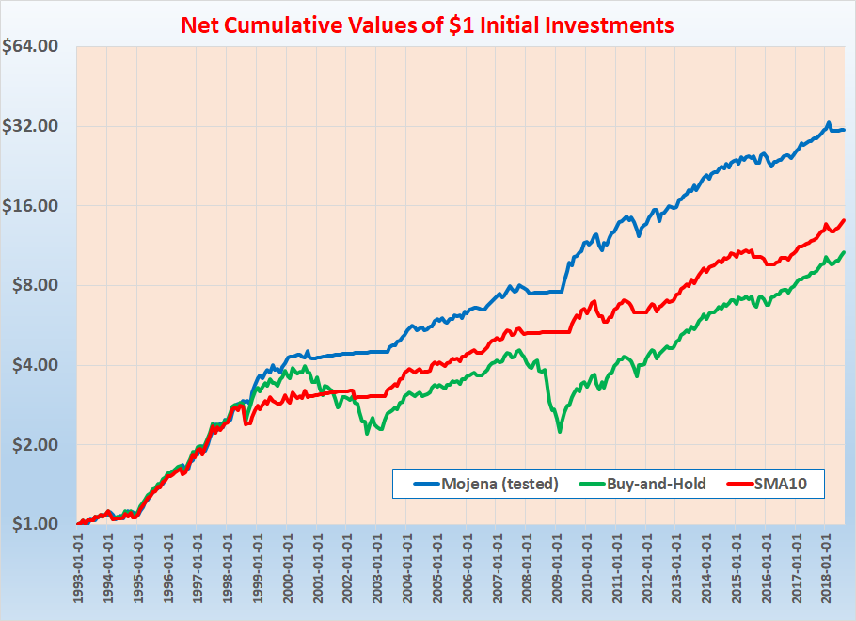

We can see that neither during the bear market of 2001 nor during 2008 the tested signal was at Buy but Sell (and therefore with this signal we can get a much higher overall result). But what is really important regarding our calculation is that real signal changed from Sell to Buy at mid-October 2008. In my reconciliation I shifted this only one signal there and back by 1-2-3 weeks but still was not able to get such a big drawdown at the end of 2008 as it can be seen in the related chart of the original article. So I cannot explain the difference at that point - but all the other periods were reconciled very closely.

Comparison of net annual return charts also strengthen this basically successful reconciliation:

**

Chart 5. Net annual returns for different SPY and ^IRX related strategies, 1993 - 2018

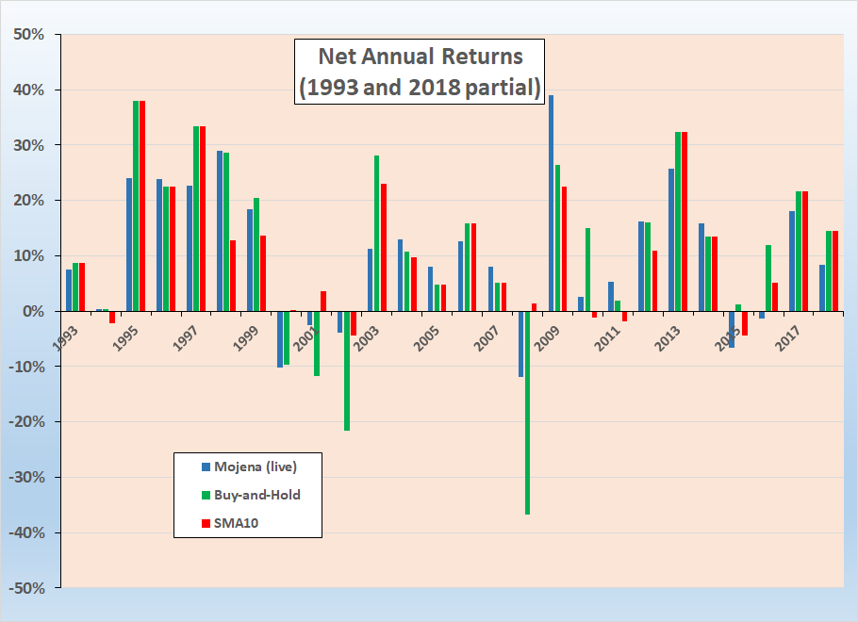

We have some differences at Mojena (live) annual return in 1996 (23.8% vs ~17%), in 1998 (29% vs ~35%), in 1999 (18.5% vs ~12%), in 2000 (-10.1% vs ~-5%), in 2003 (11.3% vs ~18%), in 2008 (-11.8% vs ~-18%), in 2009 (39.1% vs ~27%), in 2014 (15.9% vs ~10%) and 2015 (-6.5% vs ~-1%) - maybe the most interesting ones are the above mentioned 2008-2009 years. At the same time **Buy and Hold and SMA10 values are in line with the ones in the original chart and all in all Mojena values also follow the same pattern**.

For 25 years Mojena performs slightly above Buy-and-Hold (it was slightly under in the original article) and outperform that 12 times in 25 years (instead of only 5) - from which 10 times the advantage is at least 1.0% annual return. But still both of them are under the performance of SMA10.

Now let’s see the main performance indicators in details (all of them were calculated on daily basis):

Table 6. Performance indicators for SMA10 strategy (with SPY and ^IRX), 1993 - 2018

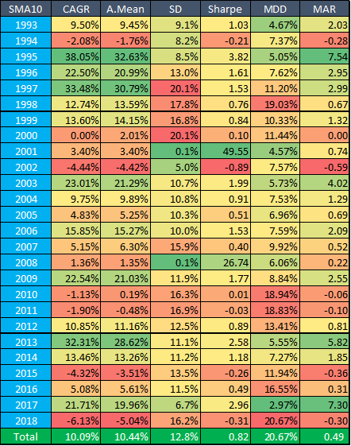

Table 7. Performance indicators for Buy-and-Hold strategy (with SPY), 1993 - 2018

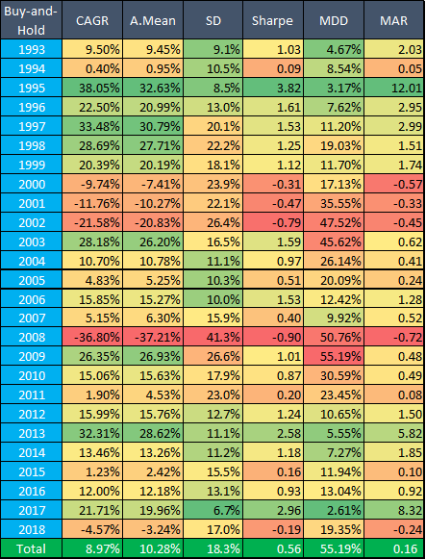

Table 8. Performance indicators for Mojena Live strategy (with SPY and ^IRX), 1993 - 2018

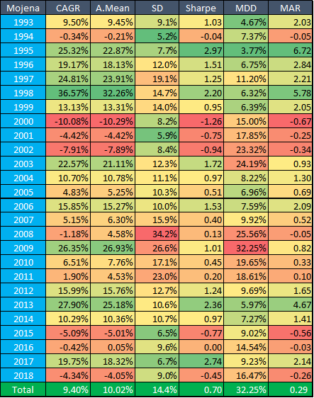

In accordance with the above charts (and the original study) **SMA10 was the only strategy that successfully avoid the huge drawdowns** (actually even the negative result) **during the bear markets of 2001 and 2008** - and as such this one had the lowest overall MDD (20.7%).

So although in CAGR, SR and MDD **Mojena-strategy** slightly beats the simple Buy-and-Hold strategy - it **clearly underperforms the SMA10 strategy**.

## 

## Analysis of SMA10

When we see these results then it’s an evident question whether SMA10 strategy could be even better with other parameters. Therefore I extended my calculations in two ways:

* first I used different look-back periods to calculate SMA value and compared that to different live values to create a signal
* second I used EMA, i.e. [Exponential Moving Average](https://en.wikipedia.org/wiki/Moving_average#Exponential_moving_average) instead of SMA, also with different parameters

The above “original” SMA10 calculation looks like this:

* Take the (adjusted) monthly closing prices for 10 consecutive months M(-9), M(-8), …, M(0) as P(-9), P(-8), …, P(0)
* Calculate the arithmetical average of them: A(0)
* Compare A(0) and and P(0). If P(0)> A(0), then the S(0) signal for month M(0) is 1, otherwise 0
* During whole month M(1) use the signal S(0) - i.e invest in SPY if S(0)=1, otherwise in Bond.

For first extension of SMA10 I created 12 versions where calculation and usage of S(0) looked like this:

Table 9. SMA 10 versions by calculation and usage of S(0)

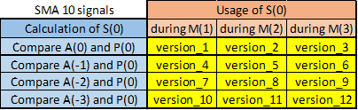

So version_1 means that for example:

* Take the (adjusted) monthly closing prices for January, February, …, October
* Calculate the arithmetical average of them: A(0)
* Compare A(0) and monthly closing price of October (which is P(0)). If October closing price > A(0), then we get a signal of 1, otherwise 0
* Use this signal during whole November, i.e. invest in SPY if this signal is 1, otherwise in Bond.

Meanwhile version_8 means that for example:

* Take the (adjusted) monthly closing prices for (previous) November, (previous) December, January, February, …, August (so 10 consecutive months)
* Calculate the arithmetical average of them: A(-2)
* Compare A(-2) and monthly closing price of October (which is P(0)). If October closing price > A(-2), then we get a signal of 1, otherwise 0
* Use this signal during whole December (instead of November as in version_1), i.e. invest in SPY if this signal is 1, otherwise in Bond

So version_8 in practice means that we compare the current price to an older moving average to calculate a signal (we skip the last month, which is a general practice in trend following studies to let a 1 month short term mean reversion to take place)l and use this signal not during the following but a later month.

With this bunch of possible strategies I got the following SMA10 clones:

Chart 10. Net cumulative values of $1 initial investments for different SMA10 strategies, 1993-01-01 - 2018-08-31, logarithmic scale

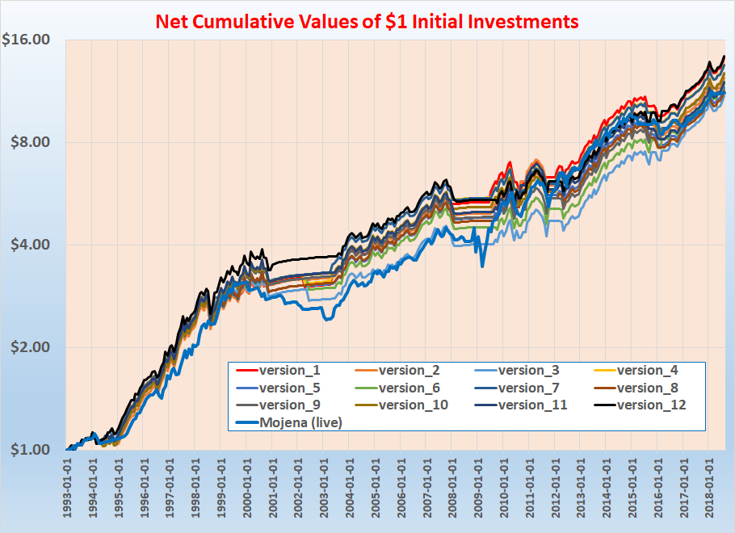

Not surprisingly version_1, …, version_12 run more or less parallel - the biggest difference between them came from the performance of 2001 (for example until 2004-01-01 version_12 is the best and version_3 is the worst, the difference between them until that point is 31%, but after 2004-01-01 the difference between them is less than 0.5%).

But what is more important for us that **11 versions out of 12 still outperform Mojena** and the **best versions are version_12 and the original version_1** (the first one is better only by 1% after nearly 26 years).

For a second extension of SMA10 I used longer look-back periods instead of 10 (namely 11, 12, 13, 14 and 15) and applied those with version_1-style signal calculation. The related chart looks like this:

Chart 11. Net cumulative values of $1 initial investments for different SMA strategies, 1993-01-01 - 2018-08-31, logarithmic scale

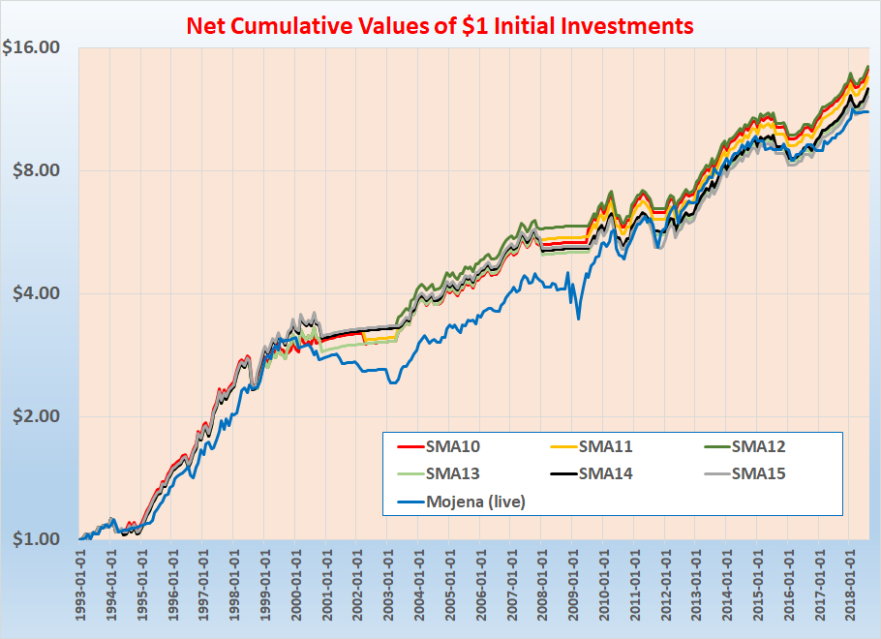

The conclusions are similar: **SMA10 is still the second best and all 6 strategies outperform Mojena**. Among SMA versions also SMA10 performed the best recovery after March 2009.

## Using EMA instead of SMA

As we mentioned above the second possible extension is using of EMA instead of SMA.

First I calculated EMA10 and its 11 eleven variants with the same logic as above. For doing that I had to choose a discount factor and I used the most commonly used k = 2 / (N+1) = 2/11 =0.1818% factor this time.

Although version_1 was among the best even until 2015, finally it reached only a tied 5th place (with version_4).

But all 12 variants outperformed Mojena. Actually the best 3 (version_3, version_6 and version_9) even slightly outperformed the best SMA10 variant (version_12). The common in these 3 versions that all apply (a differently calculated signal) only 3 months later.

Chart 12. Net cumulative values of $1 initial investments for different EMA10 strategies, 1993-01-01 - 2018-08-31, logarithmic scale

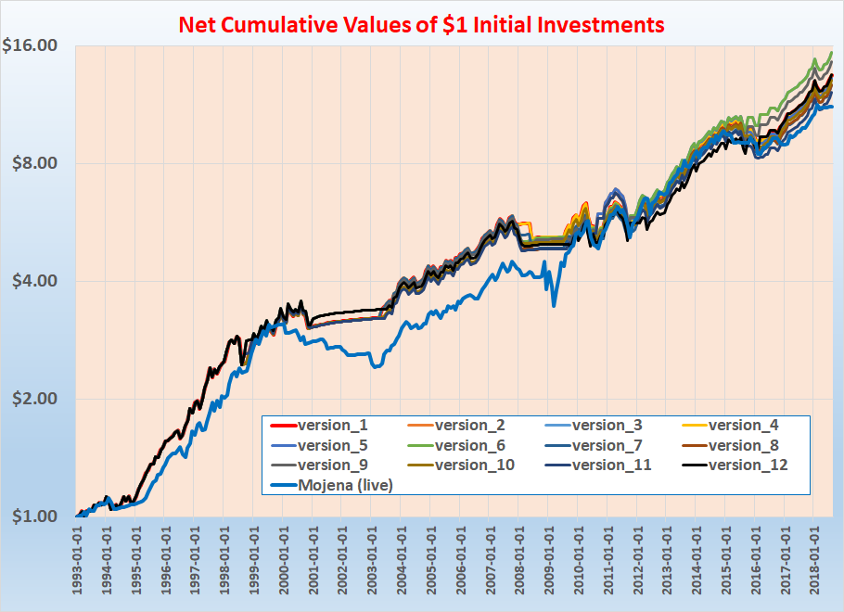

After this I also prepared EMA10, …, EMA15 variants - and the conclusion was the same as at SMA: **EMA10 is the second best (slightly under EMA12) and all version them outperformed Mojena**.

Chart 13. Net cumulative values of $1 initial investments for different EMA strategies, 1993-01-01 - 2018-08-31, logarithmic scale

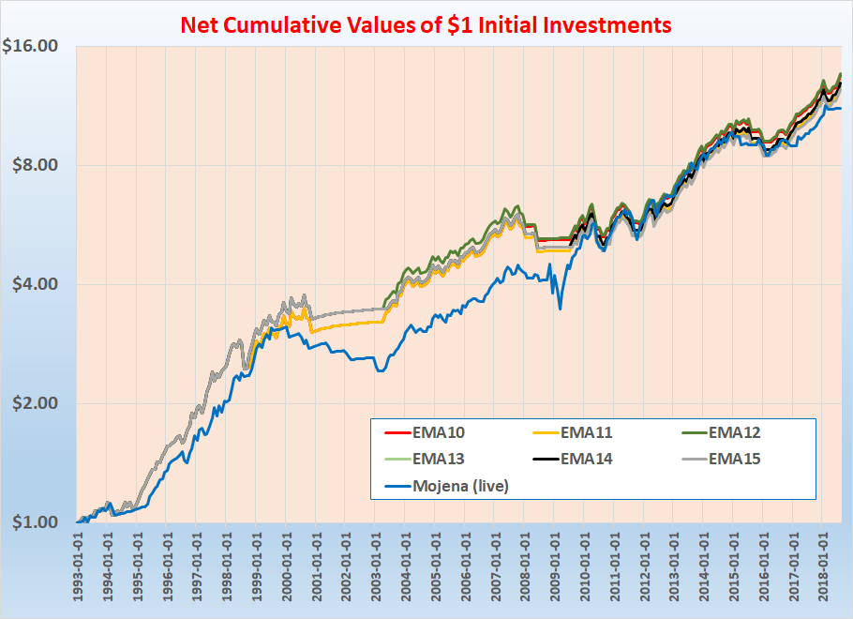

## Comparison of SMA and EMA

Finally I compared EMA10 (version_1) and SMA10 (version_1).

Chart 14. Net cumulative values of $1 initial investments for SMA10 and EMA10 strategies, 1993-01-01 - 2018-08-31, logarithmic scale

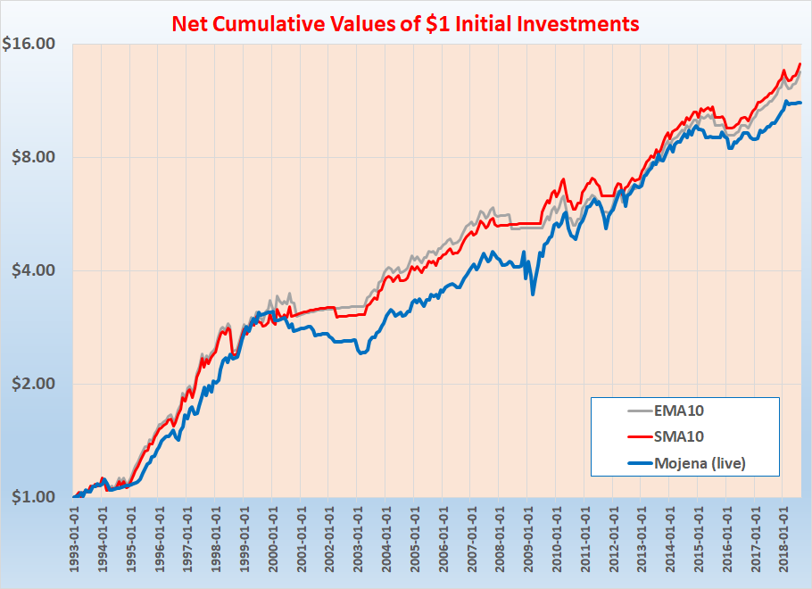

Performance indicators for SMA10 (version_1) can be found in Table 6, the same for EMA10 (version_1) in the following Table 15.

Table 15. Performance indicators for EMA10 strategy (with SPY and ^IRX), 1993 - 2018

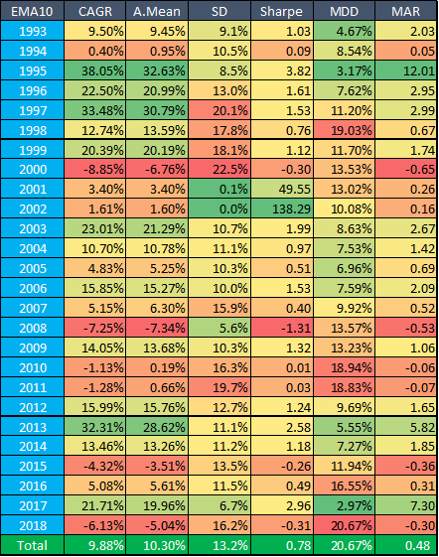

# 

# Conclusion

Although we elucidated its performance, the purpose of this study was not to test the Mojena market timing model per se. Rather, to find a bear market avoidance strategy, a crash protection, which could warn us to abandon market exposure in real trading.

We wanted to know whether Mojena or MA-based timers are more successful and also how sensitive the performance of SMA is to perturbing the parameters.

In this study we **backtest**ed professor Richard **Mojena’s** **live market timing model**. His method for timing the broad U.S. stock market based on a combination of many monetary, fundamental, technical and sentiment indicators to predict changes in intermediate-term and long-term market trends.

**Based upon the results for the last nearly 26 years** (actually from the January 1993 inception of SPDR S&P 500 ETF (SPY) until the end of 2018) we have found that even **simple Buy-and-Hold strategy** (for SPY) **just nearly remained under the performance of Mojena Live strategy[2]**.  
  
Moreover: SMA10 strategy (which switches between 13-week treasury bill and SPY) outperformed Mojena Live (10.1% CAGR vs 9.40%, 0.82 SR vs 0.7 and 20.7% MDD vs 32.3%). Therefore we also analysed SMA strategies with different parameters and even changed the simple arithmetical moving average to an exponential one (EMA).

During these parameter and methodology optimization we have found that **10 month as a look-back period** for average calculation **is among the best** - **but typically** with any **other** parameters we still got **better** results **than** with **Mojena Live** strategy.

(Actually we got the best result with EMA10 version_6, where we use a signal that was calculated by 1 month lag and was applied by 2 months lag).

Based on our findings, whenever we want a market crash protection signal to stop loss real-life market exposure, rather than the Mojena signals, we should use the SMA/EMA techniques which we have found to be quite robust to changing parameters. That basically means it is not crucial which parameters we use in particular; the performance is supposed to be similar.

1. I used 252 days because in average there are 252 trading days in a given year. However this kind of calculation is still not perfect because with this method we calculate the same interest rate for a 3-day-long weekend and a common weekday. We could use 360 (or more precisely 365) instead of 252 and then take into account the time-difference between the trading days - but it would have only a small effect on our final results and deductions (for example in case of Mojena-style investment it means only 0.3% difference in the total portfolio value - after 25 years of investment).
2. please note that for the bear market of 2008 I got a better result for Mojena than the related cxoadvisory.com article in its own backtest