Dr. George Antal

3D Click Limited

c/o Suite 431, 28 Old Brompton Road, London SW7 3SS

The “anomaly” of tenth day in autocorrelation  
of VIX and VXX

Addendum to the previous studies   
“Exploit Short-term VIX Reversion with VXX” and   
“Historical daily change autocorrelations of VIX and VXX”

Introduction

In my previous studies (“Exploit Short-term VIX Reversion with VXX” and “Historical daily change autocorrelations of VIX and VXX”) I examined the ability of VXX for interpreting short-term reversion of the implied volatility of the VIX and I looked it up, how formed the daily change autocorrelations of VIX and VXX as time goes by. In both paper we have seen a high autocorrelation between the daily change of T-th day and daily change of T-10-th day (we called it Lag10) both in case of VIX and VXX. It occurred to us a question of whether this is a real effect or just an “anomaly”. In this paper we try to find out this “mystery” in many ways.

Data

In this paper, I use daily closes of VIX for 02/01/1990 through 05/04/2013 (5,862 trading days) and daily adjusted closes of VXX for 26/03/2004 through 04/04/2013 (from 26/03/2004 to 30/01/2009 with estimated data based on VIX futures – 2,271 trading days).

Retrospection

The following chart (Chart 1) summarizes correlations between the change in VIX on a given trading day and the daily change in VIX and in VXX on each of the next 21 trading days over the entire sample period from 26/03/2004 to 04/04/2013 (with estimated data between 26/03/2004 and 30/01/2009 - based on VIX futures).

Chart 1: Daily return autocorrelations for lags of 1 to 20 days: 26/03/2004 – 04/04/2013



It is observed in this chart, that **there is a high autocorrelation between the daily change of t-th day and daily change of t-10-th day (Lag10) both in case of VIX and VXX**, while none of the other lags have such an outstanding value. The question is, what causes this high spike. (It is worth noting that it is not a significant autocorrelation value in itself. It is still interesting for us because in case of other lags there are only much lower links.[1])

Investigations

1. *The random effect theory*

At first the idea came to us, that it is just a random effect and if we remove randomly values from data set of VXX, then a high autocorrelation will appear at one or two lag, but not at Lag10. If that were the case, we might think the randomness. But as you can see on Chart 2, after we removed the 20 percent of data set randomly, the autocorrelation values become quite low at all lags (below 0.05). So there might be a real 10-day-effect in VXX (and in VIX) based on this.

Chart 2: Daily change autocorrelations in VXX on randomly selected data



1. *The “Monday-effect” theory*

As is well known, in VIX a weekly effect is observable called “Monday-effect”. It means that the value of VIX is higher (in average) on Mondays than other days (Monday: 2.09%, Tuesday: -0.15%, Wednesday: -0.29%, Thursday: -0.03% and Friday: -0.56%). We thought that it may cause the high value of Lag 10 in VIX autocorrelation (because 10 trading day is exactly 2 week). I modified VIX 1-day returns so that instead of the real Monday values I put the averages of Friday and Tuesday values. As the Chart 3 below shows, it doesn’t bring me closer to resolve the “anomaly”. (Otherwise, since in case of VXX the “Monday-effect” is not observable but the high value of Lag 10 is, it was expected that this “anomaly” doesn’t derived from “Monday-effect”.)

Chart 3: VIX autocorrelations without Monday-effect from 03/01/1990



1. *The weekly seasonality theory*

We thought that if the above method was not successful to eliminate the high tenth day autocorrelation, try to omit all the weekdays one-by-one (only one at a time) and check the effect of omitting. Now I don’t have written the average of two neighboring days into its place, just simply deleted it. As shown on Chart 4, the effect remained almost the same, just shifted with to days left (to Lag 8 - as it was expected because 10 day was two full weeks with two Monday, two Tuesday etc.). Maybe Thursday has a small 10-day-effect, because its removal reduced the autocorrelation magnitude slightly (perhaps effect of employment reports).

Chart 4: VXX daily change autocorrelations – omitting weekdays one-by-one



1. *A little bypass*

While this doesn’t necessarily belong to the subject of the current investigation, I kept worthwhile to examine the correlation between the daily return and *k-*day average daily return (the average of returns at day t-1, t-2, …, t-k; where k=2,…,15). The results are shown below (Chart 5):

Chart 5: Correlations between daily return and k-day average daily return

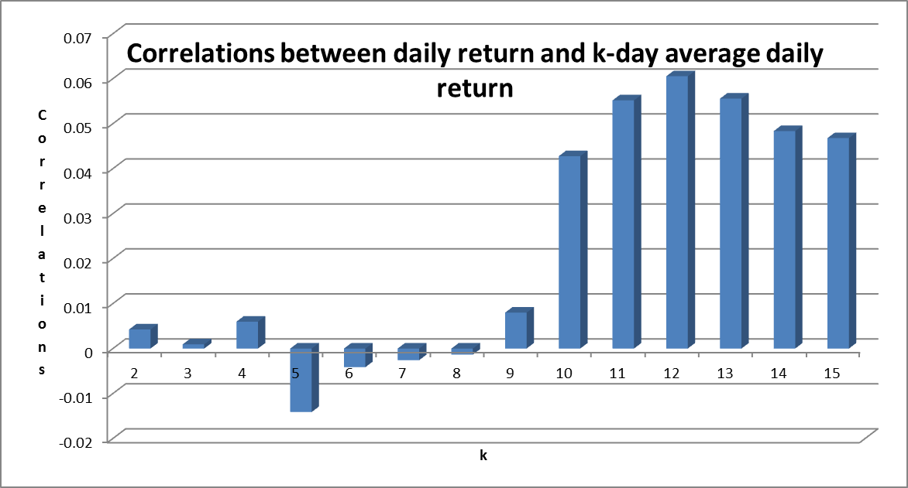

Based on this chart, we can say, that although interestingly the more-than-10-day averages are noticeably higher than short term averages, however, even the highest correlation (r=0.06 at k=12) is still negligible.

1. *“Dig deeper” to the formula of autocorrelation*

After that we checked the exact formula of autocorrelation calculation. It can be found in *Box, Jenkins and Reinsel: Time Series Analysis: Forecasting and Control (3rd edition. Upper Saddle River, NJ: Prentice-Hall, 1994.) p. 30-34.* The simplified form is the following[2]:

, (1)

where *N* is the size of the sample, $\overline{Y}$ is the average of the sample.   
As we can see, only the numerator is the function of the size of lag (*k*) in this formula, so we focused on this.  
Both in case VIX and VXX I calculated this $(Y_{t}-\overline{Y})(Y_{t-10}-\overline{Y})$ product over the entire samples in order to detect, which dates increase mostly the sum in numerator of the fraction in formula (1) ( $Y_{t}$ is the daily return (%change) at day *t*).   
The next table contains these dates, the daily returns of these days and the products of these rates (here I assumed, that the expected value of the daily return ($\overline{Y}$) is zero) (Table 1).

Table 1: The dates with the highest weight in 10-day autocorrelation

|  |  |  |  |  |  |  |  |  |  |
| --- | --- | --- | --- | --- | --- | --- | --- | --- | --- |
|  | ***VIX*** | | | | | | | |  |
|  | *T* | *T-10* | *Wday T* | *Wday T-10* | *Daily ret. at T* | *Daily ret. at T-10* | *Product* | *Rank* |  |
|  | 13/03/2007 | 27/02/2007 | Tue | Tue | 29.6% | 64.2% | 0.188 | 1 |  |
|  | 06/08/1990 | 23/07/1990 | Mon | Mon | 24.9% | 51.5% | 0.127 | 2 |  |
|  | 18/08/2011 | 04/08/2011 | Thu | Thu | 35.1% | 35.4% | 0.123 | 3 |  |
|  | 20/05/2010 | 06/05/2010 | Thu | Thu | 29.6% | 31.7% | 0.093 | 4 |  |
|  | 29/09/2008 | 15/09/2008 | Mon | Mon | 34.5% | 23.5% | 0.080 | 5 |  |
|  |  |  |  |  |  |  |  |  |  |
|  | ***VXX*** | | | | | | | |  |
|  | *T* | *T-10* | *Wday T* | *Wday T-10* | *Daily ret. at T* | *Daily ret. at T-10* | *Product* | *Rank* |  |
|  | 18/08/2011 | 04/08/2011 | Thu | Thu | 20.7% | 20.0% | 0.042 | 1 |  |
|  | 13/03/2007 | 27/02/2007 | Tue | Tue | 9.5% | 24.5% | 0.024 | 2 |  |
|  | 20/05/2010 | 06/05/2010 | Thu | Thu | 14.1% | 11.9% | 0.017 | 3 |  |
|  |  |  |  |  |  |  |  |  |  |

We wanted to know whether there are relationships between these high returning days, therefor George looked after the history of these days (please, see Appendix 1).[3] We think, that except date pair 18/08/2011 and 04/08/2011 (on both Thursdays there was an unemployment report) there isn’t any rational or fundamental relationships between these date pairs. (In other words, it is just a coincidence (randomness) that there are 10 trading days between these ‘big events’ occurred on those dates.) Thus, these dates (except date pair 18/08/2011 and 04/08/2011 ) are eliminable from our time series as they carry no fundamental information on the relationship. It is only noise that can be misleading and should be removed. The following table shows, how the eliminations changed the value of Lag10.[4]

Table 2: Changing of Lag10 autocorrelation after date eliminations

|  |  |  |  |  |
| --- | --- | --- | --- | --- |
| **Index** | **Time period** | **Lag 10 before** | **Eliminated days** | **Lag 10 after** |
| *VIX* | 02/01/1990 - 04/04/2013 | 0.07 | 06/08/1990 | 0.047 |
| 13/03/2007 |
| 29/09/2008 |
| 20/05/2010 |
| *VXX* | 26/03/2004 - 04/04/2013 | 0.111 | 13/03/2007 | 0.101 |
| 20/05/2010 |
| *VIX* | 02/02/2009 - 31/12/2012 | 0.112 | 20/05/2010 | 0.073 |
| 18/08/2011 |
| *VIX* | 02/02/2009 - 31/12/2012 | 0.112 | Days with highest and lowest products (20-20) | 0.063 |
|
|

From this table we can conclude, that if we eliminate only a couple of data (2-3) from our time series, the value of autocorrelation can significantly change. This shows how sensitive the autocorrelation calculation to only 1 or 2 outliers. **Because of that sensitivity, we learnt a very important lesson in our research, the autocorrelation is quite useful measure of the mean reversion or trendiness of a time series, but in itself it cannot be trusted, because it can be quite sensitive to only a couple of outliers.**    
So I think, there isn’t a significant relationship between the daily return at *T* and at *T-10* on average. But it could be regimes, when this effect is amplified. To verify my guess, I tried to partitioning the VIX data series into regimes (Table 3).

Table 3: Regimes in VIX

|  |  |  |  |  |  |  |
| --- | --- | --- | --- | --- | --- | --- |
| **From** | **23/02/2009** | **17/04/2010** | **11/06/2010** | **26/07/2011** | **24/11/2011** | **23/02/2009** |
| **To** | **16/04/2010** | **10/06/2010** | **25/07/2011** | **23/11/2011** | **05/04/2013** | **05/04/2013** |
| **Lag1** | -0.012 | -0.118 | 0.028 | -0.225 | -0.143 | -0.093 |
| **Lag2** | -0.083 | -0.092 | -0.128 | 0.187 | -0.030 | -0.009 |
| **Lag3** | -0.131 | -0.079 | -0.083 | -0.284 | -0.024 | -0.113 |
| **Lag4** | 0.004 | -0.096 | -0.085 | 0.078 | 0.000 | -0.003 |
| **Lag5** | 0.047 | -0.004 | 0.043 | -0.180 | -0.079 | -0.038 |
| **Lag6** | -0.075 | -0.187 | -0.049 | 0.158 | -0.025 | -0.012 |
| **Lag7** | -0.087 | 0.205 | -0.053 | -0.123 | -0.026 | -0.026 |
| **Lag8** | -0.109 | 0.116 | -0.035 | 0.223 | -0.035 | 0.040 |
| **Lag9** | 0.024 | -0.092 | -0.059 | -0.127 | -0.002 | -0.043 |
| **Lag10** | ***0.051*** | ***0.181*** | ***-0.012*** | ***0.165*** | ***0.067*** | ***0.091*** |
| **Lag11** | 0.020 | -0.074 | 0.076 | 0.035 | -0.028 | 0.017 |
| **Lag12** | -0.062 | 0.044 | -0.040 | -0.108 | 0.009 | -0.027 |
| **Lag13** | -0.014 | -0.086 | -0.051 | 0.019 | -0.115 | -0.043 |
| **Lag14** | -0.025 | -0.003 | -0.054 | -0.137 | -0.047 | -0.050 |
| **Lag15** | -0.016 | -0.078 | 0.056 | 0.025 | 0.085 | 0.038 |

In this table, I highlighted with red background if the magnitude of the autocorrelations is higher than 0.15 and with yellow if it is higher than 0.09. In the first two row there are the boundaries of regimes (I don’t state, that these are the best boundaries, but for purpose of investigation was appropriate.). Note that the second period is the 3 months of the 2010 Flash Crash, and the fourth period is the period when USA lost its AAA rating in 2011 summer. There are bearish periods regarding the S&P.The last column contains the autocorrelations over the entire sample period. We can see that there were two regimes with high autocorrelations (both negative and positive) and three with low, where don’t show the “magical” 10-day-effect. So safe to say, that generally there isn’t a high Lag10 autocorrelation.   
It should be noted, that not only Lag10 has red or yellow backgrounded values, but while other lags have both high positive and high negative autocorrelations (e.g. Lag2 or Lag6) – which cancel out each other’s effects –, Lag10 has only positive values.   
Also note for example the 2010 Flash Crash period: Lag7 has a huge positive correlation of 0.205 (Lag7 cannot be caused by the weekly cycles), but Lag6 has a big negative correlation of -0.187. Lag7 has even bigger correlation than Lag10 (0.181) in this period, but it should be clear to the reader that the Lag7 is only a random effect, and there is no “7 days Volatility Echo”, because Lag6 shows big mean reversion.

Upside and downside correlations

As it was visible above, generally there isn’t a high Lag10 autocorrelation, only in specific periods. We thought it interesting to see how the positive or negative nature of the daily return affects the value of return at a later date. To this end, I divided our VIX and VXX time series data into two parts: if the daily return was positive at a given day (at day T), I put it into the “upside subsample”, if it was negative, into the “downside subsample”. After that I calculated the correlations between the daily return at day T and day T+d (d=1…15). In upside (downside) subsample the daily return at day T is always positive (negative), but at day T+d can be negative (positive). (In other words, I investigated that if the daily return was positive at day T, how this affected to the daily return at day T + d.) Next charts (Chart 6 and 7) show, that the autocorrelations isn’t the same in case of upside and downside subsamples. For example whilst Lag10 is very high both in case of VIX and VXX upside subsamples, downside subsamples have much lower autocorrelations. (On next charts “ALL” means, that we can see the entire sample from 1990 (VIX) and from 2004 (VXX). “2009” means, that we can see the data from year 2009. “UP” and “DOWN” are the markers of upside and downside subsamples.)

Chart 6: Daily return autocorrelations in VIX supsamples

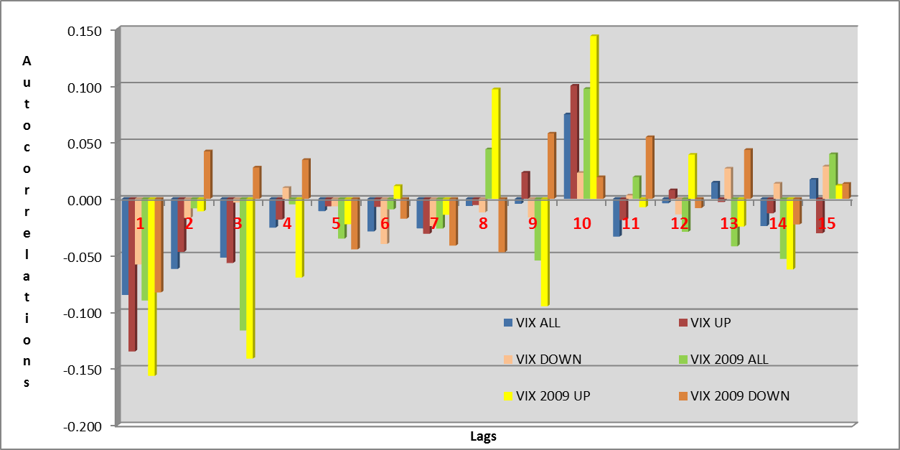

Chart 7: Daily return autocorrelations in VXX supsamples

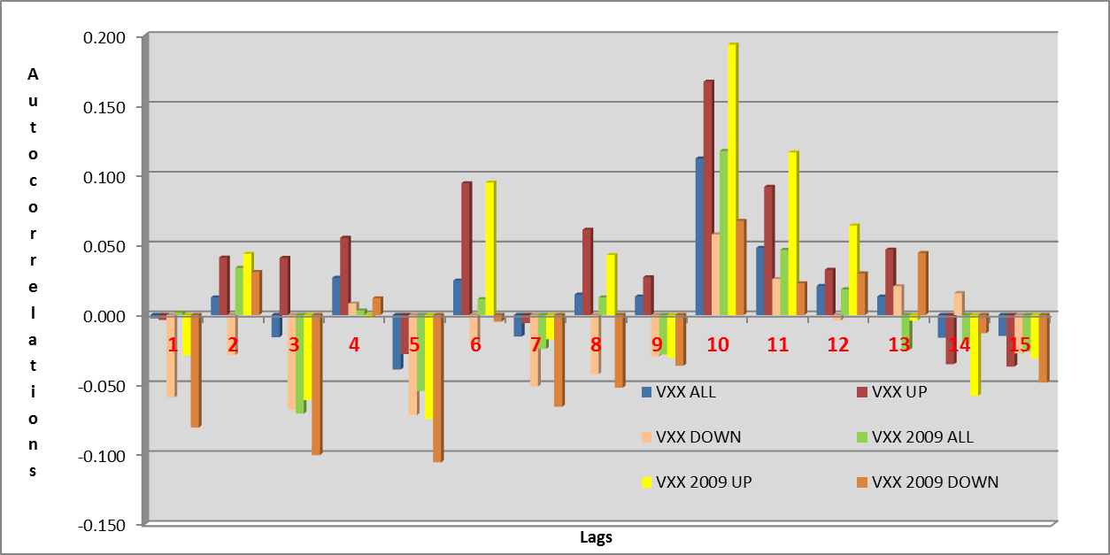

After this I calculated the autocorrelations both in case of the highest and the lowest 10% of data. These can be found on Chart 8 and 9. There are pretty high correlations, especially in upside cases. However, these values ​​should be treated with caution, because the autocorrelation values derive from small samples (with 40-150 data), so they are not necessarily reliable.

Chart 8: Daily return autocorrelations in VIX extreme cases

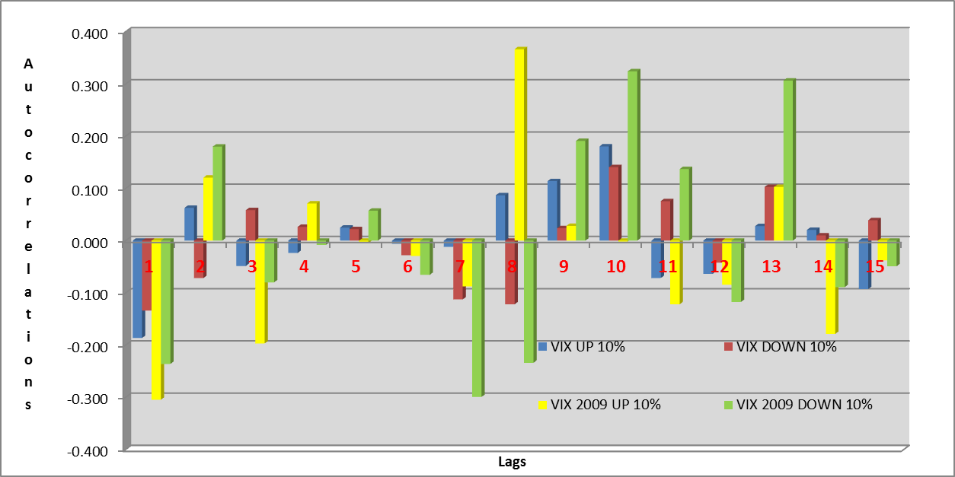

Chart 8: Daily return autocorrelations in VIX extreme cases

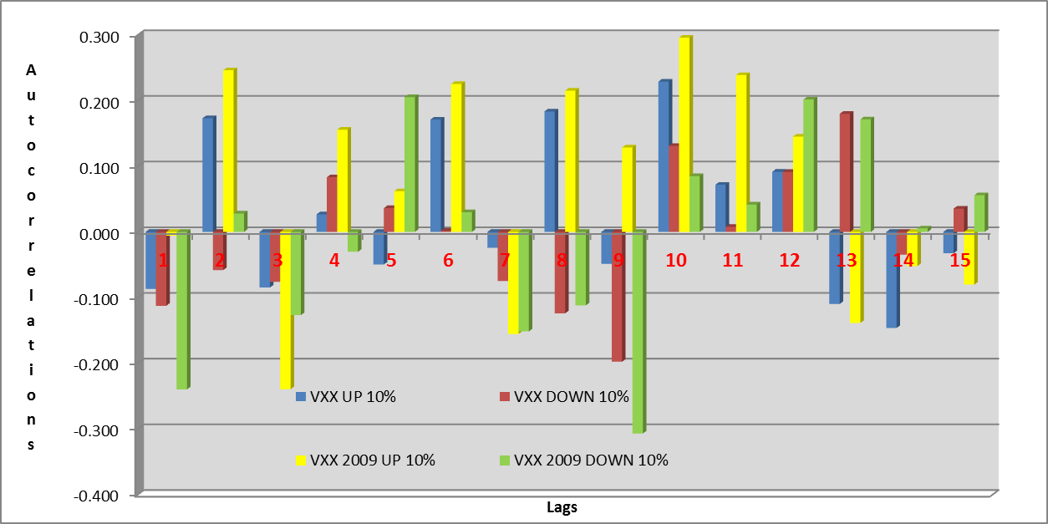

In Appendix 2 can be seen also other charts, where the entire samples from 2009 are divided into subperiods as in the above table (Table 3). However, no significant conclusion can be drawn based on those because the small sample sizes.

Upside and downside averages

We would also like to check, how the average daily percentage changes were in upside and downside samples and subsamples. We thought worthwhile to examine the ratio of these averages (upside average/downside average). For example if this ratio is equal to 2, it means, that the upside correlation should have an amplitude difference of 2 too, compared to a downside correlation (because one part of the multiplier X*Y, the X is 2 times higher in the upside correlation case, than in the downside correlation case). And what is even worse, if we calculate upside correlation, there is a 50% chance that 10 days later (or k days later) VXX %change will be up too. If both X and Y are up, the X*Y=2x2=4 times bigger in amplitude compared to the downside correlation case, that contains 50% of the time X*Y multipliers in the sum that are low values. (50% of the case both X and Y will be downside values, that has low average.) This partially explains that the upside correlation has higher magnitude / amplitude, and because of these high values, the randomness in the upside correlation can have too much randomization effect of the aggregate/total correlation.

The following table (Table 4) contains the upside average/downside average ratios according to the above cases (for individual averages, see Appendix 3). It can be seen that, although the rate is nowhere more than 1.72, upside averages are more than downside averages almost everywhere. If we investigate, which periods have a high ratio level, we can conclude, that these are the bearish periods (VXX 2009 2 and 4). It seems logical, because in bullish periods (VXX 2009 1, 3 and 5) there are almost as many upside as downside daily movement with nearly the same amplitudes, while in bearish periods there are asymmetry in amplitudes.

Table 4: Upside average/downside avereage ratios

|  |  |  |  |  |  |
| --- | --- | --- | --- | --- | --- |
| **Up/Down Ratio** | | **Up/Down Ratio** | | **Up/Down Ratio** | |
| VIX | 120% | VXX | 116% | VIX 10% | 147% |
| VIX 2009 | 129% | VXX 2009 | 115% | VIX 2009 10% | 172% |
| VIX 2009 1 | 144% | VXX 2009 1 | 100% | VXX 10% | 141% |
| VIX 2009 2 | 124% | VXX 2009 2 | 149% | VXX 2009 10% | 143% |
| VIX 2009 3 | 122% | VXX 2009 3 | 106% |  |  |
| VIX 2009 4 | 157% | VXX 2009 4 | 147% |  |  |
| VIX 2009 5 | 104% | VXX 2009 5 | 99% |  |  |

Devil’s advocate: arguing for the volatility echo

In this section we try to reason what if the volatility echo is real. What possible fundamental reason could cause this?

-Thursdays jobless claims report as economic data:

Remember that we wrote this in a previous chapter: “Maybe Thursday has a small 10-day-effect, because its removal reduced the autocorrelation magnitude slightly (perhaps effect of employment reports).”. There is a weekly initial jobless claims report on Thursdays, and it is possible that the initial jobless claims are a trending time series (that would be logical: a fundamental economic indicator: when the unemployment starts to be better, this has inertia for next weeks and months.). The fly in the ointment with this reasoning is that there is no positive autocorrelation in the Lag 5 case.

-Thursdays ECB rate decision every second week:

We don’t think it has a significant effect, but the fact that ECB meeting happens on every fortnight would explain why there is no high autocorrelation in Lag 5.

-Monthly seasonality.

Take a look at the VIX monthly seasonality from [here](http://seekingalpha.com/article/596951-the-monthly-volatility-wave-can-help-you-trade-vxx-and-uvxy-options):

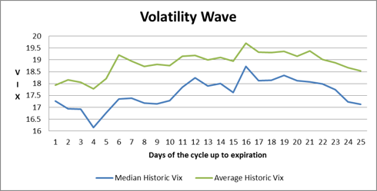

Note that options expire on the 3rd Friday of the month. That is about the Day 17, Day18 where we see a little dip in the VIX. There is a tiny spike on day 6 and day 16.

Or the SPY monthly (May only) seasonality from [here](http://marketsci.wordpress.com/2013/04/30/day-of-month-seasonality-for-may/)

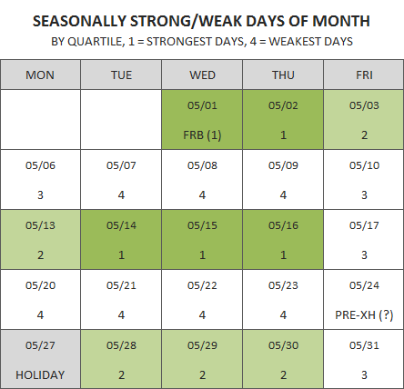

This may suggest some kind of 9,10,11 day positive autocorrelation, because:

* Bullish day 1-3 is followed by bullish day 14-16 (the VXX should decrease in both periods, that leads positive Lag9,10,11 autocorrelation)
* Bearish day 6-10 is followed by bearish day 20-24 (VXX should increase in these periods, that leads positive Lag9,10,11 autocorrelation)
* Bullish day 1-3 is followed by bearish day 6-10 (that leads to negative Lag 3.. 6 VXX autocorrelation)
* bearish day 6-10 is followed by bullish day 13-16 (that leads to negative Lag 3.. 6 VXX autocorrelation)
* and so on.

That could be a pretty good fundamental explanation for the Lag9,10,11 effect, and at first we thought we have found the real reason. Based on that assumption, the explanation why we see the mysterious volatility echo in Lag9, Lag10, Lag11 autocorrelation, because it is solely caused by the day of the month seasonality effect. If that is true, we shouldn’t use the term volatility echo, but we should call it monthly seasonality.

We measured the VXX monthly seasonality from 2004, and it looks like this:

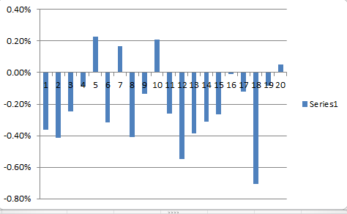

-Notice that VXX is short-biased. It loses its value over time because of the general contango. Therefore almost all days has negative average %change that is understandable.   
-There is a lot of randomness in it: Day 4, 5, 6, 7 can cancel each other out as total random. This is the most VXX bullish period (SPX bearish).  
-considering the SPX bullish periods: the start of the month, and middle month is bullish, this can be seen here as VXX has negative %changes during this days.  
- the eastern egg is Day18. It is either randomness effect, or it is the option expiration Friday effect.

All seemed to be a good explanation, but we still have our doubts. A good proof of this concept would have been if we play the Lag9, 10, 11 strategy (fix follow through) with daily VXX trades and calculate the average CAGR of those 3 strategies.  
As a competing strategy, if we play the monthly seasonality on the VXX and measure the CAGR, too. If the monthly seasonality is more profitable, then that is the source of the alpha, so that is the reason of the ‘volatility echo’ effect. We could achieve this goal, but we had to do serious parameter optimization on the monthly seasonality strategy (just look at the previous VXX monthly seasonality chart to see that: using Day18 in the short VXX or in the long VXX group made a huge difference.) More about it in our next research document: VIX monthly seasonality.

Conclusion

According to this study, **we think**, that **10 days volatility echo** that everybody is talking about is **only an illusion**, not justified statistically, so we wouldn’t play it in real life (imagine a strategy that bets next day VXX direction based on what happened 10 days ago). We consider that maybe the following effects can lead to this high Lag10 autocorrelation:

* mainly caused by randomness (Lag10 was lucky, Lag9, Lag8 wasn’t);
* mainly comes from the behaviour of the calculation of the autocorrelation equation (that it magnifies randomness effect in specific cases);
* mainly comes from the Upside autocorrelation;
* mainly comes from bearish periods only (but not in general);
* mainly comes from extreme values (outliers, top10%) (The previous 3 reasons are interrelated!);

We cannot exclude totally the possibility that there is a slight weekly effect (weekly jobless claims on Thursdays, ECB has a meeting every 2 weeks), but we think this effect is too weak and that is not the reason of the spike we see in the Lag10 autocorrelation calculation.

A clearly more serious fundamental reason could be the **monthly seasonality that has a chance to explain the volatility echo**. **But if it can be proved, we suggest using the expression ‘monthly volatility seasonality’, instead of the obscure term ‘volatility echo’**. We plan to investigate the monthly seasonality effect further.

Future work

In the next research paper, I will make trading back-tests with helps of autocorrelations. I would like to test the predicting abilities of these lags (Lag 1, Lag 2, Lag 3 and Lag 10) separately and maybe in one common model. Based on this paper, I expect that 10-day autocorrelation isn’t useable for trading, but Lag 1 is. The main goal would be the improvement of the current used trading strategy.

Appendix 1

Historical dates:

We tried to find out what were the historical events on those dates that caused the 5 biggest contribution to the Lag10 autocorrelation calculation. What we wanted to determine is that the big %change of VIX on the date and 10 days earlier have a meaningful ‘connection’ or not. Are these 2 evens related fundamentally, or it is just randomness? For example, a stock market drop that is caused by the a USA debt downgrade that is followed 10 days later by a Japanese tsunami are not related events. If this kind of events cause the ‘famous’ 10 days volatility echo, that everybody is talking about then we are in trouble, because it is only a randomness that this event pair is in the Lag10 bucket, not in the Lag9, or Lag11 bucket. So, let’s investigate the events, the news on the 5 biggest contributing date-pairs.  
(collected by George)

*13/03/2007 and 27/02/2007*

27/02/2007:

<http://en.wikipedia.org/wiki/Chinese_stock_bubble_of_2007>

13/03/2007:

<http://www.stockmarketwire.com/article/1835125/FTSE-closes-markedly-weaker.html>

"'The market is being hit by talk that a UK hedge fund is about to go bust,' one London-based trader said. 'We've nothing concrete and don't know if it's commodities related or not.'"

*06/08/1990 and 23/07/1990*

23/07/1990:

J.A. Grundfest, "The Damning Facts of a New Stocks Tax," The Wall Street Journal, 23 July 1990.

06/08/1990:

August 6, 1990 Gulf War: The United Nations Security Council orders a global trade embargo against Iraq in response to Iraq's invasion of Kuwait.  
August 6, 1990 President George Bush orders Operation Desert Shield  
August 6, 1990 UN Security Council votes 13-0 (2 abstentions Cuba & Yemen) to place economic sanctions against Iraq

http://www0.gsb.columbia.edu/faculty/fmishkin/PDFpapers/W8992.pdf

1990  
 In August 1990, a major stock market decline began with the Dow Jones falling 10 percent and the S&P500 declining 8.1 percent. By October 1990, the market had fallen 15.9 percent and 14.7 percent by these measures. The decline in the market closely followed the movement of the economy into a recession, the peak of the expansion having been reached in July 1990. Yet, although the 1990-91 recession was a relatively mild one and the stock market decline was moderate, the interest-rate spread did rise substantially, as seen in Figure 12. A likely source of this widening of the spread was the very weak initial condition of depository institutions. The savings and loans already required a bailout from the government on the order of $150 billion, while loan losses were increasing and commercial bank failures had risen to over 200 per year by the late 1980s. (White, 1992)

*18/08/2011 and 04/08/2011*

04/08/2011:

<http://money.cnn.com/2011/08/04/markets/markets_newyork/index.htm>

"U.S. markets were already sharply lower on widespread worries, including the weak job market. But the selling gained momentum as Japanese and European policymakers stepped in with dramatic measures to shore up their financial markets."

"Fears about a global slowdown are at the forefront of investors' minds amid recent weak economic data. Early Thursday, the latest reading on jobless claims showed a large number of Americans remain unemployed.  
Adding further to investors' jitters, Wall Street is waiting for Friday's jobs report, which BlackRock's Doll said was adding to the selling pressure.  
The ECB wasted no time and immediately started buying European bonds while Trichet's press conference was still going on. But bond traders were quickly disappointed, after they discovered the central bank only bought Portuguese and Irish debt -- not the Spanish and Italian bonds at the center of the crisis.  
There were 400,000 initial unemployment claims filed in the week ended July 30, the Labor Department said Thursday, down 1,000 from an upwardly revised 401,000 the prior week. Economists surveyed by Briefing.com were expecting jobless claims to rise to 405,000."

<http://www.guardian.co.uk/business/2011/aug/04/stock-markets-exchange-plunge-business>

"6.41pm: In Europe, there were two triggers for today's global selloff (or the "classic capitulation", as Knight Capital MD Peter Kenny has dubbed it), a stark warning from José Manuel Barroso, the European Commission president, and the monthly press conference from Jean-Claude Trichet, head of the ECB."

<http://en.wikipedia.org/wiki/August_2011_stock_markets_fall>

Standard & Poor's downgraded America's credit rating from AAA to AA+ on 6 August 2011 for the first time.

18/08/2011:

<http://money.cnn.com/2011/08/18/markets/markets_newyork/index.htm>

Stocks were hit with bad news on multiple fronts. Morgan Stanley put out a dismal forecast for global economic growth. A key reading on U.S. housing came in worse than expected. And a report showed a significant slowdown in the domestic manufacturing sector.

"Morgan Stanley's dire commentary was combined with four disappointing U.S. economic reports out Thursday, with investors putting a great deal of weight on the Philadelphia Federal Reserve's regional manufacturing index."

Maybe the report comes every second Thursday.

"This index is published by the Philadelphia Federal Reserve Bank on the third Thursday of the month at 10 am EST. It is considered to be a good gauge of general business conditions. "

It is monthly.

"The VIX (VIX) -- Wall Street's so-called "fear gauge" -- jumped 35% on Thursday to a reading of 42.7. Anything above 30 is considered high fear in the market.  
In other economic data, the Labor Department reported that weekly jobless claims rose by a worse-than-expected 9,000 claims to 408,000 in the week ended Aug. 13.  
The National Association of Realtors said existing home sales dropped by 3.5% in July, far worse than the 2% rise that the market was looking for.  
To further complicate things, the government also reported that Americans paid more for consumer goods and services in July, as inflation rose more than expected over the month.  
The consumer price index, increased 0.5% in the month -- led by a 4.7% jump in gas prices from month to month. Economists expected a 0.2% rise in July, according to a survey from Briefing.com.”

*20/05/2010 and 06/05/2010*

06/05/2010:

Flash crash:

<http://money.stackexchange.com/questions/1587/may-6-2010-stock-market-decline-plunge-why-did-it-drop-9-in-a-few-minutes>

"Economy: The number of Americans filing new claims for unemployment fell to 444,000 last week from a revised 451,000 the previous week. Economists surveyed by Briefing.com thought claims would fall to 440,000.  
Continuing claims, a measure of Americans who have been receiving benefits for a week or more, dropped to 4,594,000 from a revised 4,653,000 in the previous week. Economists expected 4,600,000 continuing claims.  
The report was released one day ahead of the government's closely watched April jobs report, due Friday morning. That report is expected to show employers added 187,000 jobs to their payrolls after adding 162,000 in March, according to economists surveyed by Briefing.com."

Good job report.

20/05/2010:

<http://www.salon.com/2010/05/20/stock_market_gloom_and_doom/>

An unexpectedly large jump in jobless claims, a decline in the Conference Board’s Leading Economic Indicator index for the first time in a year, stock markets crashing all over Europe.  
The jobless claims number — a 25,000 jump after weeks of modest declines — is clearly catalyzing another round of bearish sentiment.  
Economy: Reports on jobless claims and leading economic indicators (LEI) disappointed, while the Philadelphia Fed index, a regional reading on manufacturing, topped forecasts.  
The number of Americans filing new claims for unemployment rose last week to 471,000 from 446,000 the prior week. Economists surveyed by Briefing.com expected claims to fall to 439,000.  
Continuing claims, the number of Americans who have been receiving benefits for a week or more, fell to 4,625,000 from 4,665,000 in the previous week. Economists thought claims would fall to 4,600,000.  
After the start of trading, the Conference Board released its index of leading economic indicators. LEI fell 0.1% in April after rising 1.3% in March. The index was expected to have risen 0.2%.  
The Philadelphia Fed index rose to 21.4 in May from 20.2 in April, topping predictions for a rise to 20.7.

*29/09/2008 and 15/09/2008*

This is the spillover of Lehman. So, there is a connection, but this could be in the Lag9, or lag11 bucket, so it is just random luck that it is in the Lag10 bucket.

15/09/2008:

<http://money.cnn.com/2008/09/15/markets/markets_newyork2/>

Lehman is bankrupt

29/09/2008:

<http://money.cnn.com/2008/09/29/markets/markets_newyork/>

"Morgan Stanley shares fall nearly 8 percent, following news that Japan's biggest bank, Mitsubishi UFJ Financial Group, will take a 21-percent stake in the Wall Street firm.  
The Crisis: 1 Year Later - A CNBC Special Report - See Complete Coverage  
As the trading day nears an end, the House rejects the financial rescue bill. Investors are stunned and dump stocks frantically until the Dow ends 777 points lower, at 10365.45, its biggest one-day point drop ever. The S&P 500 also logs its biggest one-day point drop, falling 106.59, or 8.8 percent, to 1106.42. The Nasdaq has its biggest one-day point decline since 2000, falling 199.61, or 9.1 percent, to 1983.73.  
Wall Street's key barometer of investor fear, the VIX (CBOE Volatility Index), jumps 34.48 percent to 46.72, its highest level ever. The VIX hasn't been above 40 in more than 10 years."

Appendix 2

*Other charts:*

On these charts, the entire samples from 2009 are divided into subperiods as in the above table (Table 3). However, no significant conclusion can be drawn based on those because the small sample sizes.

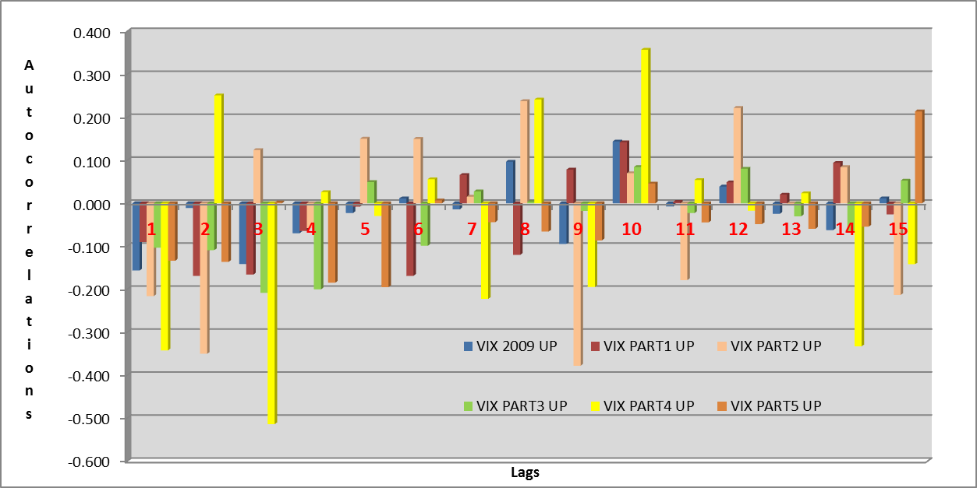

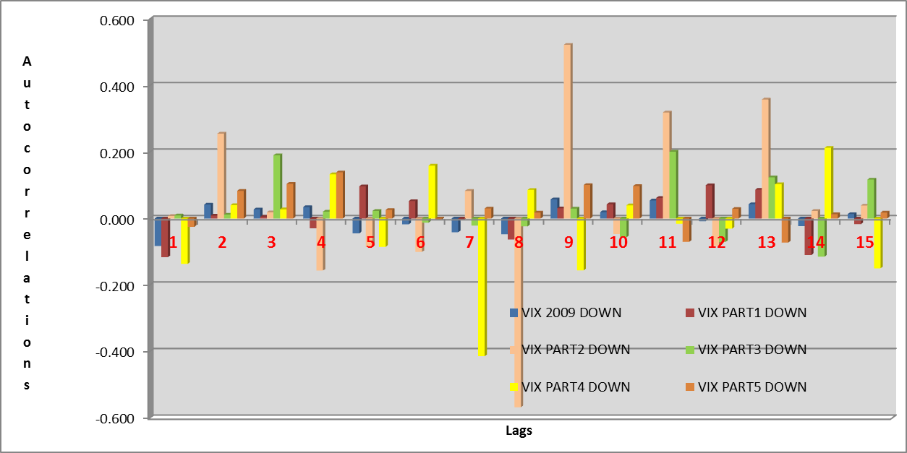

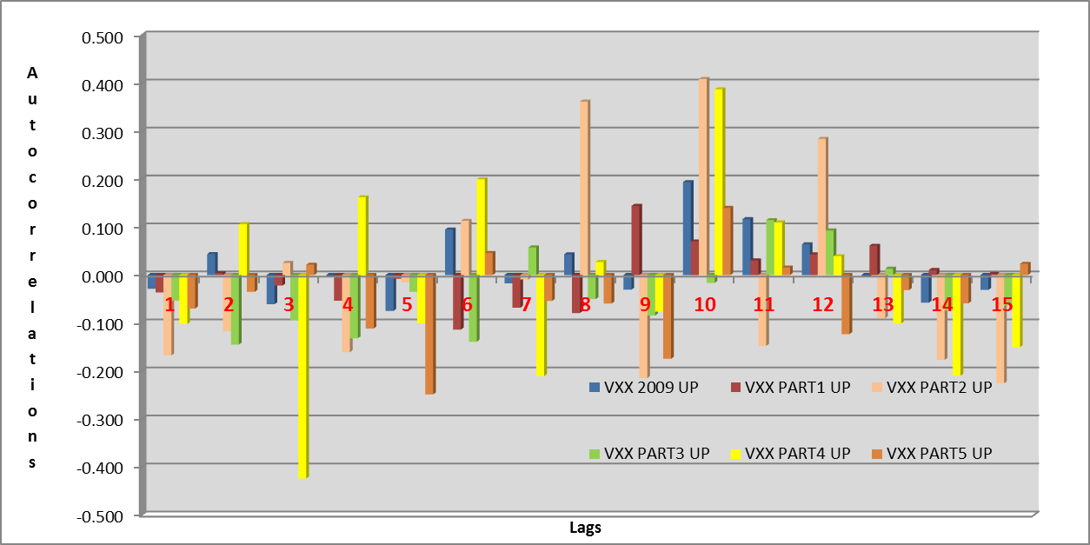

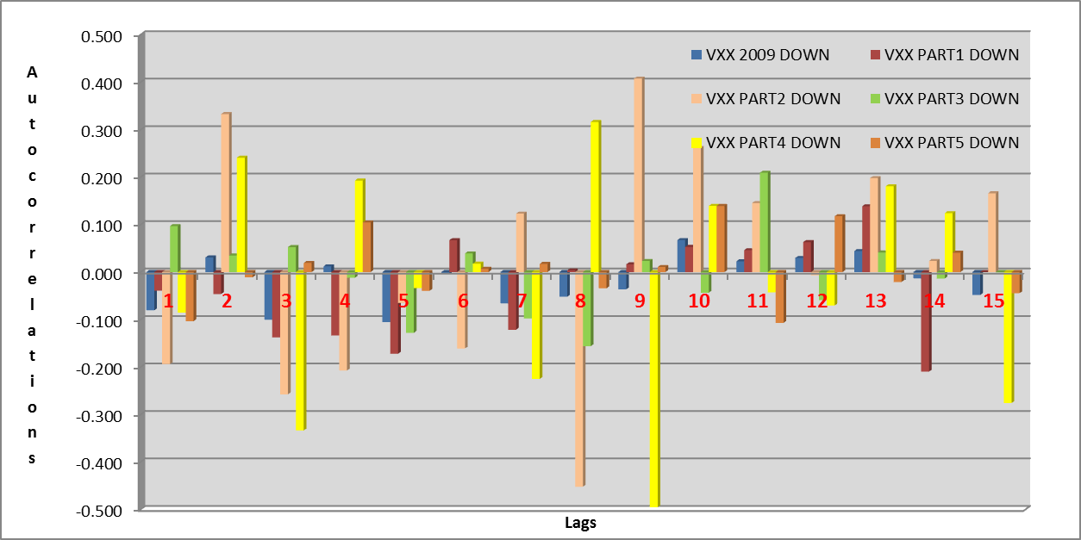

Appendix 3

|  |  |  |
| --- | --- | --- |
|  | **Average** | **N** |
| VIX All | 0.0018 | 6069 |
| VIX Up | 0.0492 | 2761 |
| VIX Down | -0.0410 | 3050 |
| VIX 2009 All | 0.0010 | 1075 |
| VIX 2009 Up | 0.0576 | 454 |
| VIX 2009 Down | -0.0446 | 564 |
| VIX 2009 Up 1 | 0.0493 | 112 |
| VIX 2009 Up 2 | 0.1185 | 21 |
| VIX 2009 Up 3 | 0.0517 | 128 |
| VIX 2009 Up 4 | 0.1031 | 40 |
| VIX 2009 Up 5 | 0.0484 | 153 |
| VIX 2009 Down 1 | -0.0342 | 178 |
| VIX 2009 Down 2 | -0.0955 | 17 |
| VIX 2009 Down 3 | -0.0425 | 154 |
| VIX 2009 Down 4 | -0.0655 | 46 |
| VIX 2009 Down 5 | -0.0465 | 169 |
| VXX All | -0.0019 | 2355 |
| VXX Up | 0.0277 | 955 |
| VXX Down | -0.0239 | 1289 |
| VXX 2009 All | -0.0036 | 1075 |
| VXX 2009 Up | 0.0324 | 412 |
| VXX 2009 Down | -0.0282 | 603 |
| VXX 2009 Up 1 | 0.0237 | 111 |
| VXX 2009 Up 2 | 0.0591 | 20 |
| VXX 2009 Up 3 | 0.0268 | 106 |
| VXX 2009 Up 4 | 0.0576 | 45 |
| VXX 2009 Up 5 | 0.0316 | 130 |
| VXX 2009 Down 1 | -0.0237 | 179 |
| VXX 2009 Down 2 | -0.0397 | 18 |
| VXX 2009 Down 3 | -0.0253 | 174 |
| VXX 2009 Down 4 | -0.0391 | 41 |
| VXX 2009 Down 5 | -0.0318 | 191 |
| VIX Up 10% | 0.1689 | 276 |
| VIX Down 10% | -0.1147 | 305 |
| VIX 2009 Up 10% | 0.2077 | 46 |
| VIX 2009 Down 10% | -0.1209 | 56 |
| VXX Up 10% | 0.0962 | 98 |
| VXX Down 10% | -0.0684 | 135 |
| VXX 2009 Up 10% | 0.1060 | 41 |
| VXX Down 10% | -0.0743 | 64 |

1. The absolute value of a correlation is a measure of the strength of the association, with larger absolute values indicating stronger relationships (Usually, absolute values below 0.2 are very weak to negligible correlation, between 0.2 and 0.4 weak, low correlation (not very significant), between 0.4 and 0.7 moderate correlation, between 0.7 and 0.9 strong, high correlation, between 0.9 and 1 very strong correlation. However, during a test values less than 0.2 can we regard as significant).
2. Matlab and Excel use the same formula.
3. In addition, it has been found, that in case of VXX, six from the ten highest product was on Thursday (maybe caused by above mentioned employement report effect).
4. For accurate measurement of the impact I filled out the data series in such a way, that when the market was closed on weekdays, I wrote zero return to those days. So I assured, that the boundaries of a 10-day interval are the same day of the week.