Dr. George Antal

3D Click Limited

c/o Suite 431, 28 Old Brompton Road, London SW7 3SS

**The ‘Charmat Rebalancing’ Method**

**Motivation** **1**

**Used data** **1**

**Our Current Results** **2**

The simple case 2

Stepping towards more complex cases 4

Result of simulations 6

Real world adult-stock example 9

Percentile channels with GameChangers 12

Percentile channels with Nasdaq100 20

Extension of the above “percentile channels with Nasdaq100” results 22

Percentile channel strategy with different entry and exit signs 30

Percentile channels with random stocks 32

Different parameters for percentile channels strategy with random stocks 33

Percentile channels strategy with our suggested addiction-portfolio 34

**Conclusion** **35**

**Appendix** **36**

# 

# Motivation

In several backtests we faced the following conclusion: we had a higher PV for a given portfolio if we had chosen a more frequent rebalance period. One may think that these results are against our expectations. Let’s consider the following example: we have 10 stocks, one of them is a dying one: loses 15% from its value in each period. The prices of the other nine remain flat. If we never rebalance this portfolio then we will lose only 10%. If we do a rebalance in every period (which is a mean reversion style strategy), then in the long term, we will lose all of our money. So in this simple example more frequent rebalance leads to a worse result. Can we say something in general?

# Used data

For creating random groups based on real life data I used daily adjusted closing prices for more than 2700 stocks that were all in-force between 2002-12-31 and 2018-12-31.

# 

# Our Current Results

## The simple case

First things first: we have good news and bad news.

Good news is that **our backtests** seem to be **correct**. In THOSE cases daily rebalance indeed leads to a better result.

Bad news is that **there isn’t any** exact **general rule**. Let’s see in details.

At first step consider the following simple (more precisely: the most simple) example: we have two stocks (A and B) and two periods. Let denote the earned yields by a1, a2, b1, b2 respectively.

If we invest $1 in the beginning then we have two possibilities:

* rebalance (i.e. buy 50%-50% from each stock) only before the first period (Rare case) or
* rebalance before both periods (Frequent case).

|  |  |  |
| --- | --- | --- |
| %changes | Stock A | Stock B |
| period1 | a1 | b1 |
| period2 | a2 | b2 |

What will be our result in each case and which one will be higher?

|  |  |  |  |  |  |  |
| --- | --- | --- | --- | --- | --- | --- |
|  | Frequent case | | | Rare case | | |
|  | Stock A | Stock B | PV | Stock A | Stock B | PV |
| before period1 |  |  | 1 |  |  | 1 |
| after period1 | * (1+) | * (1+) | 1+) | * (1+) | * (1+) | 1+ $(\frac{a{}_{1}+b{}_{1}}{2}$) |
| after rebalance = before period2 | +) | +) | 1+) =  * (2 ++) | * (1+) | * (1+) | 1+) |
| after period2 | * (1+) | * (1+) | * (2 ++) * (2 ++) | * (1+) * (1+ $a_{2}$) | $\frac{1}{2}$* (1+ $b_{1}$) * (1+ $b_{2}$) | $$\frac{(1+a_{1}) * (1+a_{2}) + (1+b_{1}) * (1+b_{2})}{2}$$ |

So we have to compare the red and green values.

If we restructure the expressions then we get that:

Frequent case PV >=< Rare case PV

only if

(a1+b1) * (a2+b2) >=< 2 * (a1 * a2 + b1 * b2)

which is only if

0 >=< (a1 - b1) * (a2 - b2)

**What does it mean in practice?**

For example if stock B is flat (i.e. b1=b2=0) then we get:

Frequent case PV >=< Rare case PV

only if

0 >=< a1 * a2

i.e. if a1 and a2 have different signs then frequent rebalance is a better choice.

In general the above rule means that

if a1 > (or <) b1

then frequent rebalance is a better choice only if

a2 < (or >) b2

**In other words: if both b1 and b2 are above (or below) a1 and a2 respectively then rare rebalance is a better choice - otherwise choose frequent rebalance.**

Stockwise, if Stock B is consistently better then Stock A in both period1 and period2, then rare rebalance is better. Which makes sense intuitively: if Stock B was better, its size is bigger at the halfway point. Because we know that it will make more profit in the second half, we want this Stock B portion to be bigger. Therefore, at halfway point, no rebalancing is the better choice.

This line of thinking works in the case of the example of 10 stocks mentioned in the Motivation section. If stock A is the dying stock, and Stock B is consistently better, then rebalancing is bad. The no rebalancing or rare rebalancing is better. However, if one Stock B is not consistently better (or Stock A is not consistently worse) then others, but if they randomly fluctuate in a mean reversion style, then the opposite is true and more frequent rebalance is the better choice.

## 

## Stepping towards more complex cases

If we inspect more than 2 periods then the picture soon becomes more complex. It is easy to prove then in case of *n* periods we have to compare the “frequent”

$\frac{1}{{2^{n}}^{}}$* (2 + $a_{1}$ + $b_{1}$) * (2 + $a_{2}$ + $b_{2}$) * … * (2 + $a_{n}$ + $b_{n}$)

with the “rare”

$$\frac{[(1+a_{1}) * (1+a_{2}) * ... * (1+a_{n})] + [(1+b_{1}) * (1+b_{2}) * ... * (1+b_{n})] }{2}$$

The problem with these expressions is that we cannot transform them into a “nice” product of different expressions which could give us an exact rule for those cases.

For example for n=3 we would get that

Frequent case PV >=< Rare case PV

only if

0 >=< (2 + a1 + b1) * (a2 - b2) * (a3 - b3) **+** (a1 - b1) * (2 + a2 + b2) * (a3 - b3) **+** (a1 - b1) * (a2 - b2) * (2 + a3 + b3)

This expression has several different solutions, let’s see some examples:

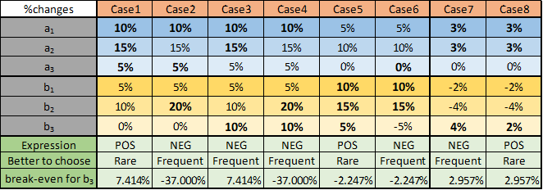

In Case1 and Case2 the only difference is b2: it is 10% in Case1 and 20% in Case2. As we can see the optimal rebalancing frequency differs.

In Case1 and Case3 the only difference is b3: it is 0% in Case1 and 10% in Case2. As we can see the optimal rebalancing frequency differs.

However in Case2 and Case4 the only difference is exactly the same as in the previous paragraph: b3 is 0% in Case2 and 10% in Case4. As we can see the optimal rebalancing frequency is the same in these cases. Actually we can see in the “break-even for b3” row that if we fix a1, a2, a3, b1 and b2 then for any b3 that is greater than -37% the frequent rebalancing will be the winner.

In this example the break-even point is (indeed) exactly -37% and someone may think that it’s the sign of an exact rule in the background - but it’s just by pure chance. In Case7 and Case8 the only difference is b3 again and the break-even point in this case is exactly 70/2367 = 2.957%. We can see that this value isn’t in a clear relationship with 3%, 3%, 0%, -2% and -4%.

Actually from the above examples we can also learn that in some cases we have very extreme break-even points (compare 5%, 10%, 15%, 20% yields in Case2 with the break-even point of -37%) - which means that in practice we more probably face a difference between the results of frequent and rare rebalances if there is an extremely volatile stock in the portfolio (e.g. a penny-stock… we will see it later).

Again, the table confirms that if one stock is consistently better (e.g. momentum stock in a bullish market) in every period (Case 1) then Rare rebalance is the winner.

Don't rebalance the momentum winners, but let them grow. Similarly, don't rebalance the momentum losers, but let them fall.

However, if the performance of the stocks in the periods alternate (Case 2: A is better in period1, B is better in period2, A is better in period3) then Frequent rebalance is

the winner. In a choppy market environment, we should fade the big up spikes of the momentum stocks, and buy them if they are undervalued because of a down spike. Harvest the noise and the volatility.

Another instructive example could be the following one with 10 different stocks and 10 periods:

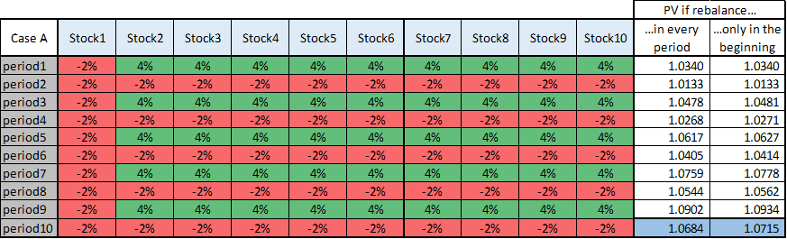

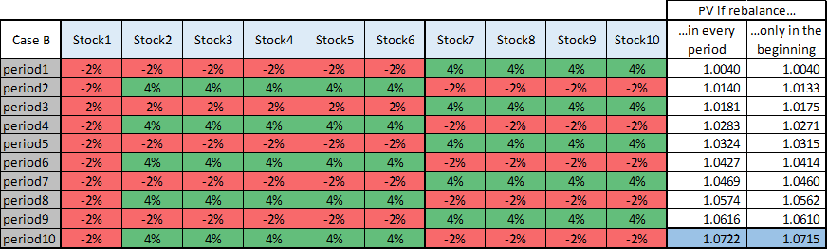

As we can see the only difference between Case A and B that we shifted the yields of Stock2, Stock3, Stock4, Stock5 and Stock6 by one period. The PV of rare rebalance remains the same (1.0715) because of this shift while PV of frequent rebalance has increased. In Case A rare rebalance is the better choice - in Case B the more frequent rebalance.

Again, the table confirms that if the stocks are moving together (Case A: if one stock is up, all the others are up) then Rare rebalance is the winner.

However, if the stocks have independent performances, and half of the stocks are down when the other half is up, then there is a profit to be made by harvesting this idiosyncratic volatility. Look at Case B and period 2. At the end of period1, it is worth rebalancing because we foresee that those stocks which lost value in period1 will be big gainers in period2. And those stocks which spiked up by 4% will fall by -2%, therefore rebalancing their profit and lessen their weight is well worth it.

A choppy, non-trending, sideways market is a perfect flowerbed for these kinds of stocks. In that case, the mean reversion of the rebalancing can bring extra profit. However, it is akin to a volatility harvesting method. A small positive carry which in general gives overperformance. Yes. The more frequent rebalancing brings overperformance in terms of CAGR. But there should be a catch, a hidden risk somewhere. Where is it? It is exactly the risk which is outlined in the motivation chapter. If one stock is going to die by consistently dropping its value to zero, the mean reversion style frequent rebalancing strategy will underperform. The extra risk is compensated by the extra profit. The extra profit is balanced by the extra risk. As expected.

Without any formal mathematical or physical provement consider the following heuristic interpretation of our findings: let’s think about periodical %changes as waves in the water. If the waves are moving “nicely” together then we don’t have to intervene to get higher waves because they have a “constructive interference” - while if they work against each other (or chaotic) then they imply a “destructive interference” and we have to throw a pebble in the water again and again to reach higher waves.

Of course it’s not a clear rule and there is not even a clear definition of “nicely” and “chaotic” but this high level heuristic interpretation may indicate how complex is this problem and how many different outcomes can be achieved sometimes with only a small change.

## Result of simulations

Someone may think that these %changes are not realistic ones and in real life we would get different results. Therefore I made 5000 simulation with 10 stocks and 100 periods. In Case A I rebalanced in every period while in Case B only in every 10th period. All 1000 %changes in each scenario were normal distributed random numbers (with a mean of 0 and standard deviation of 1).

I checked at the end of every 10th period whether frequent (Case A) or rare (Case B) rebalance led to a better result.

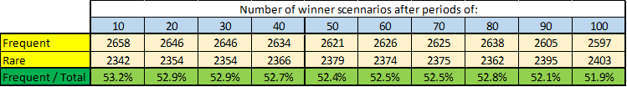

**According to these results it is clear that there is no exact rule in real life** (at least for randomly selected stocks. Someone may say the picture would be different for stocks selected from a given industry or with similar risk-profile. We will soon check real world results regarding adult stocks).

However the results of the above table are somehow interesting because at any period frequent rebalancing could reach 52-53% winratio.

The next table shows that out of the 5000 scenarios there were 954 (19.1%) where frequent rebalance performed better after 10, 20, …, 90 and 100 periods as well. It strengths the theorem that in terms of profit (but not risk) in general choosing frequent rebalance is slightly a better choice.

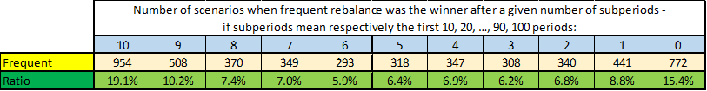

Someone may think that normal distributed random numbers with a mean of 0 and standard deviation of 1 are not realistic because real life values have a positive mean and different standard deviance. Therefore I repeated the same calculations with three more setups.

First with a mean of 0.16% and a standard deviation of 2.12% (these values were derived from AAPL’s performance for the last 16 years). The results were very similar:

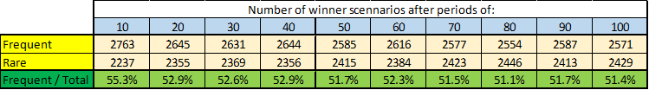

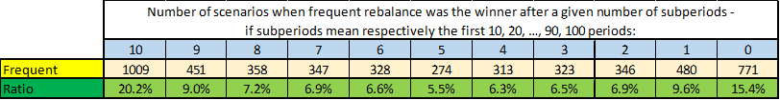

Second with a mean of 0.04% and a standard deviation of 1.14% (these values were derived from SPY’s performance for the last 16 years). The results were very similar again:

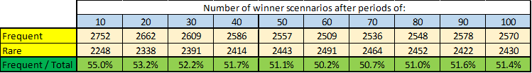

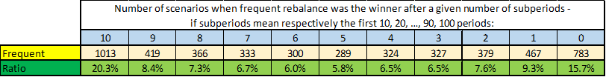

Finally I mixed “normal” GameChanger-style assumptions with dying stock-style assumptions - i.e. I used the above mentioned AAPL-based random numbers in 90% of the periods, but random numbers with a mean of -5% and a standard deviation of 2% in the remaining 10% of the periods. Results were very similar again.

This is good news. Because even if 10% of the stocks are dying-style, (which is our worst-case scenario mentioned in the motivation chapter), it was not enough to significantly diminish the PV of the portfolio. Note that the test had 10 stocks and 100 periods. Assuming weekly rebalance the 100 periods can last for 2 years. So, even if we rebalance every week for 2 years (instead of no rebalancing at all), and 10% of the stocks are dying-style, the frequent rebalancing is still the winner. Profitwise, of course. And “in general”.

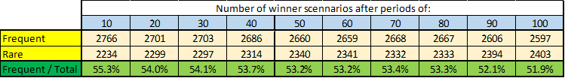

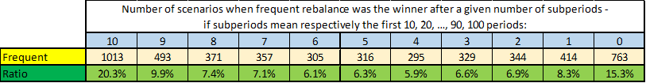

## Real world adult-stock example

Another good question can be: if there is a difference among different rebalance-frequencies what is the extent of it? For answering this let examine in more details the portfolio of 8 adult business-related stocks which was already analysed in the “Vice beats virtue” [study](https://docs.google.com/document/d/1dBHg3-McaHeCtxCTZdJhTKF5NPaixXYjEngZ4F2_ZBE/edit#heading=h.j6y772wpjxnj).

There we saw that daily rebalance led to a CAGR of 20.9% over 20 years - while it was only 8.9% with weekly and 1.4% with monthly rebalance. At first sight it seems to be a huge a difference.

But in the next step we eliminated the final period of two penny-stocks (after that point of time when their price fell below $0.50) and with this “cleaned” dataset the results were 13.9% CAGR with daily, 12.9% with weekly and 11.8% with monthly rebalance. This looks believable because the extra underperformance risk of the daily rebalancing (think dying-style stocks) should be compensated by a mild additional profit.

A problem with these results is that they are related to 20 years (i.e. in other words they were calculated for a 20 year long look-back period). So therefore I calculated PVs for different look-back periods - for daily and monthly rebalances as well. In the next Chart we can see the ratio of them:

Chart 1a. Ratio of adult business related-stock PVs calculated with daily and monthly rebalance

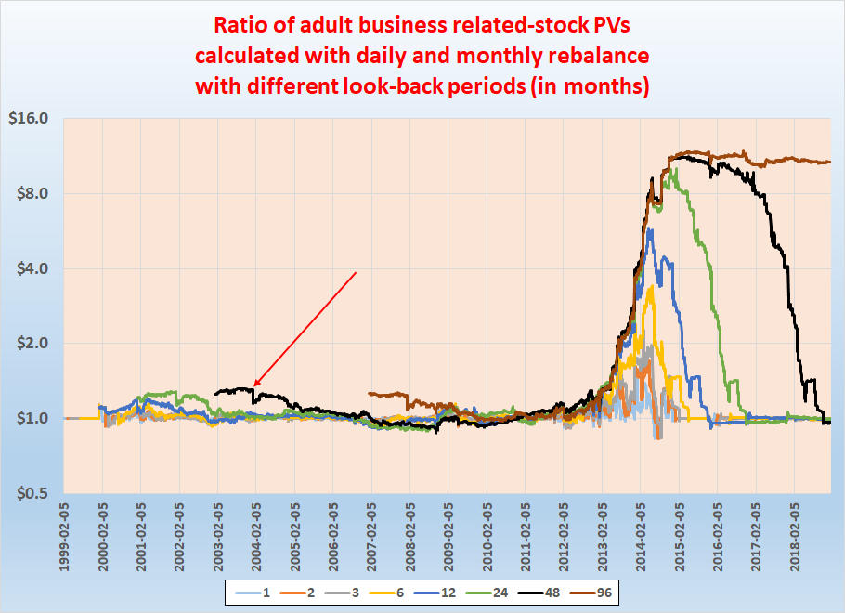

For a better understanding of the chart I highlighted a point with a red arrow on the black curve which has a value of 1.3 at 2003-12-31. It means that at date with a 4 year look-back period, i.e. for the period of [1999-12-31, 2003-12-31] the daily rebalanced PV was 1.3 times higher than the monthly rebalanced PV.

So from this chart we can see that regardless of the length of the look-back period this ratio was mainly in the [0.8, 1.3] array. (Actually a 30% higher performance over 4 years means an advantage of 7.45% in CAGR if the lower performance had 10% CAGR and 8.13% advantage if the lower performance had 20% CAGR)

It is also clear from the chart that some strange daily %changes in the [2012-12-31, 2014-12-31] period must have been the reason of the sharply increasing ratio (which means that in those periods frequent rebelance performed clearly better).

If we eliminate the stock LNET (which ended as penny-stock) then we get a similar chart, so we have to search for the answer somewhere else:

Chart 1b. Ratio of adult business related-stock PVs (without LNET) calculated with daily and monthly rebalance

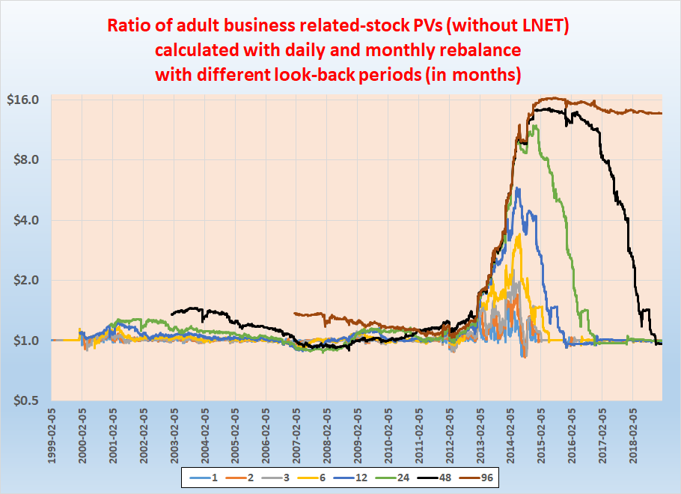

If we eliminate the other stock that ended as a penny-stock (PRVT) then we get a much more normal chart:

Chart 1c. Ratio of adult business related-stock PVs (without PRVT) calculated with daily and monthly rebalance

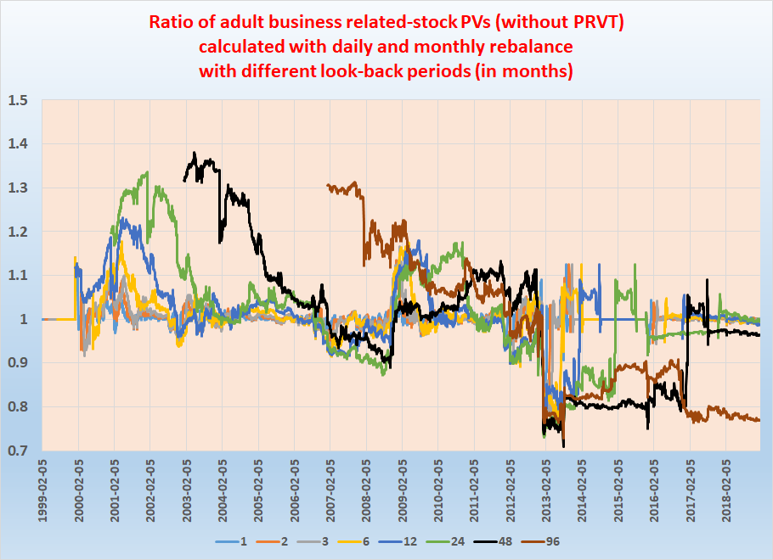

So from this chart it is clear that some strange daily movement of PRVT caused that 20 year length CAGR of daily rebalanced portfolio was much higher than of monthly rebalanced.

Because in the [2012-12-31, 2014-12-31] period PRVT’s average daily price was only $0.1 sometimes it had a daily %change of +185% (increasing up to $0.2 from $0.07).

## 

## Percentile channels with GameChangers

A problem with simple **equal weight rebalancing** is that with this technique we **could continuously invest into dying stocks** too. We would **need** such **a barrier** that preserve us from such amiss. A **possible solution** for this problem can be applying **percentile channels**. 4 years ago Balázs in [this](http://www.snifferquant.com/docs/Studies/Misc/Tactical%20Asset%20Allocation%20with%20Game%20Changer%20Stocks.docx) study already analyzed this tool - now let’s see the results with our current GameChangers and with a good estimation of Nasdaq100 (top10-15 QQQ holdings).

But before going into details we summarize the advantages of this method:

* We **buy only** those stocks which perform **above a given level**
* **Keep** them **only above** **a** given **minimum** performance level
* **Weight** of each stock **depends** at the same time **on its own and other stocks’ performance** - weighted by their risk (which are measured by their historical volatility).

In practice it means (assuming that historical volatilities are the same for all stocks in the portfolio) that we buy more from a given stock if its performance (i.e. its current price compared to the related percentile channels) is better than the others. We also buy more from a given stock if the performances are the same but produces it with a lower risk (i.e. its historical volatility is lower than the others).

* If a stock performs under the minimum level then we keep Cash / SHY / TLT instead of its part

To brush up our memories here are the exact rules from Balazs’ document:

*“Steps:*

*1. For every stocks, calculate the 60-, 120-, 180- and 252-day (these are trading days) percentile channel with 25% threshold every day. For example, 120-day percentile channel with 25% threshold is the following: calculate the 25th and 75th percentile of the close prices in the last 120 days. The former will be the lower threshold, while latter the upper threshold. If the daily close price of the given stock on Day T is higher (or equal) than the upper threshold (75th percentile of T-119,…,T close prices), the signal of the 120-day percentile channel is +1. If lower (or equal) than the lower threshold, the signal is -1. Otherwise, the signal of Day T is the same as on Day T-1. Every stock have 4 channels with different look-back periods, thus we get 4 signal (-1 or +1) every day for every stocks.*

*2. For every stocks, sum up the four signals every day. This sum will be -4, -2, 0, +2 or +4. Divide it by 4 to get a signal between -1 and +1 (this will be the “score”). Calculate the 20-day historical volatility of daily percentage changes for every stock. Divide the “score” by this volatility in case of all stocks. These “Score/Vol” quotients will define the weights of the stocks in the portfolio.*

*3. Sum up the absolute values of the “Score/Vol” quotients (as they can be negative as well) and divide each of the individual quotients with this sum. If the score of a stock is positive, this ratio is the weight of the given stock in the portfolio. If the score of a stock is not positive, this stock will be omitted from the portfolio.*

*4. Replace the omitted stocks with SHY.*

*5. Rebalance monthly.*

*An example:*

* *Stocks: ABC (score: +4, volatility: 2%), DEF(score: +4, volatility: 4%), GHI(score: +2, volatility: 3%) and JKL(score: -4, volatility: 6%)*
* *Score/Vol: ABC: +200, DEF: +100, GHI: +67 and JKL: -67. Sum of their absolute values: +434.*
* *The weights in portfolio: ABC: +200/434=46%, DEF: +100/434=23%, GHI: +67/434=15.5%, JKL: 0% (negative score) and SHY: 1-46%-23%-15.5%=15.5%.”*

I used the same rules in my calculations - the only difference was that **I used TLT instead of SHY.** Because TLT exists only from 2002-07-31 I prepared my analysis for the period of 2003-2018.

First we can ask **2 basic questions**:

* **Frequent or rare** rebalance gives better result?
* Will our result be **better** with the above-described strategy **than** with **simple equal-weight buy and hold strategy**?

For answering the first question I prepared with our current GameChangers monthly and weekly rebalance too. I also calculated monthly rebalance with different starting points than the first day of a given month: I shifted it back and forward by 10 trading days as well. PV can be seen in Chart 2 while performance indicators in Table 3a-d.

We can see that the overall results are very similar: monthly rebalance (rarer rebalancing) led to a slightly better result: 33.0% CAGR, 1.62 SR and 29.7% MDD.

Chart 2. PV of percentile channels strategy with different rebalance periods

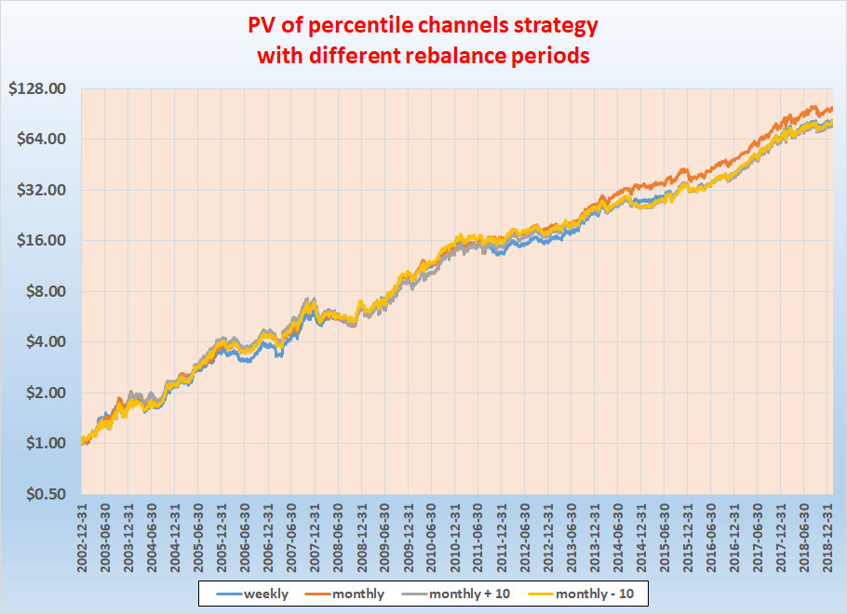

Table 3a-d. Performance indicators for percentile channels strategy with GameChangers with different rebalance periods

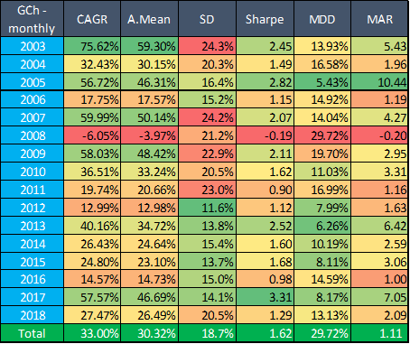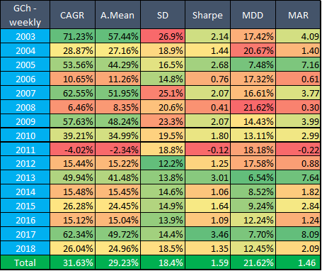

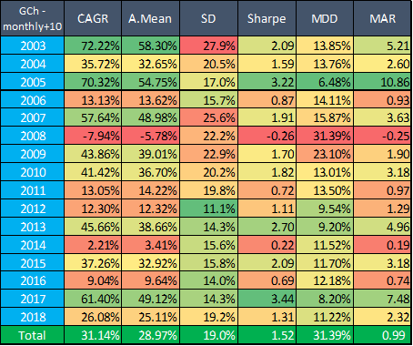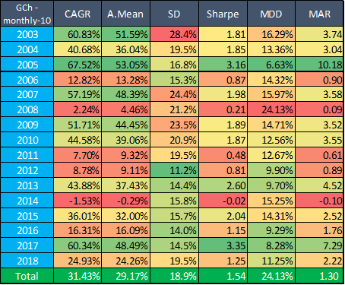

However, comparing yearly CAGRs we can spot that there was a **huge difference in 2011** between monthly and weekly rebalance (+19.7% vs -4%). What could happen here?

In Chart 4a-c we can see the comparison of monthly and weekly rebalance year by year. We calculated the ratio of the two different PVs for each year, starting the two different portfolios from the same level in each calendar year.

We can see that this ratio typically was in the [0.9, 1.1] range in each year (only 2008 went slightly below 0.9) - but during the last third of 2011 monthly PV boosted over weekly one and their ratio reached a peak of 1.25 until the end of the year.

If we take a look on their exact PV instead of the ratios of them (see Chart 4d) than it is clear that we have to dig deeper for the reasons somewhere in **2011 August-September**.

Chart 4a-c. Evolution of monthly rebalanced PV / weekly rebalanced PV during a given year in yearly breakdown

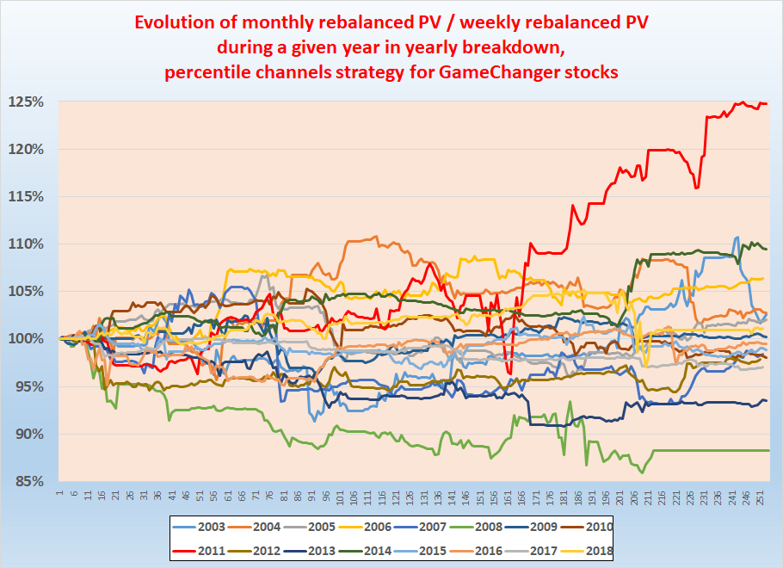

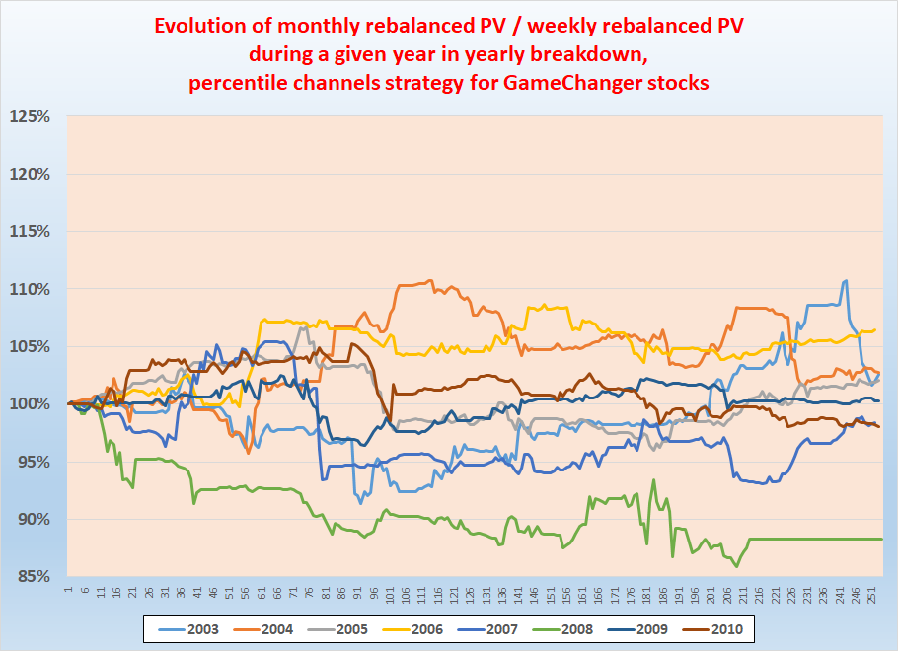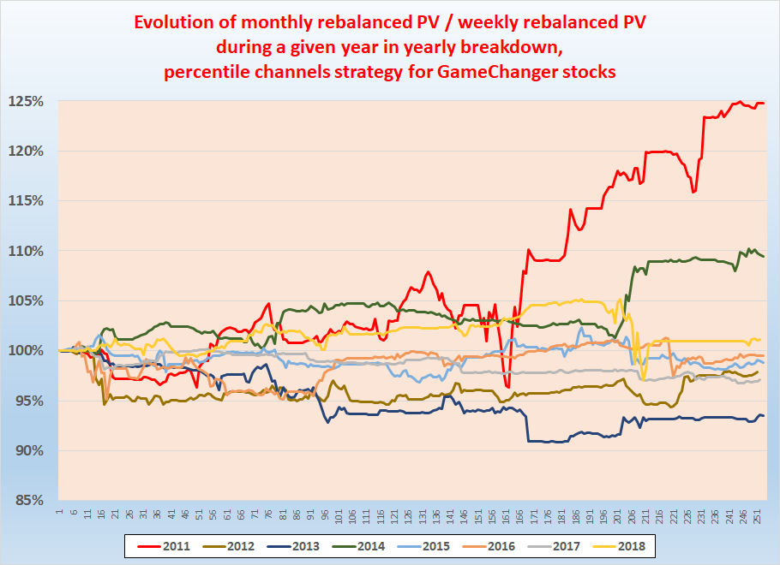

Chart 4d. PV of monthly and weekly rebalanced percentile channels strategy for GameChangers in 2011

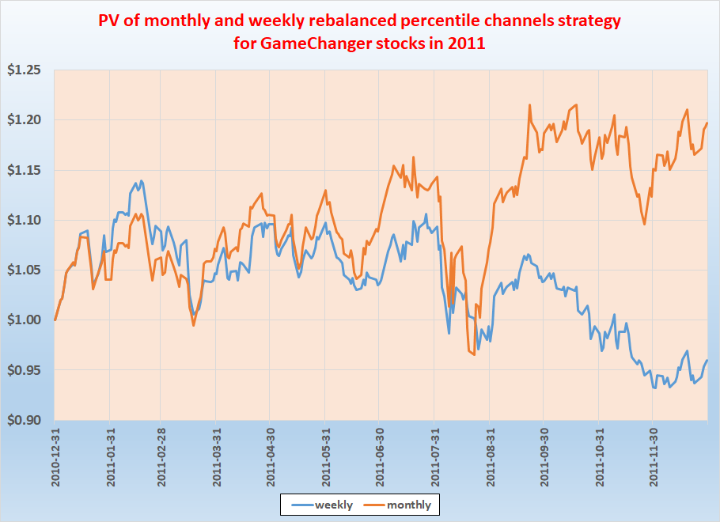

Let’s see the detailed numbers in the period of [2011-08-22, 2011-09-22] in Table 5.

What we can learn here is that in **weekly rebalanced strategy** our position **were mainly in TLT** (~89%) for the last days of August and only the rest (~11%) was in AAPL. Meanwhile **monthly rebalanced** strategy stayed **only 5% in TLT**. This means that monthly rebalanced strategy could earn the profit from the high yields of AAPL, AMZN, BIDU, CRM, NFLX and TCEHY on 2011-08-23 (and 2011-08-29). Of course similar things happened from time to time (i.e. that weekly/monthly strategy was mainly in TLT while the other one was not) - this was interesting because of the extent of the mentioned daily % changes.

Actually the daily %change of 2011-08-23 in the analyzed period was the

* 86th highest for AAPL during 4027 trading days (so in the best 2.1%)
* 26th highest for AMZN during 4027 trading days (so in the best 0.7%)
* 64th highest for BIDU during 3373 trading days (so in the best 1.9%)
* 61st highest for CRM during 3656 trading days (so in the best 1.7%)
* 75th highest for GOOGL during 3616 trading days (so in the best 2.1%)
* 125th highest for MSFT during 4027 trading days (so in the best 3.1%)
* 97th highest for NFLX during 4027 trading days and (so in the best 2.4%)
* 31st highest for TCEHY during 2262 trading days (so in the best 1.4%).

All in all it means that **2011-08-23 was generally a good day** - actually the 4th best day[1] in the period of [2002-12-31,2018-12-31]. Because in monthly rebalanced strategy we were mainly in stock position we could earn 5.3% on that single day which was **6.0% more** than the -0.7% of weekly rebalanced strategy. We **also had ~2% advantage** on 2011-08-24, 2011-08-26, 2011-08-31, 2011-09-21, 2011-09-22 and **3.6%** on 2011-08-29 too.

(Actually on 2011-09-21 and 2011-09-22 the opposite thing happened: monthly rebalanced strategy was mainly in TLT (76%) and therefore suffered a small loss because of the negative daily % change of AAPL and MSFT on those days and earned more from TLT’s 3.3-3.8%).

So during these 30 days from 2011-08-22 until 2011-09-22 **monthly rebalanced strategy boosted out the weekly one** **simply because of the lucky difference in weights**.

Table 5. Daily weights and %changes in weekly and monthly rebalanced percentile channels strategy for GameChangers between 2011-08-22 and 2011-09-22

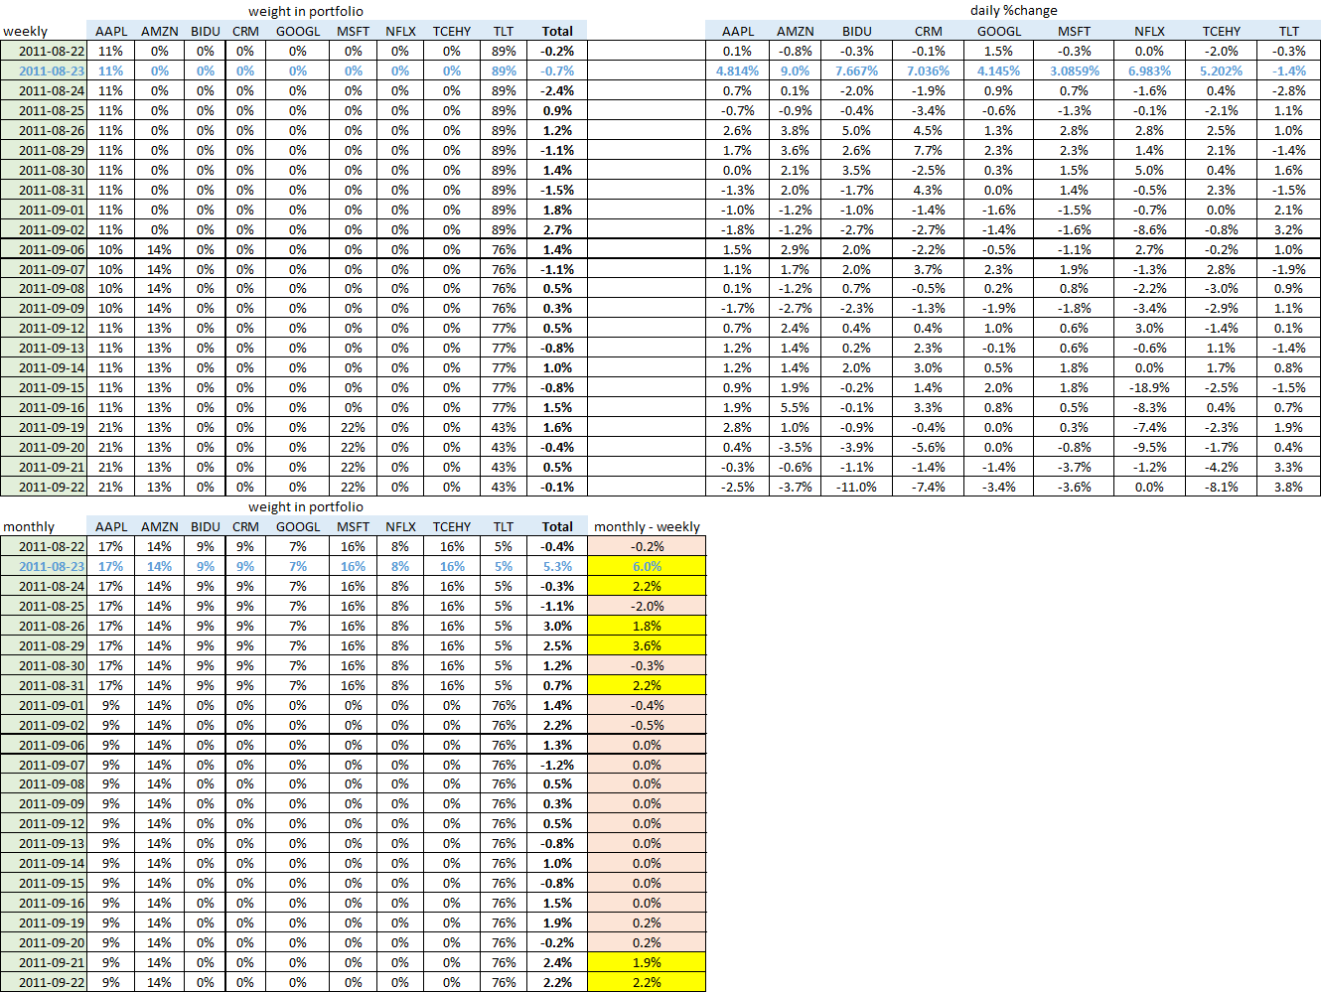

For comparison reasons let’s check the best 10 days in the mentioned 16 years:

Table 6. Daily weights and %changes in weekly and monthly rebalanced percentile channels strategy for GameChangers

for top 10 days during 2003-2018

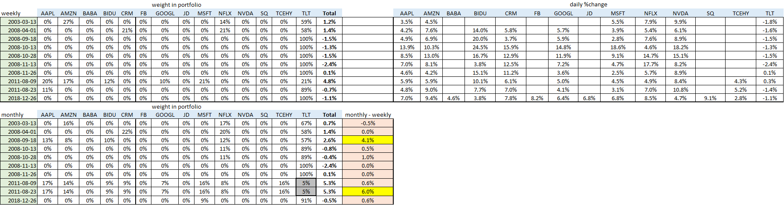

We can see that only 2 times (2008-09-18 and 2011-08-23) out of 10 were the performance of the monthly rebalanced tactic much higher (see the yellow cells). Also only in two cases were TLT’s weight close to zero (in August 2011, see the grey cells) - but in the first case TLT’s weight was also low in weekly rebalanced tactic, so in that case there wasn’t so high difference between the two tactics.

It’s also interesting that 5 out of top 10 days took place during the autumn of 2008 - but during these months both tactics were mainly in TLT (weekly one was actually only in TLT) and therefore the difference between them also was not high (except on 2008-09-18).-

So all in all in the long term CAGR of monthly tactic was slightly higher - however maxDD was lower for weekly tactic. **We** also **saw that an unfortunate/late change in weights can cause even 20% difference between the two tactics in short term**.

Now let’s focus on the answer for **our second question**:

* Will be our result **better** with the above described strategy **than** with **simple equal-weight buy and hold strategy**?

Chart 7. PV of percentile channels and equal weight strategy with GameChangers by different rebalance periods

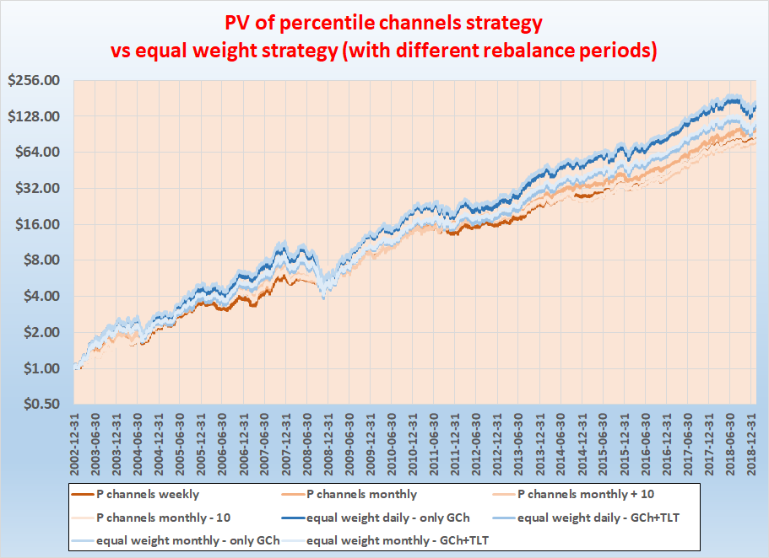

Table 8. Performance indicators of equal weight strategy with GameChangers by different rebalance periods

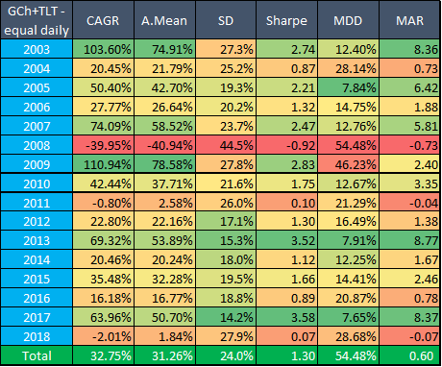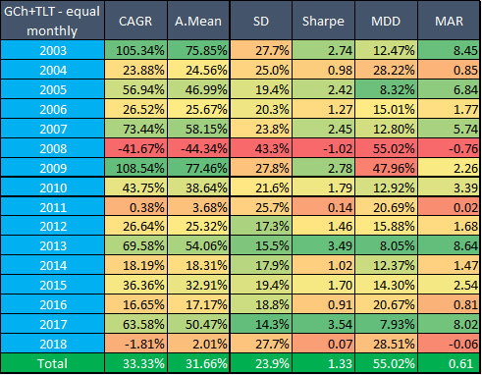

According to Chart 7 and Table 8 monthly results (GameChangers + TLT) are slightly, but not significantly better than daily. Looking back to Table 3a-d we can see the monthly rebalanced Percentile Channels strategy and the equal weight has about the same profit (33.33% CAGR vs 33.00% CAGR). However SR (1.62 vs 1.33) and **MDD (29.7% vs 55%)** are still better at **Percentile Channels strategy** - so we **suggest to use that** instead of simple equal weight strategy. The trend following Percentile Channels approach nicely decreases the volatility while keeping the profit about the same. At least, for these kind of momentum stocks it works brilliantly.

## Percentile channels with Nasdaq100

Now let’s see the same results with Nasdaq100 companies. In our calculation we didn’t use all N100 companies but estimate the portfolio by QQQ’s top 13 holdings which **currently** covers 60% of QQQ’s asset (QQQ itself tracks a modified-market-cap-weighted index of 100 NASDAQ-listed stocks), namely: MSFT, AAPL, AMZN, GOOGL, FB, INTC, CSCO, CMCSA, PEP, NFLX, ADBE, PYPL and AMGN.

Table 9. Performance indicators of percentile channels strategy with top QQQ stocks by different rebalance periods

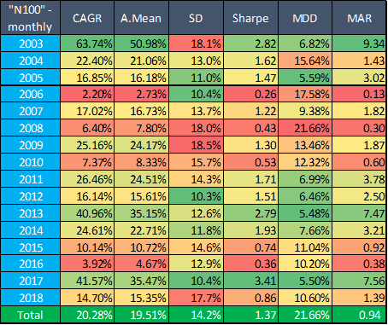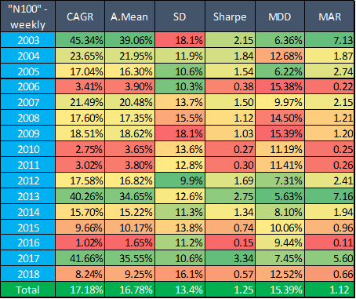

We can observe that our CAGR and SR have decreased (comparing to GameChangers 33% CAGR vs 20.3% and 1.62 SR vs 1.37) - although also our MDD improved (29.7% with GChs vs 21.7%). Meanwhile for these stocks also - the less frequent - monthly rebalance seems to be a better choice.

If we compare these results to simple equal weight strategy again then we can see that (again) the monthly rebalancing shows slightly better results (22.7% CAGR vs 20.3% of with Percentile channels strategy) but it is accompanied with a lower SR (1.18 vs 1.37) and a higher MDD (41.6% vs 21.7%).

What is also interesting that **Percentile channels strategy with N100 had no losing year**! So the **overall result is again that we should use Percentile channels strategy** instead of simple equal weight rebalancing.

Table 10. Performance indicators of equal weight strategy with top QQQ stocks by different rebalance periods

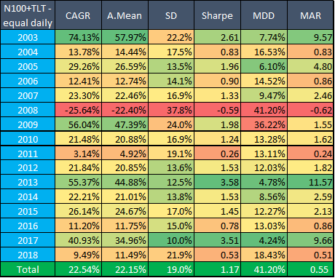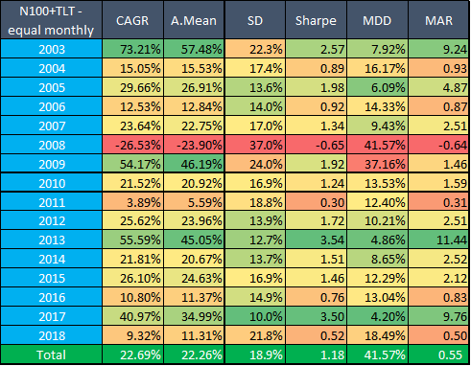

## 

## Extension of the above “percentile channels with Nasdaq100” results

We have extended our above calculation (which used portfolio of the QQQ’s top 13 holdings) with

* 4 additional years (to see the effect of bear the market of 2001)
* monthly breakdown (to see more details)
* cash instead of TLT (to see the boost-effect of TLT)[2]

We start with the default case, which uses TLT.

Table 11a. Performance indicators of percentile channels strategy with top QQQ stocks by different rebalance periods,

using TLT

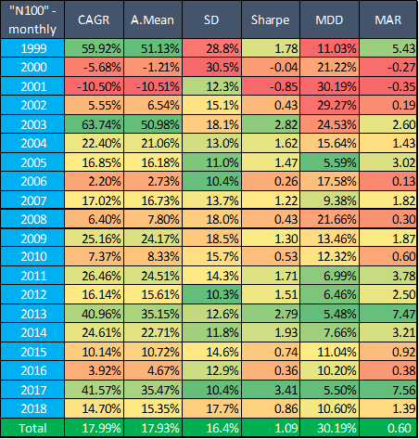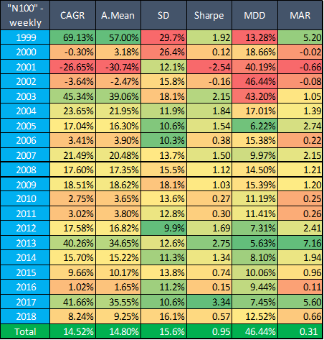

Adding years 1999-2002 to our tables somehow spoils our previous results: the “Percentile channels strategy with N100 had no losing year!” statement is not true anymore. Market crash in 2001 resulted -10% CAGR even with monthly rebalance (which is still better than weekly rebalance). However if we compared to the extended results (Table 11b) of equal weight strategy then we can see that in terms of CAGR, SR and MDD this percentile channel strategy is still better.

Roughly speaking, with this robust, quasi parameter-insensitive trend-following style strategy - even including the last 2 bear markets over 20 years - approximately the CAGR are kept, while max drawdown is halved and MAR is doubled compared to the mean reversion based equal-weight rebalancing. A big success.

In Tables 11 c-d we can find the monthly breakdowns of Table 11a.

Table 11b. Performance indicators of equal weight buy and hold strategy with top QQQ stocks + TLT by different rebalance periods

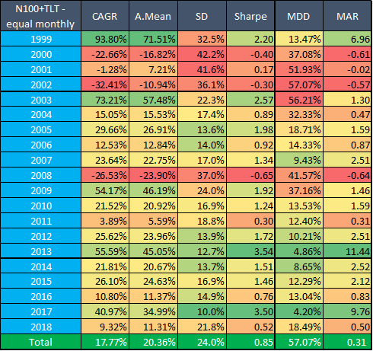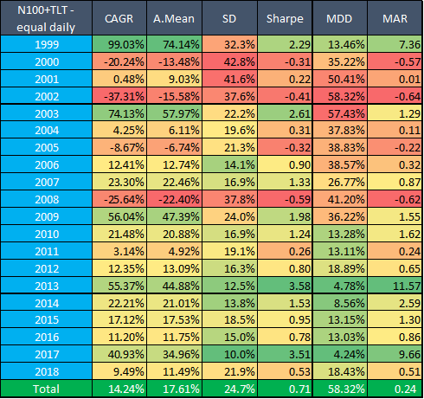

Table 11c. Monthly %change and MDD of percentile channels strategy with top QQQ stocks, monthly rebalance

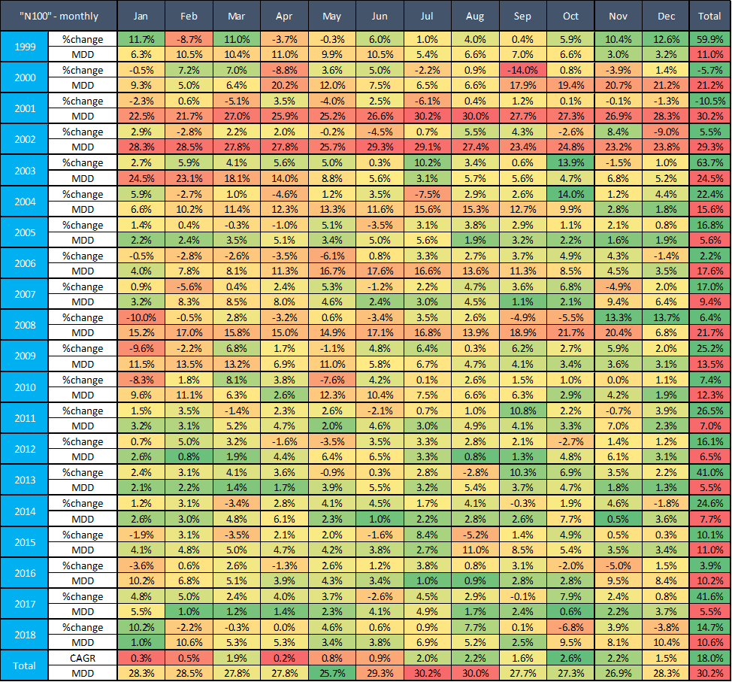

Table 11d. Monthly %change and MDD of percentile channels strategy with top QQQ stocks, weekly rebalance

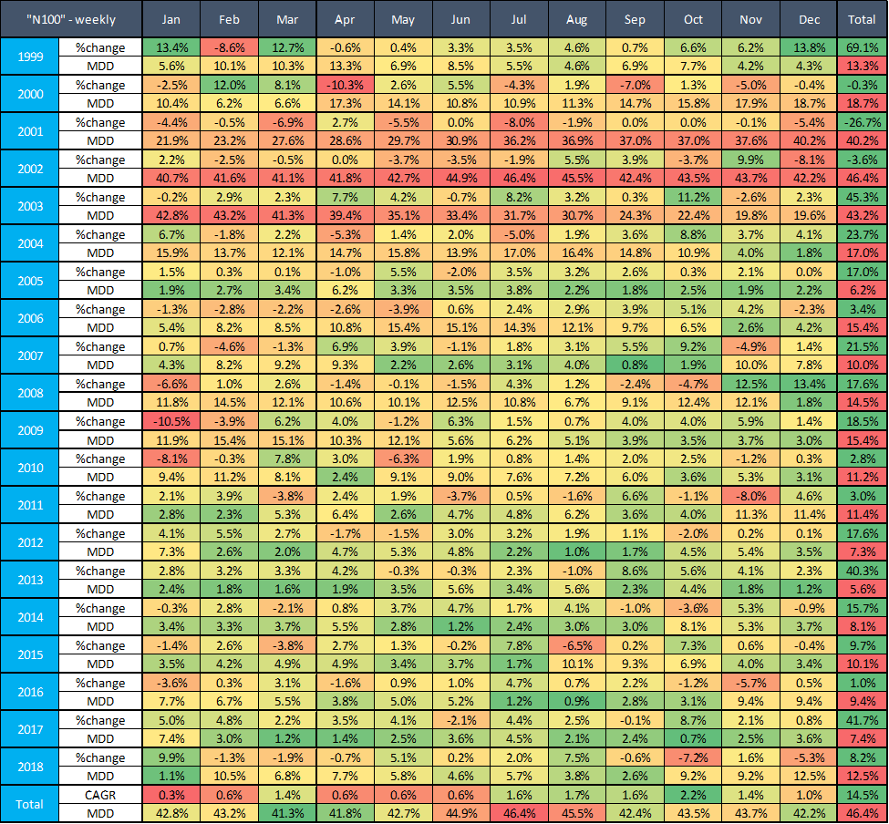

To be able to examine the effect of using of TLT I prepared the same tables regarding percentile channels strategy with cash instead of TLT as well. As we can see from Tables 11e-f TLT had an overall positive effect on results (18% CAGR vs 14.4% with monthly rebalance; 1.09 SR vs 0.92 SR, MDD is the same). Especially using of TLT turned the negative result of 2008 into a positive one (although it also eroded the result of 2009). Please note again that until 2002-07-30 no TLT was used in this backtest (so therefore the first 3 rows are coincidentals in Table 11e and 11f).

Monthly breakdown of Table 11e can be found in Table 11g-h.

Table 11e. Performance indicators of percentile channels strategy with top QQQ stocks by different rebalance periods,

using cash instead of TLT

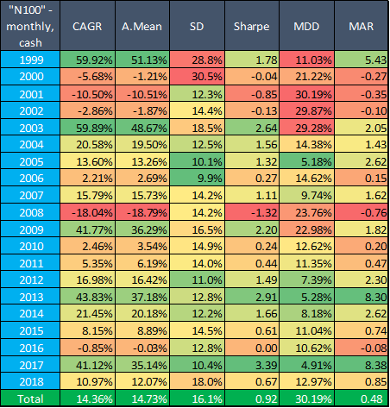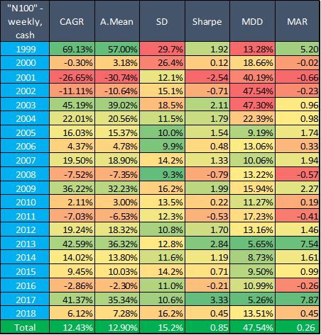

Table 11f = Table 11a. Performance indicators of percentile channels strategy with top QQQ stocks by different rebalance periods,

using TLT



Table 11g. Monthly %change and MDD of percentile channels strategy with top QQQ stocks, monthly rebalance,  
using cash instead of TLT

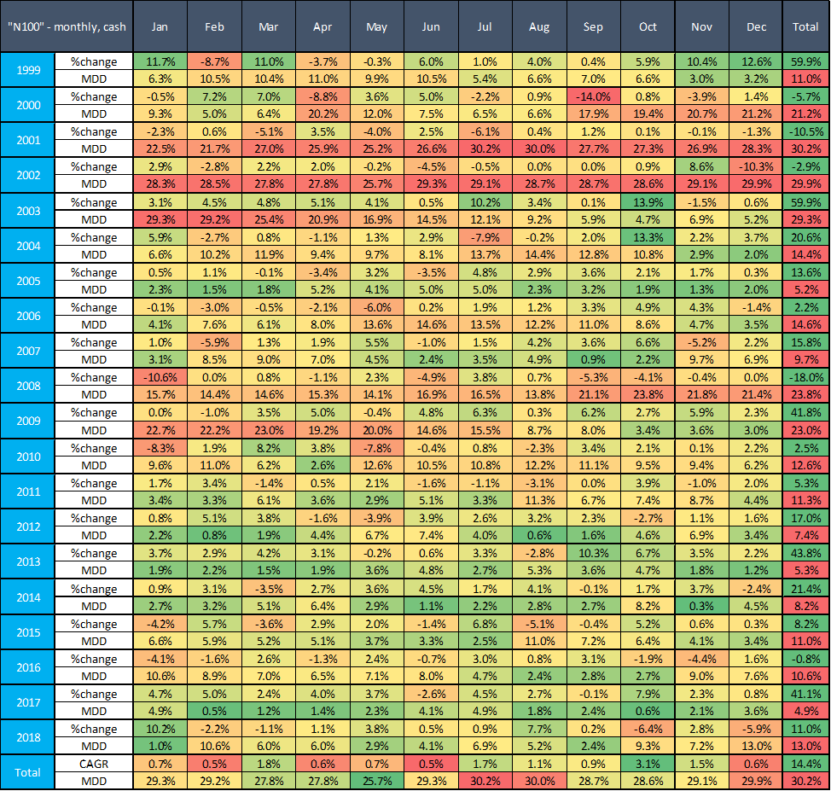

Table 11h. Monthly %change and MDD of percentile channels strategy with top QQQ stocks, weekly rebalance,  
using cash instead of TLT

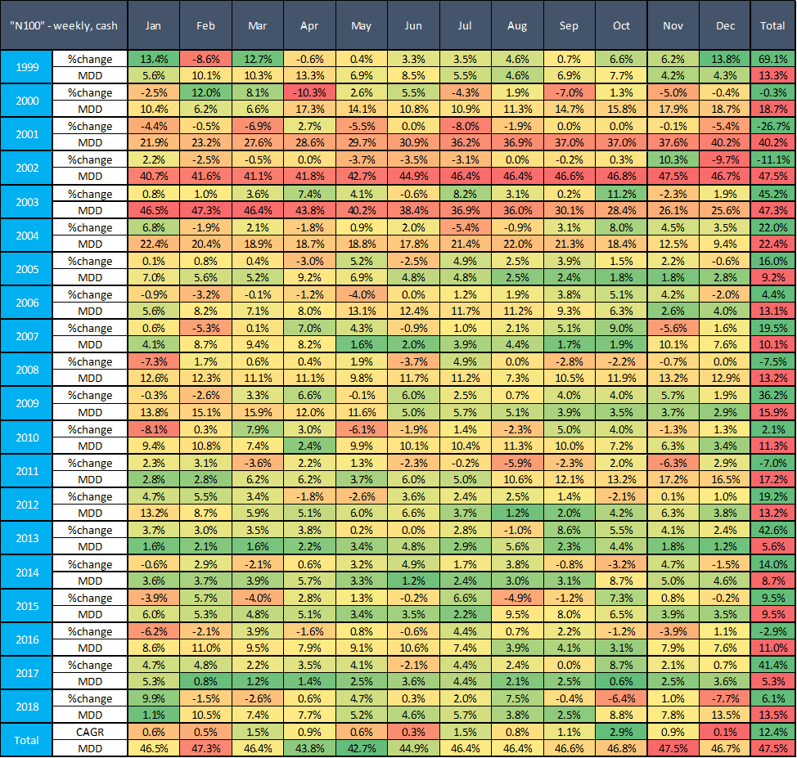

For a comparison reason let see the same table for QQQ itself (which exists from March 1999):

Table 11i. Monthly %change and MDD of simple buy and hold QQQ strategy

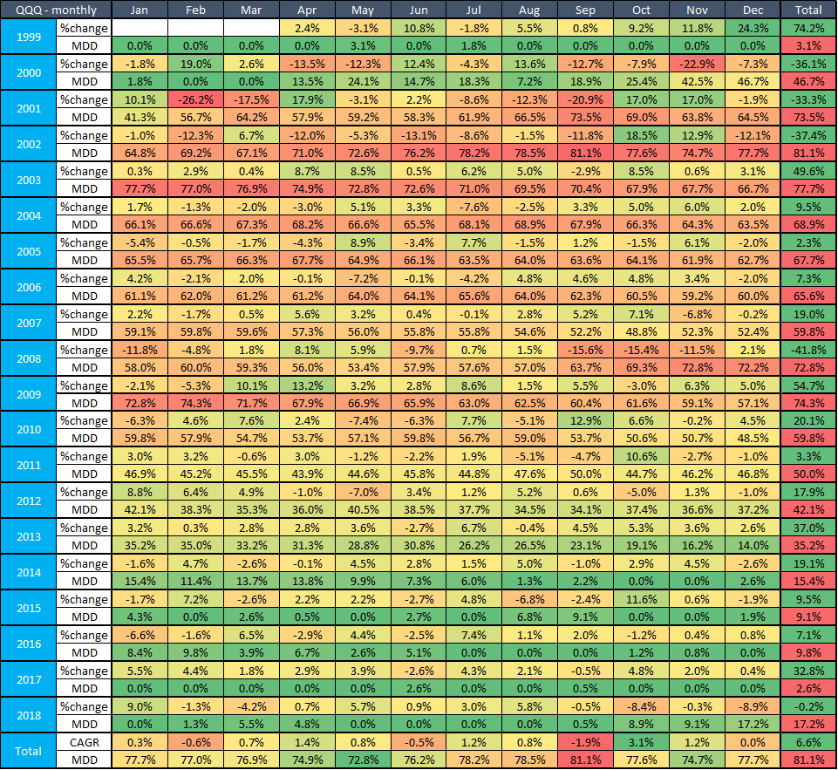

## 

## Percentile channel strategy with different entry and exit signs

One may think that why we buy at 75th percentile and sell at 25th percentile because it also would be a rational thought that we enter at 25th (or maybe at 50th) percentile (i.e. when the stock starts to arise so we can catch the rally very early) and exit when it starts to weaken (for example when it falls under the 75th percentile for the first time - in practice it means that we sell immediately if it falls under 25th percentile immediately).

Let’s the results for such a strategy with our current GameChangers. The exact rules would be the following:

*“For every stocks, calculate the 60-, 120-, 180- and 252-day (these are trading days) percentile channel with 25% threshold every day. For example, 120-day percentile channel with 25% threshold is the following: calculate the 25th ,* ***50th****and 75th percentile of the close prices in the last 120 days. The former will be the lower threshold,* ***the middle one will be the middle threshold****, while latter the upper threshold. If the daily close price of the given stock on Day T is higher (or equal) than the* ***lower******(or middle)*** *threshold (****25th******(or 50th)*** *percentile of T-119,…,T close prices)* ***while it was lower than the respective (lower or middle) threshold on the previous day****, the signal of the 120-day percentile channel is +1. If lower (or equal) than the* ***higher (or middle)*** *threshold* ***while it was higher than the respective (higher or middle) threshold on the previous day****, the signal is -1. Otherwise, the signal of Day T is the same as on Day T-1. Every stock have 4 channels with different look-back periods, thus we get 4 signal (-1 or +1) every day for every stocks.”*

In practice it means that the first time the price of a given stock on Day T exceeds the lower or middle threshold then the signal changes for +1 and the first time the price of a given stock on Day T falls under the higher or middle threshold then the signal changes for -1 (so we have 2 entry- and 2 exit-signals).

For a better understanding let’s see the next (real life) example of AMZN (for the period March-July 2018):

Chart 12. Signals, price and percentile channels for AMZN in a modified percentile channels strategy

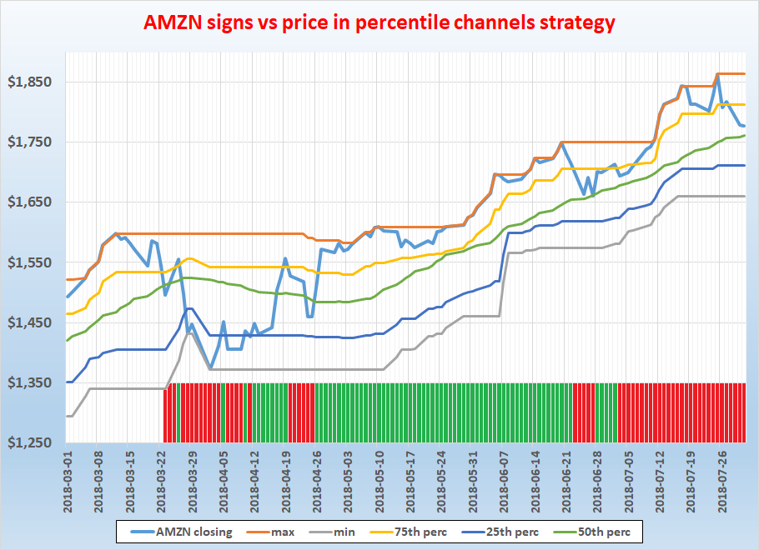

Whatever was the signal (marked with red and green bars in the chart) before 2018-03-23 (actually it was already negative) it turned to negative on that day because close price (light blue line) went below the (yellow) 75th percentile line.

3 days later it crossed the (green) 50th percentile line from below therefore the signal turned to positive but immediately turned to negative again because the price went under the yellow line again.

On 2018-04-05 it turned to positive again when crossed the (dark blue) 25th percentile line from below etc.

Table 13a-d. Performance indicators of “reverse” percentile channels strategy with GameChangers by different rebalance periods

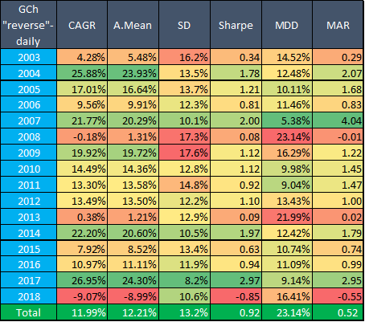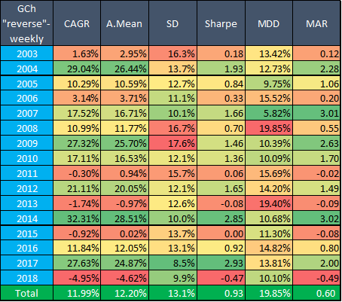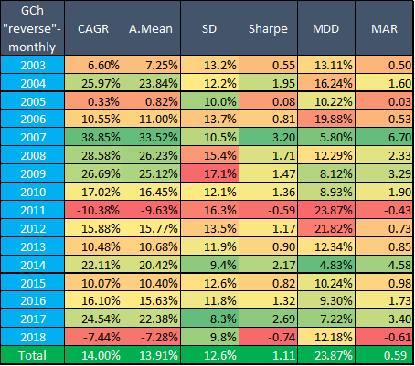

**Results are not as attractive as we might thought in advance**: CAGR is just 12-14% and SR is only 0.92-1.11. Actually if we skip the 50th percentile rule and use only 25th and 75th percentiles as thresholds (but with still the above described “reverse” rules) then the results would be even worse: 12.3% CAGR, 0.76 SR and 47% MDD.

It’s maybe interesting that daily rebalanced results in long term are so similar to the weekly ones. Although daily rebalance was not interpreted at “normal” percentile channels strategy the situation was similar there: CAGR was 31.6% (weekly) vs 31.3% (daily), SR was 1.59 (w) vs 1.58 (d) and MDD was 21.6% (w) vs 25.5% (d) (for monthly results see Table 13d above (which is the same as Table 3a)).

## Percentile channels with random stocks

Above we saw (both with GameChanger and N100 stocks) that although CAGR can be (slightly) higher with equal weight strategy - Sharpe Ratio and MDD are still better with (original) Percentile channels strategy. **One may say that this is true only for blue chips**. To test this I created **208 random groups of stocks** from our database - 13 stocks within each group. These 2,704 stocks all were in-force during 2003-2018 (a possible extension of this test could be the same calculation with dying stocks too). I calculated for all 208 groups the main performance indicators as above for both strategies.

These are my main findings (for detailed results see the Appendix):

CAGR

* with percentile channels strategy varies from 5.9% to 20.9% with an average of 12.9%
* with equal weight strategy varies from 5.7% to 23.5% with an average of 13.2%
* **105 times percentile channels strategy had a higher CAGR, 103 times the equal weight**

Sharpe Ratio

* with percentile channels strategy varies from 0.72 to 1.43 with an average of 1.09
* with equal weight strategy varies from 0.39 to 1.11 with an average of 0.73
* **Percentile channels strategy had a higher SR in all(!!!) 208 groups**

Max DD

* with percentile channels strategy varies from 9.7% to 28.2% with an average of 19.3%
* with equal weight strategy varies from 34.8% to 73% with an average of 54.4%
* So not surprisingly **Percentile channels strategy had a lower MDD also in all(!!!) 208 groups**

Number of losing years

* with percentile channels strategy varies from 0 to 5 with an average of 1.8
* with equal weight strategy varies from 1 to 6 with an average of 3.0
* Percentile channels strategy had less losing years in 141 groups and the same in in other 45 groups. Equal weight strategy had less losing years only in 22 cases

Based upon these findings we can state that **percentile channels strategy is clearly better than equal weight strategy regardless the selected stocks**. Although it’s a fifty-fifty situation regarding CAGRs - **percentile channels strategy can reach these values with much better SRs and MDDs**. This is a big win of the trend following approach vs. the mean reversion approach not only in our momentum style gamechanger stocks but also in a general real-life stock universe case (2,704 stocks).

## 

## Different parameters for percentile channels strategy with random stocks

I also performed several calculation with these random groups to check **whether there are better thresholds** for the original percentile channels strategy. Instead of the original 75th (entry) and 25th (exit) percentile I tried the following combinations:

Table 14. Main performance indicators for percentile strategy in 208 random groups,

with different entry and exit thresholds, 2003-2018

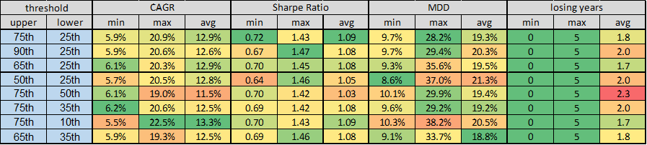

As we can see the **minimum and average Sharpe Ratio and maxDD too was the best with the original thresholds and meanwhile max and average CAGR was also the second highest**.

The second best option seems to be the 75th-10th combination: it has the highest max and average CAGR, the second best average Sharpe Ratio, the lowest avg number of losing years - but unfortunately the highest max MDD as well. The third best candidate maybe the 65th-35th thresholds: it has the lowest average maxDD, the third lowest average number of losing years and the third highest average Sharpe Ratio.

However all in all **I don’t suggest to change the original thresholds** (and this finding is inline with Balazs’ previous results).

I also checked whether there are better look-back period for historical volatility:

Table 15. Main performance indicators for percentile strategy in 208 random groups,

with different historical volatility look-back periods, 2003-2018

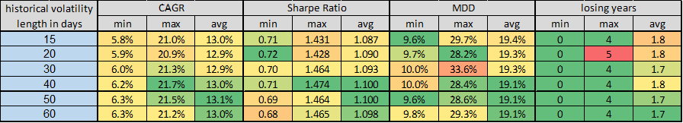

Although minimum of Sharpe Ratio and maximum of maxDD are the best with the original 20 day parameter it seems that this parameter is not the best choice. Maybe 40 (or 50) days would be better - however the difference is not significant. My suggestion is to use the original 20 days or (40 days if we want to change).

## Percentile channels strategy with our suggested addiction-portfolio

In January 2019 we started a [new portfolio](https://docs.google.com/document/d/1dBHg3-McaHeCtxCTZdJhTKF5NPaixXYjEngZ4F2_ZBE/edit#heading=h.1zfdmy2euu4y) with addiction related stocks. Among our suggested stocks alcohol, defense, gambling and tobacco related stocks had a long history - therefore I tested percentile channels strategy vs equal weight strategy on that portfolio too. Namely I used the following 20 stocks (+TLT) in this backtest: ATVI, BA, BUD, DEO, EA, GD, HEINY, HON, LMT, LVS, MO, MTCH, NOC, PM, PDRDY, RTN, SCHYY, STZ, UTX and WYNN.

Table 16a-d. Main performance indicators for addictive-stocks with percentile channels strategy and equal weight strategy,

with weekly and monthly rebalance frequencies, 2003-2018

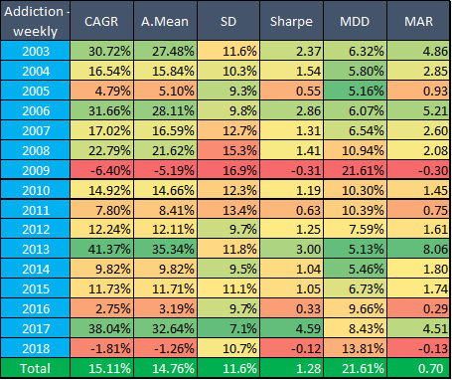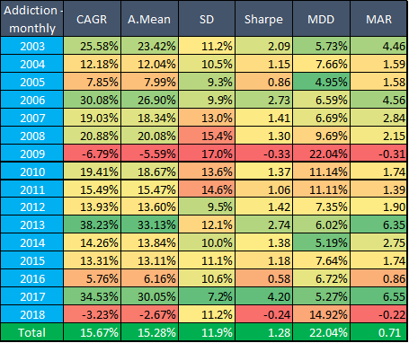

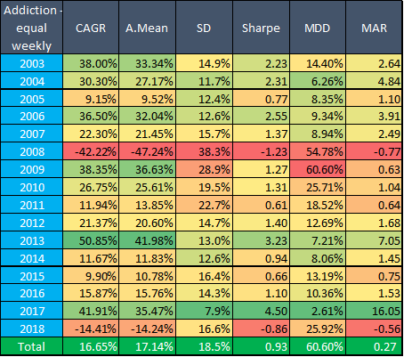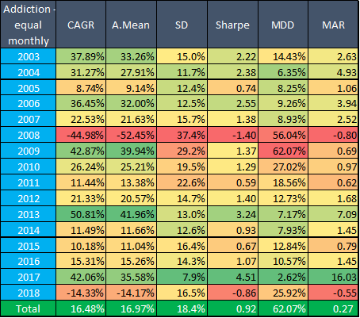

The situation is the same again: **equal weight strategy produces slightly better CAGRs but we have to pay a big price on lower SRs and higher MDDs**. There is **no significant differences between weekly and monthly** rebalances - so **all in all using the monthly (rarer rebalancing) percentile channels strategy is recommended at this group of stocks as well**.

# Conclusion

In this study we tried to **find an optimal rebalance technique** for our portfolios, where optimal basically means:

* to find an optimal rebalance frequency
* not to invest into into dying stocks
* take into account the performance of other stocks in the portfolio to find the optimal weights

In the first section of the study we saw that although in the most simple case we can find a rule that helps to make a decision in the rare vs frequent rebalancing question but the situation becomes extremely complex very soon if we have more stocks and periods. Generally we cannot state anything which frequency is the better. However according to the result of some random number based modelling **it seems that frequent rebalance has a slight advantage** (51-52% vs 48-49%) over rare rebalance.

This small extra profit seems to be the compensation of the small probability extra risk of the dying stocks scenario. More frequent rebalancing is more of a mean reversion play. While less rebalancing is a better environment for trend following stocks by keeping winners and not investing into losers.

In the second part, we tested one trend following rebalancing, the so called percentile channels strategy where the entry point in case of a given stock based on the 75th percentile and the exit point on the 25th percentile of the closing prices of last n days. We tested this strategy with many setups and different (even random) group of stocks. Here we saw that although **in the long term weekly and monthly rebalance produce nearly the same results** on short term the difference can reach sometime even 20%. What was in common in them that both rebalance frequencies produced better results than simple **equal weight technique**. Actually **CAGR is not significantly differs** with percentile channels strategy but **with this technique we can reach it with a lower standard deviation (and therefore with higher Sharpe Ratio) and lower max drawdown** - so it is strongly recommended to a risk-averse investor.

We tried other entry- and exit-rules and different parameter setups as well. While the changing of former ones erodes our results - applying of new parameters doesn’t improve them significantly. (Maybe only our historical volatility look-back period could be changed from 20 days to 40 days).

We also checked that the above statement about SR and mDD are true not only in given group of stocks but even in (practically any) random groups. Actually **Sharpe Ratio and maxDD were better in each case** that we tested (more than 200 groups)! So did in the last chapter where we tested the advantages on our **brand-new addiction-portfolio: with percentile channels we got ~1.3 SR and ~22% MDD in our backtest while they were only 0.9 and ~62% with equal weight technique.**

**It is strongly recommended** to rebalance our **SIN portfolio every month according to this Percentile Channels strategy.**

# 

# Appendix

Results of 208 random group of stocks with percentile channel and equal weight rebalance techniques (both monthly)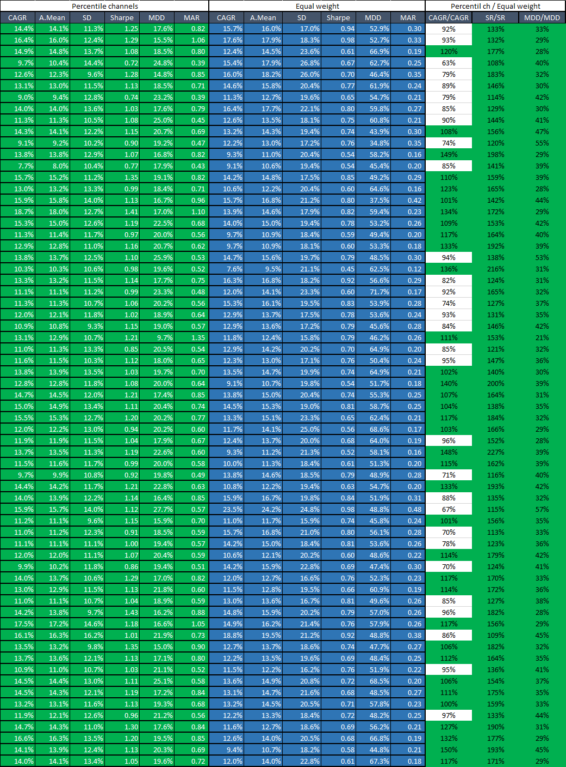

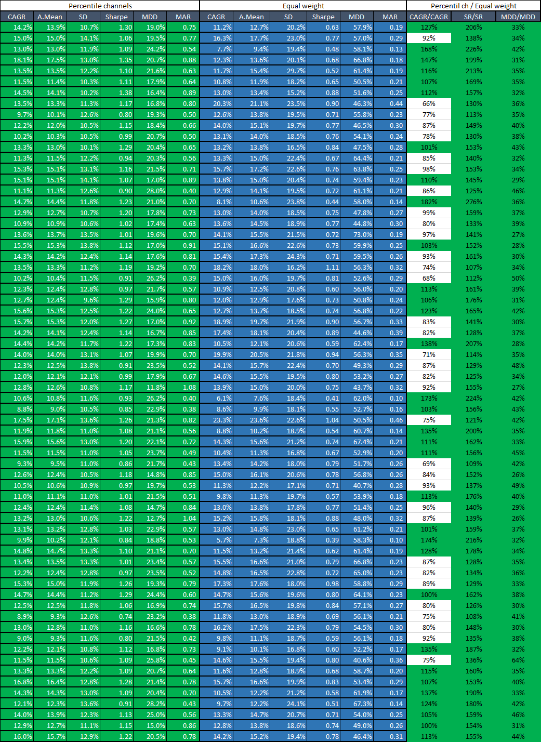

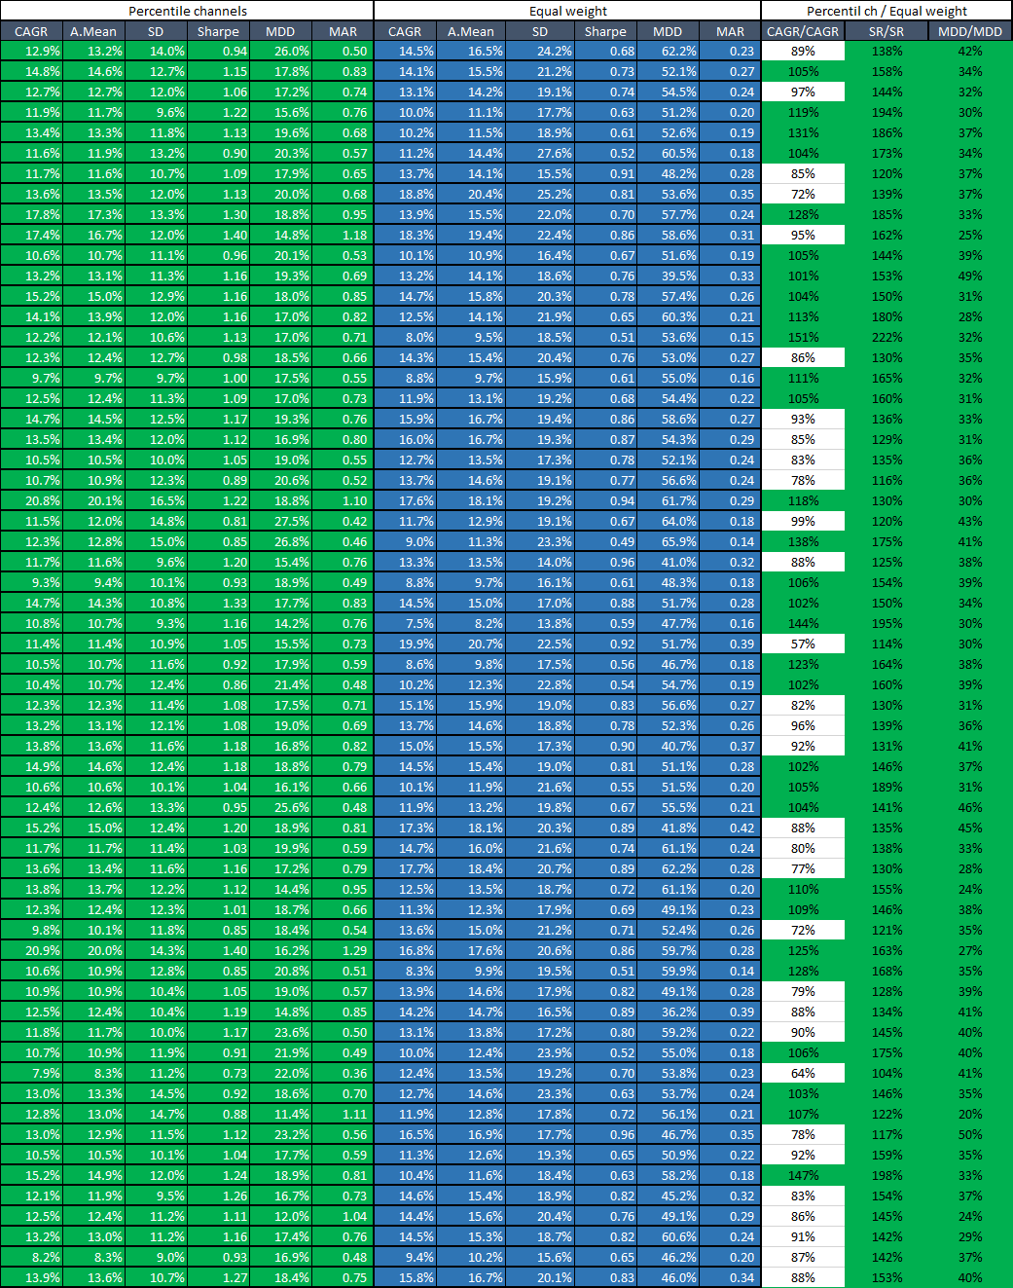

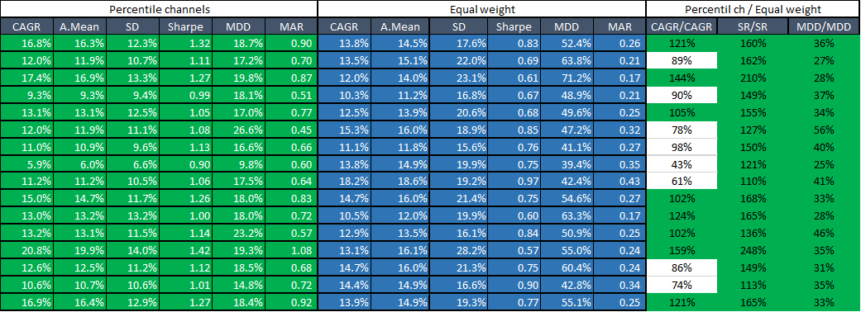

1. For ranking the days first I ranked the days for each stock individually and assigned to them a percentile ranking - then I took the average of these percentile rankings and calculated an overall ranking according to this average
2. Please note that until 2002-07-30 we used cash instead of TLT in both calculations anyway