Dr. George Antal

3D Click Limited

c/o Suite 431, 28 Old Brompton Road, London SW7 3SS

**Reconfirming and Improving The SQ Earnings Score System**

**Motivation** **1**

**Data** **2**

**Results** **3**

SHIR 3

Portfolio-based simulation 8

GameChangers 1-2-3 + ARK Universe 14

Portfolio-based simulation with GameChangers 1-2-3 + ARK Universe 18

Earnings Surprise and Price Strength in Previous Quarter 22

GameChangers 1-2-3 + ARK Universe 23

Nasdaq100 Universe 29

**Conclusions** **34**

**Appendix** **35**

Earnings Surprise and Price Strength in Previous Quarter 35

GameChangers 1-2-3 + ARK Universe 35

Nasdaq100 Universe 38

# **Motivation**

*‘An earnings announcement is an official public statement of a company's profitability for a specific period, typically a quarter or a year. An earnings announcement occurs on a specific date during earnings season and is preceded by earnings estimates issued by equity analysts. If a company has been profitable leading up to the announcement, its share price will usually increase up to and slightly after the information is released. Because earnings announcements can have such a prominent effect on the market, they are often considered when predicting the next day's open.’[1]*

Since 2016, our SQScore earnings strategy (developed by Laszlo) has been played with varying degrees of success. With this study, our main goal is to reconfirm and improve this scoring system.

# 

# **Data**

The used data come from our database. It contains about 63K earnings events from 2005 to 2021. This contains only historical S&P500 (from 1999), historical Nasdaq100 (from 1999), GCh 1 (from 2015-05) - 2 (from 2018-05) - 3 (from 2020-08) and historical ARK (from 2021-04) universes, which is 952 tickers together. However, many missing data can be found for each indicator (e.g. SHIR, revenue, earnings estimate etc), so the actual number of used events are different for each part of this study.

Used indicators/variables:

* Event Date;
* Virtual Release Date;
* Open Gap (T0);
* Relative Open Gap (T0);
* Close-to-close return (T0);
* SHIR;
* SHIRPercentileRanking;
* SHIR2WeeksBefore;
* SHIR2WeeksBeforePercentileRanking;
* SHIR1MonthBefore;
* SHIR1MonthBeforePercentileRanking;
* SHIR3MonthsBefore;
* SHIR3MonthsBeforePercentileRanking.

# **Results**

In this chapter, our own calculations and results are presented.

## SHIR

The first indicator we are dealing with has the **biggest weight** in our current **EarningsCloseToOpen HQScore strategy**. This is the short interest ratio (SHIR), which *”is a simple formula that divides the number of shares short in a stock by the stock's average daily trading volume (3 months). Simply put, the ratio can help an investor find out very quickly if a stock is heavily shorted or not shorted versus its average daily trading volume. The term is also used interchangeably with days to cover.”[2]*

The use of ‘**SHIR PercentileRanking**’ instead of the pure SHIR number was developed by Laszlo for the sake of comparability of stocks. **This percentile rank is between 0 and 1 and it is calculated using SHIR numbers of S&P500 and Nasdaq100 companies. The lower this indicator the less shorted the company**. It is worth noting, that these SHIR numbers can even be 1 month old due to its publish method.

Based on the **scatter plot of SHIR Percentile Rank vs. open gap on T0** (Chart 1a-b) one can conclude that **a weak but significant correlation (corr = -0.041 with p=0.00 because the number of sample is 28,776) can be found between these two variables**. It **suggests that the short traders are right**: **one should buy the earnings open gap in case of the least shorted companies and avoid buying in case of heavily shorted ones.**

It is worth emphasizing that these results are based on the **historical S&P500 (from 1999), historical Nasdaq100 (from 1999), historical GCh 1 (from 2015-05) - 2 (from 2018-05) - 3 (from 2020-08) and historical ARK (from 2021-04) universes with appropriate SHIR data (825 tickers)**.

Chart 1a: SHIR Percentile Rank vs. open gap - 2015-2021

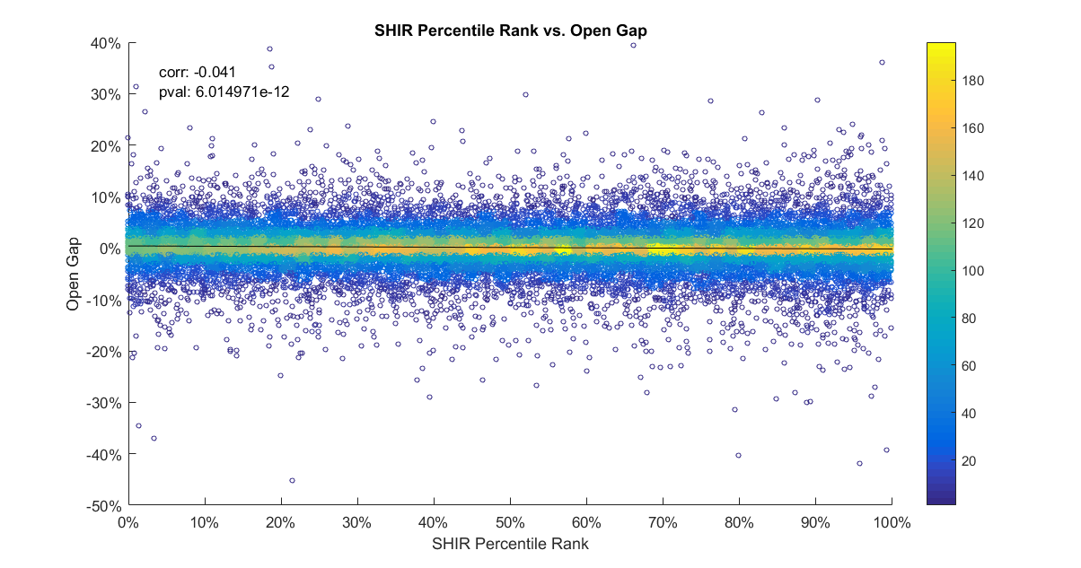

Chart 1b: SHIR Percentile Rank vs. open gap - 2015-2021 - zoomed version

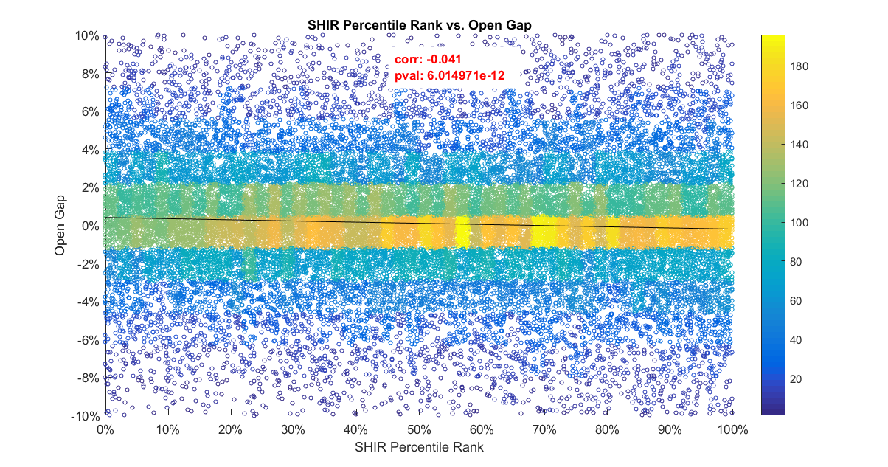

In order to thoroughly examine this conjecture, the **dataset has been split into deciles based on the SHIR PercentileRanking right before / 2 weeks before / 1 month before / 3 months before the earnings announcement and the arithmetic mean of open gap on T0, relative open gap (compared to SPY) on T0 and close-to-close return on T0 have been calculated**. As it can be seen in Table 1a-1c, **a significant pattern exists especially in case of the open gap and when the latest SHIR PercentileRanking is used**. Our conjecture seems to be confirmed. One may think that this phenomena is caused by outliers, therefore not only the arithmetic means but medians can also be found in Table 2a-c. Furthermore, one may wonder if this phenomenon still exists in recent years, so the arithmetic means using data only from 2015 to 2021 also can be seen in Table 3a-c. Figures do not change significantly.

Based on these charts and tables we can **conclude that the short sellers are really right**: **one should play the earnings open gap in case of the least shorted companies (SHIR Percentile Rank is below 20%) and avoid in case of heavily shorted ones**.

Table 1a: Arithmetic Mean of Open Gap by SHIR PercentileRank deciles - 2005-2021

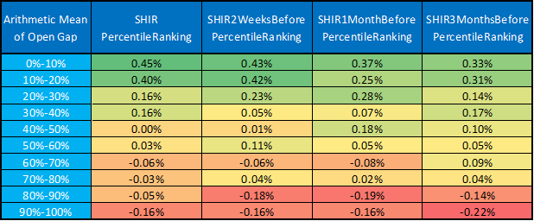

Table 1b: Arithmetic Mean of Relative (SPY adjusted) Open Gap by SHIR PercentileRank deciles - 2005-2021

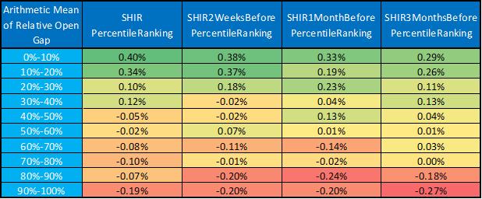

Table 1c: Arithmetic Mean of Close-to-close Return by SHIR PercentileRank deciles - 2005-2021

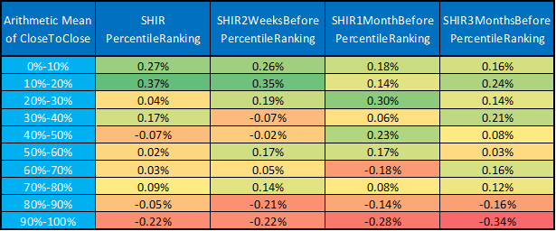

Table 2a: Median of Open Gap by SHIR PercentileRank deciles - 2005-2021

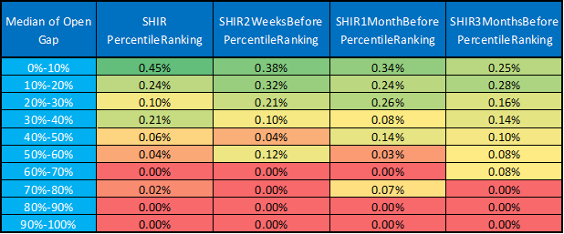

Table 2b: Median of Relative (SPY adjusted) Open Gap by SHIR PercentileRank deciles - 2005-2021

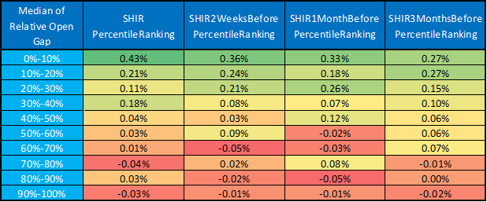

Table 2c: Median of Close-to-close Return by SHIR PercentileRank deciles - 2005-2021

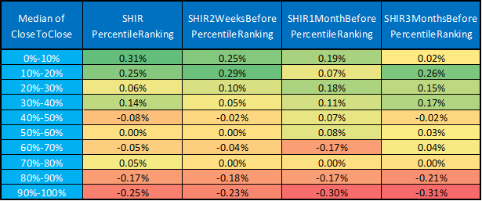

Table 3a: Arithmetic Mean of Open Gap by SHIR PercentileRank deciles - 2015-2021

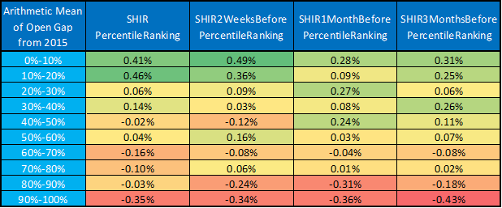

Table 3b: Arithmetic Mean of Relative (SPY adjusted) Open Gap by SHIR PercentileRank deciles - 2015-2021

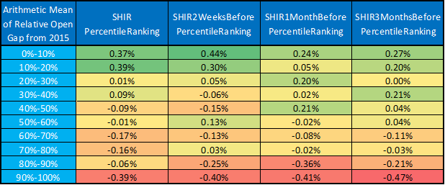

Table 3c: Arithmetic Mean of Close-to-close Return by SHIR PercentileRank deciles - 2015-2021

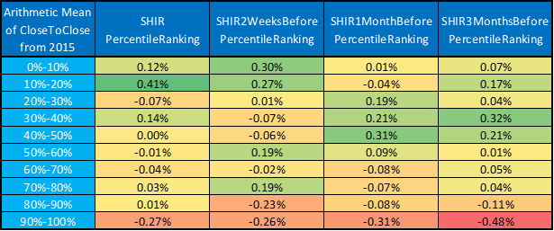

### Portfolio-based simulation

After checking arithmetic means, let’s look at **how this earnings open gap strategy would have performed in the past**. Table 4 shows the **performance indicators by SHIR Percentile Rank deciles which means that we play only companies whose SHIR Percentile Rank falls within that decile**. In the last column the performance of the strategy can be found when we play the two smallest deciles together. During the calculation, a **20% maximum weight/position** was used to avoid the undesirable effect of outliers. Furthermore, **it never invested more than 100% (there is no over-leverage)**. If e.g. there are 10 company reports on a given day, the weight per position is 10%.

Based on Table 4 and Chart 2a-b it can be concluded that **playing the open gap strategy when the SHIR Percentile Rank is below 20% is highly profitable: 24.41% CAGR, 11.78% MDD, 1.873 Sharpe- and 2.072 MAR-ratio.**

Table 5 shows that **the arbitrarily chosen maximum weight per position parameter does not significantly affect the results**.

Again, one may suspect that there may be some outlier data behind the good results. To avert these accusations, we repeated the calculations by **maximizing the outliers** (-15% and +15% minimum and maximum open gap was used in case of outliers). As Table 6 and Chart 3 show, **figures did not change significantly**.

Table 4: Performance indicators of OpenGap strategy by SHIR PercentileRank deciles using 20% max. weight/position - 2005-2021

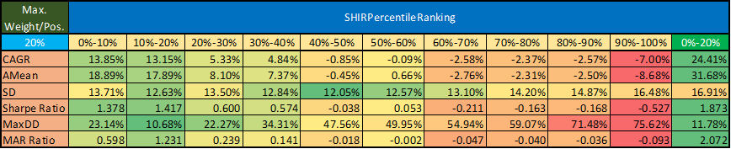

Chart 2a: PV of OpenGap strategy by SHIR PercentileRank deciles using 20% max. weight/position - 2005-2021

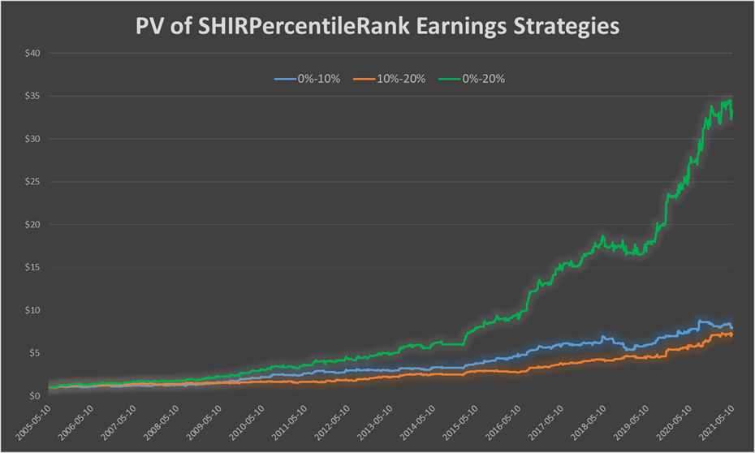

Chart 2b: PV of OpenGap strategy by SHIR PercentileRank deciles using 20% max. weight/position - 2005-2021 - logarithmic scale

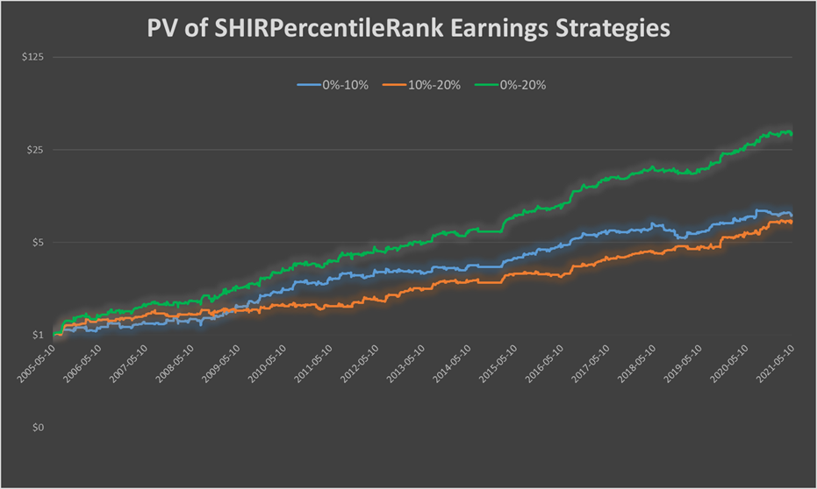

Table 5: Sharpe ratio of OpenGap strategy by SHIR PercentileRank deciles and max. weight/position - 2005-2021

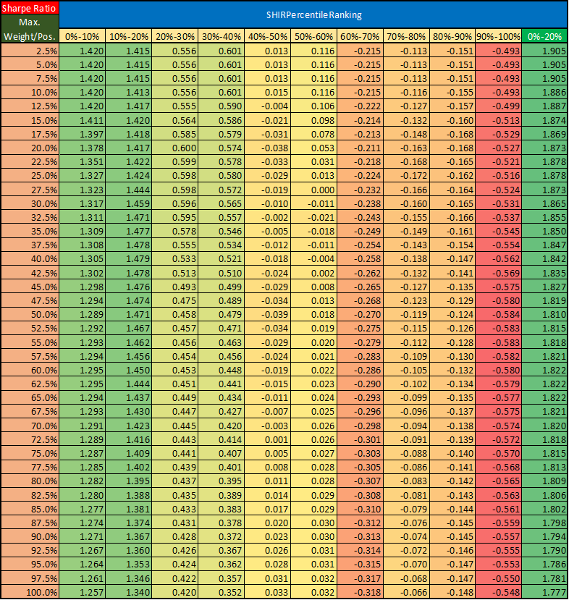

Table 6: Performance indicators of OpenGap strategy w/o outliers by SHIR PercRank deciles using 20% max. weight/position - 2005-2021

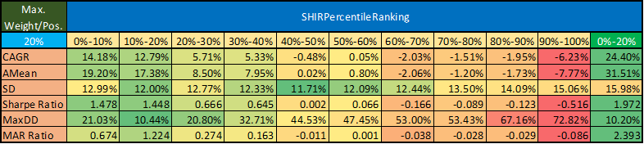

Chart 3: PV of OpenGap strategy w/o outliers by SHIR PercentileRank deciles using 20% max. weight/position - 2005-2021

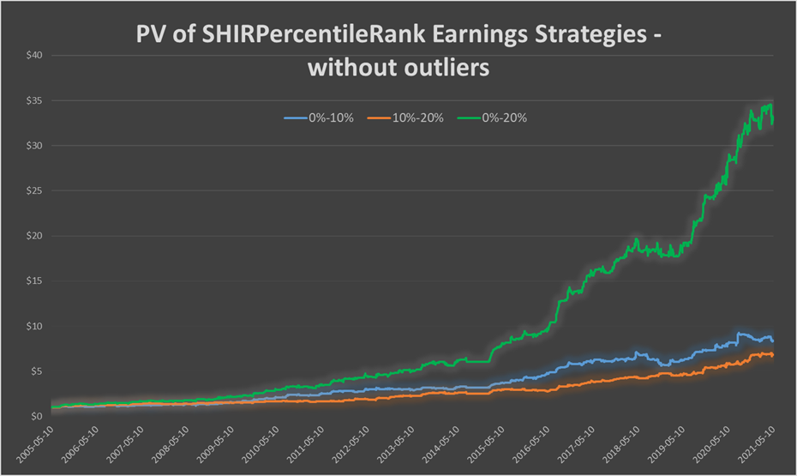

One might also wonder **what result we would achieve if we not only looked at the last value of SHIR but combined it with its previous value**. Since a decrease or increase in short proportion may have a meaning, we also examined this. Arithmetic means of open gap can be found in Table 7a and 8a (with number of events in Table 7b and 8b). Figures with grey background have not got enough samples thus they are meaningless. These tables suggest that **only those events should be played where the actual SHIR Percentile Rank is below 20% and it was below 40% 3 months ago** (that is, at the time of the previous report).

**But Table 9 and Chart 4 do not confirm the need for this restriction.**

Table 7a: Arithmetic Mean of Open Gap by actual vs. 1 month earlier SHIR PercentileRank deciles - 2005-2021

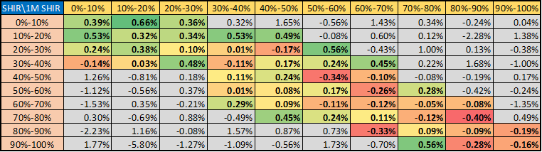

Table 7b: Number of events by actual vs. 1 month earlier SHIR PercentileRank deciles - 2005-2021

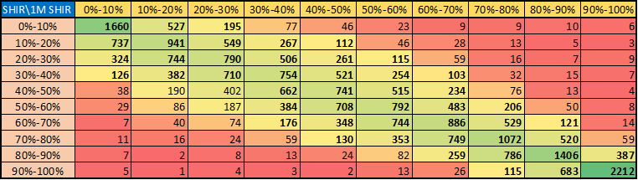

Table 8a: Arithmetic Mean of Open Gap by actual vs. 3 months earlier SHIR PercentileRank deciles - 2005-2021

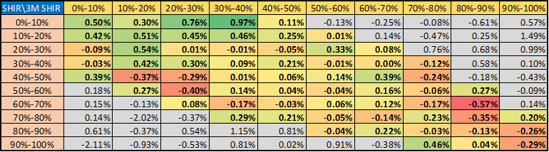

Table 8b: Number of events by actual vs. 3 months earlier SHIR PercentileRank deciles - 2005-2021

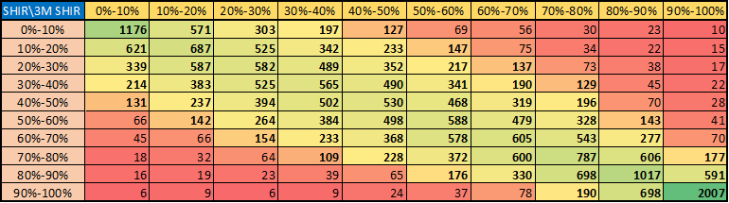

Table 9: Performance indicators of OpenGap strategy by 3M SHIR PercRank deciles using 20% max. weight/position - 2005-2021

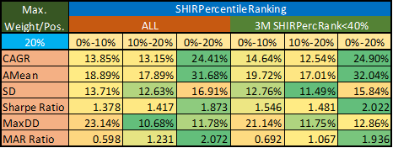

Chart 4: PV of OpenGap strategy by 3M SHIR PercentileRank deciles using 20% max. weight/position - 2005-2021

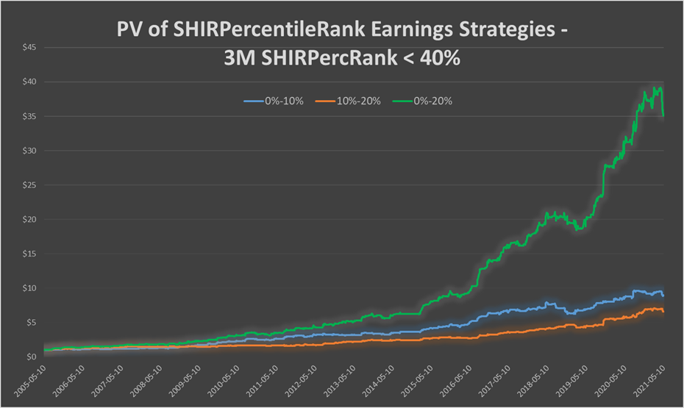

### GameChangers 1-2-3 + ARK Universe

Seeing the above excellent results, one may wonder **whether the figures will remain so good even if we reduce the ‘historical S&P500 (from 1999), historical Nasdaq100 (from 1999), historical GCh 1 (from 2015-05) - 2 (from 2018-05) - 3 (from 2020-08) and historical ARK (from 2021-04)’ stock universe used above to the not historical GameChanger 1-2-3 + ARK Universe** (300 stocks[3] from which 165 have proper SHIR data).

It is worth clarifying at the outset that the **results can be misleading and suffering from selection bias** as the **narrowed universe is not historical**. **A big portion of these tickers may have been penny- and/or small cap stocks earlier that could have behaved completely differently than they do today**.

Now, the **number of samples is just 5,901, compared to the 28,776 in the case of the whole ticker universe before**.

As it can be seen in Table 10a-c, **the previously found significant pattern exists also for this narrowed ticker universe**. Furthermore, it is worth noting that **not only the two less shorted deciles perform well but all the companies with SHIR PercentileRank below 40% - on average**. **Our previous conjecture (short sellers are right) seems to be confirmed again**.

Table 10a: Arithmetic Mean of Open Gap by SHIR PercentileRank deciles - 2005-2021

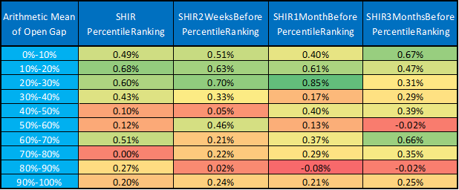

Table 10b: Arithmetic Mean of Relative (SPY adjusted) Open Gap by SHIR PercentileRank deciles - 2005-2021

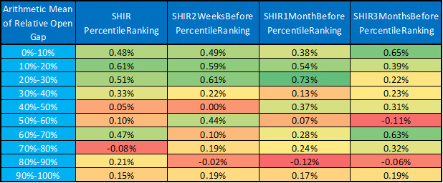

Table 10c: Arithmetic Mean of Close-to-close Return by SHIR PercentileRank deciles - 2005-2021

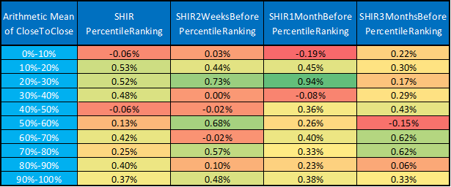

Medians can also be found in Table 11a-c, which further confirms our previous observation.

Table 11a: Median of Open Gap by SHIR PercentileRank deciles - 2005-2021

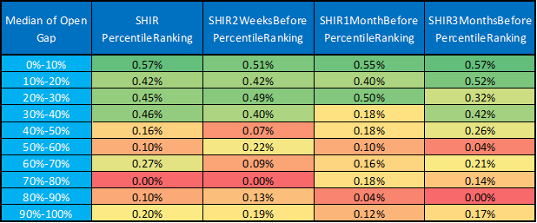

Table 11b: Median of Relative (SPY adjusted) Open Gap by SHIR PercentileRank deciles - 2005-2021

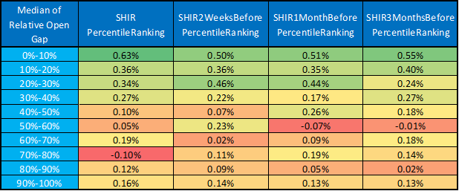

Table 11c: Median of Close-to-close Return by SHIR PercentileRank deciles - 2005-2021

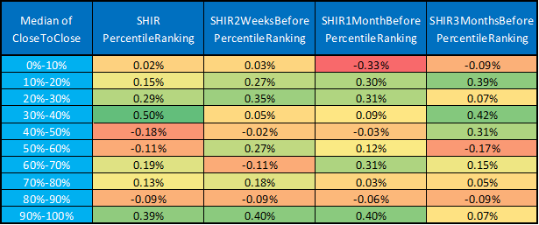

The arithmetic means using data only from 2015 to 2021 also can be seen in Table 12a-c. **Figures do not change significantly**.

Table 12a: Arithmetic Mean of Open Gap by SHIR PercentileRank deciles - 2015-2021

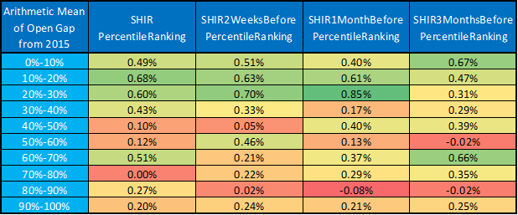

Table 12b: Arithmetic Mean of Relative (SPY adjusted) Open Gap by SHIR PercentileRank deciles - 2015-2021

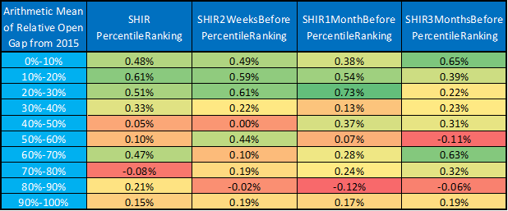

Table 12c: Arithmetic Mean of Close-to-close Return by SHIR PercentileRank deciles - 2015-2021

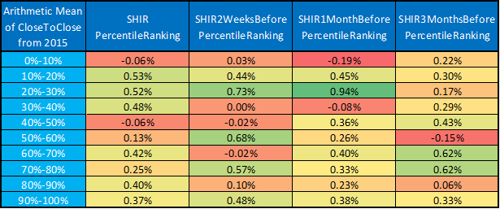

Based on these tables we can conclude again that the **short sellers are really right: one should play the earnings open gap in case of the least shorted companies (SHIR Percentile Rank is below 30-40%) and avoid long positions in case of heavily shorted ones.**

#### Portfolio-based simulation with GameChangers 1-2-3 + ARK Universe

In this subsection, let’s look atagain **how this earnings open gap strategy would have performed in the past**. Table 13 shows the **performance indicators by SHIR Percentile Rank deciles which means that we play only companies whose SHIR Percentile Rank falls within that decile**. In the last three columns the performance of the strategy can be found when we play the two-, three- and four smallest deciles together. During the calculation, a **20% maximum weight/position** was used to avoid the undesirable effect of outliers. Furthermore, **it never invested more than 100% (there is no over-leverage)**. If e.g. there are 10 company reports on a given day, the weight per position is 10%.

Based on Table 13 and Chart 5a-b it can be concluded that **playing the open gap strategy when the SHIR Percentile Rank is below 20% / 30% / 40% is highly profitable: 9.62% / 13.85% / 16.76% CAGR, 13.95% / 14.04% / 14.46% MDD, 1.193 / 1.401 / 1.495 Sharpe- and 0.69 / 0.987 / 1.159 MAR-ratio. It is worth noting that the lower CAGRs compared to the whole ticker universe in the previous subsection is partly due to the lower number of events, partly due to the selection bias.**

Table 14 shows that **the arbitrarily chosen maximum weight per position parameter does not significantly affect the results**.

Again, one may suspect that there may be some outlier data behind the good results. To avert these accusations, we repeated the calculations by **maximizing the outliers** (-15% and +15% minimum and maximum open gap was used in case of outliers). As Table 15 and Chart 6 show, **figures did not change significantly**.

Table 13: Performance indicators of OpenGap strategy by SHIR PercentileRank deciles using 20% max. weight/position - 2005-2021

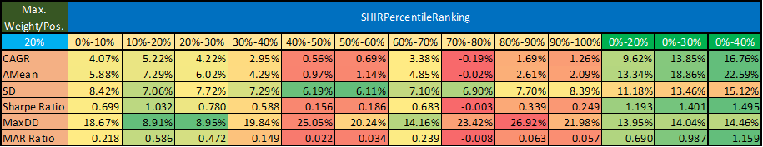

Chart 5a: PV of OpenGap strategy by SHIR PercentileRank deciles using 20% max. weight/position - 2005-2021

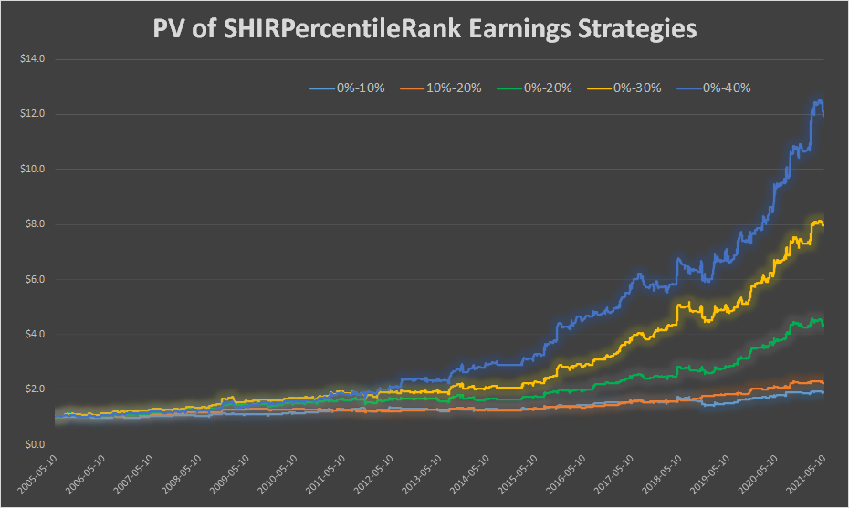

Chart 5b: PV of OpenGap strategy by SHIR PercentileRank deciles using 20% max. weight/position - 2005-2021 - logarithmic scale

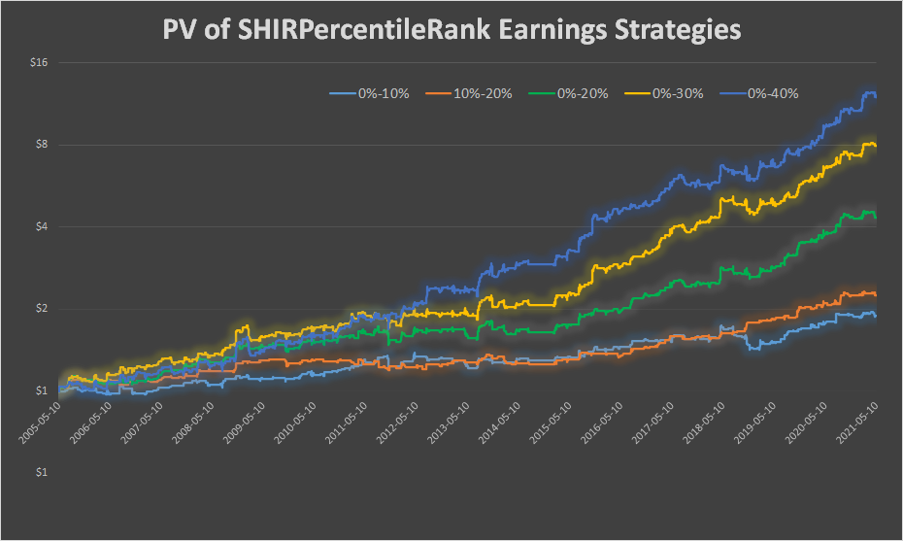

Table 14: Sharpe ratio of OpenGap strategy by SHIR PercentileRank deciles and max. weight/position - 2005-2021

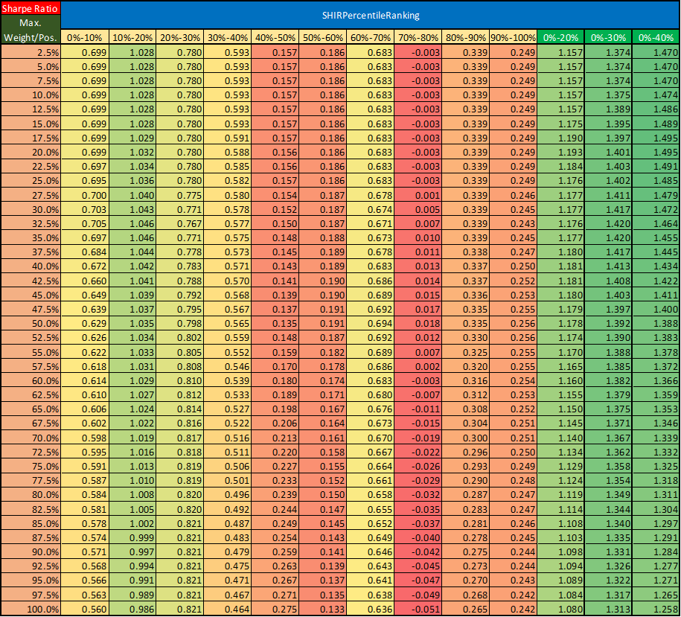

Table 15: Performance indicators of OpenGap strategy w/o outliers by SHIR PercRank deciles using 20% max. weight/position - 2005-2021

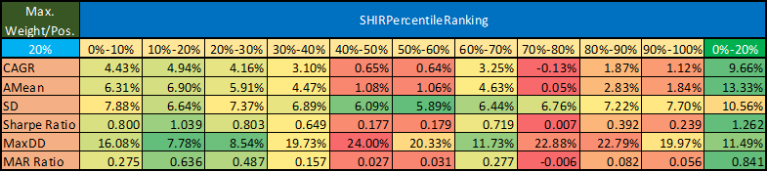

Chart 6: PV of OpenGap strategy w/o outliers by SHIR PercentileRank deciles using 20% max. weight/position - 2005-2021

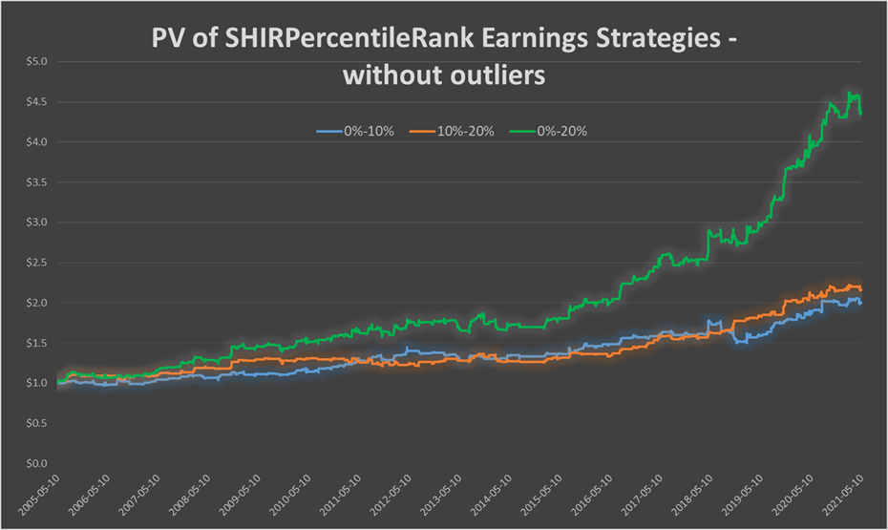

## 

## Earnings Surprise and Price Strength in Previous Quarter

*“An earnings surprise, or unexpected earnings, in accounting, is the difference between the reported earnings and the expected earnings of an entity. Measures of a firm's expected earnings, in turn, include analysts' forecasts of the firm's profit and mathematical models of expected earnings based on the earnings of previous accounting periods.* ***Stock markets tend to react in the same direction as earnings surprises - positively to positive earnings surprises and negatively to negative earnings surprises - although a significant proportion of earnings surprises result in stock markets reacting in the opposite direction, which may be a reaction to other relevant information released with the earnings announcement or inaccurate measurement of the earnings surprise.****”[4]*

In this section, the **effect of the earnings surprise of a given company in the previous quarter on the price movement after the earnings report announcement in the current quarter** is analysed. As in our opinion using only the difference between the estimated and the actual EPS as an ‘earnings success indicator’ is not the most appropriate one (see the above quoted sentences), we **measured the ‘ previous quarter success’ in the following ways**:

* **1-day %change after announcement (T0) (PT0/PT-1-1);**
* **3-day cumulative %change after announcement (T0+T1+T2: PT2/PT-1-1);**
* **5-day cumulative %change after announcement (T0+...+T4: PT4/PT-1-1);**
* **relative difference between estimated and actual EPS ((EPSactual-EPSestimated)/PT-1).**

This potential effect has been analysed for two (not totally distinct) ticker universes from 1999 to 2021:

* **Actual[5] GameChangers 1-2-3 + ARK Universe (300 companies, 6584 events)** and
* **Historical Nasdaq100 Universe (228 different companies, ~100 in every moment, 7047 events).**

In both cases, **announcement events were split into 10 deciles by the above listed ‘previous quarter success’ indicators and by the current quarter actual performance (open gap, 1-day-, 3-day- and 5-day %change after the announcement)** and **the existence of a possible relationship between them was investigated.**

### 

### GameChangers 1-2-3 + ARK Universe

First, **scatter plots and frequency tables** were created based on **one of the success indicators of the previous quarter** (1-day-, 3-day- and 5-day %change after the announcement and relative difference between estimated and actual EPS) and **one of the performance indicators of the current quarter** (open gap, 1-day-, 3-day- and 5-day %change after the announcement) (4x4=16 cases). Chart 7a-c and Table 16a-c contain some of them (further frequency tables can be found in the Appendix).

**Based on these charts and tables it can be concluded that:**

* **After a big movement in the previous quarter right after the earnings report (1-day-, 3-day- and 5-day %change after the announcement) (Deciles 1 and 10), another large %change can be predicted in the current season with non-negligible probability in either way;**
* **If the report induced only a small change in the previous quarter (Deciles 4-7), then there is a good chance it will be so in the current quarter;**
* **Relative difference between estimated and actual EPS in the previous quarter has almost no effect on the movement of the current season.**

Chart 7a: Scatter plot of current quarter open gap by previous quarter 3-day %change deciles

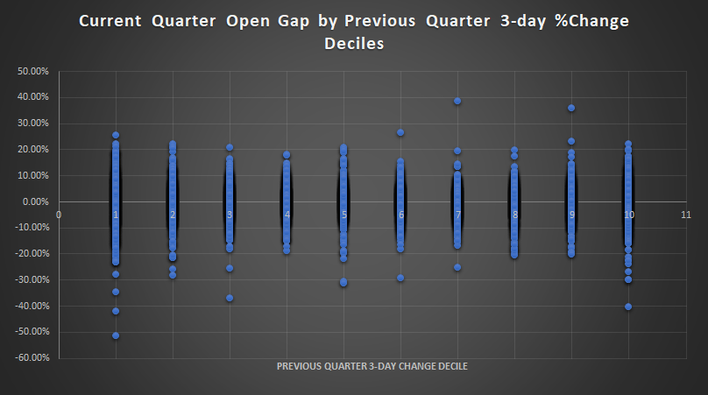

Chart 7b: Scatter plot of current quarter 1-day %change after announcement (T0) by previous quarter 1-day %change deciles

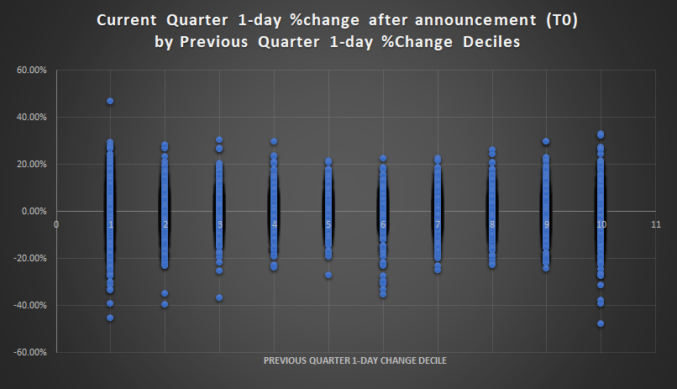

Chart 7c: Scatter plot of current quarter 1-day %change after announcement (T0) by previous quarter relative difference between estimated and actual EPS deciles

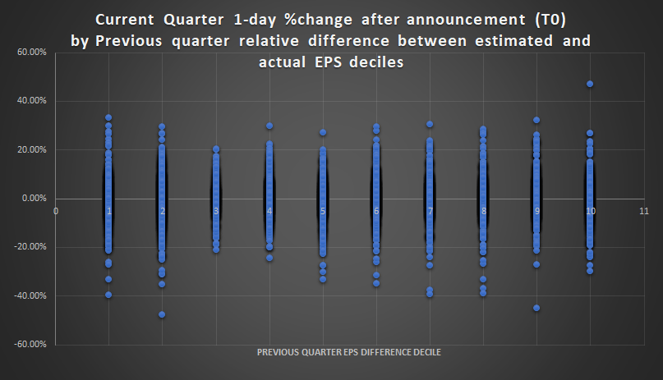

Table 16a: Number of earnings announcements by current quarter open gap and previous quarter 3-day %change deciles

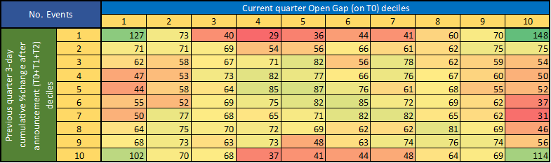

Table 16b: Number of earnings announcements by current quarter 1-day %change after announcement (T0) and previous quarter 1-day %change deciles

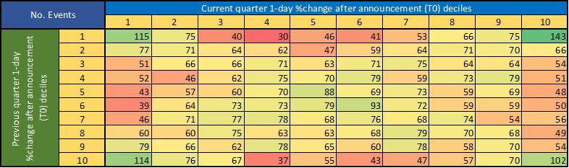

Table 16c: Number of earnings announcements by current quarter 1-day %change after announcement (T0) and previous quarter relative difference between estimated and actual EPS deciles

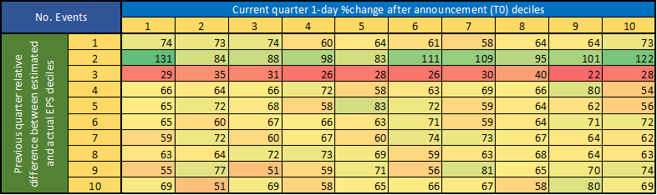

After that, Table 17a-d shows **arithmetic means and standard deviations of price movement in the actual quarter split by the ‘success’ indicator deciles of the previous quarter**. After analysing these tables one can conclude that:

* **Worst performing companies after last quarter’s report (Decile 1) have the best average profit after the current report announcement but this decile has the biggest SD as well. Furthermore, Decile 2 is much weaker in all of the cases which means that the relative good performance of Decile 1 is probably due to some outliers and chance.**
* **Relative difference between estimated and actual EPS in the previous quarter has almost no effect on the movement of the current season.**

Table 17a: Arithmetic mean and standard deviation of current quarter x-day %change by previous quarter 1-day %change deciles

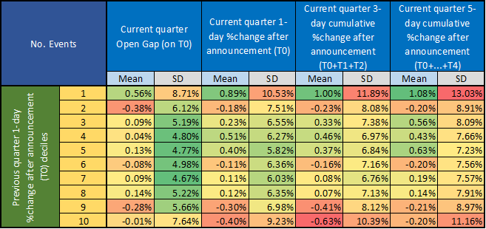

Table 17b: Arithmetic mean and standard deviation of current quarter x-day %change by previous quarter 3-day %change deciles

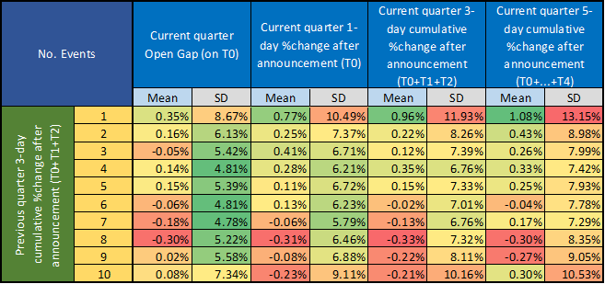

Table 17c: Arithmetic mean and standard deviation of current quarter x-day %change by previous quarter 5-day %change deciles

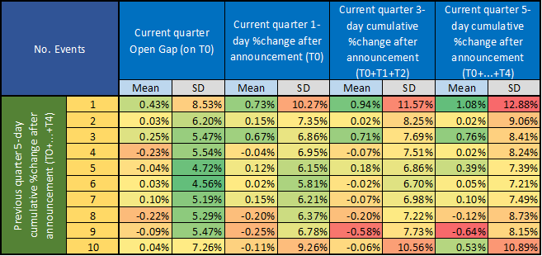

Table 17d: Arithmetic mean and standard deviation of current quarter x-day %change by previous quarter relative difference between estimated and actual EPS deciles

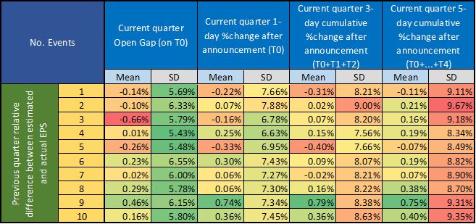

It has to be emphasized again, that **although the worst performing companies after last quarter’s report (Decile 1) have the best average profit after the current report announcement, this decile has the biggest SD as well**. This can cause **wild fluctuation in portfolio value** if someone would like to play a strategy based on this. For example, the portfolio value of the **‘Long T0 in current quarter if T0 was in the lowest decile (D1) in the previous quarter’** strategy would have been performed as it can be seen in Chart 8a despite the **+0.89%** average return (Table 17a, Chart 7b). In addition, the fact must also be taken into account that **Decile 2 is much weaker in all of the cases which means that the relative good performance of Decile 1 is probably due to some outliers and chance.** To illustrate its effect on the portfolio value, a chart (Chart 8b) has also been prepared where the evolution of the portfolio value of the **‘Long T0 in current quarter if T0 was in the second lowest decile (D2) in the previous quarter’ strategy (with -0.18% average)** can be seen. **The difference speaks for itself.** And let’s keep in mind that **if a stock were in the 9.99th percentile, it would belong to D1, but with a slightly better return, such as in the 10.01th percentile, it would already be in the second decile.**

**In addition to the above, looking at all deciles, no trend can be detected among their averages (neither bullish nor bearish). That is why this seemingly significant ‘previous worst decile (D1)’ return can not be exploited.**

Chart 8a: PV of ‘Long current quarter 1-day after announcement (T0) if previous quarter 1-day %change was in the lowest decile (D1)’

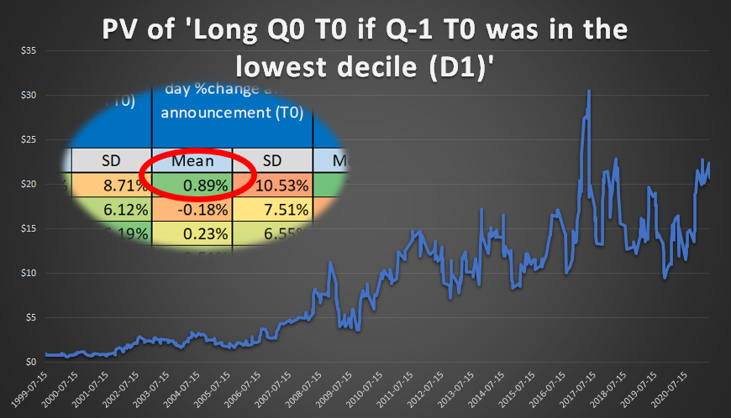

Chart 8b: PV of ‘Long current quarter 1-day after announcement (T0) if previous quarter 1-day %change was in the second lowest decile (D2)’

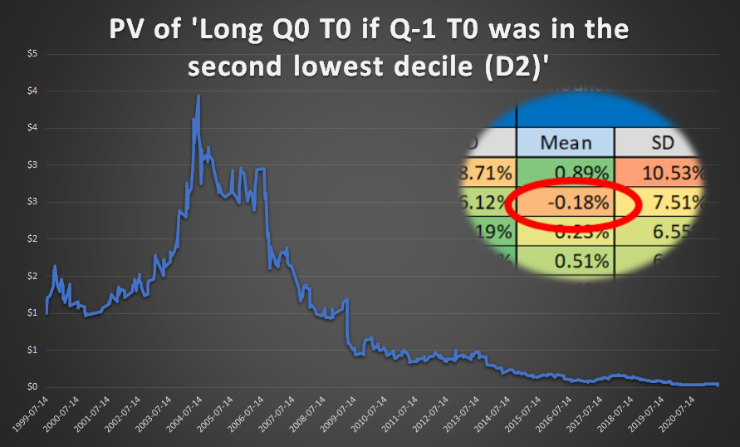

### Nasdaq100 Universe

After investigating the current GameChanger 1-2-3 and ARK universe (which stocks performed well on average recently) **one might wonder if this would be the case for Nasdaq100 companies as well. Or are these ‘extreme’ results due to selection bias?**

Chart 9a-c and Table 18a-19d show the same content as before with **almost the same figures. It means that our previous conclusions are true in the case of the Nasdaq100 universe as well.**

**In our opinion, there may be two (somewhat related) explanations:**

* **If a company presented very good or very bad results in the previous quarter (after which there was an extremely large price movement), investors expect that in the current season as well. And if the company manages to meet expectations again or successfully refutes very pessimistic forecasts, it can easily induce a big increase in price. However, otherwise a huge fall in the stock price is also conceivable.**
* **In the case of some companies (e.g. NFLX is one of their most prominent representatives), the earnings report always has a huge impact on stock prices. Sometimes it is positive, sometimes negative. But negligible movement is almost unimaginable.**

**Based on all of the above conclusions we do not recommend using the earnings surprise in the previous quarter as a part of our SQ Earnings Score system. However, it may be used for weighting, e.g. if it fell into extreme deciles in the previous quarter, then we expect high volatility in this quarter, therefore let’s reduce its position size now.**

Chart 9a: Scatter plot of current quarter open gap by previous quarter 3-day %change deciles

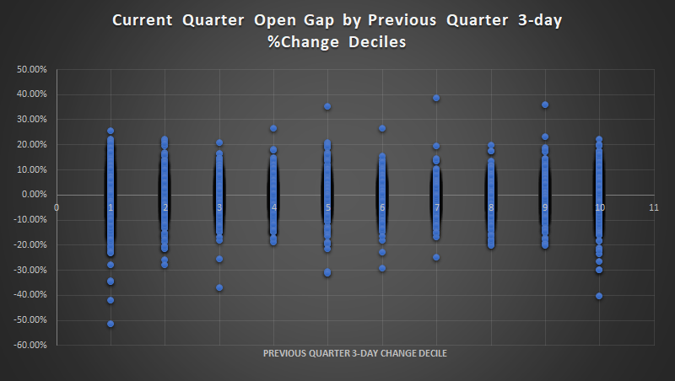

Chart 9b: Scatter plot of current quarter 1-day %change after announcement (T0) by previous quarter 1-day %change deciles

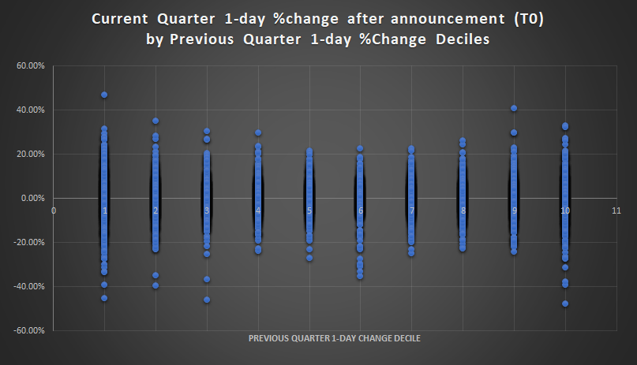

Chart 9c: Scatter plot of current quarter 1-day %change after announcement (T0) by previous quarter relative difference between estimated and actual EPS deciles

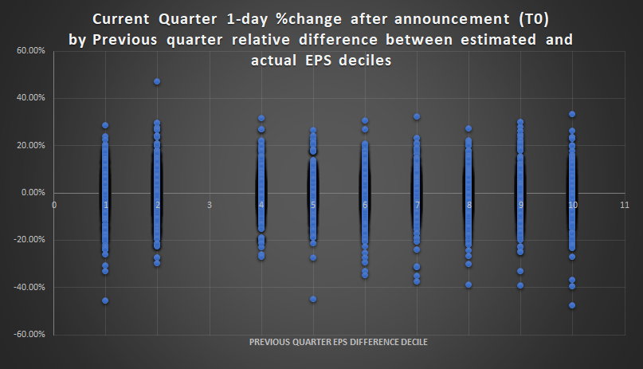

Table 18a: Number of earnings announcements by current quarter open gap and previous quarter 3-day %change deciles

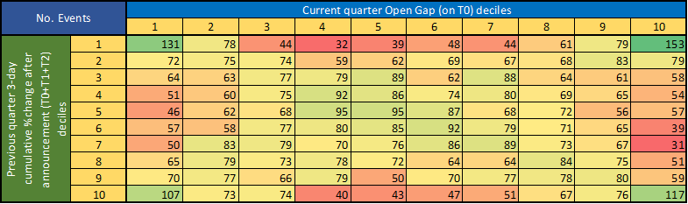

Table 18b: Number of earnings announcements by current quarter 1-day %change after announcement (T0) and previous quarter 1-day %change deciles

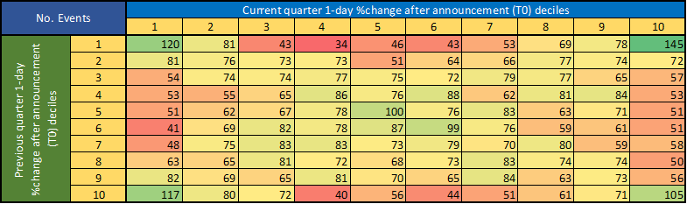

Table 18c: Number of earnings announcements by current quarter 1-day %change after announcement (T0) and previous quarter relative difference between estimated and actual EPS deciles

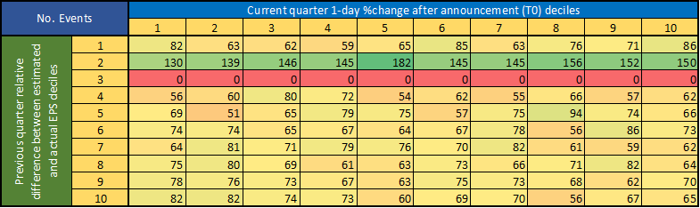

Table 19a: Arithmetic mean and standard deviation of current quarter x-day %change by previous quarter 1-day %change deciles

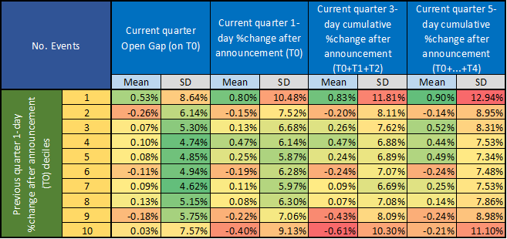

Table 19b: Arithmetic mean and standard deviation of current quarter x-day %change by previous quarter 3-day %change deciles

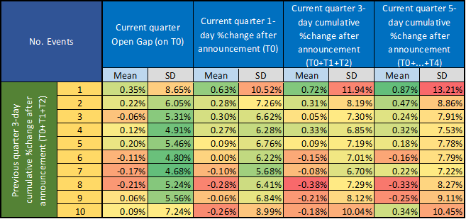

Table 19c: Arithmetic mean and standard deviation of current quarter x-day %change by previous quarter 5-day %change deciles

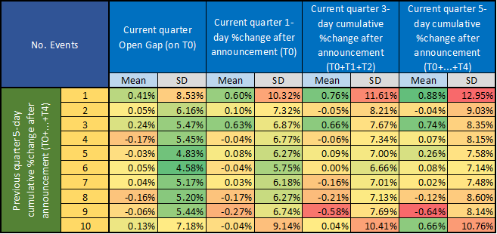

Table 19d: Arithmetic mean and standard deviation of current quarter x-day %change by previous quarter relative difference between estimated and actual EPS deciles

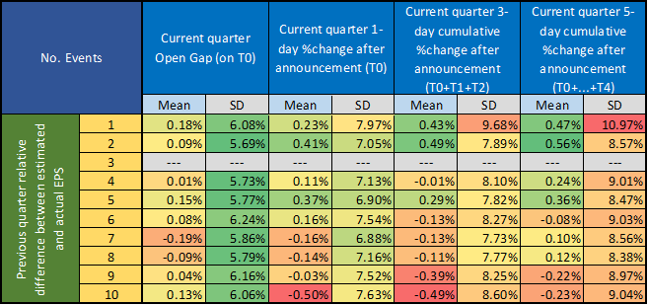

# 

# **Conclusions**

Our main goal with this study was reconfirming and improving our SQ Earnings Score system.

First, the effect of short interest ratio (SHIR) on open gap on T0 was examined deeper. We have found that **the short sellers are really right: one should buy the earnings open gap in case of the least shorted companies (SHIR Percentile Rank is below 20%) and avoid buying in case of heavily shorted ones.**

Second, the **earnings surprise and price strength in the previous quarter** was investigated. We found that after a huge price movement in the previous quarter after the announcement often induces another significant change in either direction in the current quarter. But this pattern can not be exploited in our opinion, thus **it is not recommended using this indicator in our SQ Earnings Score system**.

This study will be expanded with a number of additional chapters in the near future.

# **Appendix**

## Earnings Surprise and Price Strength in Previous Quarter

### GameChangers 1-2-3 + ARK Universe

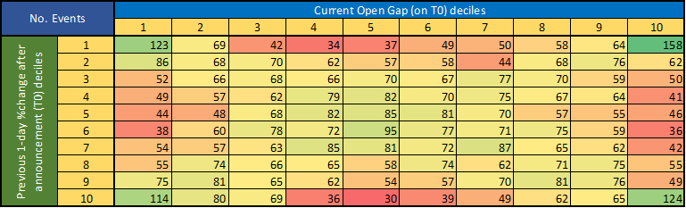

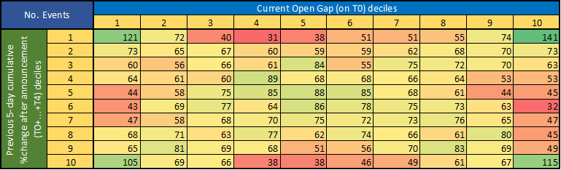

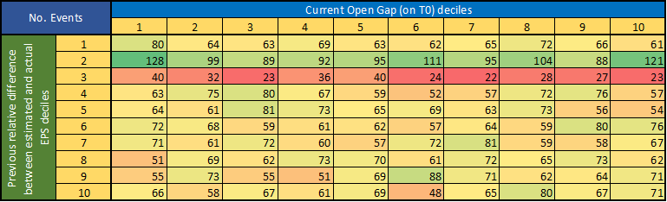

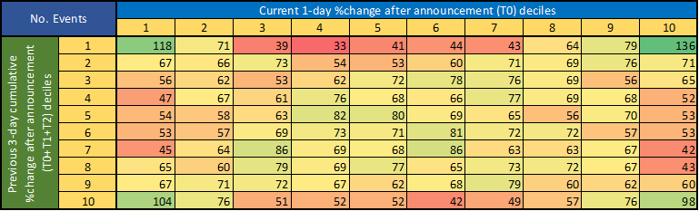

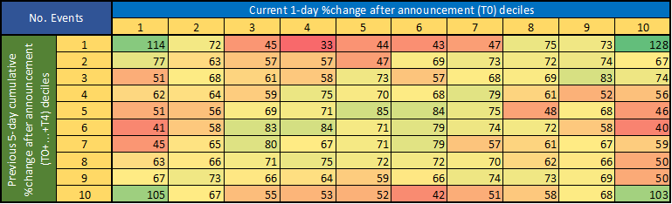

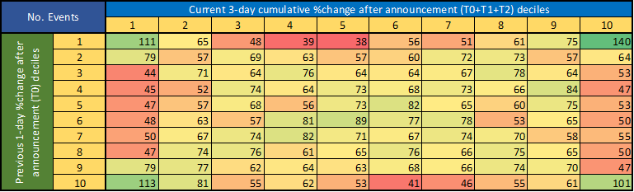

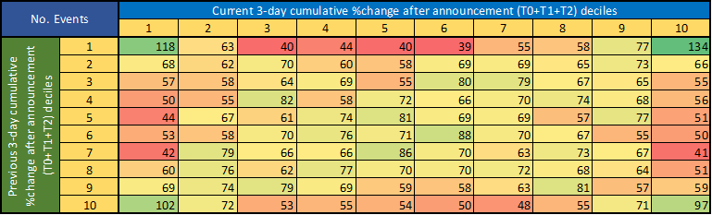

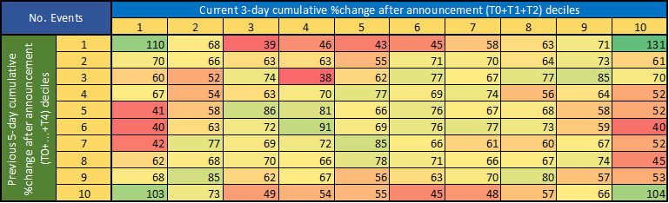

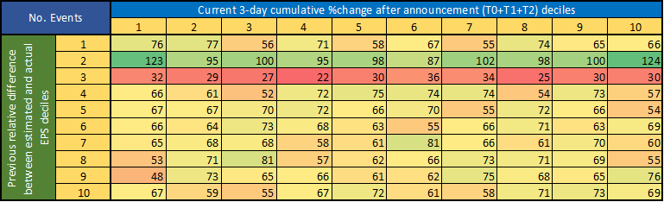

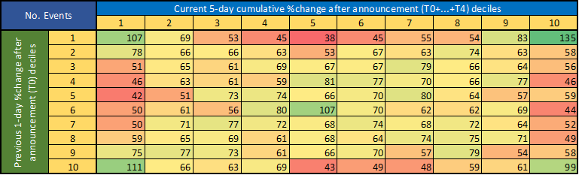

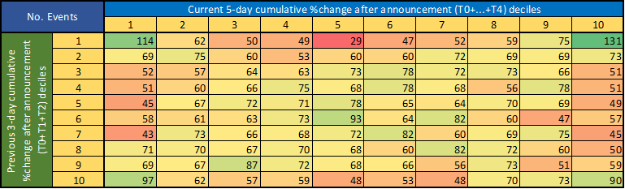

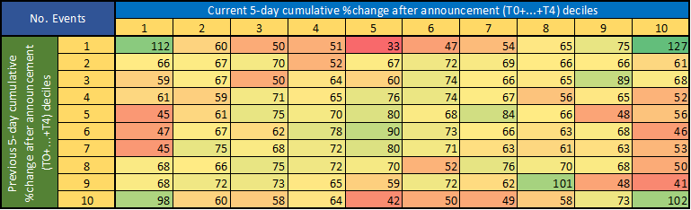

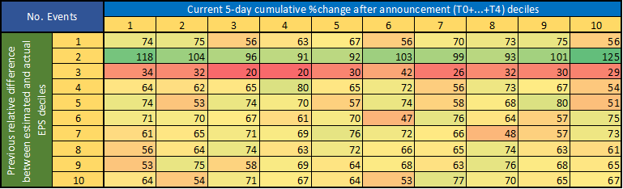

### Nasdaq100 Universe

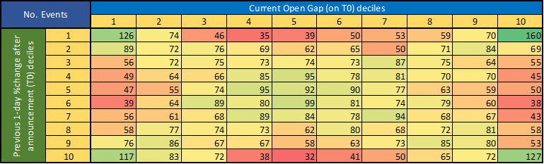

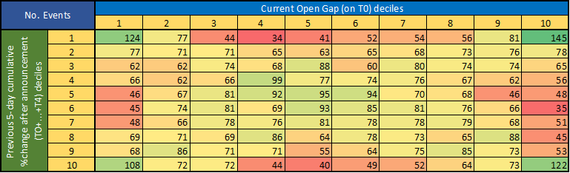

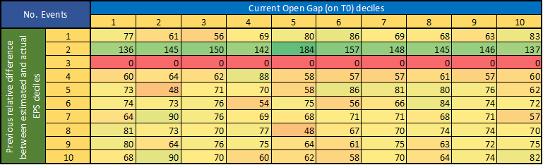

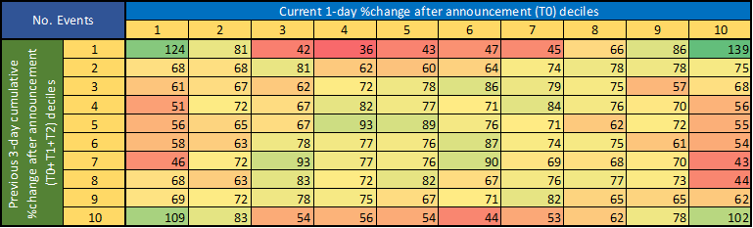

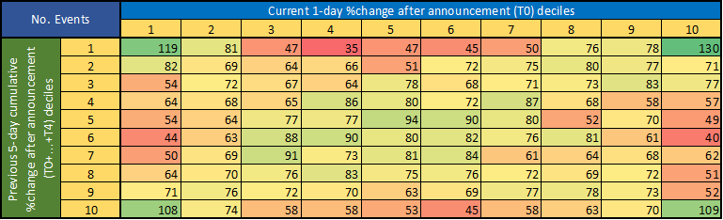

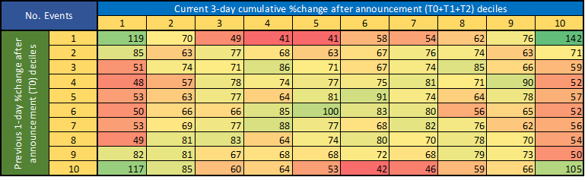

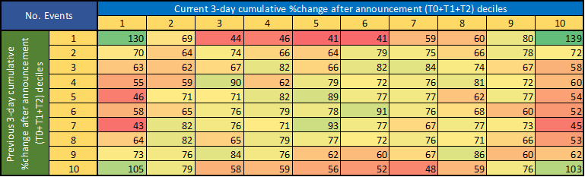

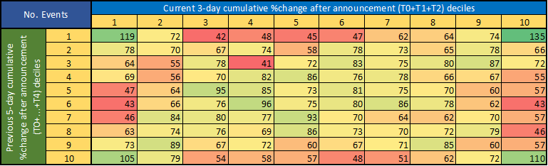

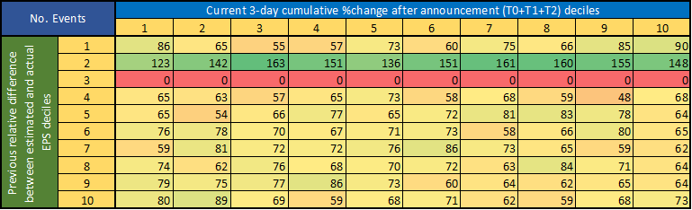

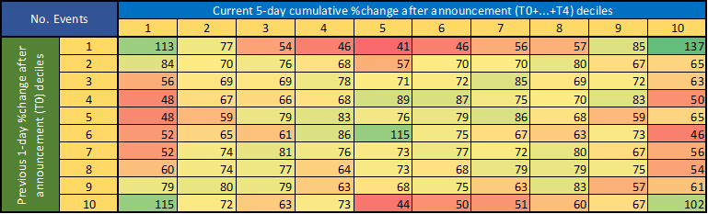

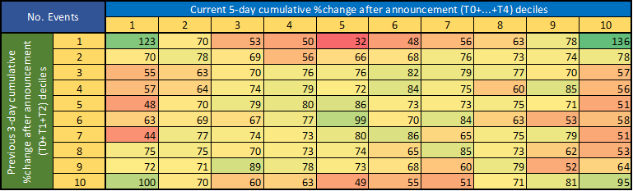

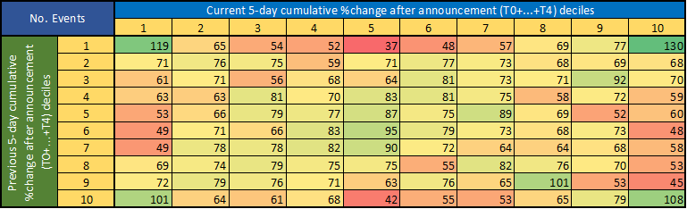

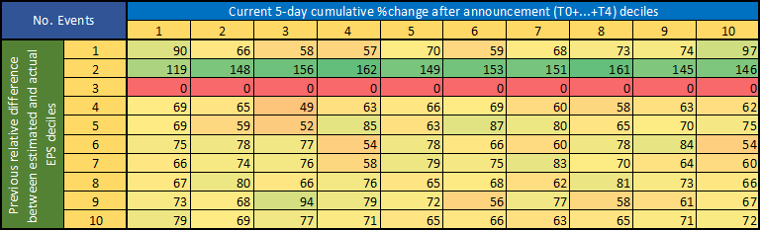

1. https://www.investopedia.com/terms/e/earnings-announcement.asp
2. https://www.investopedia.com/terms/s/shortinterestratio.asp
3. As on 2021-05-31. Not historical.
4. https://en.wikipedia.org/wiki/Earnings_surprise
5. As on 2021-05-31. Not historical.