Dr. George Antal

3D Click Limited

c/o Suite 431, 28 Old Brompton Road, London SW7 3SS

**Analysis of Zacks Rank System**

**Motivation** **1**

**Results** **2**

Monthly performance of stocks based on Zacks Ranks 2

S&P500 + Nasdaq100 + GameChanger 1-2-3 + ARK Universe 2

Nasdaq100 + GameChanger 1-2 + ARK Universe 8

Performance of stocks after Zacks Rank changes 14

S&P500 + Nasdaq100 + GameChanger 1-2-3 + ARK Universe 15

Nasdaq100 + GameChanger 1-2 + ARK Universe 16

**Conclusions** **17**

# **Motivation**

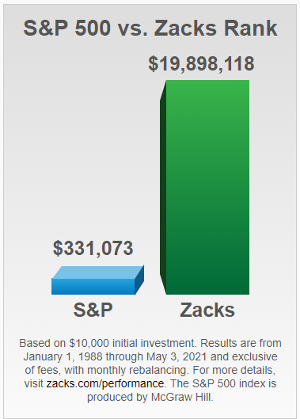

*‘In 1978, Zacks' Founder and CEO hit upon a key discovery: earnings estimate revisions are the most powerful force impacting stock prices. With this crucial finding, he developed the Zacks Rank to harness the power of earnings estimates.*

*For more than a quarter century, it has more than doubled the S&P 500 with an average gain of +25.57% per year. These returns cover a period from January 1, 1988 through May 3, 2021.’[1]*

In this system, the most promising stocks get Rank 1, while Rank 5 indicates the worst expected performance.

Based on these numbers, we wonder if this Zacks Ranks system is really as good an indicator as they claim. In this brief study, we have checked if this rank system can be used somehow in real life.

# 

# **Results**

In this chapter, our own calculations and results are presented. Their performance disclosure can be read [here](https://www.zacks.com/performance_disclosure/). It can be read there that their calculating and rebalancing method varies from time to time. So **it was not our goal to replicate their incredibly good performance numbers but to check if this rank system can be used somehow in real life.**

The used data (adjusted close prices and Zacks Ranks) come from our database. It contains about **70K Zacks Rank changes from 2008 to 2021** with longer or shorter gaps before 2017. This contains only **historical S&P500 (from 1999), historical Nasdaq100 (from 1999), historical GCh 1 (from 2015-05) - 2 (from 2018-05) - 3 (from 2020-08) and historical ARK (from 2021-04) universes, which is 1022 tickers together.**

## Monthly performance of stocks based on Zacks Ranks

In this section, **monthly average performance of stocks is presented based on their Zacks Rank**. During the calculations, **end-of-month adjusted close prices and ranks** were used. First, the performance of the **whole S&P500 + Nasdaq100 + GameChanger 1-2-3 + ARK universe** was analysed. After that, only **Nasdaq100 + GameChanger 1-2 + ARK** stocks were kept.

### S&P500 + Nasdaq100 + GameChanger 1-2-3 + ARK Universe

Before embarking on a detailed analysis, it is worth taking a look at the **distribution of ranks**. Chart 1 shows how the members of our universe are distributed among each rank on 2021-04-30. It can be seen that only about 3% of stocks belong to Rank 1 and Rank 5, about 16% to Rank 2 and Rank 4, while almost 63% of stocks have Rank 3.

Chart 1: Distribution of stocks by Zacks Ranks on 2021-04-30 - S&P500 + Nasdaq100 + GameChanger 1-2-3 + ARK Universe

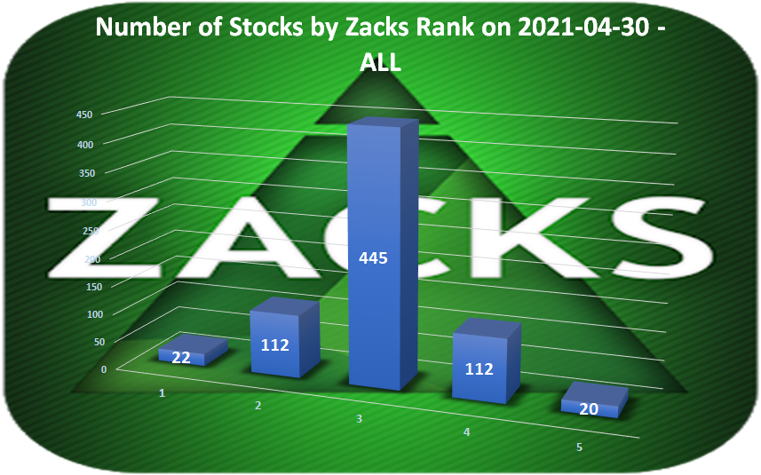

Table 1a-b show **arithmetic mean** (also can be seen in Chart 2), **median and quartile mean**[2] of monthly returns and **number of samples** by Zacks Rank and year. **Based on these figures it can be concluded that stocks with the best rank numbers do not have a clear advantage, in fact, those with the worst rank have performed even better on average (mean reversion?). Furthermore, stocks in the Rank 2 group have the worst result on average.**

**The analysis of variance (ANOVA) test ended with a result of F=1.714 and p=0.144 which means that there is no significant difference in the performance of each group. In other words, our analysis failed to support the Zacks’ result that the Rank 1 group has performed better than the higher rank groups.**

Table 1a: Arithmetic Mean of monthly returns and number of samples by Zacks Rank and year

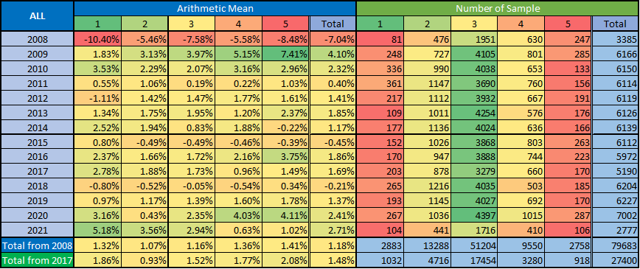

Table 1b: Median and Quartile Mean of monthly returns by Zacks Rank and year

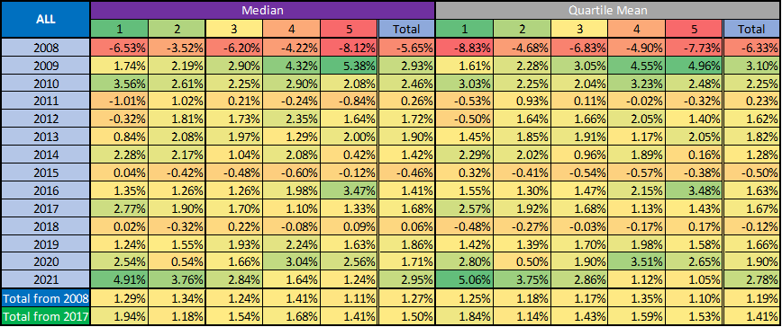

Chart 2: Arithmetic mean of monthly returns - S&P500 + Nasdaq100 + GameChanger 1-2-3 + ARK Universe

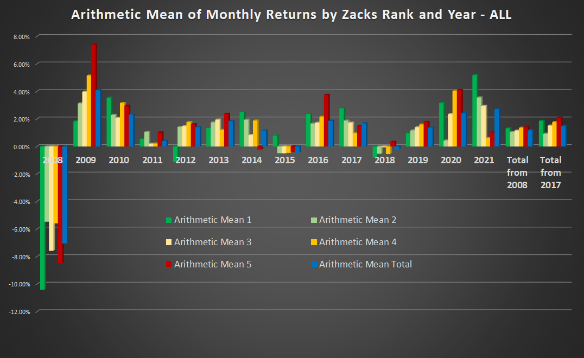

Chart 3 contains the **density plot of monthly returns by Zacks Rank** from 2008 to 2021. It can be concluded that **the density of each group is almost similar with almost the same skewness**. **Rank 2-4 have somewhat higher kurtosis than Rank 1 and 5 have, partly because of the higher number of samples. This figure also confirms our previous conclusions.**

Chart 3: Density plot of monthly returns by Zacks Rank from 2008 to 2021 - S&P500 + Nasdaq100 + GameChanger 1-2-3 + ARK Universe

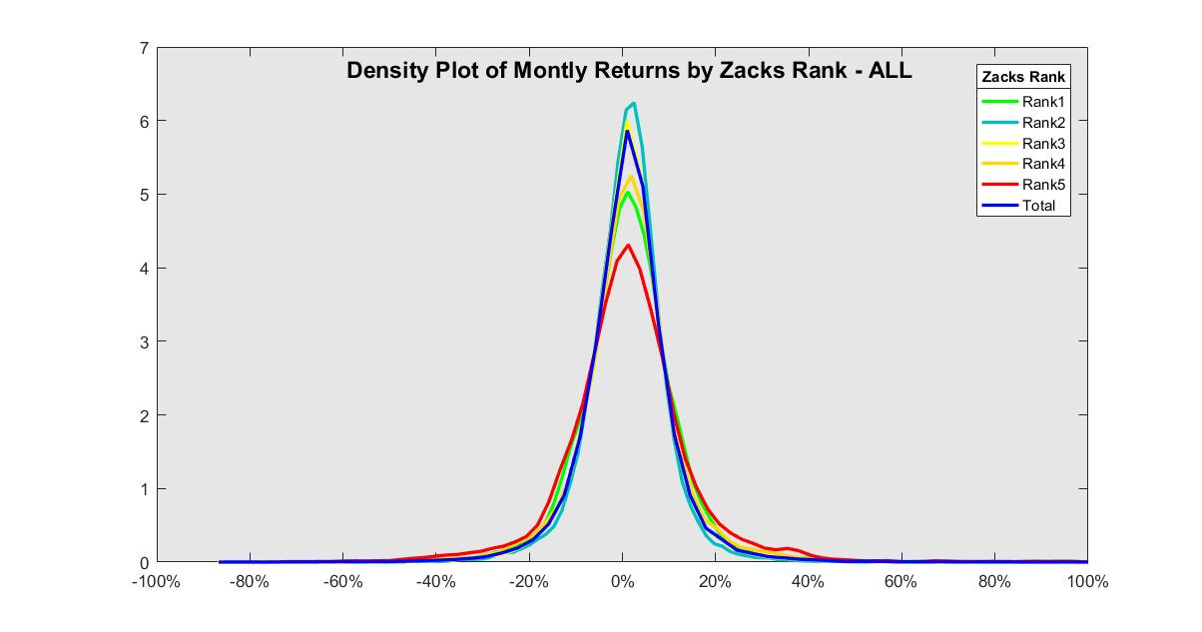

It’s also worth taking a look at the **monthly breakdown of results** (Table 2a-c). Especially in periods when regime changes or corrections have taken place. However, it should also be kept in mind that the **number of samples is quite low in some cases, so the results may be skewed by outliers**.

Table 2a: Arithmetic Mean of monthly returns and number of samples by Zacks Rank and month - from 2008 to 2012

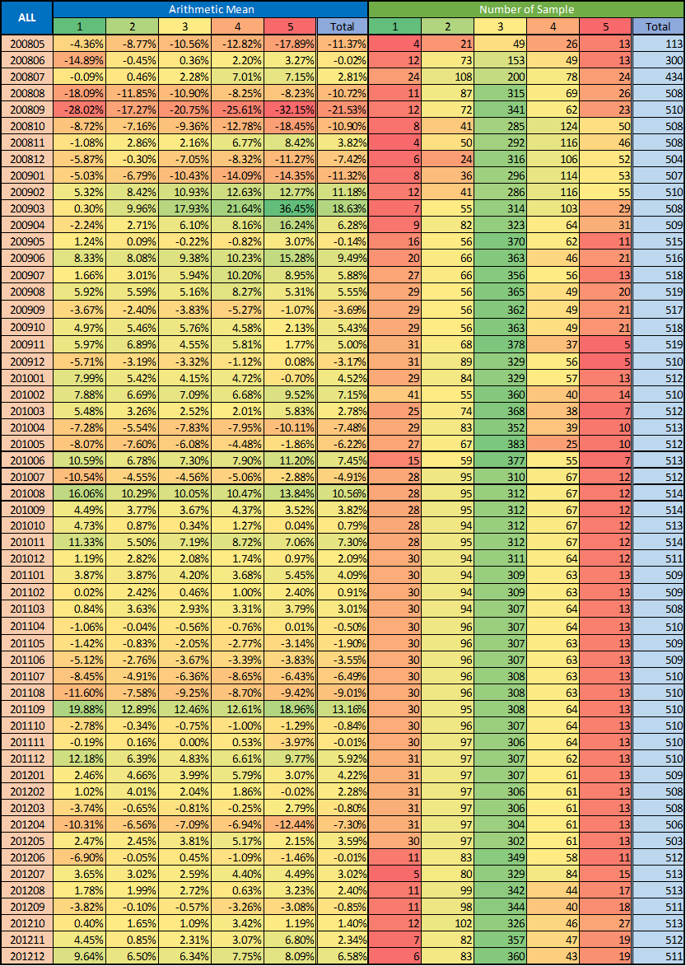

Table 2b: Arithmetic Mean of monthly returns and number of samples by Zacks Rank and month - from 2013 to 2016

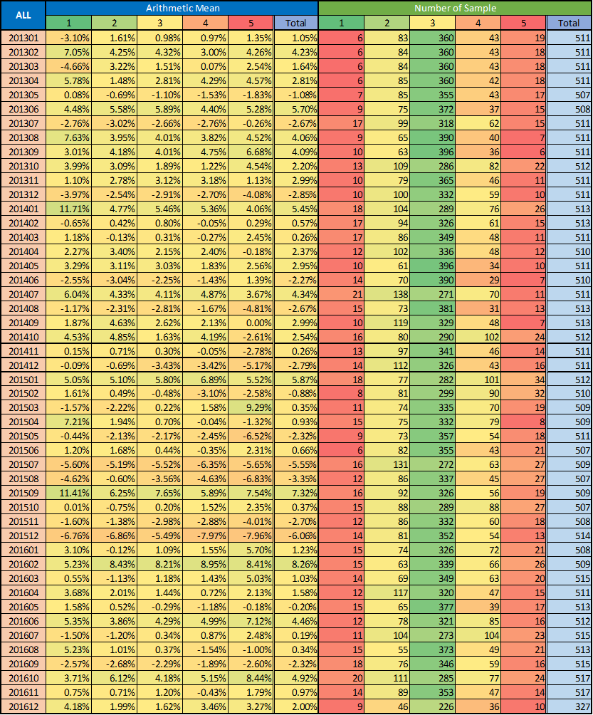

Table 2c: Arithmetic Mean of monthly returns and number of samples by Zacks Rank and month - from 2017 to 2021

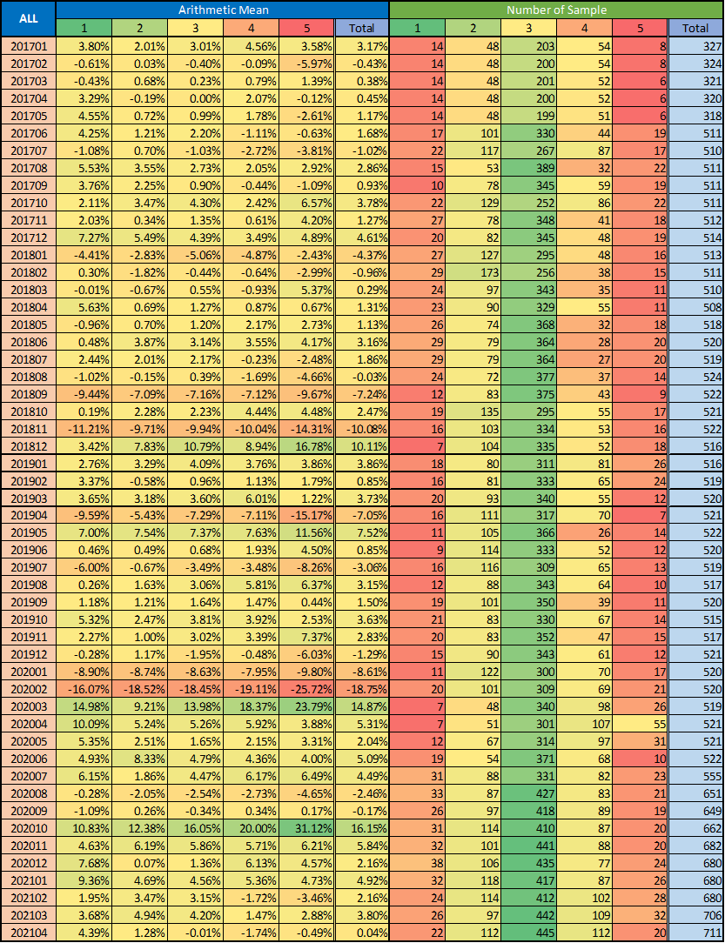

### Nasdaq100 + GameChanger 1-2 + ARK Universe

In this subsection, the **above analyses are repeated with a narrower ticker universe: only historical Nasdaq100 + historical GameChanger 1-2 + historical ARK stocks**. It is worth noting that **these are mostly technology companies. Therefore, the results may differ slightly from those we saw earlier.**

Based on the following charts and tables it can be concluded that the **above figures did not change significantly. Some minor differences:**

* **Aggregating all history, the distribution of ranks is not as symmetric as above: there are more companies in Rank 1-2 groups than in Rank 4-5 groups in the long term (although this is contradicted by the Chart 4 describing the snapshot of the current situation).**
* **Rank 1-2 groups have slightly better performance than Rank 4-5 groups, but unfortunately the difference is not statistically significant even now using monthly averages from 2008 to 2021 (ANOVA: F=0.915; p=0.454).**
* **Density functions of monthly returns are not as symmetrical as above. Rank 1-2 groups have some negative-, while Rank 4-5 groups have some positive skewness.**

Chart 4: Distribution of stocks by Zacks Ranks on 2021-04-30 - Nasdaq100 + GameChanger 1-2 + ARK Universe

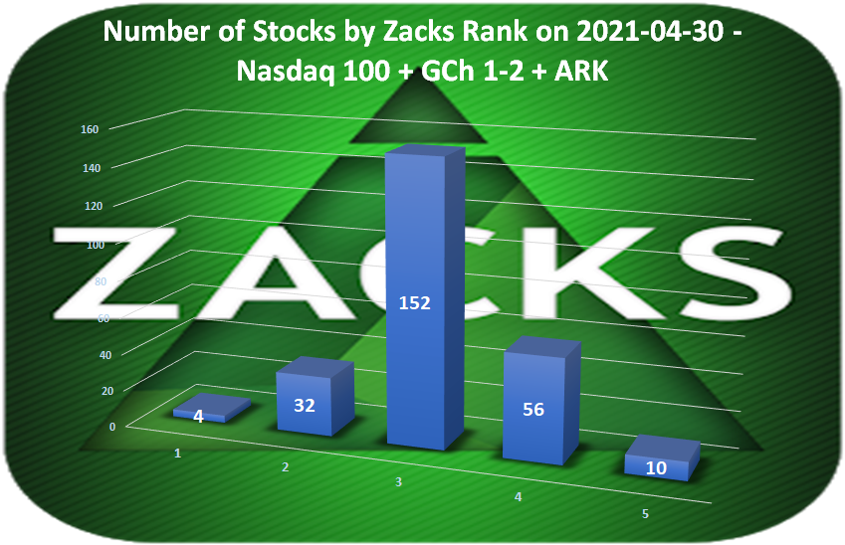

Table 3a: Arithmetic Mean of monthly returns and number of samples by Zacks Rank and year

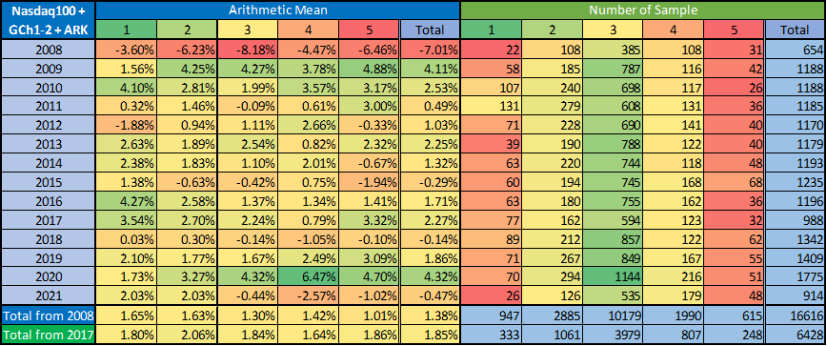

Table 3b: Median and Quartile Mean of monthly returns by Zacks Rank and year

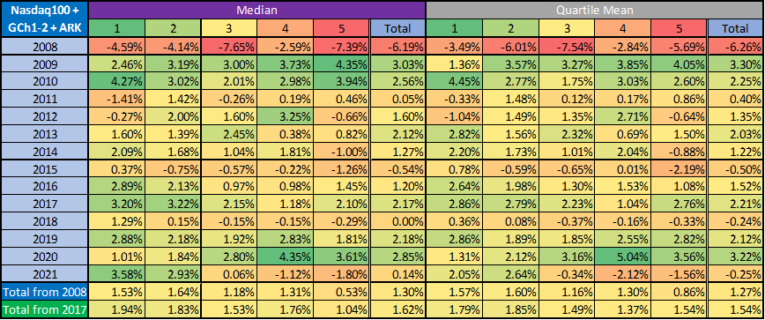

Chart 5: Arithmetic mean of monthly returns - Nasdaq100 + GameChanger 1-2 + ARK Universe

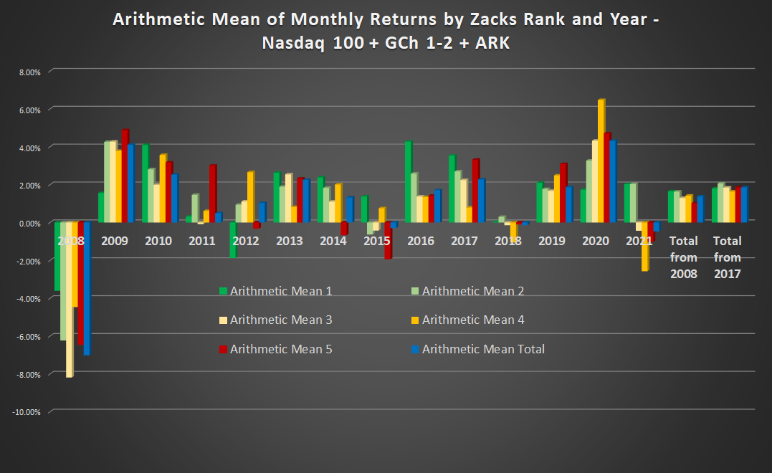

Chart 6: Density plot of monthly returns by Zacks Rank from 2008 to 2021 - Nasdaq100 + GameChanger 1-2 + ARK Universe

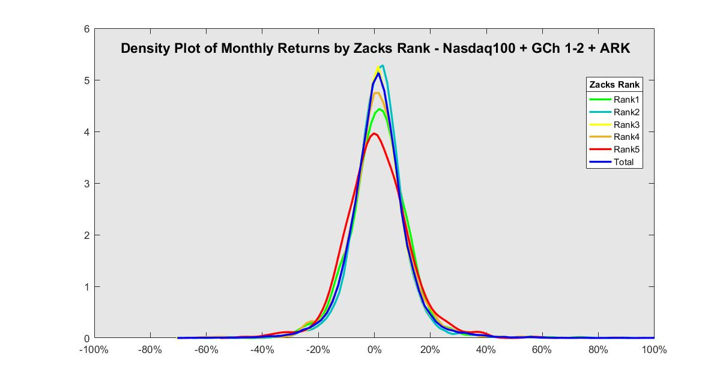

Table 4a: Arithmetic Mean of monthly returns and number of samples by Zacks Rank and month - from 2008 to 2012

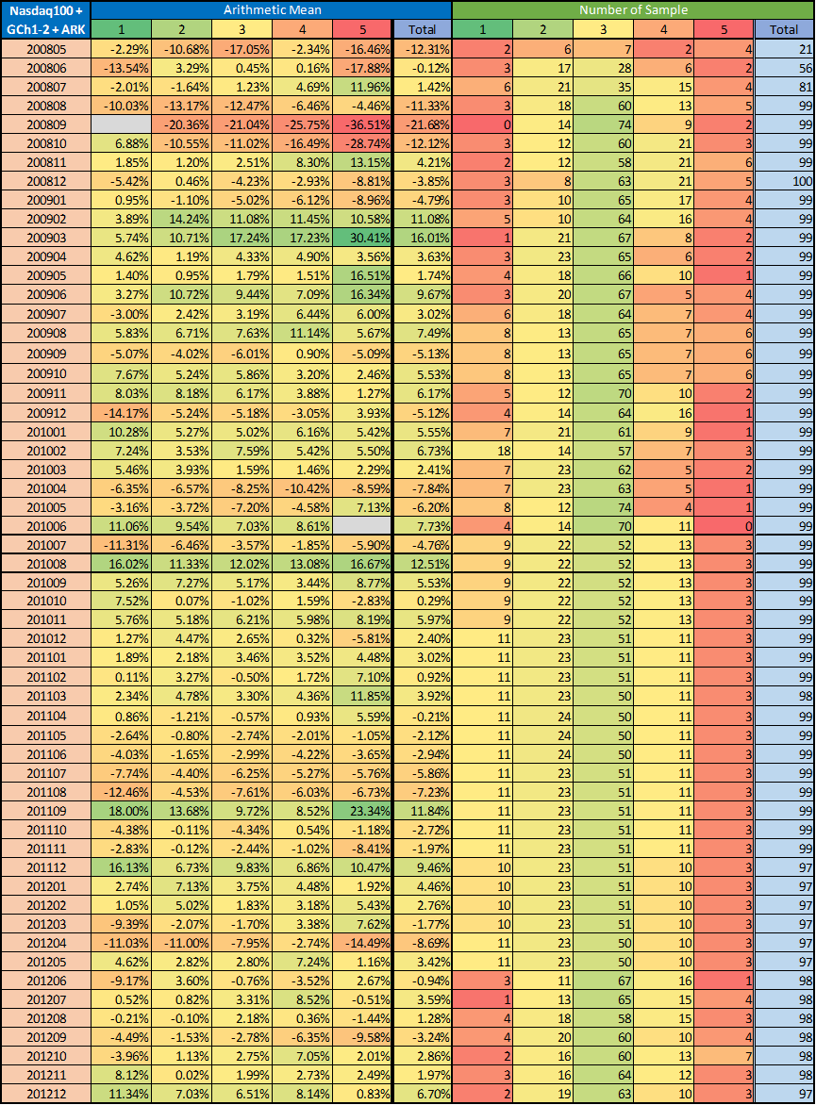

Table 4b: Arithmetic Mean of monthly returns and number of samples by Zacks Rank and month - from 2013 to 2016

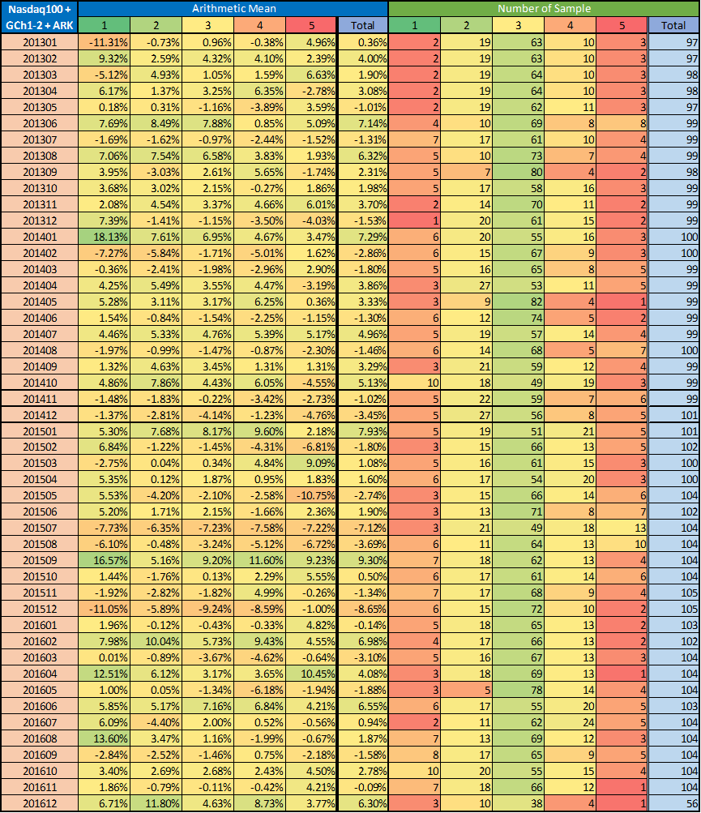

Table 4c: Arithmetic Mean of monthly returns and number of samples by Zacks Rank and month - from 2017 to 2021

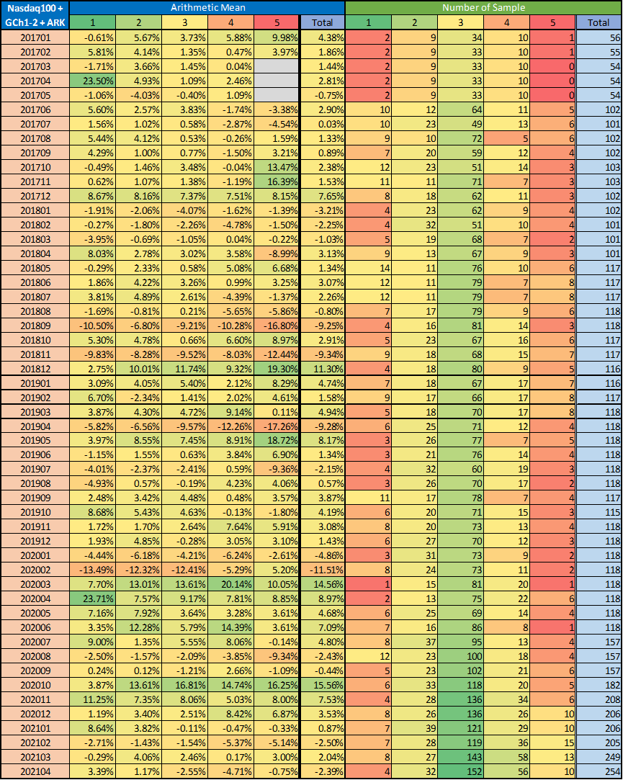

## Performance of stocks after Zacks Rank changes

In this short section, we are dealing with **rank level and changes in rank together**. In one of our previous studies (‘[Thorough Analysis of Analyst Ratings](https://docs.google.com/document/d/1YupIf59pQx9SGC6ML8Qcv3S1bF6p3cyjDPvnqB1dYks)’), we have found that **not only the analyst rating itself but the action (upgrade vs. downgrade) is also important**.

In the following tables (Table 5a-6b) the arithmetic mean, quartile mean and median of 1-day, 5-day, 2-week, 1-month and 3-month percent changes of stock prices after a Zacks downgrade or upgrade (i.e. change in rank) can be found split by new and old level.

As it can be seen in Chart 7 - which shows **distribution of the changes from 2008 to 2021** -, stocks are generally **upgraded or downgraded by one (or possibly two) level**. It means that some results in the following tables (for changes of more than 2 levels) are not significant due to the lack of enough samples (especially in case of the narrowed universe). Only bold numbers should be taken into account.

**Based on these tables it can be concluded that although a two-level upgrade can have an above average positive effect on stock price in subsequent days/months, stocks may perform just as well after downgrades. It means that there is no significant and exploitable pattern after change in rank.**

Chart 7: Distribution of Zacks Rank changes from 2008 to 2021 - S&P500 + Nasdaq100 + GameChanger 1-2-3 + ARK Universe

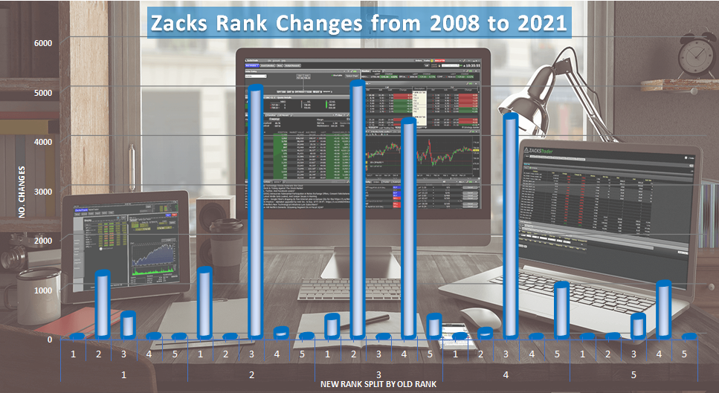

### 

### S&P500 + Nasdaq100 + GameChanger 1-2-3 + ARK Universe

Table 5a: Arithmetic mean, quartile mean and median of x-day %changes after Zacks Rank changes by new and old level - from 2008

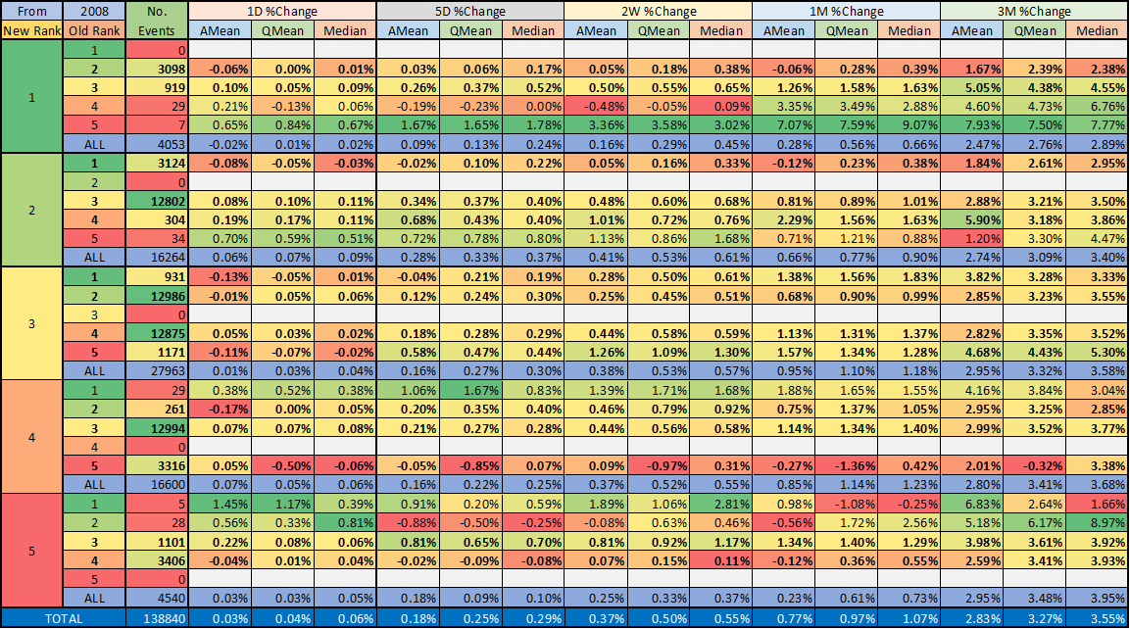

Table 5b: Arithmetic mean, quartile mean and median of x-day %changes after Zacks Rank changes by new and old level - from 2017

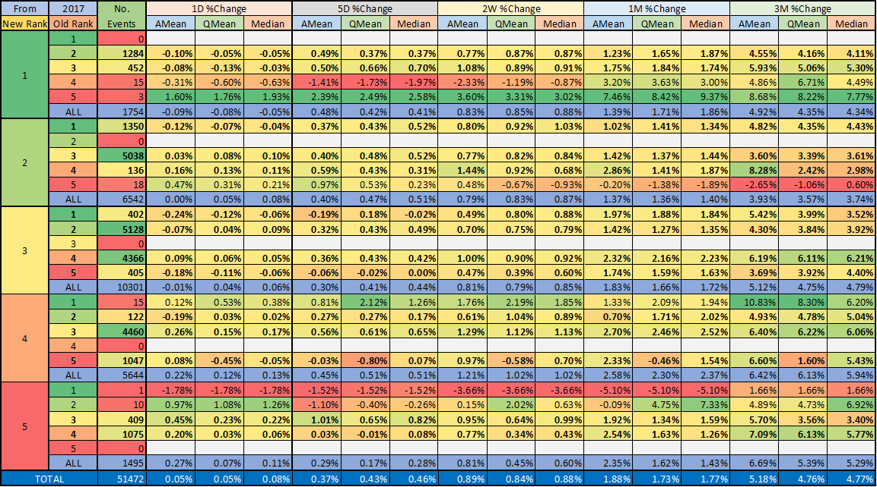

### Nasdaq100 + GameChanger 1-2 + ARK Universe

Table 6a: Arithmetic mean, quartile mean and median of x-day %changes after Zacks Rank changes by new and old level - from 2008

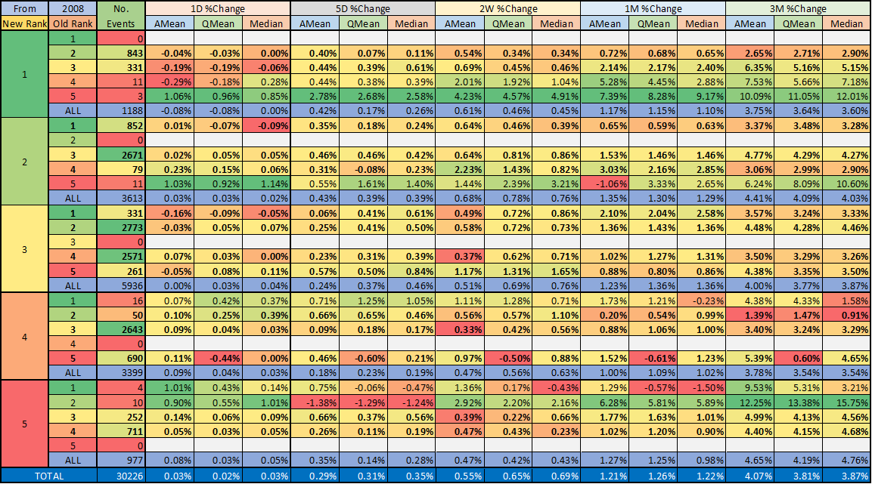

Table 6b: Arithmetic mean, quartile mean and median of x-day %changes after Zacks Rank changes by new and old level - from 2017

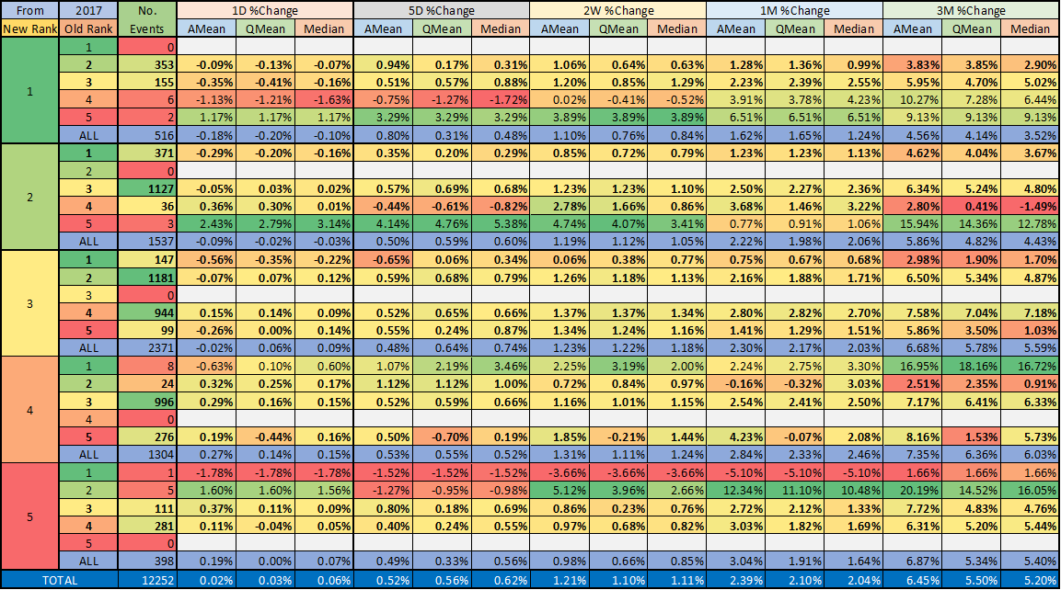

# **Conclusions**

In this study, the **Zacks Rank system was analysed briefly**. Using **end-of-month ranks and stock prices from 2008**, we found that **there is no statistically significant difference in average monthly returns of different ranks. There may be a slight positive relationship between rank and subsequent monthly return for technology companies (Nasdaq 100 + GCh 1-2 + ARK universe). In addition, the change in rank level does not have any significant effect on subsequent return.**

**We do not claim that this Zacks Rank system cannot be used or that their results are unrealistic. But for the stock universes we examined, we found no significant performance difference between each rank.**

**Reasons for this and for results that differ from the numbers they publish may include the following:**

* **A big part of their good result comes from before the studied period.** (1998 is their start date)
* **We used equal weighting while the SP500 is not equally weighted.**
* **Different stock universes.**
* **Selection bias.**
* **Different rebalance period.**
* **Etc.**

1. https://www.zacks.com/stocks/zacks-rank
2. Quartile mean is the average of first (Q1), second (Q2=median) and third (Q3) quartiles. It is an outlier-robust indicator.