Dr. George Antal

3D Click Limited

c/o Suite 431, 28 Old Brompton Road, London SW7 3SS

**VXX intraday movement around FOMC announcement days  
-  
Revisiting our 3-day intraday strategy**

**Motivation** **1**

**Our Previous Results** **2**

**Current Results** **17**

**Conclusions** **21**

# **Motivation**

Does anticipation of Federal Open Market Committee (**FOMC**) monetary policy **announcements move the market**? Is any such anticipation permanent? In the June 2012 revision of their paper entitled ‘[**The Pre-FOMC Announcement Drift**](https://papers.ssrn.com/sol3/papers.cfm?abstract_id=1923197)’, **David Lucca** and **Emanuel Moench** investigate the effects of FOMC announcements on global equity markets. They focus on the **U.S. stock market during the 3-day interval from 9:30 (open) on the day before to 16:00 (close) on the day after the scheduled FOMC announcements**.

**8 years ago, in 2013, this potential 3-day effect was examined by us** in more detail in our ‘[**VXX intraday movement around FOMC announcement days**](https://www.snifferquant.com/blukucz/VXX%20intraday%20movement%20around%20FOMC%20announcement%20days.docx)' study. In that study, not only the U.S. stock market (SPX) but its volatility (**VIX and VXX**) was also analysed. Based on that study, **a 3-day VXX intraday strategy has been developed but has not been played in real life yet**. In this current study, we **recall our previous results and examine how the strategy would have performed since then**.

# 

# **Our Previous Results**

*‘Introduction*

*In one of my previous studies[1]I examined the effect of FOMC announcements on daily percentage changes of the VIX, VXX and SPX. That study was a reproduction and expansion of Bill Luby’s investigations in this issue[2]. During the previous examination I used daily close prices and got a promising strategy called ‘FOMC Strategy’. In my present study I have analysed this effect of FOMC meetings on global equity markets with intraday (per minute) data. It will be shown how the VXX, VIX, SPX, SPY and QQQ prices are developing in the hours near the FOMC releases and a new VXX intraday strategy will be presented.*

*Data*

*In this paper, I have used per minute close prices of VXX (from 30/01/2009 to 06/09/2013), VIX, SPX, SPY and QQQ (from 22/09/2003 to 26/07/2013).*

*Motivation*

*We have thought due to our previous results in this issue that it would be worth examining the effect of the FOMC announcements not only on daily close prices but also on intraday (per minute) close prices. As it can be seen in the next chapter – in which I have summarized the results of my previous study –, it is hard to find a significant pattern in the development of daily close prices in case of the VXX (where we found a promising strategy), VIX or SPY around the FOMC announcement. In contrast, David Lucca and Emanuel Moench reported an interesting phenomenon in their study[3].*

*They investigate the effects of FOMC announcements on global equity markets. They focus on the U.S. stock market during the 24-hour interval from 2 PM on the day before to 2 PM on the day of scheduled FOMC announcements. Using FOMC announcement dates and intraday returns for the S&P 500 Index, other major stock market indexes and other asset classes, and daily returns for individual U.S. stocks and 49 industries, during February 1994 through March 2011 (131 scheduled FOMC meetings), they find that:*

* *Over the sample period, S&P 500 Index returns during the 24 hours prior to scheduled FOMC announcements account for over 80% of the gross equity premium. More specifically:*
  + *During 2PM one day to 2PM the next day, U.S. stock market average gross return is 0.49% (0.004%) just before FOMC announcements (all other days). 98 (33) of pre-announcement returns are positive (negative).*
  + *An investor holding the S&P 500 Index only during the 24 hours preceding FOMC announcements earns an average annual gross return above the risk-free rate of 3.89%, compared to 0.89% for holding the index the rest of the time, translating to an annualized gross Sharpe ratio of 1.14.*
  + *On a close-to-close basis, an investor holding the S&P 500 Index only on FOMC announcement days earns an average annual gross return above the risk-free rate of 2.70%, compared to 2.03% for holding the index all other days, translating to an annualized gross Sharpe ratio of 0.84.*
* *In contrast, the average gross excess return between 2PM and the close on FOMC announcement days is zero. In other words, the FOMC on average does not surprise investors.*
* *This FOMC pre-announcement effect is:*
  + *Persistent through subsequent trading days (does not reverse).*
  + *Generally persistent over the sample period.*
  + *Not driven by outliers.*
  + *Not related to the actual policy action (loosening or tightening).*
  + *Present but somewhat lower for small ﬁrms.*
  + *Significant for 36 out of 49 industry portfolios.*
* *Short-term realized volatility and trading volume tend to be somewhat lower just before FOMC announcements than on other days, but jump substantially at the announcement.*
* *Other major country stock indexes (excluding Japan) exhibit similar behaviour around FOMC announcements (but not around monetary policy announcement days of their own central banks).*
* *No FOMC pre-announcement effect is evident in ﬁxed income and foreign exchange markets.*
* *No pre-announcement effect is evident for other major macroeconomic data releases.*

*The following chart (Chart 1), taken from the paper, plots average gross cumulative intraday (one-minute) S&P 500 Index returns in percentage points over three-trading day windows during the sample period for:*

* *Windows centered on the 138 FOMC announcement days (solid black line, with the dashed vertical red line marking the 2:15 PM announcement time).*
* *Windows excluding the three trading days bracketing FOMC announcements (dashed black line).*

*Chart 1: Intraday S&P 500 Index returns in percentage points over three-trading day windows*

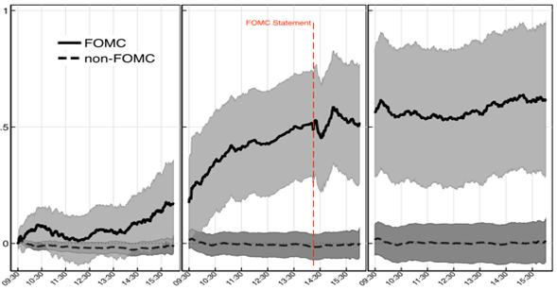

*The solid line shows that the index tends to rise during the afternoon of the day before scheduled FOMC announcements and continue to rise during announcement day morning for a total gain of about 0.5%. Immediately after announcement, the index tends to fall for about ﬁfteen minutes but then reverses to about the 2 PM level. The market tends to be flat the day after FOMC announcements.*

*The dashed line shows that the index tends to be flat over three-day windows that exclude the days around FOMC announcements.*

*In summary, evidence indicates that investors may be able to exploit a tendency for most major stock market indexes to rise during the 24 hours before scheduled FOMC monetary policy announcements.*

*Cautions regarding findings include:*

* *Return calculations are gross, not net. A trading strategy designed to exploit findings would incur trading frictions material in size compared to excess returns.*
* *Statistical significance tests assume tame return distributions. To the extent actual return distributions are wild, these tests lose validity.[4]’*

*In this article, I am representing a reproduction of this calculation (reproduction of Chart 1) and it will be shown not only in case of the SPX but also in case of the VXX, VIX, SPY and QQQ. My calculations were made with our available intraday data: VXX from 2009, while VIX, SPX, SPY and QQQ from 2003. These periods contain 36 and 78 (scheduled) FOMC meetings.*

*My previous results*

*VIX*

*At first I tried to repeat Luby’s calculation and get his figures. For this, I used VIX daily closing prices from 02/01/1990 to 31/07/2013 and 189 announcement dates. The selection of these dates was not entirely clear for me, because in the calendar of FED there are not only meeting dates but conference calls, and there are scheduled and unscheduled ones. In addition, there were both one- and two-day-long meetings. For the sake of clarity, I chose only the last days of the scheduled meetings. (I think Luby’s method was not exactly the same.) On the following charts (Chart 2 and 3) you can see the relative changes in the VIX and its relative standard deviation near FOMC announcement days. It is visible that Chart 2 is almost the same as Chart 1 (Luby’s graph). On Day -1 the average normalized VIX is 102.54 and on Day 1 it is 99.34. The relative standard deviation is relatively low (below 15%). Nevertheless, if we look at the figures only from 2004 (Chart 3), the results are significantly different, especially on subsequent days (Day 1-3). The standardized VIX are higher than 100 even in these days, and the preceding days are also higher than on Chart 2(103.64 on Day -1).*

*Chart 2: Relative changes in the VIX end-of-day prices – from 1990 to 2013*

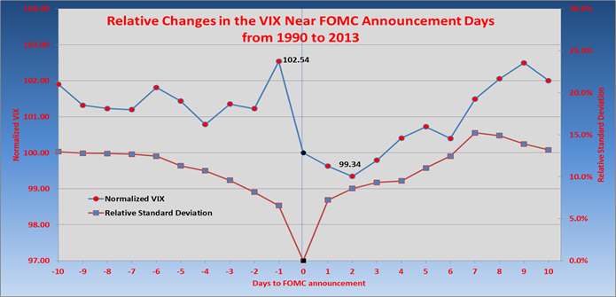

*Chart 3: Relative changes in the VIX end-of-day prices – from 2004 to 2013*

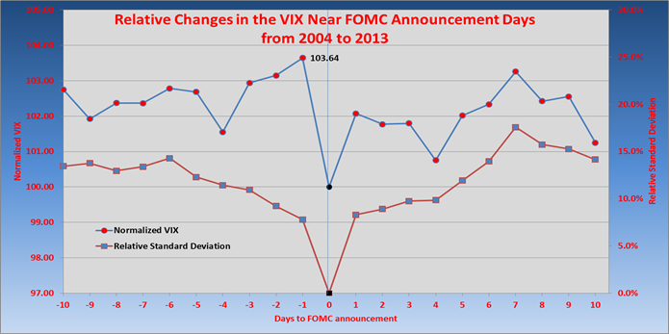

*VXX and XIV*

*As we could see above, the end-of-day VIX price is rising on average before the FOMC announcement days, and falling down on the day of the meeting. Now, let us see how it works in the case of VXX and XIV.*

*Chart 4: Relative changes in the VXX end-of-day prices – from 2004 to 2013*

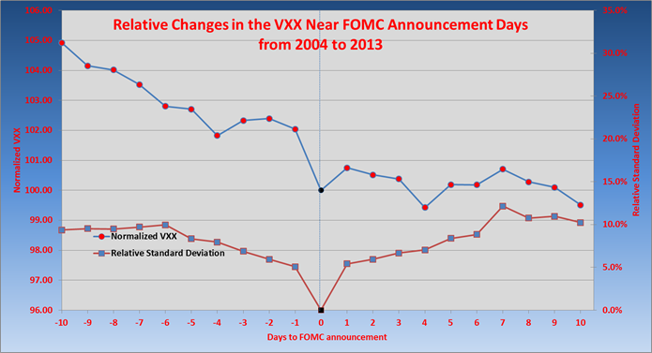

*Chart 5: Relative changes in the XIV end-of-day prices – from 2004 to 2013*

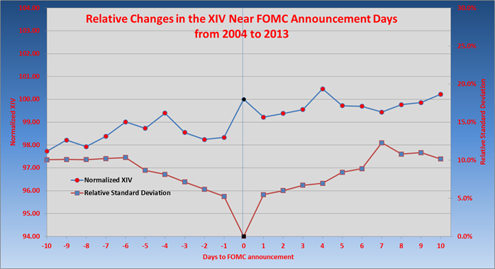

*As we can see on Chart 4 and 5, the normalized VXX price is decreasing from Day -10 to Day 10, while XIV is increasing and there is only a small deviation from trend at the announcement day. In my opinion, it comes from the general behaviours of these ETNs. As we know it (see Chart 6 and 7), the VXX is in a massive reduction from 2004 (except for a few short periods), while XIV is in a growth. As I first thought this effect is much stronger than the ‘FOMC-effect’, that is why I could not find a convincing pattern around the announcement days. However, relative standard deviations are small around Day 0, so it is imaginable that the deviation from the steady decline (increase between Day -4 and Day -1; on Day 1) is not randomness. In order to check this, I have made a simple trading strategy: buy VXX at the end of Day -4 and hold it until the end of Day -2, then short VXX from then to the end of Day 0, where buy VXX. At the end of Day 1 VXX needs to be sold. It is a 5-day-long strategy, so it means that most of the time our money is in cash (we need to trade on 8*5=40 days from 252 trading days per annum). It can be seen on Chart 8 how this strategy has worked in the past. There were 76 FOMC dates from 26/03/2004 and on two-thirds of these (51 times from 76) was this strategy profitable. The average profit is 3.65% per a 5-day period around announcement which is not negligible. And what would happen if we compose this strategy with the above mentioned massive reduction? I have called my new strategy as ‘FOMC Strategy’. It operates as follows: short VXX (or long XIV) permanently except on Day -3, Day -2 as well as on Day 1. On these days go long with VXX. The results are demonstrated on Chart 9 (compared to ‘short VXX all the time’) and in Table 1 and 2. As I think it would be worth it to play this strategy in real life and examine this with intraday data for a possible more efficient strategy.*

*Chart 6: The movement of VXX closing price – from 2004 to 2013*

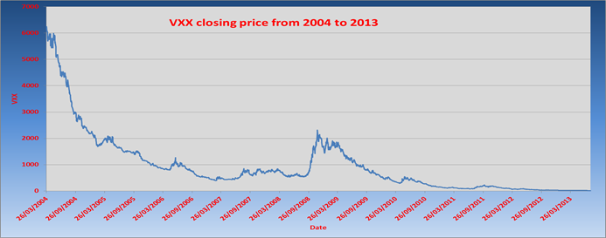

*Chart 7: The movement of XIV closing price – from 2004 to 2013*

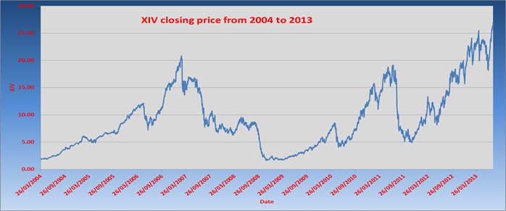

*Chart 8: Returns with the basic FOMC strategy around the announcement days*

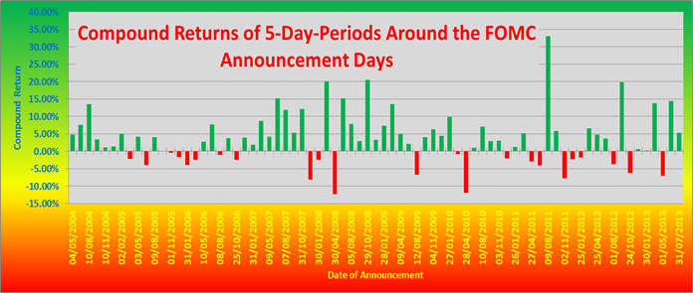

*Chart 9: The Portfolio Value of the FOMC Strategy – logarithmic scale*

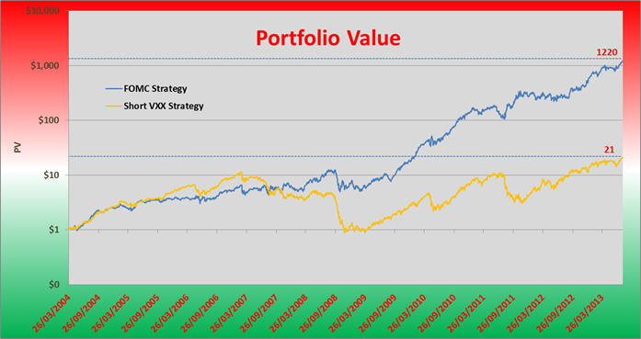

*Table 1: Performance indicators of the FOMC Strategy – on annual basis*

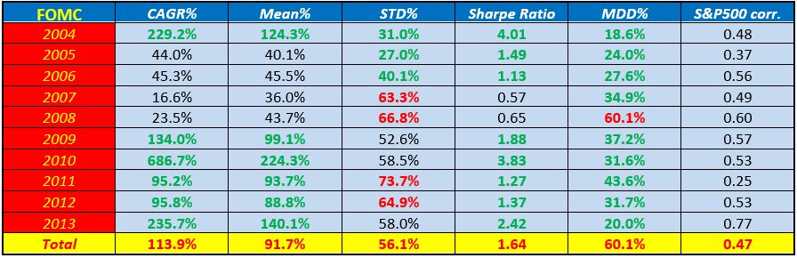

*Table 2: Performance indicators of the Short VXX Strategy – on annual basis*

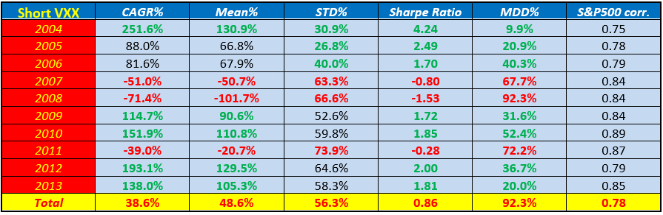

*S&P 500 Index*

*I have investigated the SPX like the VIX above. Chart 10 and 11 show my results.*

*Chart 10: Relative changes in the SPX end-of-day prices – from 1990 to 2013*

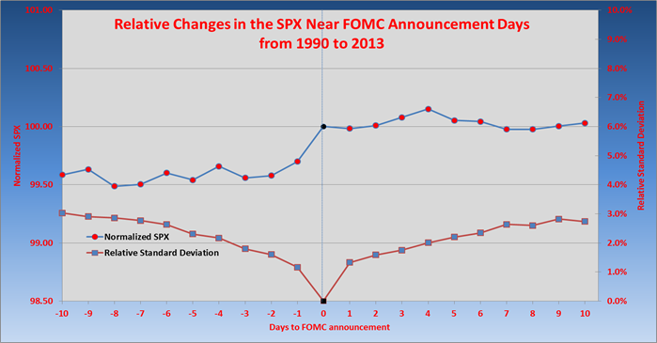

*Chart 11: Relative changes in the SPX end-of-day prices – from 2004 to 2013*

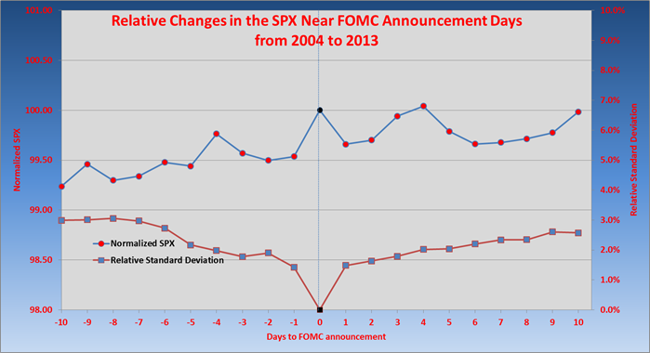

*Present results*

*VXX*

*Chart 12 shows the average cumulative minutely returns of the VXX on three day windows. The blue line in the chart represents the mean point-wise cumulative intraday percentage return of the VXX over a three-day window from the market open of the day ahead of scheduled FOMC meetings to the day after. The mean is taken over the 36 scheduled FOMC meetings from 30/01/2009 to 06/09/2013.*

*Chart 12: Cumulative Returns of the VXX – from 2009 to 2013*

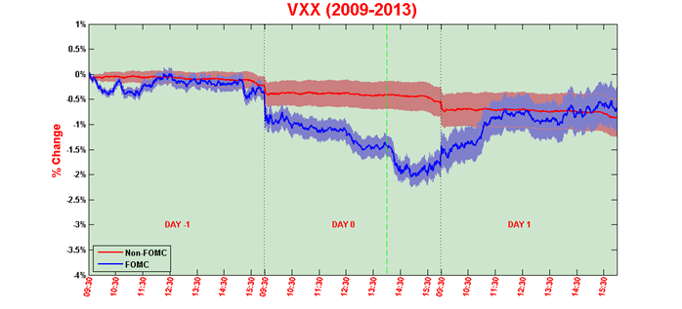

*As seen in the figure, the VXX displays a strong downward drift in the hours ahead of FOMC announcements. First, the VXX seems to be nearly unchanged on the day before the FOMC (Day -1), and it then drifts sharply lower in the morning of scheduled FOMC announcements (Day 0). Right before the time of the announcement (vertical green dashed line) it reaches a level about 1.5% lower than on the previous day's open. Following the announcement the VXX price still reduces until 15:00 (about -2%). After that and on the following day, VXX rose significantly (with about 1.5%). As evidenced by the pointwise 95% confidence interval for the mean return (light blue area), the cumulative return earned prior to scheduled FOMC announcements is strongly significantly different from zero.*

*To put the economic magnitude of this pre-FOMC drift in perspective, the red line on Chart 12 shows the average cumulative returns on all other three-day windows in the sample excluding day triplets centered around FOMC announcements, along with the pointwise 95% confidence bands (light red shaded area). On average, cumulative returns on these days have been essentially zero with a small reduction (due to the VXX being reduced in the examined time period).*

*Chart 13 plots empirical densities of the Open-to-3p.m. intraday returns on VXX. The red line represents the intraday return on FOMC meeting days, while the blue is the return distribution on all other days. The shapes of these lines are almost the same, but the left side of the red line has higher density mass than the blue one has. This means that the intraday returns are really significantly lower on FOMC meeting days.*

*Chart 13: Empirical densities of Open-to-3p.m. percentage returns*

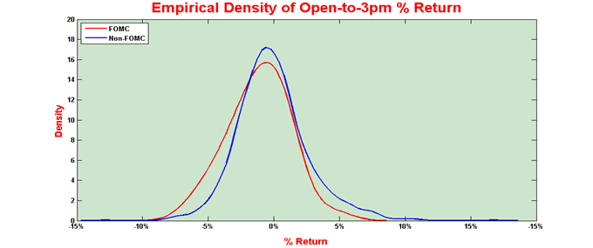

*Chart 14 contains intraday realized volatility of the VXX over three-day windows. The red line is the average five minute volatility on FOMC meeting days, while the blue is on all other days. Volatility on the day prior (and after) FOMC announcements follow the typical U-shaped pattern observed on other days. On FOMC days, one and half hours prior to the announcement, realized volatility is somewhat higher. As one may suspect, realized volatility jumps after 14:00 on scheduled FOMC days when the FOMC statement is released.*

*Chart 14: Intraday realized volatility of VXX % returns*

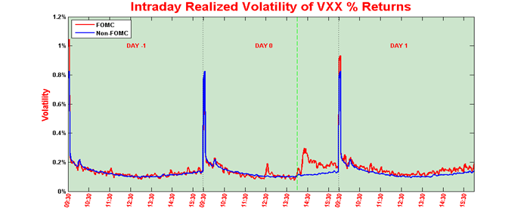

*The VXX FOMC Intraday Strategy*

*Based on the above represented results, I have thought that it would be worth to make an easy intraday strategy for VXX on FOMC announcement days. The strategy would be the following: we short VXX from 9:30 on Day -1 (or from market close on Day -2) until about 15:00 on Day 0, when we buy VXX and sell it at market close on Day 1. There are two questions in connection with this: when do we short (9:30 on Day –1 or 16:00 on Day -2) and at what time we change our trading position (likely about 15:00 would be appropriate)? In order to facilitate the decision, I have made a chart about this (Chart 15). It shows that if for example we short at 9:30 on Day -1 (red line) and change our trading position at 14:00 on Day 0 (x-value), after 36 events our Portfolio Value would be doubled (we started with $1). But if we do not change position until 14:00 on Day 1, our Portfolio Value remains almost the same.*

*Chart 15: Portfolio Value at different turning points*

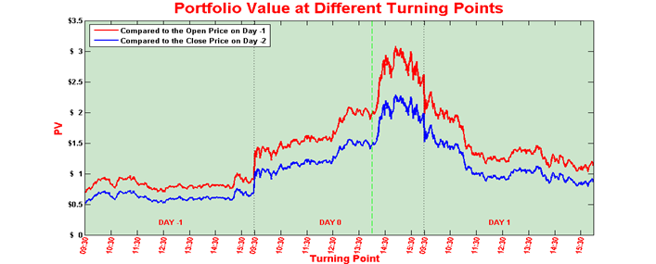

*As we can see, independently of when we change our position (which is our turning time), the red line is always above the blue line. It comes from the Close-to-Open gap (between Day -2 and Day -1), which is nearly 0.5% on average. So it is worth to short at 9:30 on Day -1. (In addition, we could take into consideration how to exploit this open gap.) The maximum of the red line is at about 15:00 on Day 0, as we thought based on previous charts. Our PV would be about $3 after 36 events.*

*Table 3 contains the cases with highest cumulative returns (after 36 events).*

*Table 3: Cases with highest cumulative returns*

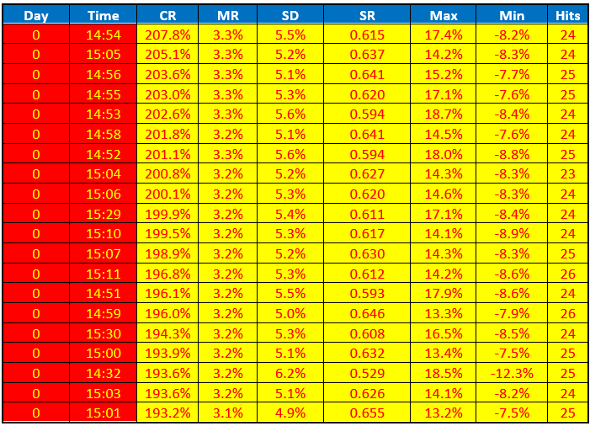

*where CR is the cumulative return (after 36 events), MR is the 3-days mean return per event (not annualized!), SD is the 3-days standard deviation (not annualized), SR is a special type of Sharpe Ratio (it is not calculated with annualized mean return and standard deviation), Max and Min are the maximum gain and loss during an event, while Hits represents, how many times this strategy was profitable (maximum could be 36).*

*VIX*

*I made the same chart for the VIX as for the VXX. However, we have got intraday data for VIX not only from 2009 (as in case of VXX) but from 2003 (78 events), so I prepared two charts (Chart 16 and 17). We can see that these are very similar to the chart of the VXX. But as the VIX is mean-reverting, it has a positive open gap on non-FOMC days. In addition, it has a higher increase on Day -1 and on Day 1.*

*Chart 16: Cumulative Returns of the VIX – from 2009 to 2013*

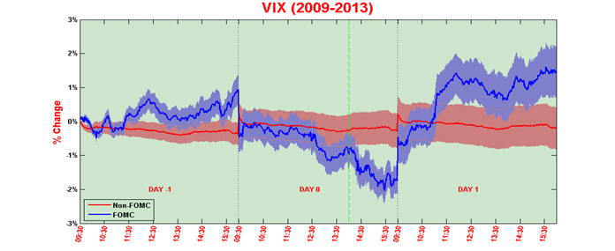

*Chart 17: Cumulative Returns of the VIX – from 2003 to 2013*

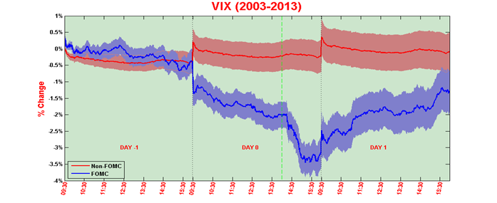

*SPX*

*In the case of the SPX (Chart 18 and 19), I got almost the same results as Lucca and Moench got. On non-FOMC days the SPX return remains close to zero (a small raise could be observed from 2009). However, on FOMC days there is a spectacular increase, but it is only 0.6% on average. On Day 1, SPX falls back to its initial value.*

*Chart 18: Cumulative Returns of the SPX – from 2009 to 2013*

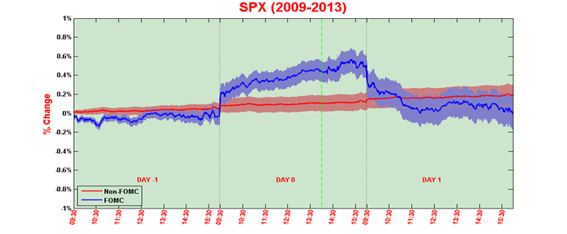

*Chart 19: Cumulative Returns of the SPX – from 2003 to 2013*

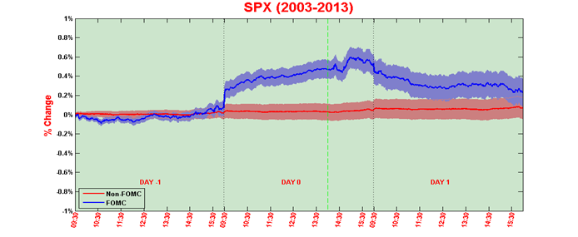

*SPY*

*In the case of SPY (Chart 20 and 21), the results are almost exactly the same as in the case of SPX – as we expected. On non-FOMC days the SPY return remains close to zero (a small raise could be observed from 2009). However, on FOMC days there is a 0.6% increase on average. On Day 1, SPY falls back to its initial value.*

*Chart 20: Cumulative Returns of the SPY – from 2009 to 2013*

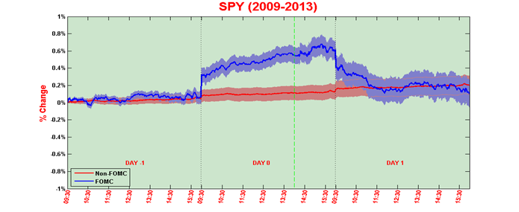

*Chart 21: Cumulative Returns of the SPY – from 2003 to 2013*

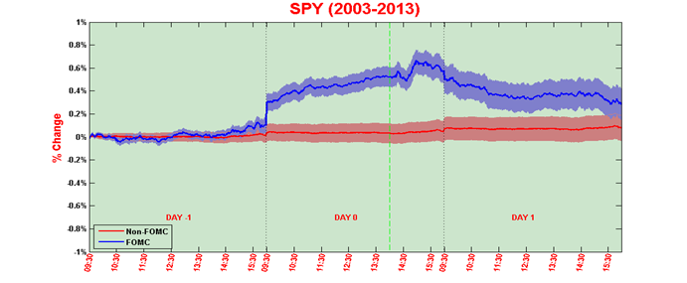

*QQQ*

*The QQQ (NASDAQ-100) is a stock market index of 100 of the largest non-financial companies listed on the NASDAQ. It does not contain financial companies, and includes companies incorporated outside the United States, so these distinguish it from the SPX. In other words, we would expect that its result (Chart 22 and 23) is significantly different from the results of the SPX (one can think that the FOMC announcement has a noticeable impact only in the case of financial companies). But the real results are almost the same as above.*

*Chart 22: Cumulative Returns of the QQQ – from 2009 to 2013*

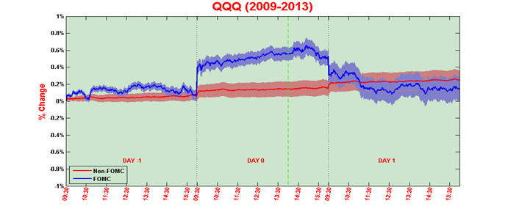

*Chart 23: Cumulative Returns of the QQQ – from 2003 to 2013*

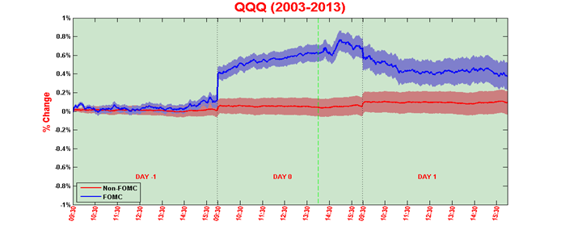

*Conclusion and recommendation*

*In this study I have examined how the VXX, VIX, SPX, SPY and QQQ prices are developing in the hours near the FOMC releases and a new VXX intraday strategy has been presented. We have found that there is a significant pattern in the intraday change of the VXX and VIX on FOMC days (± 1 day); while the same effect is lower in case of the SPX, SPY and QQQ.*

*Our easy VXX FOMC intraday strategy could be profitable: short VXX at 9:30 on Day -1, then buy VXX at about 15:00 on Day 0 and sell it at 16:00 on Day 1.*

*Over the sample period (from 2009), ‘The VXX FOMC Intraday Strategy’ during the 3 days around the scheduled FOMC announcements account for over 20% of the Buy&Hold XIV strategy .*

*More specifically: An investor playing ‘The VXX FOMC Intraday Strategy’ only during the 3 days around FOMC announcements earns an average annual gross return of 20.81%, compared to 79.22% for holding XIV the rest of the time. Nevertheless, ‘The VXX FOMC Intraday Strategy’ is being played only in 10.5% of the year (24 day/252 day on average) and our portfolio can be in cash the rest of the time.*

*However, it is definitely worth mentioning that this strategy was calculated based only on 36 events.’*

# **Current Results**

In this chapter, the **evolution of the VXX prices around the FOMC meeting announcements and our 3-day VXX FOMC Intraday Strategy** are re-examined.

In our previous analysis, **VXX intraday data from 2009 to 2013 was used**. That period contained **35 scheduled FOMC meetings**. Now, we **re-calculated these cumulative returns using intraday VXX prices from 2019 to 2021 (20 meetings)**. Unfortunately, we do not have intraday prices between 2014 and 2018.

However, we also have the intraday data needed (we collect prices of VXX at 15:00 on Day 0 [here](https://docs.google.com/spreadsheets/d/1GYJYOmugIdpWzn4RJZrkZsyrqzzYTtfPEbNe82GKfew)) to **analyze the performance of our 3-day strategy from 2009 to 2021, which covers 99 scheduled meetings**.

Chart 24 shows the **evaluation of cumulative returns of the VXX around FOMC announcements (3-day window) from 2019 to 2021 (20 meetings)**. The chart contains the arithmetic average, median, Q1, Q3 and quartile mean of cumulative returns with a vertical dashed white line at 15:00 on Day 0, one hour after the announcement. As it can be seen, **results are almost the same as between 2009 and 2013** (Chart 12 and Chart 25): **the price of the VXX declines significantly from the open (or close ?) of Day -1 to about 15:00 on Day 0, then increases until the end of Day +1 (or until 12:00 on Day +1 ?).**

Chart 24: Cumulative Returns of the VXX around FOMC announcement – from 2019 to 2021

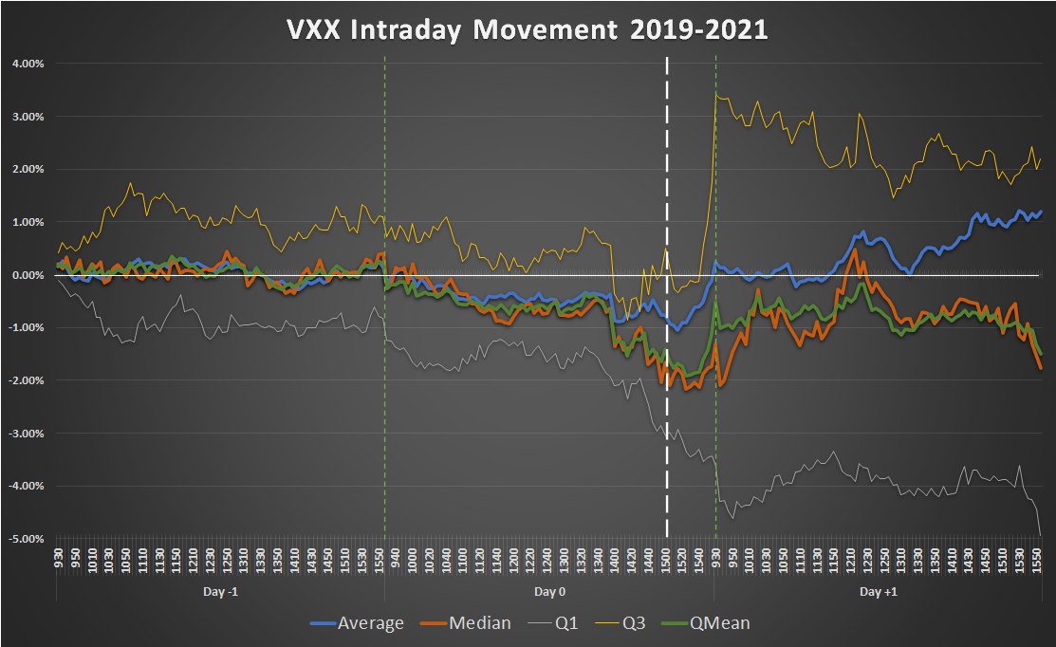

Chart 25: Cumulative Returns of the VXX around FOMC announcement – from 2009 to 2013

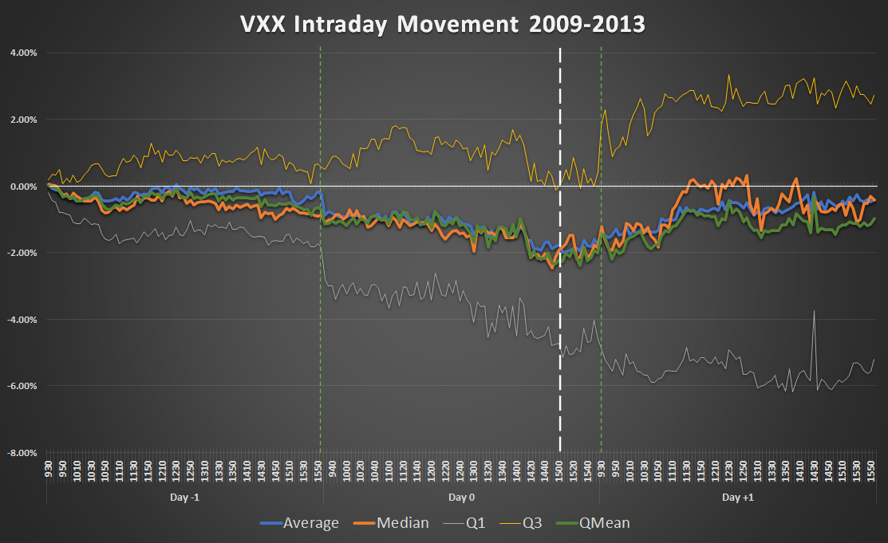

This above observation **legitimizes our 3-day VXX FOMC Intraday Strategy** which was developed in 2013 and has not been played in real life yet: **short VXX at open on Day -1, change it to long VXX at 15:00 on Day 0 and close this position at close on Day +1**.

The performance of this strategy can be found in Chart 16 and in Table 4-6. It can be seen that **the strategy has been working well not only in the backtested period (2009-2013) but ever since**. **Only the current year (2021) has a negative return (after 5 events), but it is only due to an outlier which could have been avoided by using intraday stop-loss in real life trading.** It is worth noting that **the strategy has been played only on 8*3=24 days per year** (which causes the low Sharpe ratio).

**The average return by event is 2.89%, of which 1.84% belongs to the short part (open on Day -1 - 15:00 on Day 0) and 1.06% to the long part (15:00 on Day 0 - close on Day +1).**

**Based on these figures, it is highly recommended playing this 3-day VXX FOMC Intraday Strategy in real life.**

Chart 26: PV of the 3-day VXX FOMC Intraday Strategy – from 2009 to 2021

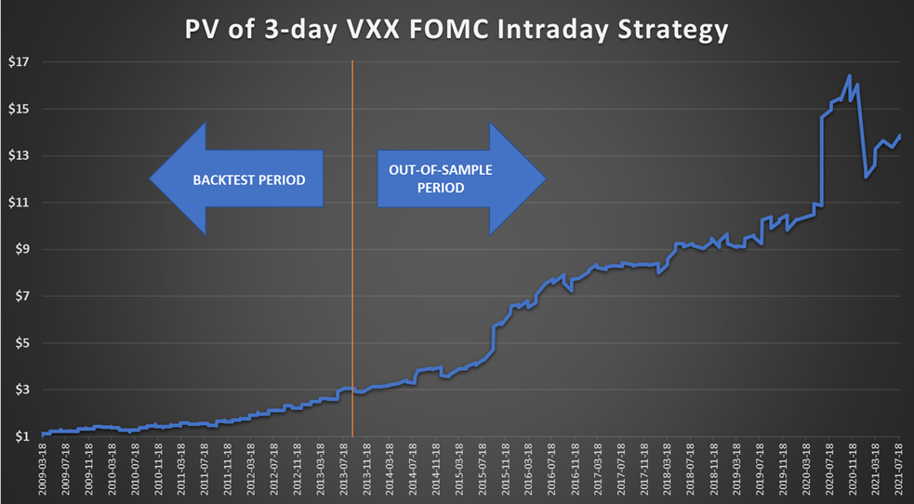

Table 4: Performance indicators of the 3-day VXX FOMC Intraday Strategy – from 2009 to 2021

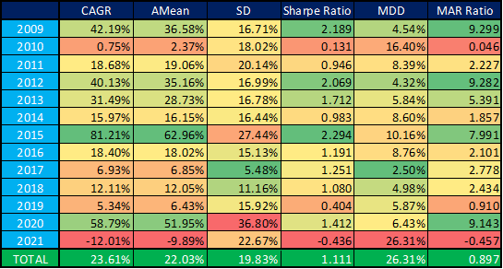

Table 5: Descriptive statistics of the 3-day VXX FOMC Intraday Strategy by events and short/long parts – from 2009 to 2021

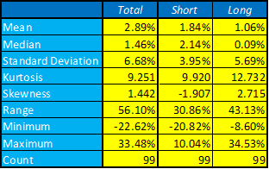

Table 6: Returns of the 3-day VXX FOMC Intraday Strategy by events and short/long parts – from 2009 to 2021

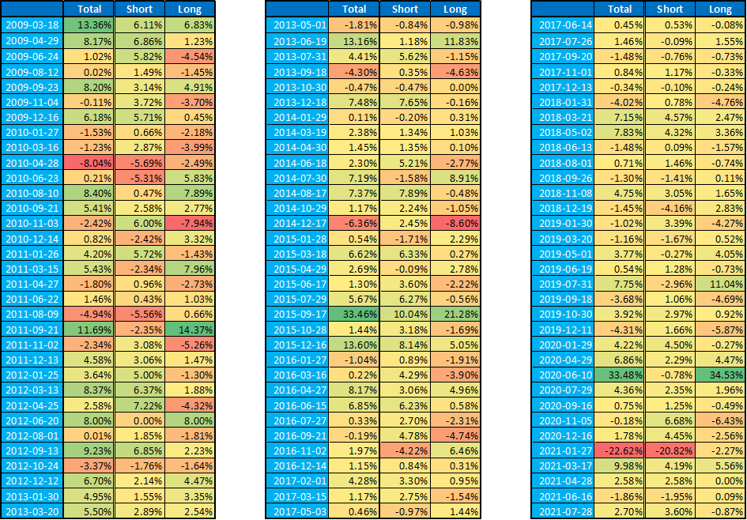

# **Conclusions**

In this study we **revived and extended our previous results** in connection with the **evaluation of the VXX prices around FOMC meeting announcements**. Furthermore, we **re-examined our 3-day VXX intraday strategy** developed 8 years ago. We analysed how our portfolio value would have evolved if the strategy had been played in real life. We found that it **would definitely be worth using this 3-day VXX FOMC Intraday Strategy in real life as well**.

1. [*VIX trends around FOMC announcement days*](https://hqavms.cloudapp.net/blukucz/VIX%20trends%20around%20FOMC%20announcement%20days.docx)
2. <http://vixandmore.blogspot.hu/2007/01/vix-price-movement-around-fomc-meetings.html>

   <http://vixandmore.blogspot.hu/2008/12/vix-trends-around-fomc-announcement.html>

   <http://vixandmore.blogspot.hu/2013/06/the-vix-and-pre-fomc-post-fomc-trades.html>
3. [*The Pre-FOMC Announcement Drift*](http://papers.ssrn.com/sol3/papers.cfm?abstract_id=1923197)
4. <http://www.cxoadvisory.com/16375/economic-indicators/fomc-drives-global-equity-markets/>