Dr. George Antal

3D Click Limited

c/o Suite 431, 28 Old Brompton Road, London SW7 3SS

**Hedges and Correlations**

# **Motivation**

One of the biggest challenges in financial markets is to **build a profitable portfolio which avoids high volatility and big drawdowns**. One idea could be developing a **supplementary hedge system to a base portfolio** (even for a simple buy&hold index strategy, e.g buy&hold SPY/QQQ/FAANG/GameChangers). Hedges are like **insurance**, i.e. they **have a cost**. **The reduction in risk provided by hedging typically results in a reduction in potential profits** (e.g. using long volatility futures can significantly reduce market risk but it can erode even the whole profit of a portfolio). Our main goal is to **build a dynamic hedge system** which not only **protects the portfolio from tail risk**, but can even **generate profit**. In our opinion, **selecting hedges dynamically based on the current market environment** is the most important part of the construction of a well performing system - as in real life, where we need to protect ourselves from rain differently than from falling off a cliff.

In this study, a **method** will be presented how to select the hopefully **optimal hedges depending on the current market situation**. We use our recently developed **SnifferQuant Market Strength Indicator (SQ MSI),** the **CPI-SQ3M inflation indicator, the GDP** and the **Excess Earnings Yield** (S&P500 Earnings Yield vs. Real 10-Year Treasury Yield) separately as the proxy of the current market environment.

# **Background**

## [Tail Risk Hedging by Kai Wu](https://mailchi.mp/verdadcap/tail-risk-hedging)

*“****As markets plunged in Q1 of 2020, an eccentric investment strategy was the stand-out winner. Hedge funds that focus on tail risk hedging, betting on what Nassim Taleb famously called “black swans,” profited handsomely as stocks plummeted****. The Eurekahedge Tail Risk Hedge Fund Index was up 57% over this period, and a few tail risk hedge funds (including one advised by Taleb) delivered eye-popping returns over +1000%. The below chart compares the performance of tail risk hedge funds in Q1 to the S&P 500 and a US 60/40 portfolio.*

*Figure 1: Asset Class Returns in Q1 2020*

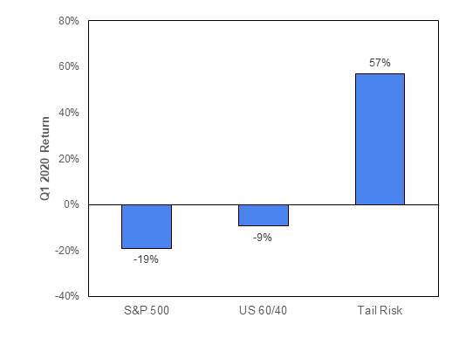

*Source: Bloomberg, S&P, Eurekahedge*

***This outstanding performance has raised significant interest in these strategies among asset allocators.******A strategy that could help smooth returns by providing strong positive profits in times of crisis when all other assets are down would be enormously valuable as a portfolio tool.***

***But if markets are efficient, the best hedges should also be very expensive.*** *In the same way you pay a monthly premium to insure your home, you should expect to incur a negative return to insure your portfolio. This cost comes into focus by examining the long-term performance of the aforementioned Eurekahedge Tail Risk Hedge Fund Index.*

*Figure 2: Performance of Eurekahedge Tail Risk Hedge Fund Index*

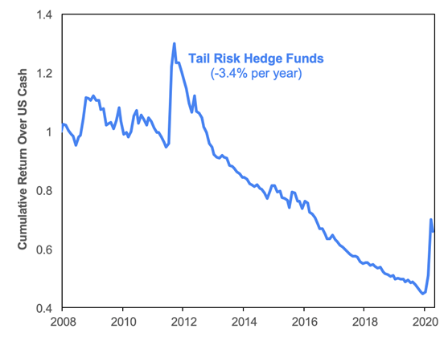

*Source: Eurekahedge, Bloomberg*

***This chart shows that buyers of tail risk funds have historically paid about 3.4% per year to make 25–50% in crises.******Given that the long-term equity risk premium has been roughly 3–5%, this feels like a steep cost to pay for reducing volatility in times of crisis.***

*In addition, the payoff profile of tail hedge funds presents unique challenges in an institutional setting.* ***It is difficult to justify bleeding for ten years waiting for the big payoff.*** *Tail hedges have a devilish tendency to pay out when markets are most complacent. As illustrated by the unfortunate decision by CalPERS to unwind its tail hedge program a few months before the recent selloff, successfully implementing a tail hedge program requires a godlike fortitude and long-term commitment to the idea.*

***But tail risk hedging strategies are only one extreme form of hedging. There are a variety of other potential hedges that investors could employ, from shorting corporate credit to owning long-duration US Treasuries. Each of these assets occupies a specific point on the tradeoff between hedge quality (broadly, the probability of paying off in a crisis and the significance of the payoff) and cost (the long-term return of the asset).***

***This simple framework can be applied to a broad range of potentially interesting hedge strategies using simple quantitative metrics to assess hedge quality and cost.***

1. ***Hedge Quality: We use correlation with the S&P 500 as a rough estimate of hedge quality. The more negative the correlation, the higher the hedge quality.***
2. ***Cost: We use historical returns from 1995-2020 as a simple proxy for long-term cost. We normalize historical returns using Sharpe Ratio (i.e., return over cash / volatility) to provide an apples-to-apples comparison across different asset classes.***

***The figure below illustrates this tradeoff, with hedge quality on the X-axis and cost on the Y-axis. Dark blue markers show assets held long and light blue show those held short.***

*Figure 3: Tail Risk Hedging Quality vs. Cost*

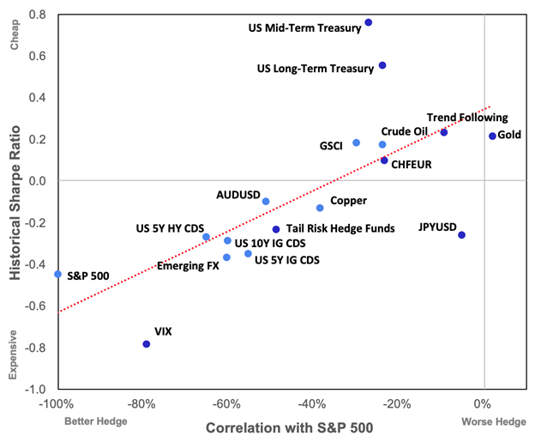

*Source: Bloomberg, S&P, Russell, MSCI, Barclays, JPM, GS, CBOE, Eurekahedge, SG*

***This graph reveals a strong relationship between hedge quality and price. Shorting the S&P 500 or buying VIX options are the most expensive hedges but also perform the best. Shorting oil futures or betting on the Swiss franc versus the euro are much cheaper hedges but are relatively less effective. The most notable outliers are US Treasuries. However, this is an artifact of our use of the disinflationary period 1995–2020 to define historical returns. Treasuries would not be as impressive over a longer period that includes the inflationary 1970s.***

***How did these different hedges work in recent crises? The below chart shows the performance of each asset during the last three times the S&P 500 drew down more than 20%.***

*Figure 4: Tail Hedge Performance in Crises*

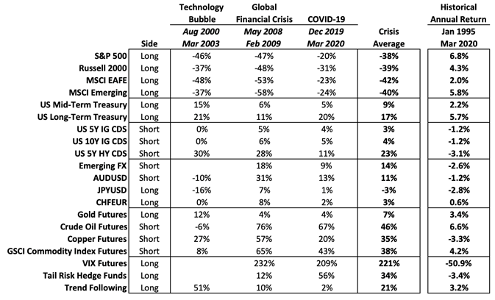

*Source: Bloomberg, S&P, Russell, MSCI, Barclays, JPM, GS, CBOE, Eurekahedge, SG. Returns are for self-funded positions in each instrument.*

***Every hedge except the Japanese yen delivered positive returns on average across the crises****. Treasuries were consistent winners. However, this favorable result is likely particular to the disinflationary tailwinds of the past few decades. Credit default spreads (CDS) did particularly well in 2008 and 2020. Currency hedges did not work in 2000 but were otherwise helpful. Gold did not provide any big payoffs but also never lost money. Shorting energy and industrial metals proved to be quite effective in all but the 2000 selloff.*

***Long volatility was helpful on average, with the current crisis a standout winner****. However, the current recession is still ongoing, so it is possible that these strategies may give back some of their gains before this is all over.* ***Also, as discussed earlier, the long-term cost of buying options is much higher than other asset classes. For instance, the VIX future return has been a whopping -50% per year since inception in 2006.***

*Finally, trend following was disappointing. It provided meaningful protection in only the 2000 and 2008 crises. Trend following strategies tend to focus on 12-month trends. As a result, they may get whipsawed in sharp selloffs and W-shaped recessions.*

***Tail risk funds are merely one extreme point in a broader menu of options. Investing solely in tail risk funds forgoes the benefit of diversification. As shown below, a simple equal-weighted basket of the above hedges would have significantly outperformed tail risk hedge funds alone.***

*Figure 5: Diversified Tail Hedging*

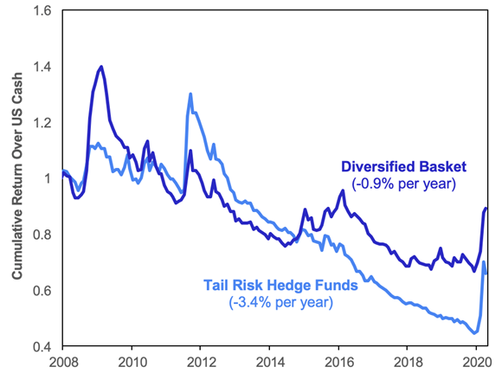

*Source: Bloomberg, S&P, Russell, MSCI, Barclays, JPM, GS, Eurekahedge, SG*

*The basket of tail hedges would have offered a similar quality of hedging at lower cost. The basket approach also offers more opportunities for alpha generation by rotating into the cheapest hedge when relative valuations diverge.*

***Adjusting for the favorable endpoint of this historical sample leads to an estimate of the long-term cost of hedging of around 2% per year, a steep cost given an expected 3–5% equity risk premium. Even after cheapening the cost of hedging through diversification, the cost of insurance is still very high.***

***In some sense, tail risk hedging is just asset allocation on steroids: investors should think through the costs and the full range of options rather than sticking only to the most popular and hence expensive hedges like VIX futures or tail risk hedge funds.****”*

## 

## [SnifferQuant Market Strength Indicator](https://docs.google.com/document/d/1TTy9i27Mn0vcQRCT1t836HUBx629diChEyQuuNcOKos)

In our [previous study](https://docs.google.com/document/d/1TTy9i27Mn0vcQRCT1t836HUBx629diChEyQuuNcOKos), our newly developed ***SnifferQuant Market Strength Indicator (SQ MSI)*** was presented. Our main goal was to **improve and combine our existing market timers and leverage indicators** such as CLMT (Combined Leverage Market Timer) and STCI (Short Term Contango Indicator) to get a **comprehensive picture of the current state of the market**.

The **SQ MSI** is a **complex indicator** which has **four parts (sub-indicators)**:

* **The XLU/VTI Indicator with 20% weight;**
* **The SPX Golden Cross Indicator with 20% weight;**
* **The SPX Highest High Indicator with 30% weight;**
* **The Short Term Contango Indicator with 30% weight.**

The SQ MSI is a **backward looking, but very fast response bullishness indicator** which shows the **current state of the stock market**. Its **high (low) level indicates a bullish (bearish) market environment**.

This *‘SQ MSI’* uses both backward- and forward-looking data (e.g. SPX prices in the recent year vs. VIX futures prices with two month maturity), but primarily the indicator is suitable for **presenting the current situation** in the light of recent events and **not for forecasting**. We found that **SQ MSI should not be considered a good market timer, but it can be an excellent leverage indicator: over-leverage should be used when MSI is over 80% (or 60%) and it is worth continuously reducing the leverage when MSI is below 40%.**

**Current level of the indicator and its parts on 2020-12-31**:

* **SQ MSI: 94.51%, which is strongly bullish**
  + XLU/VTI Indicator: 100%;
  + SPX Golden Cross Indicator: 100%;
  + SPX Highest High Indicator: 100%;
  + Short Term Contango Indicator: 81.7%.

## [CPI-SQ3M Inflation Indicator](https://docs.google.com/document/d/1Ef5az6qkO8H3t2UiAVeEwm1RdrHzzLDqoiVPCVuURk0/edit" \l "heading=h.6or6ww1c3ng3)

In one of our [previous studies](https://docs.google.com/document/d/1Ef5az6qkO8H3t2UiAVeEwm1RdrHzzLDqoiVPCVuURk0/edit#heading=h.6or6ww1c3ng3), our self-developed **‘CPI-SQ3M’** **inflation indicator**was presented.

We have dealt with **seasonally adjusted monthly CPI data**[1] from 1947 to 2020. These CPI data are available about **two weeks after the month-end**[2]. It means that these figures also suffer from some hindsight bias. At first, it had to be decided **how long lookback period should be used during calculating percentage changes**. Albeit noisy, **the 1-month data can be used as an immediate signal, while the 1-year data is a lagging, but smoothed indicator**. Both have good and bad features. Our idea was to **create a rapid response indicator which is somewhat smooth and uses not only most recent (1-3 months) data but even from a year earlier**. Our solution is the **exponential average of last 12 monthly data** with the following weights: 29.08%, 20.77%, 14.84%, 10.60%, 7.57%, 5.41%, 3.86%, 2.76%, 1.97%, 1.41%, 1.01% and 0.72%. After calculating these monthly changes, they have been **multiplied by three to get ‘quarterly’ changes**. Thereby, in Chart 0, this quarterly EMA named **CPI-SQ3M** (yellow line) can be easily compared to the simple 3-month percentage change (orange line) of CPI data. In addition, ‘quarterized’ 1-month and 6-month data are also visible in this chart. **In the following, we use this calculated CPI-SQ3M % change data**. **It has to be emphasized again that the last 3 months has more than 65% weight (29.08% + 20.77% + 14.84%) in the indicator and it is ‘quarterized’ (monthly data is multiplied by 3). For these reasons, the number 3 is included in the name of the indicator, while SQ (SnifferQuant) means that it is not a simple indicator but self-developed.**

The **arithmetic mean of historical CPI-SQ3M data is +0.83% (quarterized) with +0.75% standard deviation and median value is +0.70%**. The **latest CPI-SQ3M value for January 2021 is 0.66% (annualized 2.64%), which is the ~45th percentile of the dataset (from 1947 to 2020)**.

Chart 0: Quarterized CPI Changes using different lookback periods

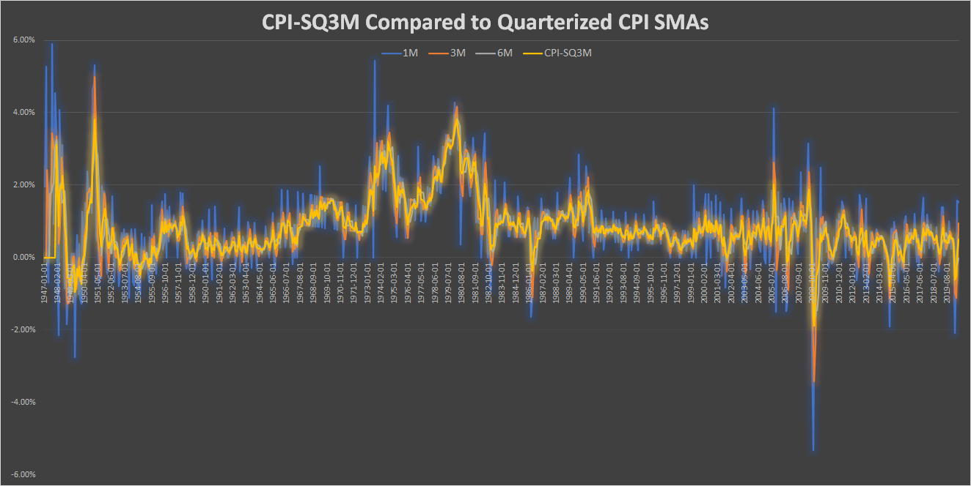

## GDP

In the above cited [previous study](https://docs.google.com/document/d/1Ef5az6qkO8H3t2UiAVeEwm1RdrHzzLDqoiVPCVuURk0), we have dealt with the **annualized (seasonally adjusted) quarterly growth rate (percent change from preceding period) of the real GDP (adjusted from inflation).** These final GDP data[3] are available three months after the quarter-end (“BEA (U.S. Bureau of Economic Analysis) estimates GDP three times. The advance estimate, coming about a month after the quarter's end, is an early look based on the best information available at that time. The second estimate and third estimate each incorporate additional source data that weren't available the month before, improving accuracy.”[4]). For example, the **(final[5]) value of October-December quarter 2020 is available only from 2021-03-25** (it means that these figures suffer from hindsight bias)**. The second estimate for 2020Q4 is +4.1%**

The **arithmetic mean of historical annualized GDP data is +3.17% with +4.67% standard deviation and the median value is +3.00%**.

It is worth noting that an almost always up-to-date **‘GDP forecast’** can be found on [Atlanta Fed’s webpage](https://www.frbatlanta.org/cqer/research/gdpnow). Instead of the backward-looking GDP numbers, this can be used for our forward-looking subjective prediction. As GDPNow is based on a well-trained mathematical model, it is unlikely that we can create a better predictive model ourselves. *“The growth rate of real gross domestic product (GDP) is a key indicator of economic activity, but the official estimate is released with a delay. Our GDPNow forecasting model provides a "nowcast" of the official estimate prior to its release by estimating GDP growth using a methodology similar to the one used by the U.S. Bureau of Economic Analysis. GDPNow is not an official forecast of the Atlanta Fed. Rather, it is best viewed as a running estimate of real GDP growth based on available economic data for the current measured quarter. There are no subjective adjustments made to GDPNow—the estimate is based solely on the mathematical results of the model.”*

**Their latest estimate for 2021Q1 is 5.7 percent as on 17th March 2021.**

*“The GDPNow model estimate for real GDP growth (seasonally adjusted annual rate) in the first quarter of 2021 is 5.7 percent on March 17, down from 5.9 percent on March 16. After this morning's housing starts report from the U.S. Census Bureau, the nowcast of first-quarter real gross private domestic investment growth decreased from 11.5 percent to 10.6 percent.”*

Table 0: Descriptive statistics of annualized GDP from 1947 to 2020

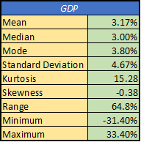 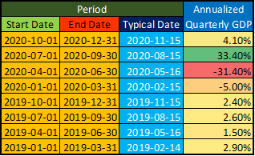

## Excess Earnings Yield: S&P500 Earnings Yield vs. Real 10-Year Treasury Yield

When we scrutinize macro-economic indicators that affect the stock market, **looking at only the absolute value of the 10-year treasury yield is not good enough.** We should evaluate the value of T-yield to the S&P500 annual earnings yield (S&P500 Earnings / MarketCap). For instance, if stocks yield more than 5x times than treasuries, then the stock market is undervalued, therefore the stock market should have a bullish future. This is partially what drove the stock market strength in 2020 summer.

Because in 2020 the nominal value of the T-yield was close to zero (the real T-yield is even negative), the stock-market was precious. In general, all investors know that the volatility in stock investment is higher than in bonds. There can be risky drawdowns. But it is worth investing in stocks if the stock-yield is 5x higher than the bond-yield. The [TINA](https://en.wikipedia.org/wiki/There_is_no_alternative) abbreviation captures the essence: There is No Alternative. Simply put, if the T-yield is 5%, bond investments are good alternatives to stocks. But **in the world in which the T-yield is close to zero or negative, there is no competing alternative to stocks.** Stocks have much better profitability potential, even with the added risk. So the money goes into stocks. This is the essence behind CXO's “[Simple Asset Class ETF Value Strategy (SACEVS)](https://www.cxoadvisory.com/value-strategy/)” which switches between stocks and treasuries based on which one is undervalued compared to the other.

The S&P500 earnings yield, reflects the sum of the underlying S&P500 companies’ earnings for the previous 12 months (trailing sum), divided by the actual S&P 500 index level. As a broad market index earnings yield, one can compare this to the 10-year treasury rate to determine **valuation of the US stock market relative to the bond market** (the difference is called ‘**risk premium**’ and this is the so-called ‘Fed’s Stock Valuation Model (an almost ever up-to-date study can be found here: [Stock Market Briefing:Fed’s Stock Valuation Model](https://www.yardeni.com/pub/valuationfed.pdf))).

Investors often look at stock market returns and treasury yields without **taking the impact of inflation** into account. However, in long-term the impact of compounding inflation is massive.

* On the one hand, a stock represents ownership in the company. Ceteris paribus, the assets of the company (land, buildings, brand value, intellectual rights) goes up with the inflation over time. Therefore, the **S&P500 annual earnings yield represents profit above the inflation.**
* On the other hand, buying a bond does not represent ownership of any asset appreciating with inflation. **The 10-year treasury nominal yield is not the above inflation profit.** We shouldn’t compare apples with oranges. The bond's "**real yield**" accounts for the inflation rate and more accurately describes the gain or loss on your investment over time. For this reason, in this subsection, we have examined not only nominal but also the **real treasury yield, which is the nominal treasury yield minus the inflation rate**. In our opinion, **real treasury yields are more comparable to S&P500 earnings yields**.

In our opinion, **the difference between the S&P500 earnings yield and inflation adjusted real 10-year treasury yield is the most appropriate measurement** of the valuation of the US stock market relative to the bond market. We call this difference as **‘Excess Earnings Yield’** and denote it with ‘**EY-R10YTY**’. It is almost the same as [**Shiller’s ‘Excess CAPE Yield’**](https://www.bloomberg.com/opinion/articles/2020-12-04/shiller-sees-rational-exuberance-in-u-s-stock-valuations), but that one does not take the inflation into account.

**Current statement on 2020-03-18:**

* [EPS for 2020-01-01 - 2020-12-31](https://www.spglobal.com/spdji/en/documents/additional-material/sp-500-eps-est.xlsx?force_download=true): $94.12[6];
* S&P close on 2021-03-18: $3915.46, thus Earnings Yield is 2.4%;
* [Real 10-year Treasury rate](https://www.treasury.gov/resource-center/data-chart-center/interest-rates/pages/TextView.aspx?data=realyield) is -0.56% on 2021-03-18;
* **Excess Earnings Yield (EY-R10YTY) is 2.96% on 2021-03-18**.

# **Results**

As it can be read above, the **quality of a hedge depends on the correlation with the portfolio to be hedged**. **The more negative the correlation, the higher the hedge quality**. But the **correlation coefficient is not a constant**, its value varies over time. In the first sub-section of this section we show **how variable this correlation can be**. After that, in the second sub-section, the **continuous rolling correlation** we have developed is presented. Finally, in the third sub-section, the **list of potential hedges** and the **selecting method** we recommend can be found. It is worth noting that the **results are based on past data** **from 2004 to 2020** (and does not predict the future). Furthermore, **the method does not specify exactly which hedges to buy and how much to buy** (i.e. how much weights should be used) to avoid data-mining and parameter-optimisation biases. Instead, it shows **which hedges should be selected and combined to achieve a hopefully well performing hedge system that suits the investor’s taste and habits**.

1. <https://fred.stlouisfed.org/series/CPIAUCSL>
2. <https://www.bls.gov/cpi/>
3. <https://fred.stlouisfed.org/series/A191RL1Q225SBEA>
4. <https://www.bea.gov/data/gdp/gross-domestic-product>
5. It should be noted that sometimes these ‘final’ figures are also revised even 4-5 years later. For example, 2015Q1-2019Q4 numbers were changed in 2020Q2. Maybe there was a change in methodology?
6. Someone should be careful because this estimated EPS was $157.12 three days earlier.