Dr. George Antal

3D Click Limited

c/o Suite 431, 28 Old Brompton Road, London SW7 3SS

**Hedges and Correlations**

## Correlation

*“Correlation statistically measures the degree of relationship between two variables in terms of a number that lies between +1.0 and -1.0. When it comes to diversified portfolios, correlation represents the degree of relationship between the price movements of different assets included in the portfolio. A correlation of +1.0 means that prices move in tandem; a correlation of -1.0 means that prices move in opposite directions. A correlation of 0 means that the price movements of assets are uncorrelated; in other words, the price movement of one asset has no effect on the price movement of the other asset.*

*In actual practice, it's difficult to find a pair of assets that have a perfect positive correlation of +1.0, a perfect negative correlation of -1.0 or even a perfect neutral correlation of 0. A correlation between different pairs of assets could be any one of the numerous possibilities lying between +1.0 and -1.0 (for example, +0.62 or -0.30). Each number thus tells you how far or how close you are from that perfect 0 where two variables are uncorrelated. So, if the correlation between Asset A and Asset B is 0.35 and the correlation between Asset A and Asset C is 0.25, then you can say that Asset A is more correlated with Asset B than it is with Asset C.”[1]*

This means that if our goal is to select **optimal hedges**, we need to **choose assets that correlate significantly negatively with our portfolio**. But **correlation coefficient varies over time** and that's why **it should not be used as a constant indicator**. In the examples below, we examine the correlation between the **gold (using GLD ETF as a proxy) and the market (using SPY)** in more detail. During the calculations, daily close prices are used from 2004 to 2020.

In the first example, we analyse the connection **by the level of SnifferQuant Market Strength Indicator (SQ MSI)**. Table 1 shows the average subsequent x-day return of GLD by the level of SQ MSI. It can be seen that the **subsequent return of GLD is highest when the value of the indicator is in its lowest quintile**, i.e. when the market seemed very bearish in the recent period. Table 2 contains total returns of these periods. It shows that **GLD performed really well in these rare intervals**. But what about correlation? Table 3 (4) contains correlation coefficients between GLD and SPY subsequent x-day returns (Sharpe ratios) split by the level of SQ MSI. Based on these tables one can conclude that:

* When the **SQ MSI is in its lowest quintile**, the **correlation coefficient is surprisingly positive** using a maximum 1-month look-ahead period, which indicates that **GLD is not the most appropriate hedge of the SPY in that environment**. What can cause this **apparent contradiction**? Look at Table 2 again. At first, it's a rare period when SQ MSI is below 20%, thus **we do not have enough samples**. Furthermore, **during sudden crashes**, like in the spring of 2020, **the market can reach its bottom before SQ MSI falls below 20%** and can turn north (subsequent return of SPY becomes positive), while some investors are still worried about their money and prefer to invest it into gold (subsequent return of GLD becomes also positive).
* Using subsequent 3-month returns, **correlation jumps from -0.425 to +0.453 when SQ MSI changes from lowest quintile to second lowest quintile**. That would suggest that GLD is a very good hedge when the level of SQ MSI is about 19% (r=-0.425), but terrible when SQ MSI is about 21% (r=+0.453). This obviously indicates that the **simple correlation coefficient is unusable as a hedge selector indicator**.

**The same phenomena can be concluded in the second example (Table 5-7) where the inflation level is used instead of the SQ MSI.**

**All in all, the simple correlation coefficient can change wildly, thus we have to ‘smooth’ it. Furthermore, we have to deal with the lack of sufficient samples in given regimes (e.g. when SQ MSI is below 20%)**.

Table 1: Average subsequent X-day return of GLD by SQ MSI level

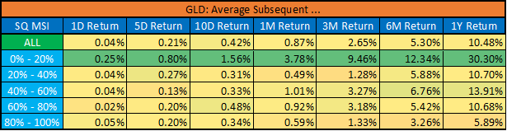

Table 2: GLD vs. SPY period returns in very bearish regimes (SQ MSI < 20%)

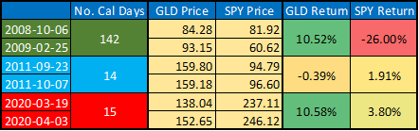

Table 3: Correlation between GLD and SPY subsequent X-day returns by SQ MSI level

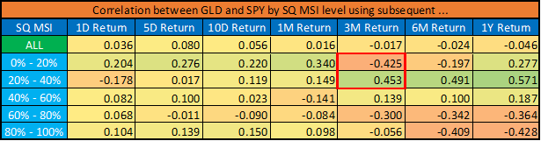

Table 4: Correlation between GLD and SPY subsequent X-day Sharpe ratio by SQ MSI level

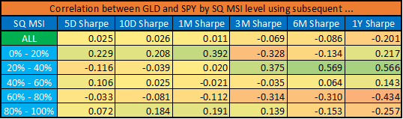

Table 5: Average subsequent X-day return of GLD by inflation level

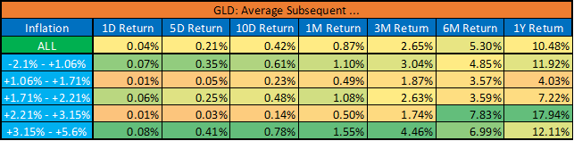

Table 6: Correlation between GLD and SPY subsequent X-day returns by inflation level

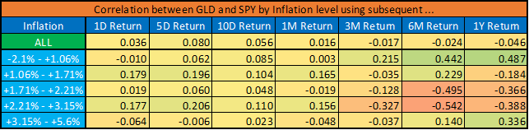

Table 7: Correlation between GLD and SPY subsequent X-day Sharpe ratio by inflation level

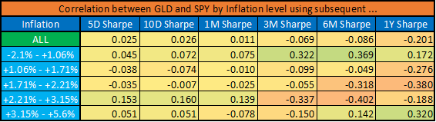

## Continuous Rolling Correlation

Our solution to these problems (smoothing, increasing the number of samples) is the introduction of the **continuous rolling correlation**. What does it mean in practice? During the calculation of correlation coefficient, we do not split the dataset into quintiles based on the SQ MSI level, but we calculate an own exact correlation for (almost) every possible SQ MSI level (from 10% to 95%). But how can we do this? For a given SQ MSI level, e.g. when SQ MSI = 65%, **the rolling correlation is calculated not only based on days (in the past) when the value of the indicator was just that much 65%. But we also take into account all days where the value of the indicator deviated by a maximum of 5% from this given 65%, i.e. when SQ MSI was between 60% and 70%.** It can **increase the number of samples using similar data (since SQ MSI = 65% and SQ MSI = 67% mean almost the same market environment) and can smooth the result thanks to the rolling method** (For example, to calculate correlation for SQ MSI = 65%, we use data from 60% to 70%. For SQ MSI = 66%, the correlation is calculated with data from 61% to 71%, which means that we change only almost one tenth of the data when switching to a neighbor.).

Chart 1a-e shows the **rolling correlation between GLD and SPY/QQQ subsequent x-day returns by SQ MSI level**. Based on these charts, **one can determine that in which periods (at what SQ MSI level) is GLD a good hedge (i.e. correlates negatively to SPY/QQQ) for the next x-day (based on past data)**. For example, GLD could be a good hedge for the next 1-month when SQ MSI level (now) is between 40% and 55% or it is around 75%. Furthermore, it can also be concluded that **the longer the look-ahead period, the smoother the rolling correlation function**. It is worth noting that the **correlation coefficients in the lower regions are less reliable than in higher regions due to the distribution of the SQ MSI level in the past** (which determines the number of samples for all levels) which can be seen in Chart 2.

This **rolling correlation method can even be used for other economic indicators as well**. Chart 3a-3d contains the rolling correlation between GLD and SPY/QQQ subsequent x-day returns by inflation level. Chart 4 shows that these correlation figures are more reliable in the middle regions of inflation level (between 1% and 3%, when we have enough data) than in extreme (and fortunately rare) cases (the two ends of the charts).

Chart 5a-d and 6a-d contain the same correlation functions for VXX as a hedge instead of GLD. Based on these charts it can be concluded that long VXX can be a good hedge (if we look at quality only on the basis of negative correlation - more in the next sub-section) at any level of SQ MSI, but not in every inflation regime.

In summary, **we can conclude that our rolling correlation method can be a useful tool for selecting appropriate hedges during different market environments. But it is not enough. We could see that long VXX correlates significantly negatively to the SPY, yet it is not a good idea to keep it as a hedge in all circumstances, as it can erode all our profits. Correlation is very important, but no all.**

Chart 1a: Rolling correlation between GLD and SPY/QQQ subsequent 1-day returns by SQ MSI level

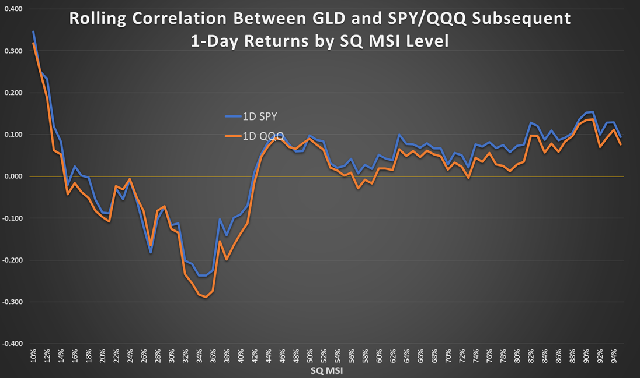

Chart 1b: Rolling correlation between GLD and SPY/QQQ subsequent 5-day returns by SQ MSI level

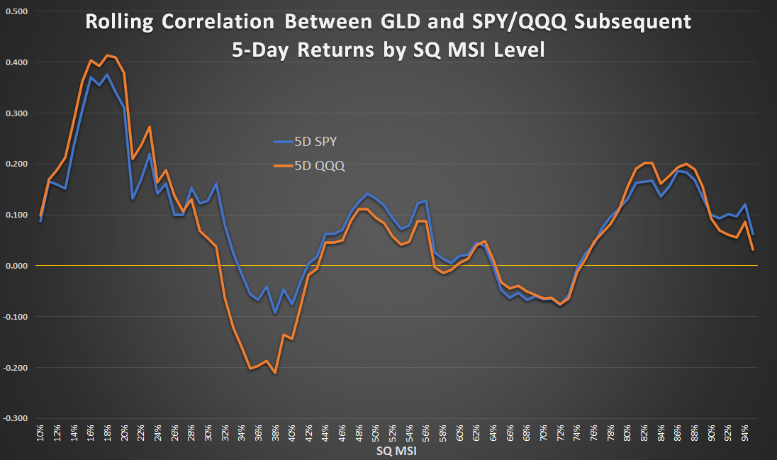

Chart 1c: Rolling correlation between GLD and SPY/QQQ subsequent 10-day returns by SQ MSI level

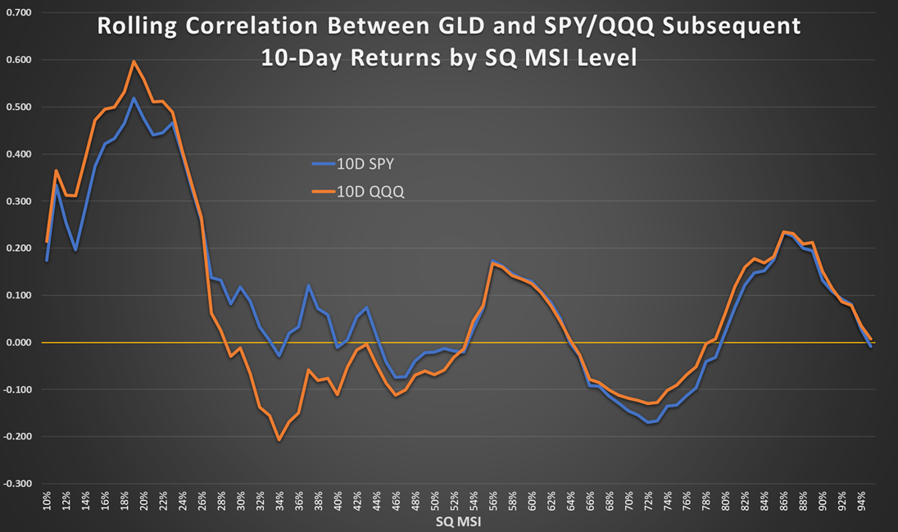

Chart 1d: Rolling correlation between GLD and SPY/QQQ subsequent 1-month returns by SQ MSI level

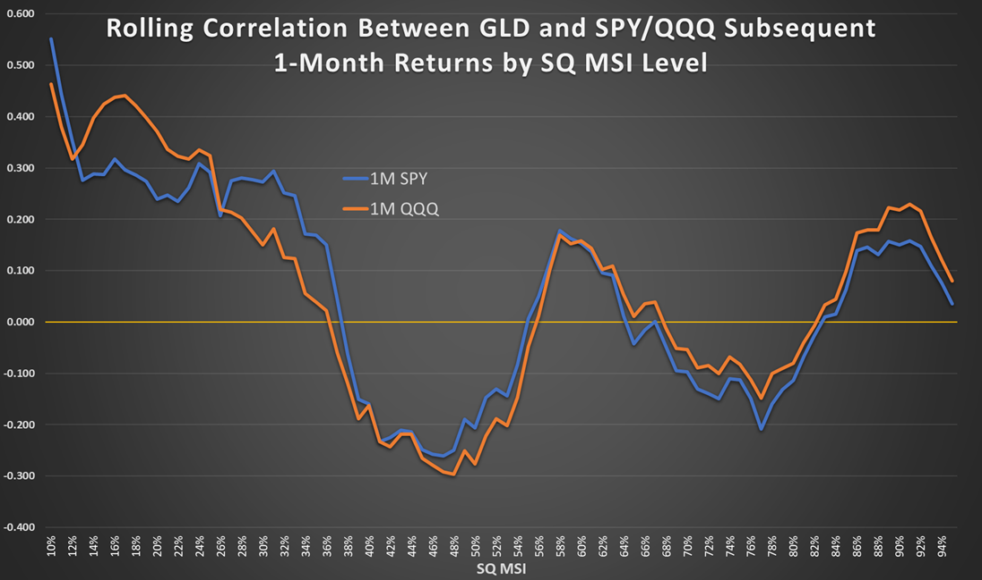

Chart 1e: Rolling correlation between GLD and SPY/QQQ subsequent 3-month returns by SQ MSI level

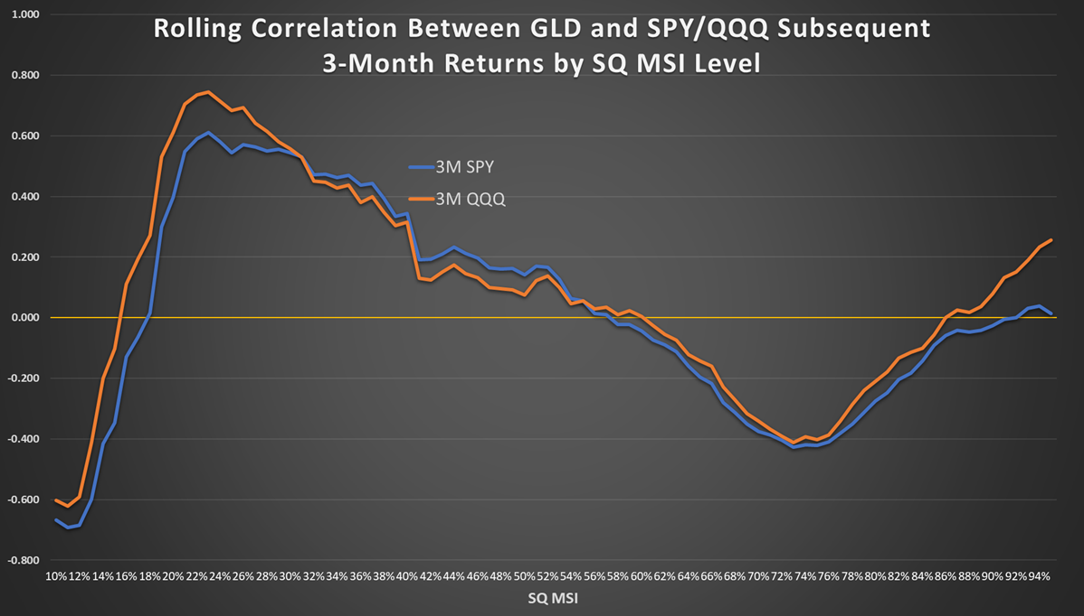

Chart 2: Distribution of ‘rolling’ SQ MSI level

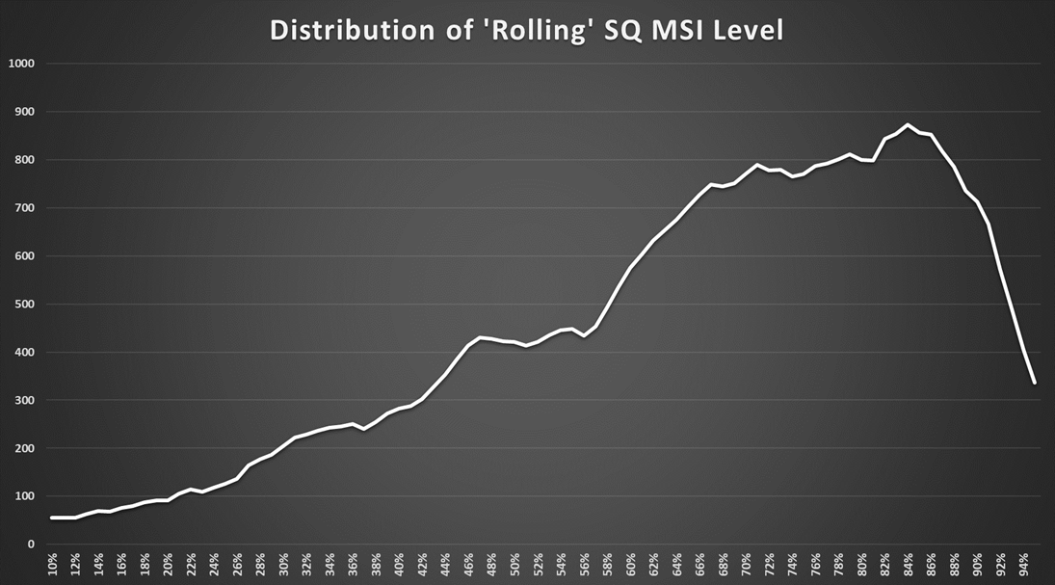

Chart 3a: Rolling correlation between GLD and SPY/QQQ subsequent 1-day returns by inflation level

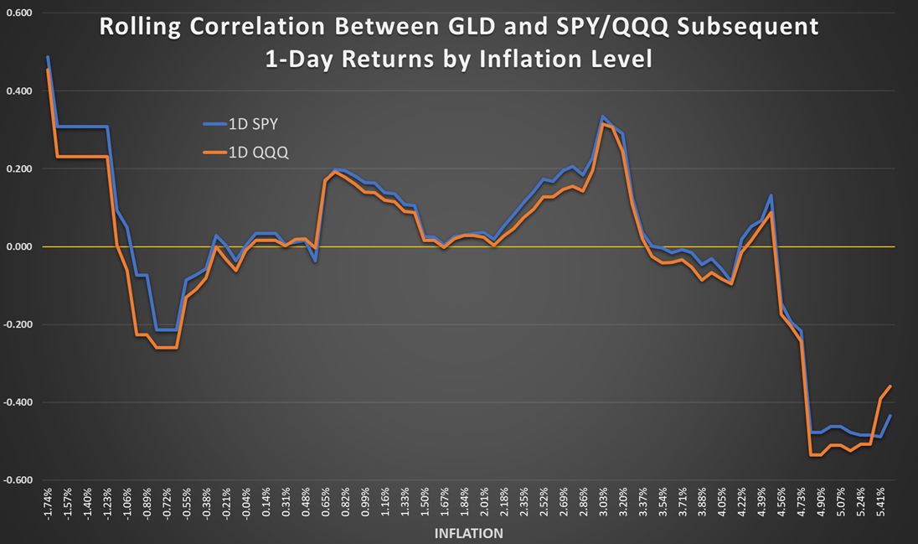

Chart 3b: Rolling correlation between GLD and SPY/QQQ subsequent 5-day returns by inflation level

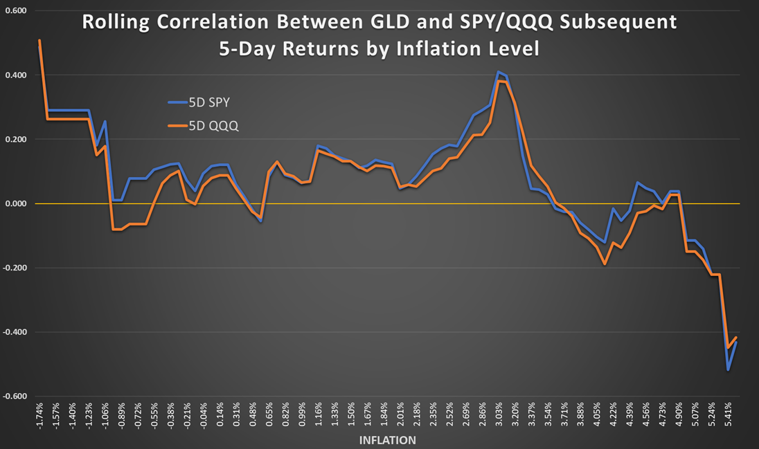

Chart 3c: Rolling correlation between GLD and SPY/QQQ subsequent 10-day returns by inflation level

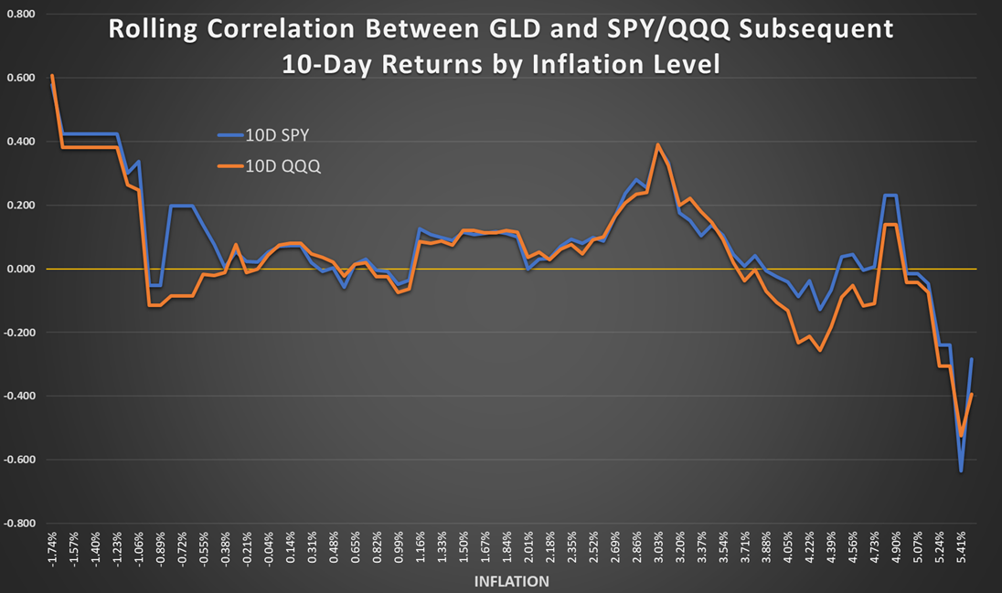

Chart 3d: Rolling correlation between GLD and SPY/QQQ subsequent 1-month returns by inflation level

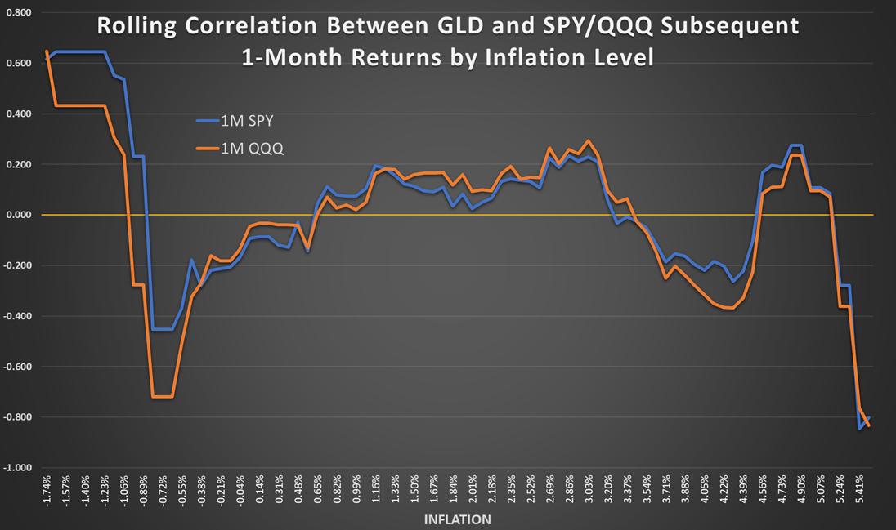

Chart 4: Distribution of ‘rolling’ inflation level

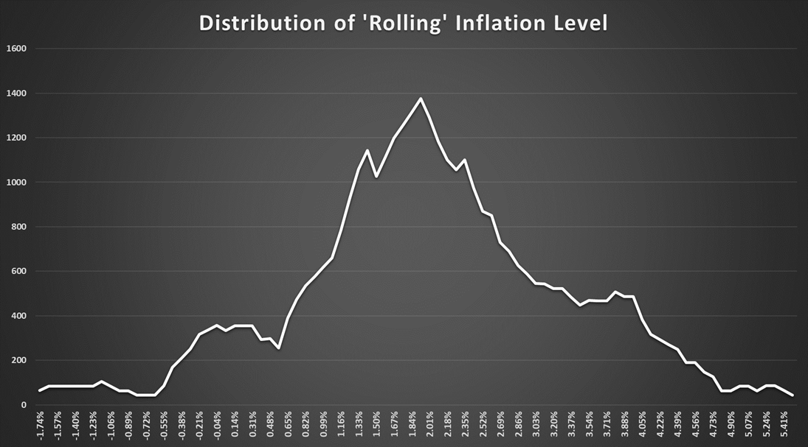

Chart 5a: Rolling correlation between VXX and SPY/QQQ subsequent 1-day returns by SQ MSI level

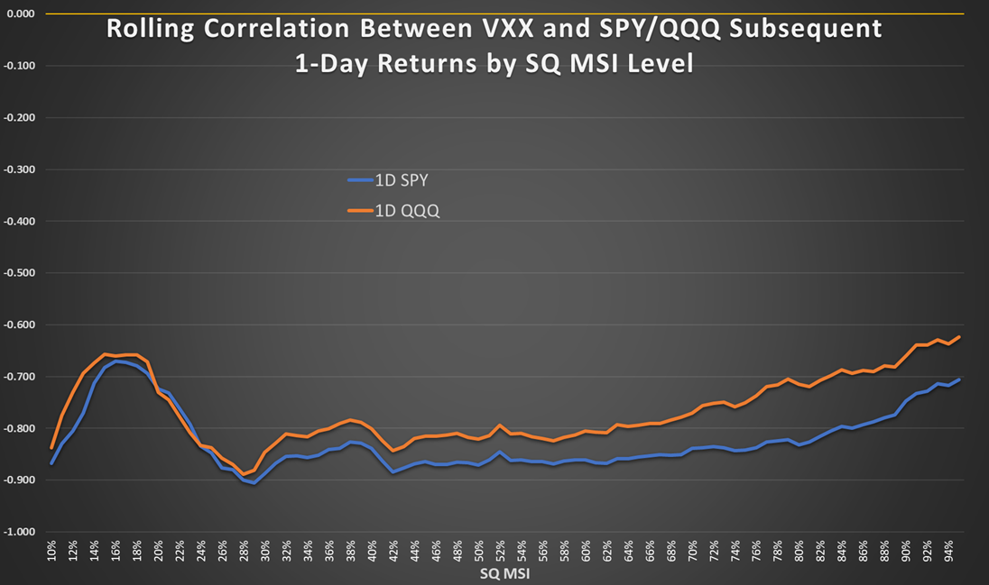

Chart 5b: Rolling correlation between VXX and SPY/QQQ subsequent 5-day returns by SQ MSI level

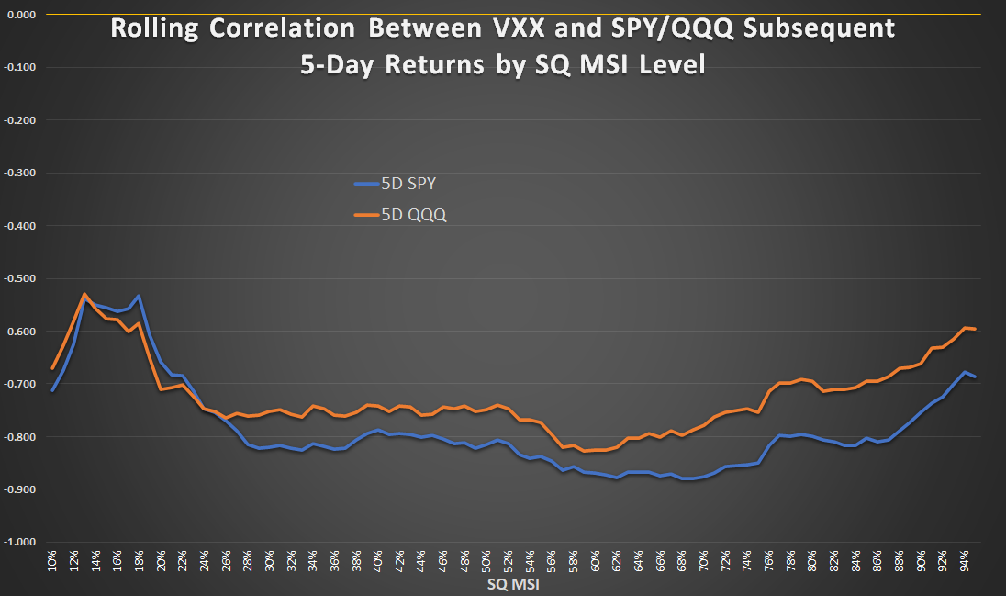

Chart 5c: Rolling correlation between VXX and SPY/QQQ subsequent 10-day returns by SQ MSI level

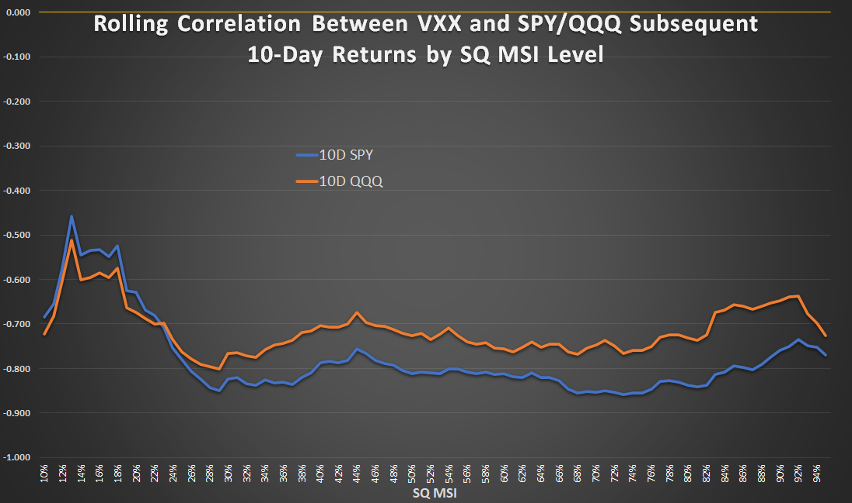

Chart 5d: Rolling correlation between VXX and SPY/QQQ subsequent 1-month returns by SQ MSI level

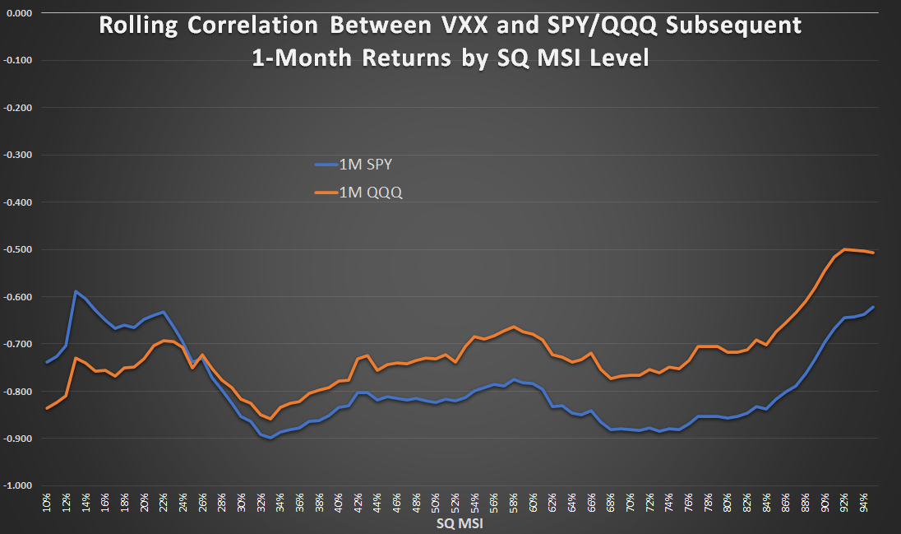

Chart 6a: Rolling correlation between VXX and SPY/QQQ subsequent 1-day returns by inflation level

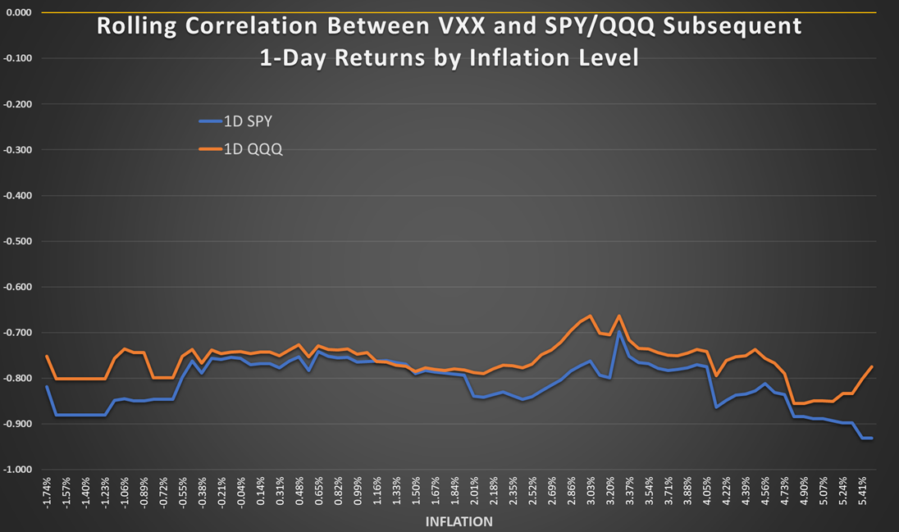

Chart 6b: Rolling correlation between VXX and SPY/QQQ subsequent 5-day returns by inflation level

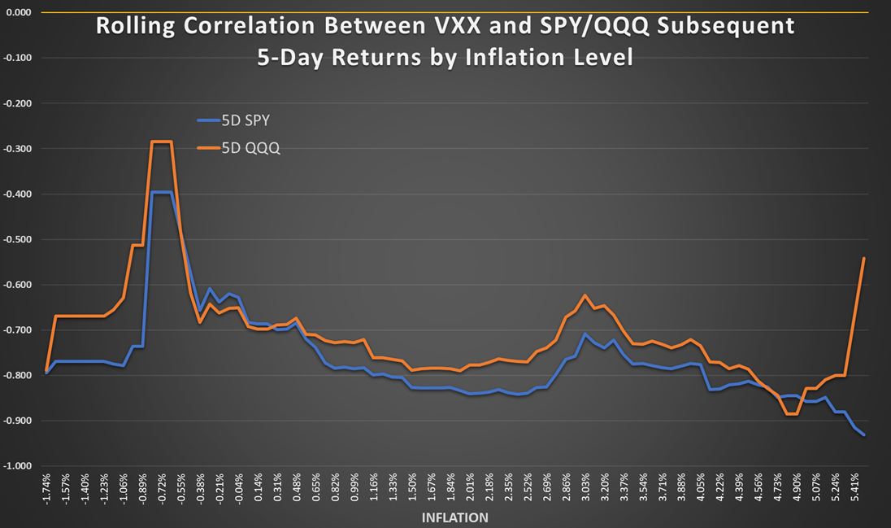

Chart 6c: Rolling correlation between VXX and SPY/QQQ subsequent 10-day returns by inflation level

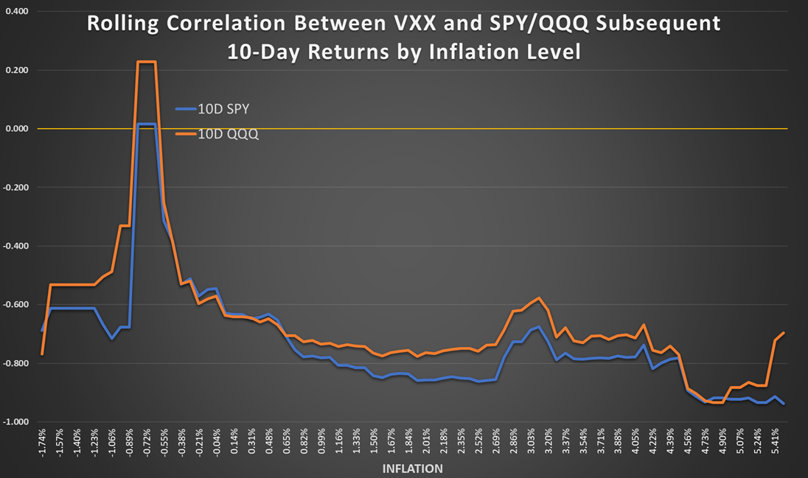

Chart 6d: Rolling correlation between VXX and SPY/QQQ subsequent 1-month returns by inflation level

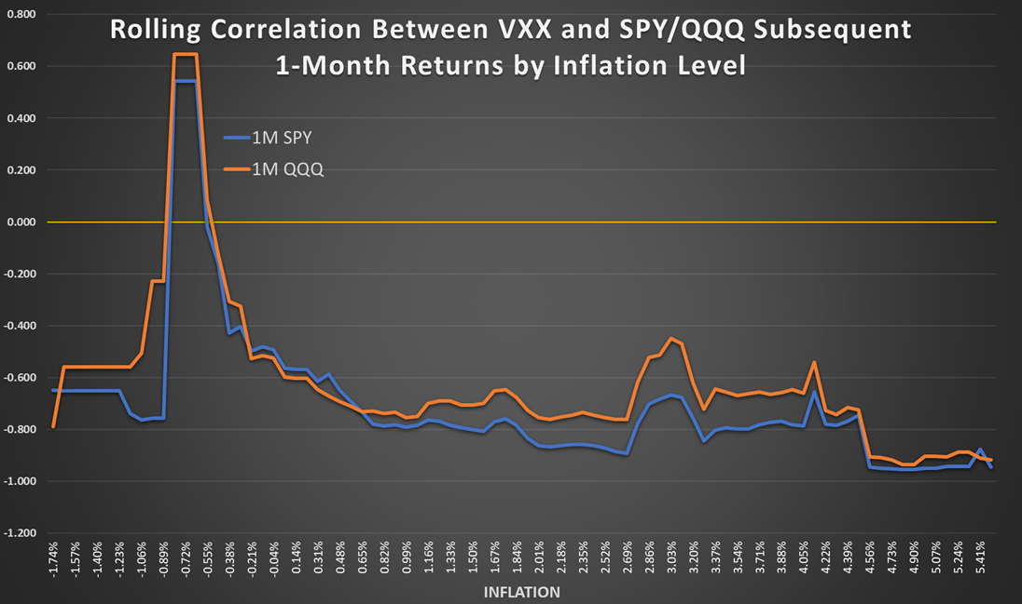

1. [Protecting Portfolios Using Correlation Diversification](https://www.investopedia.com/articles/financial-theory/09/uncorrelated-assets-diversification.asp)