Dr. George Antal

3D Click Limited

c/o Suite 431, 28 Old Brompton Road, London SW7 3SS

**Hedges and Correlations**

## SnifferQuant Hedge-Selection Method

### Hedge Universe data

During our analyses, **16 different ETPs** are used as possible hedges. Fortunately, **almost all of them were incepted before 2008, thus they were available during the financial crisis as well**.

The examined ETPs can be split into **four groups: bonds, commodities, safe haven and others**. The annualized mean returns of these ETPs by years can be found in Table 8. It is visible that, **compared to each other, these ETPs behave differently in various regimes, thus they (or their shorts) may be appropriate hedges for our portfolio and they should be selected dynamically**.

Possible hedger ETPs used during calculations:

* Bonds:
  + [TLT - iShares 20+ Year Treasury Bond ETF](http://finance.yahoo.com/quote/tlt) (since 2002-07-22);
  + [IEF - iShares 7-10 Year Treasury Bond ETF](https://finance.yahoo.com/quote/IEF) (since 2002-07-30);
  + [SHY - iShares 1-3 Year Treasury Bond ETF](https://finance.yahoo.com/quote/SHY) (since 2002-07-30);
  + [BWX - SPDR Bloomberg Barclays International Treasury Bond ETF](http://finance.yahoo.com/quote/bwx) (since 2007-10-02);
  + [EMB - iShares JPMorgan USD Emerging Markets Bond ETF](http://finance.yahoo.com/quote/Emb) (since 2007-12-17);
* Commodities:
  + [JJC - iPath Bloomberg Copper Subindex Total Return ETN](http://finance.yahoo.com/quote/jjc) (since 2007-10-23);
  + [UNG - United States Natural Gas Fund LP](http://finance.yahoo.com/quote/ung) (since 2007-04-18);
  + [USO - United States Oil Fund LP](http://finance.yahoo.com/quote/uso) (since 2006-04-10);
  + [DBC - Invesco DB Commodity Index Tracking Fund](https://finance.yahoo.com/quote/DBC) (since 2006-02-06);
* Safe Haven:
  + [GLD - SPDR Gold Trust](http://finance.yahoo.com/quote/gld) (since 2004-11-12);
  + [SLV - iShares Silver Trust](http://finance.yahoo.com/quote/slv) (since 2006-04-21);
  + [UUP - Powershares DB US Dollar Index Bullish Fund](http://www.etf.com/Uup) (since 2007-02-20);
* Other:
  + [EEM - iShares MSCI Emerging Markets ETF](http://finance.yahoo.com/quote/EEM/) (since 2003-04-07);
  + [XLU - Utilities Select Sector SPDR Fund](https://finance.yahoo.com/quote/XLU) (since 1998-12-22);
  + [TAIL - Cambria Tail Risk ETF](https://finance.yahoo.com/quote/TAIL) (since 2017-04-06);
  + [VXX - iPath Series B S&P 500 VIX Short-Term Futures ETN](https://finance.yahoo.com/quote/VXX) (since 2004-03-26).

Table 8: Annualized Mean returns of different ETPs by years

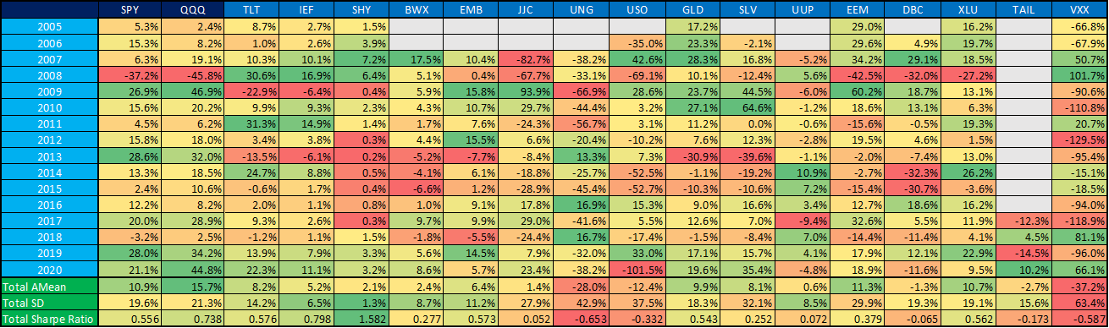

### Rolling correlation examples

### 

As it can be seen in the Background section, **not only the quality (correlation to the portfolio) but the cost of a hedge is also important**. In this study, **we use the subsequent x-day Sharpe ratio of the selected hedge as an inverse proxy of the cost** (that is, the higher the Sharpe ratio, the lower the cost of the selected hedge - or even can generate extra profit when the Sharpe ratio is positive).

In other words, **we need to choose hedges for a given environment that have a negative correlation to the portfolio (SPY/QQQ/FAANG/etc.) and a Sharpe ratio as high as possible.** **Or, we can short an ETF when its correlation is significantly positive and its Sharpe ratio is significantly negative**.

In this subsection, 5-day, 10-day and 1-month look-ahead periods will be used.

Chart 7a-c shows some interesting **Sharpe ratio vs. correlation to the QQQ paths** (from SQ MSI = 10% to SQ MSI = 95%) using different hedges (TLT, UNG and VXX). Based on these charts, it can be concluded that:

* **TLT is almost always a good hedge with negative correlation and positive Sharpe ratio** (can generate extra profit) - using 5-day look-ahead period;
* **Short UNG can also be a good hedge, but in more than half of the cases, its correlation is not very significant** - using 10-day look-ahead period;
* **Although long VXX almost always strongly negatively correlates to the QQQ (which is good), its Sharpe ratio is almost always negative (which is bad)** - using a 1-month look-ahead period;
* **But most importantly, these paths are ‘smooth’, non-oscillating, thus our ‘Rolling correlation vs. Sharpe Ratio’ method seems reliable to use.**

Chart 7a: Path of TLT Sharpe ratio vs. correlation to QQQ - 5-day look-ahead period

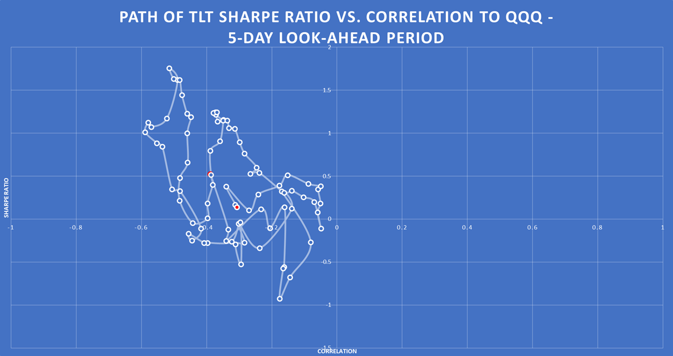

Chart 7b: Path of UNG Sharpe ratio vs. correlation to QQQ - 10-day look-ahead period

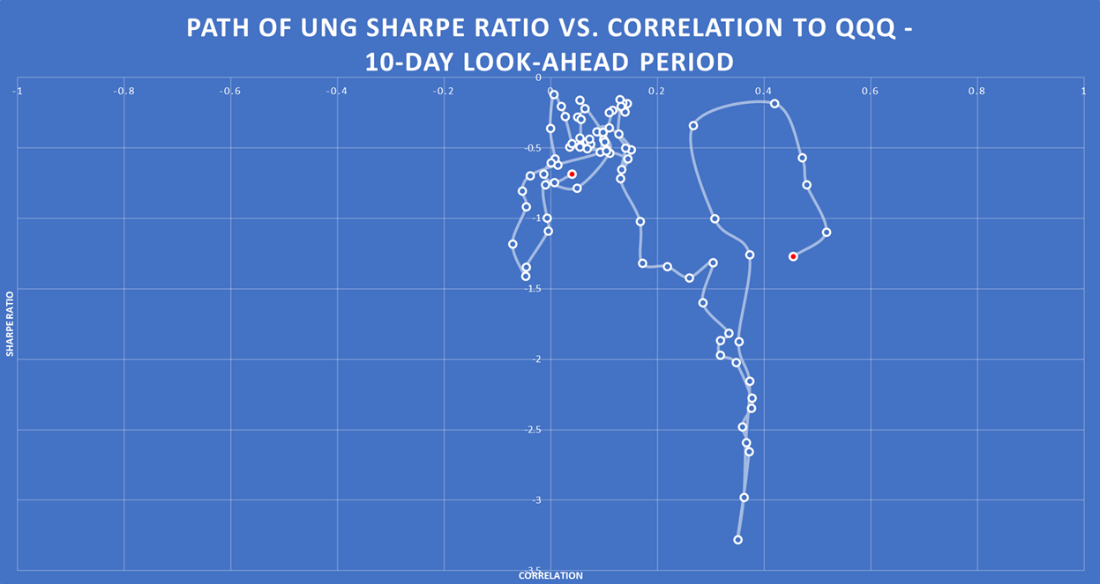

Chart 7c: Path of VXX Sharpe ratio vs. correlation to QQQ - 1-month look-ahead period

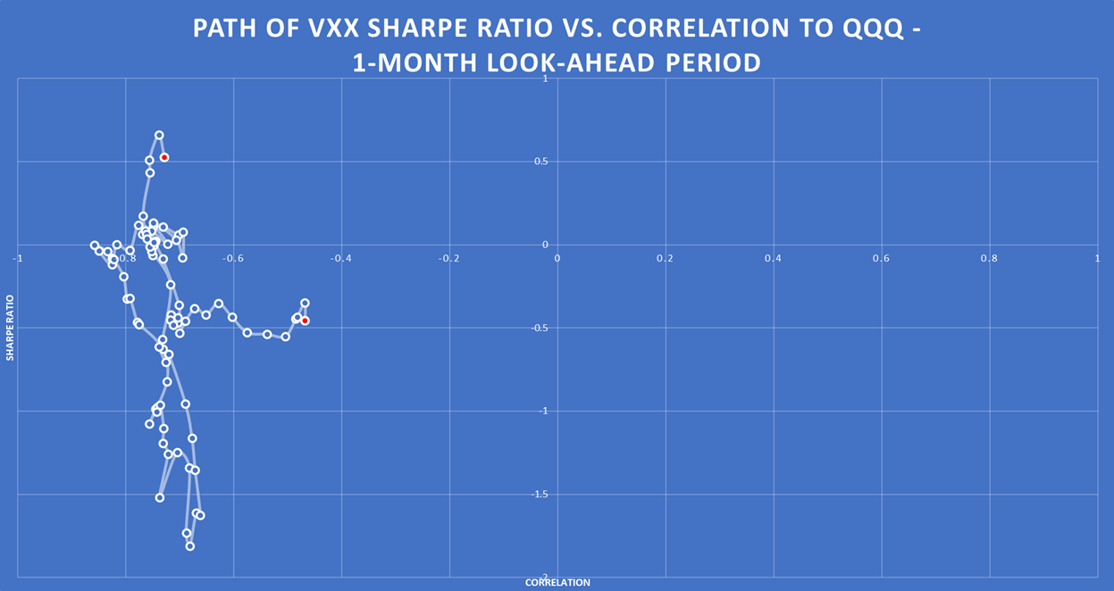

### Case studies for SQ MSI in practice

After **the method has been validated**, let us see **how it could work in practice**. In this part of the study, we examine:

* **2 hedgeable ‘portfolio’: long SPY and long QQQ;**
* **3 different SQ MSI level: 25%, 60% and 85%;**
* **3 different look-ahead periods: 5-day, 10-day and 1-month.**

In each **nine cases (3 SQ-MSI x 3 look-ahead)**, at first, the **scatter plot of correlation vs. Sharpe ratio** can be seen (e.g. Chart 8a-b), which helps us to **select the most promising hedges** (significantly negative correlation and positive Sharpe ratio and/or significantly positive correlation and negative Sharpe ratio (short)). After that, a table can be found (e.g. Table 9) which contains **not only the correlation coefficients for every hedge, but the beta compared to the SPY/QQQ** as well. Based on these beta, one can **specify the desired weights** of the selected hedges. We do not recommend any exact method for this, but it would theoretically be possible to create a near-beta-neutral portfolio. However, this would have been an overly over-fitted system. **Our recommended weights** in the penultimate column are discretionary determined based on the previous columns. Finally, a **portfolio value chart** (e.g. Chart 9) and a **performance indicator table** (Table 10) can be found which shows how the performance of the **portfolio (SPY/QQQ) with and without hedges (double leverage in this case in this study because of the weights of the hedges)** would have progressed in the days when the level of SQ MSI is between x-5% and x+5%. It is worth noting that these results may suffer from look-ahead and data-mining biases.

In this subsection, we will not explain each case in detail, as we could describe nearly identical things in each one. Our main findings and thoughts are:

* **As the SPY and the QQQ are highly correlated, the same hedges are appropriate for both in a given market environment.**
* **TLT and UUP are good choices in almost all cases.**
* **Long VXX is only very rarely worth using as a hedge.**
* **Short gas (UNG) and/or short oil (USO) can also be used very often in the hedging basket.**
* **Short copper (JJC) is a useful hedge when SQ MSI is high.**
* **The beta of SHY is too low to be worth dealing with this ETF.**
* **TAIL seems like a good choice in many cases, but it is worth being careful, as there is very little historical data available so far (TAIL is available only from 2017).**
* **In all the nine cases, using hedge can improve both the Sharpe and the MAR ratios (it does not depend on the leverage!).**

An **online GoogleSheet version for this SnifferQuant Hedge-Selection Method** can be found [**here**](https://docs.google.com/spreadsheets/d/1F-8oRq1wiKqAhNPctLMjeT0OCjktorB-UglUS-UFDa0), where the **SQ MSI level** (cell ‘B1’), the **look-ahead period** (cell ‘E1’) and the **discretionary hedge weights** (cells ‘G24:G39’) should be changed.

**In summary, we strongly believe that this SnifferQuant Hedge-Selection Method can be a useful tool in all market situations. It helps us to select the expectedly most effective hedges which can even generate extra profit as well (in addition to risk reduction).**

**SQ MSI: 25%, 5-day look-ahead period**

Chart 8a: Correlation vs. Sharpe ratio SQ MSI: 25%, using SPY - 5-day look-ahead period

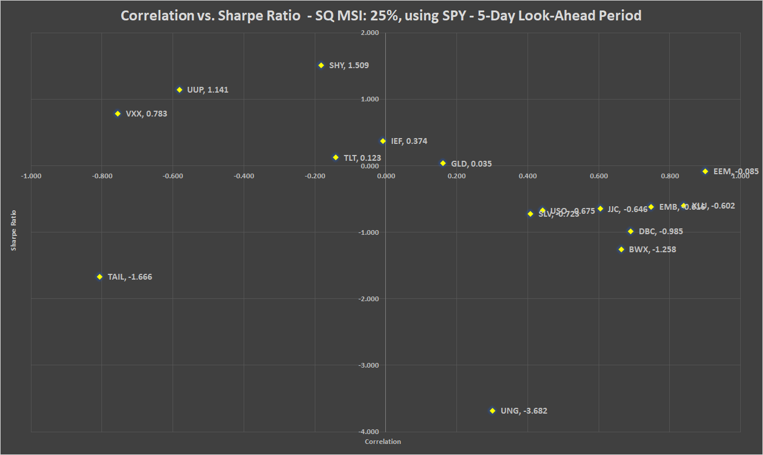

Chart 8b: Correlation vs. Sharpe ratio SQ MSI: 25%, using QQQ - 5-day look-ahead period

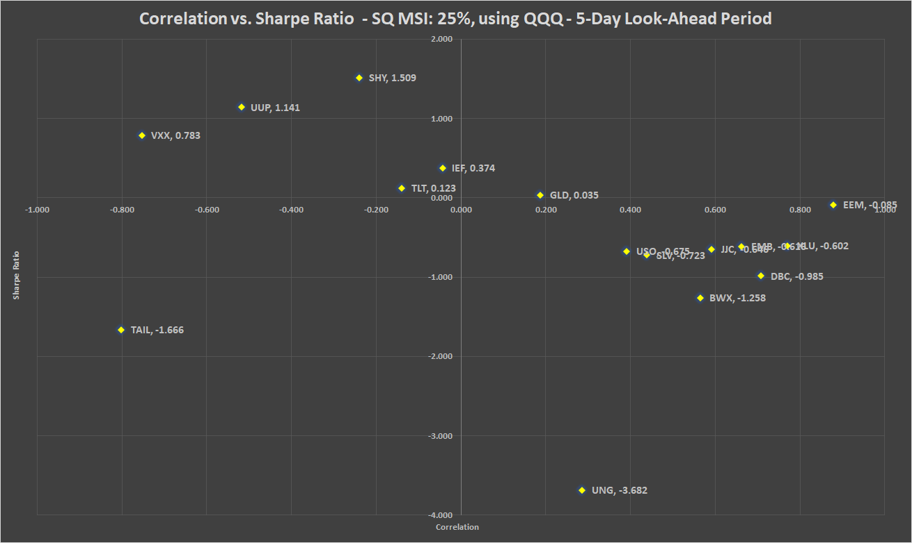

Table 9: Correlation, beta, Sharpe ratio and recommended weights of hedges - SQ MSI: 25% - 5-day look-ahead period

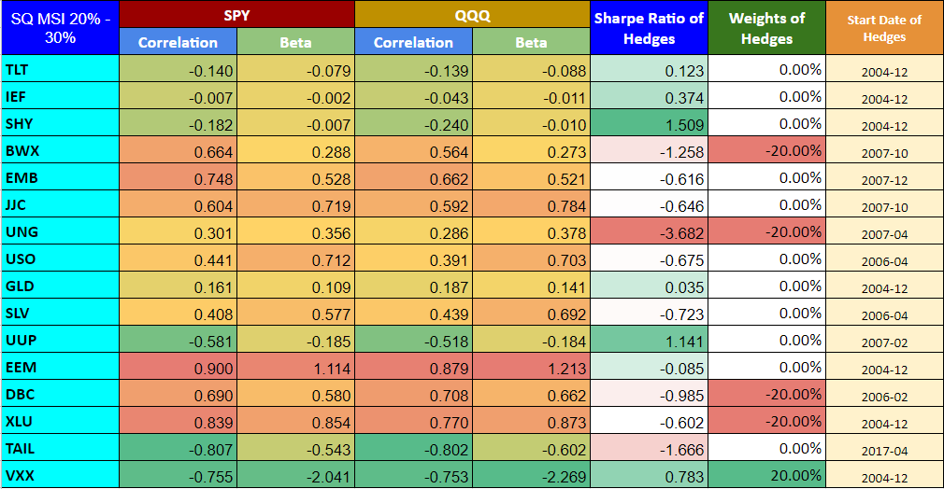

Chart 9: PV - SQ MSI: 25% - 5-day look-ahead period

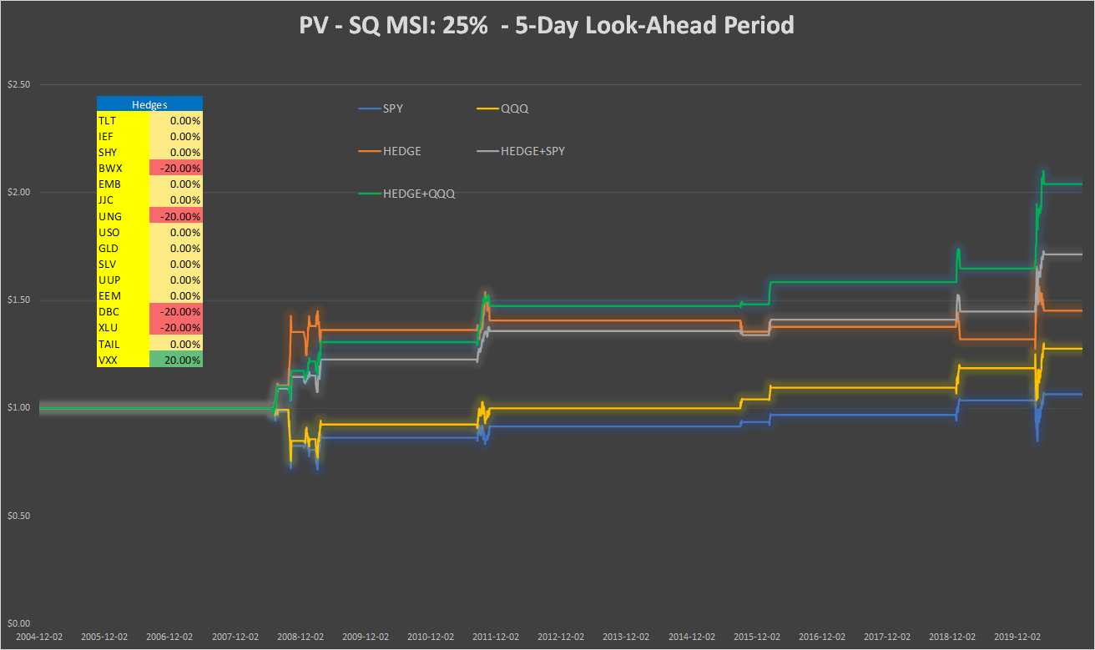

Table 10: Performance indicators with and without hedges - SQ MSI: 25% - 5-day look-ahead period

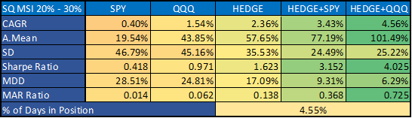

**SQ MSI: 60%, 5-day look-ahead period**

Chart 10a: Correlation vs. Sharpe ratio SQ MSI: 60%, using SPY - 5-day look-ahead period

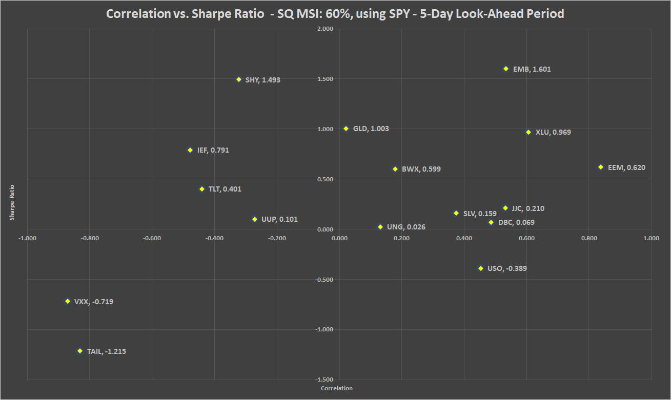

Chart 10b: Correlation vs. Sharpe ratio SQ MSI: 60%, using QQQ - 5-day look-ahead period

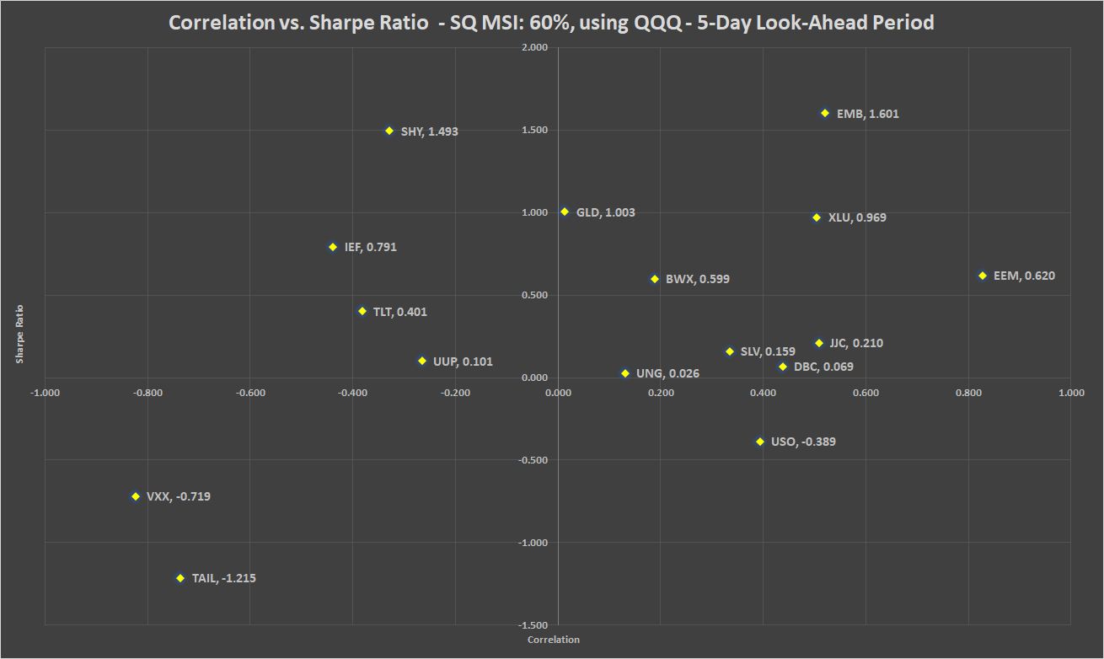

Table 11: Correlation, beta, Sharpe ratio and recommended weights of hedges - SQ MSI: 60% - 5-day look-ahead period

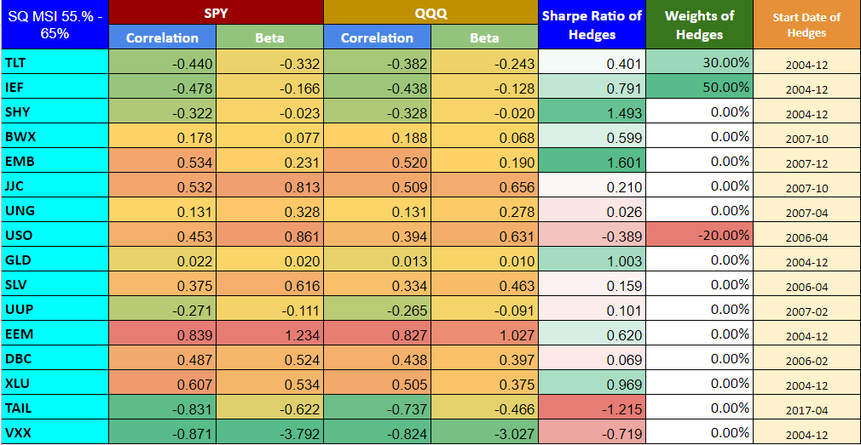

Chart 11: PV - SQ MSI: 60% - 5-day look-ahead period

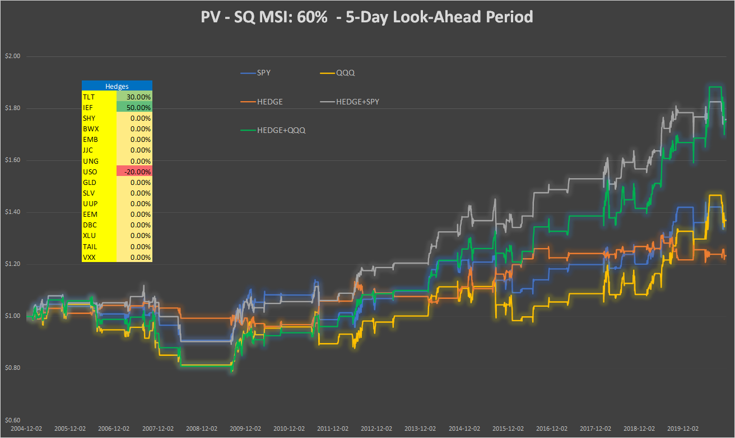

Table 12: Performance indicators with and without hedges - SQ MSI: 60% - 5-day look-ahead period

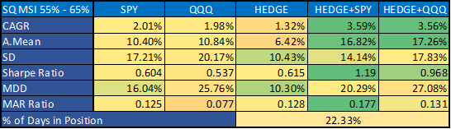

**SQ MSI: 85%, 5-day look-ahead period**

Chart 12a: Correlation vs. Sharpe ratio SQ MSI: 85%, using SPY - 5-day look-ahead period

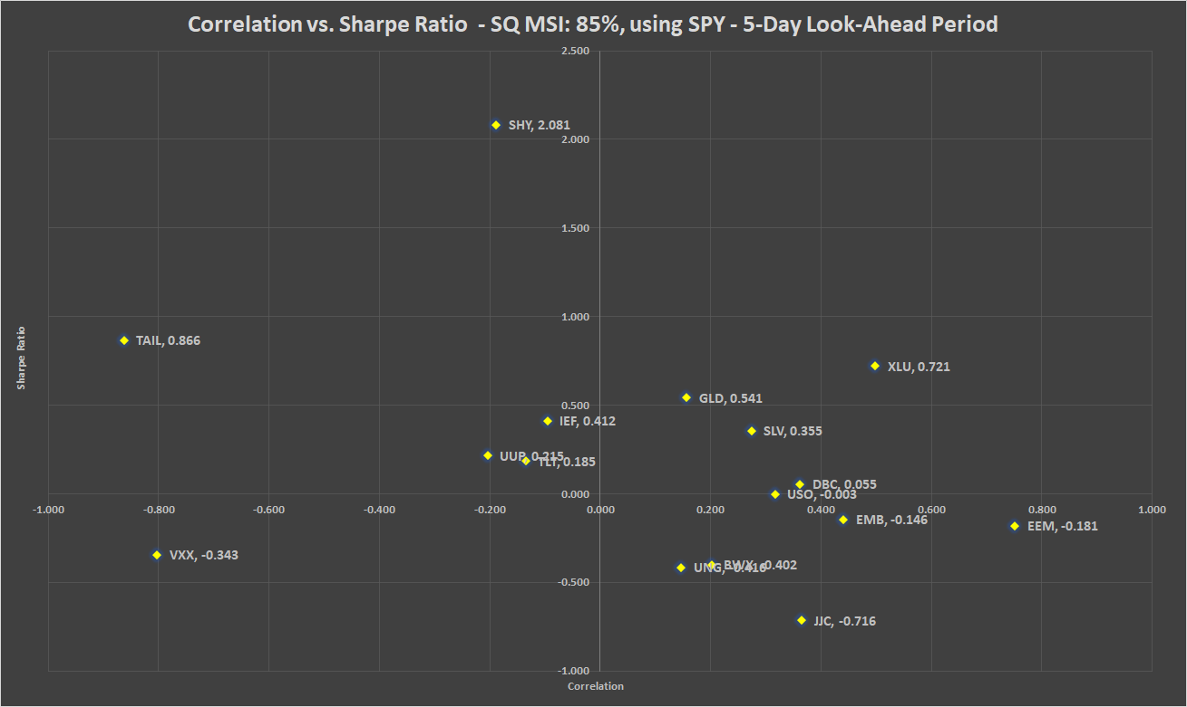

Chart 12b: Correlation vs. Sharpe ratio SQ MSI: 85%, using QQQ - 5-day look-ahead period

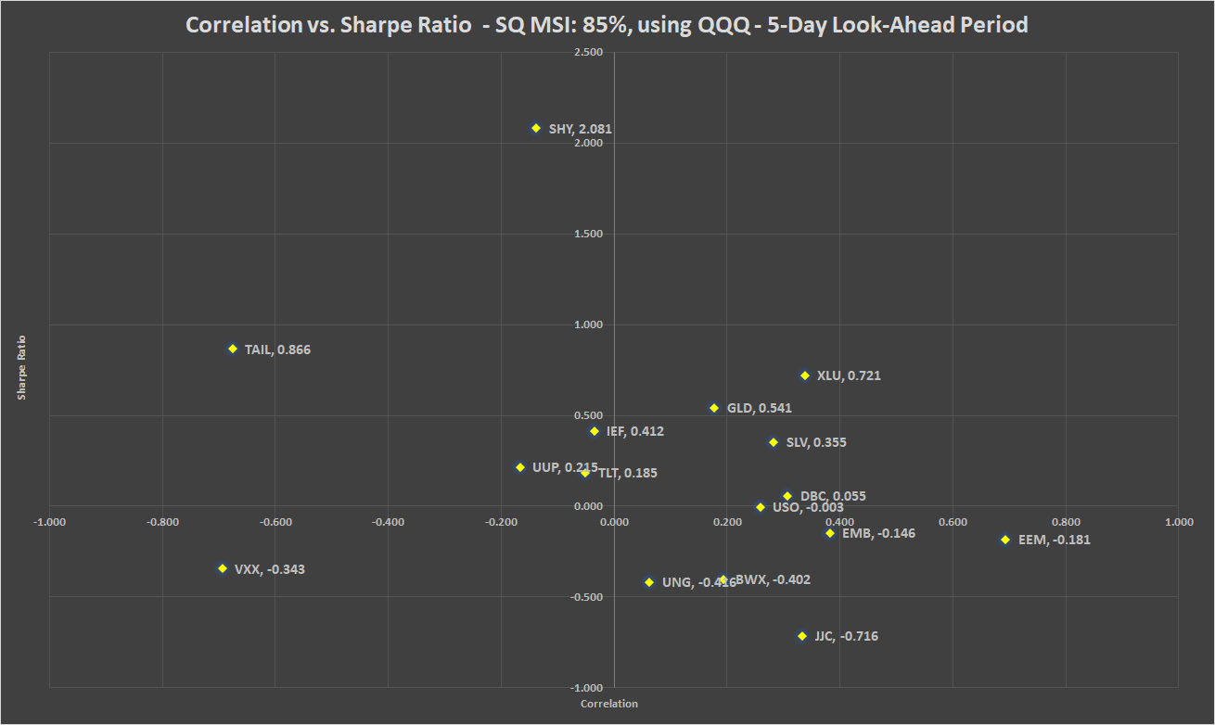

Table 13: Correlation, beta, Sharpe ratio and recommended weights of hedges - SQ MSI: 85% - 5-day look-ahead period

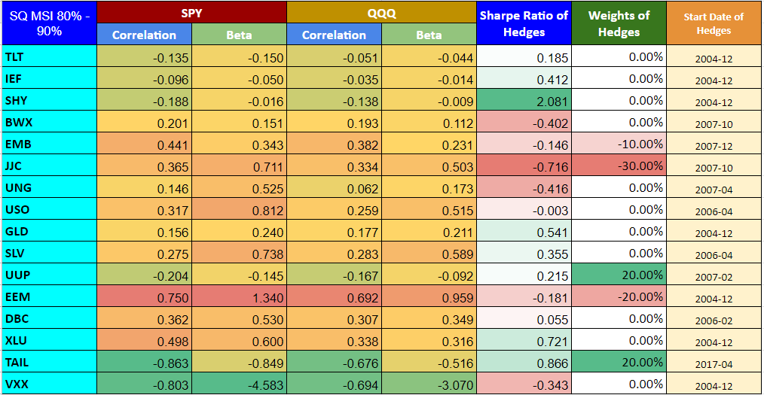

Chart 13: PV - SQ MSI: 85% - 5-day look-ahead period

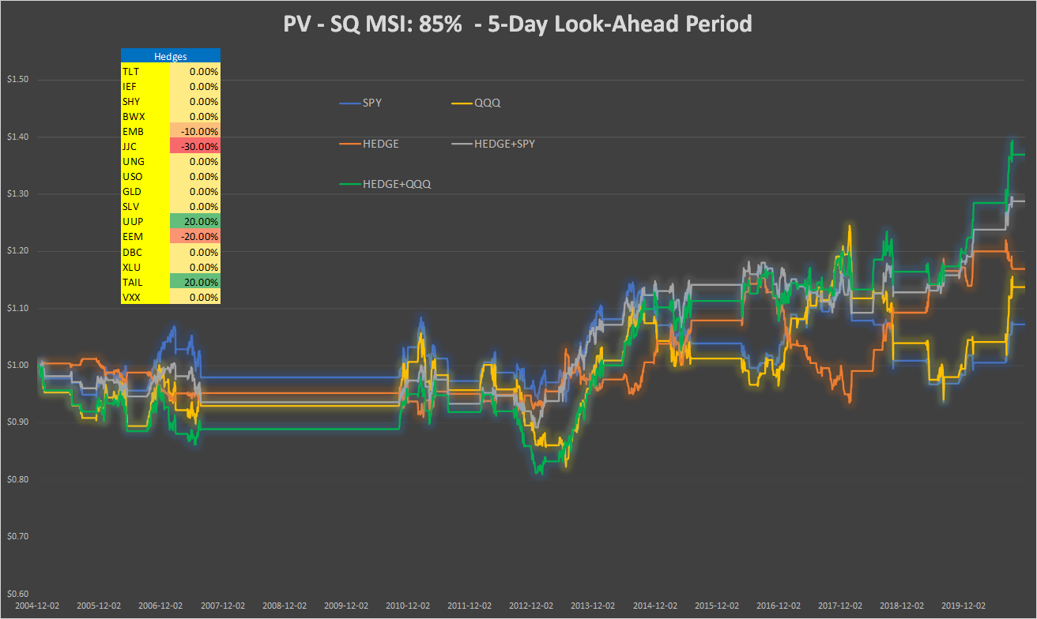

Table 14: Performance indicators with and without hedges - SQ MSI: 85% - 5-day look-ahead period

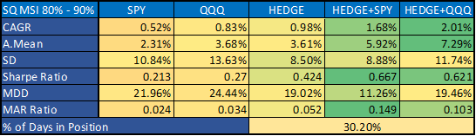

**SQ MSI: 25%, 10-day look-ahead period**

Chart 14a: Correlation vs. Sharpe ratio SQ MSI: 25%, using SPY - 10-day look-ahead period

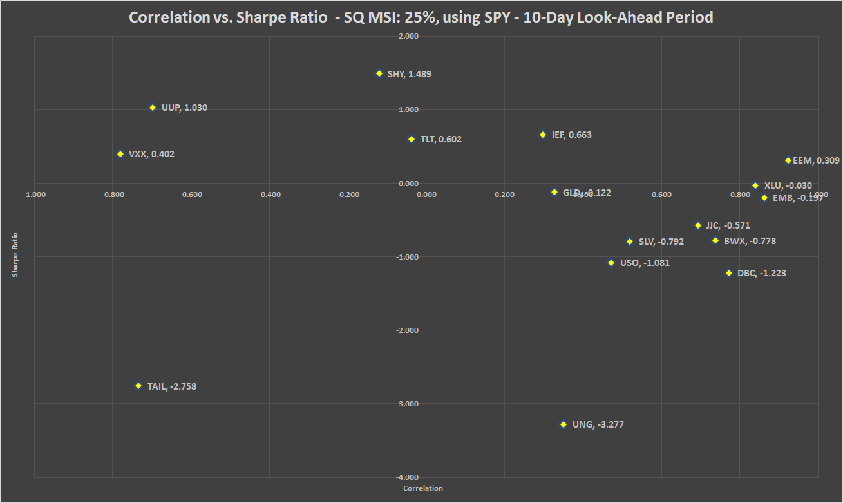

Chart 14b: Correlation vs. Sharpe ratio SQ MSI: 25%, using QQQ - 10-day look-ahead period

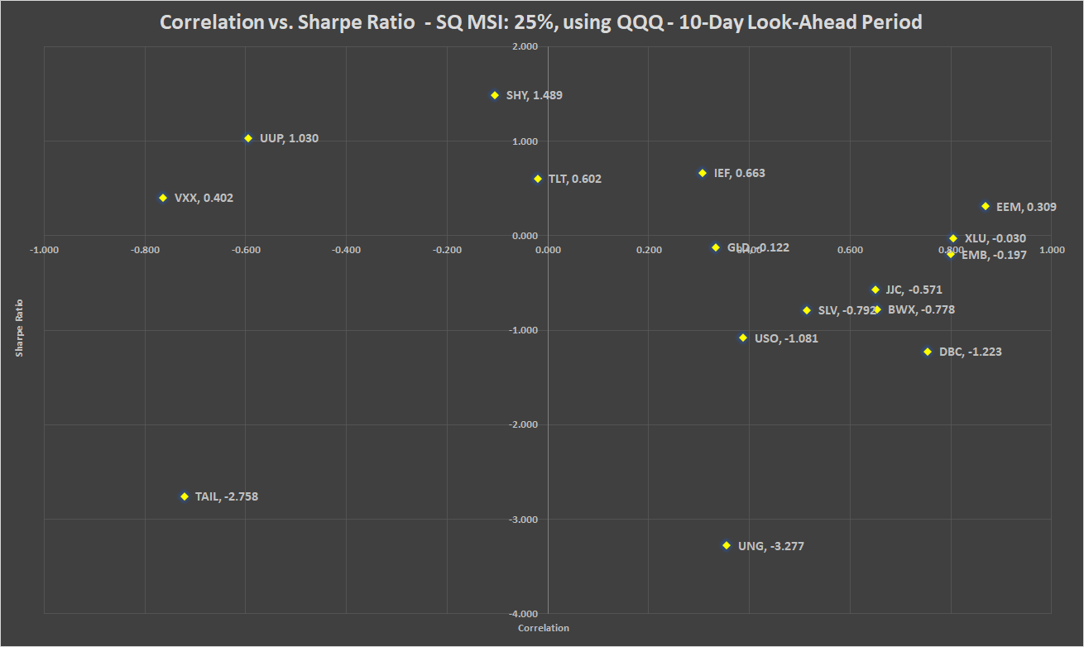

Table 15: Correlation, beta, Sharpe ratio and recommended weights of hedges - SQ MSI: 25% - 10-day look-ahead period

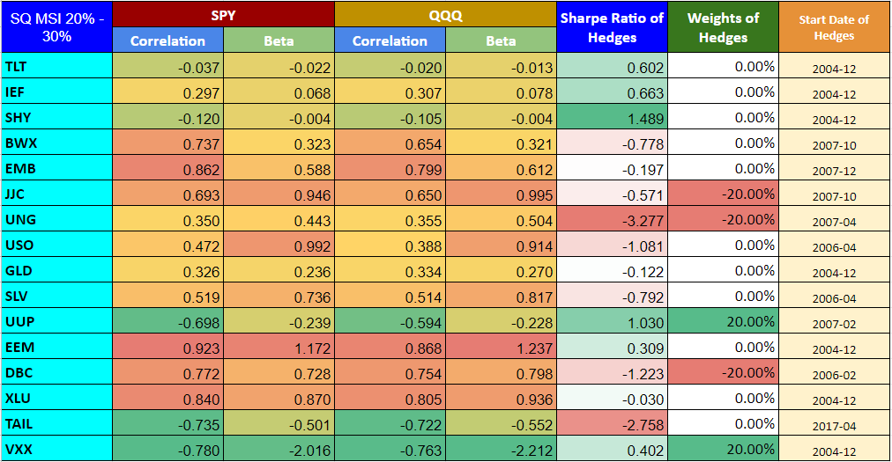

Chart 15: PV - SQ MSI: 25% - 10-day look-ahead period

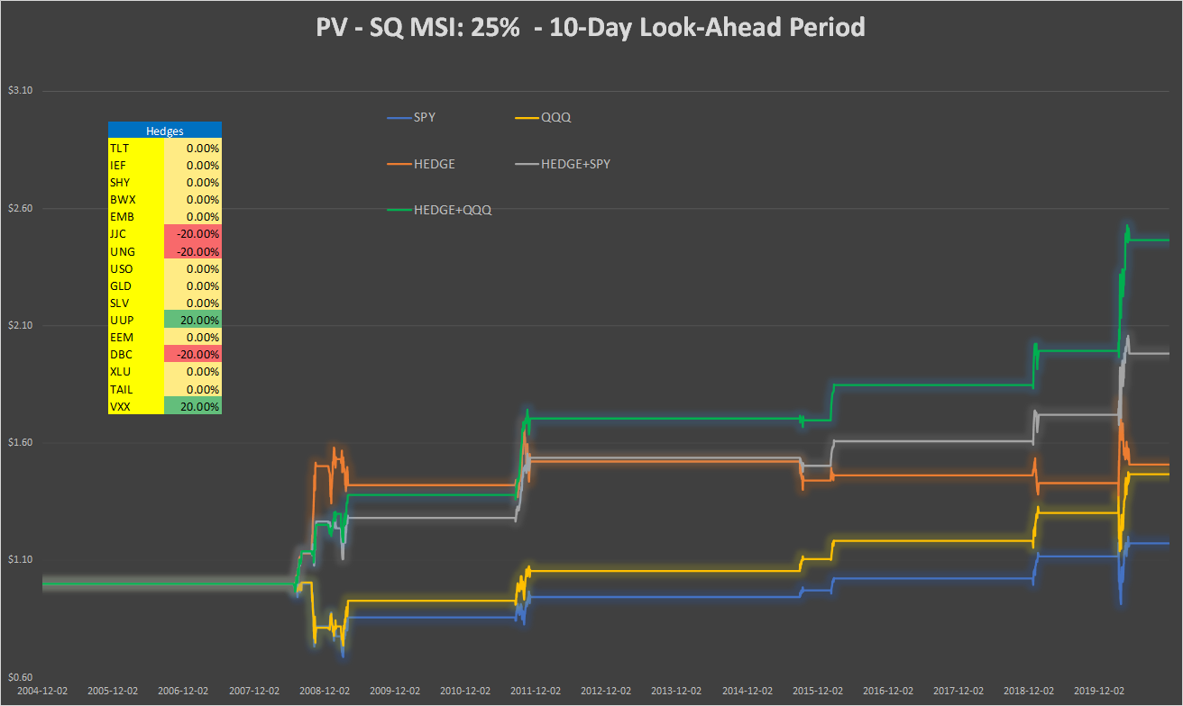

Table 16: Performance indicators with and without hedges - SQ MSI: 25% - 10-day look-ahead period

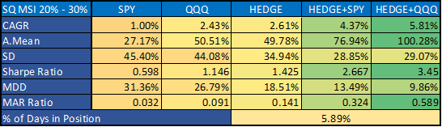

**SQ MSI: 60%, 10-day look-ahead period**

Chart 16a: Correlation vs. Sharpe ratio SQ MSI: 60%, using SPY - 10-day look-ahead period

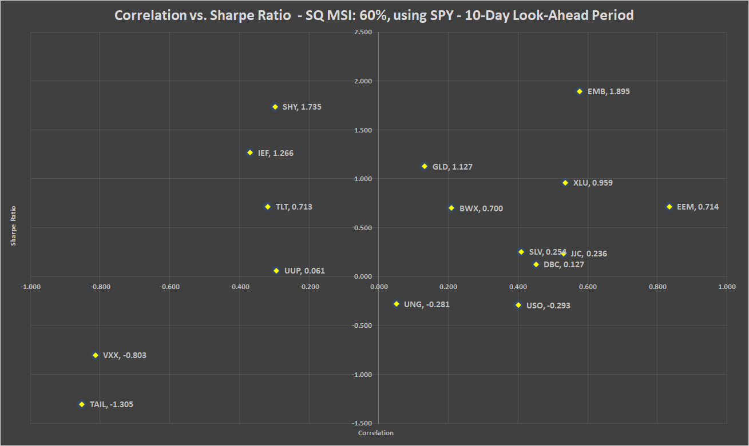

Chart 16b: Correlation vs. Sharpe ratio SQ MSI: 60%, using QQQ - 10-day look-ahead period

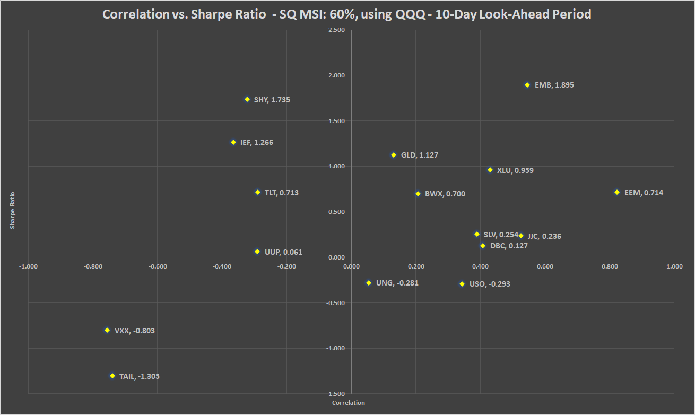

Table 17: Correlation, beta, Sharpe ratio and recommended weights of hedges - SQ MSI: 60% - 10-day look-ahead period

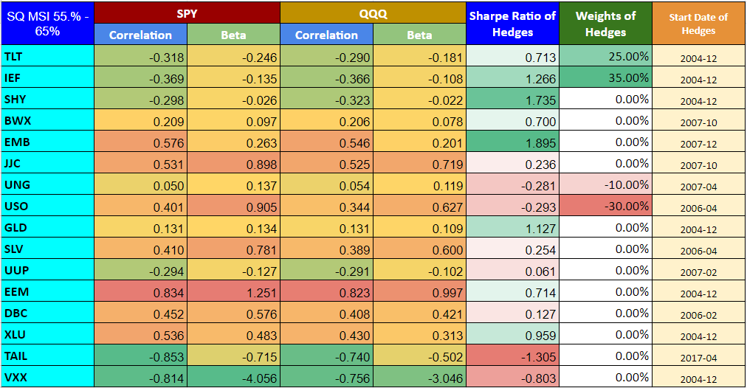

Chart 17: PV - SQ MSI: 60% - 10-day look-ahead period

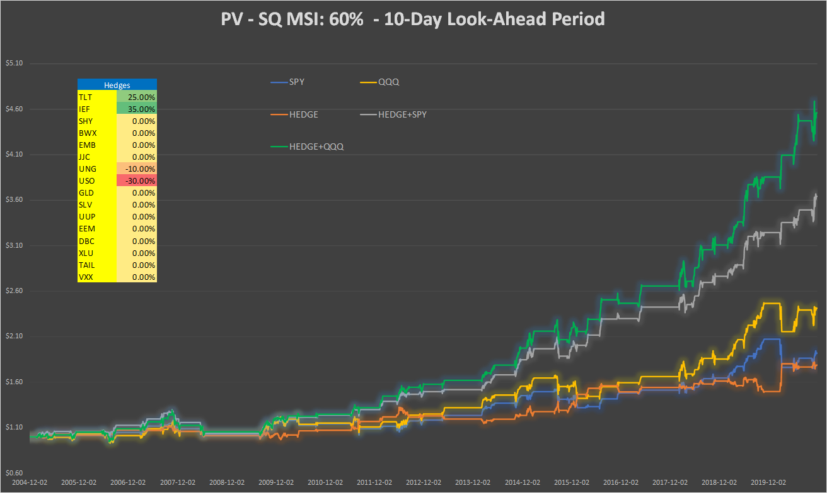

Table 18: Performance indicators with and without hedges - SQ MSI: 60% - 10-day look-ahead period

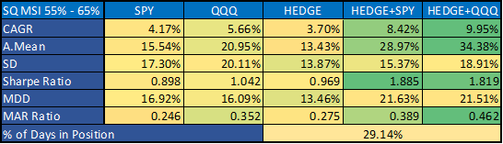

**SQ MSI: 85%, 10-day look-ahead period**

Chart 18a: Correlation vs. Sharpe ratio SQ MSI: 85%, using SPY - 10-day look-ahead period

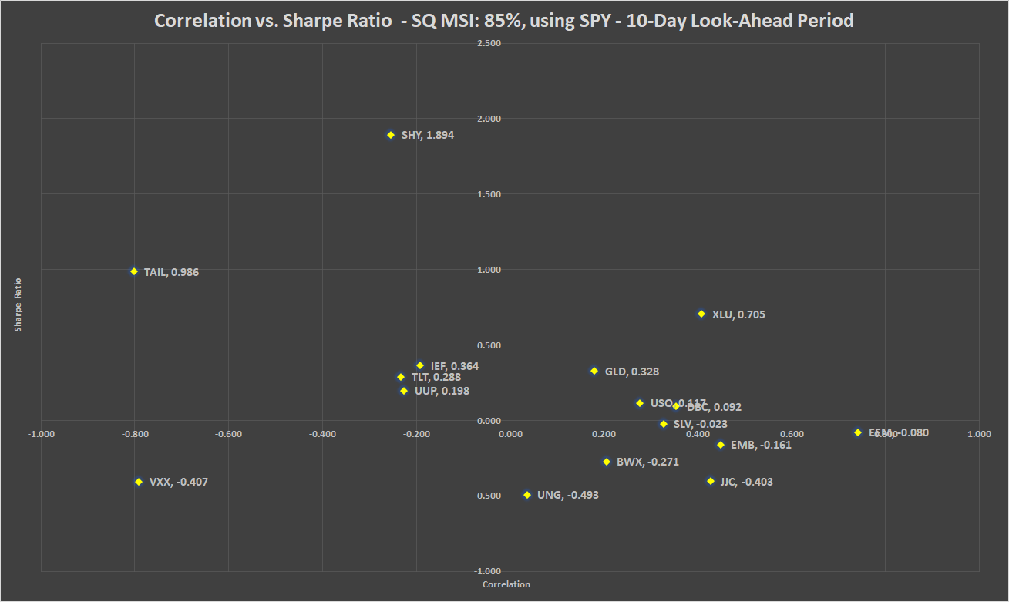

Chart 18b: Correlation vs. Sharpe ratio SQ MSI: 85%, using QQQ - 10-day look-ahead period

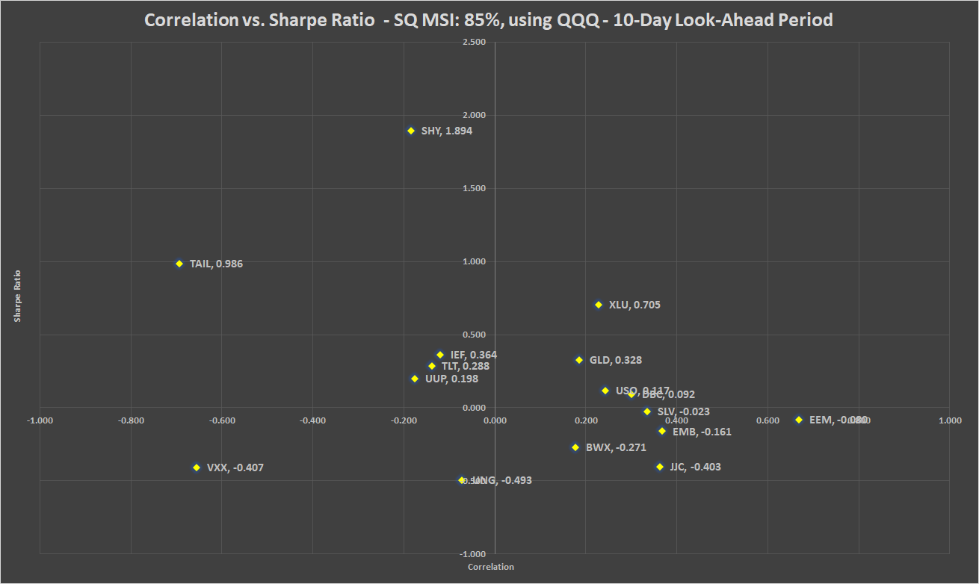

Table 19: Correlation, beta, Sharpe ratio and recommended weights of hedges - SQ MSI: 85% - 10-day look-ahead period

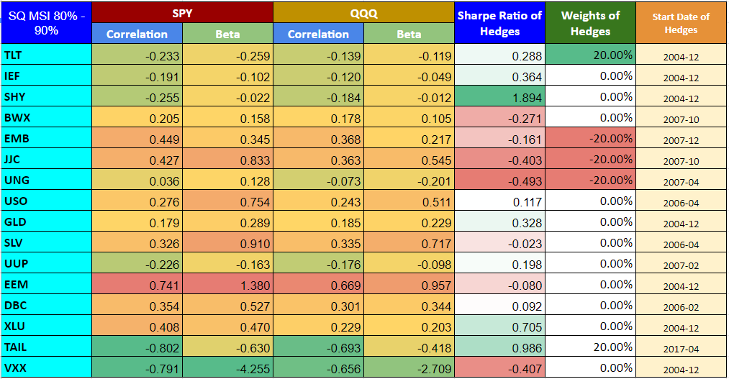

Chart 19: PV - SQ MSI: 85% - 10-day look-ahead period

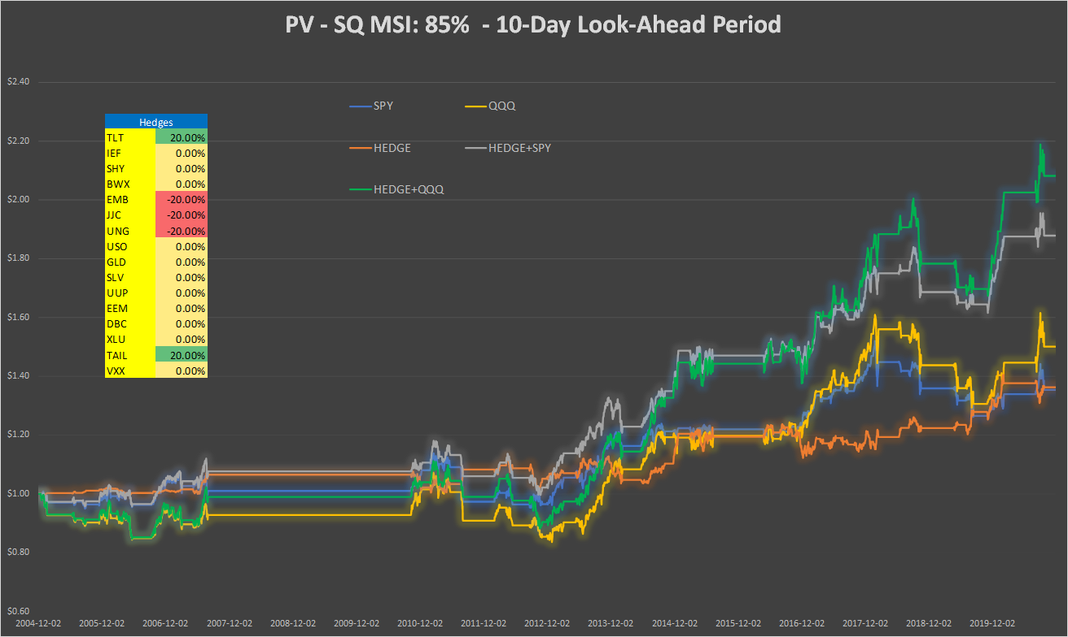

Table 20: Performance indicators with and without hedges - SQ MSI: 85% - 10-day look-ahead period

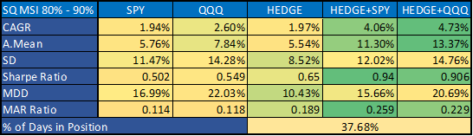

**SQ MSI: 25%, 1-month look-ahead period**

Chart 20a: Correlation vs. Sharpe ratio SQ MSI: 25%, using SPY - 1-month look-ahead period

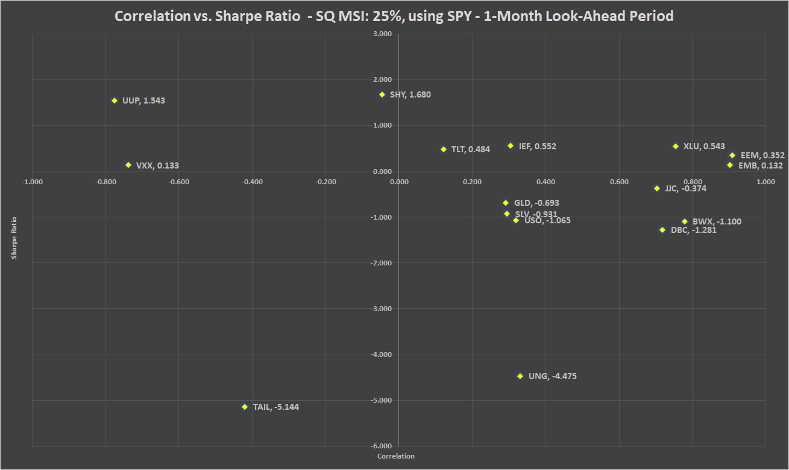

Chart 20b: Correlation vs. Sharpe ratio SQ MSI: 25%, using QQQ - 1-month look-ahead period

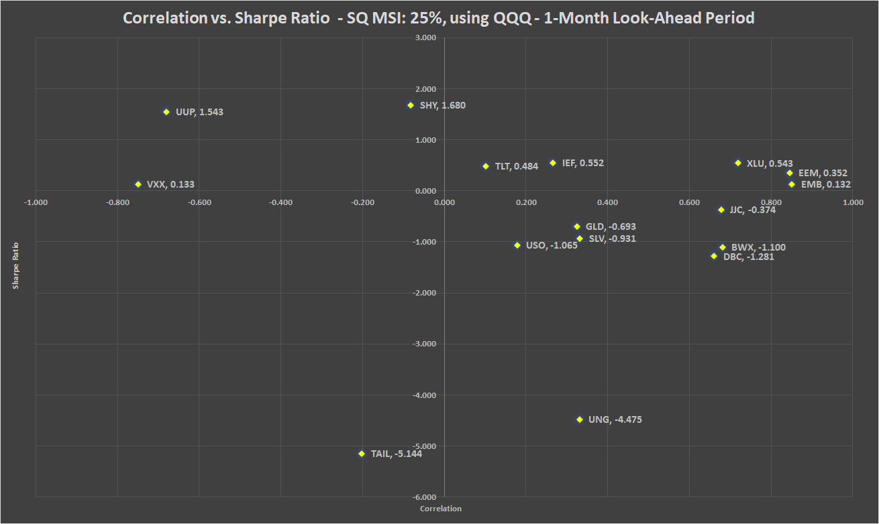

Table 21: Correlation, beta, Sharpe ratio and recommended weights of hedges - SQ MSI: 25% - 1-month look-ahead period

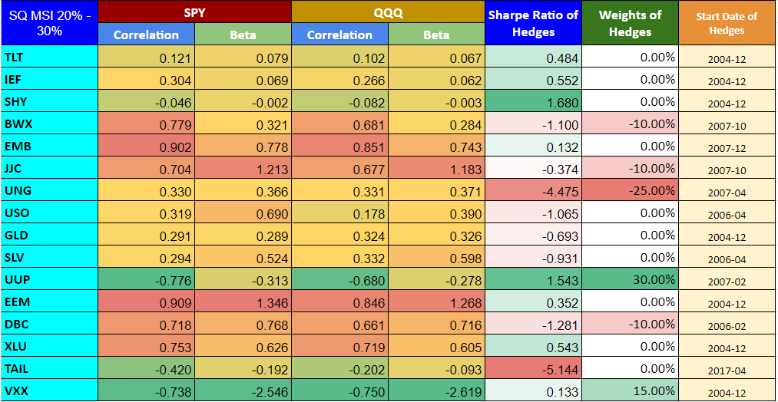

Chart 21: PV - SQ MSI: 25% - 1-month look-ahead period

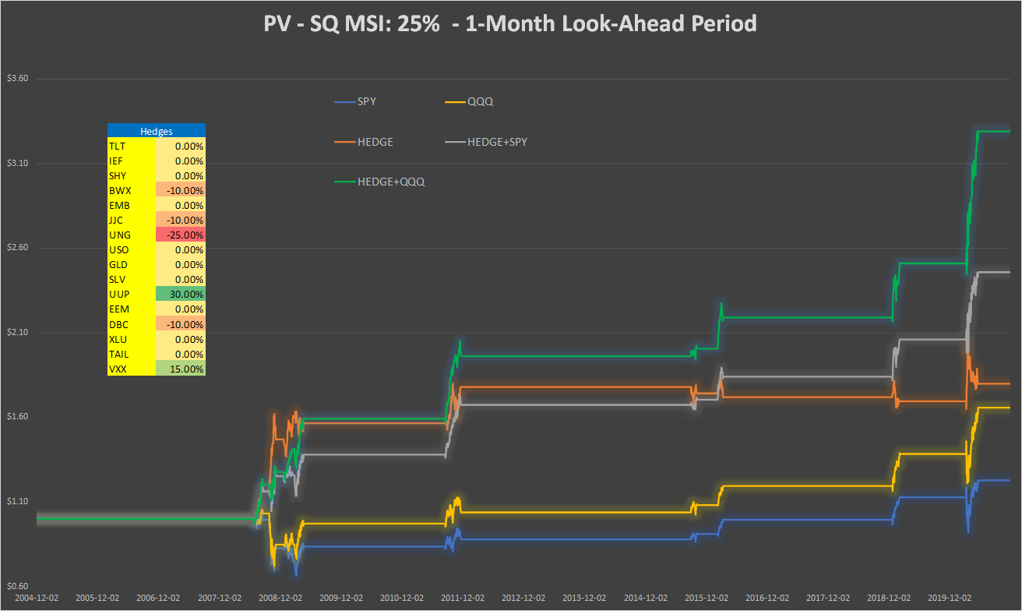

Table 22: Performance indicators with and without hedges - SQ MSI: 25% - 1-month look-ahead period

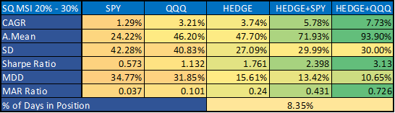

**SQ MSI: 60%, 1-month look-ahead period**

Chart 22a: Correlation vs. Sharpe ratio SQ MSI: 60%, using SPY - 1-month look-ahead period

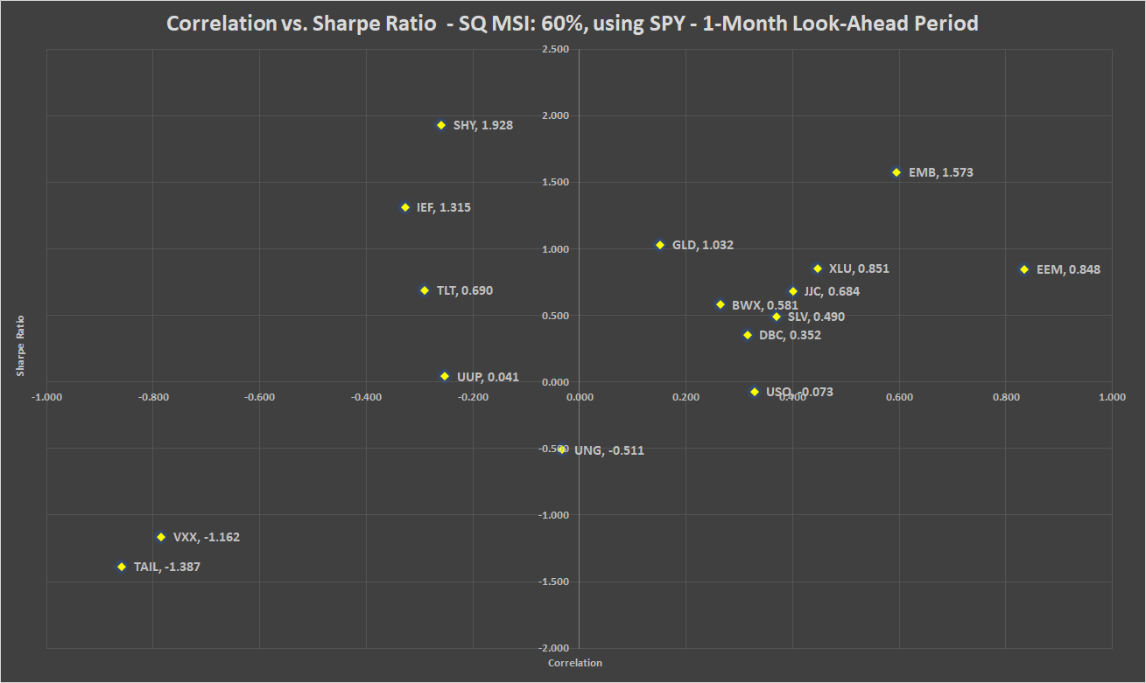

Chart 22b: Correlation vs. Sharpe ratio SQ MSI: 60%, using QQQ - 1-month look-ahead period

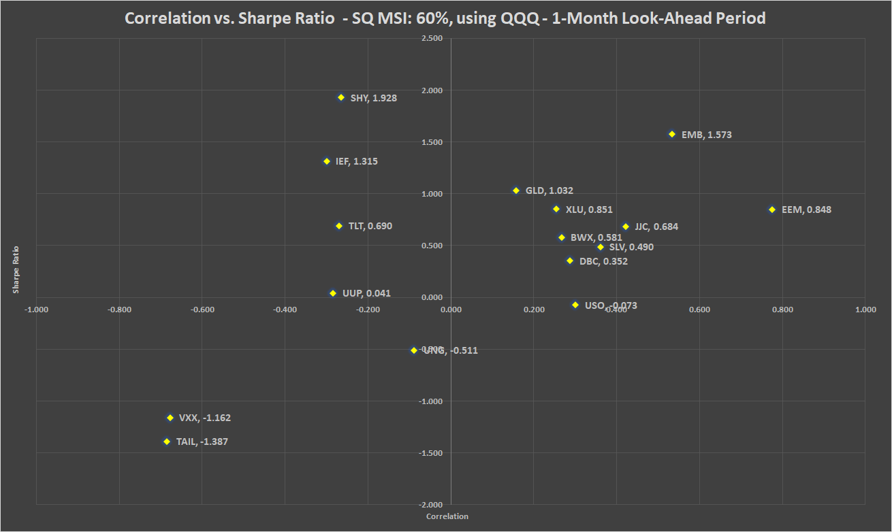

Table 23: Correlation, beta, Sharpe ratio and recommended weights of hedges - SQ MSI: 60% - 1-month look-ahead period

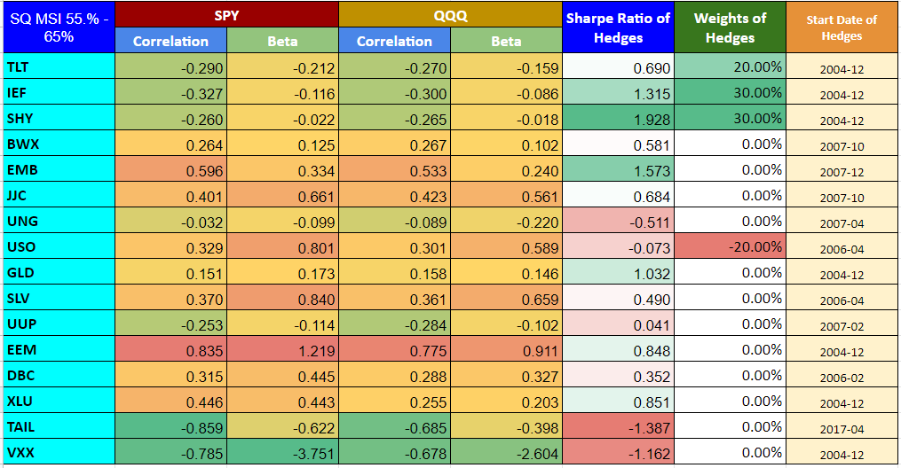

Chart 23: PV - SQ MSI: 60% - 1-month look-ahead period

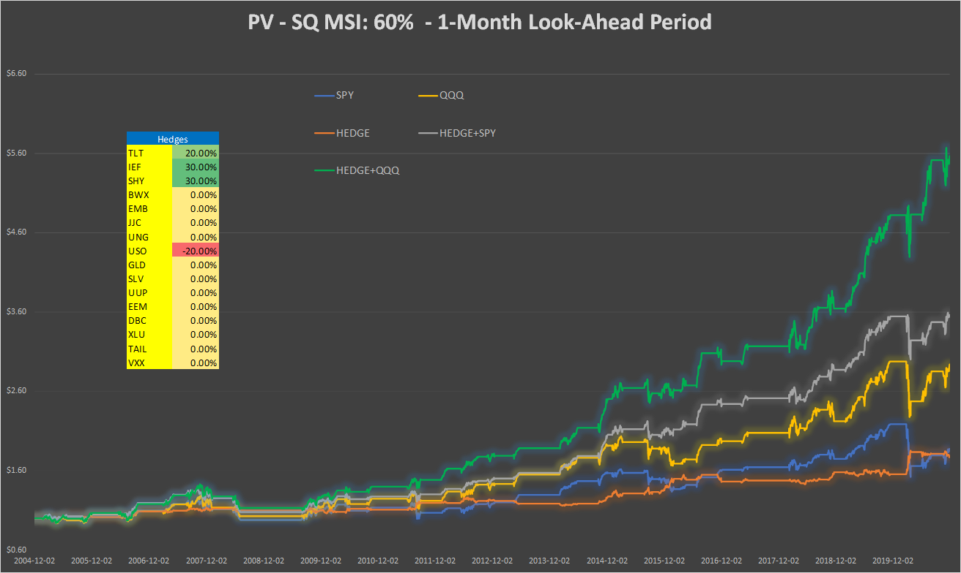

Table 24: Performance indicators with and without hedges - SQ MSI: 60% - 1-month look-ahead period

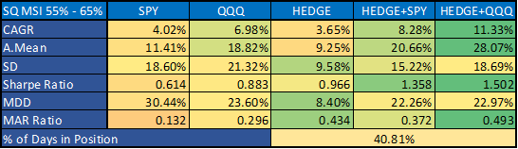

**SQ MSI: 85%, 1-month look-ahead period**

Chart 24a: Correlation vs. Sharpe ratio SQ MSI: 85%, using SPY - 1-month look-ahead period

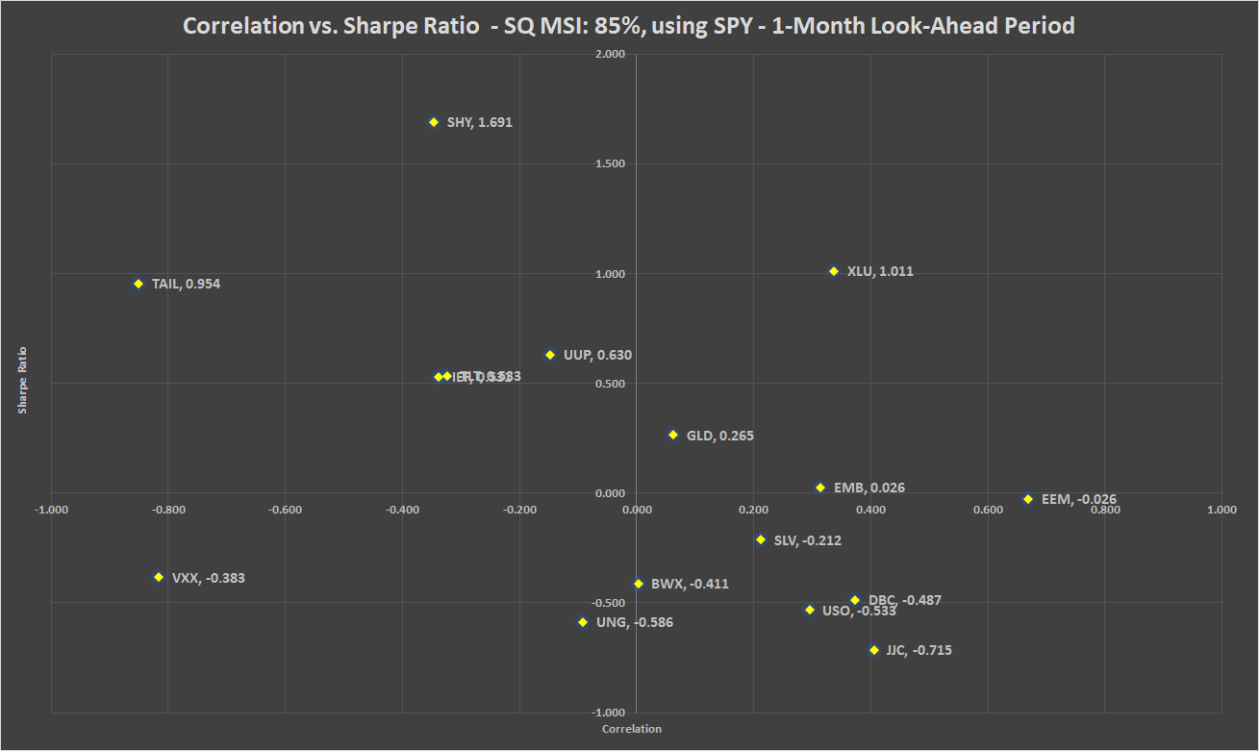

Chart 24b: Correlation vs. Sharpe ratio SQ MSI: 85%, using QQQ - 1-month look-ahead period

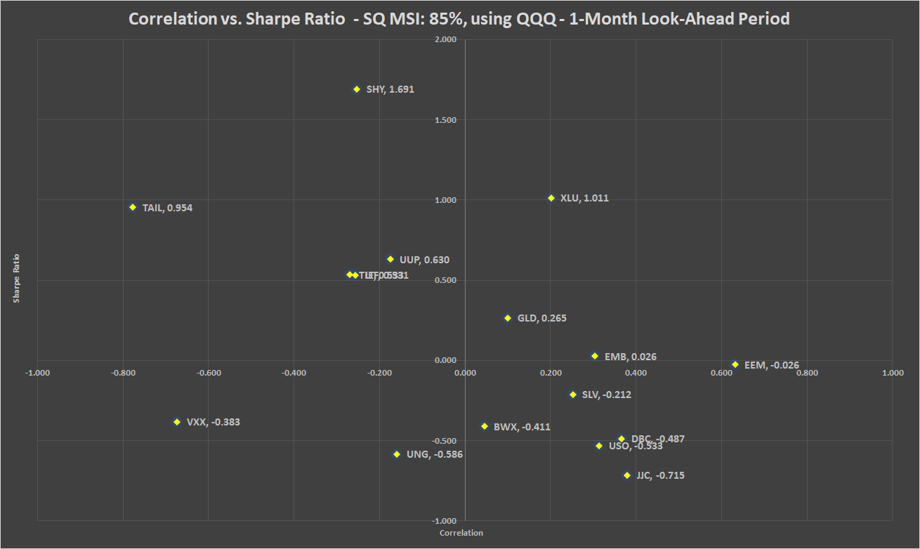

Table 25: Correlation, beta, Sharpe ratio and recommended weights of hedges - SQ MSI: 85% - 1-month look-ahead period

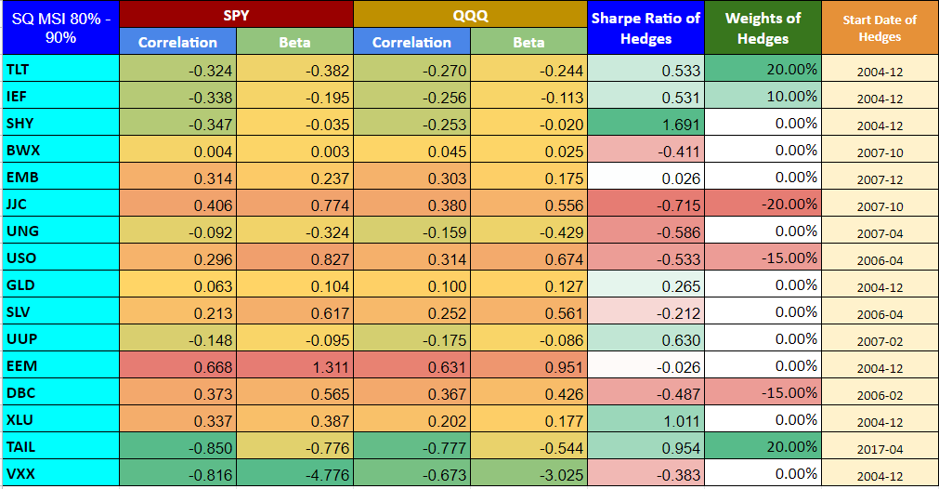

Chart 25: PV - SQ MSI: 85% - 1-month look-ahead period

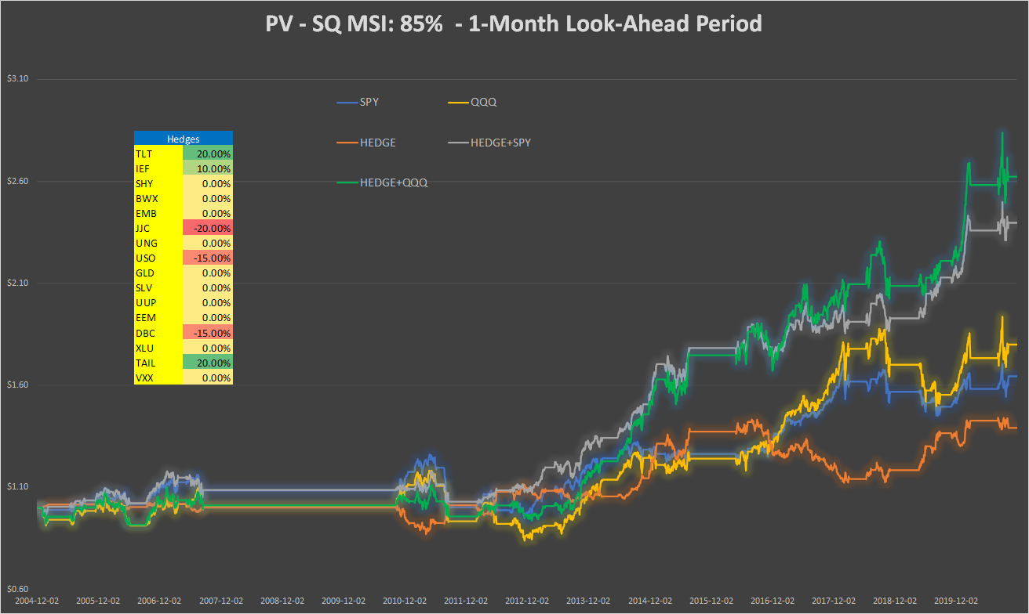

Table 26: Performance indicators with and without hedges - SQ MSI: 85% - 1-month look-ahead period

