Dr. George Antal

3D Click Limited

c/o Suite 431, 28 Old Brompton Road, London SW7 3SS

**Hedges and Correlations**

### Case studies for CPI-SQ3M in practice

In this subsection, case studies for **CPI-SQ3M inflation indicator** is presented. After taking a look at Chart 26 one can conclude that **our simple rolling correlation calculation method used above will not be a perfect one for CPI-SQ3M**, as **extreme cases are very rare and the biggest part of the data is around its median (~+0.55%)**.

In case of the SQ MSI in the previous subsection, for a given SQ MSI level, e.g. when SQ MSI = 65%, **the rolling correlation was calculated not only based on days (in the past) when the value of the indicator was just that much 65%. But we also took into account all days where the value of the indicator deviated by a maximum of 5% from this given 65%, i.e. when SQ MSI was between 60% and 70%.** It could **increase the number of samples using similar data (since SQ MSI = 65% and SQ MSI = 67% mean almost the same market environment) and could smooth the result thanks to the rolling method** (For example, to calculate correlation for SQ MSI = 65%, we used data from 60% to 70%. For SQ MSI = 66%, the correlation was calculated with data from 61% to 71%, which means that we changed only one tenth of the data when switching to a neighbor.).

Now, we cannot use this fixed ±5% channel, (because there are very few data at the outliers), so we have to **define the lower and upper bounds separately for each CPI-SQ3M level to obtain enough sample size**. Chart 27 shows these bounds and the distribution of these accumulated number of cases. **After that modification, the method is the same as before.**

Chart 26: Level of CPI-SQ3M Inflation Indicator

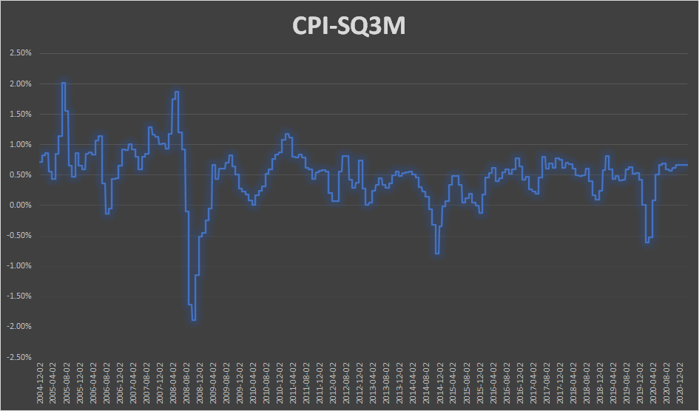

Chart 27: Lower and Upper Bounds and Distribution of Accumulated Number of Cases

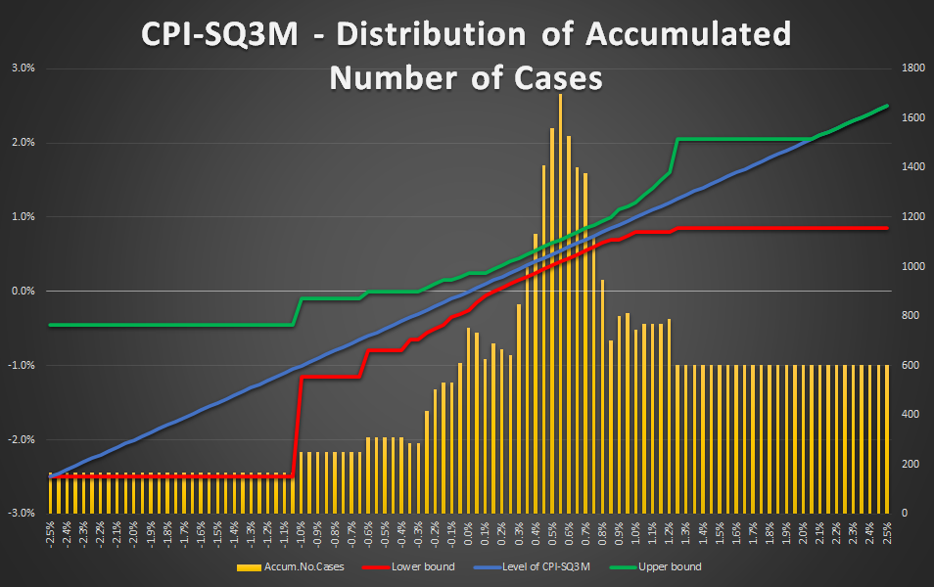

In this part of the study, we examine:

* **2 hedgeable ‘portfolio’: long SPY and long QQQ;**
* **3 different CPI-SQ3M level: -0.55% (deflation, -2.2% annualized), 0.5% (the median from 2004 to 2020, +2% annualized) and 1.25% (extreme inflation, +5% annualized);**
* **3 different look-ahead periods: 5-day, 10-day and 1-month.**

In each **nine cases (3 CPI-SQ3M x 3 look-ahead)**, at first, the **scatter plot of correlation vs. Sharpe ratio** can be seen (e.g. Chart 28a-b), which helps us to **select the most promising hedges** (significantly negative correlation and positive Sharpe ratio and/or significantly positive correlation and negative Sharpe ratio (short)). After that, a table can be found (e.g. Table 27) which contains **not only the correlation coefficients for every hedge, but the beta compared to the SPY/QQQ** as well. Based on these beta, one can **specify the desired weights** of the selected hedges. We do not recommend any exact method for this, but it would theoretically be possible to create a near-beta-neutral portfolio. However, this would have been an overly over-fitted system. **Our recommended weights** in the penultimate column are discretionary determined based on the previous columns. Finally, a **portfolio value chart** (e.g. Chart 29) and a **performance indicator table** (Table 28) can be found which shows how the performance of the **portfolio (SPY/QQQ) with and without hedges (double leverage in this case in this study because of the weights of the hedges)** would have progressed in the days when the level of **CPI-SQ3Ml** is between the above defined **lower and upper bounds**. It is worth noting that these results may suffer from look-ahead and data-mining biases.

In this subsection, we will not explain each case in detail, as we could describe nearly identical things in each one. Our main findings and thoughts are:

* **As the SPY and the QQQ are highly correlated, the same hedges are appropriate for both in a given market environment.**
* **TLT, IEF and SHY are good choices in almost all cases.**
* **Only bonds (and maybe short gas (UNG)) are appropriate hedges during ‘normal times’, ie. when the level of CPI-SQ3M is around its median (~+0.5%).**
* **Long VXX is only worth using as a hedge during deflation.**
* **Short gas (UNG), short commodity (DBC) and/or short oil (USO) can also be used in the hedging basket only during deflation.**
* **Short dollar (UUP), long International T-bond (BWX) and long metals (GLD, SLV, JJC) are useful hedges when the inflation indicator is very high.**
* **The beta of SHY is too low to be worth dealing with this ETF.**
* **TAIL seems like a good choice during deflation, but it is worth being careful, as there is very little historical data available so far (TAIL is available only from 2017).**
* **In all the nine cases, using hedge can improve both the Sharpe and the MAR ratios (it does not depend on the leverage!).**

It is worth emphasizing that international T-bond (BWX) can also be a good hedge during high inflation. Furthermore, its CAGR (from 2007-10-05 until 2021-02-19) is not significantly worse than that of US bonds:

* TLT: 6.89%
* IEF: 4.99%
* SHY: 2.08%
* BWX: 2.56%

Thus, It may be worth considering the use of this ETF in our other strategies for diversification purposes as well - not only during high inflation.

An **online GoogleSheet version for this CPI-SQ3M - SnifferQuant Hedge-Selection Method** can be found [**here**](https://docs.google.com/spreadsheets/d/10PSZudUNOmvMYyppYgSXpLDwrQMRf-zb2i573dDxXdA), where the **CPI-SQ3M level** (cell ‘B1’), the **look-ahead period** (cell ‘E1’) and the **discretionary hedge weights** (cells ‘G24:G39’) should be changed.

**In summary, we strongly believe that this CPI-SQ3M - SnifferQuant Hedge-Selection Method can be a useful tool in all market situations. It helps us to select the expectedly most effective hedges which can even generate extra profit as well (in addition to risk reduction).**

**CPI-SQ3M: -0.55%, 5-day look-ahead period**

Chart 28a: Correlation vs. Sharpe ratio CPI-SQ3M: -0.55%, using SPY - 5-day look-ahead period

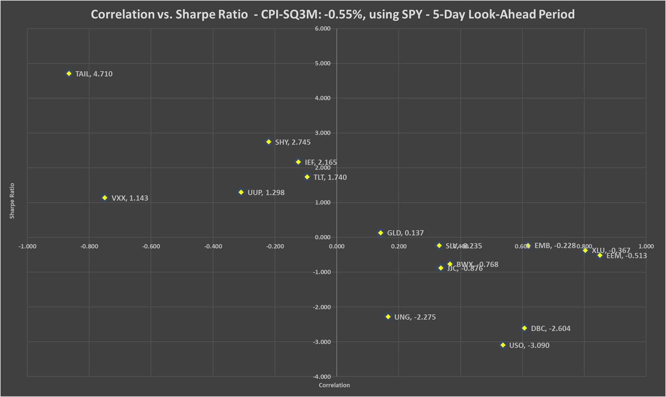

Chart 28b: Correlation vs. Sharpe ratio CPI-SQ3M: -0.55%, using QQQ - 5-day look-ahead period

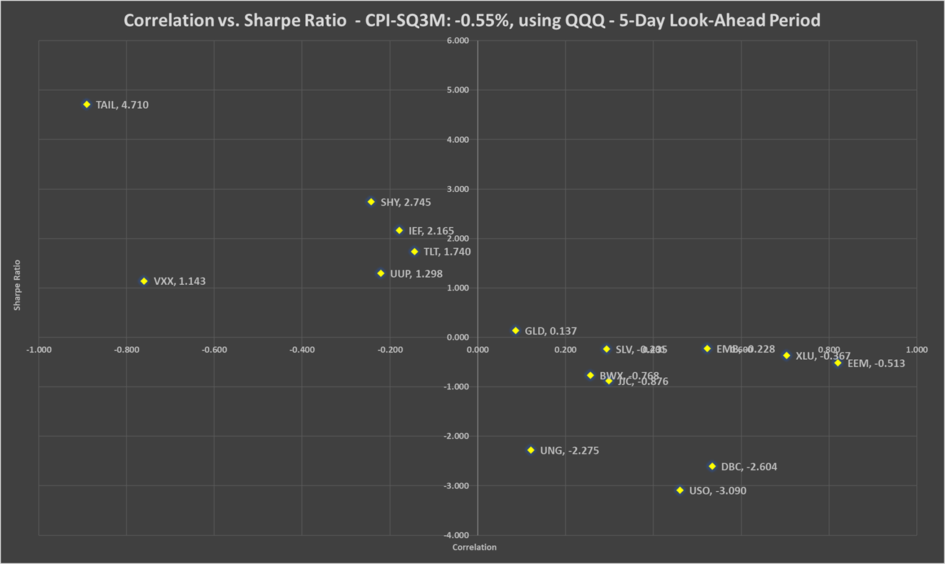

Table 27: Correlation, beta, Sharpe ratio and recommended weights of hedges - CPI-SQ3M: -0.55% - 5-day look-ahead period

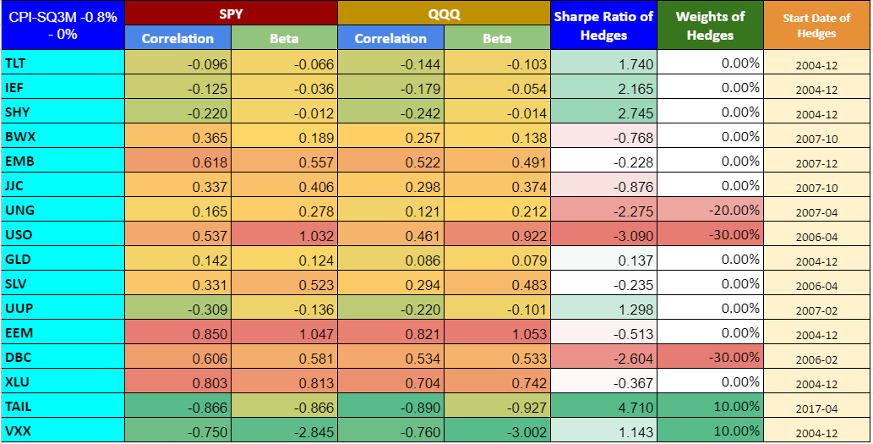

Chart 29: PV - CPI-SQ3M: -0.55% - 5-day look-ahead period

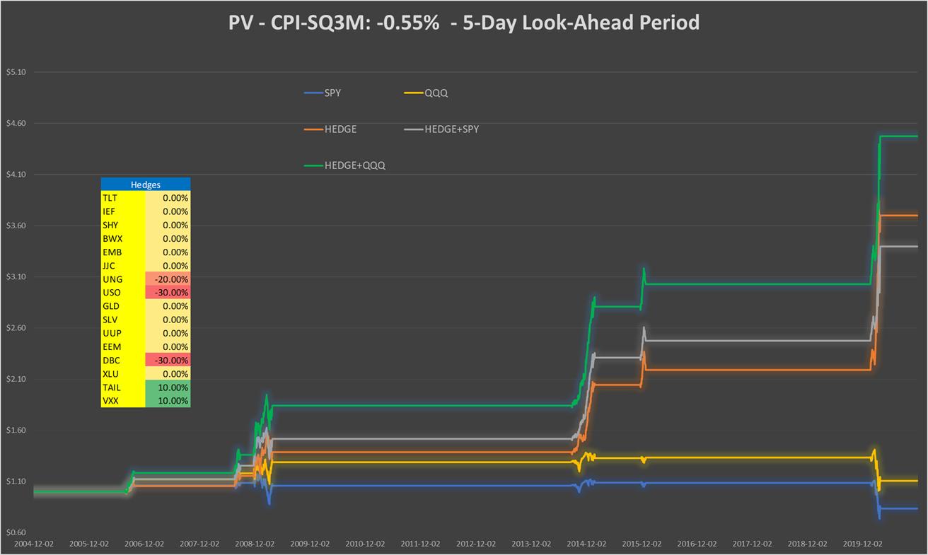

Table 28: Performance indicators with and without hedges - CPI-SQ3M: -0.55% - 5-day look-ahead period

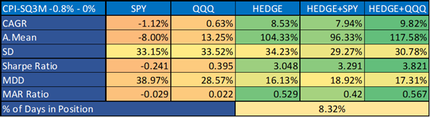

**CPI-SQ3M: +0.5%, 5-day look-ahead period**

Chart 30a: Correlation vs. Sharpe ratio CPI-SQ3M: +0.5%, using SPY - 5-day look-ahead period

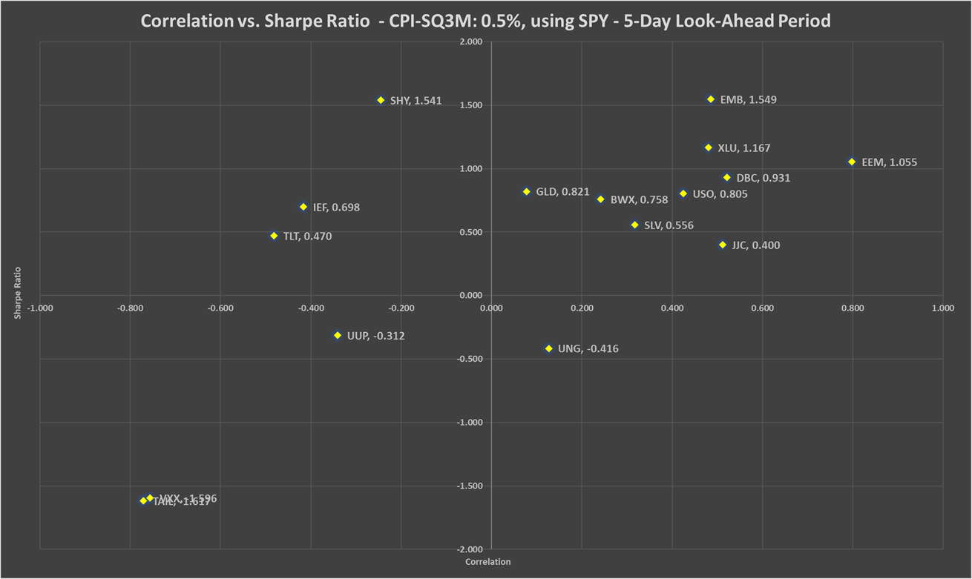

Chart 30b: Correlation vs. Sharpe ratio CPI-SQ3M: +0.5%, using QQQ - 5-day look-ahead period

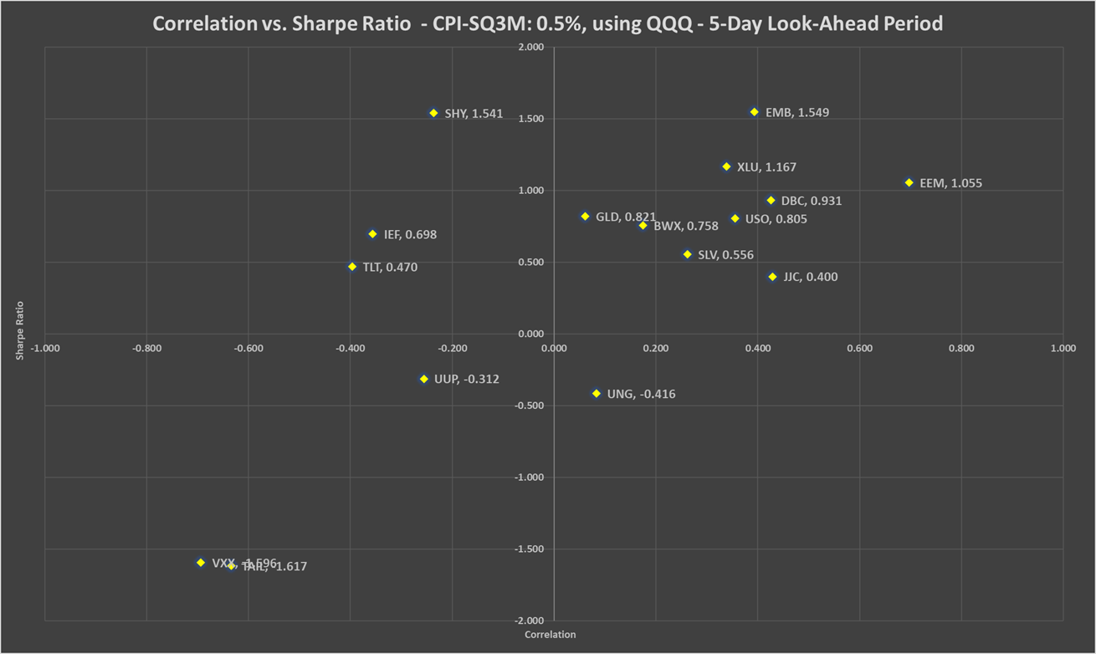

Table 29: Correlation, beta, Sharpe ratio and recommended weights of hedges - CPI-SQ3M: +0.5% - 5-day look-ahead period

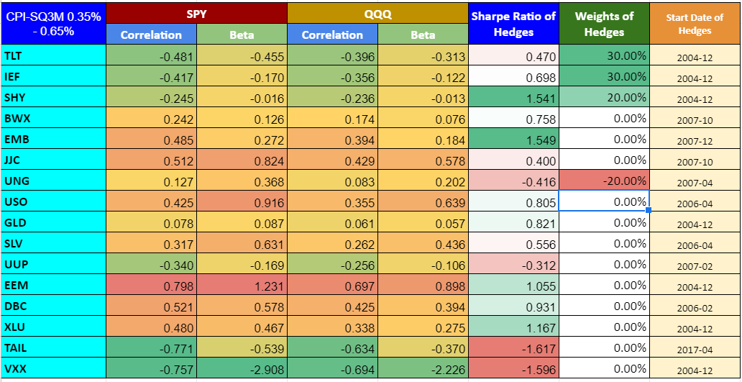

Chart 31: PV - CPI-SQ3M: +0.5% - 5-day look-ahead period

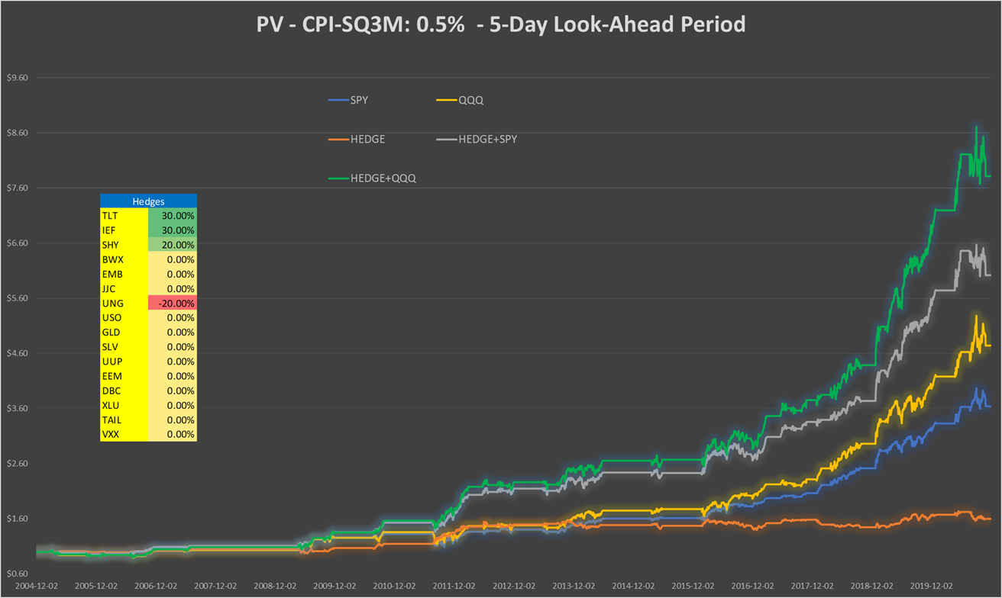

Table 30: Performance indicators with and without hedges - CPI-SQ3M: +0.5% - 5-day look-ahead period

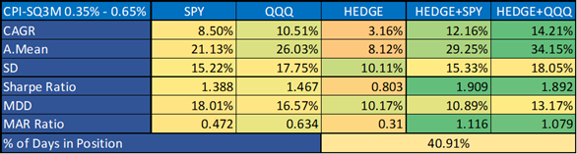

**CPI-SQ3M: +1.25%, 5-day look-ahead period**

Chart 32a: Correlation vs. Sharpe ratio CPI-SQ3M: +1.25%, using SPY - 5-day look-ahead period

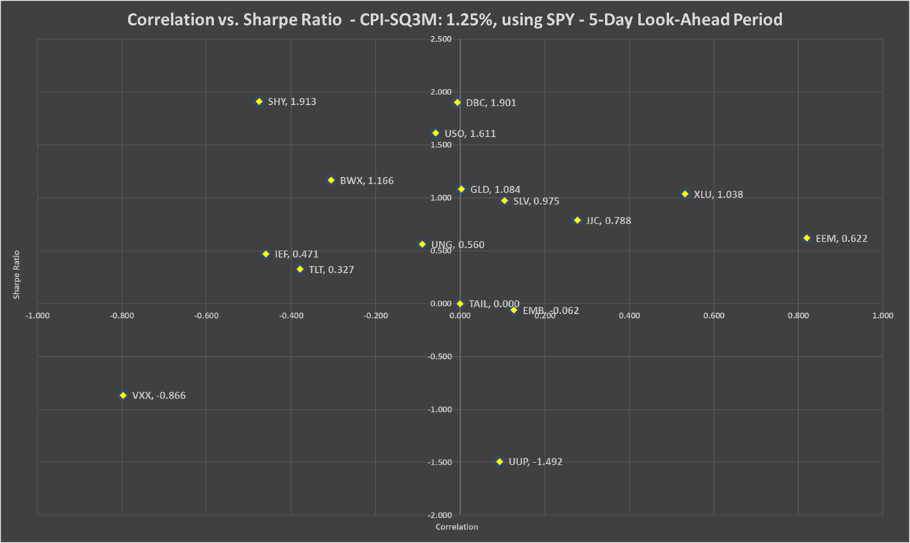

Chart 32b: Correlation vs. Sharpe ratio CPI-SQ3M: +1.25%, using QQQ - 5-day look-ahead period

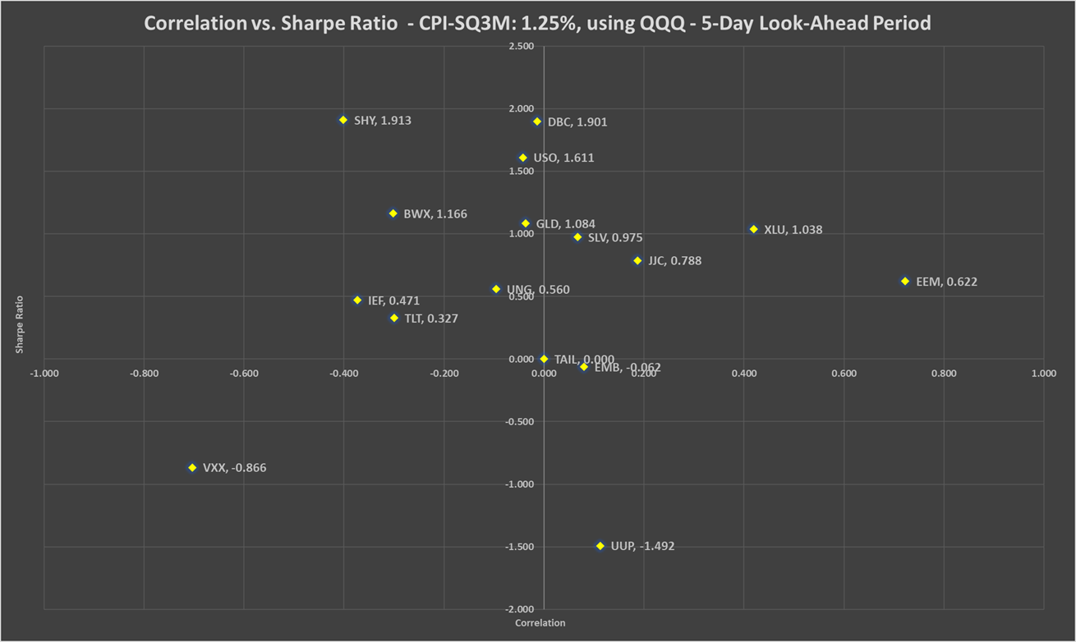

Table 31: Correlation, beta, Sharpe ratio and recommended weights of hedges - CPI-SQ3M: +1.25% - 5-day look-ahead period

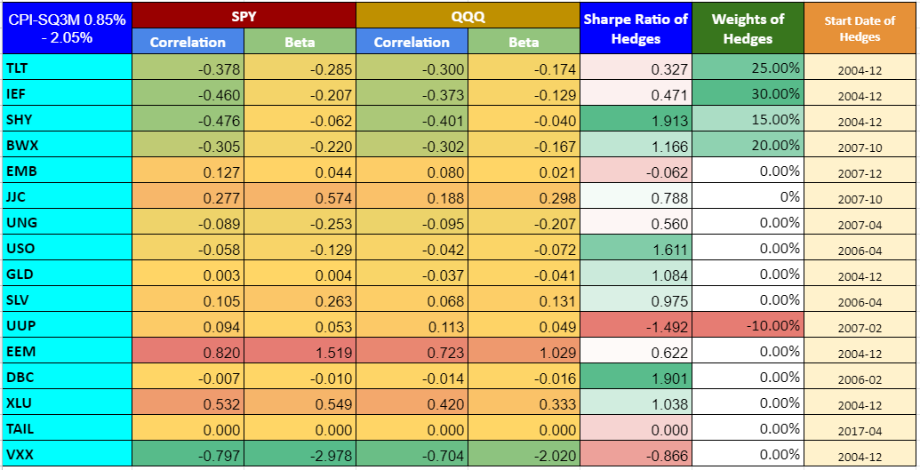

Chart 33: PV - CPI-SQ3M: +1.25% - 5-day look-ahead period

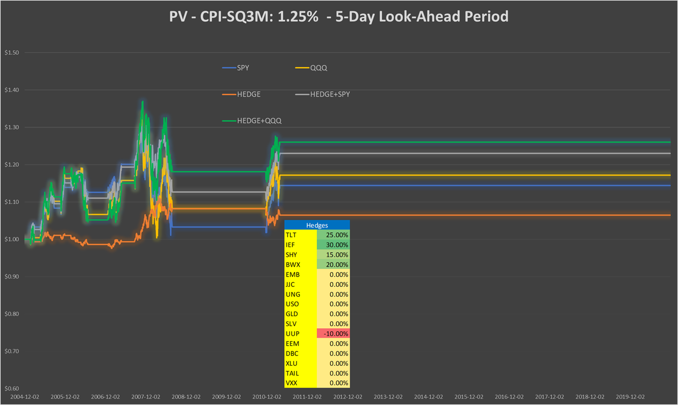

Table 32: Performance indicators with and without hedges - CPI-SQ3M: +1.25% - 5-day look-ahead period

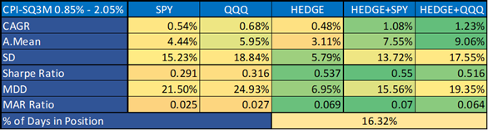

**CPI-SQ3M: -0.55%, 10-day look-ahead period**

Chart 34a: Correlation vs. Sharpe ratio CPI-SQ3M: -0.55%, using SPY - 10-day look-ahead period

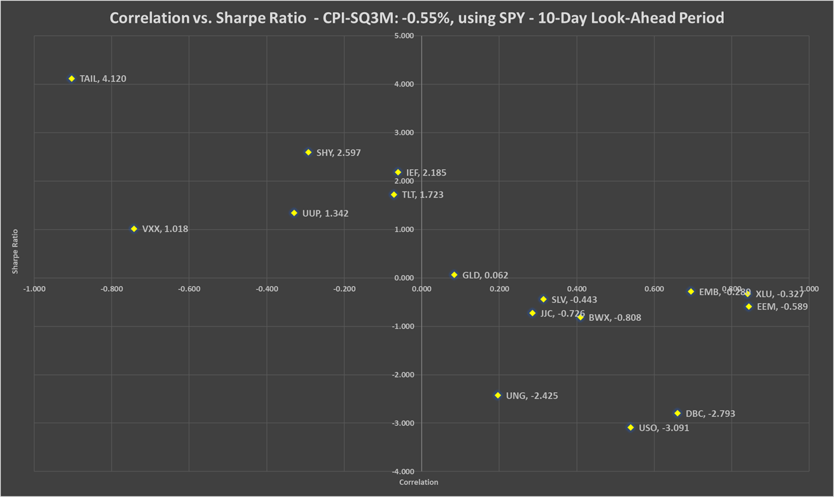

Chart 34b: Correlation vs. Sharpe ratio CPI-SQ3M: -0.55%, using QQQ - 10-day look-ahead period

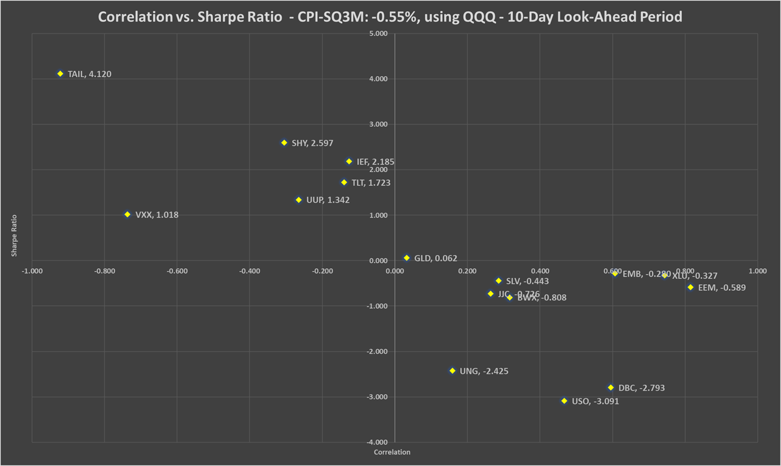

Table 33: Correlation, beta, Sharpe ratio and recommended weights of hedges - CPI-SQ3M: -0.55% - 10-day look-ahead period

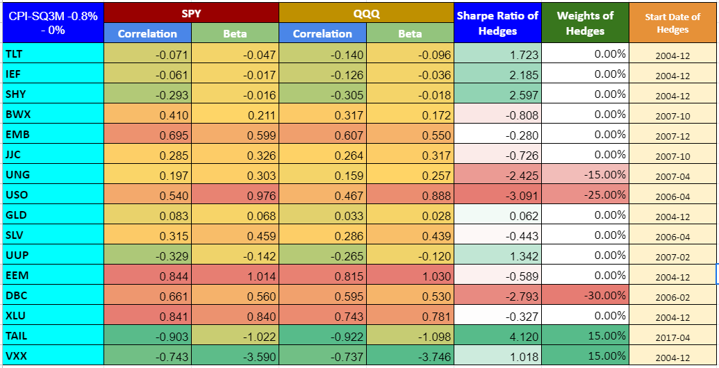

Chart 35: PV - CPI-SQ3M: -0.55% - 10-day look-ahead period

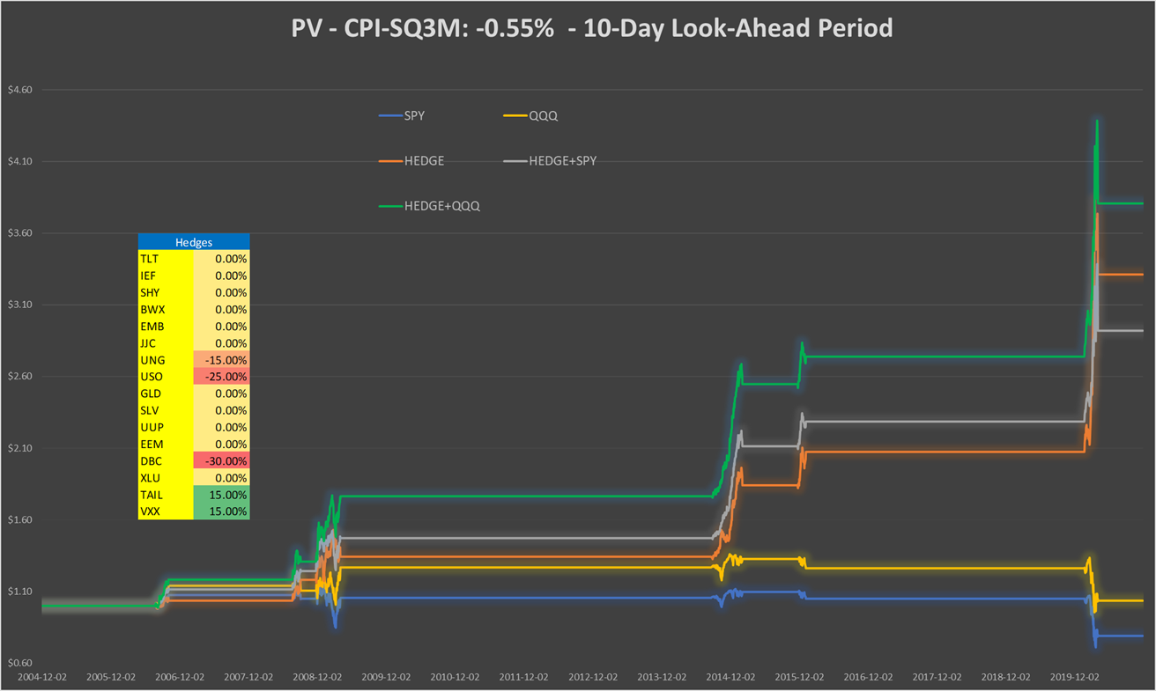

Table 34: Performance indicators with and without hedges - CPI-SQ3M: -0.55% - 10-day look-ahead period

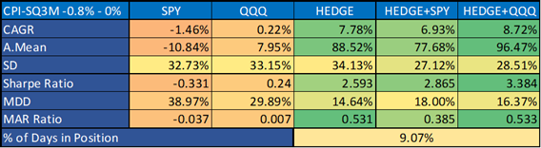

**CPI-SQ3M: +0.5%, 10-day look-ahead period**

Chart 36a: Correlation vs. Sharpe ratio CPI-SQ3M: +0.5%, using SPY - 10-day look-ahead period

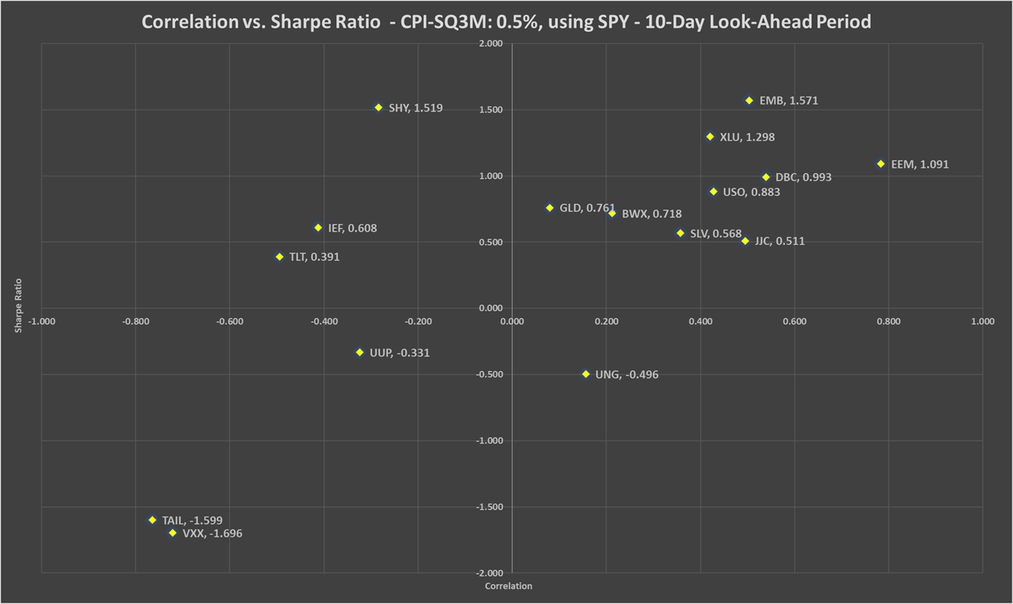

Chart 36b: Correlation vs. Sharpe ratio CPI-SQ3M: +0.5%, using QQQ - 10-day look-ahead period

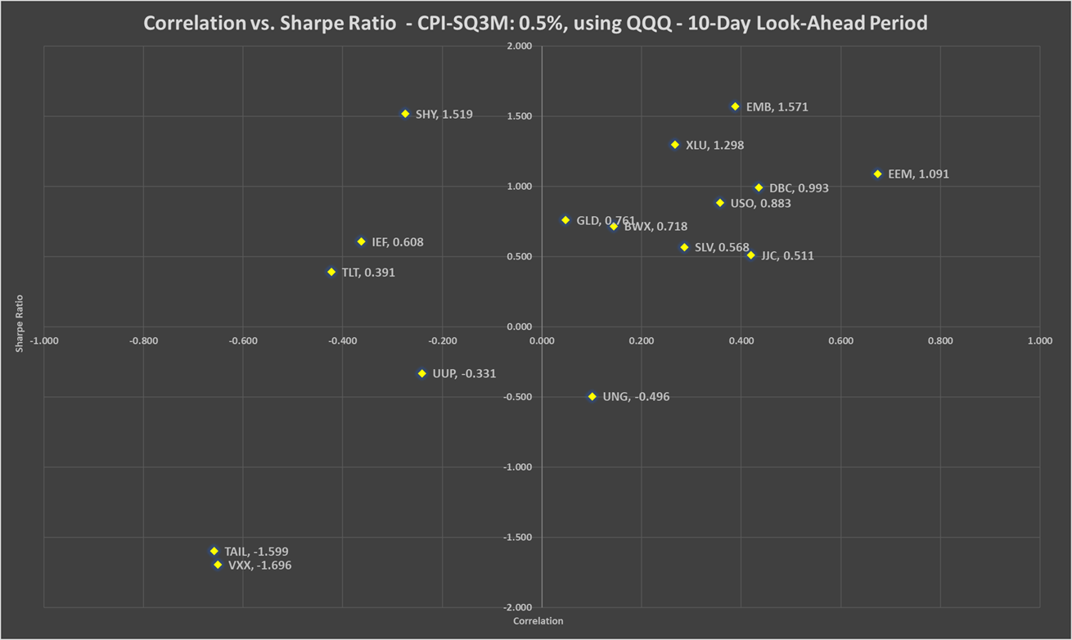

Table 35: Correlation, beta, Sharpe ratio and recommended weights of hedges - CPI-SQ3M: +0.5% - 10-day look-ahead period

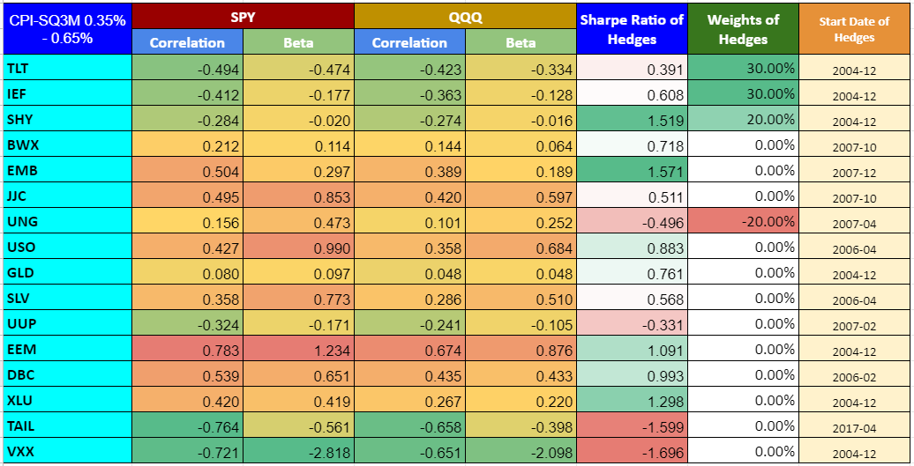

Chart 37: PV - CPI-SQ3M: +0.5% - 10-day look-ahead period

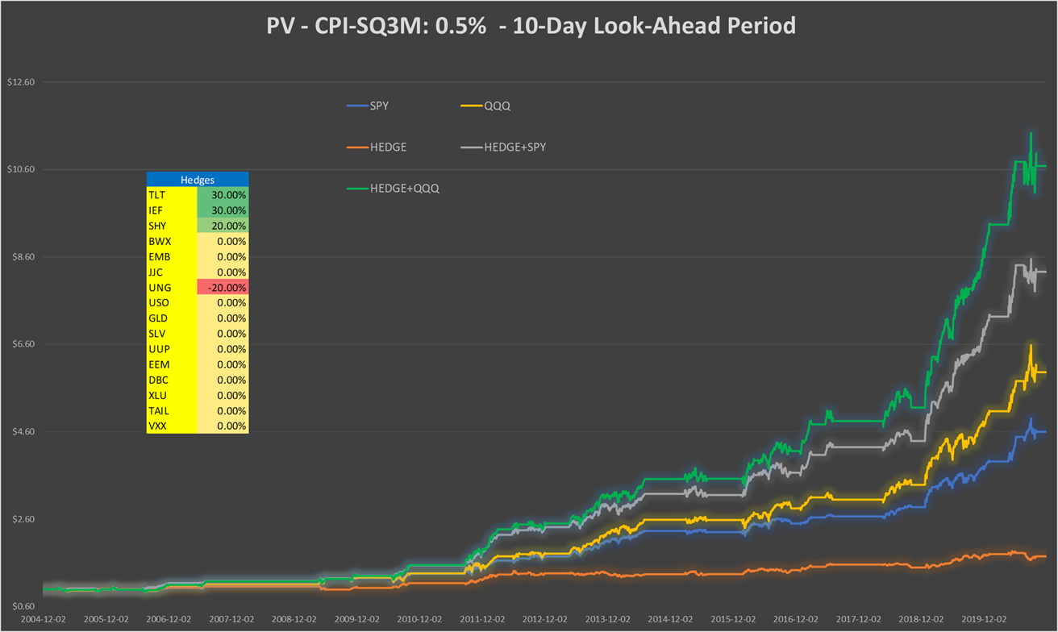

Table 36: Performance indicators with and without hedges - CPI-SQ3M: +0.5% - 10-day look-ahead period

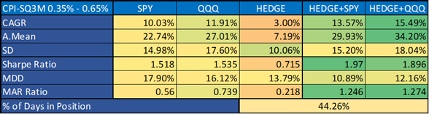

**CPI-SQ3M: +1.25%, 10-day look-ahead period**

Chart 38a: Correlation vs. Sharpe ratio CPI-SQ3M: +1.25%, using SPY - 10-day look-ahead period

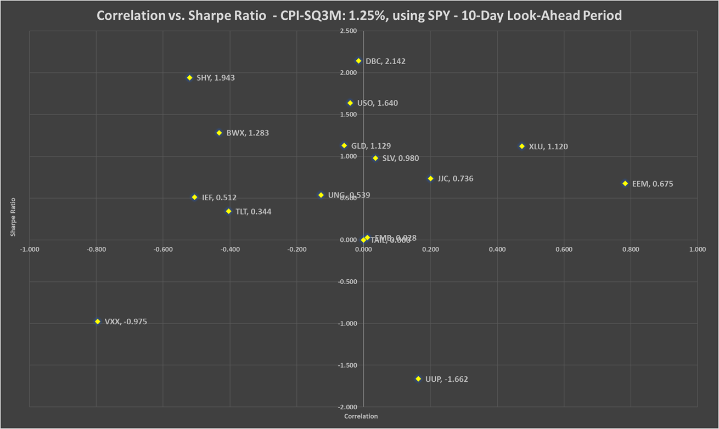

Chart 38b: Correlation vs. Sharpe ratio CPI-SQ3M: +1.25%, using QQQ - 10-day look-ahead period

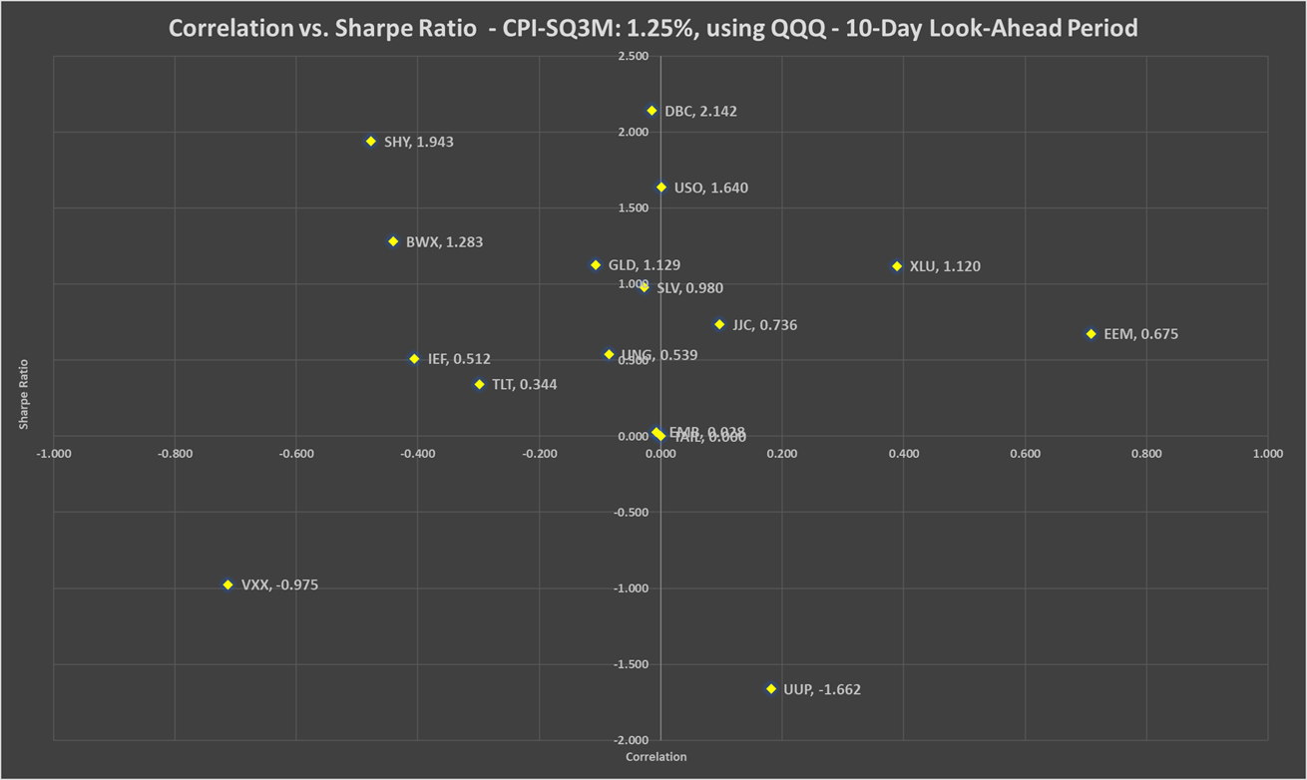

Table 37: Correlation, beta, Sharpe ratio and recommended weights of hedges - CPI-SQ3M: +1.25% - 10-day look-ahead period

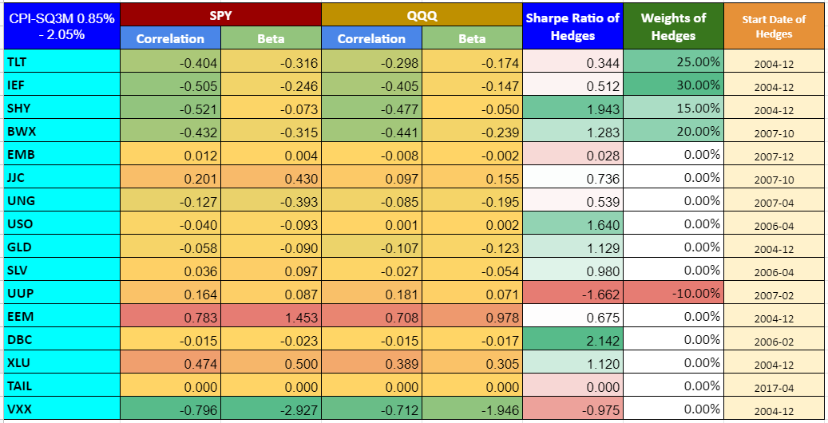

Chart 39: PV - CPI-SQ3M: +1.25% - 10-day look-ahead period

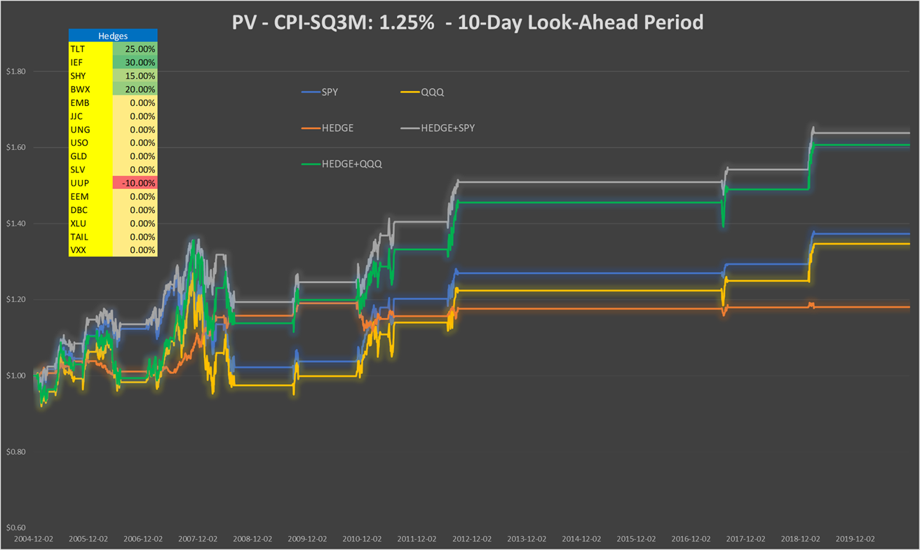

Table 38: Performance indicators with and without hedges - CPI-SQ3M: +1.25% - 10-day look-ahead period

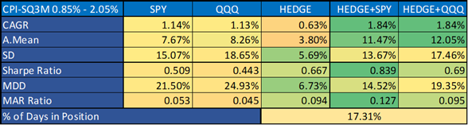

**CPI-SQ3M: -0.55%, 1-month look-ahead period**

Chart 40a: Correlation vs. Sharpe ratio CPI-SQ3M: -0.55%, using SPY - 1-month look-ahead period

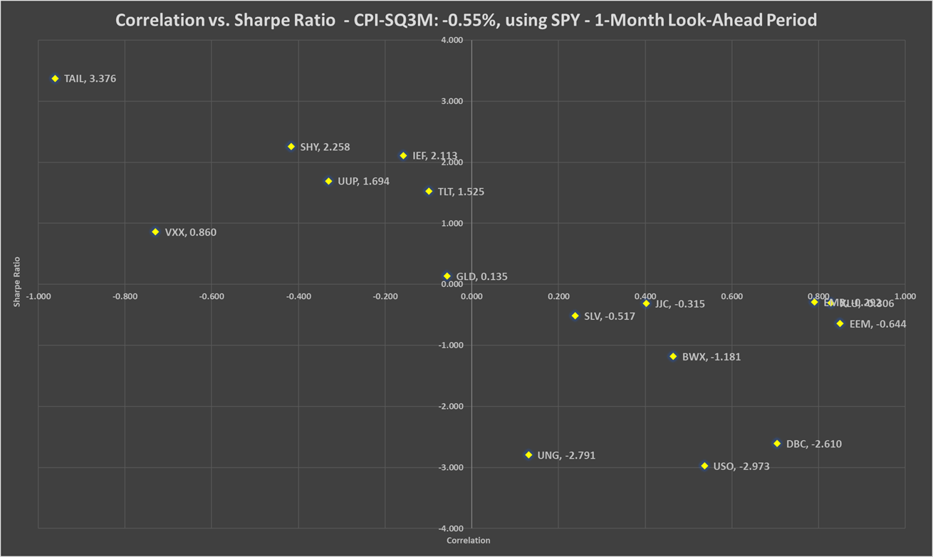

Chart 40b: Correlation vs. Sharpe ratio CPI-SQ3M: -0.55%, using QQQ - 1-month look-ahead period

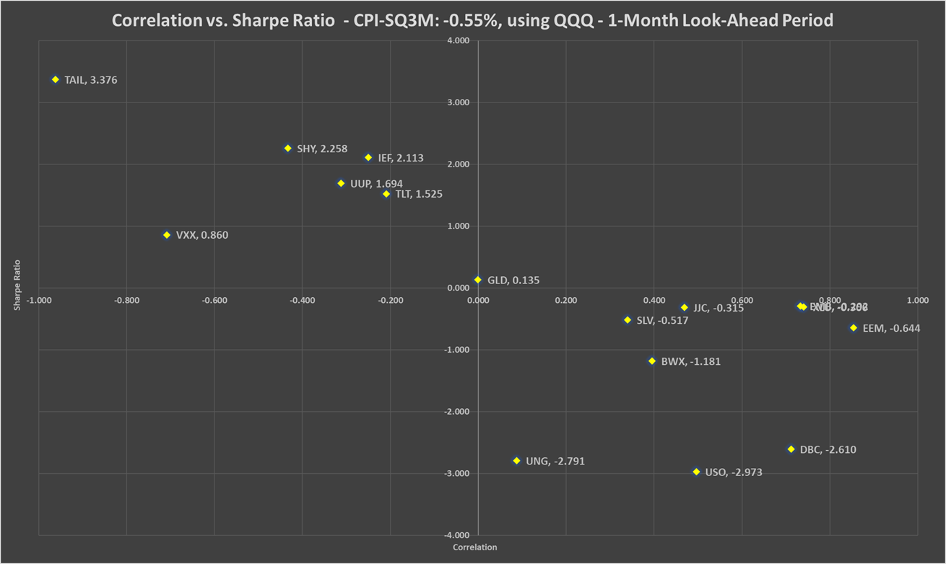

Table 39: Correlation, beta, Sharpe ratio and recommended weights of hedges - CPI-SQ3M: -0.55% - 1-month look-ahead period

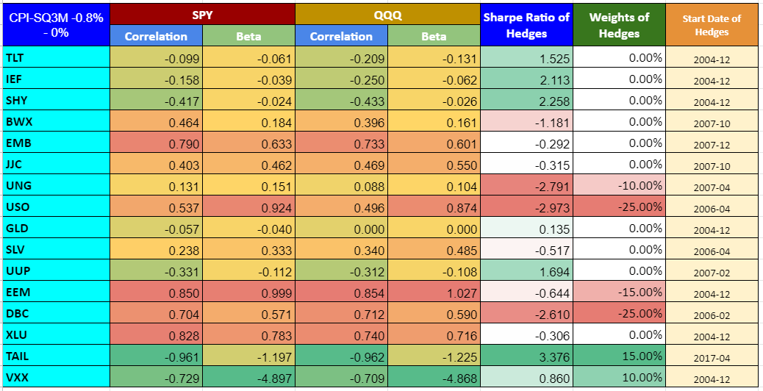

Chart 41: PV - CPI-SQ3M: -0.55% - 1-month look-ahead period

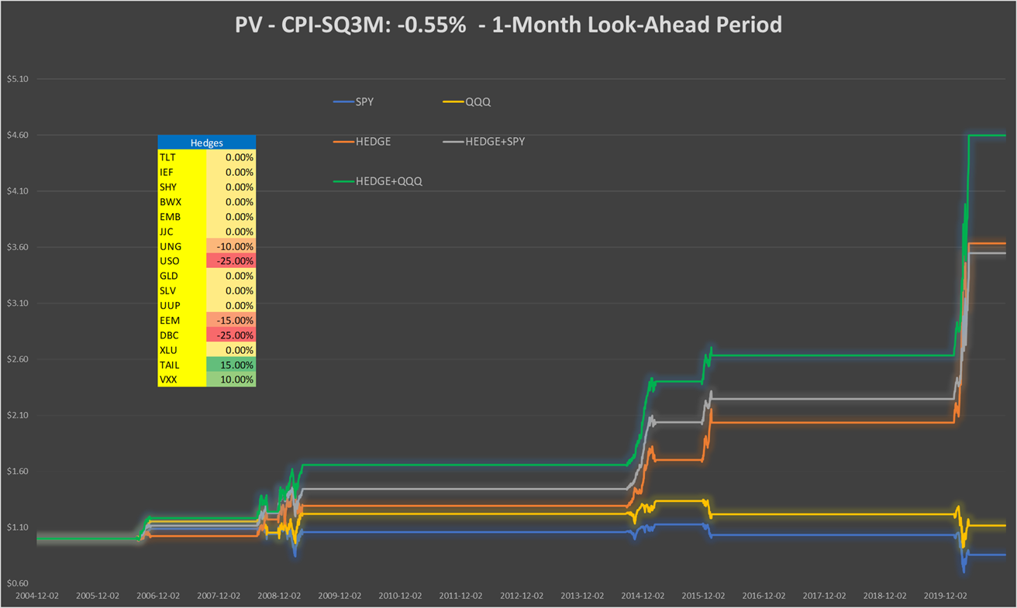

Table 40: Performance indicators with and without hedges - CPI-SQ3M: -0.55% - 1-month look-ahead period

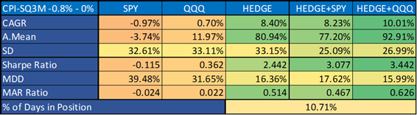

**CPI-SQ3M: +0.5%, 1-month look-ahead period**

Chart 42a: Correlation vs. Sharpe ratio CPI-SQ3M: +0.5%, using SPY - 1-month look-ahead period

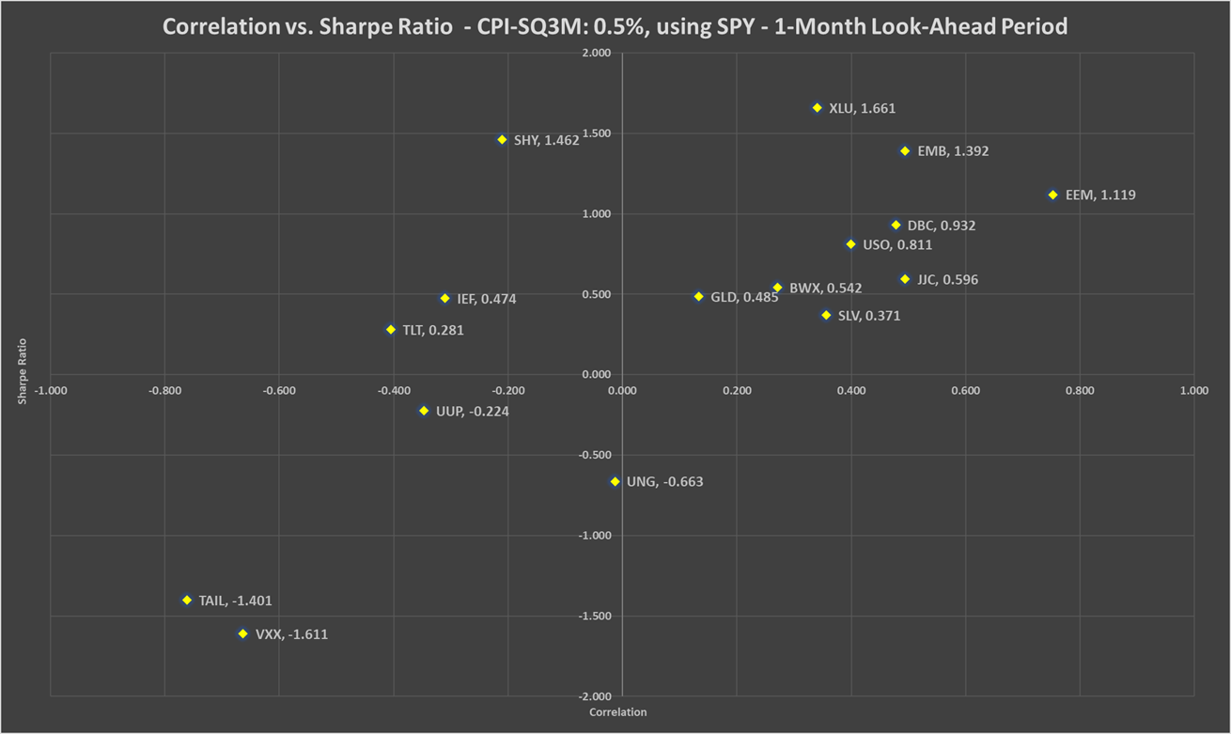

Chart 42b: Correlation vs. Sharpe ratio CPI-SQ3M: +0.5%, using QQQ - 1-month look-ahead period

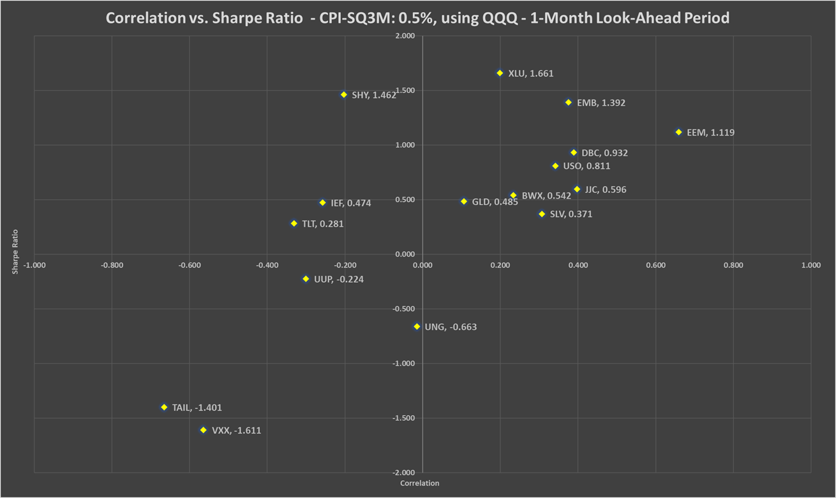

Table 41: Correlation, beta, Sharpe ratio and recommended weights of hedges - CPI-SQ3M: +0.5% - 1-month look-ahead period

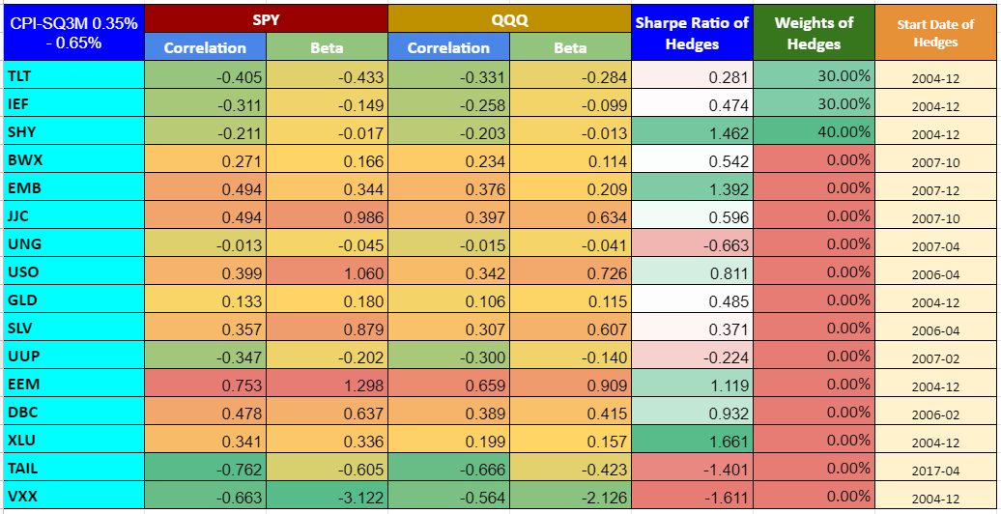

Chart 43: PV - CPI-SQ3M: +0.5% - 1-month look-ahead period

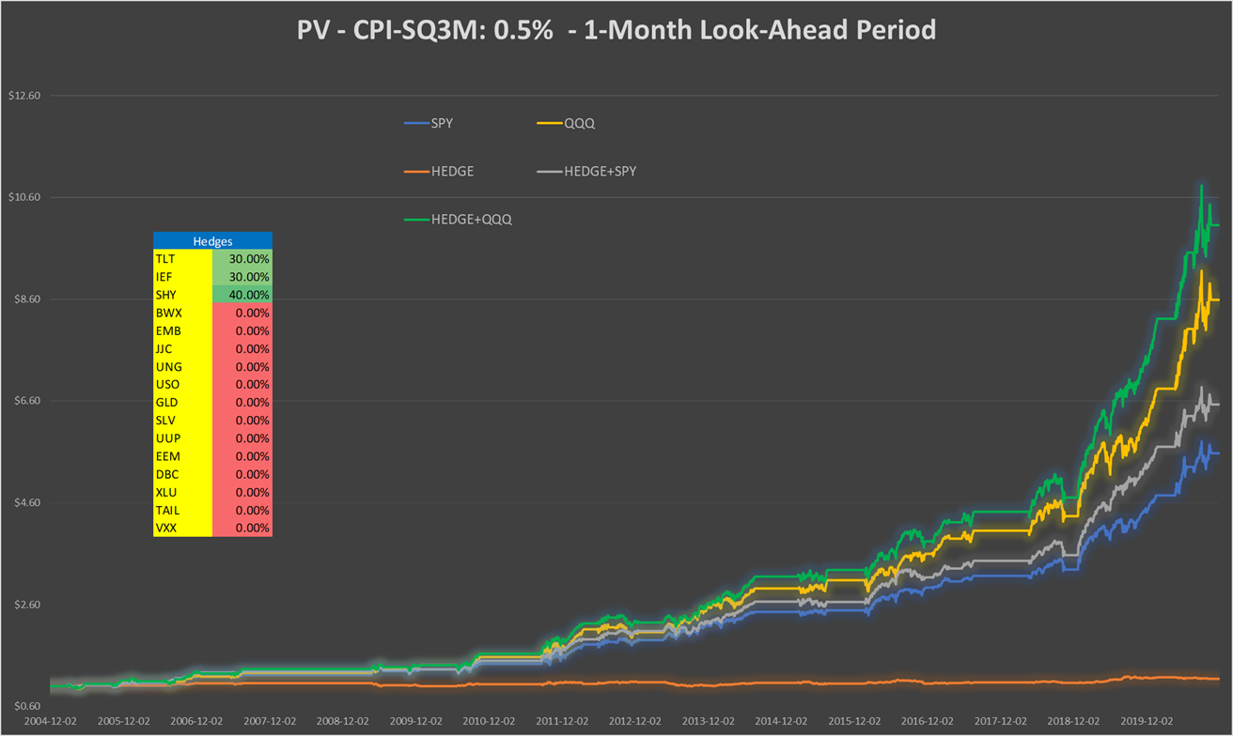

Table 42: Performance indicators with and without hedges - CPI-SQ3M: +0.5% - 1-month look-ahead period

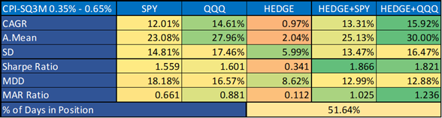

**CPI-SQ3M: +1.25%, 1-month look-ahead period**

Chart 44a: Correlation vs. Sharpe ratio CPI-SQ3M: +1.25%, using SPY - 1-month look-ahead period

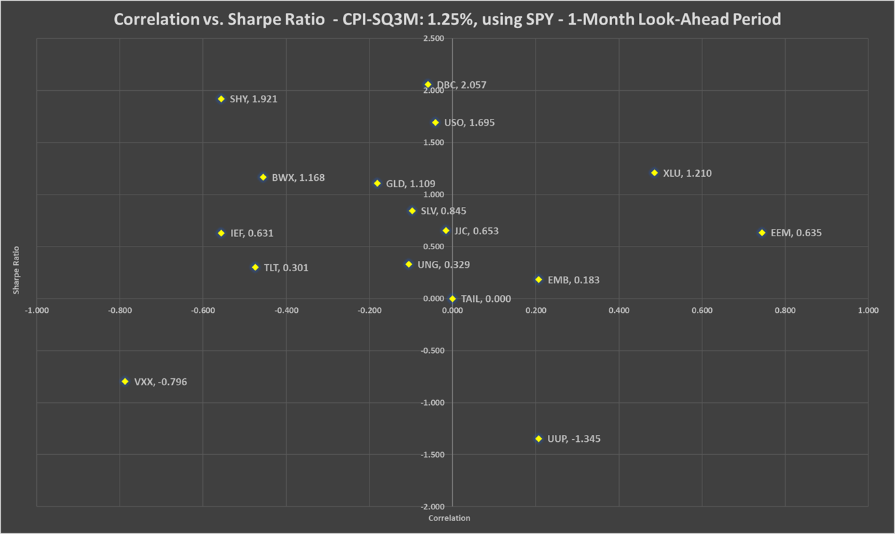

Chart 44b: Correlation vs. Sharpe ratio CPI-SQ3M: +1.25%, using QQQ - 1-month look-ahead period

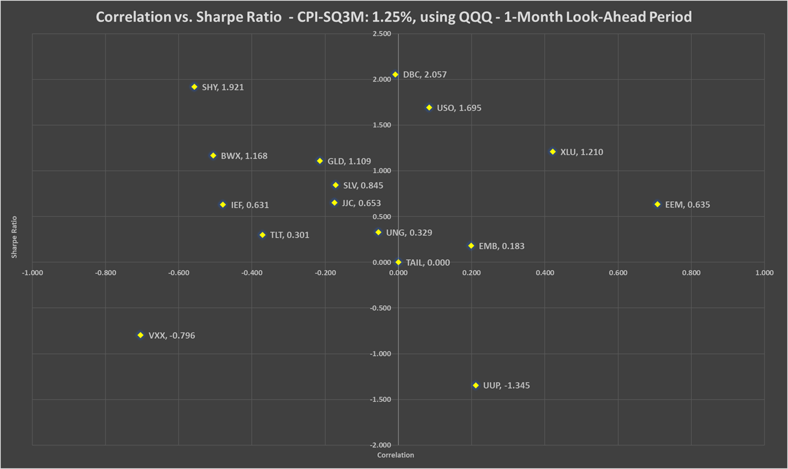

Table 43: Correlation, beta, Sharpe ratio and recommended weights of hedges - CPI-SQ3M: +1.25% - 1-month look-ahead period

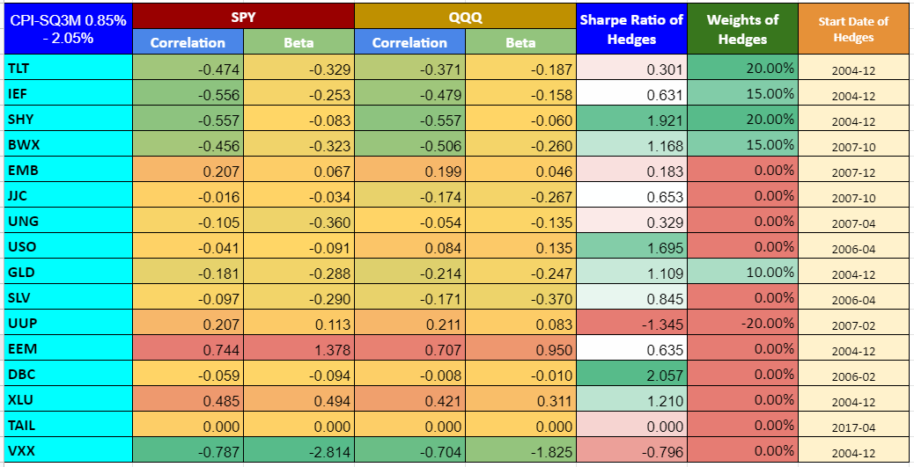

Chart 45: PV - CPI-SQ3M: +1.25% - 1-month look-ahead period

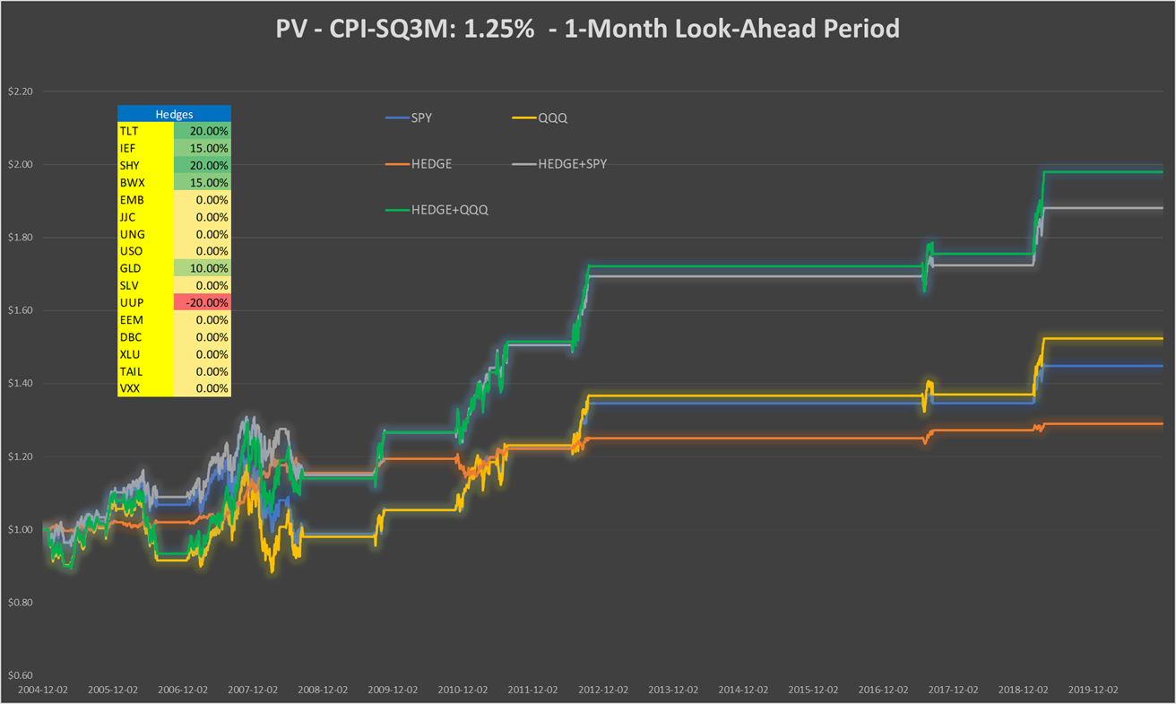

Table 44: Performance indicators with and without hedges - CPI-SQ3M: +1.25% - 1-month look-ahead period

