Dr. George Antal

3D Click Limited

c/o Suite 431, 28 Old Brompton Road, London SW7 3SS

**Hedges and Correlations**

### Case studies for GDP in practice

In this subsection, case studies for **GDP** is presented. After taking a look at Chart 46 one can conclude that **our simple rolling correlation calculation method used above will not be a perfect one for GDP either**, as **extreme cases are very rare and the biggest part of the data is around its median (~+3%)**.

We have to **define the lower and upper bounds separately for each GDP level again to obtain enough sample size**. Chart 47 shows these bounds and the distribution of these accumulated number of cases. **After that modification, the method is the same as before.**

Chart 46: Level of Annualized Quarterly GDP

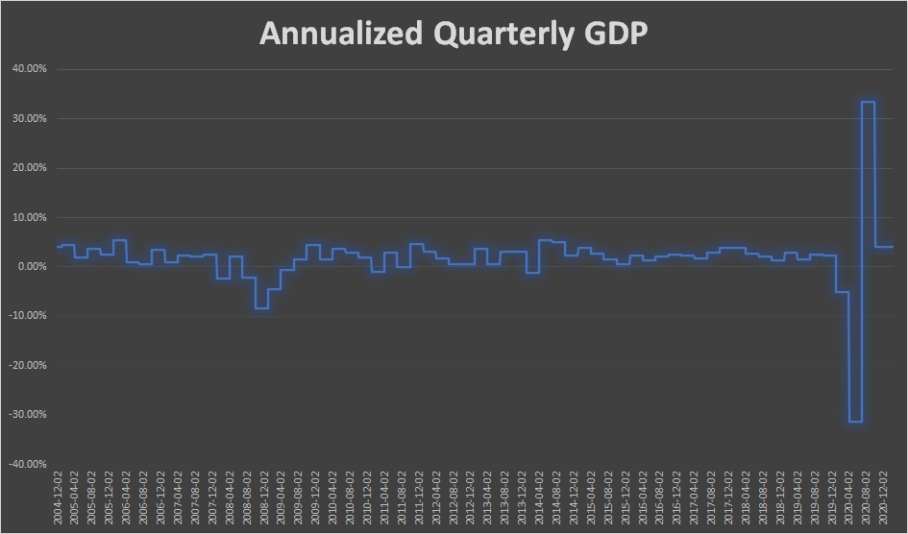

Chart 47: Lower and Upper Bounds and Distribution of Accumulated Number of Cases

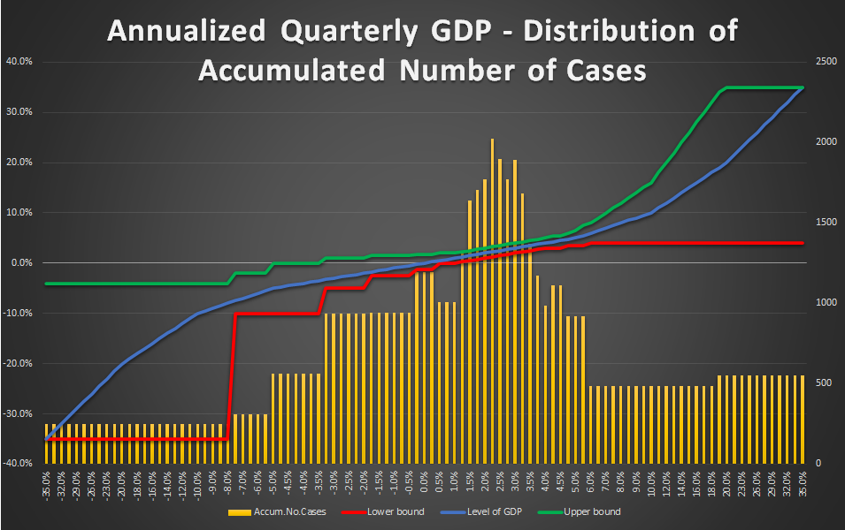

In this part of the study, we examine:

* **2 hedgeable ‘portfolio’: long SPY and long QQQ;**
* **3 different GDP level: -0.5% (negative growth rate), +3% (the median from 1947 to 2020) and +6% (extreme positive growth rate);**
* **3 different look-ahead periods: 5-day, 10-day and 1-month.**

In each **nine cases (3 GDP x 3 look-ahead)**, at first, the **scatter plot of correlation vs. Sharpe ratio** can be seen (e.g. Chart 48a-b), which helps us to **select the most promising hedges** (significantly negative correlation and positive Sharpe ratio and/or significantly positive correlation and negative Sharpe ratio (short)). After that, a table can be found (e.g. Table 45) which contains **not only the correlation coefficients for every hedge, but the beta compared to the SPY/QQQ** as well. Based on these beta, one can **specify the desired weights** of the selected hedges. We do not recommend any exact method for this, but it would theoretically be possible to create a near-beta-neutral portfolio. However, this would have been an overly over-fitted system. **Our recommended weights** in the penultimate column are discretionary determined based on the previous columns. Finally, a **portfolio value chart** (e.g. Chart 49) and a **performance indicator table** (e.g. Table 46) can be found which shows how the performance of the **portfolio (SPY/QQQ) with and without hedges (double leverage in this case in this study because of the weights of the hedges)** would have progressed in the days when the level of **GDP** is between the above defined **lower and upper bounds**. It is worth noting that these results may suffer from look-ahead and data-mining biases.

In this subsection, we will not explain each case in detail, as we could describe nearly identical things in each one. Our main findings and thoughts are:

* **As the SPY and the QQQ are highly correlated, the same hedges are appropriate for both in a given market environment.**
* **TLT, IEF and SHY are good choices in almost all cases.**
* **Only bonds (and maybe GLD, UUP and short gas (UNG)) are appropriate hedges during ‘normal times’, ie. when the level of GDP is around its median (~+3%). In these periods, the markets themselves are performing very well.**
* **Long VXX is only worth using as a hedge when the growth rate is negative.**
* **Short gas (UNG), short commodity (DBC), short utilities (XLU), short emerging markets (EEM), short copper (JJC) and/or short oil (USO) can also be used in the hedging basket when the growth rate is negative (short everything except bonds, long volatility and safe havens).**
* **When the performance of the economy increases significantly, the dollar also strengthens significantly, so long UUP can be the most appropriate hedge during periods with extreme high growth rate.**
* **The beta of SHY is too low to be worth dealing with this ETF.**
* **TAIL seems like a good choice during negative growth rate periods, but it is worth being careful, as there is very little historical data available so far (TAIL is available only from 2017).**
* **In all the nine cases, using hedge can improve both the Sharpe and the MAR ratios (it does not depend on the leverage!).**

An **online GoogleSheet version for this GDP - SnifferQuant Hedge-Selection Method** can be found [**here**](https://docs.google.com/spreadsheets/d/1o2NHNm_NypZaDYeZT3-0xGzzN2Wg0--423dqAeI_iyc), where the **GDP level** (cell ‘B1’), the **look-ahead period** (cell ‘E1’) and the **discretionary hedge weights** (cells ‘G24:G39’) should be changed.

**In summary, we strongly believe that this GDP - SnifferQuant Hedge-Selection Method can be a useful tool in all market situations. It helps us to select the expectedly most effective hedges which can even generate extra profit as well (in addition to risk reduction).**

**GDP: -5%, 5-day look-ahead period**

Chart 48a: Correlation vs. Sharpe ratio GDP: -5%, using SPY - 5-day look-ahead period

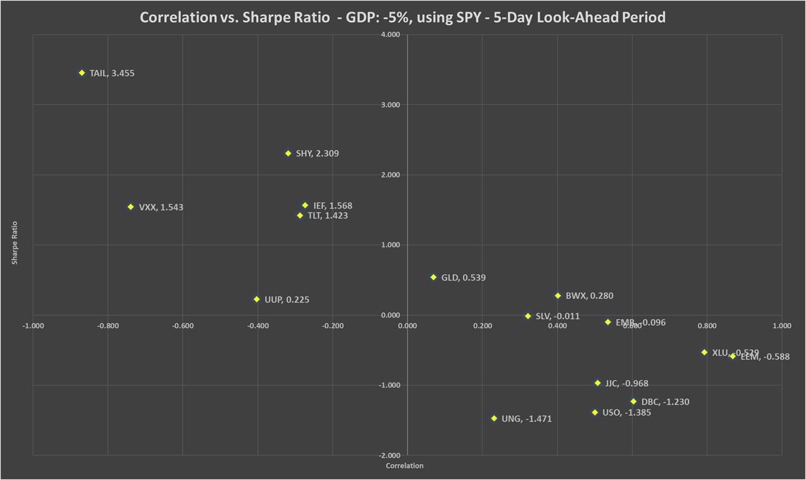

Chart 48b: Correlation vs. Sharpe ratio GDP: -5%, using QQQ - 5-day look-ahead period

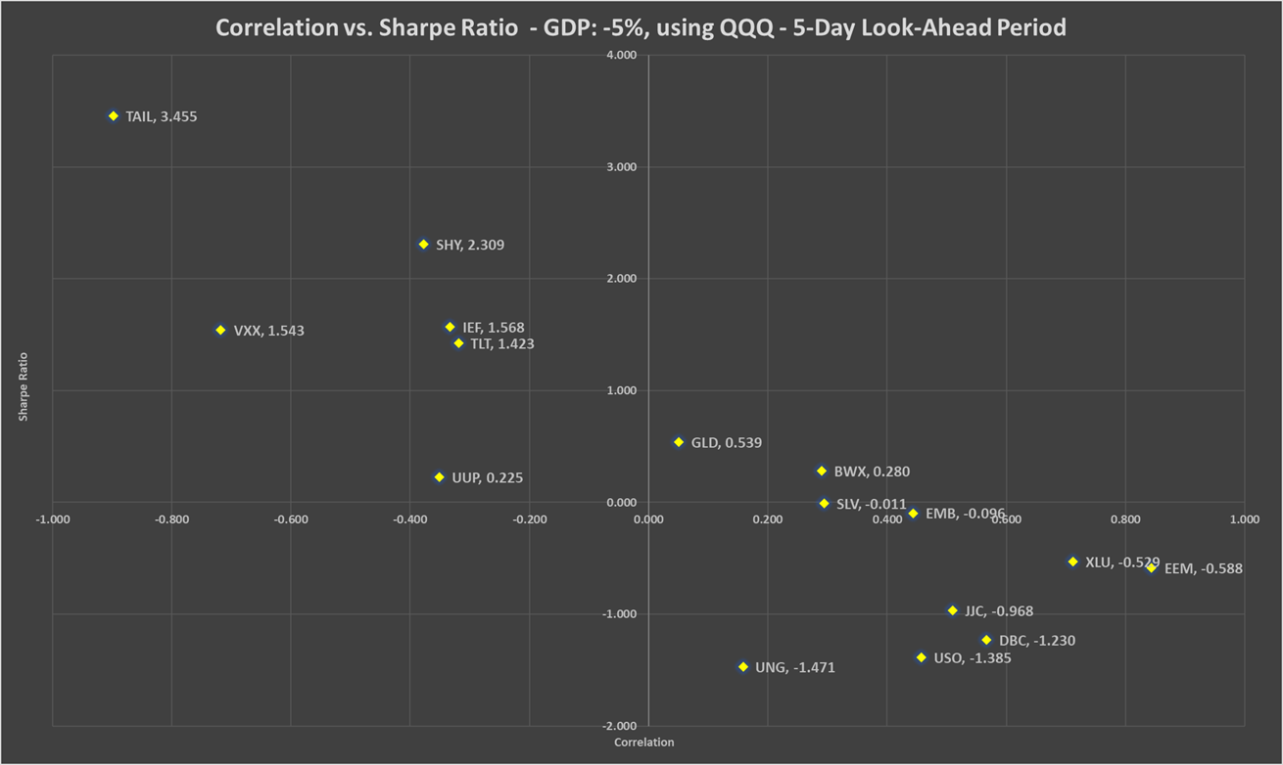

Table 45: Correlation, beta, Sharpe ratio and recommended weights of hedges - GDP: -5% - 5-day look-ahead period

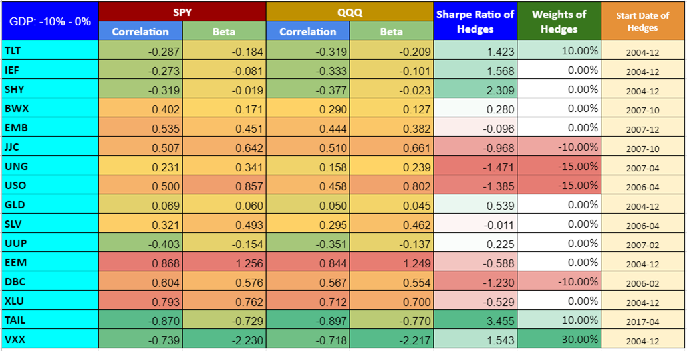

Chart 49: PV - GDP: -5% - 5-day look-ahead period

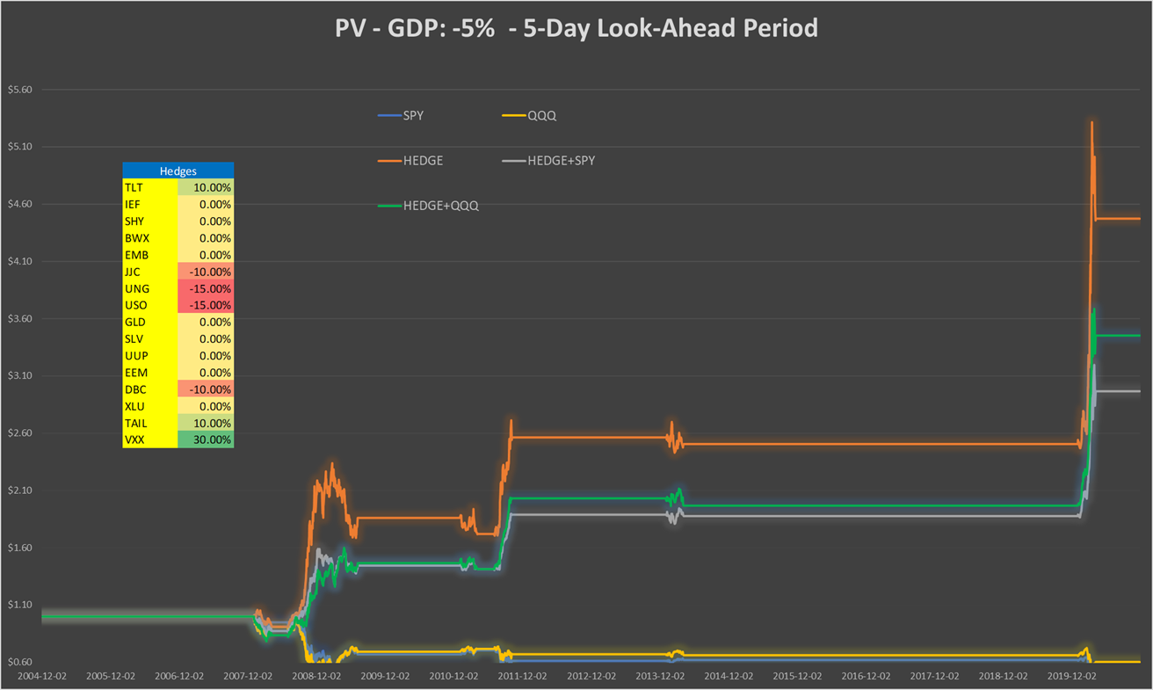

Table 46: Performance indicators with and without hedges - GDP: -5% - 5-day look-ahead period

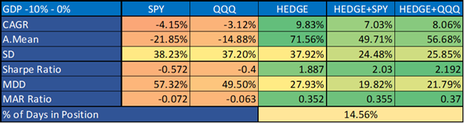

**GDP: +3%, 5-day look-ahead period**

Chart 50a: Correlation vs. Sharpe ratio GDP: +3%, using SPY - 5-day look-ahead period

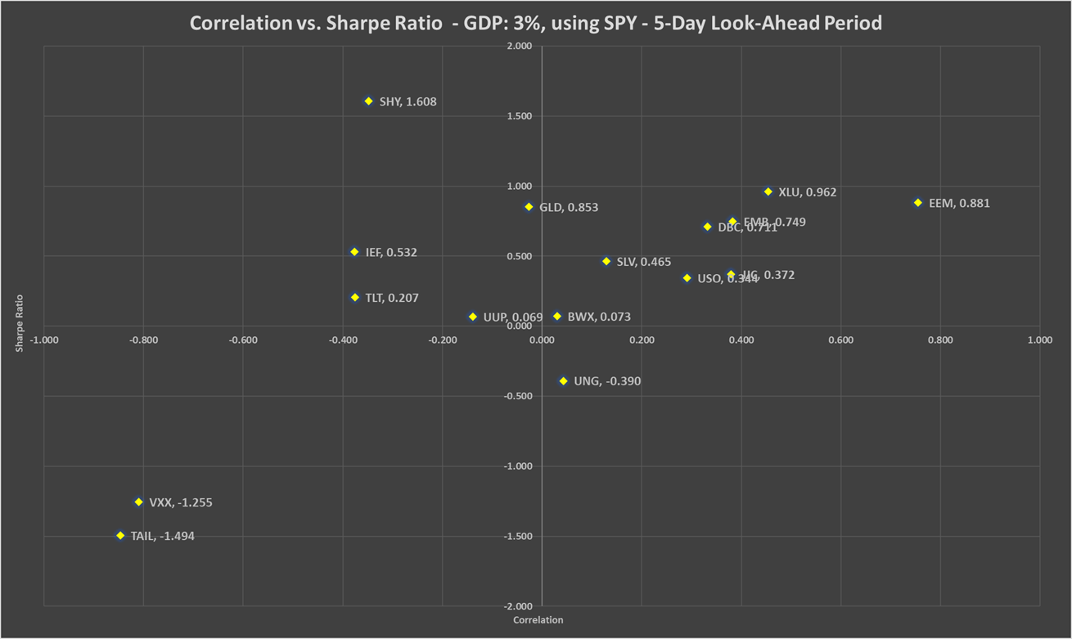

Chart 50b: Correlation vs. Sharpe ratio GDP: +3%, using QQQ - 5-day look-ahead period

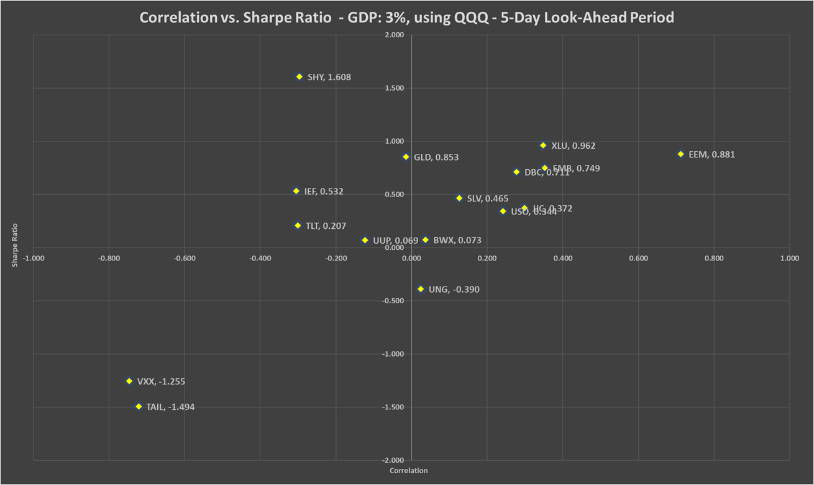

Table 47: Correlation, beta, Sharpe ratio and recommended weights of hedges - GDP: +3% - 5-day look-ahead period

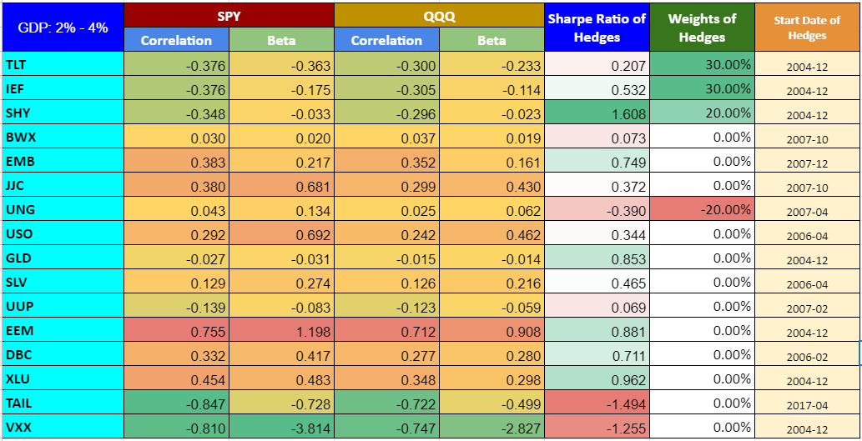

Chart 51: PV - GDP: +3% - 5-day look-ahead period

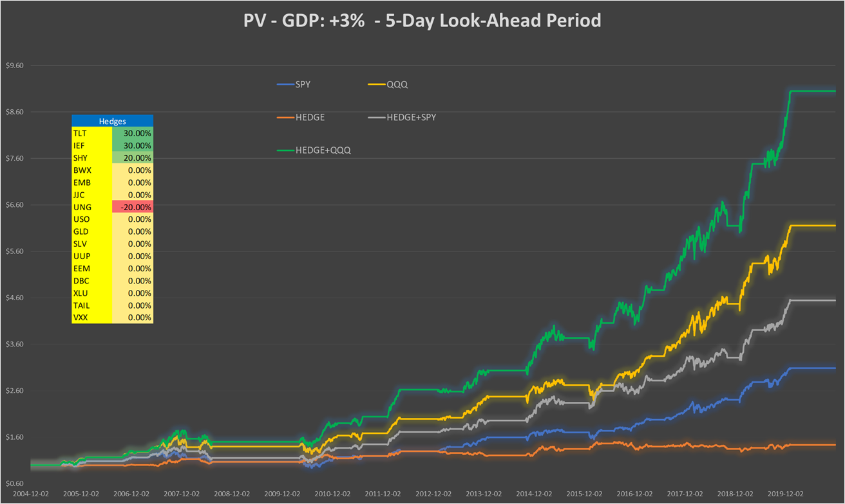

Table 48: Performance indicators with and without hedges - GDP: +3% - 5-day look-ahead period

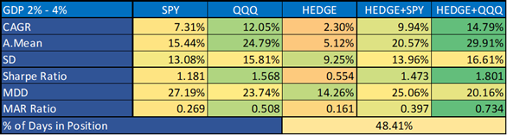

**GDP: +6%, 5-day look-ahead period**

Chart 52a: Correlation vs. Sharpe ratio GDP: +6%, using SPY - 5-day look-ahead period

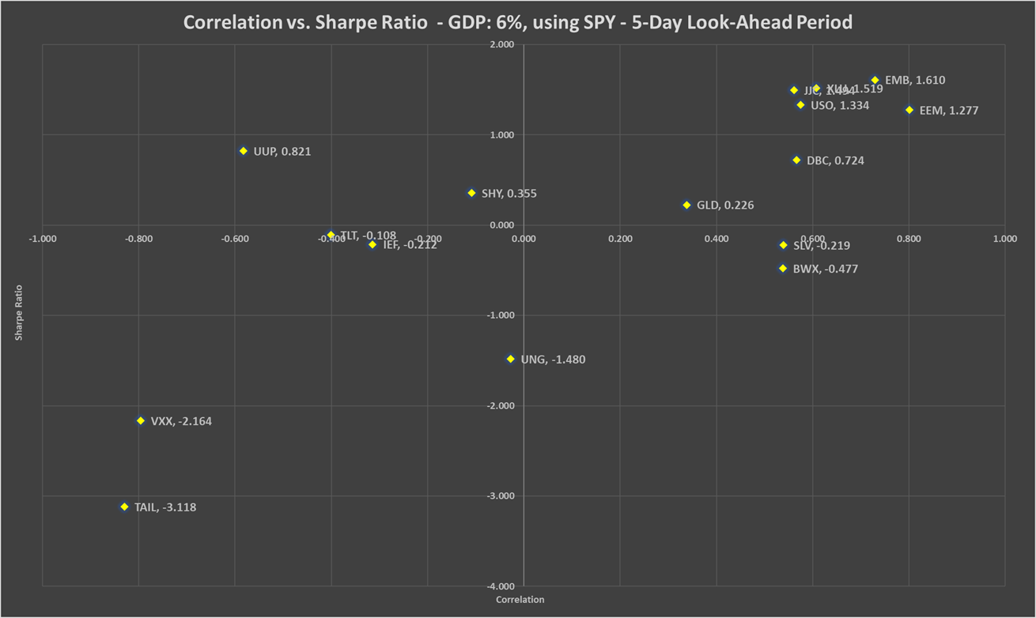

Chart 52b: Correlation vs. Sharpe ratio GDP: +6%, using QQQ - 5-day look-ahead period

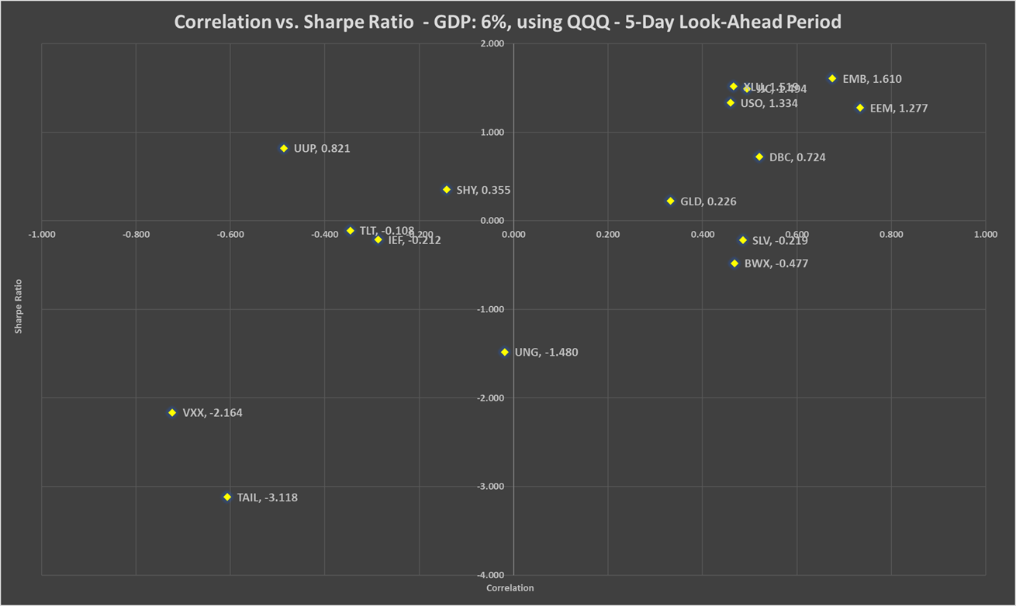

Table 49: Correlation, beta, Sharpe ratio and recommended weights of hedges - GDP: +6% - 5-day look-ahead period

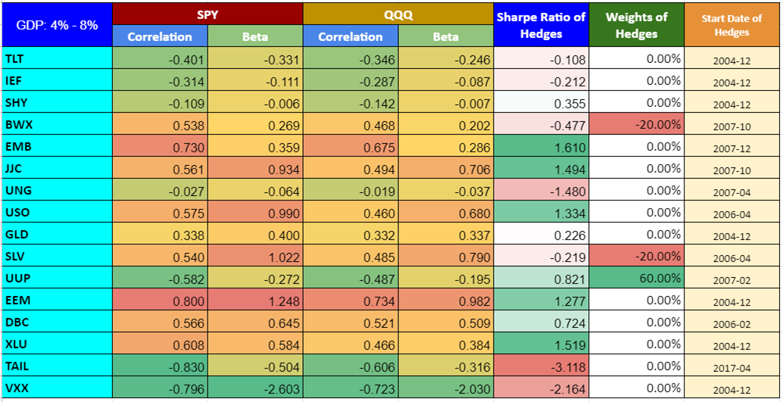

Chart 53: PV - GDP: +6% - 5-day look-ahead period

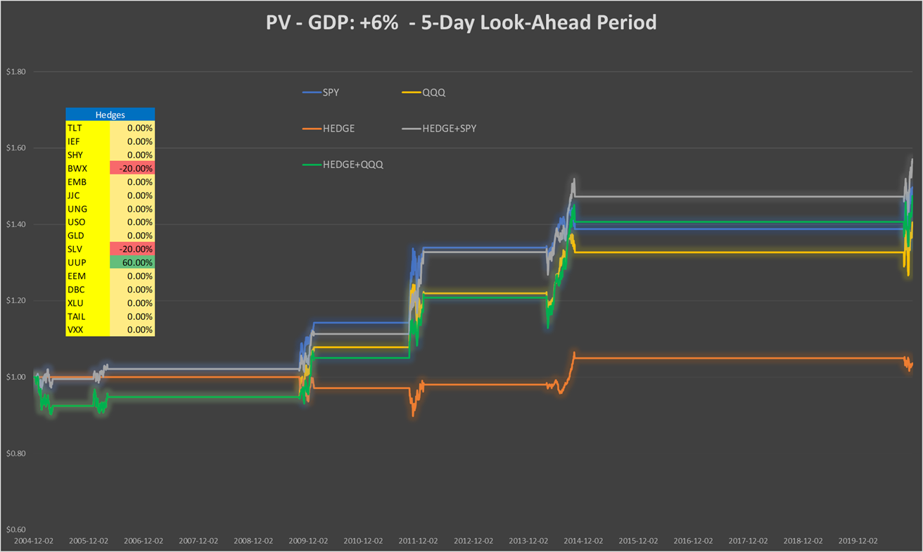

Table 50: Performance indicators with and without hedges - GDP: +6% - 5-day look-ahead period

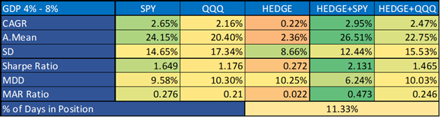

**GDP: -5%, 10-day look-ahead period**

Chart 54a: Correlation vs. Sharpe ratio GDP: -5%, using SPY - 10-day look-ahead period

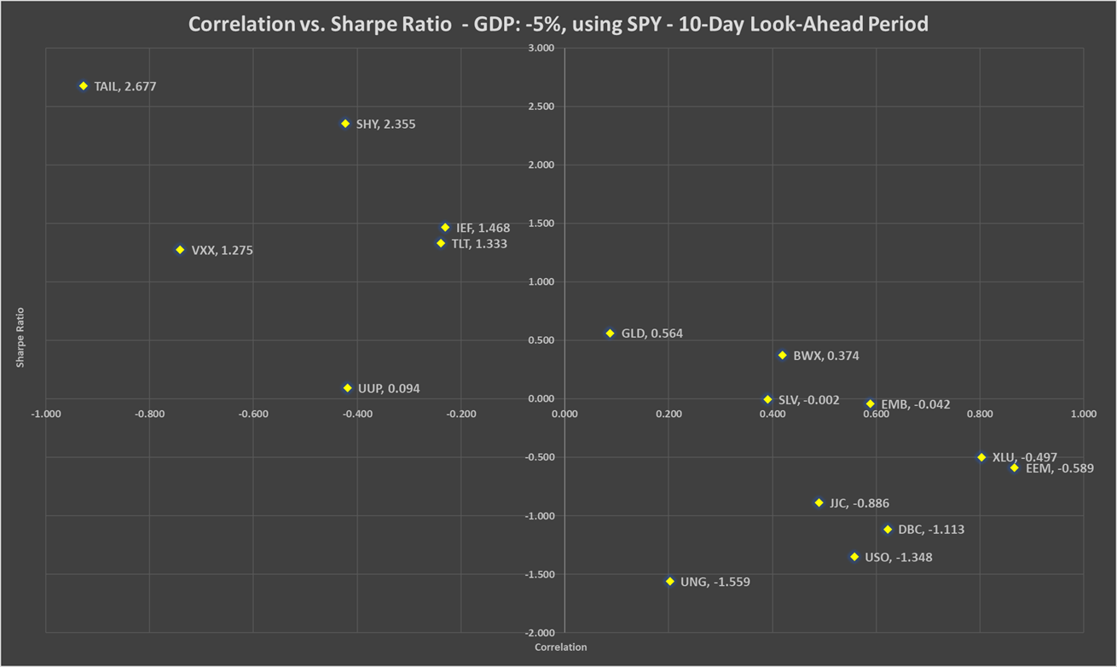

Chart 54b: Correlation vs. Sharpe ratio GDP: -5%, using QQQ - 10-day look-ahead period

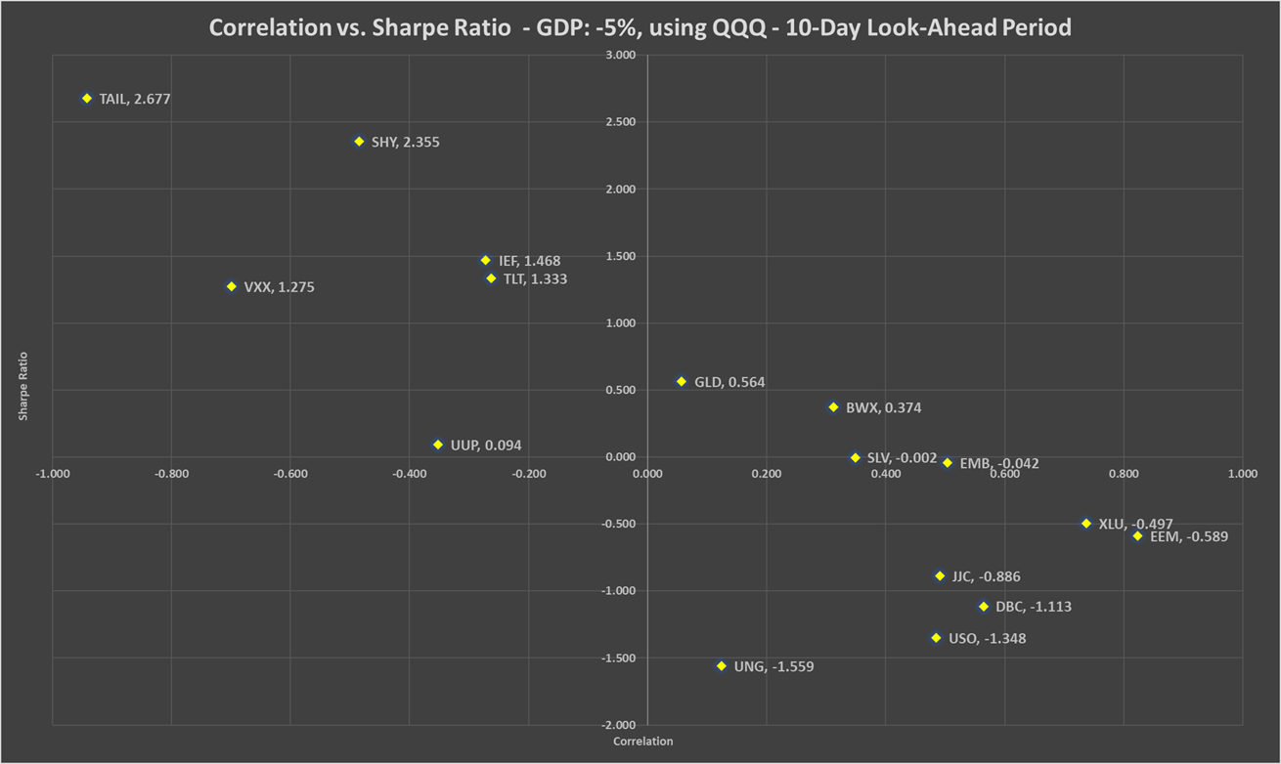

Table 51: Correlation, beta, Sharpe ratio and recommended weights of hedges - GDP: -5% - 10-day look-ahead period

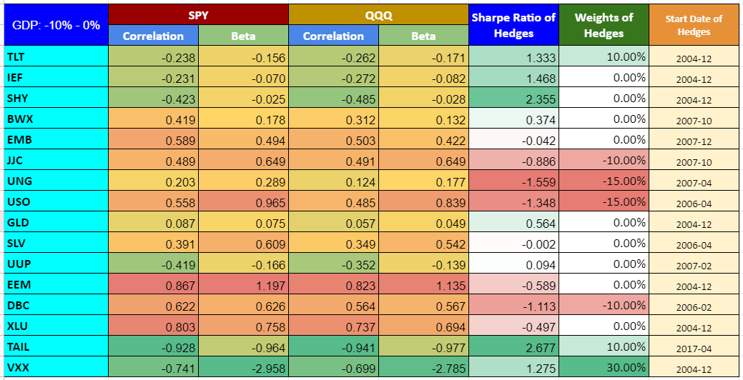

Chart 55: PV - GDP: -5% - 10-day look-ahead period

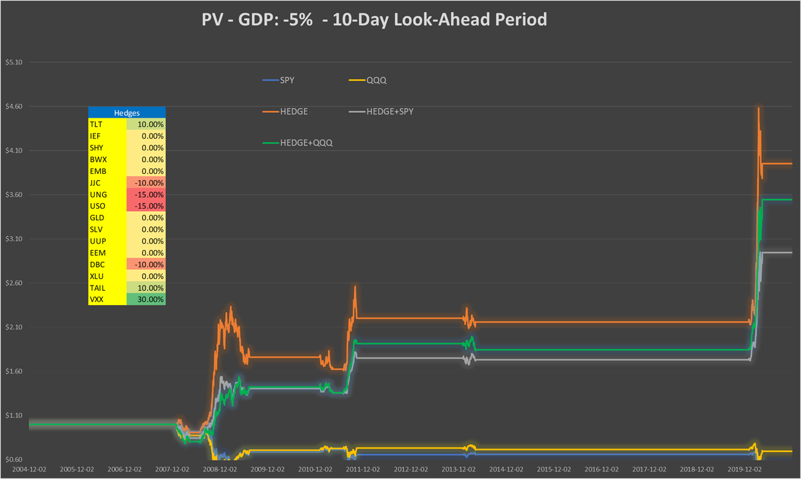

Table 52: Performance indicators with and without hedges - GDP: -5% - 10-day look-ahead period

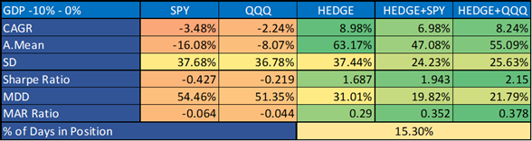

**GDP: +3%, 10-day look-ahead period**

Chart 56a: Correlation vs. Sharpe ratio GDP: +3%, using SPY - 10-day look-ahead period

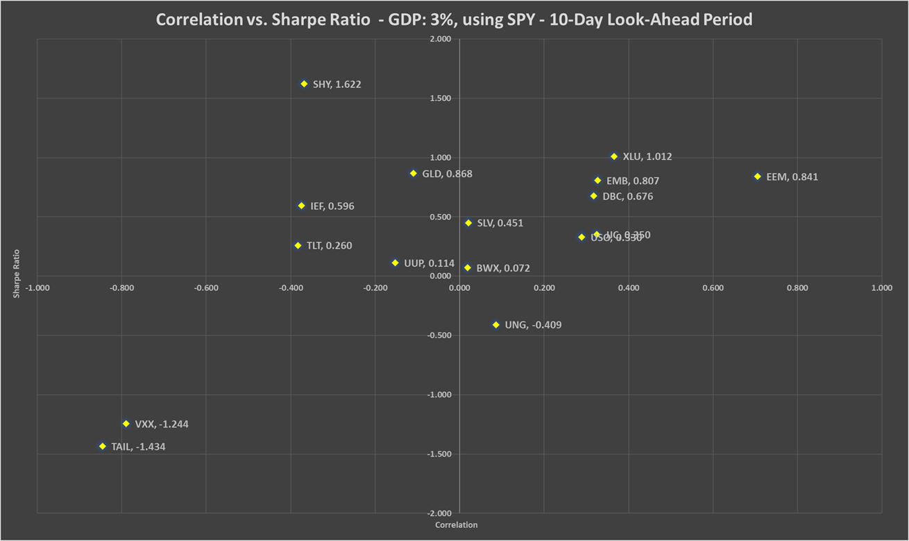

Chart 56b: Correlation vs. Sharpe ratio GDP: +3%, using QQQ - 10-day look-ahead period

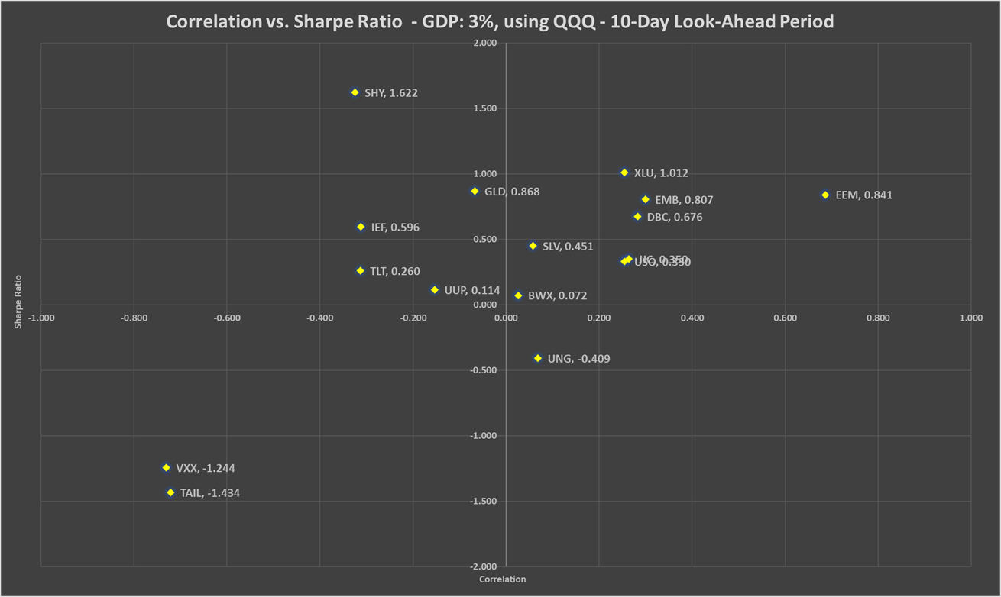

Table 53: Correlation, beta, Sharpe ratio and recommended weights of hedges - GDP: +3% - 10-day look-ahead period

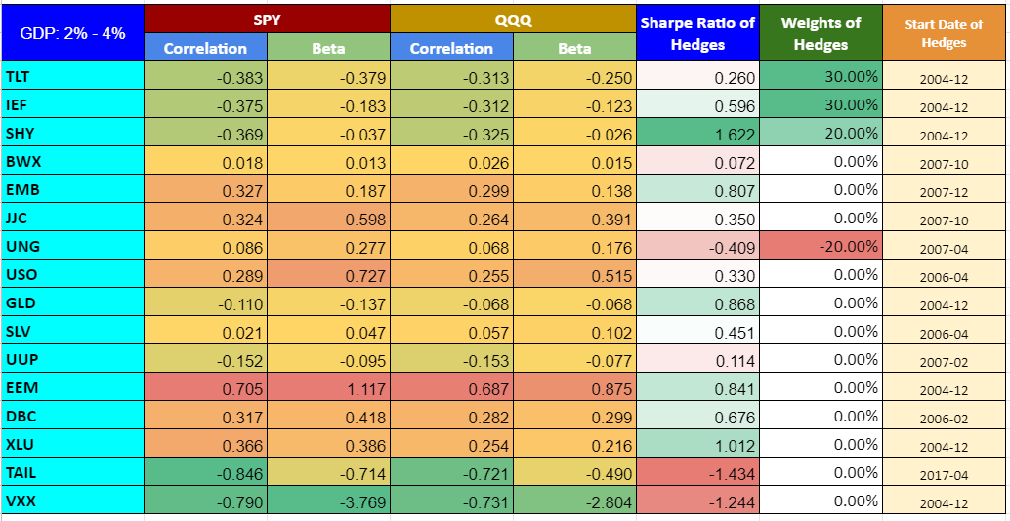

Chart 57: PV - GDP: +3% - 10-day look-ahead period

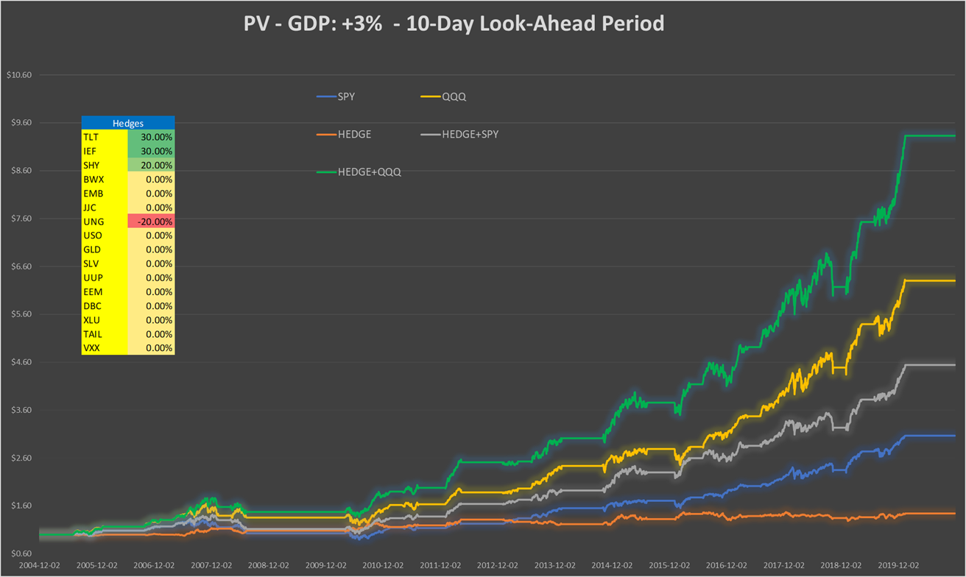

Table 54: Performance indicators with and without hedges - GDP: +3% - 10-day look-ahead period

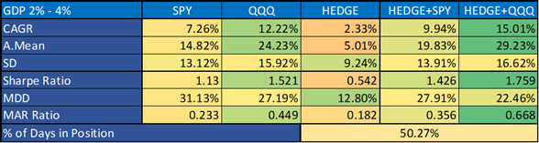

**GDP: +6%, 10-day look-ahead period**

Chart 58a: Correlation vs. Sharpe ratio GDP: +6%, using SPY - 10-day look-ahead period

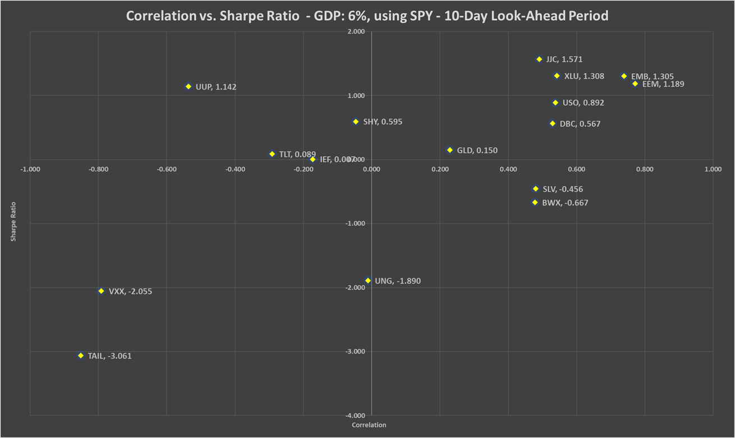

Chart 58b: Correlation vs. Sharpe ratio GDP: +6%, using QQQ - 10-day look-ahead period

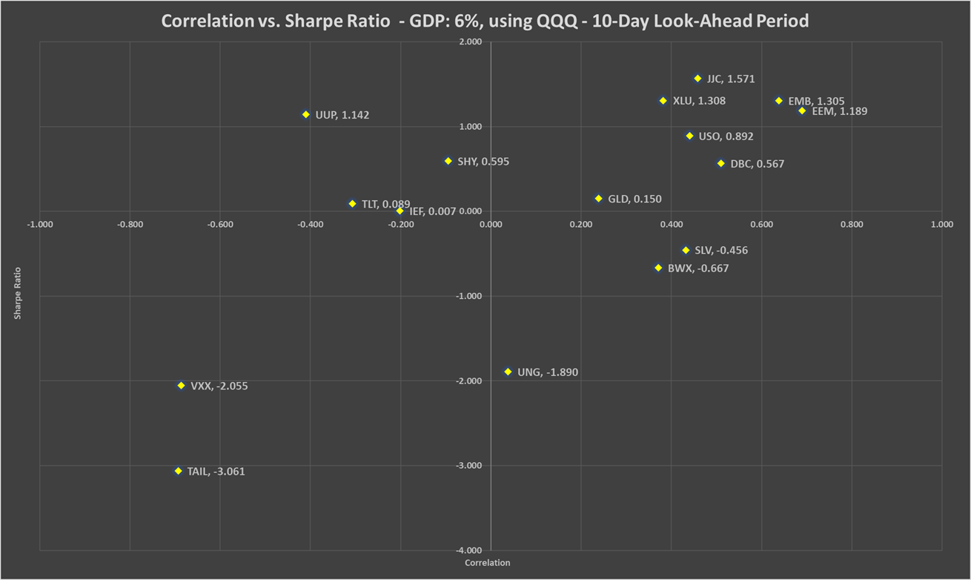

Table 55: Correlation, beta, Sharpe ratio and recommended weights of hedges - GDP: +6% - 10-day look-ahead period

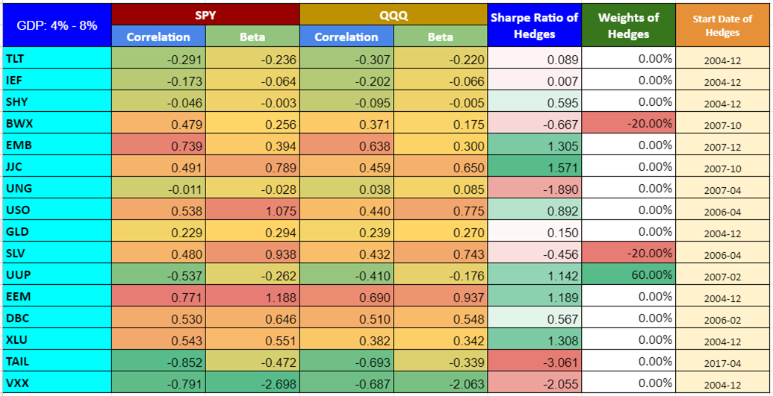

Chart 59: PV - GDP: +6% - 10-day look-ahead period

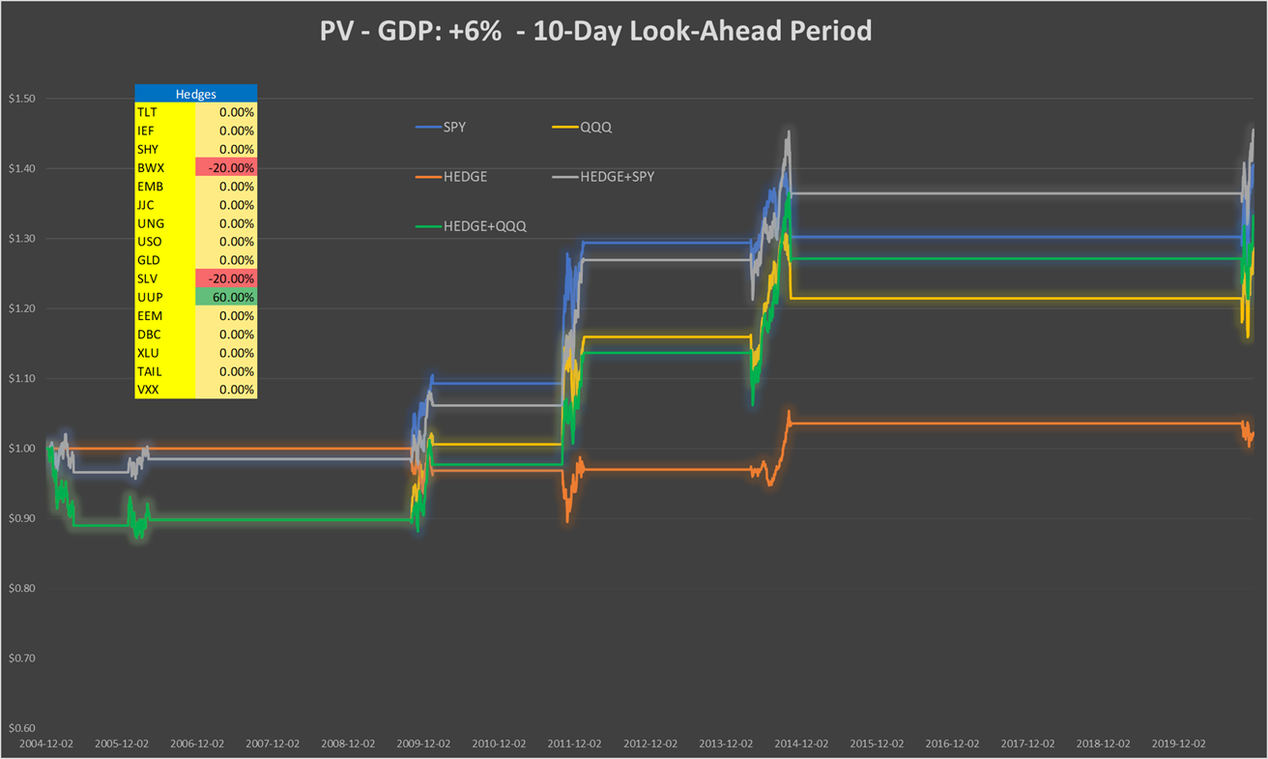

Table 56: Performance indicators with and without hedges - GDP: +6% - 10-day look-ahead period

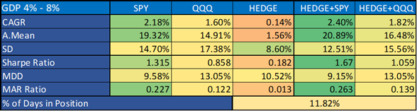

**GDP: -5%, 1-month look-ahead period**

Chart 60a: Correlation vs. Sharpe ratio GDP: -5%, using SPY - 1-month look-ahead period

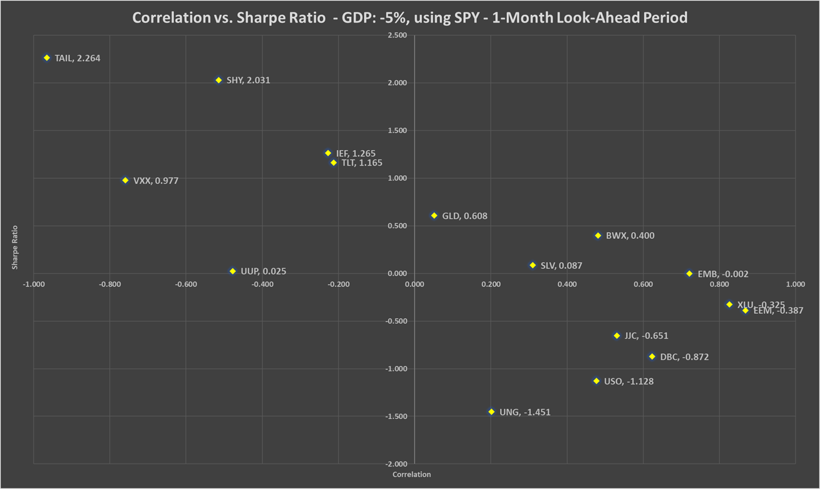

Chart 60b: Correlation vs. Sharpe ratio GDP: -5%, using QQQ - 1-month look-ahead period

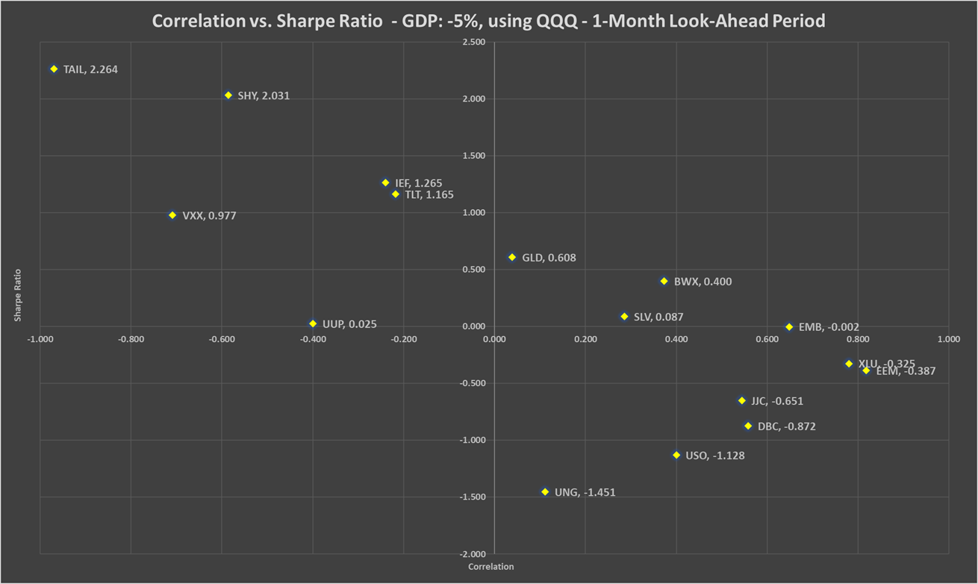

Table 57: Correlation, beta, Sharpe ratio and recommended weights of hedges - GDP: -5% - 1-month look-ahead period

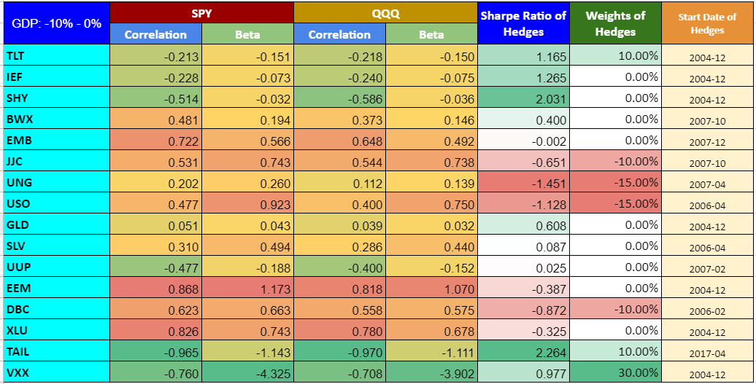

Chart 61: PV - GDP: -5% - 1-month look-ahead period

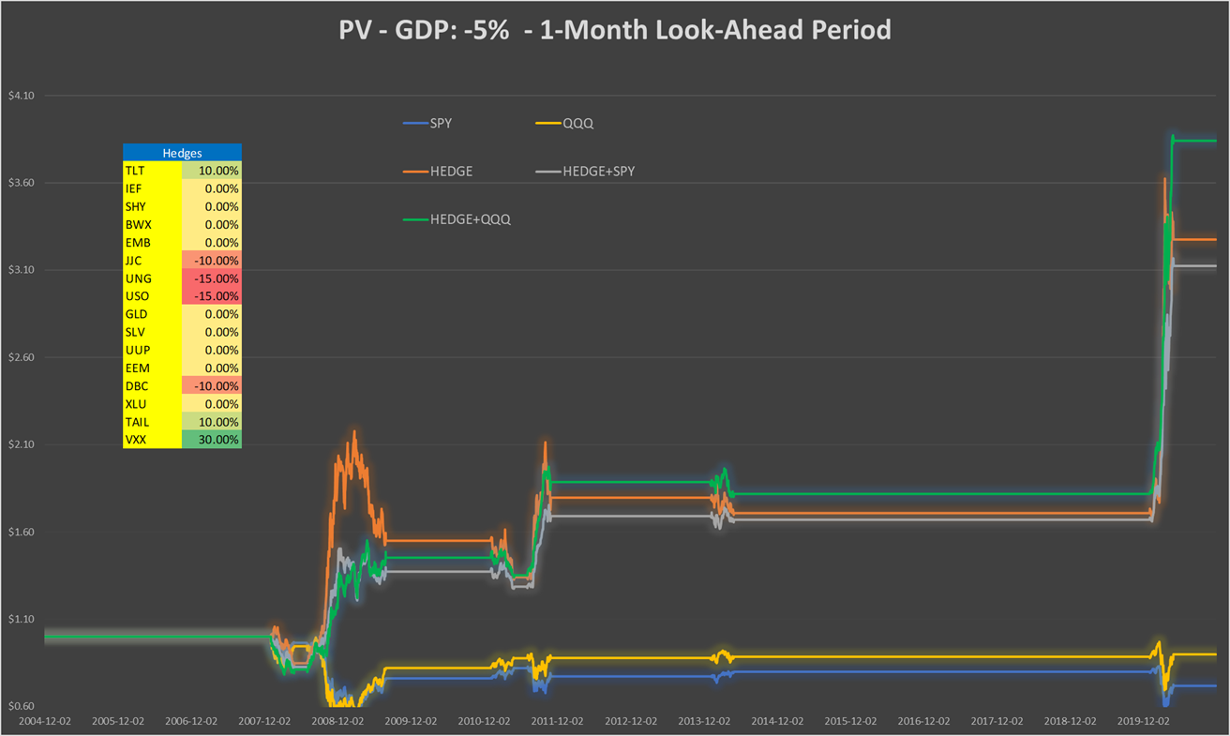

Table 58: Performance indicators with and without hedges - GDP: -5% - 1-month look-ahead period

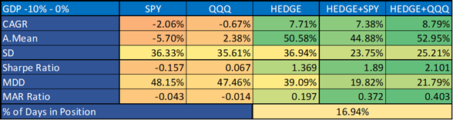

**GDP: +3%, 1-month look-ahead period**

Chart 62a: Correlation vs. Sharpe ratio GDP: +3%, using SPY - 1-month look-ahead period

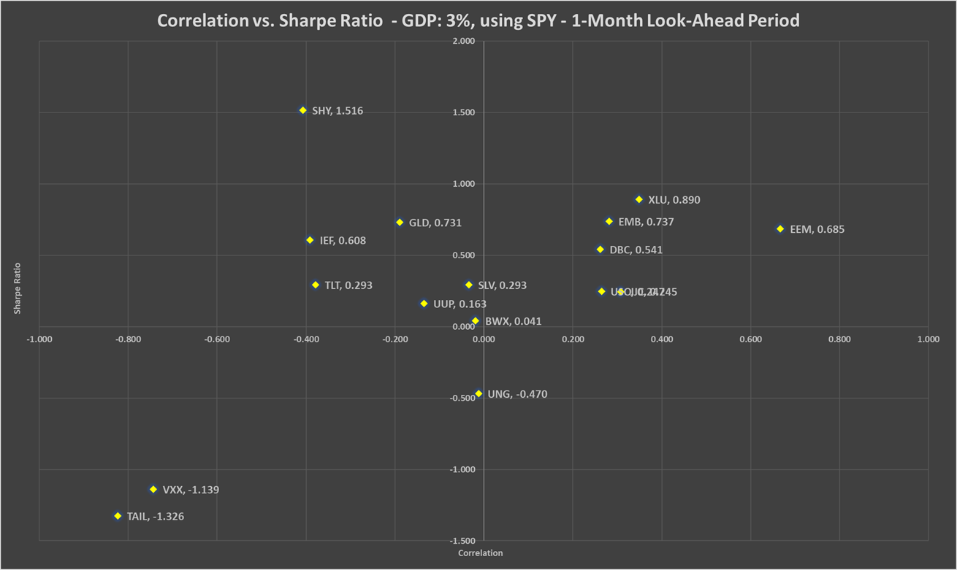

Chart 62b: Correlation vs. Sharpe ratio GDP: +3%, using QQQ - 1-month look-ahead period

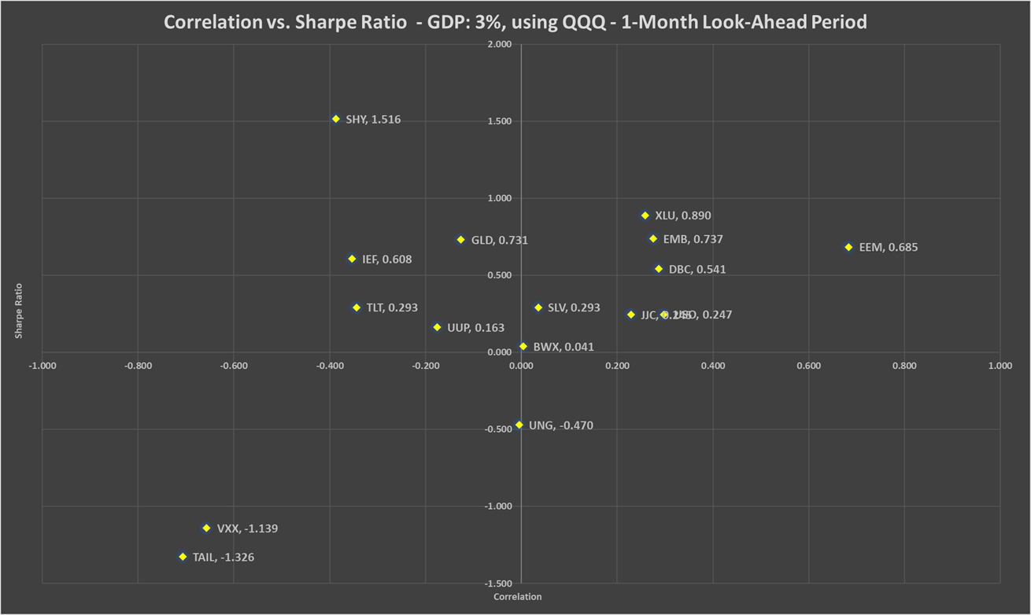

Table 59: Correlation, beta, Sharpe ratio and recommended weights of hedges - GDP: +3% - 1-month look-ahead period

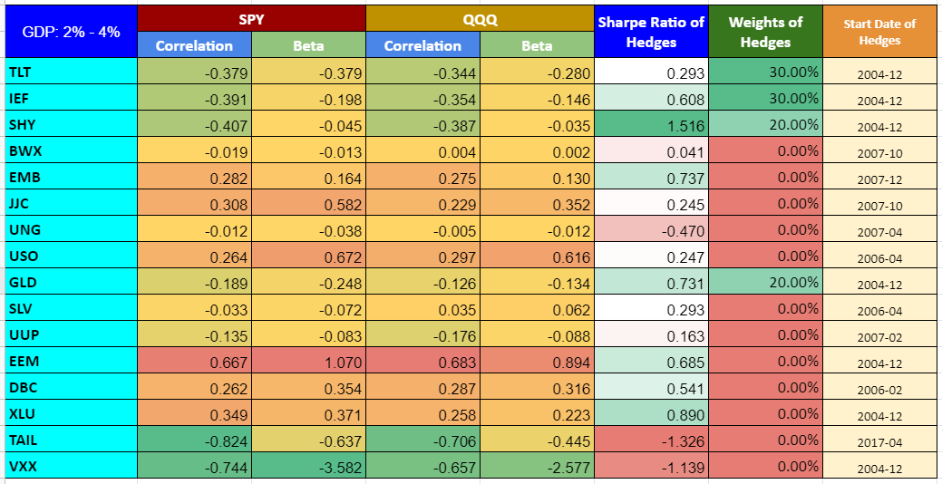

Chart 63: PV - GDP: +3% - 1-month look-ahead period

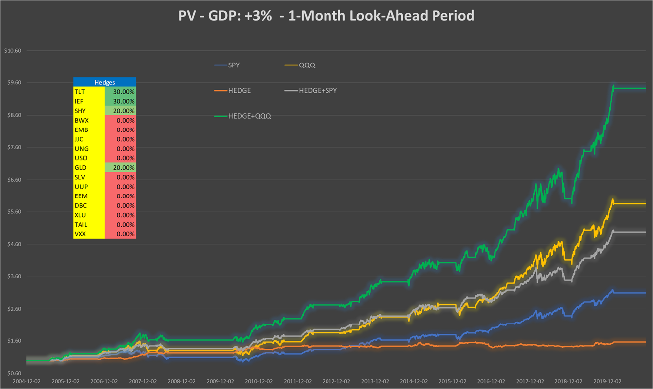

Table 60: Performance indicators with and without hedges - GDP: +3% - 1-month look-ahead period

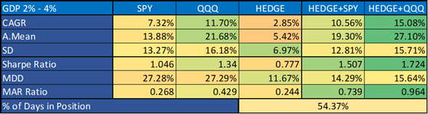

**GDP: +6%, 1-month look-ahead period**

Chart 64a: Correlation vs. Sharpe ratio GDP: +6%, using SPY - 1-month look-ahead period

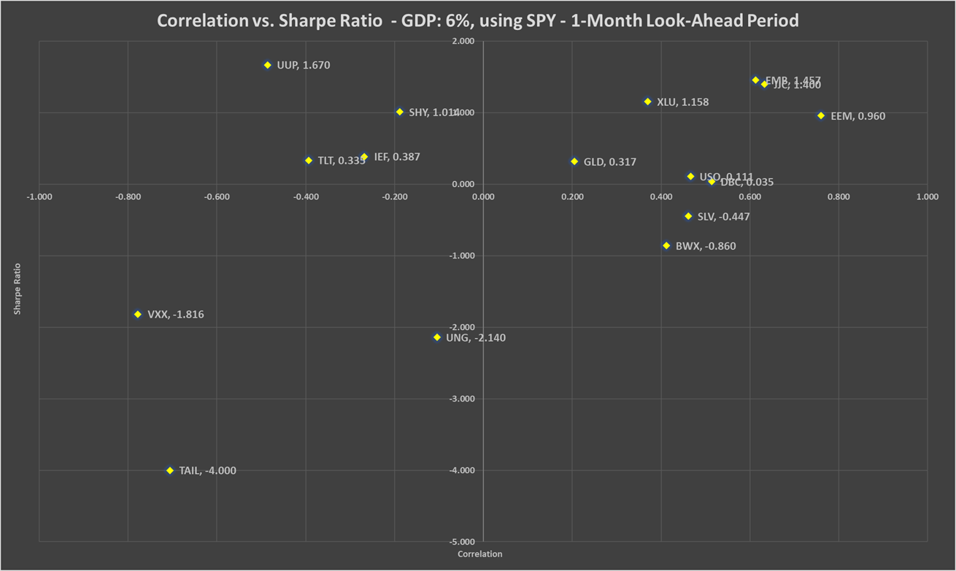

Chart 64b: Correlation vs. Sharpe ratio GDP: +6%, using QQQ - 1-month look-ahead period

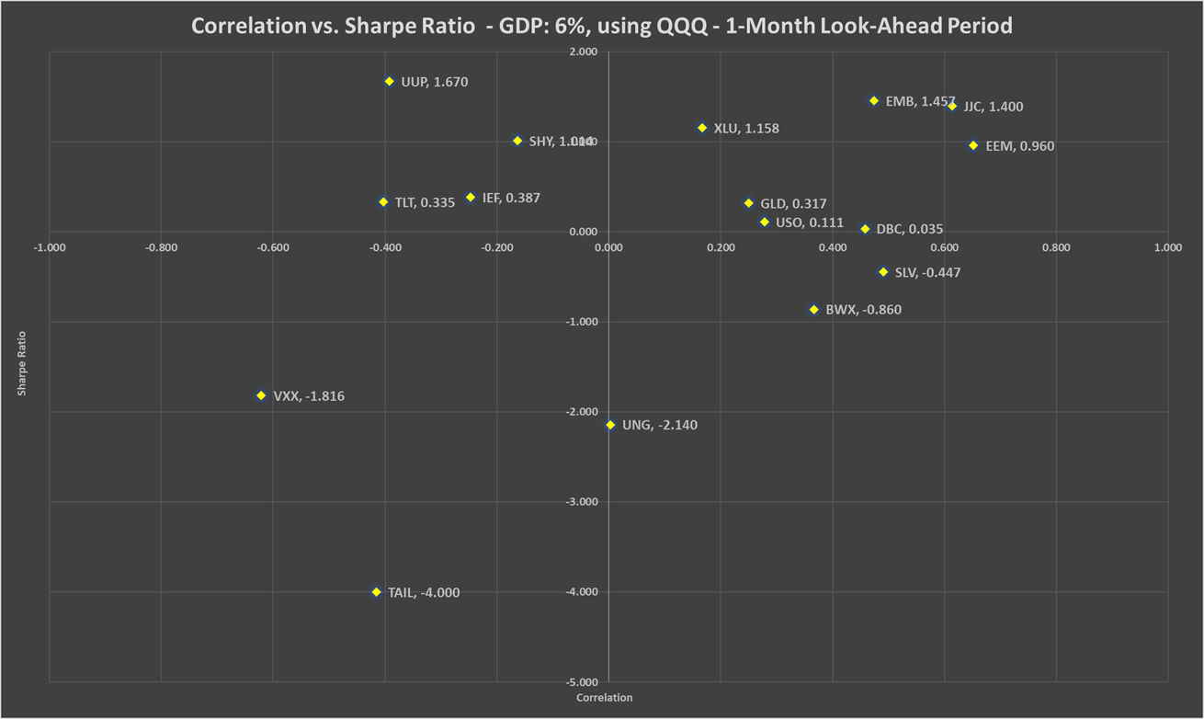

Table 61: Correlation, beta, Sharpe ratio and recommended weights of hedges - GDP: +6% - 1-month look-ahead period

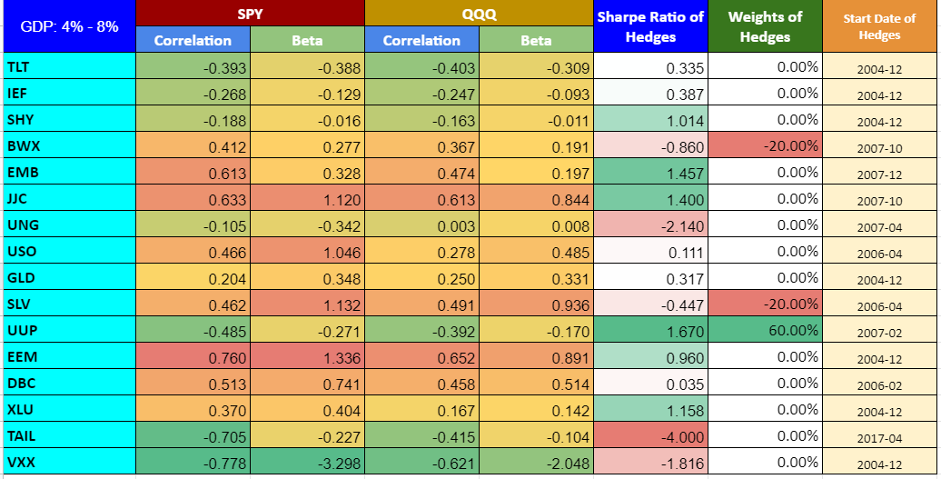

Chart 65: PV - GDP: +6% - 1-month look-ahead period

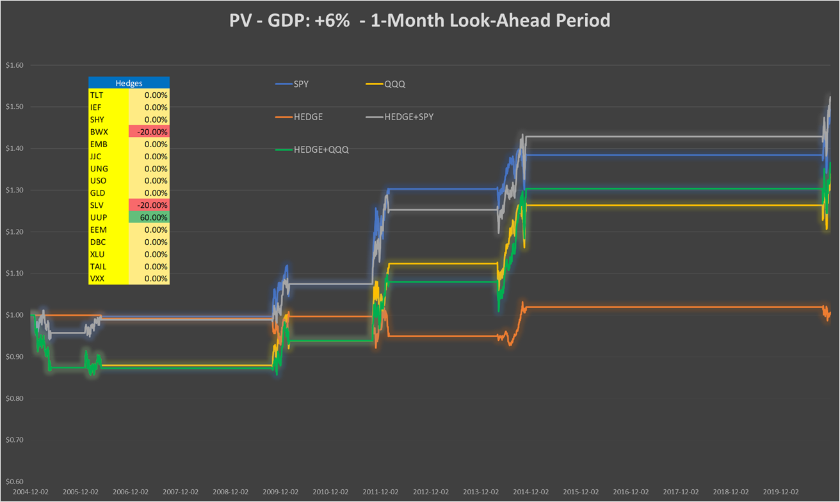

Table 62: Performance indicators with and without hedges - GDP: +6% - 1-month look-ahead period

