Dr. George Antal
3D Click Limited
c/o Suite 431, 28 Old Brompton Road, London SW7 3SS

Hedges and Correlations

Case studies for Excess Earnings Yield in practice

In this subsection, case studies for Excess Earnings Yield (EY-R10YEY) indicator is presented. After taking a look at Chart 66 one can conclude that our simple rolling correlation calculation method used above will not be a perfect one for Excess Earnings YIeld either, as the distribution of its level is not even.

We have to define the lower and upper bounds separately for each Excess Earnings Yield level again to obtain enough sample size. Chart 67 shows these bounds and the distribution of these accumulated number of cases. After that modification, the method is the same as before.

Chart 66: Level of Excess Earnings Yield
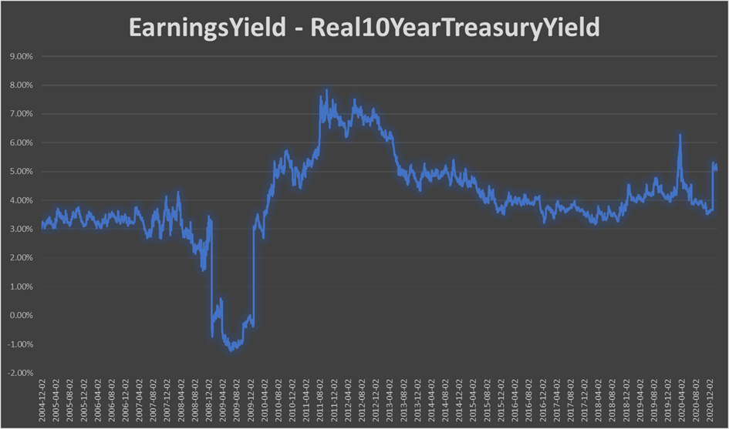

Chart 67: Lower and Upper Bounds and Distribution of Accumulated Number of Cases
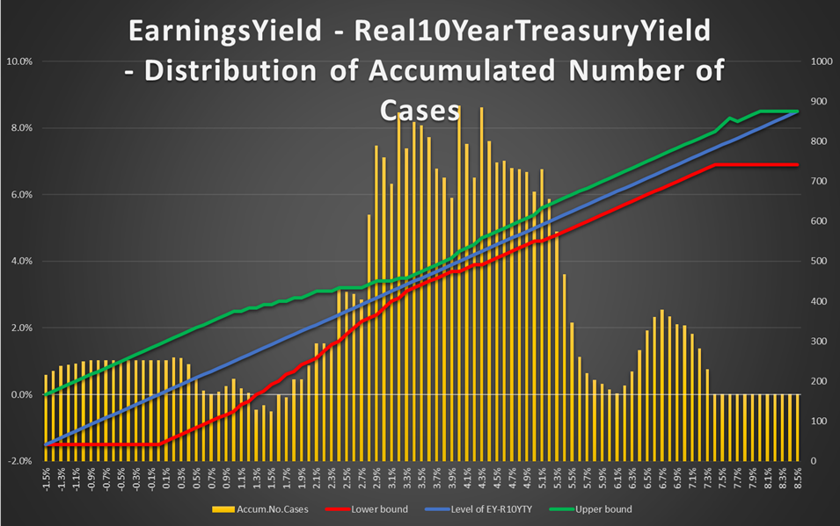

In this part of the study, we examine:
- 2 hedgeable ‘portfolio’: long SPY and long QQQ;
- 3 different EY-R10YEY level: -0.5% (negative excess earnings yield), +3.8% (the median from 2004 to 2020) and +6.5% (extreme high excess earnings yield);
- 3 different look-ahead periods: 5-day, 10-day and 1-month.

In each nine cases (3 EY-R10YEY x 3 look-ahead), at first, the scatter plot of correlation vs. Sharpe ratio can be seen (e.g. Chart 68a-b), which helps us to select the most promising hedges (significantly negative correlation and positive Sharpe ratio and/or significantly positive correlation and negative Sharpe ratio (short)). After that, a table can be found (e.g. Table 63) which contains not only the correlation coefficients for every hedge, but the beta compared to the SPY/QQQ as well. Based on these beta, one can specify the desired weights of the selected hedges. We do not recommend any exact method for this, but it would theoretically be possible to create a near-beta-neutral portfolio. However, this would have been an overly over-fitted system. Our recommended weights in the penultimate column are discretionary determined based on the previous columns. Finally, a portfolio value chart (e.g. Chart 69) and a performance indicator table (Table 64) can be found which shows how the performance of the portfolio (SPY/QQQ) with and without hedges (double leverage in this case in this study because of the weights of the hedges) would have progressed in the days when the level of EY-R10YEY is between the above defined lower and upper bounds. It is worth noting that these results may suffer from look-ahead and data-mining biases.

In this subsection, we will not explain each case in detail, as we could describe nearly identical things in each one. Our main findings and thoughts are:
- As the SPY and the QQQ are highly correlated, the same hedges are appropriate for both in a given market environment.
- TLT, IEF and SHY are good choices except when the real treasury yield is higher than the earnings yield.
- Bonds, short gas (UNG), short oil (USO), short commodity (DBC) and maybe gold (GLD) are appropriate hedges during ‘normal times’, ie. when the level of Excess Earnings Yield is around its median (~+3.8%). In these periods, the markets themselves are performing very well.
- Long VXX is never worth using as a hedge based on the level of EY-R10YEY.
- Only short gas (UNG) and maybe long gold (GLD) are appropriate hedges when the excess earnings yield is below 0. It is worth noting that both the markets (SPY and QQQ) and the selected ETFs but UNG, US bonds and VXX perform well in those periods. But correlations are mainly positive, thus these ETFs cannot work as a hedge.
- When the earnings yield significantly exceeds the real treasury yield, long bonds, UUP and ‘short everything’ is the best hedge tactic. In those times, all the money flows into the market (SPY and QQQ) which may cause the underperformance of safe havens, gas, oil, commodities and emerging markets as well,
- The beta of SHY is too low to be worth dealing with this ETF.
- In all the nine cases, using hedge can improve both the Sharpe and the MAR ratios (it does not depend on the leverage!).

An online GoogleSheet version for this EY-R10YEY - SnifferQuant Hedge-Selection Method can be found here, where the EY-R10YEY level (cell ‘B1’), the look-ahead period (cell ‘E1’) and the discretionary hedge weights (cells ‘G24:G39’) should be changed.

In summary, we strongly believe that this EY-R10YEY - SnifferQuant Hedge-Selection Method can be a useful tool in all market situations. It helps us to select the expectedly most effective hedges which can even generate extra profit as well (in addition to risk reduction).

EY-R10YTY: -0.5%, 5-day look-ahead period

Chart 68a: Correlation vs. Sharpe ratio EY-R10YTY: -0.5%, using SPY - 5-day look-ahead period
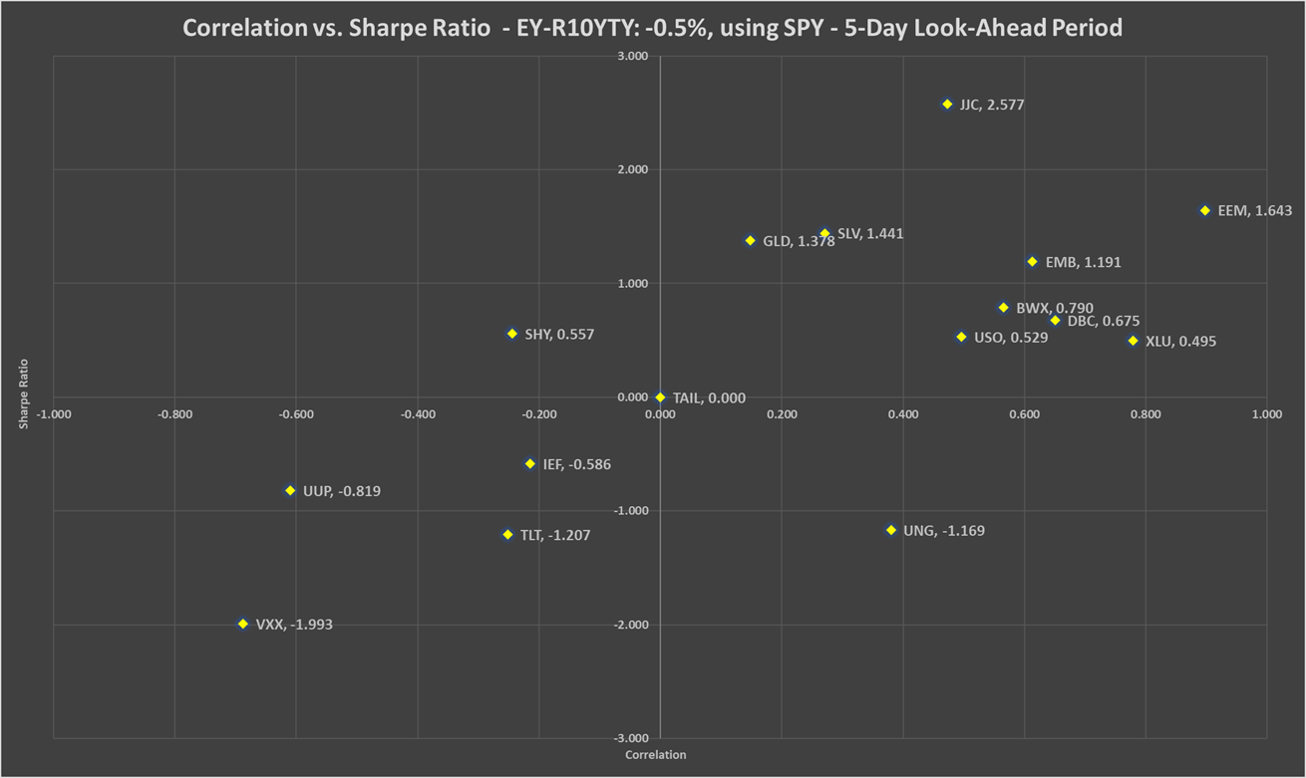
Chart 68b: Correlation vs. Sharpe ratio EY-R10YTY: -0.5%, using QQQ - 5-day look-ahead period
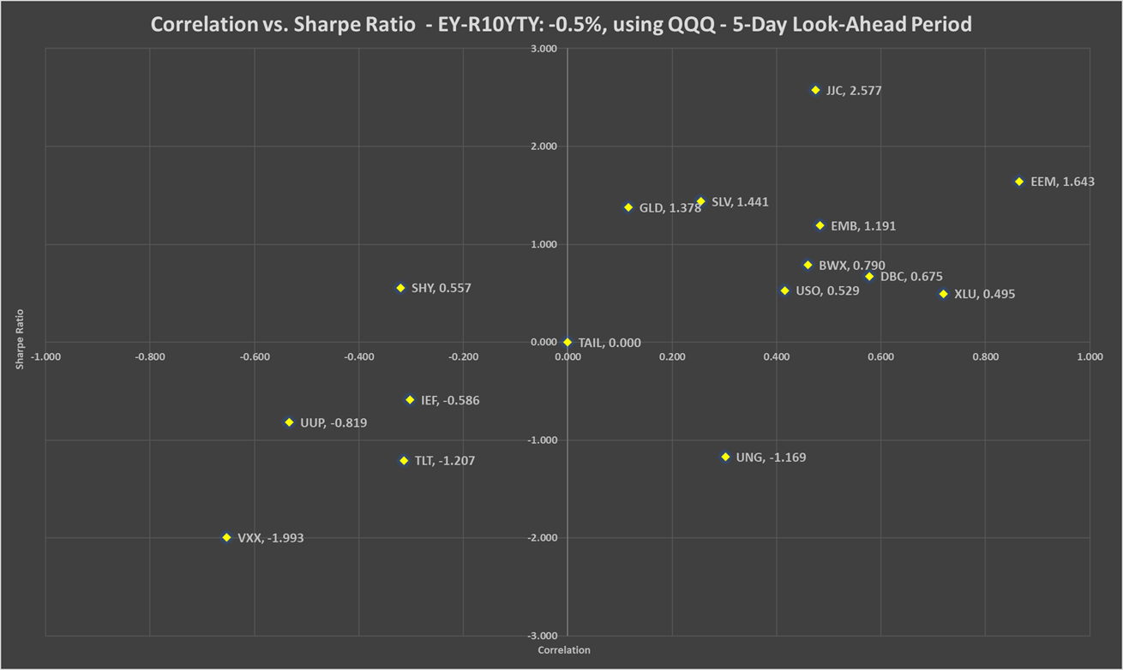
Table 63: Correlation, beta, Sharpe ratio and recommended weights of hedges - EY-R10YTY: -0.5% - 5-day look-ahead period
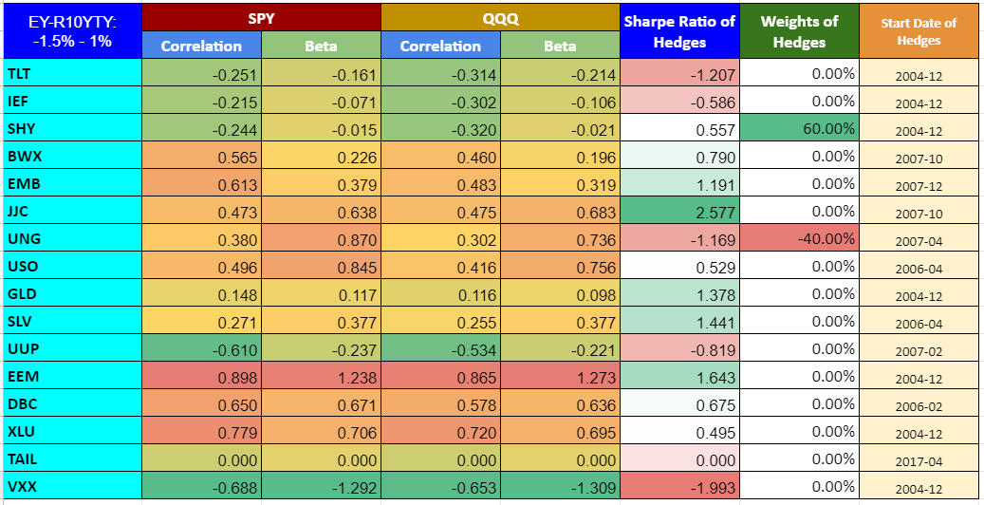

Chart 69: PV - EY-R10YTY: -0.5% - 5-day look-ahead period
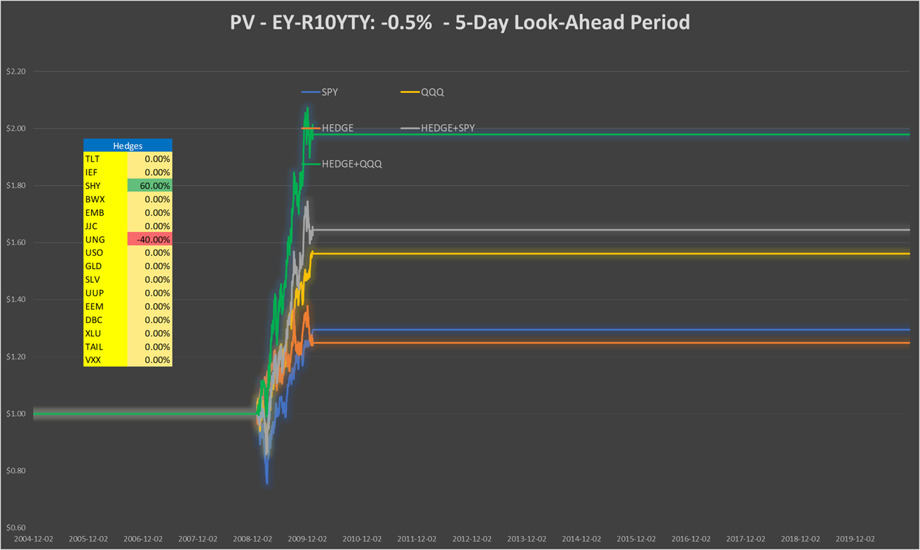

Table 64: Performance indicators with and without hedges - EY-R10YTY: -0.5% - 5-day look-ahead period
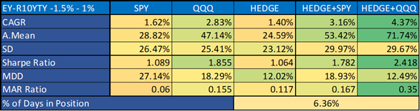

EY-R10YTY: +3.8%, 5-day look-ahead period

Chart 70a: Correlation vs. Sharpe ratio EY-R10YTY: +3.8%, using SPY - 5-day look-ahead period
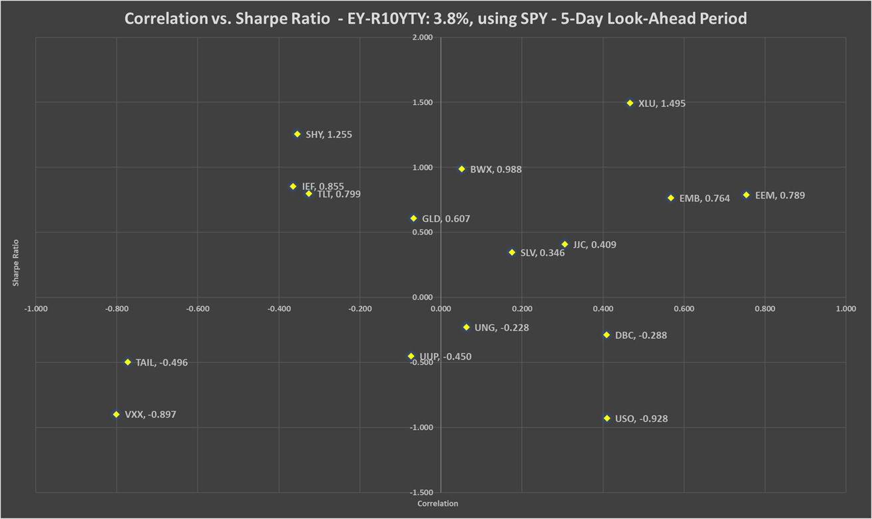

Chart 70b: Correlation vs. Sharpe ratio EY-R10YTY: +3.8%, using QQQ - 5-day look-ahead period
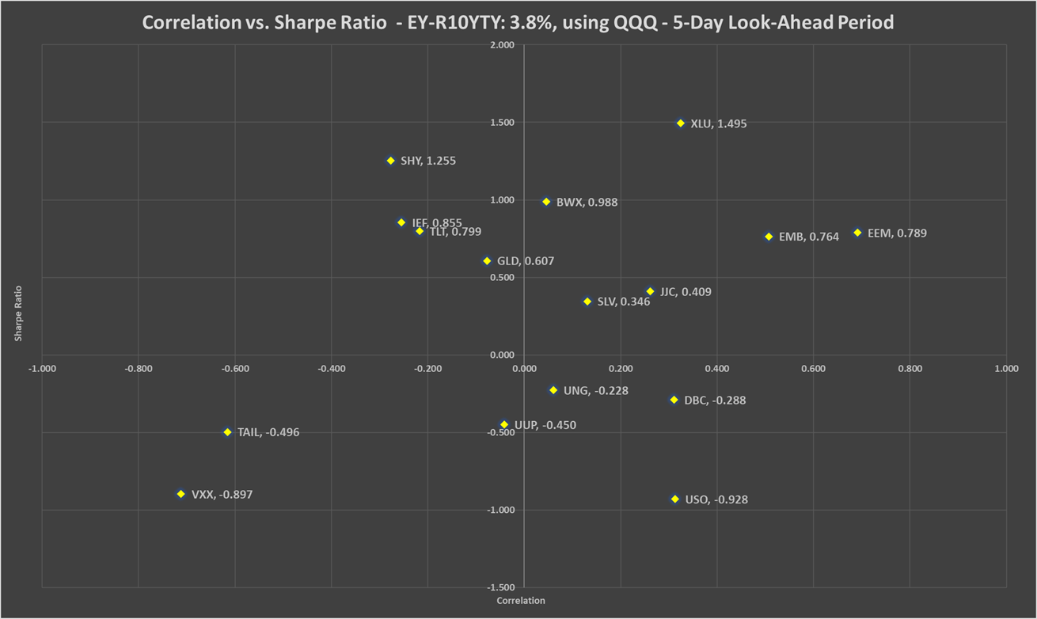

Table 65: Correlation, beta, Sharpe ratio and recommended weights of hedges - EY-R10YTY: +3.8% - 5-day look-ahead period
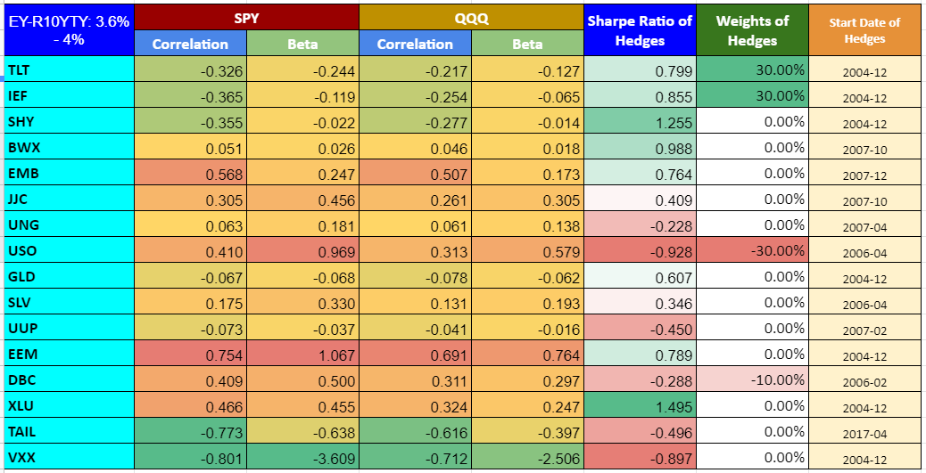

Chart 71: PV - EY-R10YTY: +3.8% - 5-day look-ahead period
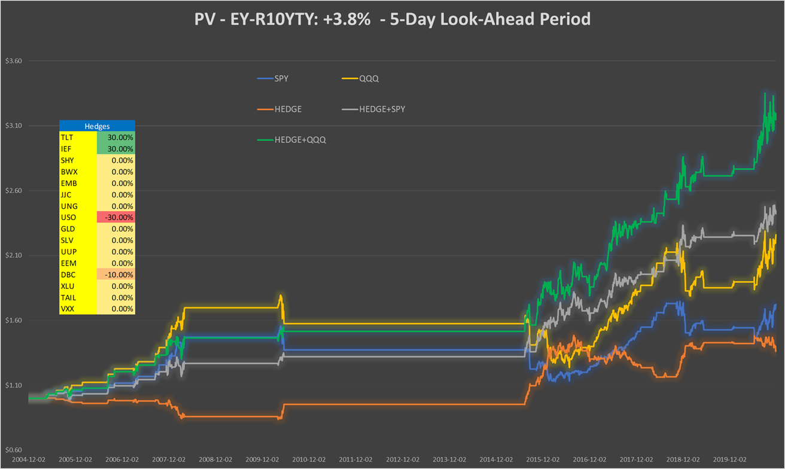

Table 66: Performance indicators with and without hedges - EY-R10YTY: +3.8% - 5-day look-ahead period
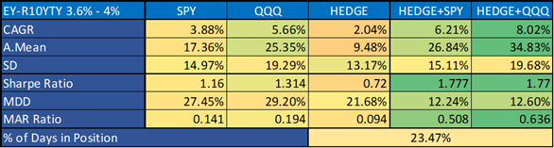

EY-R10YTY: +6.5%, 5-day look-ahead period

Chart 72a: Correlation vs. Sharpe ratio EY-R10YTY: +6.5%, using SPY - 5-day look-ahead period
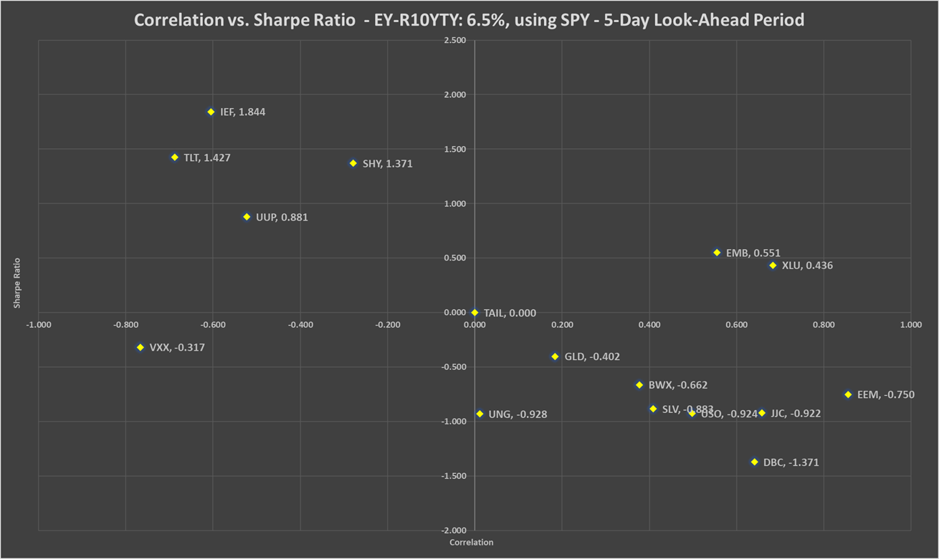
Chart 72b: Correlation vs. Sharpe ratio EY-R10YTY: +6.5%, using QQQ - 5-day look-ahead period
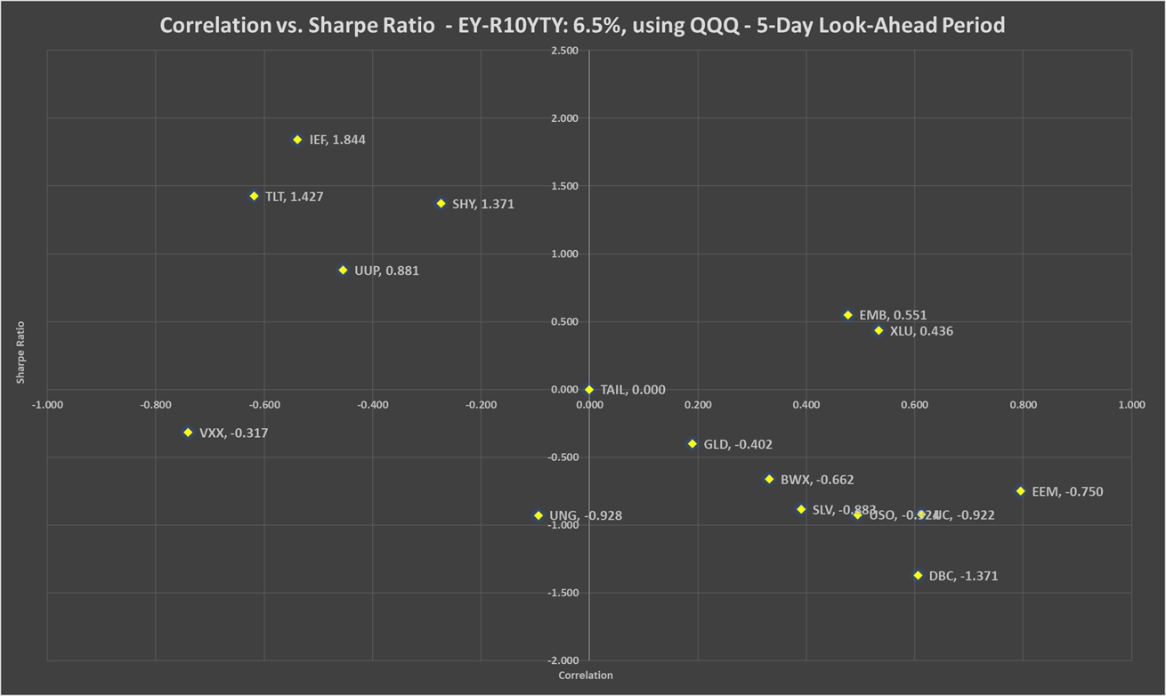
Table 67: Correlation, beta, Sharpe ratio and recommended weights of hedges - EY-R10YTY: +6.5% - 5-day look-ahead period
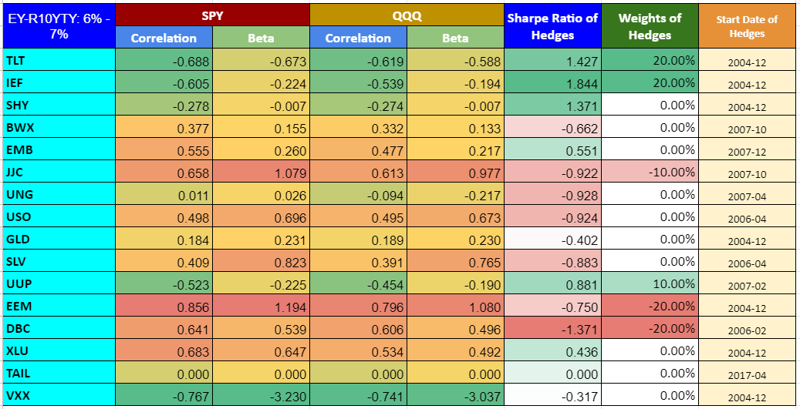

Chart 73: PV - EY-R10YTY: +6.5% - 5-day look-ahead period
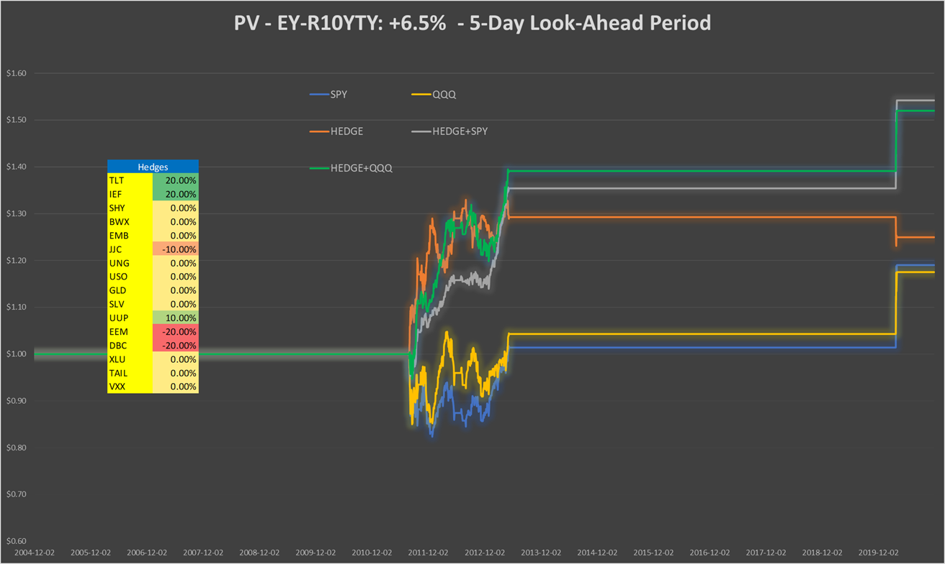

Table 68: Performance indicators with and without hedges - EY-R10YTY: +6.5% - 5-day look-ahead period
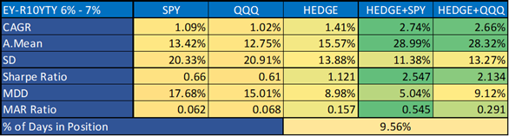

EY-R10YTY: -0.5%, 10-day look-ahead period

Chart 74a: Correlation vs. Sharpe ratio EY-R10YTY: -0.5%, using SPY - 10-day look-ahead period
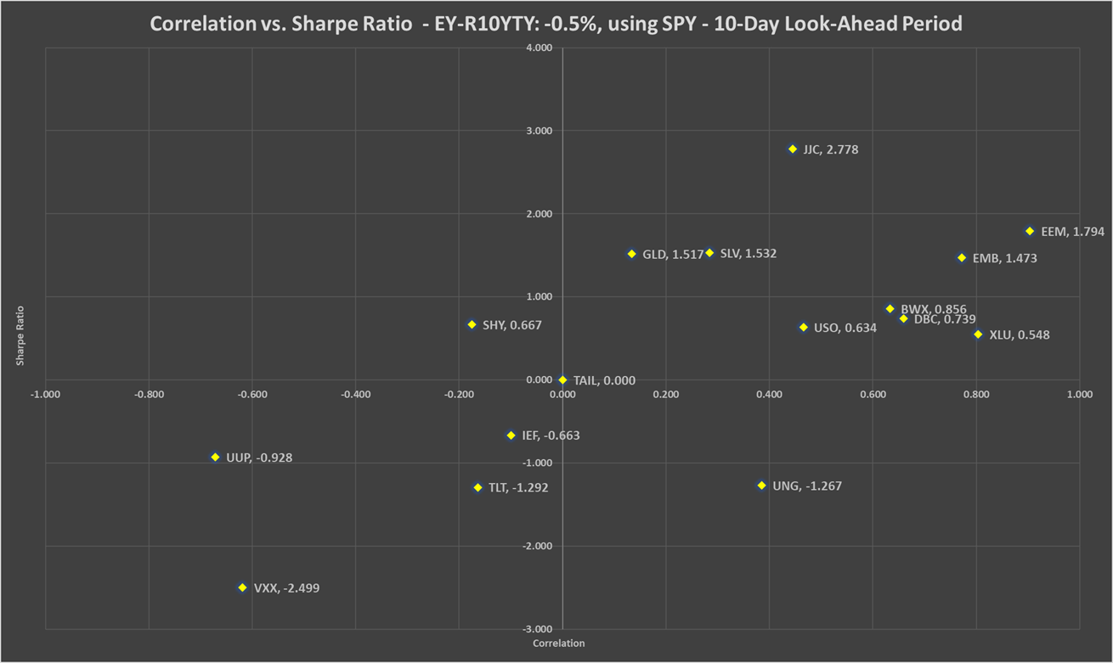

Chart 74b: Correlation vs. Sharpe ratio EY-R10YTY: -0.5%, using QQQ - 10-day look-ahead period
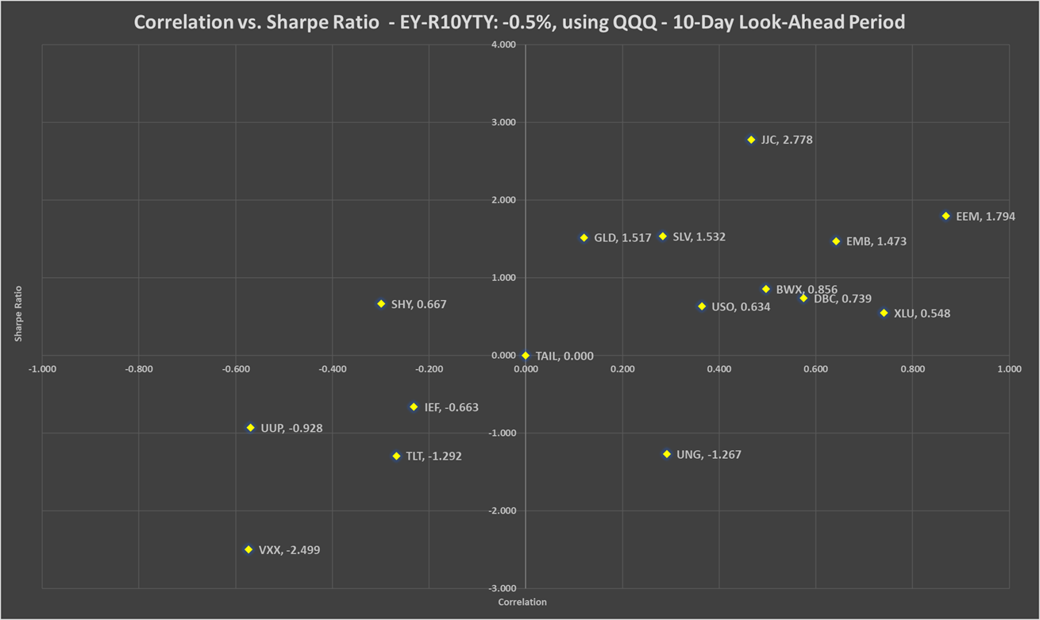

Table 69: Correlation, beta, Sharpe ratio and recommended weights of hedges - EY-R10YTY: -0.5% - 10-day look-ahead period
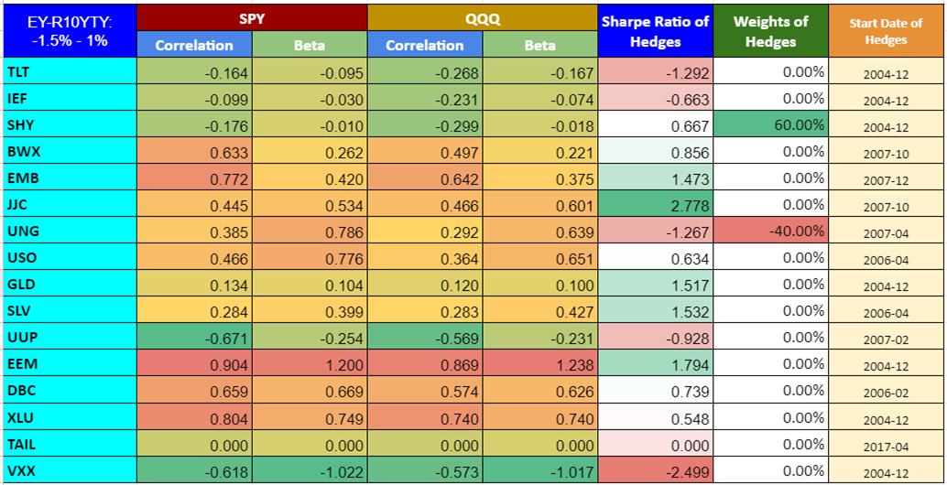

Chart 75: PV - EY-R10YTY: -0.5% - 10-day look-ahead period
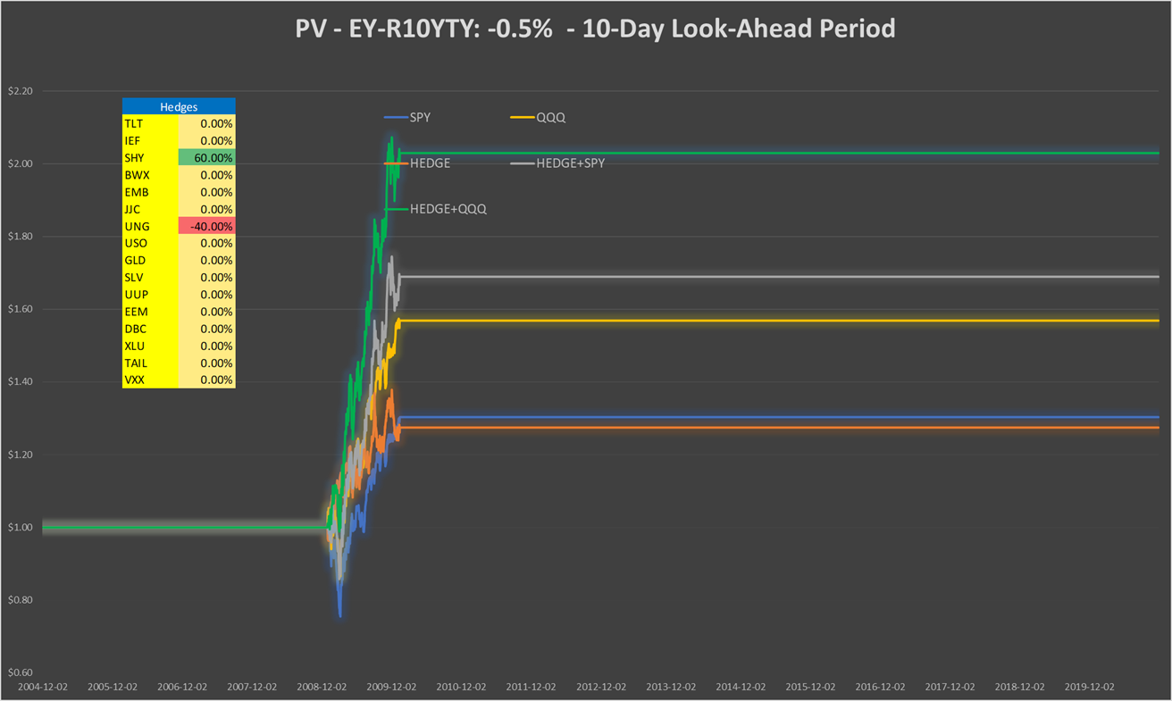

Table 70: Performance indicators with and without hedges - EY-R10YTY: -0.5% - 10-day look-ahead period
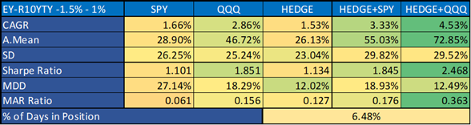

EY-R10YTY: +3.8%, 10-day look-ahead period

Chart 76a: Correlation vs. Sharpe ratio EY-R10YTY: +3.8%, using SPY - 10-day look-ahead period
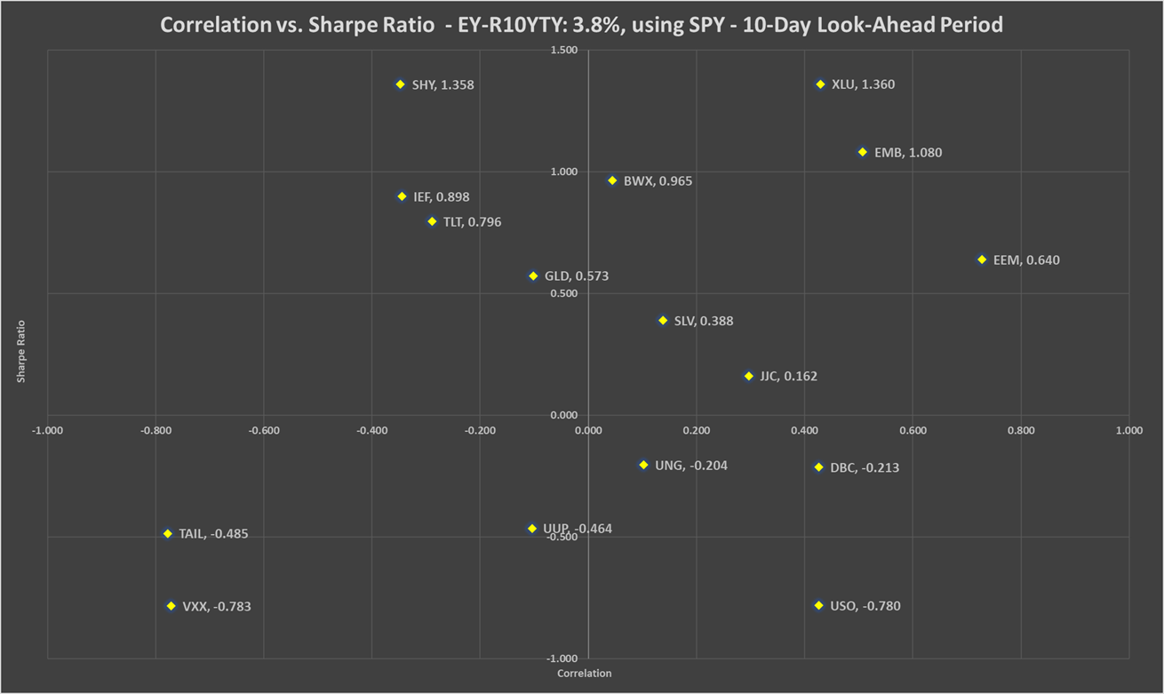
Chart 76b: Correlation vs. Sharpe ratio EY-R10YTY: +3.8%, using QQQ - 10-day look-ahead period
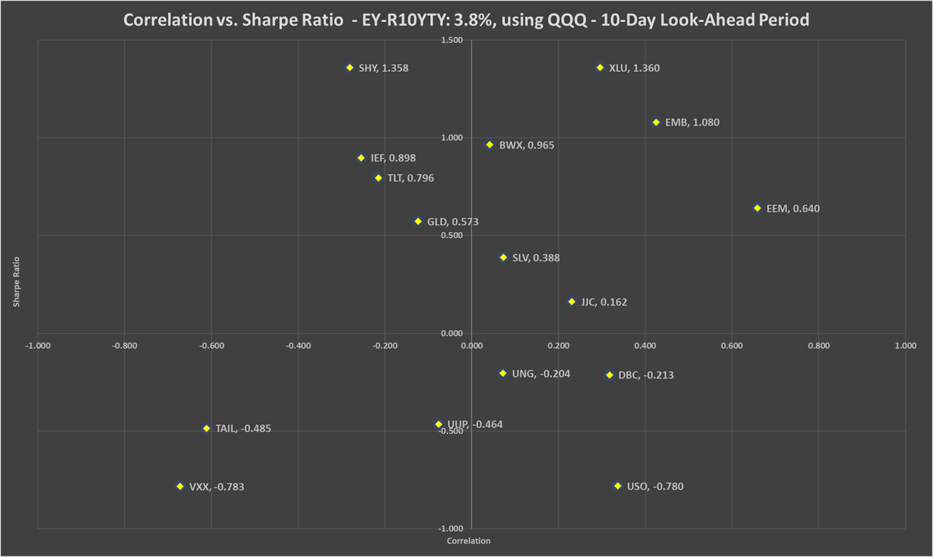
Table 71: Correlation, beta, Sharpe ratio and recommended weights of hedges - EY-R10YTY: +3.8% - 10-day look-ahead period
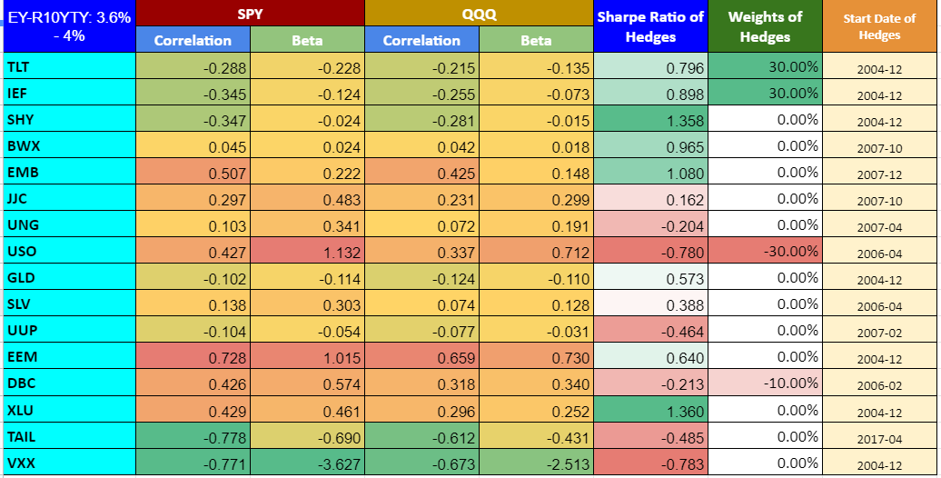

Chart 77: PV - EY-R10YTY: +3.8% - 10-day look-ahead period
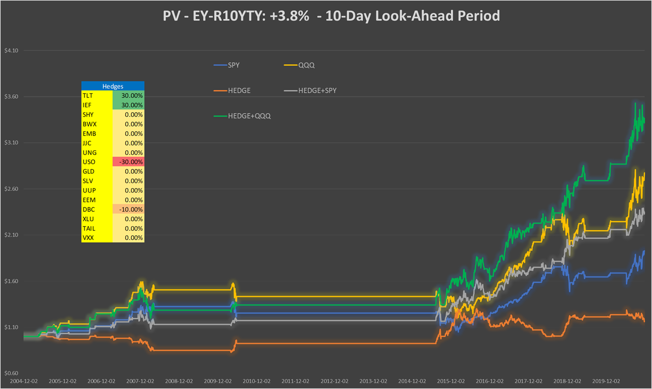

Table 72: Performance indicators with and without hedges - EY-R10YTY: +3.8% - 10-day look-ahead period
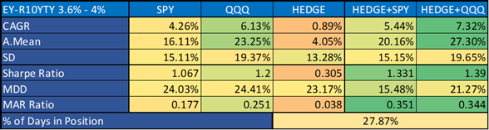

EY-R10YTY: +6.5%, 10-day look-ahead period

Chart 78a: Correlation vs. Sharpe ratio EY-R10YTY: +6.5%, using SPY - 10-day look-ahead period
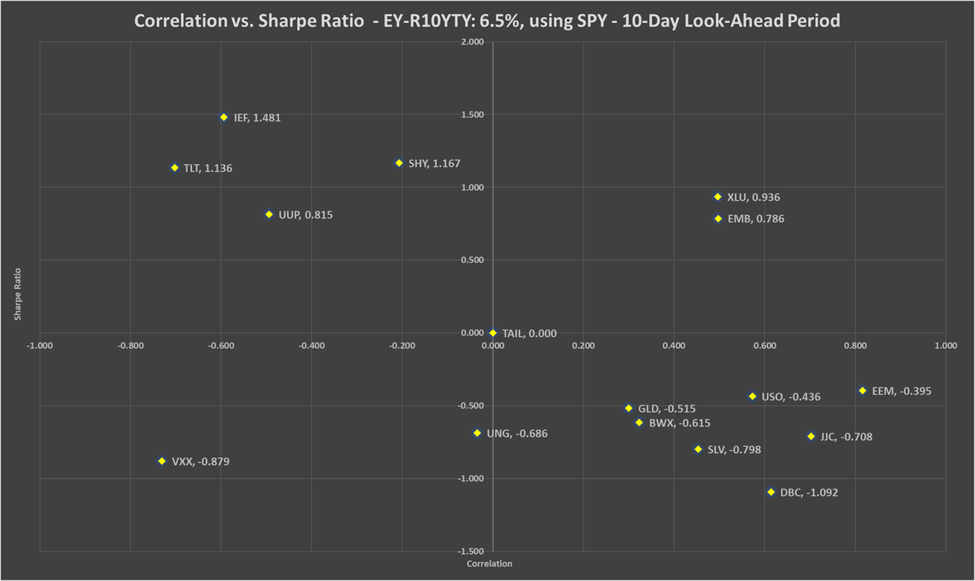

Chart 78b: Correlation vs. Sharpe ratio EY-R10YTY: +6.5%, using QQQ - 10-day look-ahead period
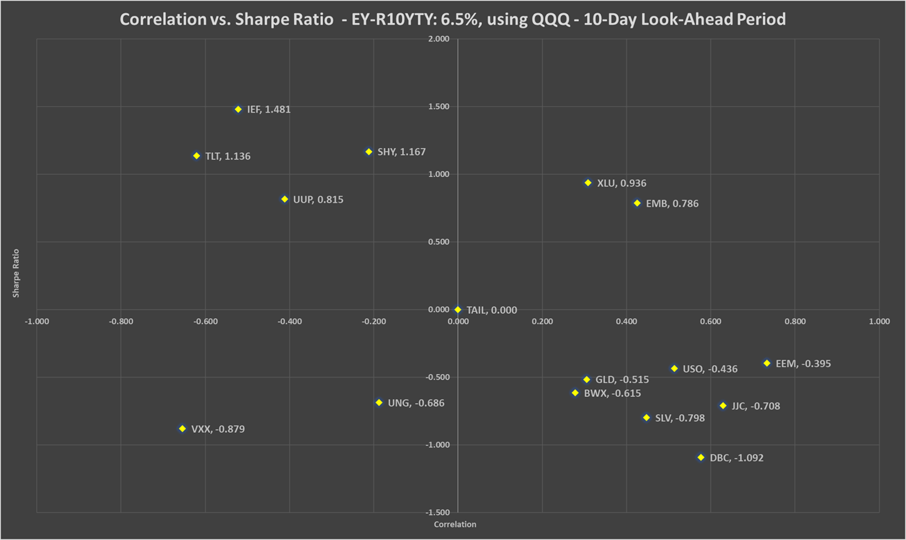

Table 73: Correlation, beta, Sharpe ratio and recommended weights of hedges - EY-R10YTY: +6.5% - 10-day look-ahead period
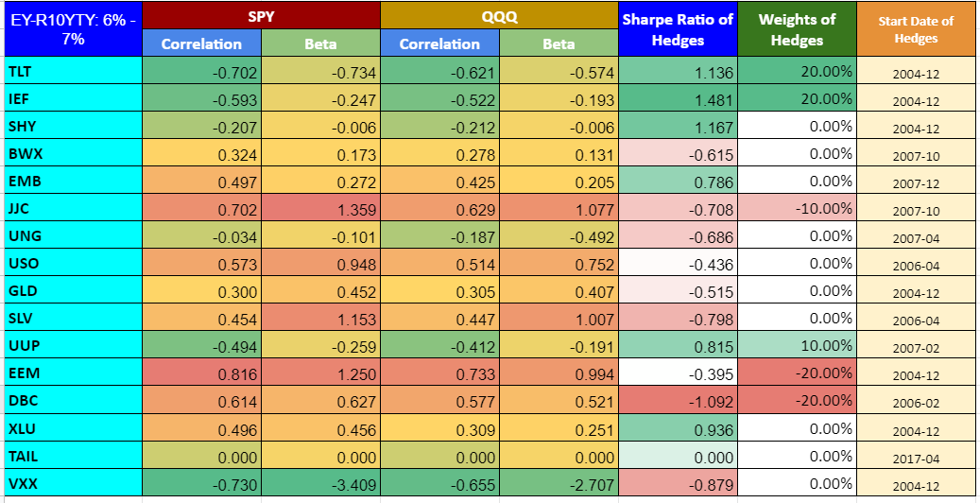

Chart 79: PV - EY-R10YTY: +6.5% - 10-day look-ahead period
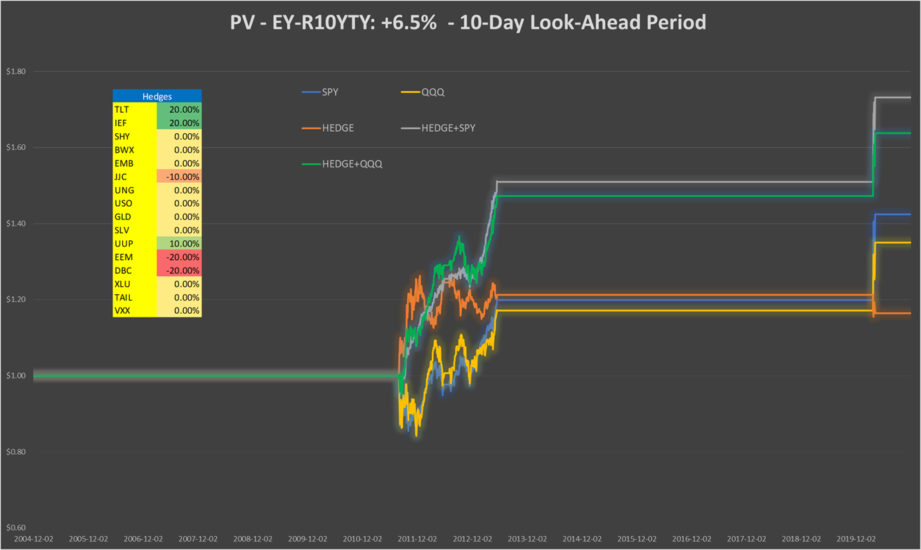

Table 74: Performance indicators with and without hedges - EY-R10YTY: +6.5% - 10-day look-ahead period
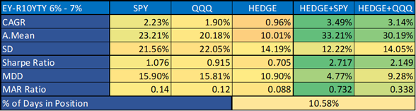

EY-R10YTY: -0.5%, 1-month look-ahead period

Chart 80a: Correlation vs. Sharpe ratio EY-R10YTY: -0.5%, using SPY - 1-month look-ahead period
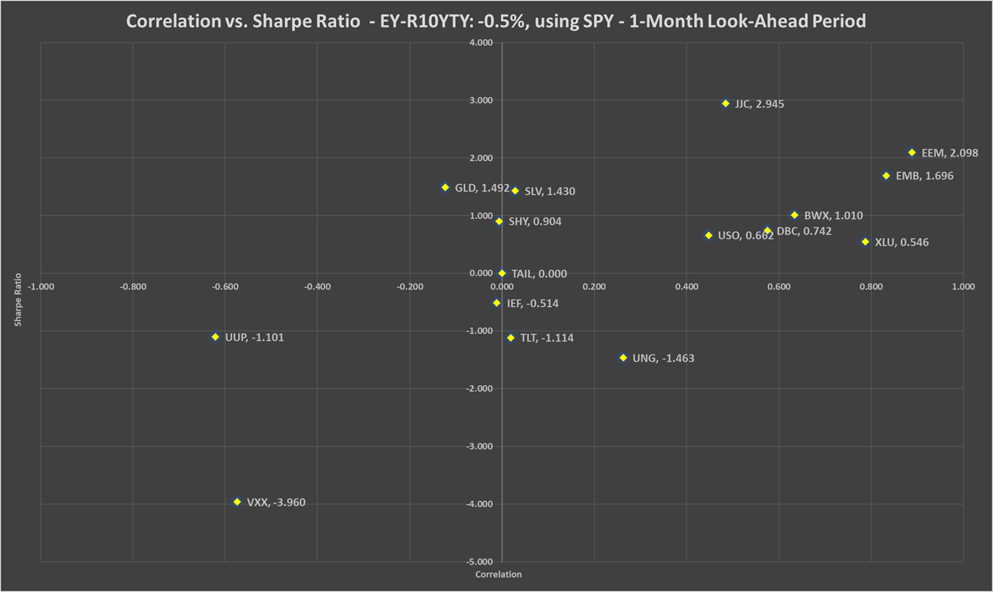
Chart 80b: Correlation vs. Sharpe ratio EY-R10YTY: -0.5%, using QQQ - 1-month look-ahead period
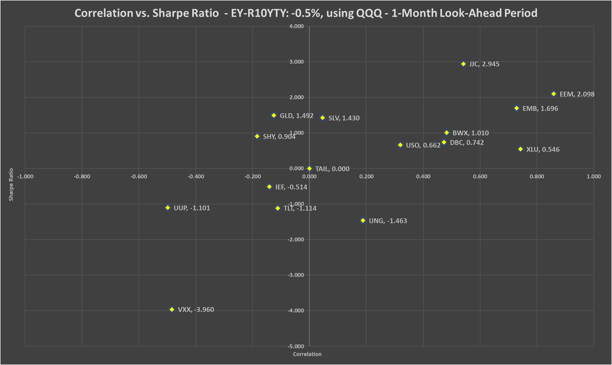
Table 75: Correlation, beta, Sharpe ratio and recommended weights of hedges - EY-R10YTY: -0.5% - 1-month look-ahead period
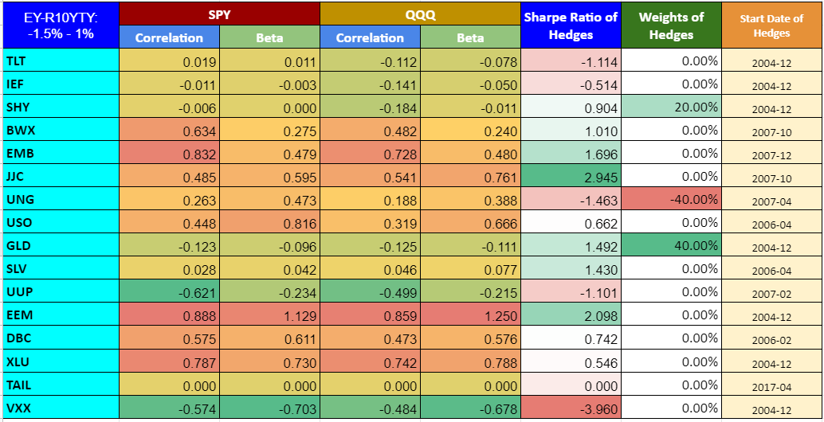
Chart 81: PV - EY-R10YTY: -0.5% - 1-month look-ahead period
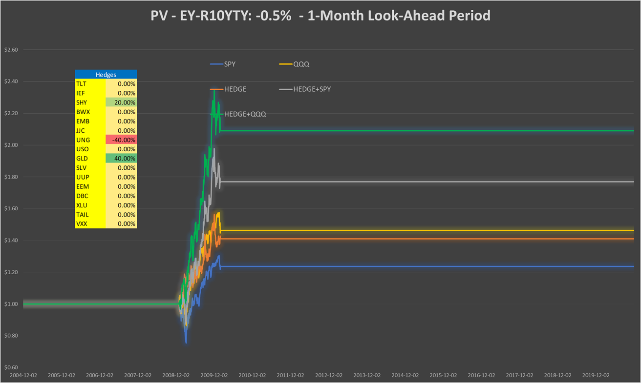

Table 76: Performance indicators with and without hedges - EY-R10YTY: -0.5% - 1-month look-ahead period
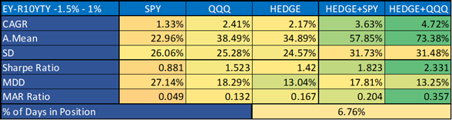

EY-R10YTY: +3.8%, 1-month look-ahead period

Chart 82a: Correlation vs. Sharpe ratio EY-R10YTY: +3.8%, using SPY - 1-month look-ahead period
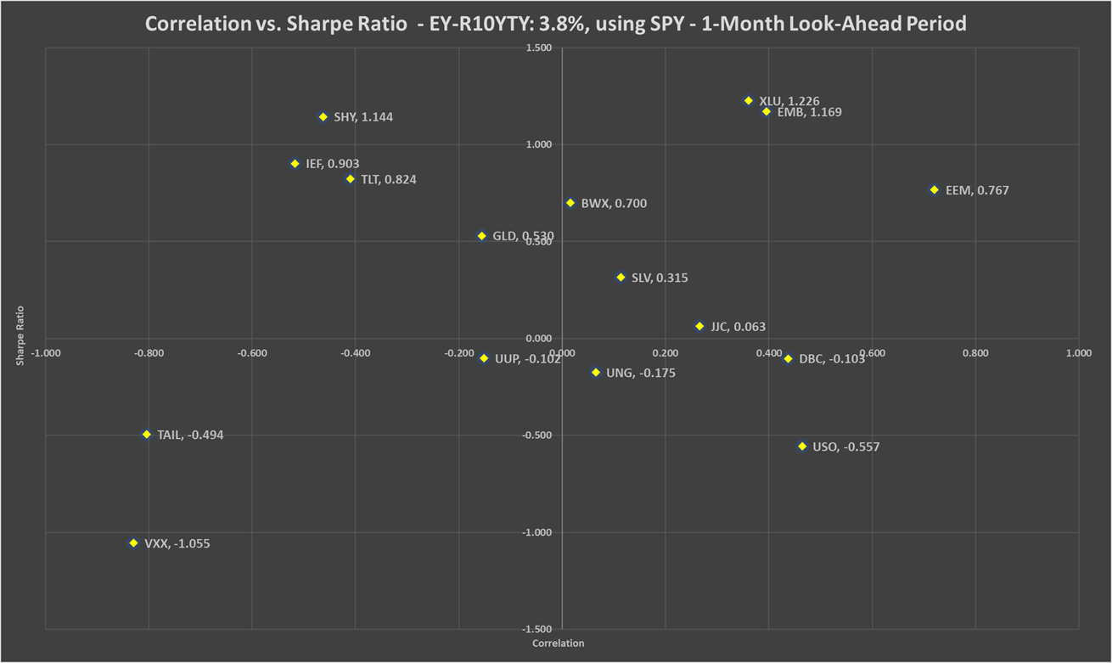

Chart 82b: Correlation vs. Sharpe ratio EY-R10YTY: +3.8%, using QQQ - 1-month look-ahead period
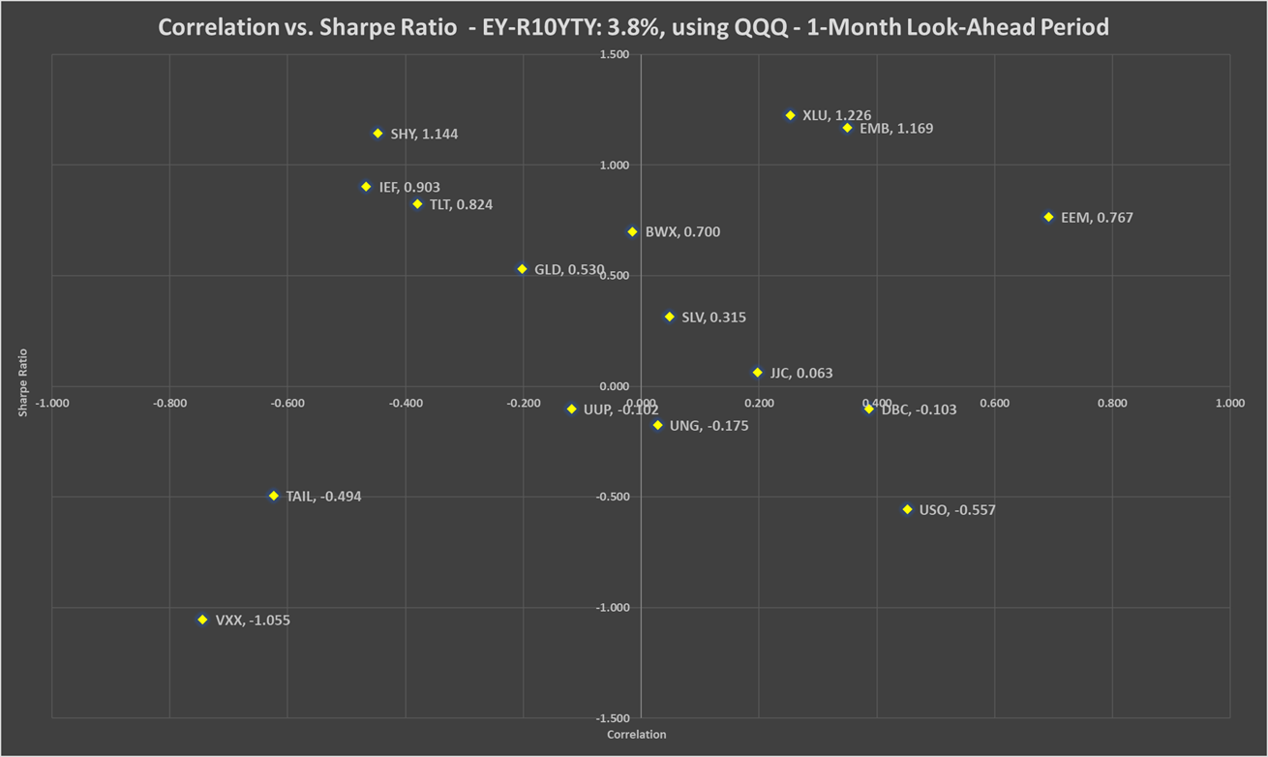

Table 77: Correlation, beta, Sharpe ratio and recommended weights of hedges - EY-R10YTY: +3.8% - 1-month look-ahead period
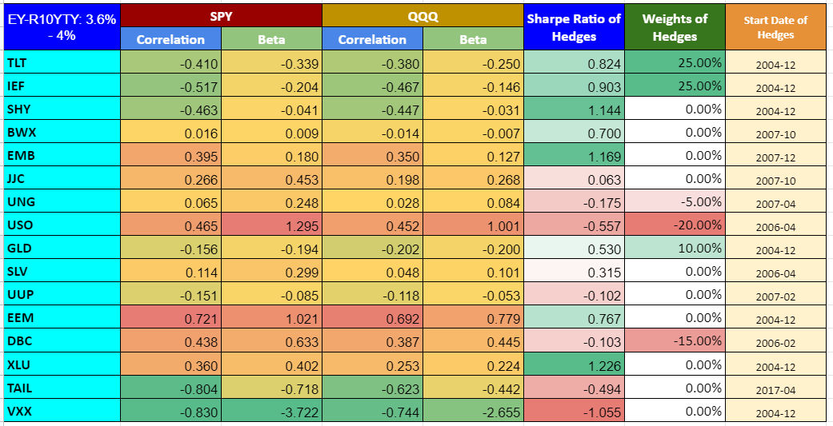

Chart 83: PV - EY-R10YTY: +3.8% - 1-month look-ahead period
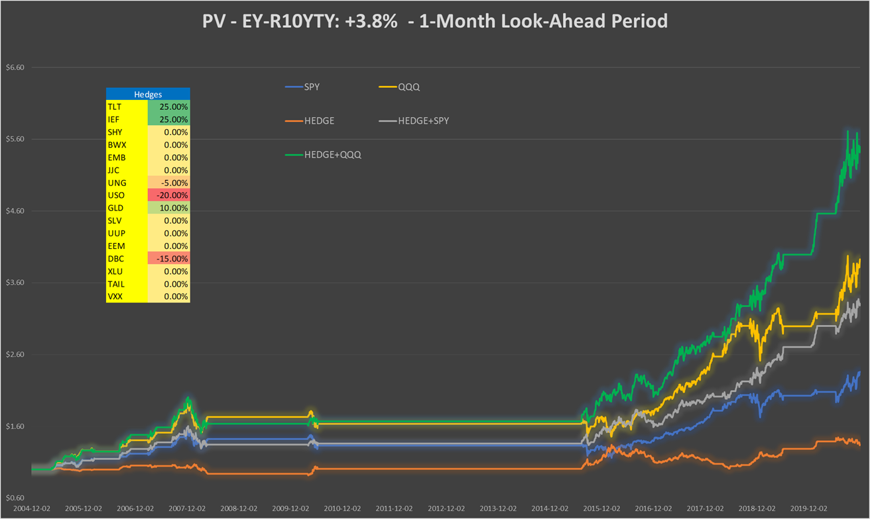

Table 78: Performance indicators with and without hedges - EY-R10YTY: +3.8% - 1-month look-ahead period
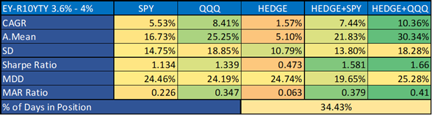

EY-R10YTY: +6.5%, 1-month look-ahead period
Chart 84a: Correlation vs. Sharpe ratio EY-R10YTY: +6.5%, using SPY - 1-month look-ahead period
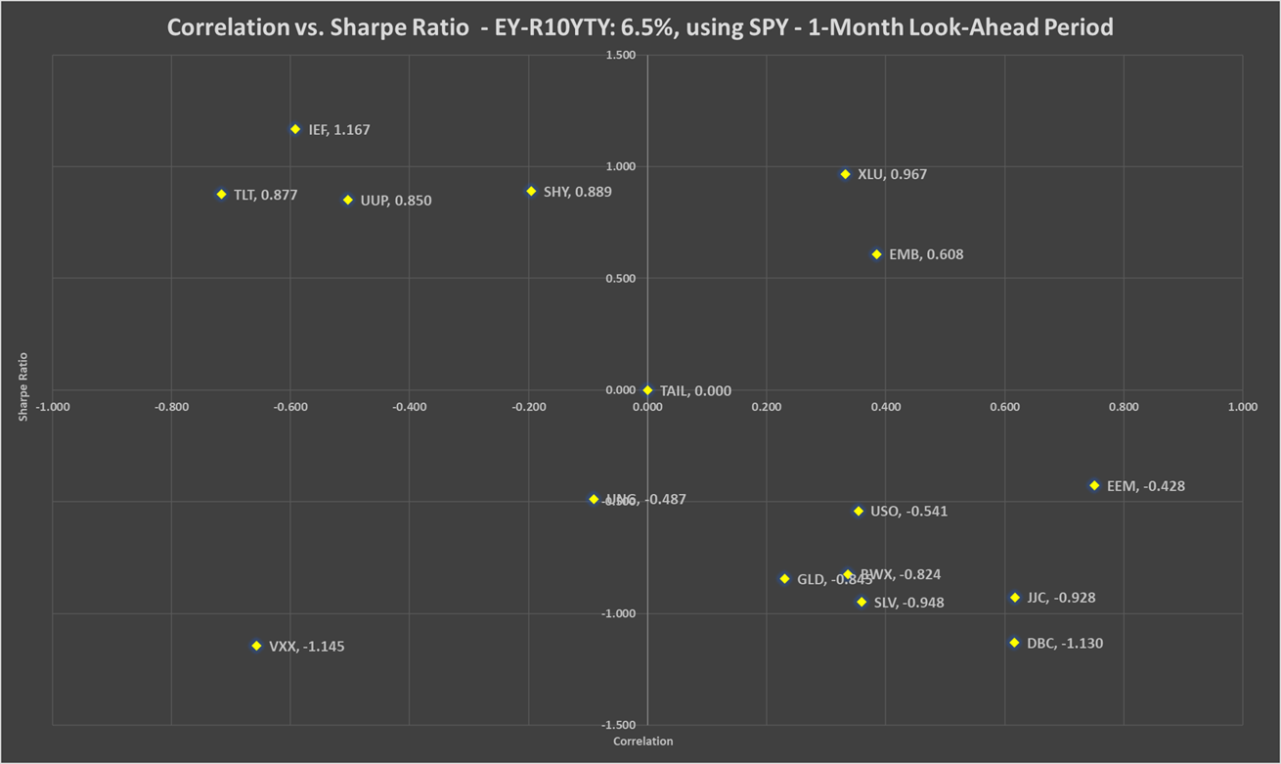
Chart 84b: Correlation vs. Sharpe ratio EY-R10YTY: +6.5%, using QQQ - 1-month look-ahead period
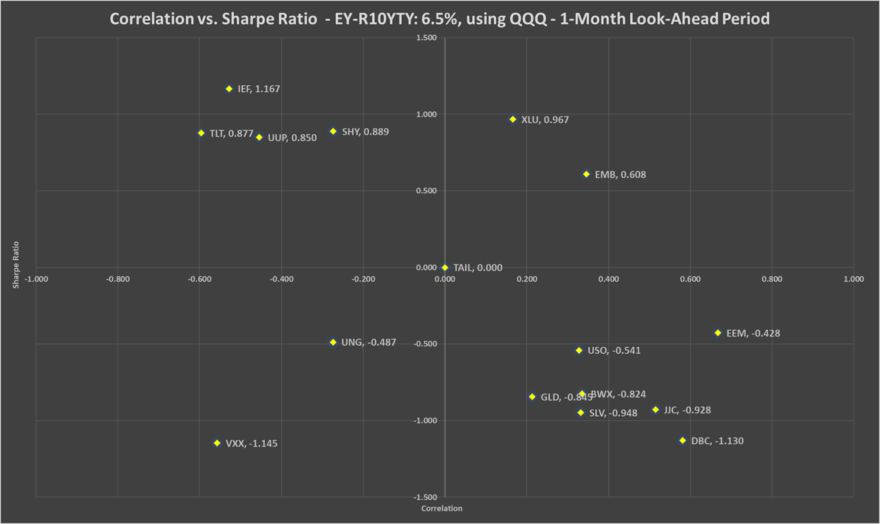

Table 79: Correlation, beta, Sharpe ratio and recommended weights of hedges - EY-R10YTY: +6.5% - 1-month look-ahead period
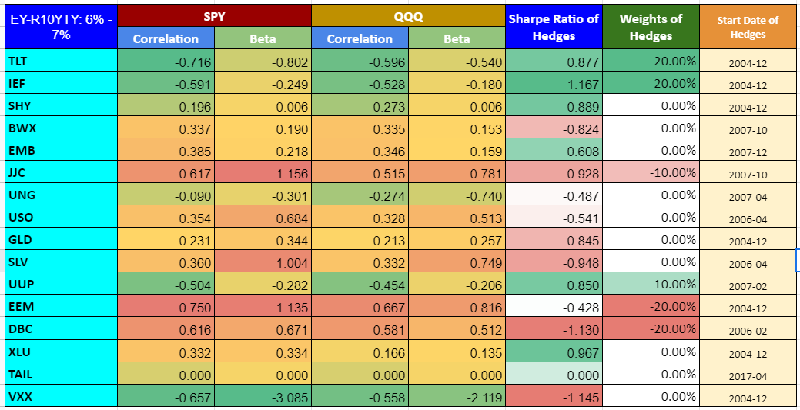
Chart 85: PV - EY-R10YTY: +6.5% - 1-month look-ahead period
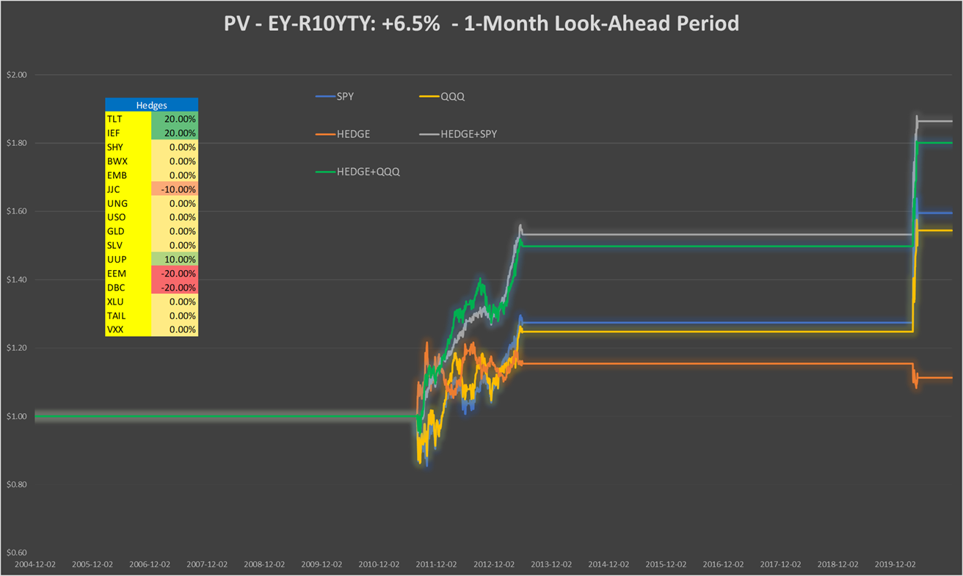

Table 80: Performance indicators with and without hedges - EY-R10YTY: +6.5% - 1-month look-ahead period
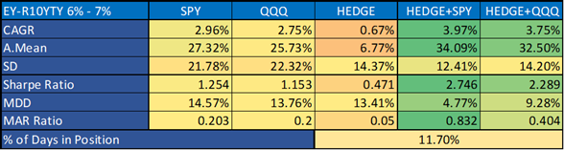

Conclusions

In this study, the SnifferQuant Hedge-Selection Method was presented. This method also takes into account the quality of the hedges (correlation to the portfolio) and their cost (using Sharpe ratio as a negative proxy of cost). Our SnifferQuant Market Strength Indicator (SQ MSI), CPI-SQ3M Inflation Indicator, the GDP and the Excess Earnings Yield (S&P500 Earnings Yield vs. Real 10-Year Treasury Yield) have been used as the proxy of the current market environment.

We are happy with the results, and recommend using our online tool for hedge selection and weighting in all market situations.

Appendix
