Dr. George Antal

3D Click Limited

c/o Suite 431, 28 Old Brompton Road, London SW7 3SS

**Calendar Seasonality in QQQ and in S&P500**

**Motivation** **1**

**Background** **2**

Jay Kaeppel: Seasonal Stock Market Trends 2

Jeff Hirsch: End of the Best Six Months. Should You Sell in May? 3

Jeff Hirsch: Santa Claus Rally Indicator Starts Today! 4

Ryan Detrick: Here Comes Sell In May 5

Ryan Detrick: Do You Believe In The Santa Claus Rally? 7

‘CXO’: “Sell in May” Over the Long Run 9

‘CXO’: U.S. Stock Market Performance by Intra-year Phase 14

Charlie Bilello: The Most Bullish Time of the Year 16

Michael Batnick: Tis The Season 16

Michael Batnick: The Fool’s Gold 18

Nick Maggiulli: When Things Stop Working 19

**Results** **22**

“Sell in May and Go Away” 24

Santa Claus Rally 30

January Effect 33

September Effect 35

**Conclusions** **37**

# **Motivation**

*“****Seasonality is a characteristic of a time series*** *in which the* ***data experiences regular and predictable changes that recur every calendar year****. Any* ***predictable fluctuation or pattern that recurs or repeats over a one-year period is said to be seasonal****.“[1]*

*“Why do stock indices rise at the turn of the year, while falling in August and September? Isn’t that just a coincidence? – Questions such as this arise whenever seasonality is studied for the first time. Because only if the stock market’s past movements were seasonally based and not coincidental,* ***can seasonality then be considered a usable forecasting instrument****.*

*In fact* ***there are reasons behind seasonal trends****. Stock funds try to improve year-end results by pushing stock prices higher. Other reasons include interest payments in December, because year-end bond coupon payments flow partially into the stock market. The holiday effect (Christmas, year-end) also plays a role. Moods are generally positive and many investors use the time-off to make investment decisions. These factors influence the course of prices and lead to seasonal patterns, which investors can utilise.*

***Each part of the year has a unique reason for its seasonal tendency, for example the rally in autumn or the market strength at the beginning of the year****.”[2]*

In this study, we **present some old beliefs about seasonality** and **describe the operation of our own seasonality calculator through related case studies**.

# 

# 

# 

# **Background**

First, in this chapter, **some thoughts on seasonality** will be presented by **analysts we appreciate**. After that, in the next chapter, **some case study** will be shown. It will be visible **how the well known seasonality patterns can change over the decades**. In our opinion, **no seasonality pattern can last forever, sooner or later Mr. Market (hedge funds, institutional investors etc.) exploits its potential, leading to the death of the pattern**. Furthermore, none of the studies and articles deal with **the question of volatility** when presenting seasonal returns. Our new calculator also eliminates this shortcoming using the **VIX index**.

In the current study, we deal only with ‘seasonal periods’ (e.g. ‘Sell in May’, Santa Claus Rally, January- or September effect), relating to a given calendar period. Days around Holidays, turn of the month etc. are the subject of our next study.

## Jay Kaeppel: Seasonal Stock Market Trends[3]

*“Within nature there exists an undeniable ebb and flow. The sun unfailingly rises in the east and then sets in the west. The moon revolves around the earth. The earth revolves around the sun. Trees grow leaves in the spring. The leaves turn bright colors in the fall and by winter they have fallen to the ground. The following spring the same routine starts anew. Most people go to bed at night and rise in the morning. What happens in nature affects humans, not only physically, but also emotionally and psychologically. Thunderstorms instill fear and a desire to seek shelter. A blizzard triggers an urge in people to hunker down and cocoon at home under a blanket. A dark, dreary day has an undeniable tendency to cause many people to experience—for lack of a better word—a funk, a state of mind in which virtually nothing feels right. But, ah, a warm, sunshine-filled day can all by itself suddenly make everything feel right. For millennia, the human race was a slave to the sun. And, to this day, people are drawn to bask in its glow. To better understand this phenomenon, picture opening the drapes first thing in the morning on a cloudless, sunny day following three days of dreary weather. Suddenly, almost magically, the darkest of moods seem to melt away.*

*So, what does any of this have to do with the stock market? The heart of the matter comes down to the fact that humans are a creature of habit and repetition, and that many, many things in life happen on a cyclical basis. And these cycles can greatly affect the way a person thinks or feels.”*

*“SEASONAL TRENDS TO CONSIDER*

*It is common for an individual approaching the topic of seasonal trends in the financial markets for the first time to be skeptical. And this is understandable. Still, what may surprise many readers is the sheer number of identifiable trends. In the following …, we will delve into and analyze a wide array of seasonal stock market trends. In each case, we will strive to identify specific and objective rules for using each trend. In other words, for virtually every trend we discuss, there will be a specific day of the week, month, or year designated as a buy date and another specific date designated as a specific sell date. The beauty of designating specific dates in this manner is that this process enables us to track the performance of a given strategy on a consistent and objective basis. This, in turn, enables us to make intelligent decisions about the potential usefulness of any particular seasonal trend and to compare the strength and consistency of performance for any given trend.*

*…*

***Sell in May and Go Away***

*The title of Chapter 8—“Sell in May and Go Away”—has been a popular adage among stock market participants for many years. The notion that the stock market has performed much better during the six-month period starting in November versus the six months starting in May was first popularized by seasonal analysis founding father Yale Hirsch. In Chapter 8, we will analyze and update this theory in great detail. The idea of having a set time of each year to be in the market and a set time to be out of the market is an alluring one to many investors. If it were possible to maximize our profitability by simply making one round-turn trade every year—and to make more money in the process than we might by using a simple buy-and-hold approach—this would, in theory, relieve a lot of concerns and would greatly reduce the amount of time, effort, and energy that we might otherwise feel compelled to exert on stock market analysis. So, is it really that simple? I will leave you to read Chapter 8 to decide for yourself. … One other departure in Chapter 8 from the data that is analyzed throughout most of this book is an analysis of the action of the Nasdaq market from October through the following June. This time frame has tended to witness some very favorable price action—with several notable exceptions. So, we will take a closer look at the Nasdaq price action during this time frame and try to identify the potential benefits as well as the inherent risks. … In this chapter we will try to identify whether there are certain periods within the May through October period that are most likely to experience negative price action. Knowing when not to be in the market can sometimes be almost as useful as knowing when to be in the market, as this can allow an alert investor to act in advance to preserve capital until such time that the market turns favorable once again. We will examine the once-vaunted summer rally and take a very close look at both the action of the stock market during the month of September and an interesting—and potentially important—anomaly regarding the month of October.”*

Interested readers can read this chapter on page 237 of the pdf (page 219 of the book) linked [here](https://www.snifferquant.com/gyantal/Incode/books2020/SeasonalKaeppel,%202009.pdf).

In addition to his book, Jay has even written articles on his blog about the sell in may phenomenon over the years, e.g. [Strategy Civil War – Sell in May vs. 60/40](http://jayonthemarkets.com/2018/05/08/strategy-civil-war-sell-in-may-vs-6040/), [The ‘Alpha Dow’ Sell in May Method](http://jayonthemarkets.com/2018/03/16/the-alpha-dow-sell-in-may-method/), [‘Sell in May’ Article #2,106](http://jayonthemarkets.com/2015/05/04/sell-in-may-article-2106/).

## 

## Jeff Hirsch: End of the Best Six Months. Should You Sell in May?[4]

(Posted April 23, 2019)

*“It’s hard for us not to be associated with “Sell in May” and we welcome the opportunity it provides to discuss seasonality and share our analysis and our evidence-based, time-tested and historically-proven “Best Six Months Switching Strategy.” First of all we do not simply Sell in May and go away. And we don’t sell anything until we get a technical confirmation from our MACD Seasonal Sell Signal. When we do get that MACD Sell Signal we will sell some positions in our Tactical Seasonal Switching Strategy Portfolio and pick up some bond positions as well as other portfolio maneuvers.*

*Because of the elevated level of risk that has been historically observed during the “Worst Six Months” of the year and its historically tepid returns, reducing long exposure and developing a defensive strategy is the approach we take in the Almanac Investor Stock and ETF Portfolios. We do not merely “sell in May and go away.” Instead we take some profits, trim or outright sell underperforming stock and ETF positions, tighten stop losses and limit adding new long exposure to positions from sectors that have a demonstrated record of outperforming during the period.*

*For those with a lower risk tolerance or a desire to take a break from trading, the “Worst Months” are a great opportunity to unwind longs and move into the relative safety of cash, Treasury bonds, gold and/or some combination of. Preservation of capital may be more important than growth and with historical averages and frequency of gains reduced; the “Worst Six Months” are a good time to simply step aside if you prefer. August, September and/or October have provided some excellent buying opportunities in recent years and could do the same again this year.*

*Sure the market got slammed in the first two months (November-December) of the Best Six Months in 2018, nothing’s perfect. It happens. We stuck it out, did not panic at the December 24 low and road the recovery rally. The history of the Best Six/Worst Six Months is undeniable and it still works. There have been off periods throughout its history. The full history is on our website and in the Almanac. But here are a couple of graphs to illustrate.*

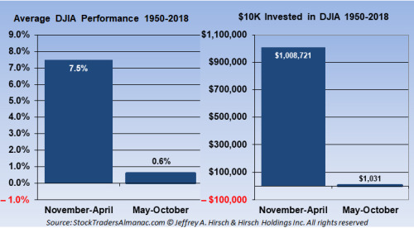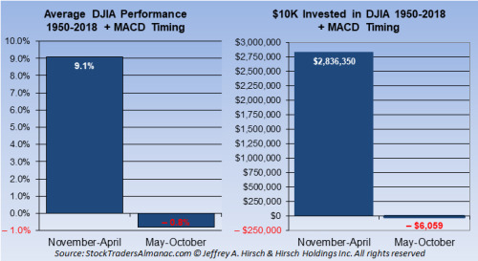

*With new highs today for S&P 500 and NASDAQ, our positive January Indicator Trifecta and historical Pre-Election year strength this Worst Six Months or “Sell in May” period is likely to be mild, but as we highlighted yesterday May has been known for rough patches as are the of the Worst Four Months (July-October) as you can see in the chart in yesterday’s post.”*

## Jeff Hirsch: Santa Claus Rally Indicator Starts Today![5]

(Posted December 27, 2021)

*“The first indicator to register a reading in January is the Santa Claus Rally created by Yale Hirsch in 1972. The seven-trading day period begins today December 27 and ends with the close of trading on January 4. Normally, the S&P 500 posts an average gain of 1.3%. The failure of stocks to rally during this time has tended to precede bear markets or times when stocks could be purchased at lower prices later in the year. As the late, great Yale Hirsch’s famous line states, “If Santa Claus should fail to call, bears may come to Broad and Wall.”*

*We are bullish for year end 2021, but the market faces several obstacles for next year. Valuations are rich and year-over-year economic and corporate comparisons will be nowhere near as easy as this year versus the 2020 pandemic numbers. While the Fed has promised patience and a slow pace it is now rather clear that they will be making a concerted effort to remove quantitative easing by mid-year and begin slowly raising rates. Plus it promises to be a contentious midterm election year and the battle against Covid-19 may linger.*

*The results of the Santa Claus Rally along with the other two components of our “January Indicator Trifecta,” the first five days of January and the full month January Barometer (also created by Yale Hirsch in 1972) will help solidify our outlook for next year.*

*When all three are up the S&P 500 has been up 90% of the time, 28 of 31 years, with an average gain of 17.5%. When any of them are down the year’s results are reduced and when all three are down the S&P was down 3 of 8 years with an average loss of -3.6% with bear markets in 1969 (-11.4%), 2000 (-10.1%) and 2008 (-38.5%), flat years in 1956 (2.6%), 1978 (1.1%) and 2005 (3.0%). Down Trifecta’s were followed by gains in 1982 (14.8%) and 2016 (9.5%).*

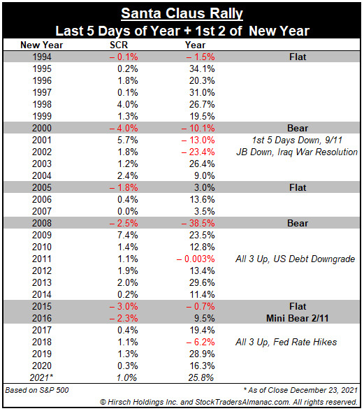

## 

## Ryan Detrick: Here Comes Sell In May[6]

(Posted April 30, 2021)

*““The sun was warm but the wind was chill. You know how it is with an April day. When the sun is out and the wind is still, you’re one month on in the middle of May.” American Poet Robert Frost*

*One of the best known investment axioms is to “sell in May and go away.” This is largely because the six months from May through October have historically been some of the weakest months of the year for stocks. As you can see below, the next six months have tended to be on the weak side.*

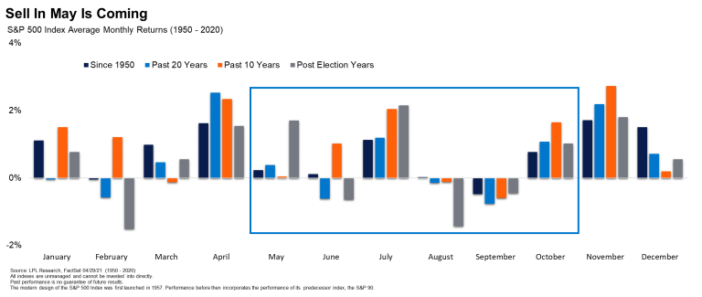

*As shown in the LPL Chart of the Day, the next six months have indeed been the worst six months of the year, up only 1.7% on average. To add insult to injury, we are leaving the six most bullish months of the year. In fact, the S&P 500 Index is set to gain close to 30% during these most bullish six months, one of the best six-month gains ever.*

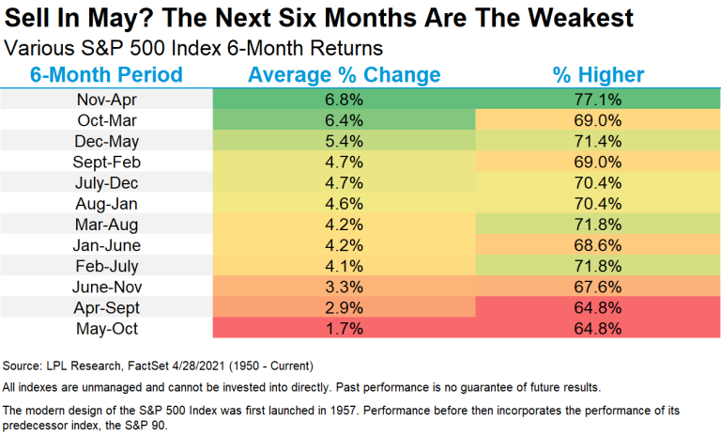

*“Stocks are up more than 87% from the March lows, suggesting a well-deserved pullback during these troublesome months is quite possible,” explained LPL Financial Chief Market Strategist Ryan Detrick. “But with an accommodative Fed, fiscal and monetary policy, along with an economy that is opening faster than nearly anyone expected, we’d use any weakness as an opportunity to add to positions.”*

*Here’s the catch, isn’t there always a catch? Stocks have actually been higher during these worst months of the year eight of the past ten years.”*

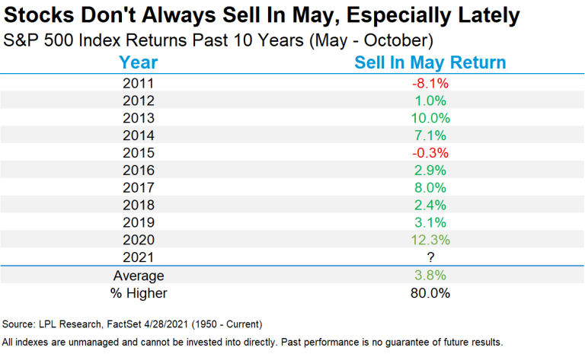

## 

## Ryan Detrick: Do You Believe In The Santa Claus Rally?[7]

(Posted December 22, 2021)

*““If Santa should fail to call, bears may come to Broad and Wall.” —Yale Hirsh*

*December is widely known as one of the best months of the year for stocks, but most don’t realize that the majority of the gains happen in the second half of the month.*

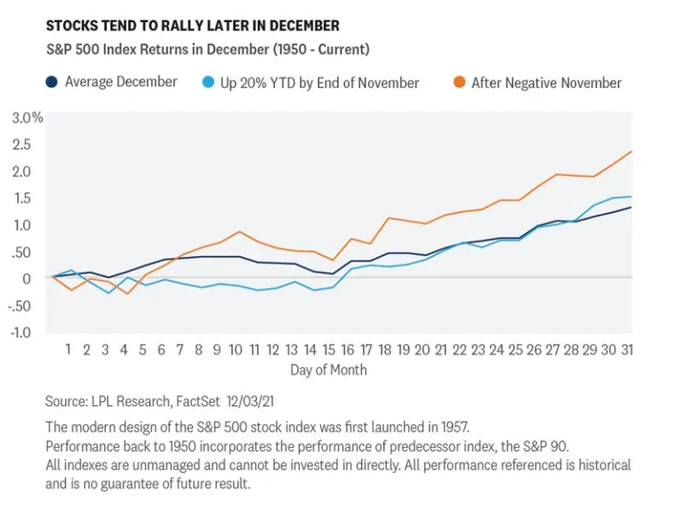

*Equity strength at this time of the year is widely known as the Santa Claus Rally, but the term is somewhat misunderstood. Discovered in 1972 by Yale Hirsch, creator of the Stock Trader’s Almanac (carried on now by his son Jeff Hirsch), the real Santa Claus Rally is the final five trading days of the year and first two trading days of the following year, not just December. In other words, the official Santa Claus Rally is set to begin Monday, December 27. Fun trivia this is the latest any Santa Claus Rally can start and the latest it has started in 11 years.*

*So how likely are these seven trading days to be higher? Well, there isn’t a single seven-day combo out of the full year that is more likely to be higher than the 78.9% of the time we've seen previously during the Santa Claus Rally. Additionally, these seven days are up an average of 1.33%, which is the third-best seven-day combo of the year. Do you believe it yet?*

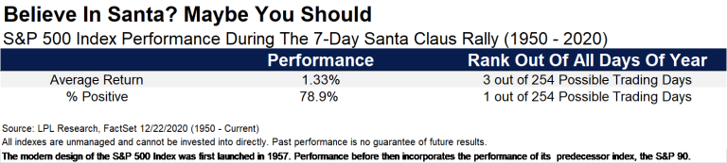

*“Why are these seven days so strong?” asked LPL Financial Chief Market Strategist Ryan Detrick. “Whether optimism over a coming new year, holiday spending, traders on vacation, institutions squaring up their books—or the holiday spirit—the bottom line is that bulls tend to believe in Santa.”*

*The LPL Chart of the Day illustrates how the Santa Claus Rally has performed since 2000. Usually these seven days are higher, which leads to strength in January and beyond. But what stands out to us is that the times Santa didn’t come, January was lower each time. Now do you believe?*

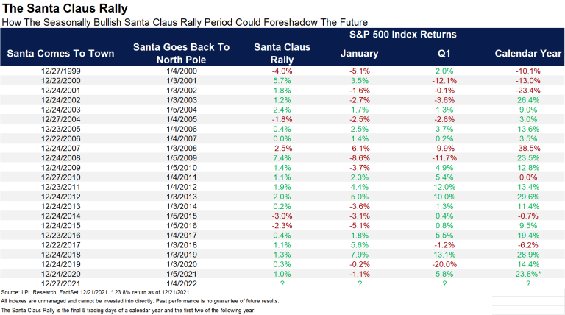

*Let’s take a closer look at what happens when things don’t go according to plan. Remember, Yale Hirsch told us, “If Santa should fail to call, bears may come to Broad and Wall.” This is because the New York Stock Exchange is at the corner of Broad and Wall Streets.*

*Going back to the mid-1990s, there have been only six times Santa failed to show in December. January was lower five of those six times, and the full year had a solid gain only once (in 2016, but a mini-bear market early in the year). “Considering the bear markets of 2000 and 2008 both took place after one of the rare instances that Santa failed to show makes believers out of us. Should this seasonally strong period miss the mark, it could be a warning sign,” explained Santa Claus believer Detrick.*

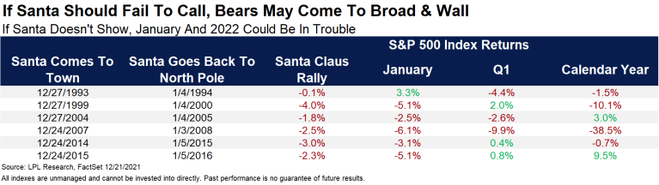

## 

## 

## ‘CXO’: “Sell in May” Over the Long Run[8]

(Posted May 13, 2021)

*“Does the conventional wisdom to “Sell in May” (and “Buy in November”, hence also the term “Halloween Effect”) work over the long run, perhaps due to biological/psychological effects of seasons (*[*Seasonal Affective Disorder*](https://www.cxoadvisory.com/calendar-effects/mirror-image-seasonality-for-stocks-and-treasuries/)*)? To check, we turn to the* [*long run dataset of Robert Shiller*](http://www.econ.yale.edu/~shiller/data/ie_data.xls)*. This data set includes monthly levels of the S&P Composite Index,* [*calculated as the average of daily closes during the month*](http://www.econ.yale.edu/~shiller/data.htm)*. We split the investing year into two half-years (seasons): May through October, and November through April. Using S&P Composite Index levels, associated dividend yields and contemporaneous long-term interest rates (comparable to yields on 10-year U.S. Treasury notes) from the Shiller dataset spanning April 1871 through April 2021, we find that:*

*Modeling assumptions for this backtest are complex, as follows:*

* *Funds switch between stocks and cash at the ends of April and October. Since the monthly level is the average daily close for the month, this assumption may be a little optimistic or pessimistic.*
* *Since December 1958 cash earns half the annualized yield on* [*6-month U.S. Treasury bills*](https://fred.stlouisfed.org/series/TB6MS)*. Before that date, we estimated 6-month return on cash as half the long-term interest rate in the Shiller dataset, less 1.35%, which is the average monthly difference between* [*10-year U.S. Treasury note yield*](http://research.stlouisfed.org/fred2/series/GS10) *and 6-month U.S. Treasury bill yield since December 1958 (the first month both series are available). This estimate of the term spread may not be representative of pre-1950s data.*
* *Dividends accrue while in stocks, with one half of the annual yield paid during each 6-month interval and frictionless reinvestment. This dividend smoothing assumption could bias results, and frictionless reinvestment of dividends is optimistic.*
* *Baseline trading frictions for moving in and out of the S&P 500 Composite Index are a constant 1% over the sample period. This assumption is crude, as indicated in* [*“Trading Frictions Over the Long Run”*](https://www.cxoadvisory.com/big-ideas/trading-frictions-over-the-long-run/)*. Given the challenges of constructing a portfolio from index components during much of the sample period, this baseline value may be optimistic. For recent data, it is pessimistic. However, trading is infrequent.*
* *Ignore the tax implications of trading.*

*The limitations of these assumptions, as well as those of the interpolation methods used in constructing the early part of the source dataset, make this analysis more of a conceptual test than a strategy backtest.*

*The following chart compares on a logarithmic scale cumulative values of $1.00 initial investments for three strategies using baseline assumptions over the entire sample period:*

1. *Buy and Hold – buy and hold stocks.*
2. *May-Oct / Cash – in stocks (cash) during May-October (November-April).*
3. *Nov-Apr / Cash – in stocks (cash) during November-April (May-October).*

*In support of conventional wisdom, being in stocks during November-April mostly beats being in stocks during May-October (terminal value $1,697 versus $92). However, buying and holding the index substantially outperforms both seasonal strategies.*

*For another perspective, we compare average 6-month return statistics for the strategies.*

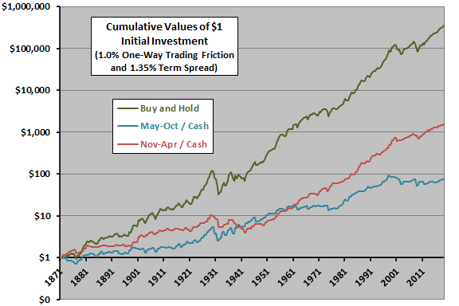

*The next chart compares the average 6-month total returns for the three strategies using baseline assumptions over the entire sample period, with one standard deviation variability range. Average total return for being in stocks during November-April is higher and volatility of returns is lower than for being in stocks during May-October, supporting conventional wisdom. Buying and holding stocks generates a substantially higher average total return, but with much higher volatility.*

*Rough 6-month net* [*Sharpe ratios*](https://en.wikipedia.org/wiki/Sharpe_ratio) *are 0.30, 0.04 and 0.15 for buy-and-hold, May-October and November-April, respectively.*

*For a different perspective on time variation of returns, we look at average seasonal total returns by decade.*

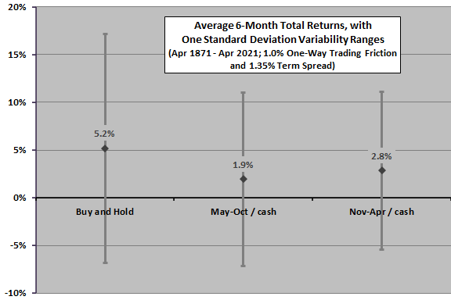

*The next chart compares average 6-month total returns by decade using baseline assumptions (the last decade partial only). Based on this metric, being in stocks during November-April beats being in stocks during May-October for 11 of 15 decades, consistently after 1950. However, poor returns for being in stocks during November-April for the 1930s and 1940s weaken the argument for a reliable biological/psychological explanation of seasonal returns.*

*How sensitive are results to modeling assumptions?*

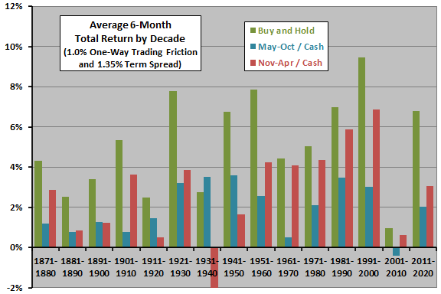

*The next chart compares* [*compound annual growth rates*](https://en.wikipedia.org/wiki/Compound_annual_growth_rate) *(CAGR) for the three strategies over the sample period using different sets of assumptions. Results consistently confirm the superiority of being in stocks during November-April as compared to being in stocks during May-October. However, only by ignoring both trading frictions and dividends does being in stocks only during November-April become competitive with buying and holding stocks.*

*Is “Sell in May” sensitive to market state (bull or bear)?*

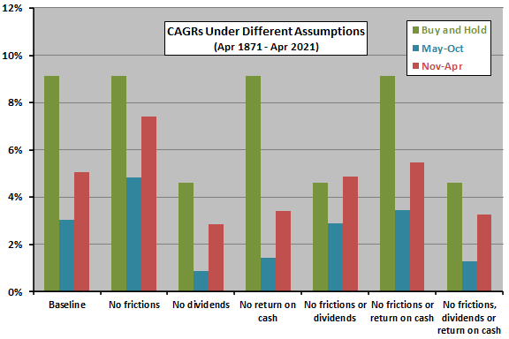

*The final two charts summarize average 6-month total returns for two ways of prospectively defining bull and bear states for the U.S. stock market:*

1. *For the upper chart, the market is in a cyclical bull state when the prior-month S&P 500 Composite Index is above (below) its 12-month simple moving average (SMA12) and in a cyclical bear state when the index is below its SMA12.*
2. *For the lower chart, the market is in a secular bull state when the prior-month S&P 500 Composite Index is above its 60-month simple moving average (SMA60) and in a secular bear state when the index is below its SMA60.*

*Results for SMA12 indicate that most of the advantage of November-April over May-October occurs during bear markets. For SMA60, most of the advantage occurs during bull markets.*

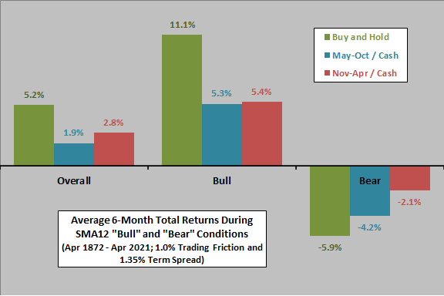

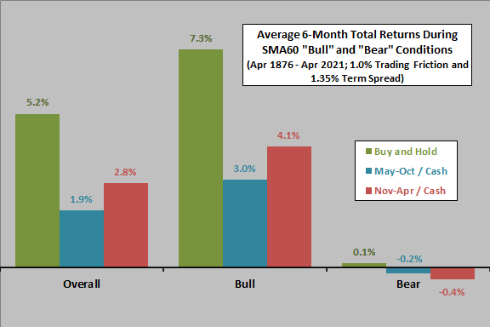

*In summary, evidence from rough modeling over the long run suggests that U.S. stocks generally do better during November-April than during May-October, but (with reasonable assumptions about return on cash, dividends and trading frictions) buying and holding stocks easily outperforms a “Sell in May” market timing strategy.*

*Cautions regarding findings include:*

* *As noted, the data set establishes monthly S&P Composite Index levels by averaging daily closes during the month, somewhat blurring seasonal effects.*
* *As noted, modeling of trading frictions and pre-1959 return on cash is crude.*
* *Ignoring taxes materially benefits an intra-year timing strategy relative to buy-and-hold.*
* *Use of an index, rather than a tradable asset, tends to overstate returns by ignoring the costs of establishing and maintaining a liquid asset.*
* *Older data may be less reliable than recent data.*

## ‘CXO’: U.S. Stock Market Performance by Intra-year Phase[9]

(Posted Jan 11, 2022)

*“The full-year Trading Calendar indicates that the U.S. stock market has three phases over the calendar year, corresponding to calendar year trading days 1-84 (January-April), 85-210 (May-October) and 211-252 (November-December). What are typical stock market returns and return variabilities for these phases? Using daily S&P 500 Index closes from the end of December 1927 through December 2021, we find that:*

*The following chart summarizes average S&P 500 Index returns by phase over the entire sample period, two sub-periods with breakpoints at the end of 1980, and even (election) and odd (non-election) years. Results generally confirm the conventional wisdom that stock market performance tends to be relatively weak during the middle part of the year. An ancillary indication is that election years are relatively weak during the first part of the year.*

*What about variabilities of returns for these intra-year phases?*

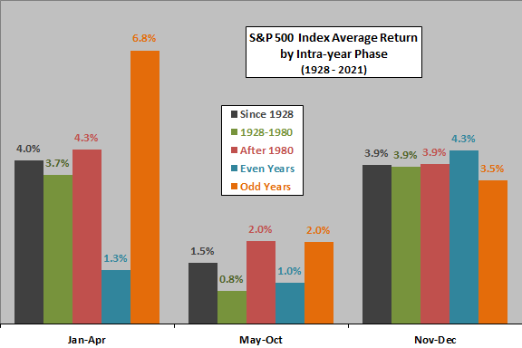

*The next chart summarizes standard deviations of S&P 500 Index returns by phase over the same sample and subsamples. Results suggest that not only does May-October (November-December) tend to be a weak (strong) phase, it also tends to be the most (least) variable.*

*What about reward-to-risk ratios?*

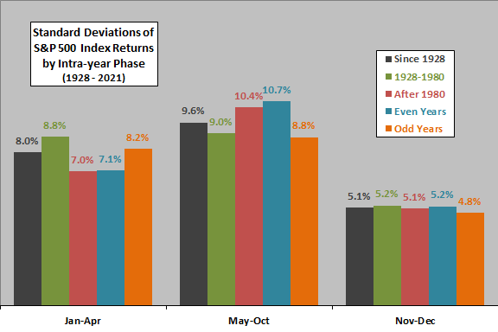

*The final chart summarizes reward-risk ratios for the S&P 500 Index by phase (average phase return divided by standard deviation of phase returns) for the same sample and subsamples. Results generally confirm the conventional wisdom that the stock market tends to perform well during the early months of the year, poorly during the middle months and very well during the final two months*.

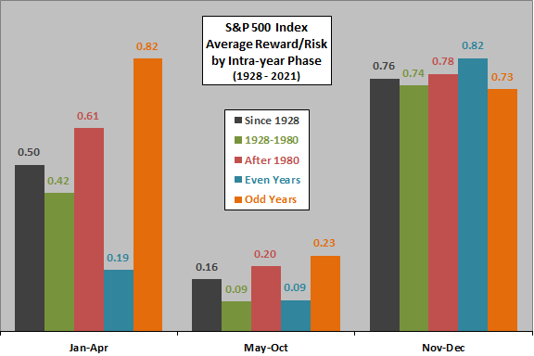

*In summary, evidence from simple tests supports the belief that the middle (end) of the year tends to be the worst (best) time to invest in U.S. stocks, and that national election years affect stock market performance.*

*Cautions regarding findings include:*

* *The analysis does not test any trading strategies, which would incur portfolio maintenance frictions.*
* *The sample and especially the subsamples are modest for reliable inference, especially in terms of market/economic conditions (such as bull/bear, and high/low inflation regimes).*

## 

## Charlie Bilello: The Most Bullish Time of the Year[10]

(Posted March 9, 2016)

*“Historically, the last 10 trading days in December have been the most bullish time of the year, with the S&P 500 gaining 1.5% on average since 1928.”*

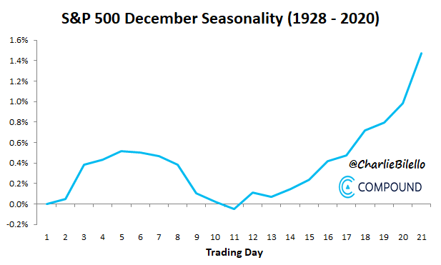

## 

## Michael Batnick: Tis The Season[11]

(Posted November 30, 2015)

*“I tend to be on the* ***skeptical side*** *when it comes to investing based on* ***seasonal trends****. I’m almost always of the mind that less is more and seasonality encourages more decision making, not less. Making changes to your portfolio based on this type of study would probably not be in your best interest when taking into consideration taxes, transaction costs, and most importantly, the cost of being wrong. While I think* ***seasonality mostly falls into the fun/interesting category****,* ***there is plenty of*** [***evidence***](http://www.amazon.com/s/?ie=UTF8&keywords=the+stock+trader%27s+almanac&tag=googhydr-20&index=aps&hvadid=21442957377&hvpos=1t1&hvexid=&hvnetw=g&hvrand=10882013453493725353&hvpone=&hvptwo=&hvqmt=b&hvdev=c&ref=pd_sl_9faulroqma_b) *to suggest otherwise so I wanted to address a couple of seasonal trends which are staring us directly in the face.*

*One of the important things that might get overlooked with seasonal studies is the sample size. Let’s take a look at the “year ending in five” as an example. At first glance, this table below looks really powerful. The S&P 500 has never experienced a negative return with a year ending in five. Furthermore, returns have been off the charts, averaging 30% compared with 12% over the entire 89-year period.*

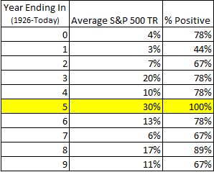

*The problem with this particular study is we have such a tiny sample size; 9 might as well be 0. Also, I don’t know when the unusually strong results were first pointed out, but I’m assuming it was well after the fact. For instance, in 2013, the Dow was up 20 Tuesday’s in a row, which was only recognized after the 19th straight positive Tuesday (tongue in cheek).*

*Look at this chart via Zero Hedge. I would put this directly into the fun but useless category.*

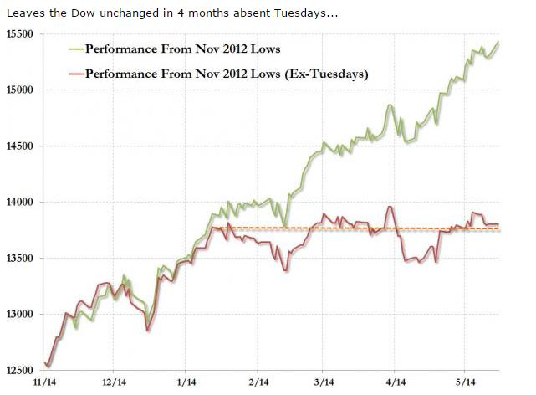

*When everyone realizes something unusual is going on and with no fundamental reason to support it, there is a good chance it’s unusual run is about to end. There is no legitimate reason why people would feel better about investing in a year ending in 5 and perhaps this “phenomenon” is running on fumes. In 2005, stocks were up 4.5% and with just a month left to go, stocks are flat for 2015.*

*Another area of the market that might have the wind at its back is the Russell 2000 (TR), which has been up the last 7 Decembers and has been positive 29 of the last 36 Decembers, or 81% of the time.*

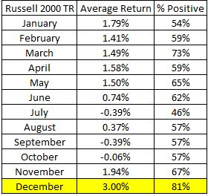

*While these returns look very enticing, again a sample size of 36 isn’t very large. Furthermore, and this is true with literally any aspect of investing, nobody is going to tell you ahead of time whether this year we’ll experience the 81% or the 19%*

***Seasonality and pattern recognition isn’t how I would choose to invest, however, what makes investing and trading so fascinating is that there are so many different ways to approach it.*** *In Sebastian Mallaby’s book “More Money than God,” portfolio manager Robert Mercer of Renaissance Technologies (founded by Jim Simons) says:*

*“Some signals that make no intuitive sense do indeed work. Indeed, it is the non-intuitive signals that often prove the most lucrative for Renaissance. The signals that we have been trading without interruption for fifteen years make no sense, Mercer explains. Otherwise someone else would have found them.”*

*So there you have it.”*

## Michael Batnick: The Fool’s Gold[12]

(Posted March 9, 2016)

*““Patterns are the fool’s gold of financial markets” Benoit Mandelbrot*

***In 1976, a group of economists discovered that stocks tended to do well in January, small cap stocks in particular.*** *Small cap stocks returned 26% in January of 1975 and an 18% in January of 1976, enough to get anybody’s attention. This came to be known as the January effect, and like many other fundamental-less anomalies, shrunk upon its discovery.*

*Below I’m showing how small cap stocks did in January until the time of the discovery, and from the time of the discovery until today. Between 1927 and 1976, small cap stocks returned 5.9% in January; from 1977 until today, they returned 1.9%.*

*From 1927-1976, small stocks beat large stocks an astounding 86% of the time; that has since shrunk to 55%, basically a coin toss.*

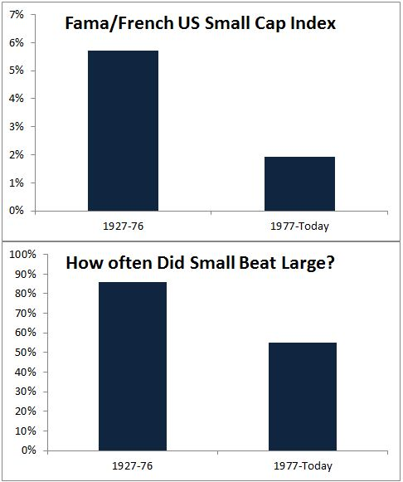

*To be fair, the 1.9% return in January since 1977 is still significantly better than the 1.1% return seen in all other months. So the January effect remains intact, but nowhere near to the extent we saw before its discovery. As Mandelbrot says,* ***“The trend has vanished, killed by its discovery.”****”*

## Nick Maggiulli: When Things Stop Working[13]

(Posted March 9, 2016)

*“When the circumstances are right, one of the best evolutionary strategies as an animal is to get larger. Larger animals have longer lifespans and are harder to kill than smaller animals. However, bigger also means more calories and typically fewer offspring, leading to slower population recovery rates. In End of the Megafauna: The Fate of the World’s Hugest, Fiercest, and Strangest Animals it states:*

*“On average, at any given time in the past, large species were no more likely to perish than smaller ones, and most large extinction events show no particular size bias.”*

*However, this all changed with the arrival of modern homo sapiens. Being big was actually a disadvantage because their populations couldn’t recover quickly enough to survive.*

*As* [*this graphic shows*](https://en.wikipedia.org/wiki/Megafauna#/media/File:Large_Mammals_Africa_Australia_NAmerica_Madagascar.svg)*, the more time megafauna had to co-evolve with humans, the longer they were able to adapt and survive while also staying large. This explains why the largest animals on Earth are currently found in Africa or the deep oceans, places that had humans for a long period of time or few humans whatsoever. One study ran simulations and estimated that the median time to extinction during the pre-historic era after the arrival of humans was 895 years.* ***Getting larger used to be an advantage, then things stopped working.***

*In the investment world,* ***stock market anomalies are the prime example of things that work for some time and then stop working****. One of my favorite such anomalies is known as* ***“The January Effect”****.* ***The January Effect is the anomaly where stock prices increase in January more than any other month in the year****. The effect was discovered by Sidney B. Wachtel and published in The Journal of Business of the University of Chicago in April 1942 under the title Certain Observations on Seasonal Movements in Stock Prices.*

*In Wachtel’s work he stated that the January Effect occurred in part because of “tax-selling” in December of the prior year, “the demand for cash”, and “the general feeling of good fellowship and cheer existing throughout Christmas Holidays,” among other things. He closed his work by stating:*

*“In the light of the scanty evidence presented here, it can readily be seen that forecasts predicated upon seasonal movements alone, ignoring completely the customary cycle and trend analysis, have an extremely high probability of success. Certainly the seasonal curve is well worth watching when formulating investment policy.”*

*However, Wachtel’s prediction could not have been more wrong.*

*From January 1927 through March 1942, the January Effect existed as Wachtel described and was statistically significant (using a KS test). Over this period, January had an average return of 2.7% while the other months had an average return of just 0.31% for the S&P 500.*

***However, from the month of its publication through the next 15 years, the January Effect disappeared.*** *From April 1942 through March 1957 (the same span of time), the month of January had an average return of 2.3% while the other months had an average return of 1.0% (the difference in their distributions was not statistically significant). Though January still had a higher return, there is no guarantee that this would be exploitable after transaction costs. As Benoit Mandlebrot so boldly proclaimed:*

*“The trend has vanished, killed by its own discovery.”*

*And Mandlebrot could not have been more right. If I look at the distribution of returns for each individual month from 1920-2017 it would look something like this:*

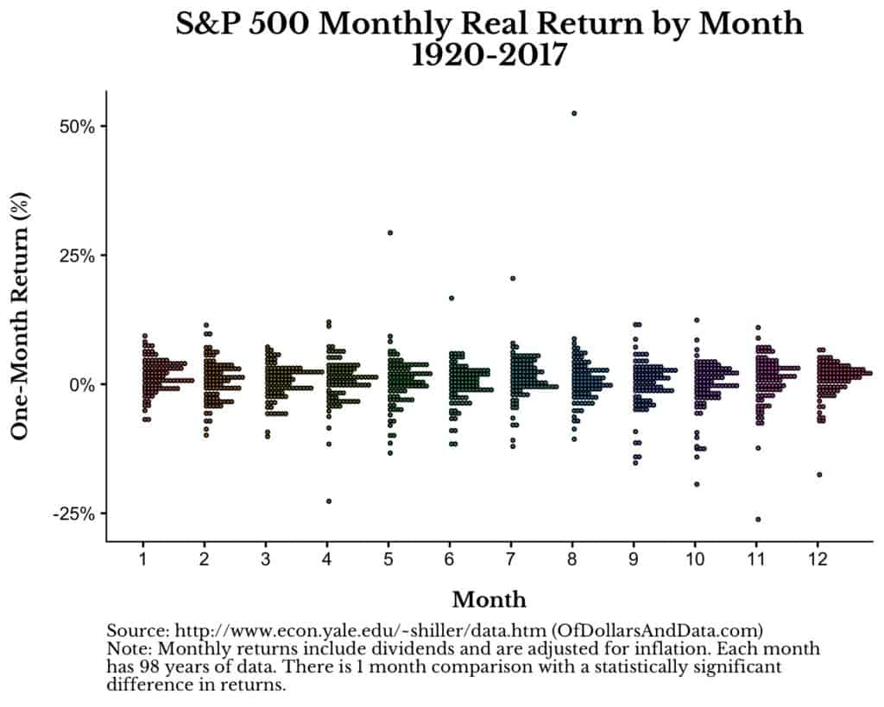

*Despite any differences we see in the distributions of returns above, if I run the KS test and compare all months for signs of seasonality, there is only 1 month pairing (January and June) that shows a statistically significant difference in returns. However, given I did 78 tests comparing different monthly pairings(i.e. Jan vs. Feb, Jan vs. March, …, Jan vs. All others, Feb vs. March, etc.), we would expect 4 of them (5%) to be statistically significant by chance alone. But, since we only observe 1 actual difference, not 4, this suggests that there is no evidence of seasonality across such a long time scale.*

*Even if we just compare January’s monthly return to all other months you might think that the January Effect existed longer than it did, but you would be wrong:*

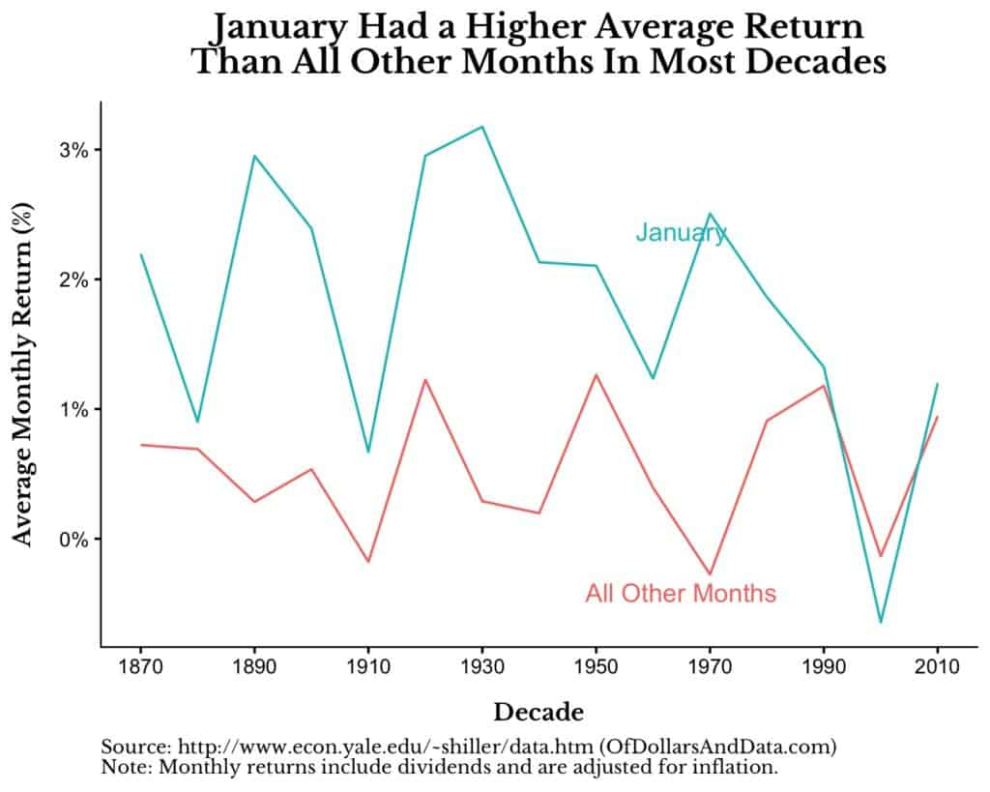

*While this image suggests the January Effect disappeared sometime around 1990, statistically, it was gone long before (as I have mentioned above). Note: I also looked at plots like the one above for all other months, and January is the only one that ever had a persistent difference in returns compared to all of the other months.*

***My point in all of this is that many times stock market anomalies stop working once they were discovered and publicized.*** *The Dogs of the Dow strategy, where you invest in the highest yielding stocks in the Dow Jones Industrial Average, used to work, but then it stopped. And this has happened to many other anomalies as well. Wes Gray highlights a paper showing how most stock market anomalies fail to replicate. The conclusion from the paper is that these anomalies were either (a) complete chance to begin with or (b) got arbitraged away after their discovery. In the end, it doesn’t matter what caused something to stop working, only that it did.*

*The One Anomaly That Never Goes Away*

*In investing, business, and life, there are times when we make a discovery that allows us to exploitably profit from a situation. Whether that means living larger (literally) or making excess returns, anomalies exist from time to time. However, the world is in a constant state of flux and the things that used to work can stop working.*

*This idea is nothing new. It is Schumpeter’s Creative Destruction. It is Mandlebrot’s discovery of the trend. It is the chaos that destroys the old order, bringing about the new. The only way to fight against such changes is to always be learning. Stay curious and be on the lookout for what is changing. What used to work may stop working, so you have to stay alert to the changing times.*

*Despite this, there is still one anomaly that will likely never go away: human nature. Fear, greed, and every other emotion in between will plague markets now and centuries hence. Evolution is far too slow to rid us of these tendencies, many of which were beneficial in a pre-historic environment. So go forth and be aware of your nature, and that of others, as you invest and face the realities of life. Because when things stop working, this is when the real work begins.”*

# **Results**

As curious investors, we are very interested in **whether these ‘intrayear’ seasonalities really work based on the results of recent years**. Therefore, an [**Excel-based calculator**](https://docs.google.com/spreadsheets/d/11qAVu_mG94zgGtvZYmd5HOOI29zoLrAf/edit?usp=sharing&ouid=115322001409227152946) (Chart 1) has been developed to easily check for the existence of seasonality **for any period during the year**. Here, the **different periods can be examined for the Nasdaq (QQQ) and the S&P500 (^GSPC index), and interestingly, the average level of the VIX index can also be monitored**.

Some information about the calculator:

* **Available data:** QQQ from 1999-03-10 to 2021-11-16, S&P500(^GSPC) from 1950-01-03 to 2021-11-16 and VIX index from 1990-01-02 to 2021-11-16**.**
* **‘Start Date’** and **‘End Date’** can be chosen in cells B2 and B3. This will be called the ‘**Selected period**’ in charts and tables.
* **Intrayear period** can be chosen in cells B10 and B11.
* **Calendar days** are used instead of trading days.
* **Not only the arithmetic mean but also the quartile mean** (average of the three quartiles - Q1, Q2 (median) and Q3) **is displayed in all calculations** (to avoid outlier bias). It is worth noting that quartile means are generally higher than arithmetic mean due to the higher proportion of negative outliers (as returns are left tailed).
* It is a **complex calculator with several parts**:
  + **Average monthly return table** by month of year - based on ‘Selected period’;
  + **Average weekly return table** by week of year - based on ‘Selected period’;
  + **Cumulative intrayear charts** (as on Seasonex webpage) for QQQ and S&P500 - based on ‘Selected period’;
  + **Average day of year VIX level charts** - based on ‘Selected period’;
  + **Cumulative average % return and CAGR tables** of selected ‘Intrayear period’.

Chart 1: User Interface of our Excel-based ‘intrayear’ seasonality calculator

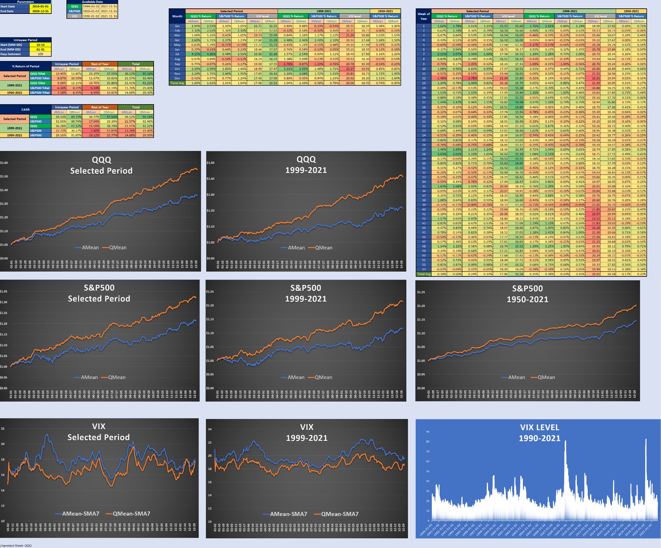

## 

## “Sell in May and Go Away”

***"Sell in May and go away"*** *is a well-known financial-world adage. It is based on* ***the historical underperformance of some stocks in the "summery" six-month period commencing in May and ending in October, compared to the "wintery" six-month period from November to April.*** *If an investor follows this strategy, they would divest their equity holdings in May (or at least, the late spring) and invest again in November (or the mid-autumn).*

*Some investors find this strategy more rewarding than staying in the equity markets throughout the year. They subscribe to the belief that, as warm weather sets in, low volumes and the lack of market participants (presumably on vacations) can make for a somewhat riskier, or at a minimum lackluster, market period.*

*The phrase "sell in May and go away" is thought to originate from an old English saying, "Sell in May and go away, and come on back on St. Leger's Day." This phrase refers to a custom of aristocrats, merchants, and bankers who would leave the city of London and escape to the country during the hot summer months. St. Leger's Day refers to the St. Leger's Stakes, a thoroughbred horse race held in mid-September and the last leg of the British Triple Crown.*

***American traders and investors who are likely to spend more time on vacation between Memorial Day and Labor Day mimic this trend and have adopted the phrase as an investing adage. And indeed, for over half a century stock market patterns have supported the theory behind the strategy.***

***From 1950 to around 2013, the Dow Jones Industrial Average has had an average return of only 0.3% during the May to October period, compared with an average gain of 7.5% during the November to April period****, according to a 2017 column in Forbes. While the exact reasons for this seasonal trading pattern were not known,* ***lower trading volumes*** *due to the* ***summer vacation*** *months and* ***increased investment flows during the winter month****s were cited as contributory reasons for the discrepancy in performance between the May to October and the November to April periods.*

*However,* ***recent statistics suggest that this seasonal pattern may not be the case anymore****. According to a May 2018 article in Investor's Business Daily, if an investor had sold stock in May 2016, she would have missed some lucrative runs. The NASDAQ ended April 2016 at 4775.36; it closed higher in May and soared in late June. The NASDAQ rose by 55% from the end of June 2016 until the end of January 2018.”[14]*

The first theory, which we examine in more detail, therefore states that **the six-month period from November to April is much more profitable than the one from May to October**. Because we primarily believe that the **stock market is constantly and rapidly changing**, it is best to **focus on the results of the past 10 years**. Therefore, for subsequent examinations, we set the 10-year period from 2011-11-17 to 2021-11-16 as a selected period in our calculator. Of course, the user can choose any other period he prefers.

Let's look at the numbers! As Table 1 shows, from 1999 to 2021, the selected six-month intrayear period (from November to April) was indeed better for both the Nasdaq and the S&P500 than the other six months. The statement is even more true for the period from 1950, but it is hardly true for the last 10 years (selected period) - especially in the case of the QQQ. **It means that the phenomena really existed but almost totally disappeared in recent years (especially in the case of QQQ, but S&P500 also confirms)**. The charts (Chart 2a-3c) further confirm us in this finding. Furthermore, a very important observation is that in **the initially less desirable period (especially in the middle of summer) the market is much calmer**, as shown by the VIX charts (Chart 4a-b).

Digging deeper into the numbers, based on Table 2 (which contains **average monthly returns by month**), it can be concluded that **taking into account the data of the last 70 years, 5 out of 6 months in Nov-Apr period were also very strong, while in the May-Oct period the S&P500 was only able to achieve an average monthly return of over 1% in July**. **In contrast, if we look only at the data for the last 10 years, the months of the period considered weaker have strengthened significantly with lower volatility (except for September, which is still weakest), especially for QQQ. In contrast, some months considered strong (e.g. March, December) underperformed.**

**All in all, based on the figures of our calculator we can state that the previously justifiably popular (and legitimate) belief is no longer valid in recent years, meaning it is not worth staying away from the market or using lower leverage during the summer season (September may be an exception).**

Table 1: ‘Sell in May’ in numbers - Selected period: 2011-11-17 - 2021-11-16 (last 10 years)

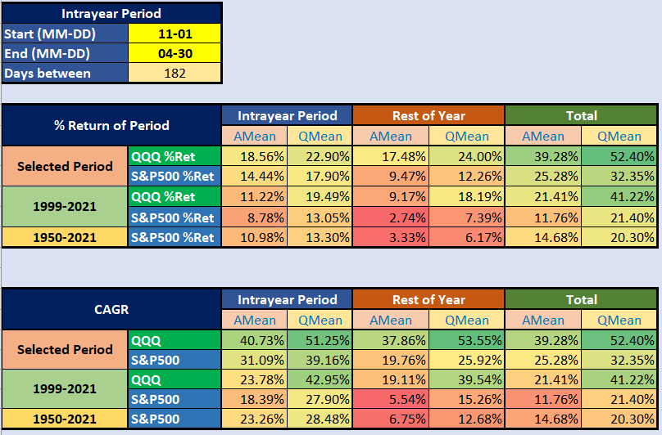

Table 2: Average monthly returns by month - Selected period: 2011-11-17 - 2021-11-16 (last 10 years)

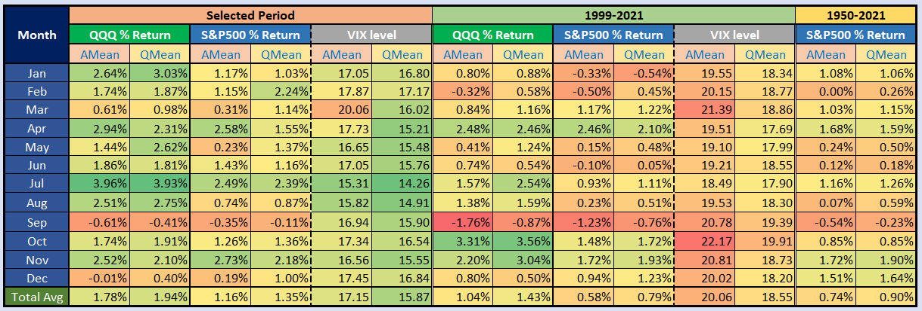

Chart 2a: Cumulative intrayear movement of QQQ - Selected period: 2011-11-17 - 2021-11-16 (last 10 years)

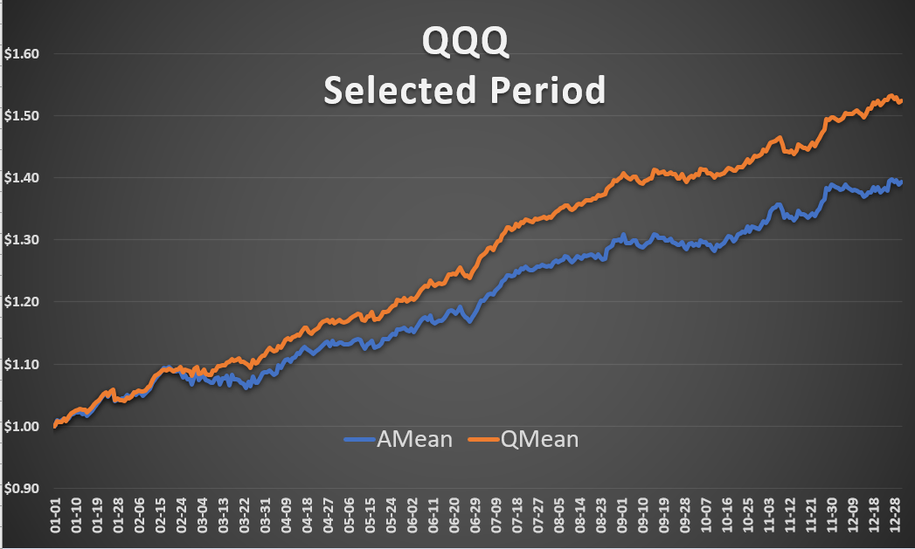

Chart 2b: Cumulative intrayear movement of QQQ - from 1999-03-10 - 2021-11-16

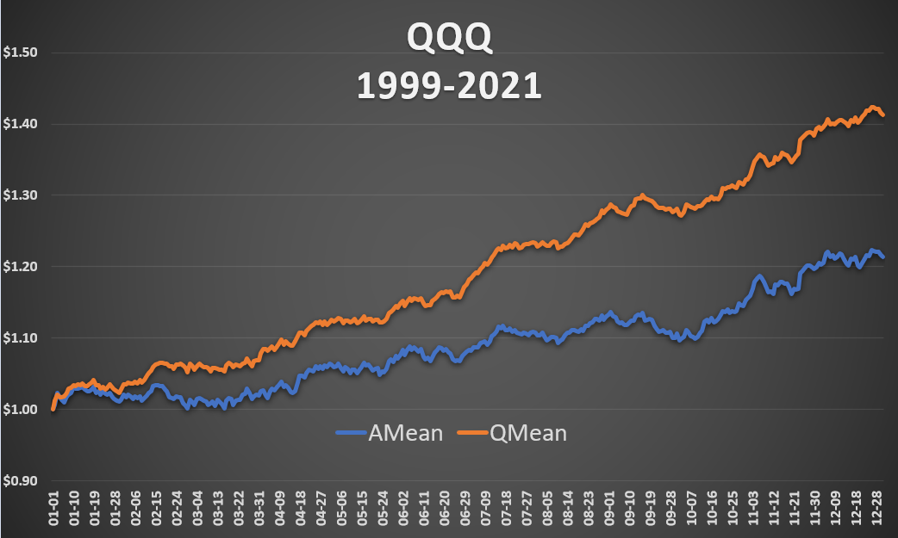

Chart 3a: Cumulative intrayear movement of S&P500 - Selected period: 2011-11-17 - 2021-11-16 (last 10 years)

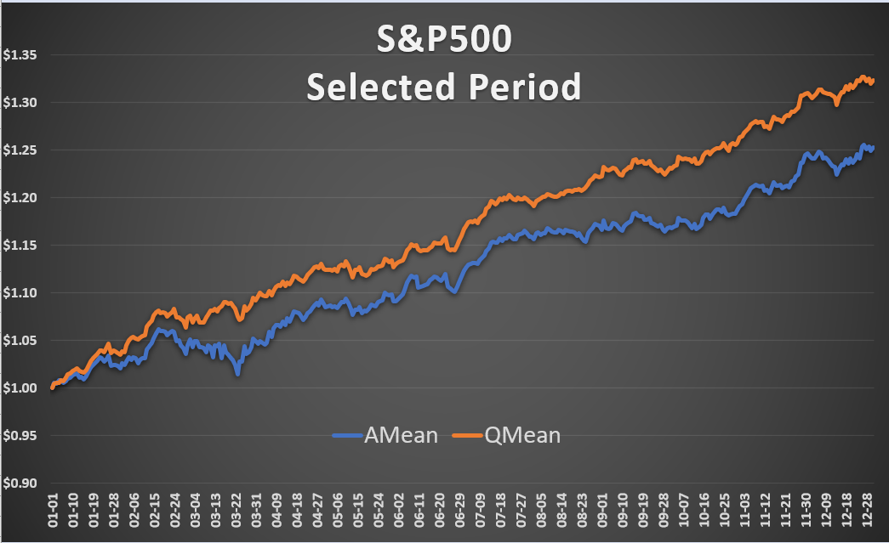

Chart 3b: Cumulative intrayear movement of S&P500 - from 1999-03-10 - 2021-11-16

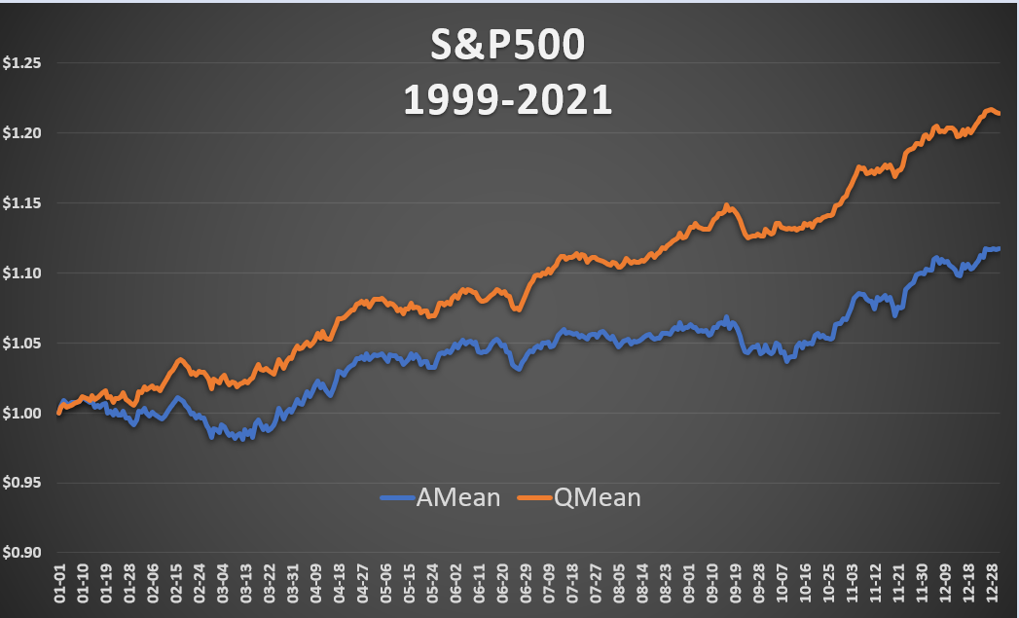

Chart 3c: Cumulative intrayear movement of S&P500 - from 1950-01-03 - 2021-11-16

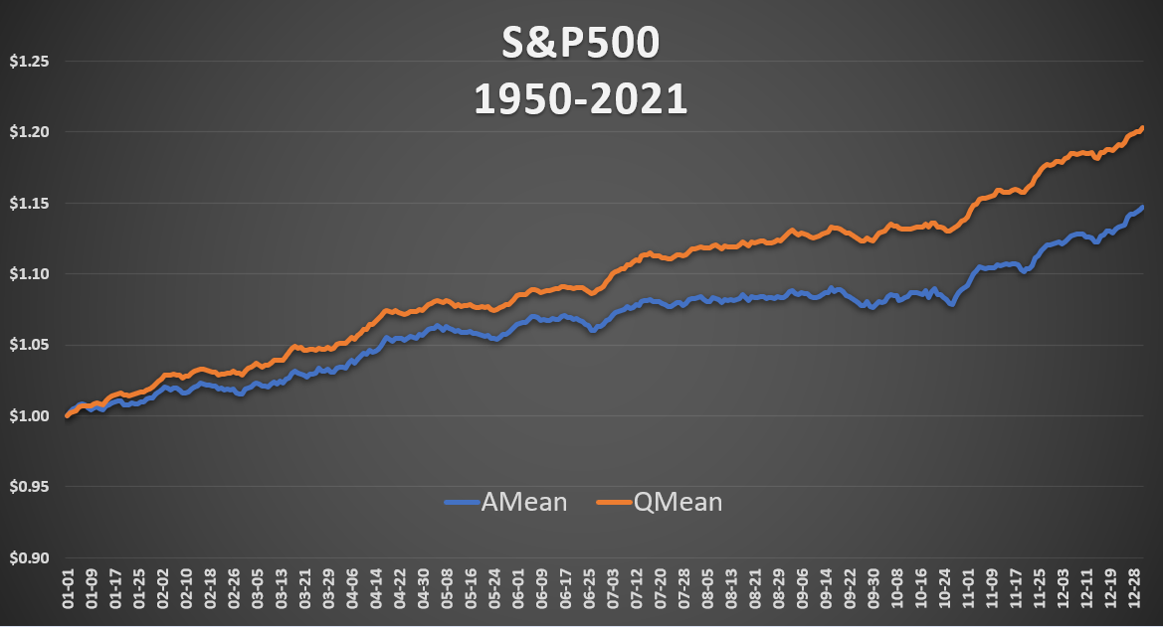

Chart 4a: Intrayear movement of 7-day moving average of VIX - Selected period: 2011-11-17 - 2021-11-16 (last 10 years)

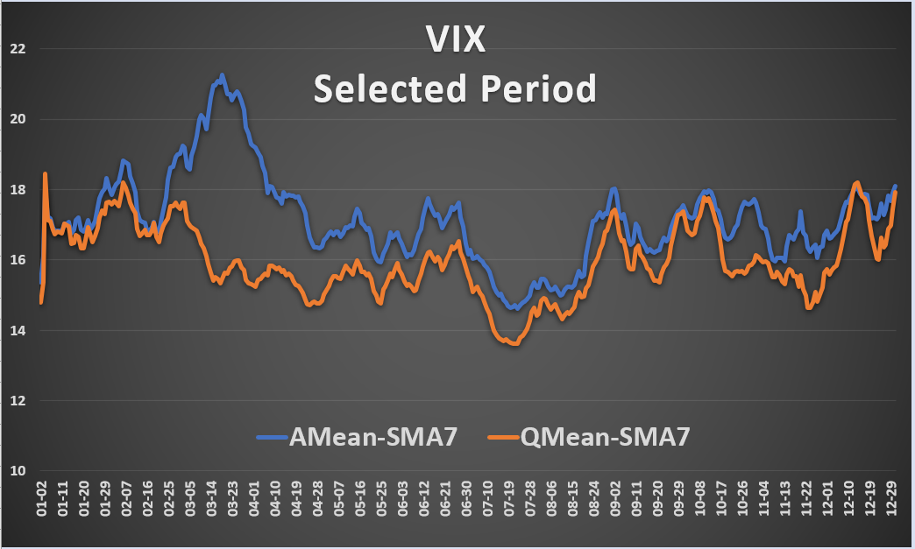

Chart 4b: Intrayear movement of 7-day moving average of VIX - from 1999-03-10 - 2021-11-16

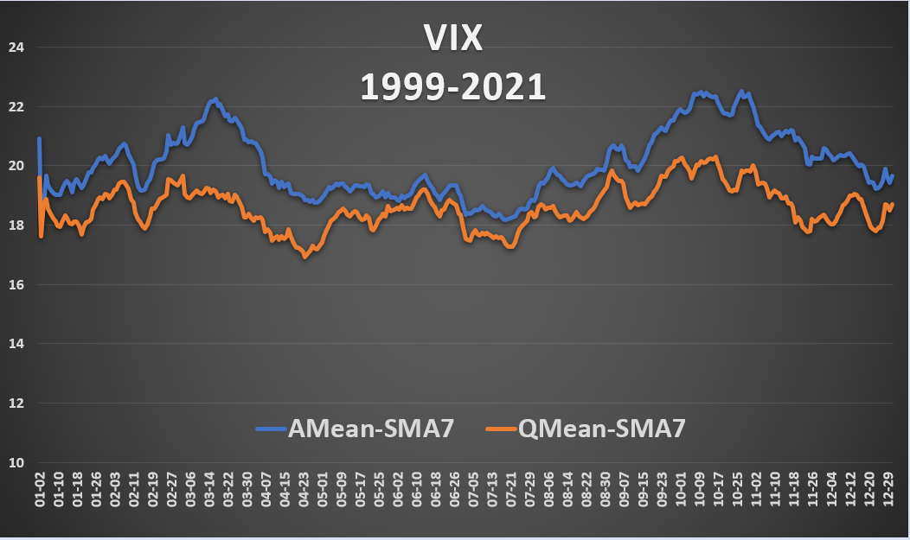

Chart 5: VIX level - from 1990-01-02 - 2021-11-16

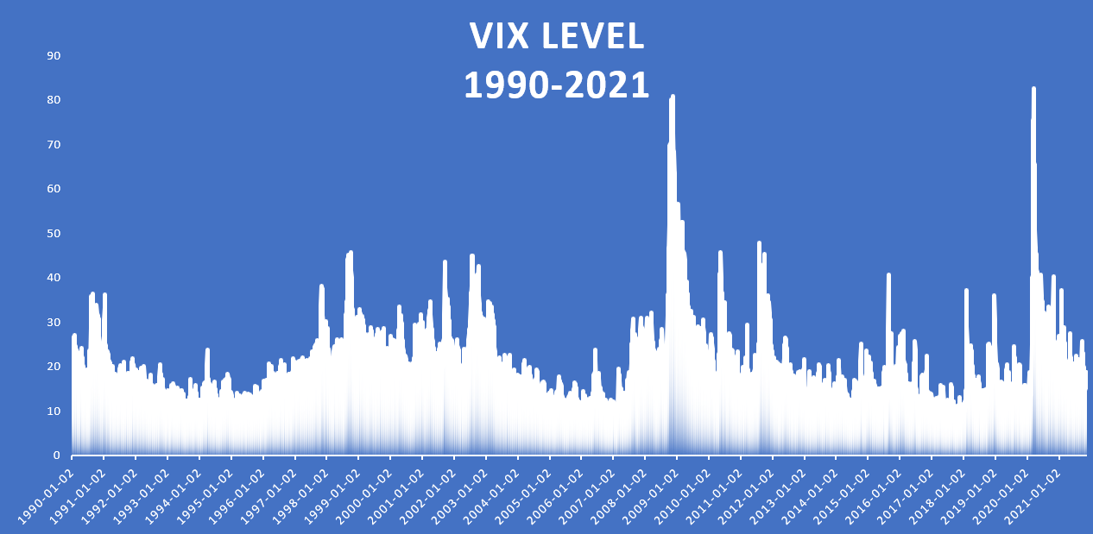

## 

## Santa Claus Rally

*“A Santa Claus rally describes a sustained increase in the stock market that occurs in the last week of December through the first two trading days in January. There are numerous explanations for the causes of a Santa Claus rally including tax considerations, a general feeling of optimism and happiness on Wall Street, and the investing of holiday bonuses. Another theory is that some very large institutional investors, a number of which are more sophisticated and pessimistic, tend to go on vacation at this time, leaving the market to retail investors, who tend to be more bullish.*

*A Santa Claus rally is a seasonal phenomenon, according to The Stock Trader’s Almanac, a longtime provider of analysis of both cyclical and seasonal market tendencies. According to the 2016 edition of the Almanac, "since 1969, the Santa Claus rally has yielded positive returns in 34 of the past 45 holiday seasons—the last five trading days of the year and the first two trading days after New Year's. The average cumulative return over these days is 1.4%, and returns are positive in each of the seven days of the rally, on average."*

*Many consider the Santa Claus rally to be a result of people buying stocks in anticipation of the rise in stock prices during the month of January, otherwise known as the January effect. Also, there is some research that points to value stocks outperforming growth stocks in December. Of note, many stock pickers in actively managed mutual funds tend to invest in value stocks.*

*Financial columnists typically opine on the likelihood of a Santa Claus rally. Some cite economic and technical analysis, and others offer pure conjecture.*

*Chartered market technicians pay attention to cyclical trends and, at times, find ways to exploit historical patterns such as the Santa Claus rally. They tend to do so repeatedly over time and by limiting both the amount of risk and reward they take on via position sizing, stop orders, and cutting losses short if positions go against them. These speculators also use technical patterns in particular indexes and carefully determine their planned entry and exit points.*

*None of this is useful for most investors who do not have the trading experience to manage risk in such short time frames. For buy-and-hold investors and those saving for retirement in 401(k) plans, for example, the Santa Claus rally does little to either help or hurt them over the long term. It is an interesting news headline happening on the periphery but not a reason to become either more bullish or bearish. A better strategy is to maintain a long-term investment strategy and not be tempted by the promise of Santa Claus rallies or January effects.*

*Several theories try to explain the Santa Claus rally, including optimism fueled by the holiday spirit, increased holiday shopping, and the investing of holiday bonuses. Another theory is that this is the time of year when institutional investors go on vacation—leaving the market to retail investors, who tend to be more bullish.*

*Since 1950, the S&P 500 has gained an average of 1.3% during Santa Claus rally periods, according to The Stock Trader's Almanac. Since the launch of the SPDR S&P 500 ETF Trust (SPY) in 1993, the Santa Claus rally has produced gains 18 out of 27 times, or about two-thirds (67%) of the time. According to Gordon Scott, a member of the Investopedia Financial Review Board, all other six-day periods since 1993 have produced positive SPY returns 58% of the time.”[15]*

Let’s see what the results of our calculator say about the possible existence of the rally. As Table 3a shows, the **phenomenon really existed in previous decades**. **This short intrayear period had an almost fourfold CAGR than the rest of the year**. Based on Table 4, which contains average weekly returns by week of the year, almost the same can be concluded: **Week 1 and Week 52-53 were strong on average**. It is worth noting that Week 53 is not a full week, it contains only 0-2 days, so in fact Week 1 and Week 52 are what really matters.

However, **in the last decade, the significant advantage of the period has disappeared compared to the rest of the year, it already has a lower CAGR**. Digging deeper into the numbers, we can draw the conclusion from Table 3b that **the first half of the rally (last week of the year) not only performed worse than before, but also turned downright negative** (that’s why we’re playing this week in our RenewedUber strategy as a bearish period). Nevertheless, the entire period is still performing acceptably, thanks to a strong start to the year (which we’re also taking advantage of for Uber).

**Overall, the rally is no longer working as it used to, so this belief has also been shattered in the last decade (for both QQQ and S&P500).**

Table 3a: Santa Claus rally in numbers - Selected period: 2011-11-17 - 2021-11-16 (last 10 years)

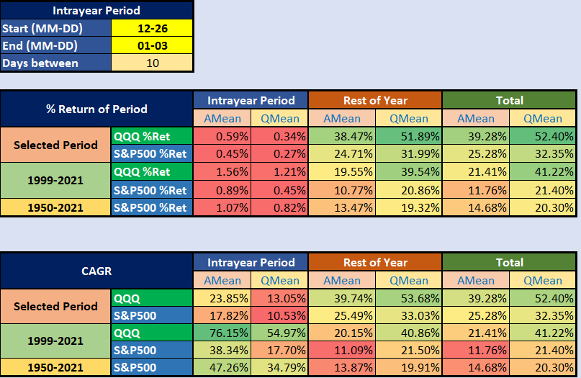

Table 3b: First half of Santa Claus rally in numbers - Selected period: 2011-11-17 - 2021-11-16 (last 10 years)

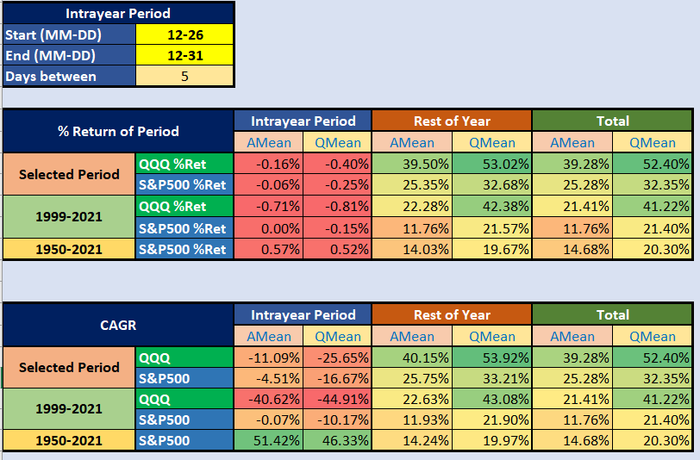

Table 4: Average weekly returns by week of year - Selected period: 2011-11-17 - 2021-11-16 (last 10 years)

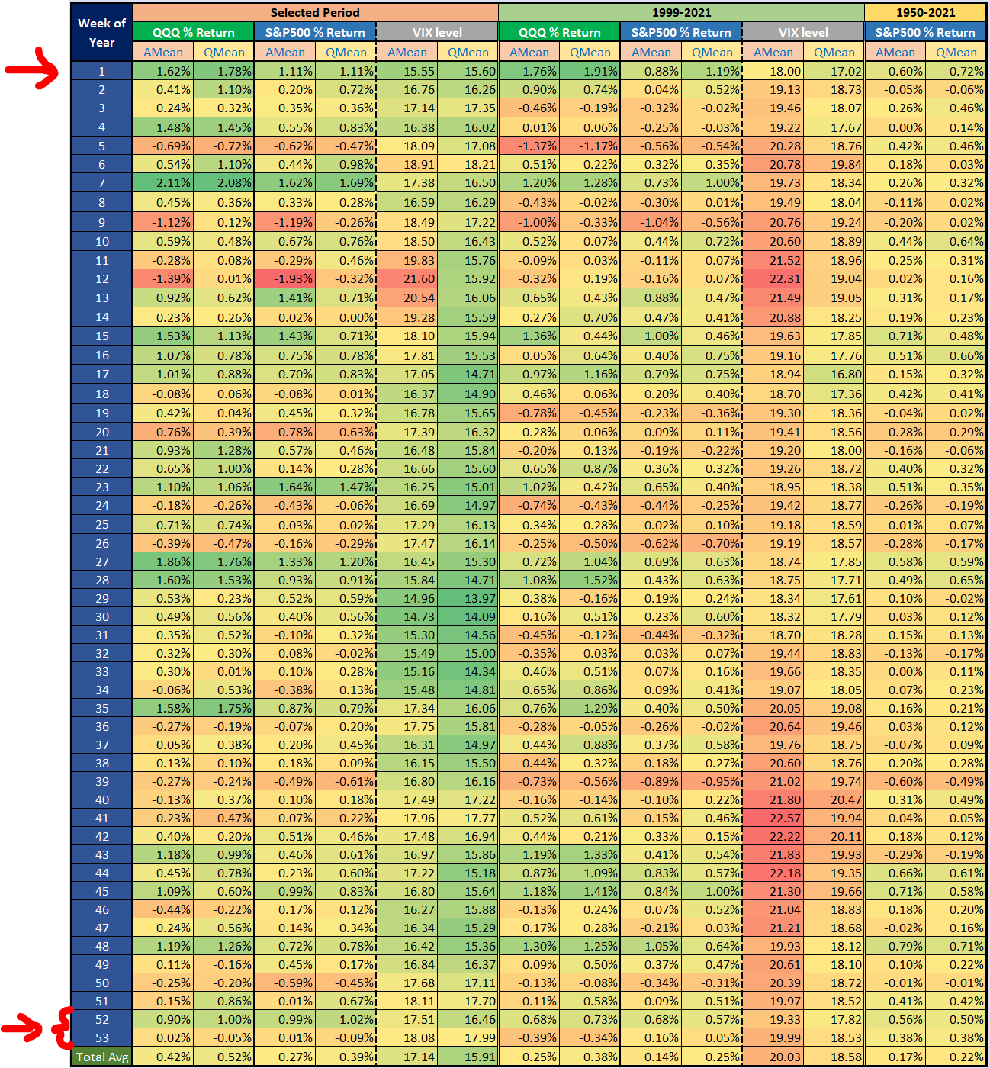

## 

## January Effect

*“The January Effect is a perceived seasonal increase in stock prices during the month of January. Analysts generally attribute this rally to an increase in buying, which follows the drop in price that typically happens in December when investors, engaging in tax-loss harvesting to offset realized capital gains, prompt a sell-off.*

*Another possible explanation is that investors use year-end cash bonuses to purchase investments the following month. While this market anomaly has been identified in the past, the January effect seems to have largely disappeared as its presence became known.*

*The January Effect is a hypothesis, and like all calendar-related effects, suggests that the markets as a whole are inefficient, as efficient markets would naturally make this effect non-existent. The January Effect seems to affect small caps more than mid or large caps because they are less liquid.*

*Since the beginning of the 20th century, the data suggests that these asset classes have outperformed the overall market in January, especially toward the middle of the month. Investment banker Sidney Wachtel first noticed this effect in 1942. This historical trend, however, has been less pronounced in recent years because the markets seem to have adjusted for it.*

*Another reason analysts consider the January Effect less important as of 2021 is that more people are using tax-sheltered retirement plans and therefore have no reason to sell at the end of the year for a tax loss.*

*Beyond tax-loss harvesting and repurchases, as well as investors putting cash bonuses into the market, another explanation for the January Effect has to do with investor psychology. Some investors believe that January is the best month to begin an investment program or perhaps are following through on a New Year's resolution to begin investing for the future.*

*Others have pontificated that mutual fund managers purchase stocks of top performers at the end of the year and eliminate questionable losers for appearance sake in their year-end reports, an activity known as "window dressing." This is unlikely, however, as the buying and selling would primarily affect large caps.*

*Year-end sell-offs also attract buyers interested in the lower prices, knowing the dips are not based on company fundamentals. On a large scale, this can drive prices higher in January.*

*An ex-Director from the Vanguard Group, Burton Malkiel, the author of A Random Walk Down Wall Street, has criticized the January Effect, stating that seasonal anomalies such as it don't provide investors with any reliable opportunities. He also suggests that the January Effect is so small that the transaction costs needed to exploit it essentially make it unprofitable. It's also been suggested that too many people now time for the January Effect so that it becomes priced into the market, nullifying it all together.”[16]*

Let’s use our calculator again to decide if **January is really still a strong month for the S&P500 and what about technology stocks in the first month of the year**?

As both Table 5 and Table 6 (which is a copy of Table 2) show, **January has not only remained a strong month, the January performance of the S&P500 has become even stronger over the past decade**. This is **even more true for technology companies, with QQQ having almost twice the CAGR in this period than in the rest of the year.**

It should be noted that this Table 5 calculates average period returns by accumulating daily average percentage changes, so the **results may differ** from the values obtained by averaging real monthly returns shown in Table 6 (and Table 2).

**Based on these results, the use of over-leverage this month may be justified**.

Table 5: January effect in numbers - Selected period: 2011-11-17 - 2021-11-16 (last 10 years)

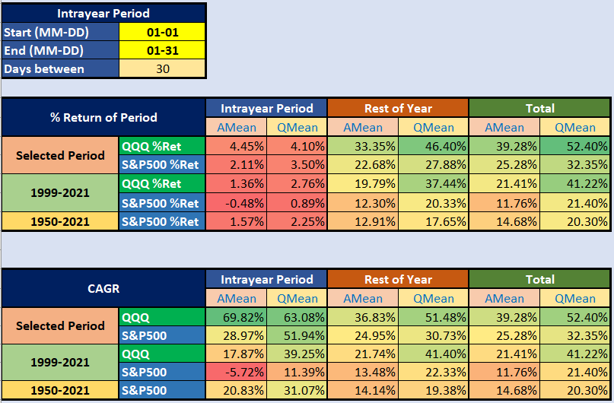

Table 6 (same as Table 2): Average monthly returns by month - Selected period: 2011-11-17 - 2021-11-16 (last 10 years)



## September Effect

*“The September effect refers to historically weak stock market returns for the month of September. There is a statistical case for the September effect depending on the period analyzed, but much of the theory is anecdotal. It is generally believed that investors return from summer vacation in September ready to lock in gains as well as tax losses before the end of the year. There is also a belief that individual investors liquidate stocks going into September to offset schooling costs for children. As with many other calendar effects, the September effect is considered a historical quirk in the data rather than an effect with any causal relationship.*

*The September effect is real in the sense that an analysis of the market data—most often the Dow Jones Industrial Average (DJIA)—shows that September is the only calendar month with a negative return over the last 100 years. However, the effect is not overwhelming and, more importantly, is not predictive in any useful sense. If an individual had bet against September over the last 100 years, that individual would have made an overall profit. If the investor had made that bet only in 2014, for instance, that investor would have lost money.*

*Like the October effect before it, the September effect is a market anomaly rather than an event with a causal relationship. In fact, October’s 100-year dataset is positive despite being the month of the 1907 panic, Black Tuesday, Thursday, and Monday in 1929, and Black Monday in 1987. The month of September has seen as much market turmoil as October. It was the month when the original Black Friday occurred in 1869, and two substantial single-day dips occurred in the DJIA in 2001 after 9/11 and in 2008 as the subprime crisis ramped up.*

*However, according to Market Realist, the effect has dissipated in recent years. Over the past 25 years, for the S&P 500, the average monthly return for September is approximately -0.4% while the median monthly return is positive. In addition, frequent large declines have not occurred in September as often as they did before 1990. One explanation is that investors have reacted by “pre-positioning;” that is, selling stock in August.*

*The September effect is not limited to U.S. stocks but is associated with markets worldwide. Some analysts consider that the negative effect on markets is attributable to seasonal behavioral bias as investors change their portfolios at the end of summer to cash in. Another reason could be that most mutual funds cash in their holdings to harvest tax losses.”[17]*

Finally, let’s look at what our calculator says about the **existence of the weak September effect**. Based on the figures of Table 7 and Table 6 (above), **it can be clearly seen that it was, it remained, and even now it is the weakest month of the year by far with negative returns both for the S&P500 and the Nasdaq**. In our opinion, **someone might consider applying some under-leverage in this month of the year.**

Table 7: September effect in numbers - Selected period: 2011-11-17 - 2021-11-16 (last 10 years)

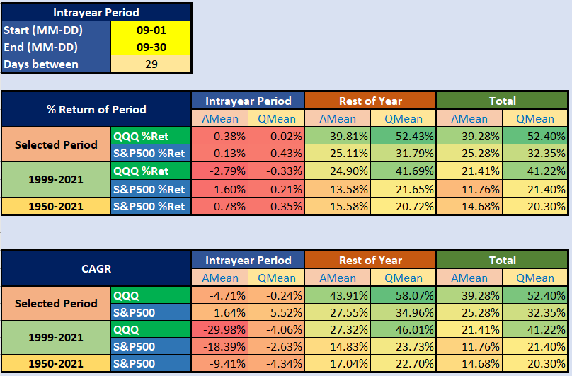

# 

# **Conclusions**

In this study, **some old beliefs about seasonality** were presented and **the operation of our own seasonality calculator were described through related case studies**.

Using our calculator, we found that:

* **The previously justifiably popular (and legitimate) ‘Sell in May and Go Away’ belief is no longer valid in recent years (both QQQ, SPY confirm), meaning it is not worth staying away from the market or using lower leverage during the summer season (September may be an exception).**
* **Both QQQ and S&P500 show that the ‘Santa Claus rally’ is no longer working as it used to, so this belief has also been shattered in the last decade. It is caused by the poor performance of the market during the last week of the year.**
* **January remained strong (especially in case of the QQQ). Over-leverage should be considered in January.**
* **September remained a bad omen for the market. Under-leverage should be considered in September.**
* **July, April, May, November and August were really strong months in the last decade (for both QQQ and S&P500).**

1. <https://www.investopedia.com/terms/s/seasonality.asp>
2. <https://www.seasonalcharts.com/saisonalitaet.html>
3. [Jay Kaeppel: Seasonal Stock Market Trends](https://www.snifferquant.com/gyantal/Incode/books2020/SeasonalKaeppel,%202009.pdf)
4. <https://jeffhirsch.tumblr.com/post/184398915153/end-of-the-best-six-months-should-you-sell-in>
5. <https://jeffhirsch.tumblr.com/post/671742668325388288/santa-claus-rally-indicator-starts-today>
6. <https://lplresearch.com/2021/04/30/here-comes-sell-in-may/>
7. <https://compoundadvisors.com/2021/7-chart-sunday-12-26-21>
8. <https://www.cxoadvisory.com/calendar-effects/sell-in-may-over-the-long-run/>
9. <https://www.cxoadvisory.com/calendar-effects/stock-market-performance-by-intra-year-phase/>
10. <https://compoundadvisors.com/2021/7-chart-sunday-12-26-21>
11. <https://theirrelevantinvestor.com/2015/11/30/tis-the-season/>
12. <https://theirrelevantinvestor.com/2016/03/09/the-fools-gold/>
13. <https://ofdollarsanddata.com/when-things-stop-working/>
14. <https://www.investopedia.com/terms/s/sell-in-may-and-go-away.asp>
15. <https://www.investopedia.com/terms/s/santaclauseffect.asp>
16. <https://www.investopedia.com/terms/j/januaryeffect.asp>
17. <https://www.investopedia.com/terms/s/september-effect.asp>