Dr. George Antal

3D Click Limited

c/o Suite 431, 28 Old Brompton Road, London SW7 3SS

**Monthly Seasonality: The Truth (CXO, TAA)**

**Motivation** **1**

**Background** **1**

‘CXO’: Combined Value-Momentum Strategy (SACEVS-SACEMS) 1

‘CXO’: Asset Class ETF Seasonalities? 5

‘CXO’: SACEVS and SACEMS Performance by Calendar Month 8

**Results** **11**

CXO: Backtest of the Strategy 11

CXO: With Monthly Seasonality 18

Tactical Asset Allocation with Monthly Seasonality 22

**Conclusions** **24**

# **Motivation**

Nearly 10 years ago **CXO** developed a **complex ETF strategy (SACEVS-SACEMS)** that takes both **value** and **momentum** into account. We have been **following the performance of the strategy closely** since the beginning, and have been **playing it in real life for some time**.

In this study, as a first step, the **performance of the strategy is presented by the CXO**. This is followed by the **results of our own backtest**. Finally, we examine **whether the performance of the strategy can be improved by taking the monthly seasonality of each ETF into account** as well.

# **Background**

This chapter first presents **the numbers related to the performance of the strategy developed by the CXO**, according to their interpretation. **Then two of their articles dealing with seasonality related to the strategy are cited**.

## ‘CXO’: Combined Value-Momentum Strategy (SACEVS-SACEMS)

“The [Simple Asset Class ETF Value Strategy](https://www.cxoadvisory.com/value-strategy/) (SACEVS) seeks diversification across a small set of asset class exchange-traded funds (ETF) plus a monthly tactical edge from timing term, credit and equity risk premiums. The two versions of SACEVS are: (1) most undervalued premium (**Best Value**) ; and, (2) weighting all undervalued premiums according to respective degree of undervaluation (**Weighted**).

The [Simple Asset Class ETF Momentum Strategy](https://www.cxoadvisory.com/momentum-strategy/) (SACEMS) seeks diversification across asset classes via ETFs plus a monthly tactical edge from intermediate-term momentum. The three versions of SACEMS, all based on total ETF returns over recent months, are: (1) top one of nine ETFs (**Top 1**); (2) equally weighted top two (**EW Top 2**); and, (3) equally weighted top three (**EW Top 3**).

Based on feedback from subscribers about combinations of interest, we look at three equal-weighted (50-50) diversifying combinations of SACEVS and SACEMS, rebalanced monthly:

1. 50-50 Best Value – EW Top 2: SACEVS Best Value paired with SACEMS Equally Weighted (EW) Top 2 (aggressive value and somewhat aggressive momentum).
2. 50-50 Best Value – EW Top 3: SACEVS Best Value paired with SACEMS EW Top 3 (aggressive value and diversified momentum).
3. 50-50 Weighted – EW Top 3: SACEVS Weighted paired with SACEMS EW Top 3 (diversified value and diversified momentum).

Supporting research includes (items may at times be unavailable for a few days during updates):

* [“SACEMS-SACEVS for Value-Momentum Diversification”](https://www.cxoadvisory.com/26930/equity-premium/sacems-sacevs-mutual-diversification/) tests benefits of diversifying across asset class ETFs based on both relative momentum and relative value.
* [“SACEVS Best Value + SACEMS EW Top 2?”](https://www.cxoadvisory.com/strategic-allocation/sacevs-best-value-sacems-ew-top-2/) tests an alternative to the tracked combined value-momentum strategy.
* [“Forcing SACEMS to Agree with SACEVS”](https://www.cxoadvisory.com/strategic-allocation/forcing-sacems-to-agree-with-sacevs/) tests effects on [Simple Asset Class ETF Momentum Strategy](https://www.cxoadvisory.com/momentum-strategy/) (SACEMS) performance of forcing SACEMS to agree with SACEVS when the latter assigns zero weight to stocks or government bonds.
* [“SACEMS-SACEVS Diversification with Mutual Funds”](https://www.cxoadvisory.com/27093/equity-premium/simple-asset-class-value-and-momentum-diversification-with-mutual-funds/) provides an extended test of the benefits of diversifying across asset classes based on both relative momentum and relative value with sets of mutual funds.
* [“SACEMS and SACEVS Changes for Coordination and Liquidity”](https://www.cxoadvisory.com/29727/fundamental-valuation/sacems-and-sacevs-changes-for-coordination-and-liquidity/) documents minor April 2017 adjustments that trade purity of logic for practicality.
* [“SACEVS-SACEMS Leverage Sensitivity Tests”](https://www.cxoadvisory.com/30658/fundamental-valuation/sacevs-sacems-leverage-sensitivity-tests/) explores use of margin rebalanced monthly to boost performance.

Some additional relevant but less directly applicable research is in the last list of items in “[What Works Best?](https://www.cxoadvisory.com/what-investing-approaches-work-best/)“.

Some investors may want to follow one of the 50-50 combined strategies. Others may want to modify the strategy with other than equal weights for SACEVS and SACEMS, as explored in [“SACEMS-SACEVS for Value-Momentum Diversification”](https://www.cxoadvisory.com/26930/equity-premium/sacems-sacevs-mutual-diversification/).

**Cumulative Performance**

The following chart tracks gross cumulative values of $100,000 initial investments in each of the above three combination strategies since the end of June 2006. It includes as a benchmark a simple technical strategy (SPY:SMA10) that holds [SPDR S&P 500 ETF Trust](https://finance.yahoo.com/quote/SPY/history) (SPY) when the S&P 500 Index is above its 10-month simple moving average and [3-month U.S. Treasury bills](https://finance.yahoo.com/quote/%5EIRX) (Cash, or T-bills) when below.

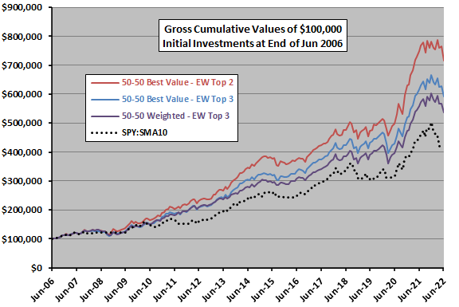

For perspective, we look at an array of performance metrics.

**Performance Statistics**

The following table summarizes annual/annualized returns for these three strategies, and for SPY and SPY:SMA10. Annualized returns are [compound annual growth rates](https://en.wikipedia.org/wiki/Compound_annual_growth_rate). Maximum drawdown is the deepest peak-to-trough drawdown for these strategies based on monthly measurements over the sample period. For [Sharpe ratio](https://en.wikipedia.org/wiki/Sharpe_ratio), to calculate excess annual return, we use average monthly yield on 3-month Treasury bills during a year as the risk-free rate for that year.

Portfolio performance calculations are based on assumptions as summarized in [Value Strategy](https://www.cxoadvisory.com/value-strategy/) and [Momentum Strategy](https://www.cxoadvisory.com/momentum-strategy/).

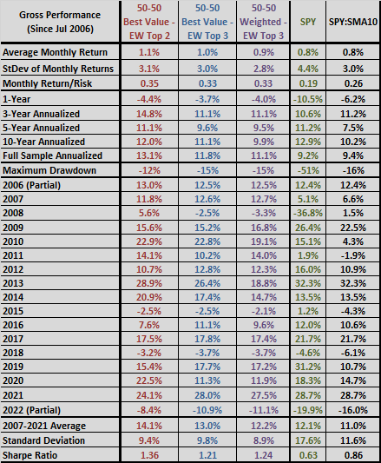

Something to keep in mind is that testing different SACEMS-SACEVS combinations and/or adjusting weights based on sensitivity tests incorporates [data snooping](https://en.wikipedia.org/wiki/Data_dredging) bias, such that the best-performing combination overstates expectations. “

## 

## ‘CXO’: Asset Class ETF Seasonalities?

“Do exchange-traded funds (ETF) that track asset classes, such as those used in the [Simple Asset Class ETF Momentum Strategy](https://www.cxoadvisory.com/momentum-strategy/) (SACEMS) and the [Simple Asset Class ETF Value Strategy](https://www.cxoadvisory.com/value-strategy/) (SACEVS), exhibit reliable seasonalities? To check, we look at average return by calendar month for the following nine ETFs:

* SPDR S&P 500 ([SPY](https://finance.yahoo.com/q/hp?s=SPY))
* iShares Russell 2000 Index ([IWM](https://finance.yahoo.com/q/hp?s=IWM))
* iShares MSCI EAFE Index ([EFA](https://finance.yahoo.com/q/hp?s=EFA))
* iShares MSCI Emerging Markets Index ([EEM](https://finance.yahoo.com/q/hp?s=EEM))
* iShares Barclays 20+ Year Treasury Bond ([TLT](https://finance.yahoo.com/q/hp?s=TLT))
* iShares iBoxx $ Investment Grade Corporate Bond ([LQD](https://finance.yahoo.com/q/hp?s=LQD))
* Vanguard REIT ([VNQ](https://finance.yahoo.com/q/hp?s=VNQ))
* SPDR Gold Shares ([GLD](https://finance.yahoo.com/q/hp?s=GLD))
* PowerShares DB Commodity Index Tracking ([DBC](https://finance.yahoo.com/q/hp?s=DBC))

Using monthly dividend-adjusted returns for these ETFs over a common sample period during March 2006 (limited by DBC) through August 2021, *we find that:*

The following chart summarizes average return by calendar month for the nine asset class ETFs over the available common sample period. Results suggest that three months (April, July and December) are almost uniformly positive across asset classes, while other months are mixed. DBC has been broadly weak across the year for the available sample.

The sample period is very short for this kind of analysis.

For perspective, we look at averages across asset classes.

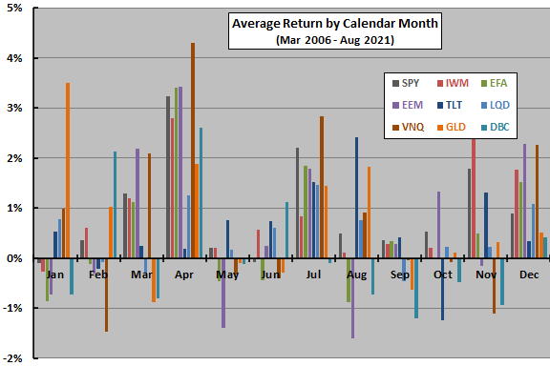

The next chart summarizes the average of average returns across asset classes by calendar month, emphasizing the broad strength of April, July and December.

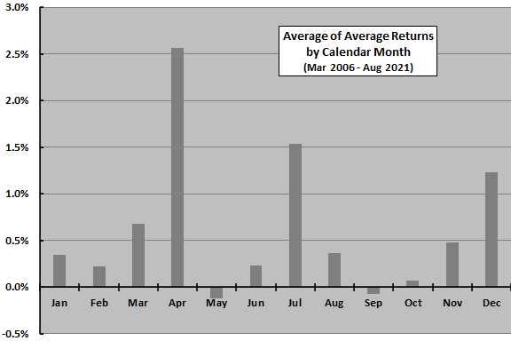

The following table provides average return data used in the two charts above.

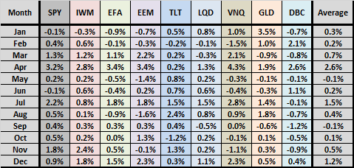

In summary, *available evidence weakly suggests a few commonalities and some differences in recent seasonalities among asset class ETFs.*

Cautions regarding findings include:

* As noted the available common sample period is very short for investigation of calendar month return effects, particularly in terms of number of economic/market cycles and secular trends.
* The 2008-2009 financial crisis and the early 2020 COVID-19 pandemic strongly influence results for some months and may not be representative of future crises.”

## 

## ‘CXO’: SACEVS and SACEMS Performance by Calendar Month

“A subscriber asked whether the [Simple Asset Class ETF Momentum Strategy](https://www.cxoadvisory.com/momentum-strategy/) (SACEMS) exhibits monthly calendar effects. In investigating, we also look at the [Simple Asset Class ETF Value Strategy](https://www.cxoadvisory.com/value-strategy/) (SACEVS)? We consider the Best Value (most undervalued asset) and Weighted (assets weighted by degree of undervaluation) versions of SACEVS. We consider the Top 1, equally weighted (EW) Top 2 and EW Top 3 versions of SACEMS, which each month equally weights the top one, two or three of nine ETFs/cash with the highest total returns over a specified lookback interval. We further compare seasonalities of these strategies to those of their benchmarks: for SACEVS, a monthly rebalanced 60% stocks-40% bonds portfolio (60-40); and, for SACEMS an equally weighted and monthly rebalanced portfolio of the SACEMS universe (EW All). Using monthly gross total returns for SACEVS since August 2002 and for SACEMS since July 2006, both through January 2022, *we find that:*

The following table summarizes average gross monthly returns for SACEVS Best Value, SACEVS Weighted and 60-40 by calendar month over the available sample period. Notable points are:

* The three strategies have almost uniformly positive average returns across calendar months (the exception is Best Value for March).
* Best Value (standard deviation 0.8%) is more uneven across calendar months than Weighted (0.6%) and 60-40 (0.7%).

However, a **sample size of 20-21 observations per calendar month is very small** for this kind of breakdown, such that **one or two additional years may materially alter results**.

For additional perspective, we focus on how SACEVS differs from its benchmark.

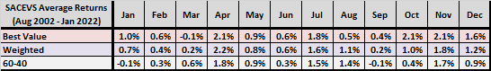

The following chart summarizes average gross monthly returns by calendar month for SACEVS Best Value and Weighted relative to the 60-40 benchmark. Best Value (Weighted) beats 60-40 during 10 (9) of 12 calendar months.

Next, we look at SACEMS.

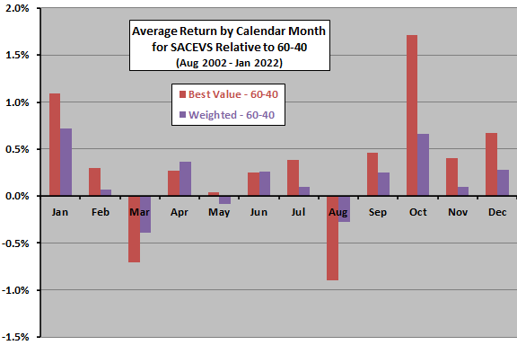

The next table summarizes average gross monthly returns for SACEMS Top 1, EW Top 2, EW Top 3 and EW All by calendar month over the available sample period. Notable points are:

* All four strategies have negative average returns for at least one calendar month, with May particularly weak.
* Top 1 (standard deviation 1.3%) is much more uneven across calendar months than EW Top 2 (0.9%), EW Top 3 (0.9%) and EW All (0.7%).

However, **a sample size of 16-17 observations per calendar month is extremely small** for this kind of breakdown, such that one or two additional years may materially alter results.

For additional perspective, we focus on how SACEMS differs from its benchmark.

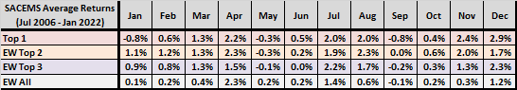

The next chart summarizes average gross monthly returns by calendar month for SACEMS EW Top 2 and EW Top 3 relative to the EW All benchmark. EW Top 2 (EW Top 3) beats EW All during 9(8) of 12 months.

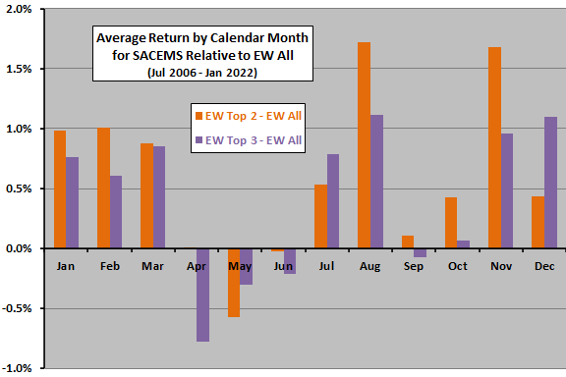

In summary, *evidence from simple tests on limited data suggests that SACEVS and SACEMS may exhibit seasonality, with reliability of* ***findings too low to support calendar-based strategy modifications.***

The seasonality in [“Stock Market Performance by Intra-year Phase”](https://www.cxoadvisory.com/4321/calendar-effects/stock-market-performance-by-intra-year-phase/) is for the U.S. stock market. Another asset class may exhibit similar or different seasonality according to correlation of its monthly returns with those of U.S. stocks. Seasonality of a multi-asset class strategy depends on how often it picks or how much it weights different asset classes.

Cautions regarding findings include:

* As noted, available samples are very short for calendar-based analysis.
* As noted, results are gross, not net. Including **switching frictions would lower returns**, with the possibility of anomalous absence/concentration of switches in specific months.”

# **Results**

This chapter consists of **three sections**. As a first step, we present **the results of our own backtest**. Here we examine **each sub-strategy ('Value' and 'Momentum Top1..2..3') separately and combined**. It is already worth emphasising here that for the 'Value' sub-strategy, we are only examining the version called **'Weighted'** by the CXO, **not the 'Best' case as CXO did most of the time above** (because that is how we play in real life). After that, we will **try to improve the performance of the strategy by introducing monthly seasonality into the strategy**. Finally, we present **how the performance of a strategy that includes the ETFs used by CXO, but gives the weights using tactical asset allocation (TAA)**, would look like. Of course, we also take into account **the possibility of seasonality** here.

**In the first two sections, we use data from 2002-08-01 to 2022-03-31, while in the third section, data from 2005-01-01 to 2021-07-30 is used.**

## CXO: Backtest of the Strategy

In this section, we present the **results of our backtest**. In our backtest **we don’t actually simulate the rules**, but **use their historical asset allocation** that is given by CXO at the end of the page [here](https://www.cxoadvisory.com/value-strategy/) and [here](https://www.cxoadvisory.com/momentum-strategy/). The following charts and tables (Chart 1-1a and Table 1a-1i) contain numbers for **both the 'Value' and the 'Momentum TopX' sub-strategies**, as well as their **combinations**. In addition, the results for the **buy&hold SPY and QQQ** strategies can be found as **benchmarks**. Finally, we summarise the aggregated results in a **comparison table** (Table 2).

Based on these figures, it can be concluded that:

* **Comparing** the numbers in column 3 of the table on page 4 (50-50 Weighted - EW Top3), broken down by year, and the numbers in Table 1g (Value + Mom Top3), we can say that we **succeeded in reproducing the results of CXO** (as they are almost the same), that is, our **backtesting calculator is good**.
* **The comparison table** (Table 2) **clearly shows** that the **‘50% Value + 50% Momentum Top2’** strategy performed best in the past 20 years based on the **Sharpe ratio, maximum drawdown and MAR ratio**. Only the buy&hold QQQ strategy has a higher CAGR, but it is much more volatile.
* This **‘50% Value + 50% Momentum Top2’** strategy had **only 2 losing years (2015 and 2018) out of the 20 full years**. It is worth noting that **we have been playing this version of the CXO strategy in real life since 2022-02-28** (instead of the ‘50% Value + 50% Momentum Top3’ strategy, which has almost equally good results).
* Among the **separate sub-strategies**, **‘Value’ has the highest Sharpe ratio**, but it also has a **high maximum drawdown**. In contrast, the **MAR ratio of the ‘Mom Top2’ and ‘Mom Top3’ strategies is much better due to the lower MDD**, with a slightly lower Sharpe ratio. **In all respects, the ‘Mom Top1’ sub-strategy is the worst performer.**

Chart 1: Portfolio Value of different CXO sub-strategies and their combinations

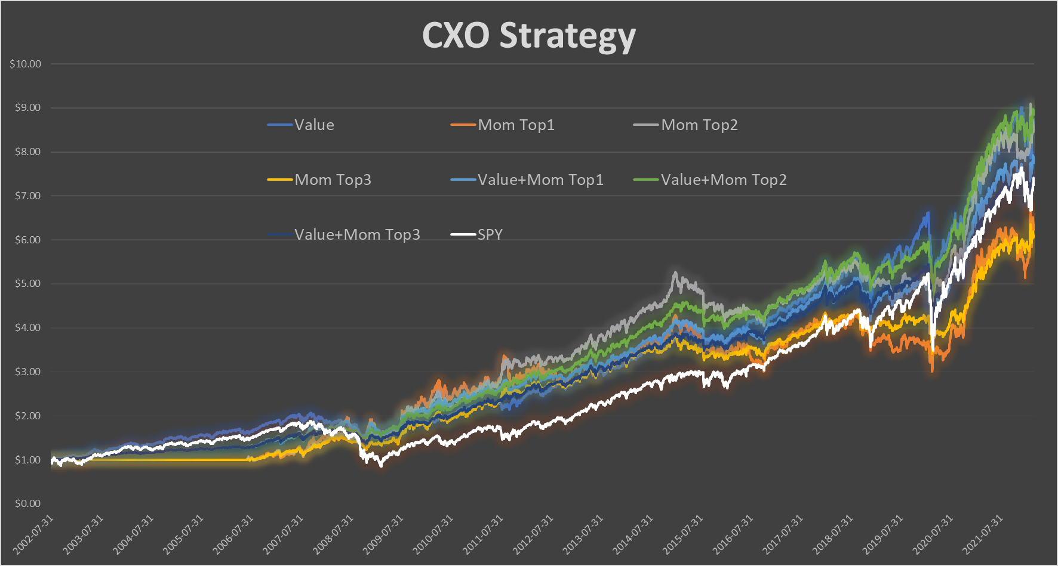

Chart 1a: Portfolio Value of different CXO sub-strategies and their combinations - logarithmic scale

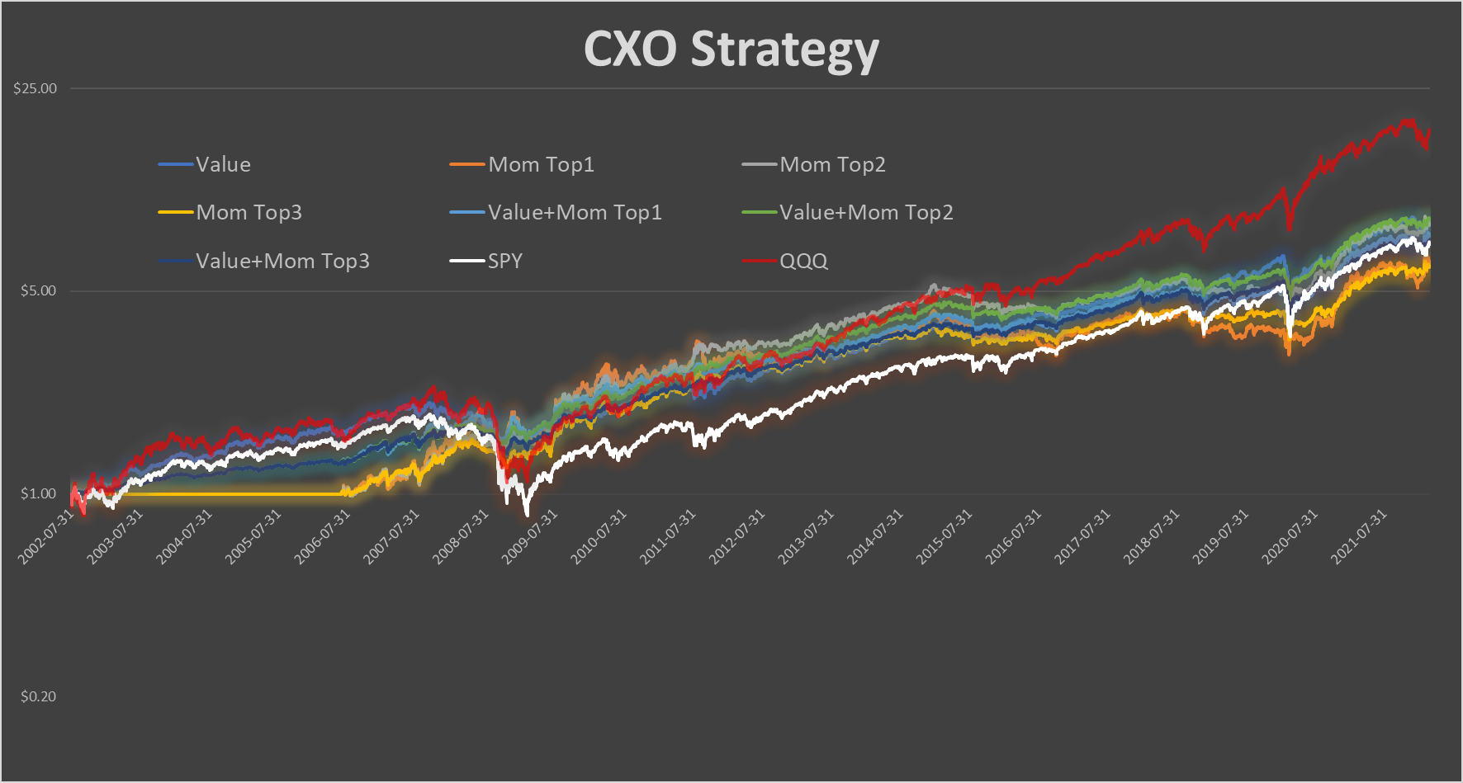

Table 1a: Performance indicators of ‘Value’ sub-strategy

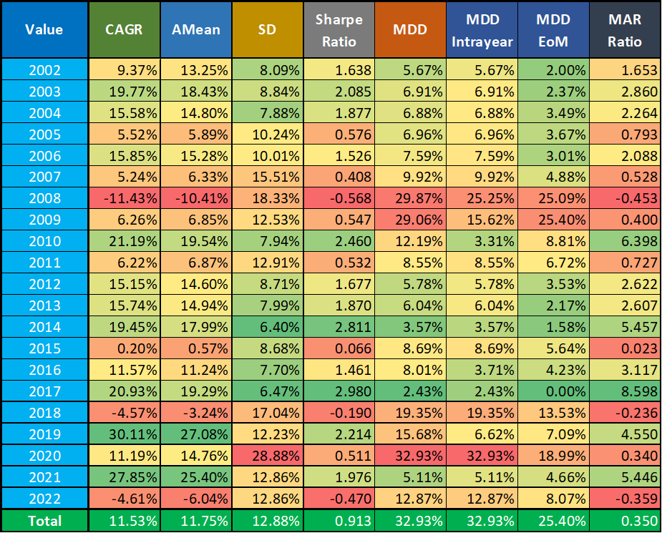

Table 1b: Performance indicators of ‘Momentum Top1’ sub-strategy

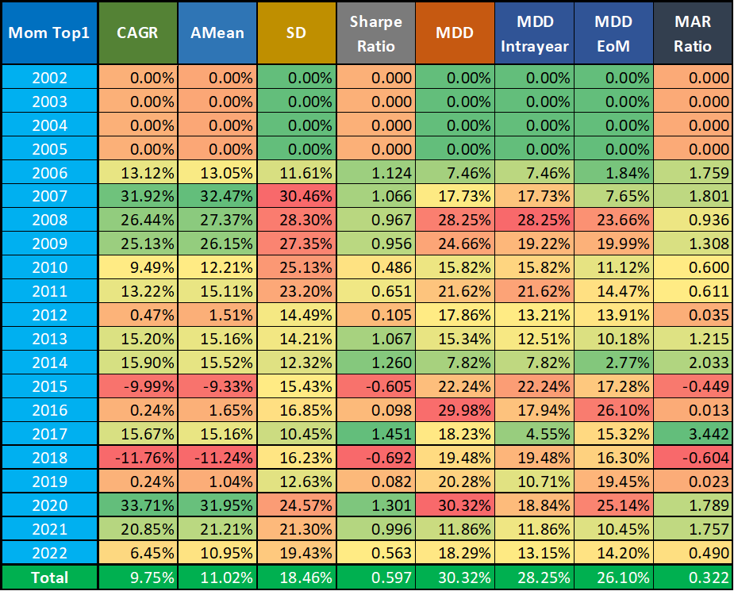

Table 1c: Performance indicators of ‘Momentum Top2’ sub-strategy

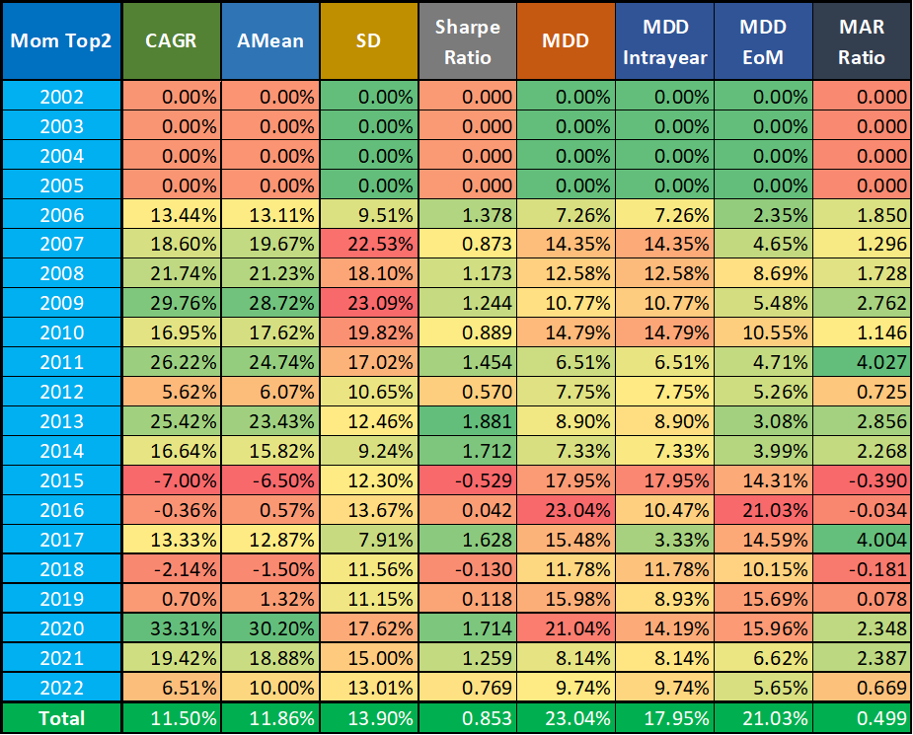

Table 1d: Performance indicators of ‘Momentum Top3’ sub-strategy

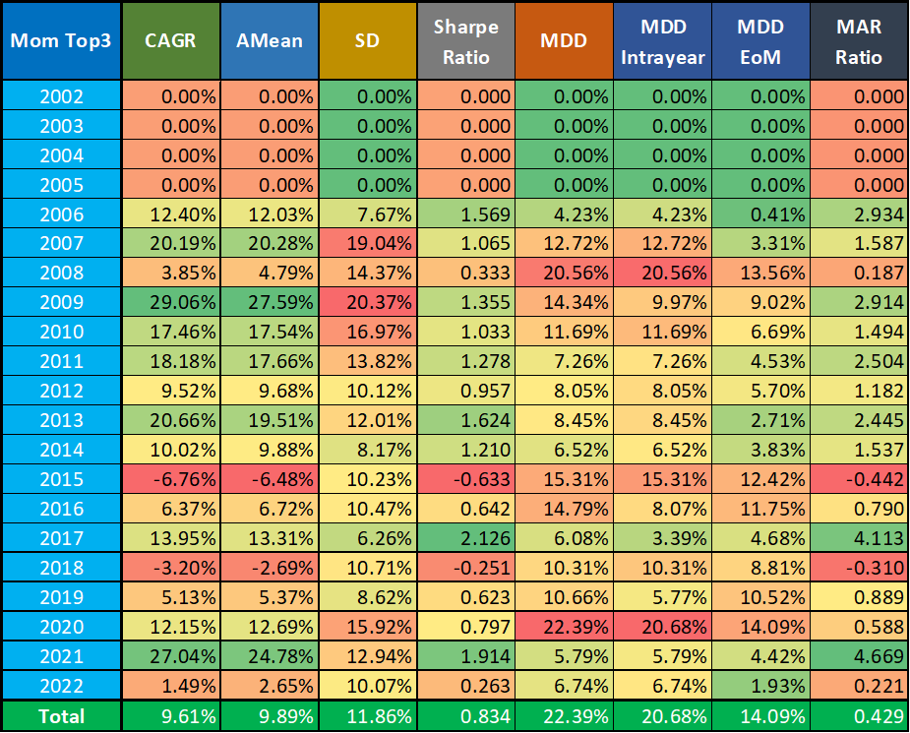

Table 1e: Performance indicators of the combination of ‘Value’ + ‘Momentum Top1’ sub-strategies

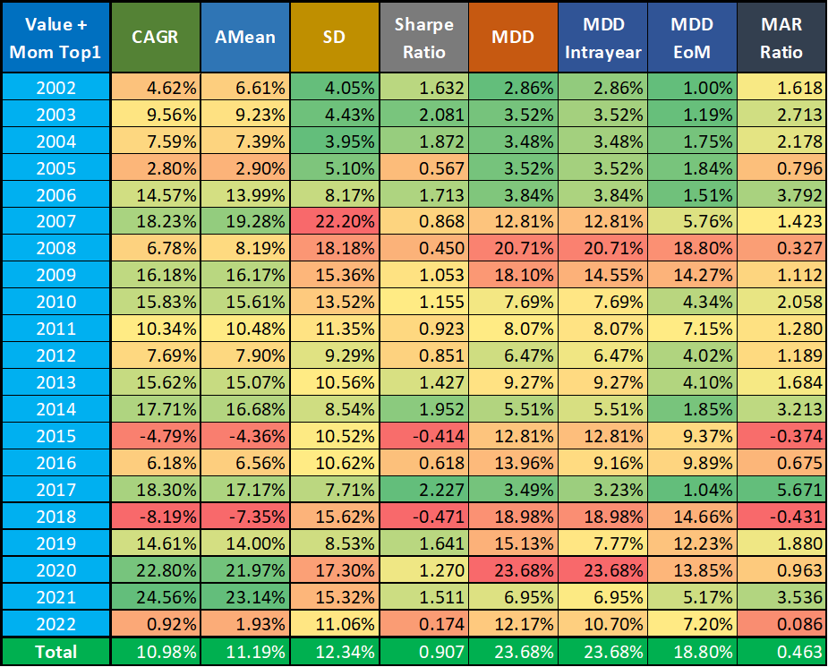

Table 1f: Performance indicators of the combination of ‘Value’ + ‘Momentum Top2’ sub-strategies

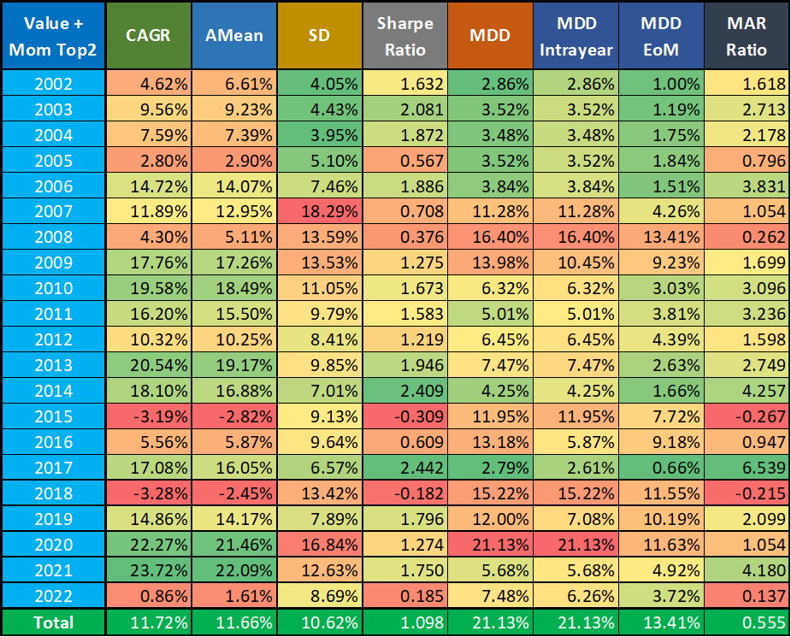

Table 1g: Performance indicators of the combination of ‘Value’ + ‘Momentum Top3’ sub-strategies

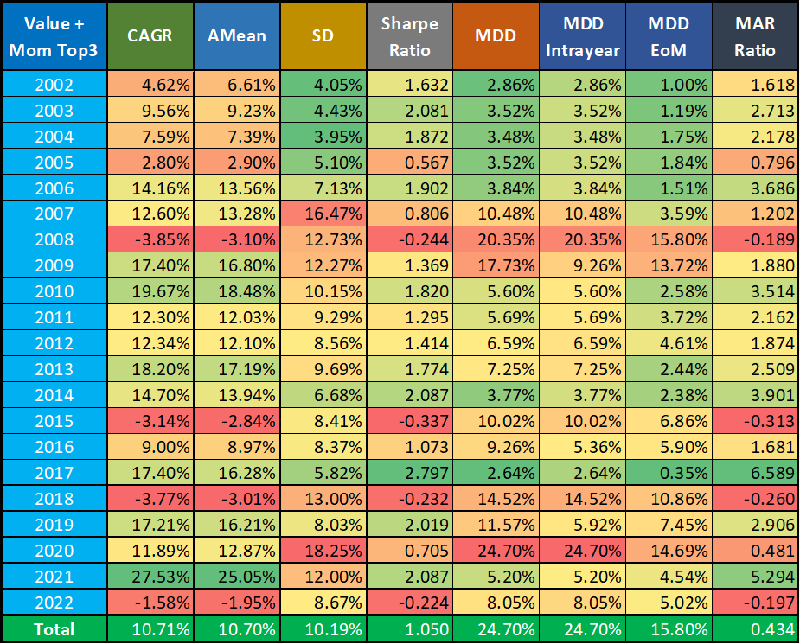

Table 1h: Performance indicators of the buy&hold SPY strategy

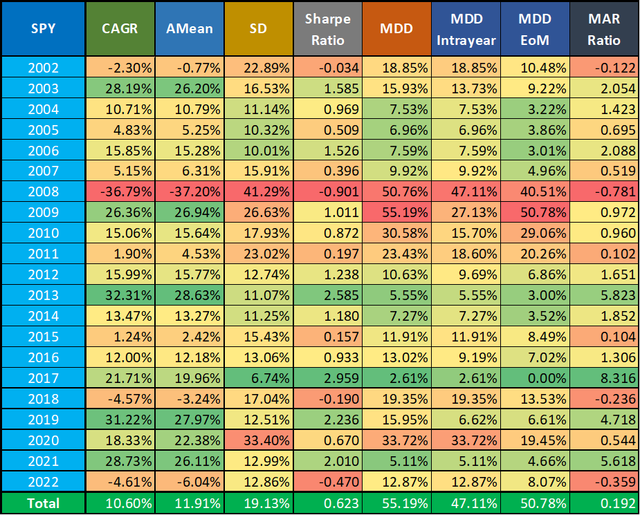

Table 1i: Performance indicators of the buy&hold QQQ strategy

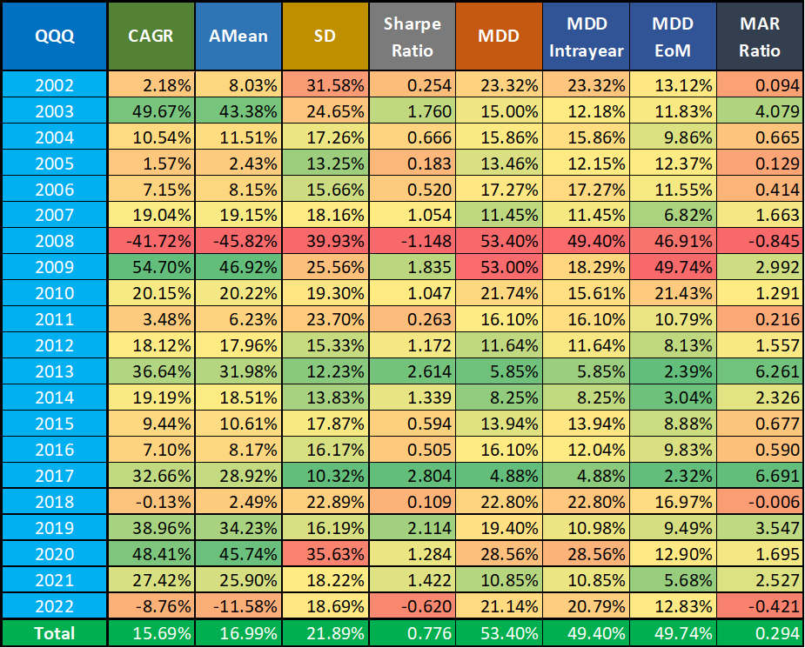

Table 2: Performance indicators of different CXO sub-strategies and their combinations (2002-2022)

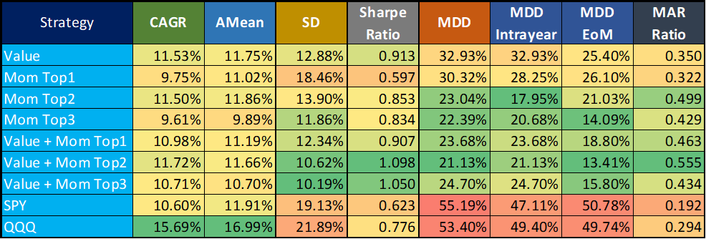

# 

## CXO: With Monthly Seasonality

Investors who like seasonality may **wonder if it would not be worthwhile to include the monthly seasonality of individual ETFs in the strategy as a leverage indicator**. In this section, we examine this issue with the help of **our calculator** (can be downloaded from [here](https://drive.google.com/file/d/1Z_-FabYhnGWNIScFU4GjjOBmpwtG-Cjv/)) created for this purpose (it uses data from 2002-08-01 to 2022-03-31).

With the help of the calculator, we can **add various leverages to sub-strategies with arbitrary weights** (e.g. 100% ‘Value’ or ‘50% Value +50% Momentum Top2’, etc. ), using **5 different leverage indicators**. Only ETFs recommended by CXO are played in a given month, but their **leverages can be changed**. Its user interface can be seen in Chart 2 (all gold colored cells can be modified as simulation parameters).

Chart 2: User interface of our ‘CXO Strategy with Monthly Seasonality’ calculator

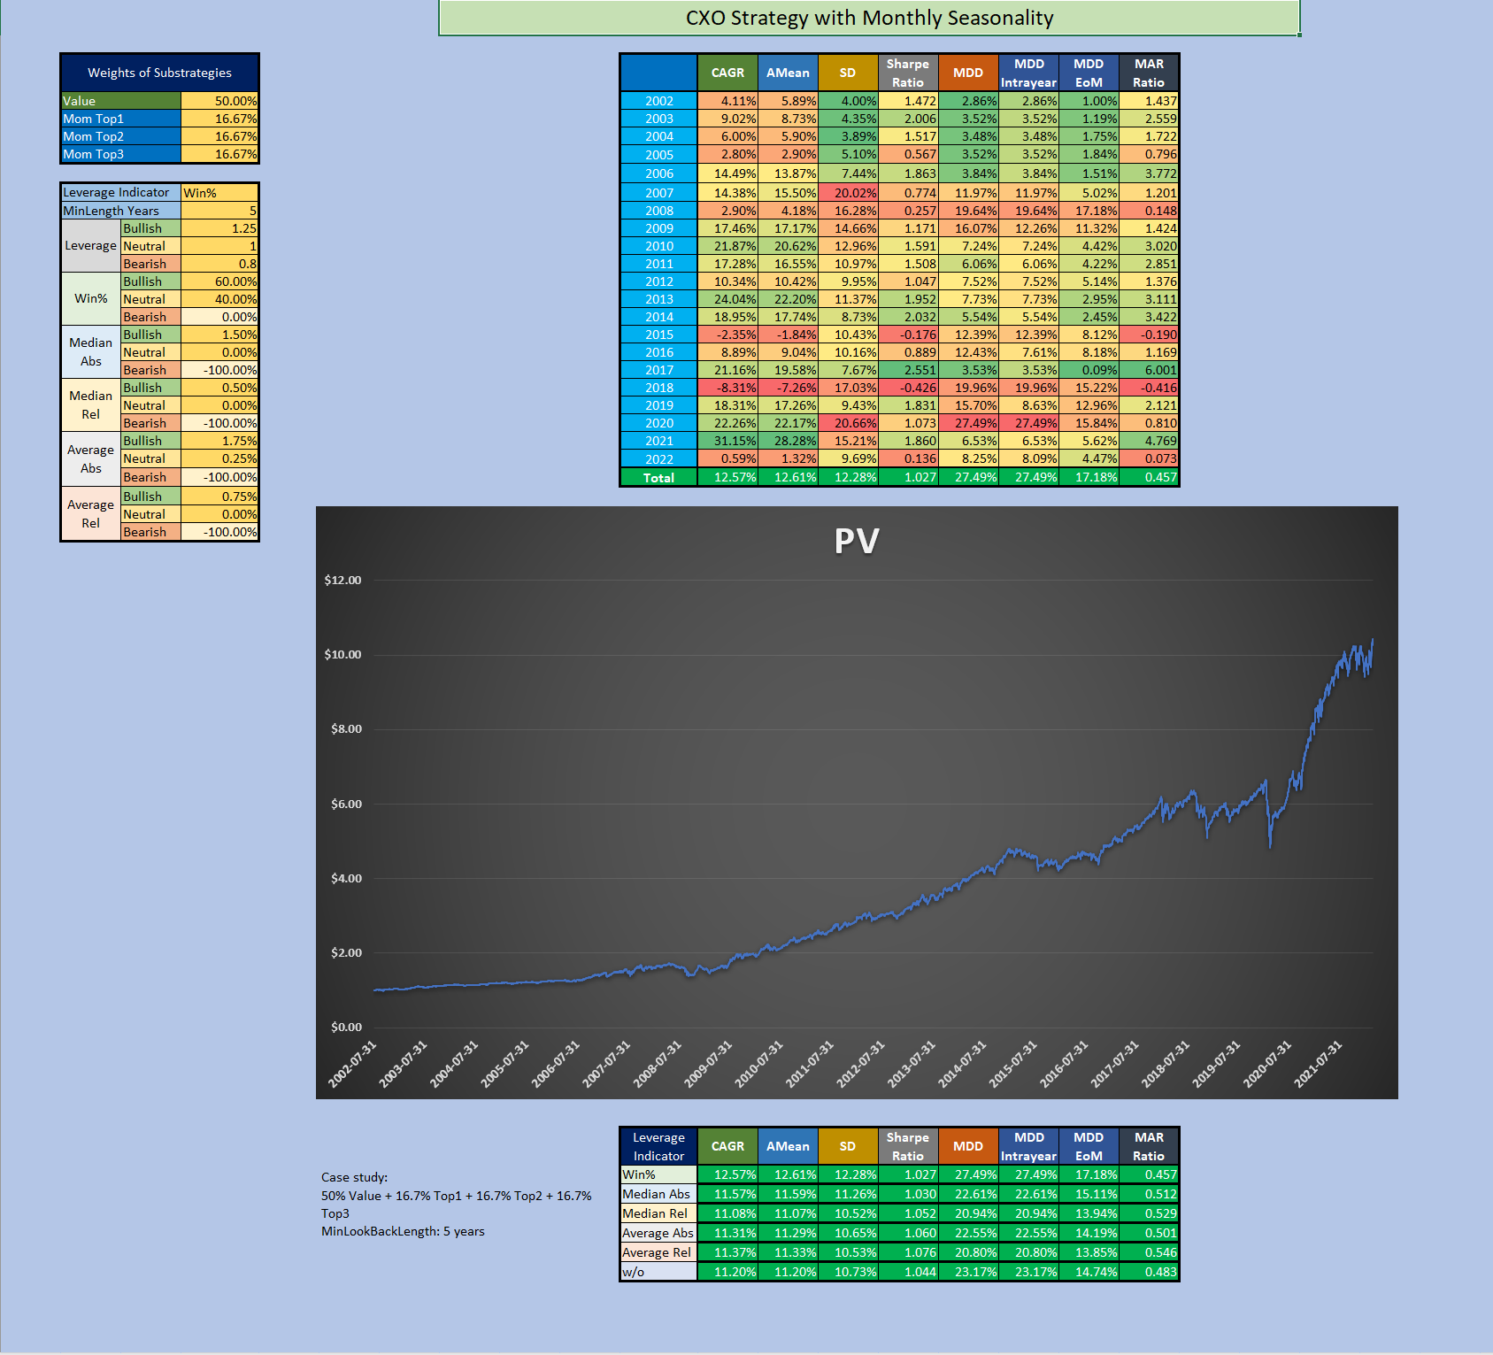

The possible indicators to choose:

* Win%: Increase/decrease the leverage of the selected ETF if its win% in the given month (e.g. January) in the past was higher/lower than a given threshold %.
* Median - Absolute: Increase/decrease the leverage of the selected ETF if its median monthly return in a given month in the past was higher/lower than a given threshold %.
* Median - Relative: Increase/decrease the leverage of the selected ETF if its median monthly return in a given month in the past was higher/lower with a given threshold % than its total median monthly return (in all months).
* Average - Absolute: Increase/decrease the leverage of the selected ETF if its average monthly return in a given month in the past was higher/lower than a given threshold %.
* Average - Relative: Increase/decrease the leverage of the selected ETF if its average monthly return in a given month in the past was higher/lower with a given threshold % than its total median monthly return (in all months).

Chart 2 already shows that due to the **large number of parameters** (minimum lookback length in years, leverage percentages, bullish and bearish thresholds), the **number of options is almost endless**. In order to be able to **compare the individual leverage indicators, and to decide whether they are needed at all, a few (6) case studies were prepared**. The **common parameters** for these are the following: minimum lookback length in years: 5 years; leverages: bullish 125%, neutral 100% and bearish 80%. The **individual threshold parameters** were selected after some optimization. The **comparative tables** of the results of these case studies can be found below (Table 3a-f). The “w/o” row shows the result of the base strategy ‘without’ this monthly seasonality.

Based on these figures, our thoughts and findings are:

* In the case of **pure ‘Momentum Top1’ and ‘Momentum Top2’ sub-strategies**, where there is very little (if any) diversification, the use of all five types of seasonality based indicators resulted in **some improvement in terms of Sharpe ratio and MAR ratio**. But it is worth noting again that this required optimising parameters.
* In the case of **more complex strategies**, the picture is more nuanced. The use of **some indicators can improve the results (in terms of Sharpe ratio and MAR ratio), while others make it worse**.
* Since it was established in the previous section that the **50% ‘Value’ + 50% ‘Momentum Top2’** strategy was the best performer in the last 20 years, it is worth taking a closer look at its results (Table 3f). In this case, it is **also true that some indicators improve the result to a small extent, while the others also do not significantly worsen the result compared to the version without seasonality**. ‘**Average - Relative’** produces the best numbers. But what these **minimal differences** mean is best shown in Chart 3. The difference is **almost invisible** to the naked eye. Because of such a **small, negligible advantage**, it is **not worth complicating the strategy by using more (optimised) parameters**.
* If this Seasonax style annual monthly-seasonality worked in the CXO ETF strategy, the **CXO researchers would have recognized it** already and would have incorporated it into the strategy. But they haven't. See their articles above with their conclusion.

Table 3a: Performance indicators of different leverage indicators with 50% ‘Value’ + 16.7% ‘Momentum Top1’ + 16.7% ‘Momentum Top2’+16.7% ‘Momentum Top3’ (2002-2022)

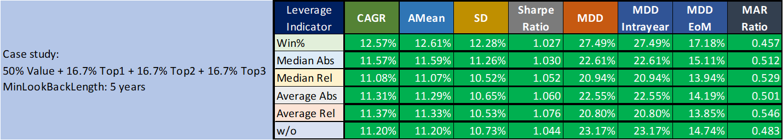

Table 3b: Performance indicators of different leverage indicators with 100% ‘Value’ (2002-2022)

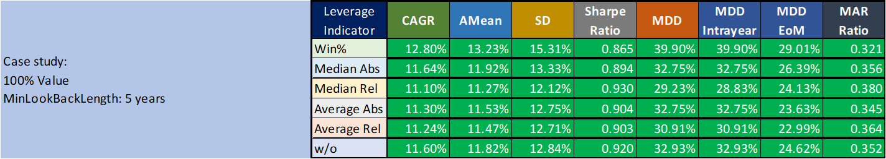

Table 3c: Performance indicators of different leverage indicators with 100% ‘Momentum Top1’ (2002-2022)

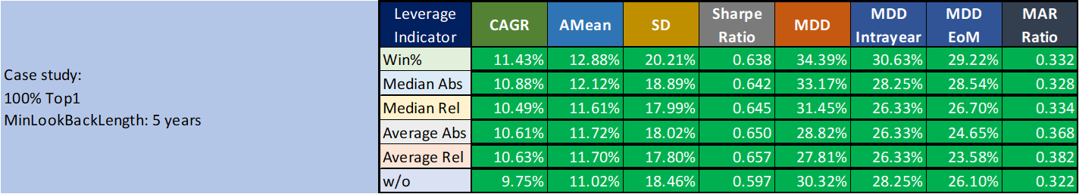

Table 3d: Performance indicators of different leverage indicators with 100% ‘Momentum Top2’ (2002-2022)

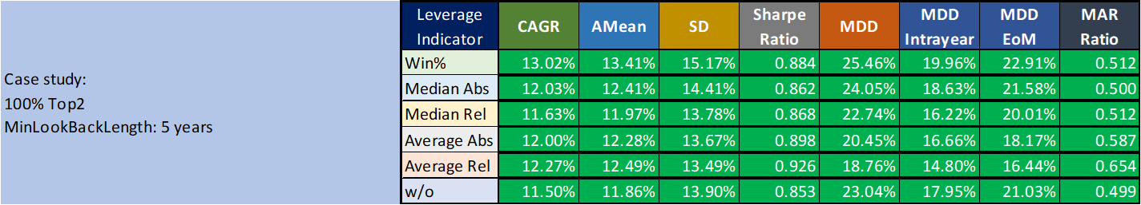

Table 3e: Performance indicators of different leverage indicators with 100% ‘Momentum Top3’ (2002-2022)

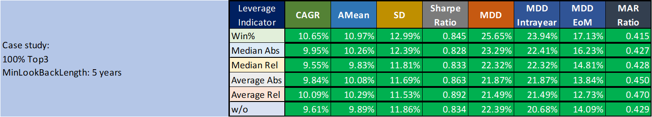

Table 3f: Performance indicators of different leverage indicators with 50% ‘Value’ + 50% ‘Momentum Top2’ (2002-2022)

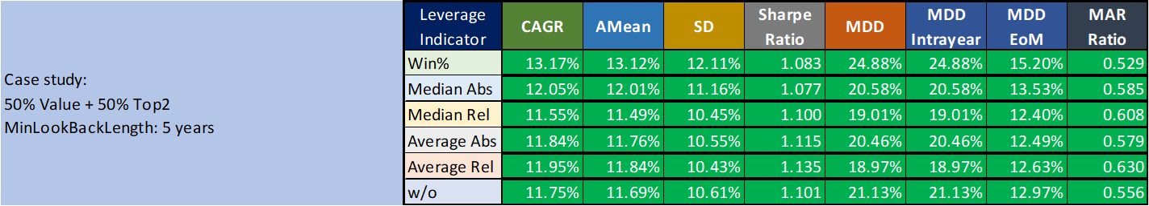

Chart 3: Portfolio Value of 50% ‘Value’ + 50% ‘Momentum Top2’ with ‘Average - Relative’ and without leverage indicator

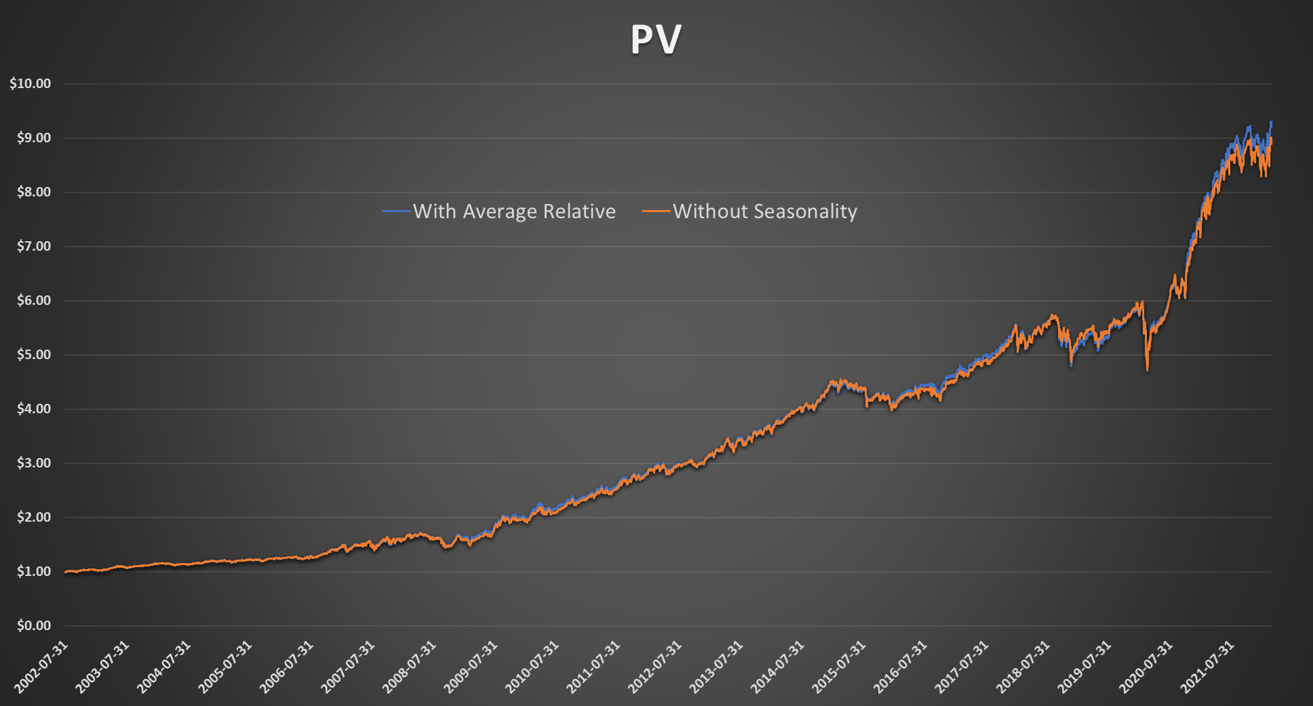

## 

## Tactical Asset Allocation with Monthly Seasonality

Speaking of CXO strategy and the issue of seasonality, it's worth recalling and taking a look at the results of one of our calculators from last year (‘[*CXO Strategy with Seasonality*](https://drive.google.com/file/d/10y4JOebG_Um0HBE83Lmp_FPksYm9W2H1)’).

In this calculator, we used **Tactical Asset Allocation (TAA) to select from all the ETFs played by CXO and give them different weights based on the position of the percentile channels**. After that, the calculation was expanded to the extent that at the time of each **rebalance**, **the weight of each ETF was modified using a leverage indicator based on calendar seasonality**. We examined **how each ETF performed in the previous years over x calendar days after the rebalance**, and based on that, we **increased, decreased or left the weights calculated by TAA** **unchanged**.

In the following chart (Chart 4) and table (Table 4), we can see the case when we apply a monthly rebalance at the end of the month and examine a monthly seasonality (with 125%, 100% and 80% leverages again). **This coincides with the seasonality examined in the previous section (only the method of selection is different)**.

**Based on these numbers and this chart, we can again draw the conclusion that even with the help of highly optimised seasonality parameters, we cannot significantly increase the performance of the strategy.**

Chart 4: Portfolio Value of TAA strategy using CXO’s ETFs and different monthly seasonality based leverage indicators (2005-2021)

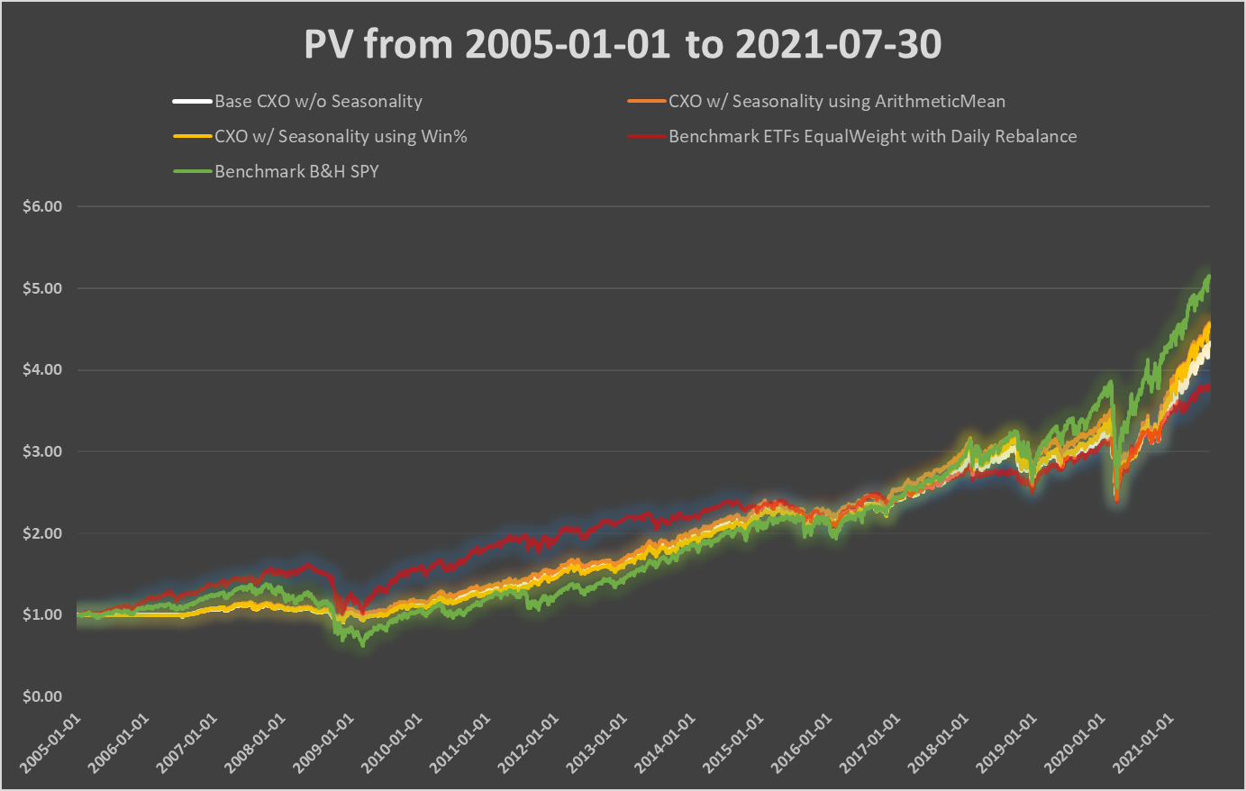

Table 4: Performance indicators of TAA strategy using CXO’s ETFs and different monthly seasonality based leverage indicators (2005-2021)

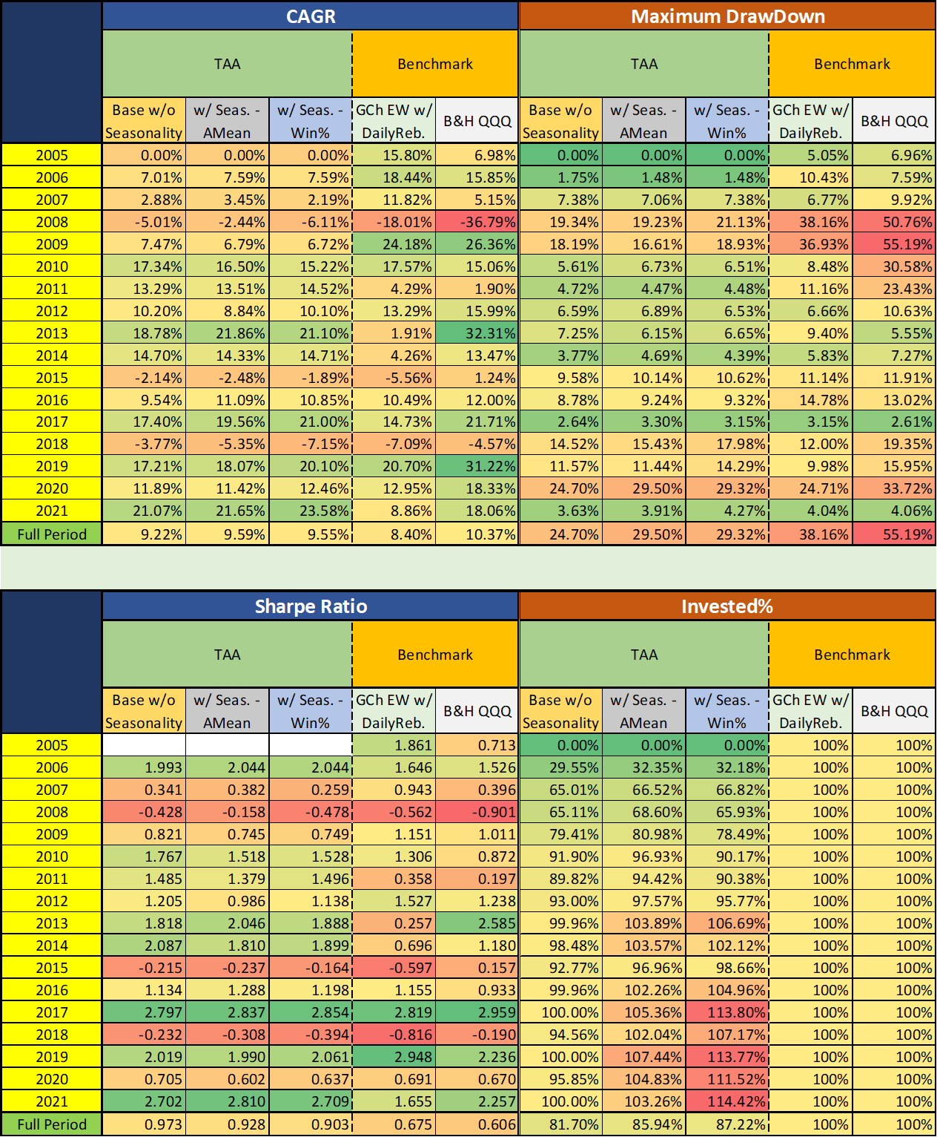

# **Conclusions**

In this study, as a first step, **the performance of the complex SACEVS-SACEMS strategy was presented by the numbers of CXO**.

This was followed by the results of our **own backtest**. In this section we came to the conclusion that, on the one hand, **we succeeded in reproducing the results of CXO**. On the other hand, **the 50% 'Value' + 50% 'Momentum Top2' combination we are currently playing seems to be the most successful**.

Finally, we examined **whether the performance of the strategy can be improved by taking the (Seasonax style) monthly seasonality of each ETF into account as well**. In these sections, we have established that **although with the help of certain indicators and over-optimized parameters, a small performance advantage can be achieved compared to the basic strategy without seasonality. But this non-significant, barely visible improvement is not worth overcomplicating the strategy.**

**The Seasonax style monthly seasonality seems to be a sound idea in theory. It is an interesting philosophical question why it doesn’t work in practice.**

CXO researchers give one kind of reason: **The Past.** They say that the number of past years that can be used (15-25) as a sample **is too low** for creating a reliable probability distribution model. They are right. They also mention that even 1 outlier year in that past sample **(just 1 very, very bad January in 20 years) distorts the probability model too much, for too many future years.**

On the other side of the coin, there can be another reason: **The Future.** Imagine for a moment that it is possible to create a good probability model by having 200 years of historical sample years. Still, **any future next year can wildly deviate from the 200 years historical slow-moving average.** An excellent illustration of this was the behaviour of natural gas **(UNG) in 2022** that was affected by the Ukraine situation.

A fourth reason is the **in-sample vs. out of sample dichotomy**. Theoretical backtests by Jay Kaeppel for example don’t make a proper distinction of training data vs. test data. The samples in the test data should not be used to train the model. And vica versa. We always do a proper walk-forward test in which only the data available until that rebalancing day is used. So our backtest is out of (training) sample. Most of the seasonality publications on the web don’t do this. It is easy to see that it leads to a big problem. Even **for a totally randomly generated number series, we can detect some fake monthly seasonality.** That is, some 2-3 months are randomly stronger, 2-3 months randomly weaker. **If a backtest is run using the same data for training as well as testing**, it is obvious that **extra illusionary profit can be detected**. Even though the numbers were totally randomly generated in the first place. That is the mistake in Jay Keappel's seasonality research, although he rightfully mentions this fact.