Dr. George Antal
3D Click Limited
c/o Suite 431, 28 Old Brompton Road, London SW7 3SS

Dual Momentum with Volatility and Correlation
Motivation 1
Background 2
‘CXO’: Asset Allocation Combining Momentum, Volatility, Correlation and Crash Protection 2
‘CXO’: A Few Notes on Dual Momentum Investing 4
‘CXO’: Simple Asset Class ETF Momentum Strategy (SACEMS) 7
‘CXO’: Are Equity Momentum ETFs Working? 13
Results 16
Who Laughs Last Laughs Best - Do winners really stay winners? 16
Dual Momentum 23
Dual Momentum with Volatility and Correlation 32
Conclusions 40

Motivation

Warren Buffett has said that trying to time the market is the number one mistake to avoid. Market timing is hard, if not impossible to do, as it often results in the investor buying or selling too late or too early rather than right on time. To even consider a market timing strategy is generally frowned upon by professional investors.

But there is a ‘successful’ strategy that has been followed — and widely discussed — for decades, yet somehow persists as a relatively reliable money-maker: “momentum” investing, which is betting that the stock market’s recent winners will remain winners in the near term and, likewise, that the recent losers will remain losers. The strategy also is known as “relative strength” investing.

An improvement of this strategy was developed and published by Gary Antonacci in 2014. This is the 'Dual Momentum strategy' that has been widely used since then. Here, we take into account not only the relative, but also the absolute momentum. It is a strategy that compares the price of a security to its historical performance or to zero (positive or negative lagged return).

We have dealt with this issue several times before. In this study, based on a CXO article (Asset Allocation Combining Momentum, Volatility, Correlation and Crash Protection), we try to find an answer to the question of whether the performance of the dual momentum strategy can be improved if we take into account the volatility and correlation of assets as well.

As a first step, in the ‘Background’ chapter, we present the original article, the dual momentum strategy itself and some interesting articles. After that, some thought-provoking results about the usefulness of relative momentum have been presented in the first section of the ‘Results’ chapter. Thereafter, we look at an example of the applicability of the dual momentum in a specific strategy with the help of our basic dual momentum calculator. Then we close the study by presenting the new version of our calculator extended with volatility and correlation and reporting its results.

Background

In this chapter, four CXO articles will be cited. The very first of them is the main reason why the entire study was written. Interestingly, this article (written 9 years ago) does not yet use the term dual momentum, as it was written before the publication of Antonacci's book. The second cited article contains thoughts related to Antonacci's book. This is followed by the moment-based strategy of the CXO, which we also like and play in real life. Finally, there is a thought-provoking article that examines how effective momentum-based ETFs are.

‘CXO’: Asset Allocation Combining Momentum, Volatility, Correlation and Crash Protection
“Does combining different portfolio performance enhancement concepts actually improve outcome? In their December 2012 paper entitled “Generalized Momentum and Flexible Asset Allocation (FAA): An Heuristic Approach”, Wouter Keller and Hugo van Putten investigate the effects of combining momentum, volatility and correlation selection criteria to form an equally weighted portfolio of the three best funds from a set of mutual fund proxies for seven asset classes, as follows:
- To follow trend, rank funds from highest to lowest lagged total return (relative momentum).
- To suppress volatility, rank funds from lowest to highest volatility (standard deviation of daily returns).
- To enhance diversification, rank funds from lowest to highest average pairwise correlation of daily returns.
- To avoid drawdown, replace with cash any selected fund that has a negative lagged return (intrinsic or absolute momentum).
Their seven asset class proxies are index mutual funds for U.S. stocks (VTSMX), developed market stocks outside the U.S. and Canada (FDIVX), emerging market stocks (VEIEX), mid-term U.S. Treasuries (VBMFX), short-term U.S. Treasuries (VFISX), commodities (QRAAX) and real estate (VGSIX). They use a default lagged measurement interval of four months for all four selection criteria. Their method of combining rankings for relative momentum, volatility and correlation is simple weighted average (with default weightings of 1, 0.5 and 0.5, respectively). They assume momentum calculations occur at the end of each month, with portfolio changes at the beginning of the next month. Using daily closing prices in U.S. dollars for the seven mutual funds from mid-1997 through mid-December 2012, they find that:
- During January 2005 through mid-December 2012 (see the chart below):
  - An equally weighted, monthly rebalanced benchmark portfolio of all seven funds generates a gross annualized average return of 5.6%, with annualized volatility 16.6% (reward-to-risk 0.34).
  - Applying relative momentum only to choose each month three winning funds generates an average annualized gross return of 9.1%, with annualized volatility 14.5% (reward-to-risk 0.63).
  - Applying the absolute momentum criterion to replace relative momentum winners with cash (VFISX) when their lagged returns are negative limits drawdowns and generates an average annualized gross return of 11.7%, with annualized volatility 12.8% (reward-to-risk 0.92).
  - Combining relative momentum and volatility, with volatility ranking given half the weight of return ranking, to select the top three funds and then applying the absolute momentum criterion generates an average annualized gross return of 12.5%, with annualized volatility 11.7% (reward-to-risk 1.07).
  - Combining relative momentum, volatility and correlation, with the latter two rankings given half the weight of return ranking, to select the top three funds and then applying the absolute momentum criterion generates an average annualized gross return of 14.7%, with annualized volatility 9.2% (reward-to-risk 1.60).
  - Adjusting the weights used to combine relative momentum, volatility and correlation rankings to optimize gross reward-to-risk ratio boosts its value to 1.76 (reducing average annualized gross return to 13.0%, but lowering annualized volatility to 7.4%).
    - Breakeven fund switching friction for this optimized portfolio relative to the benchmark is 1.2% of value switched each month.
    - Applying leverage to increase the volatility of this solution to approximately that of the S&P 500 Index and incorporating 0.1% one-way trading friction generates an average annualized net return of 22.6%, with annualized volatility 14.7% (reward-to-risk 1.54).
- During January 1998 through December 2004 (out-of-sample tests for robustness):
  - An equally weighted, monthly rebalanced benchmark portfolio of all seven funds generates a gross annualized average return of 8.3%, with annualized volatility 9.8% (reward-to-risk 0.85).
  - Combining relative momentum, volatility and correlation, with the latter two rankings given half the weight of return ranking, to select the top three funds and then applying the absolute momentum criterion generates an average annualized gross return of 13.4%, with annualized volatility 7.7% (reward-to-risk 1.73).
  - For the final in-sample optimized and leveraged solution above, average annualized net return is 21.6%, with annualized volatility 14.5% (reward-to-risk 1.49).
- On a gross basis over the entire January 1998 through mid-December 2012 test period, the combined strategy beats the benchmark for lagged measurement intervals ranging from one to 12 months, with four months optimal. Results are generally robust to small variations in the number of funds selected, the lagged measurement interval and the weights used for combining relative momentum, volatility and correlation rankings.
The following chart, constructed from data in the paper, summarizes average annualized gross returns and volatilities for progressive addition of fund selection criteria during the January 2005 through mid-December 2012 subperiod. The benchmark is the equally weighted, monthly rebalanced portfolio of all seven mutual funds. The active allocations are equally weighted portfolios of the top three mutual funds based on: relative momentum only (R); relative momentum plus the absolute momentum criterion (R+A); combined relative momentum and volatility rankings, plus the absolute momentum criterion (R+V+A); and, combined relative momentum, volatility and correlation rankings, plus the absolute momentum criterion (R+V+C+A). Weights for volatility and correlation rankings are half that for relative momentum ranking.
Results indicate that each fund selection criterion adds value, though the value from volatility ranking is modest. Respective gross reward-to-risk ratios from left to right are 0.34, 0.63, 0.92, 1.07 and 1.60.
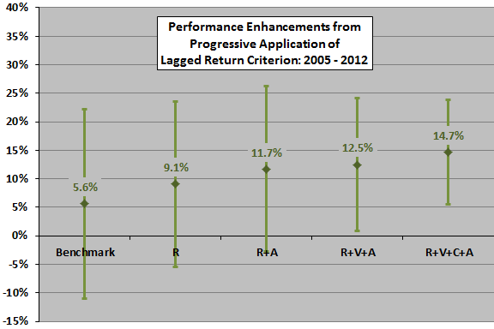
In summary, evidence indicates that a tactical asset class allocation strategy combining high relative momentum, low volatility, low correlation and absolute momentum all measured over the past few months easily outperforms passive diversification.
Cautions regarding findings include:
- As noted in the paper, parameter selections (top three funds, lagged measurement interval of four months, relative weights assigned to lagged return/volatility/correlation rankings) are empirical optimizations, subject to data snooping bias. Out-of-sample and robustness tests largely mitigate this concern.
- Results above and the simple empirical analyses in “Asset Class Diversification Effectiveness Factors” suggest that lagged volatilities of asset returns are unimportant compared to their lagged average returns and lagged average pairwise correlations.
- Costs and constraints for trading mutual funds (such as front-end loads, back-end loads, management fees and short-term trading restrictions) may differ from those for trading exchange-traded fund (ETF) alternatives. The switching friction tests in the paper are therefore notional.”

‘CXO’: A Few Notes on Dual Momentum Investing
“In the preface to his 2015 book entitled Dual Momentum Investing: An Innovative Strategy for Higher Returns with Lower Risk, author Gary Antonacci states: “We need a way to earn long-term above-market returns while limiting our downside exposure. This book shows how momentum investing can make that desirable outcome a reality. …the academic community now accepts momentum as the ‘premier anomaly’ for achieving consistently high risk-adjusted returns. Yet momentum is still largely undiscovered by most mainstream investors. I wrote this book to help bridge the gap between the academic research on momentum, which is extensive, and its real-world application… I finally show how dual momentum—a combination of relative strength and trend-following…is the ideal way to invest.” Based on a survey of related research and his own analyses, he concludes that:
From Chapter 1, “World’s First Index Fund” (Page 11): “After years of momentum research by many academics, even Eugene Fama and Kenneth French, two of the founders of EMH [Efficient Market Hypothesis], began paying attention to momentum, which they called the ‘premier anomaly.’ Momentum was powerful, persistent, and not explainable by any of the commonly known risk factors.”
From Chapter 2, “What Goes Up…Stays Up” (Pages 23-24): “All of these publicly available products apply relative strength momentum to individual stocks. They therefore miss the potential risk-reducing benefits of cross-asset diversification. Using momentum with individual stocks also results in substantially higher transaction costs than applying momentum to broad asset classes and indexes. Also important is the fact that while relative strength momentum can enhance returns, it does little to reduce volatility or maximum drawdown. These risks may even increase compared to similar portfolios using nonmomentum, buy-and-hold strategies.”
From Chapter 3, “Modern Portfolio Theory Principles and Practices” (Page 34): “While academics remained busy engineering more complex ways to model financial markets, simple momentum has stood the test of time as the premier market anomaly.”
From Chapter 4, “Rational and Not-So-Rational Explanations of Momentum” (Page 43): “…momentum is not just a 212-year flash in the pan. There are logical reasons why momentum works—and, in fact, there are plenty of them.”
From Chapter 5, “Asset Selection: The Good, the Bad, and the Ugly” (Page 70): “Today’s overemphasis on diversification often leads to mediocrity and unnecessary expense. …Without discrimination, diversification can become “deworsification.” …low-cost equity and fixed-income index funds, appropriately selected by dual momentum, are all that one needs for investment success.”
From Chapter 6, “Smart Beta and Other Urban Legends” (Page 79): “Rather than deal with all this complexity and uncertainty [of smart beta strategies], for most investors, simply using traditional capitalization-weighted indexes is most likely a better approach. Smart beta investors may…be able to capture the same incremental returns from just a rebalanced stock/bond or sector portfolio.”
From Chapter 7, “Measuring and Managing Risk” (Pages 85, 87, 89): “Absolute momentum is roughly the same as relative momentum applied to an asset paired up with Treasury bills. …The biggest advantage of absolute momentum over relative momentum…is its ability to reduce dramatically portfolio downside vulnerability by exiting positions early during bear markets. …The best approach is to use absolute and relative together in order to gain the advantages of both. The way we do that is by first using relative momentum to select the best-performing asset… We then apply absolute momentum as a trend-following filter…”
From Chapter 8, “Global Equities Momentum” (Pages 94, 103): “Dual momentum can take us from naive diversification to a dynamically adaptive asset allocation approach that keeps us better in tune with changing market regimes and less exposed to converging market correlations. …Over this entire 40-year period [1974-2013], GEM has an average annual return of 17.43% with a 12.64% standard deviation, a 0.87 Sharpe ratio, and a maximum drawdown of 22.7%. This almost doubling of the annual rate of return over ACWI [MSCI All Country World Index] comes with a reduction in volatility of 2%. The Sharpe ratio quadruples, and the maximum drawdown drops by nearly two-thirds. …As an indication of robustness, GEM also showed consistency throughout the data, having much higher Sharpe ratios and lower maximum drawdowns than ACWI during each of the four decades.” [See the figure below.]
From Chapter 9, “Mo’ Better Momentum” (Page 116): “With so much going for dual momentum, if you try to replace or modify this proven approach with something new, you face several potential problems. First is the multiple-comparisons hazard that comes from data mining when it becomes data snooping. If you look at enough different strategies, almost certainly a few of them will look attractive. However, this simply can be due to chance or luck. …By adding complexity to a model, you may make it too rigid by molding it perfectly to ‘predict’ the past.”
From Chapter 10, “Final Thoughts” (Pages 138-139): “There will undoubtedly be periods when dual momentum underperforms its benchmarks. During those times, investors may lose sight of the big picture and be tempted to behave in ways that hurt them in the long run. The main challenge facing dual momentum investors in the future may very well be their own willingness to follow the model patiently and with the requisite discipline.”
The following figure, taken from the book, compares gross average annual return-annual volatility relationships for four strategies during 1974 through 2013 (40 years):
- All Country World Index – buy and hold the GSCI All Country World Index (ACWI).
- Absolute Momentum – apply absolute momentum to ACWI by each month holding ACWI or Barclays U.S. Aggregate Bond Index according to past performance of ACWI.
- Relative Momentum – apply relative momentum to ACWI by by each month holding the S&P 500 Index or ACWI ex-U.S., according to their relative past performance.
- Global Equity Momentum: combine absolute and relative momentum by applying the monthly GEM strategy outlined in Chapter 8 of the book.
The figure shows that Absolute Momentum outperforms buying and holding ACWI by boosting gross average return and suppressing volatility. Relative Momentum also boosts gross average return, but with somewhat elevated volatility compared to buy-and-hold. In combination (Global Equity Momentum), the two types of momentum strongly boost gross average return while suppressing volatility.
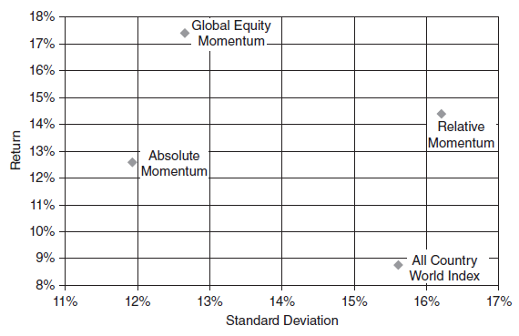
In summary, investors will find Dual Momentum Investing a useful synthesis of the stream of research on relative and absolute (or time series or intrinsic) momentum applied simply in combination to a few asset classes.
Cautions regarding conclusions include:
- Per the assumptions regarding Global Equities Momentum strategy performance in Appendix A of the book: “All performance represents total returns and includes reinvestment of interest and dividends but does not reflect possible management fees, transaction costs, taxes or other expenses.” These frictions would reduce reported performance. More specifically, frictions may include:
  - Management/administrative fees imposed and trading frictions incurred by fund managers in maintaining liquid tracking funds for the underlying indexes.
  - Trading frictions incurred directly for any changes in positions based on monthly calculations.
  - Trading frictions incurred directly from reinvestment of interest and dividends.
- The sample period is not long in terms of secular economic/market trends that may affect strategy performance. For example, much of the 1974-2013 sample period encompasses a secular decline in interest rates and attendant bull market in intermediate-term bonds. The strategy may not work as well during a secular rise in interest rates and attendant bond bear market.”
See “Intrinsic Momentum Across Asset Classes” for a summary of the paper that appears as Appendix B of the book. See also “Which Kind of (ETF) Momentum Is Best?” and “Melding Momentum, Diversification and Absolute Return” for summaries of other papers by the author.”

‘CXO’: Simple Asset Class ETF Momentum Strategy (SACEMS)
“As elaborated in "What Works Best?", a strategic allocation involving perhaps five to ten equally weighted asset classes available via low-fee exchange-traded funds (ETF) or mutual funds, with periodic rebalancing, is a simple way for individual investors to harvest uncorrelated volatility over the long term. For investors seeking an active (tactical) edge, there is evidence supporting exploitation of intermediate-term relative momentum of asset class proxies.
The Simple Asset Class ETF Momentum Strategy (SACEMS) seeks diversification plus a monthly tactical edge by holding a few top-performing ETFs. We consider three versions of SACEMS, which at the end of each month allocate all funds to the top one (Top 1), the equally weighted top two (EW Top 2) or the equally weighted top three (EW Top 3) asset class ETFs from a diversified set of nine, based on total return over recent months.
…
Some investors may want to follow one of the alternatives tracked here. Others may want to adapt them with modifications suited to their individual goals and constraints. Still others may want to apply the analysis approaches to test other strategies. Something to keep in mind is that adding complexity to a strategy increases the number of ways to optimize it in backtests and thereby elevates potential for data snooping bias.
The next section summarizes historical (backtest) performance data.
Historical Performance
The following chart shows the gross cumulative values of $100,000 initial investments in SACEMS Top 1, EW Top 2 and EW Top 3 since the end of June 2006 (based on availability of ETF data). The chart includes three benchmarks: (1) an equally weighted, monthly rebalanced portfolio of all ETFs in the SACEMS universe (EW All), indicative of simple diversification; (2) buying and holding SPDR S&P 500 (SPY); and, (3) SPY:SMA10, a simple timing strategy that holds SPY (Cash) when the S&P 500 Index is above (below) its 10-month simple moving average.
Results indicate that SACEMS is attractive, but has setbacks. For perspective, we look at an array of performance metrics.
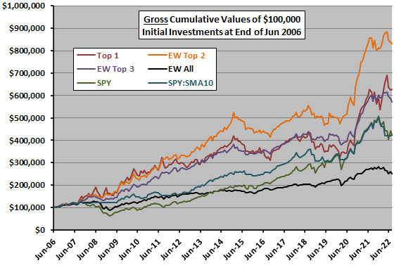
The following table summarizes some monthly statistics for these same strategies over the available sample period. Return/Risk is average return divided by standard deviation. Maximum (peak-to-trough) drawdowns are based on monthly measurements over the sample period.
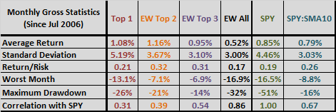
The next table summarizes annual/annualized returns for these strategies over different intervals commonly used to describe performance of funds. The annualized returns are compound annual growth rates (CAGR). Only the longest measurement intervals include a major equity bear market. For Sharpe ratio, to calculate excess annual return, we use average monthly yield on 3-month Treasury bills during a year as the risk-free rate for that year.
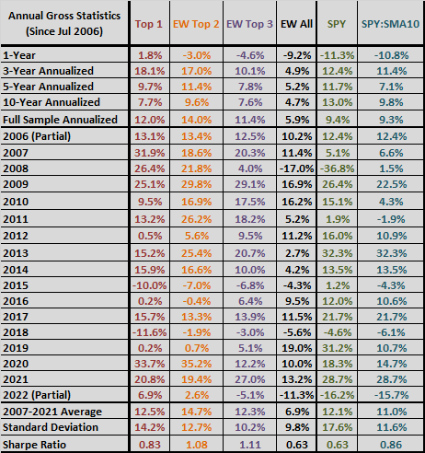

Performance Assessment
Results at this point suggest:
- EW All is not attractive.
- Outperformance of SACEMS EW Top 2 and EW top 3 relative to the very simple SPY:SMA10 is material with respect to both returns and Sharpe ratios. SACEMS seeks to access the resilience of multiple asset classes efficiently. SPY:SMA10 is essentially a one-asset class (two, viewing cash as an asset class) timing strategy, with a lookback interval somewhat comparable to that of SACEMS. A possible interpretation of results is that the momentum strategy gives many noisy choices when times are good for U.S. stocks, but that buying and holding SPY and SPY:SMA10 do not give enough choices when times are bad.
- Overall, SACEMS outperforms SPY, especially in terms of Sharpe ratios. However, in recent intervals, SPY wins.
There are longer backtests of relevant strategies in the second list of links at "What Works Best?", which mostly weigh in on the side of considering multiple asset classes, but these backtests generally have biases.
Pairing SACEMS with a value strategy to offset its setbacks while retaining nearly all performance appears to be attractive.
What one picks as the best strategy should take into consideration: investment horizon; risk tolerance; taxes; and, beliefs about future financial environments. For example:
- How likely is another deep bear market for U.S. stocks? What will be the future bull/bear mix?
- The available sample period is largely disinflationary (probably favorable to stocks, bonds and real estate). Is a sustained rise in the inflation rate plausible, and what would it do to the different asset classes?
- How might the geopolitical environment evolve and affect U.S. versus non-U.S. stocks?
The next section describes aspects of the strategy in detail.
In-depth Strategy Background
The following 8 asset class ETFs, plus cash, comprise the universe of asset class proxies considered:
- Invesco DB Commodity Index Tracking (DBC)
- iShares MSCI Emerging Markets Index (EEM) until December 2007, and iShares JPMorgan Emerging Markets Bond Fund (EMB) thereafter
- iShares MSCI EAFE Index (EFA)
- SPDR Gold Shares (GLD)
- iShares Russell 2000 Index (IWM)
- SPDR S&P 500 (SPY)
- iShares Barclays 20+ Year Treasury Bond (TLT)
- Vanguard REIT ETF (VNQ)
- 3-month Treasury bills (Cash)
This set of ETFs offers: (1) opportunities to capture momentum across global developed and emerging equity markets (EMB is substantially equity-like, but calmer), large and small U.S. equities and bonds and commodities; (2) gold and cash as safe havens; (3) histories long enough for backtesting across multiple market environments; and, (4) simplicity of computation and recognition of the trade-off between number of ETFs and trading frictions.
We rank these assets based on total (dividend-adjusted) returns over past (lookback) intervals of one to 12 months. We consider portfolios of past ETF winners based on Top 1 and on EW Top 2 through EW Top 5. We consider as EW All, SPY and SPY:SMA10 as benchmarks. We use monthly dividend-adjusted closing prices for the asset class proxies and the yield for Cash since February 2006 (based on availability of selected ETFs).
Portfolio performance calculations assume:
- Identify the top performing ETFs over the ranking (lookback) interval just before the close on the last trading day of each month and reallocate at that same close. This assumption is problematic when performance differences among ETFs are very small.
- Ignore trading frictions, which depend on portfolio turnover, ETF bid-ask spreads, specific broker fees and portfolio size. This assumption is especially problematic for investors whose brokerage fees are material relative to portfolio size. There is sometimes a meaningful trade-off between exact rebalancing to equal weights and trading frictions.
- Ignore tax implications of trading. This assumption is problematic for investors using taxable accounts.
We first compare CAGRs and maximum drawdowns (MaxDD) of Top 1, EW Top 2 and EW Top 3 across lookback intervals ranging from one to 12 months (left column of each of the following two tables), all reformed monthly. All calculations start at the end of February 2007 to accommodate inception of DBC with the longest lookback interval. Color coding uses red as good and blue as bad. Notable points are:
- A 4-month lookback interval is best overall based on gross performance.
- Top 1 (EW Top 3) performance is unstable (fairly stable) across ranges of lookback intervals. Combining momentum with diversification limits consequences of choosing a lookback interval.
- The number of switches generally increases as lookback interval decreases, as indicated by the number of Top 1 portfolio switches in the middle column.
- Longer lookback intervals are relatively unattractive.
- Experimentation with lookback intervals without supporting theory introduces data snooping bias. The fairly short available sample exacerbates this bias.
We select a 4-month lookback interval for subsequent analyses. This decision incorporates a qualitative judgment that, due to accelerating movement of data and increasing use of algorithmic trading, inter-asset class dynamics seem more likely to speed up than slow down in the future.
What are the selection frequencies of the ETFs based on a 4-month lookback interval?
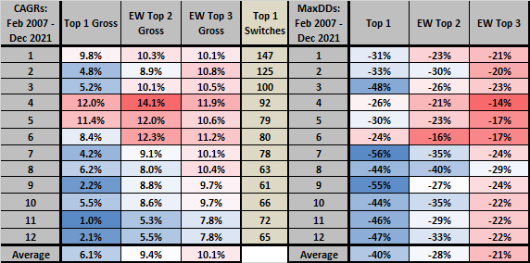
The following chart summarizes selection frequencies for ranks 1, 2 and 3 among the nine available assets over the test period commencing June 2006 (accommodating an initial 4-month lookback interval for all ETF series). Results suggest that all nine play material roles.
Does momentum effectively pick asset classes that perform well the next month?
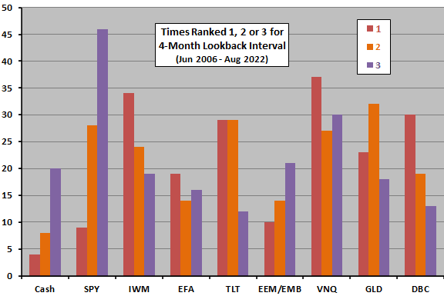
The next chart compares average gross monthly returns with one standard deviation variability ranges for momentum ranks 1 through 9 based on a 4-month lookback interval over the test period. Notable points are:
- Though the progression is imperfect, results generally support belief that asset class proxies with higher (lower) 4-month past returns tend to perform well (poorly) next month.
- Even the worst-performing ranks have non-negative returns.
Return/Risk values (average return divided by standard deviation) range from 0.01 for rank nine to 0.31 for rank two.
How do these results translate to diversified momentum portfolios?
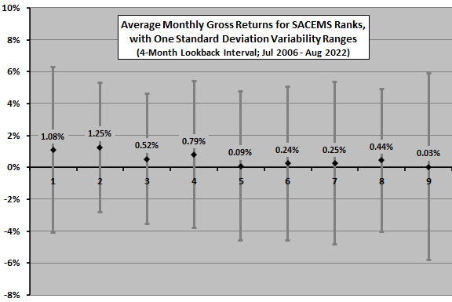
The next chart shows average gross monthly returns with one standard deviation variability ranges for EW Top 2, EW Top 3, EW Top 4 and EW Top 5 momentum portfolios based on a 4-month lookback interval over the test period. It also shows the same for EW All, SPY and SPY:SMA10 benchmarks. Notable points are:
- EW Top 2 through EW Top 4 are fairly attractive.
- EW All is not attractive as an asset class diversification approach.
- SPY:SMA10 is fairly attractive as a U.S. equity market timing alternative.
Return/Risk values for EW Top 2 through EW Top 5 are 0.32, 0.31, 0.30 and 0.25, respectively. Those for EW All, SPY and SPY:SMA10 are 0.17, 0.19 and 0.26.
Is the momentum effect consistent over time?
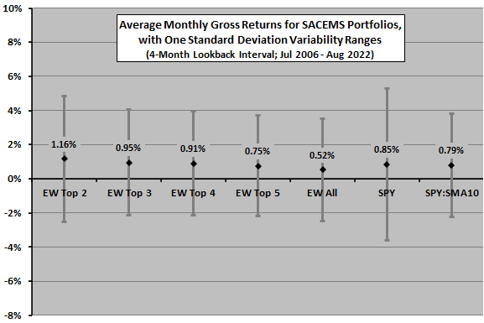
The final chart shows EW Top 2 monthly return based on a 4-month lookback interval minus EW All return by month over the sample period, along with a best-fit linear trend line. Results indicate that the ability of 4-month past return to pick next-month winners deteriorates over the test period, but the available sample is short in terms of variety of market conditions (especially number of equity bull and bear states). Deterioration may derive from multiple asset class bear markets early in the sample period and multiple bull markets later in the sample period.
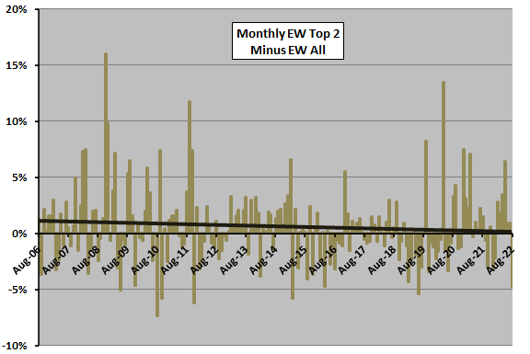
In summary, evidence suggests that diversified SACEMS portfolios are attractive compared to various benchmarks, but the added value of momentum may be dissipating or concentrated in unusual market conditions.
Cautions regarding findings include:
- As noted, sample size is modest (in terms of independent 4-month lookback intervals).
- As noted, analyses are gross. Accounting for costs of monthly portfolio reformation would reduce returns. Trading frictions during the sample period are low.
- As noted, momentum strategy outperformance concentrates during the financial crisis and may be weakening over time. The body of associated research (see the second list of research summaries in “What Works Best”) offers some mitigation of these concerns.
- Live tracking of this strategy commenced about mid-2010. In September 2012, we adjusted the strategy to optimize the lookback interval (see “Model Momentum Strategy Adjustment”). In May 2014, we incorporated changes in historical return data for some ETFs (see “Simple Asset Class ETF Momentum Strategy Data Changes”). We made minor changes to coordinate with the Simple Asset Class ETF Value Strategy at the end of April 2017. In January 2019, we again adjusted the lookback interval per “Adjust the SACEMS Lookback Interval?”. In June 2019, we adjusted the SACEMS asset universe per "Adjust the SACEMS Asset Universe?".
- Other combinations of ETFs may work as well or better. See "SACEMS Portfolio-Asset Exclusion Testing" and "SACEMS Portfolio-Asset Addition Testing".
Several subscribers have asked whether precise rebalancing to exact equal weights each month is necessary (for example, when a given ETF stays in the EW Top 2 or EW Top 3 portfolio from month to month). The test assumes exact rebalancing for conceptual and programming simplicity. However, deviations of a few percent from equal weights do not substantially change outcomes.”

‘CXO’: Are Equity Momentum ETFs Working?
“Are stock and sector momentum strategies, as implemented by exchange-traded funds (ETF), attractive? To investigate, we consider eight momentum-oriented equity ETFs, all currently available, in order of longest to shortest available histories:
- Invesco DWA Momentum Portfolio (PDP) – invests at least 90% of assets in approximately 100 U.S. common stocks per a proprietary methodology designed to identify powerful relative strength characteristics, reformed quarterly. Benchmark is iShares Russell 3000 (IWV).
- Invesco DWA SmallCap Momentum (DWAS) – invests at least 90% of assets in approximately 200 small-capitalization U.S. common stocks per a proprietary methodology designed to identify powerful relative strength characteristics, reformed quarterly. Benchmark is iShares Russell 2000 (IWM).
- iShares Edge MSCI USA Momentum Factor (MTUM) – holds U.S. large-capitalization and mid-capitalization stocks with relatively high momentum. Benchmark is iShares Russell 1000 (IWB).
- First Trust Dorsey Wright Focus 5 (FV) – holds five equally weighted sector and industry ETFs selected via a proprietary relative strength methodology, reformed twice a month. Benchmark is IWV.
- iShares MSCI Intl Momentum Factor (IMTM) – holds international developed market large-capitalization and mid-capitalization stocks with relatively high momentum. Benchmark is iShares MSCI ACWI ex U.S. (ACWX).
- SPDR Russell 1000 Momentum Focus (ONEO) – tracks the Russell 1000 Momentum Focused Factor Index, picking U.S. stocks that have recently outperformed. Benchmark is IWB.
- First Trust Dorsey Wright Dynamic Focus 5 (FVC) – similar to FV but with added risk management via an increasing allocation to cash equivalents when relative strengths of more than one-third of the universe diminish relative to a cash index, reformed twice a month. Benchmark is IWV.
- JPMorgan U.S. Momentum Factor (JMOM) – holds U.S. common stocks with strong risk-adjusted momentum. Benchmark is IWB.
We focus on monthly return statistics, along with compound annual growth rates (CAGR) and maximum drawdowns (MaxDD). We assign benchmark ETFs according to momentum fund descriptions. Using monthly returns for the eight momentum funds and respective benchmarks as available through April 2022, we find that:
The appropriate benchmarks for FV and FVC are not obvious, perhaps an equally weighted combination of the universe of sectors/industries as in “Simple Sector ETF Momentum Strategy”. We use IWV because of its breadth in covering U.S. industries.
The following table summarizes sample periods and monthly performance statistics for the eight momentum ETFs and respective benchmarks. Notable points are:
- Momentum ETFs have high monthly return correlations with benchmarks.
- Four of eight momentum ETFs have higher average monthly returns than benchmarks, and six of eight have higher monthly volatilities than benchmarks. Only two of eight have higher return/risk ratios (average monthly return divided by standard deviation of monthly returns).
- Four of eight momentum ETFs have higher CAGRs than benchmarks, and four have modestly shallower MaxDDs.
For additional perspective, we look at cumulative performances of matched portfolios of benchmark ETFs and momentum ETFs.
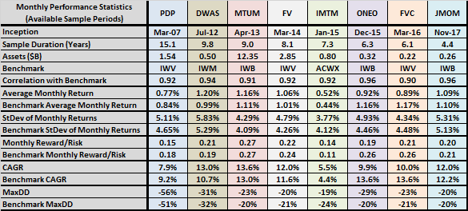
The following chart compares gross cumulative values of $1.00 initial investments in equal-weighted (EW) portfolios of momentum ETFs and benchmark ETFs, matched and rebalanced monthly as the former become available. The momentum ETF portfolio consists only of PDP until August 2012. Average monthly gross return for the EW Momentum (EW Benchmark) portfolio is 0.83% (0.80%), with standard deviation of monthly returns 5.03% (4.67%).
CAGR for EW Momentum (EW Benchmark) is 8.7% (8.6%), and MaxDD is -56% (-51%).
Monthly rebalancing costs after August 2012 are likely higher for EW Momentum ETFs than for EW Benchmark ETFs based on liquidity of holdings.
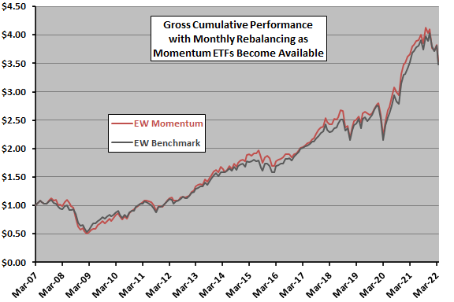
In summary, available evidence on attractiveness of momentum-oriented U.S. stock and sector ETFs is less than compelling.
Cautions regarding findings include:
- As noted, available sample periods are short, especially in terms of variety of market conditions, undermining confidence in findings.
- As noted, other benchmarks may be more appropriate for FV and FVC.”

Results

This chapter consists of three sections. In the first step, we present some thought-provoking results regarding the profitable usability of momentum strategies. In other words, would it really be that easy to exploit this perceived or real phenomenon? This is followed by the presentation of our basic dual momentum calculator. With the help of this, we also deal with the parameter sensitivity of the dual momentum strategy. In the third section of this chapter, there is a demonstration of our newest, expanded calculator, which, in addition to the dual momentum, also takes into account the volatility and correlation of individual assets during the selection process. Finally, a recommendation of a strategy that can be played in real life will be read.

In all three chapters, data between 2006-01-01 and 2022-06-10 is used. Although when using the calculators it is possible to use data prior to this date in case of some ETFs, we still used this starting date due to the better comparability of the results.

Who Laughs Last Laughs Best - Do winners really stay winners?
In the first half of this section, we use a ticker universe consisting of 15 country ETFs (EW*), the Famous-5 ETFs (6 pieces: GLD, VO, VB, VTI, QQQ and SPY + TLT as cash substitute), VNQ, DBC, TLT and SHY for our investigations. To do this, we call on one of our previous calculators: ‘ETF Momentum - Performance and Correlation Calculator’. In it, the 25 ETFs can be ranked based on their price changes (momentum) over the past period (1 week, 1 week, 1 week, 3 months, 6 months or 12 months), and then it can be seen how they performed in the following (subsequent) periods.
As a first step, let's take a look at how these future changes have developed in the case of rankings based on 3-month % price change made at 3 different times: one year ago (2021-06-01), right after the coronavirus-bottom (2020-04-01) and three months later (2020-07-01). The figures can be seen in Table 1a-c.
Based on these tables, the following conclusions can be drawn by these 3 case studies:
- Randomness: In the case of an arbitrarily selected time (2021-06-01, free of major events and market movements) (Table 1a), we can see that the performance of the last 3 months does not at all predict the % price change of the next period. For example, the EWZ ranked first can be considered the worst performer 3 or 6 months later, while the price of QQQ, ranked 21st, skyrocketed in the same period.
- Momentum weakness: After reaching a market bottom (right before 2020-04-01), when the market changes direction, there is naturally a mean-reversion process rather than a continuation of the momentum. Because of this, Table 1b shows that past winners move downward in the rankings based on their future performance, while past losers emerge as winners.
- Momentum strength: However, once the market recovery starts after a crisis (like in case of 2020-07-01), the benefit of momentum increases, as can be seen for example in Table 1c. Those who get off to a strong start are expected to outperform in the next period as well, while the slower ones are expected to remain at the bottom of the ranking.
Summarising the above observations, we can say that strategies based on momentum can be profitable in general, but in many periods (e.g. in the case of mean reversion) a drop in their profitability can be expected. Let's look at 1-2 more interesting tables related to this topic on the following pages.

Table 1a: Future performance of ETFs based on past performance - ranked on 2021-06-01
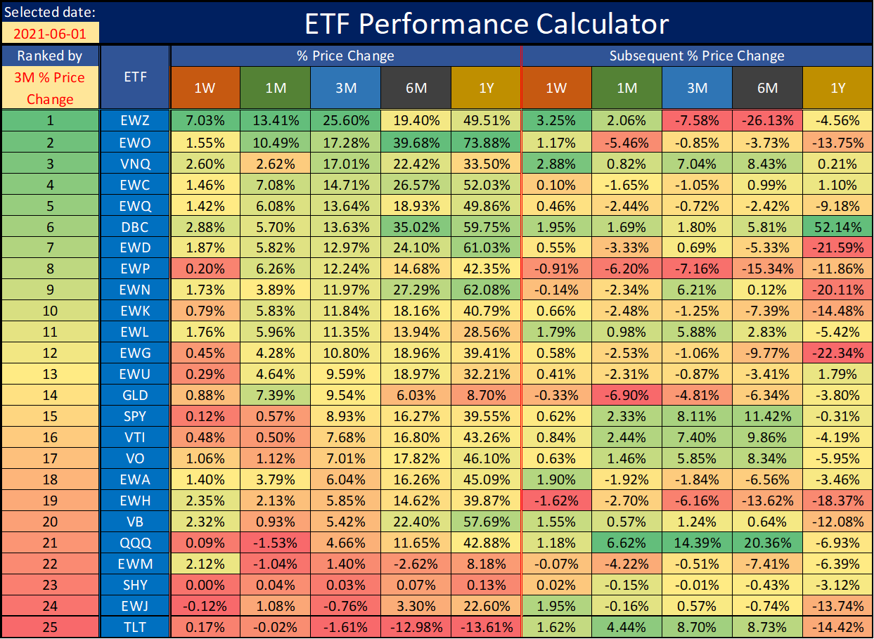
Table 1b: Future performance of ETFs based on past performance - ranked on 2020-04-01
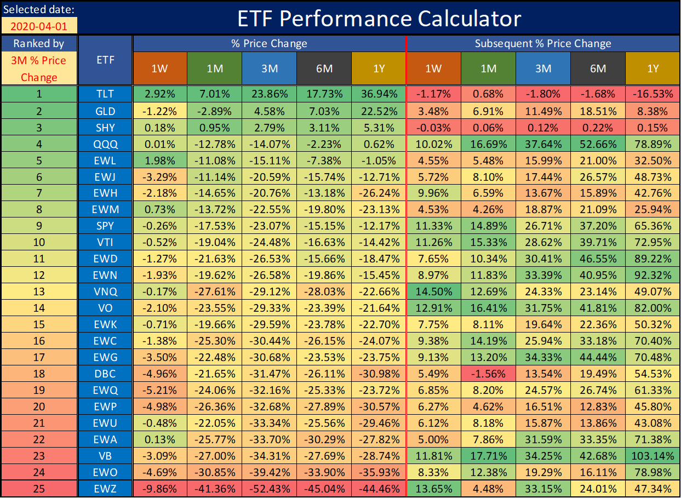
Table 1c: Future performance of ETFs based on past performance - ranked on 2020-07-01
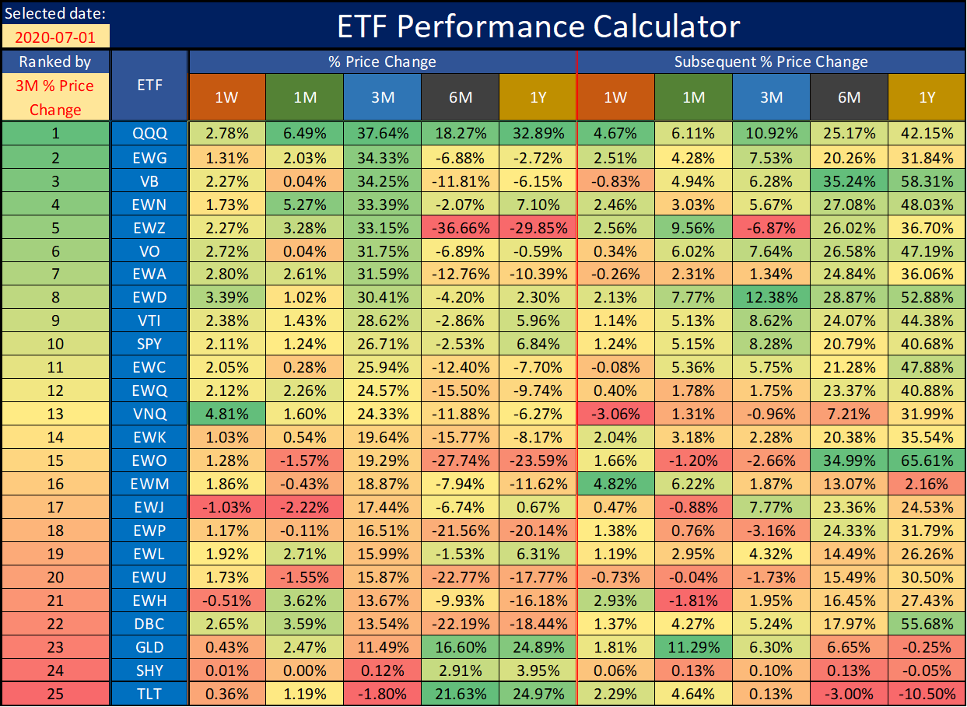
In the following, we will continue to use our ticker universe defined above, but now let's not only analyse snapshots. At the end of each month for 16 years, we ranked our 25 ETFs above based on their percentage price changes over the previous x months, and then analysed how these ETFs performed in the subsequent y months (weeks) by rank numbers. We will examine two examples. In the case of the first, we analyse the next 1-month performance of ETFs ranked based on the percentage price change of the last 3 months (Table 2a and Chart 1a). In the second, we take into account the next 1-week change of those ranked based on the last 1 month (Table 2b, Chart 1a and Table 3). Based on the numbers of these tables it can be concluded that:
- In the case of the first example, based on Table 2a, we can say that excellent performers in the previous 3 months will, on average, perform best in the subsequent 1 month as well. However, if one looks at Chart 1a showing the distribution of past and future rank numbers, one may be surprised by the "peaks" in the four corners. This means that those who performed extremely well or extremely poorly in the previous period (both ends of the ranking) are likely to perform extremely in the next period as well, in any direction. In other words, the first ones will remain the first ones, or there is a good chance they may even fall to the end of the line and there will be the worst. And in the same way, the former last ones either continue to lag behind or can even jump to the top. This can make it quite dangerous to "glorify" (buy) the best- and "despise" (short) the worst performers.
- In the second case, the numbers in Table 2b show a strong variation, compared to the previous example. Based on this, past performance does not determine future performance, even on average. The difference may be due to the fact that in the previous example there was an overlap between the sample elements (one month's past performance of an ETF was included in 3 sample elements), while here all samples are disjoint. In the distribution of the ranks, “peaks at the corners” experienced previously still exist, as can be seen in Chart 1b and in Table 3.
Thought provoking…
Table 2a: Average subsequent 1-month % price changes of ETFs based on past 3-month performance ranking
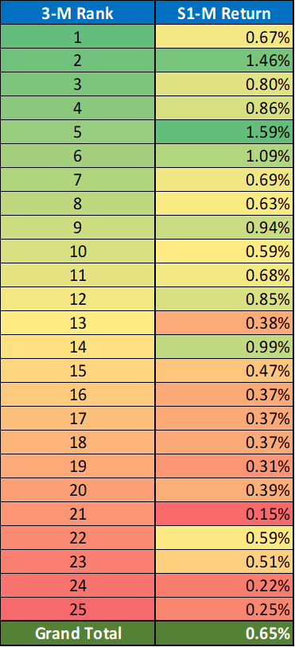
Chart 1a: Distribution of past and future rank numbers: past 3-month performance vs. subsequent 1-month performance
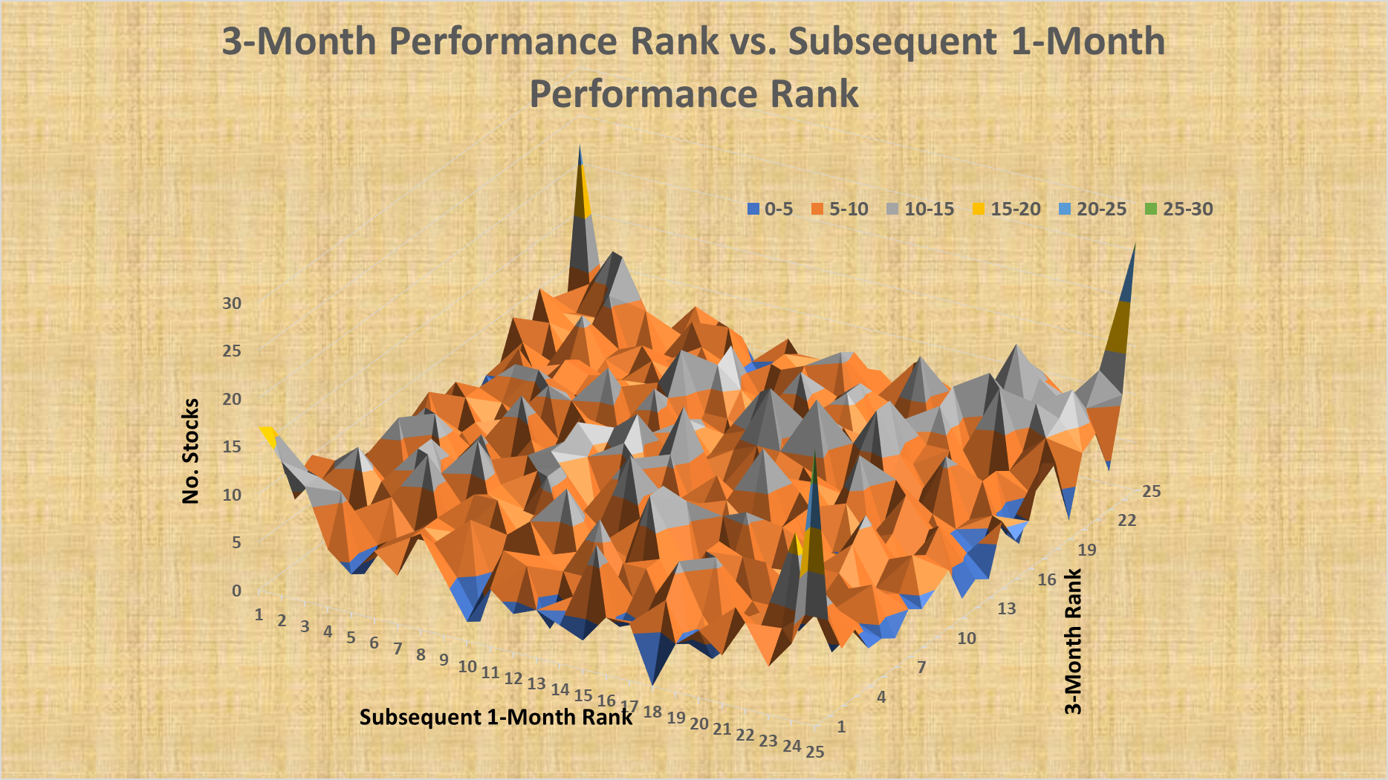
Table 2b: Average subsequent 1-week % price changes of ETFs based on past 1-month performance ranking
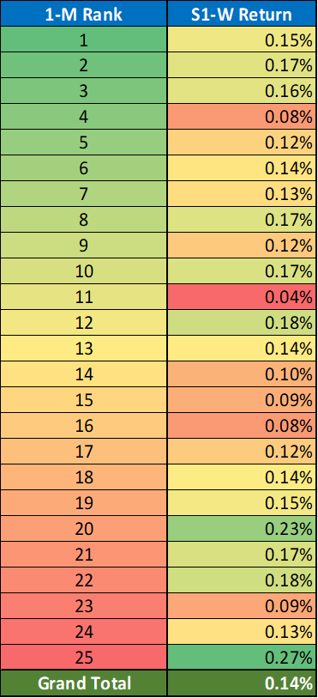
Chart 1b: Distribution of past and future rank numbers: past 1-month performance vs. subsequent 1-week performance
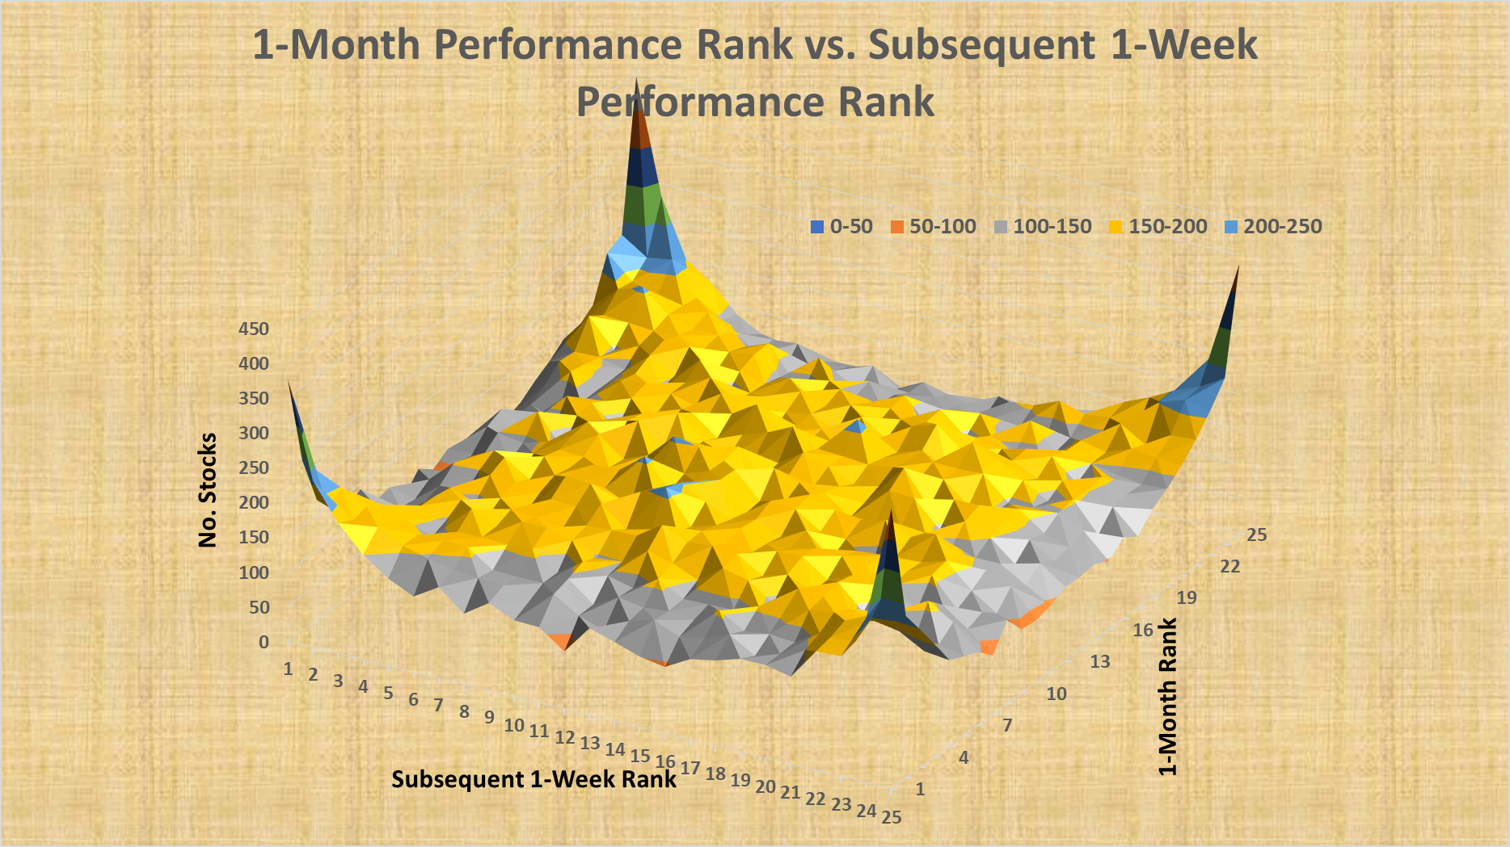
Table 3: Distribution of past and future rank numbers: past 1-month performance vs. subsequent 1-week performance
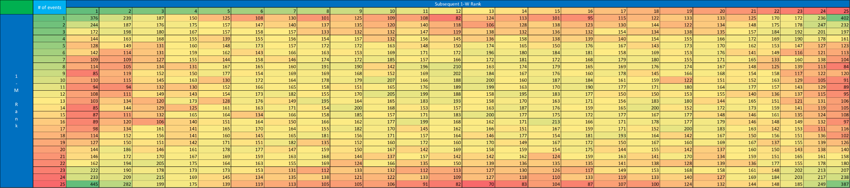
To end this section, let's look at an example from a completely different place. Here, we used the data of the last 23 years, while the ticker universe is the union of companies belonging to the S&P500 and the Nasdaq 100 in the given year (~12,000 data points). For each company, we scrutinised its performance (percentage price change) on the last 10 trading days of the given year. We also looked at how the stock performed in the previous 3, 6, 9 and 12 months. Based on their performance in the previous period, we classified the companies into 25-quantiles (separately for each lookback), where the best performers were in the 25th 25-quantile, while the worst performers were in the first. After the 25-quantiles were formed, we calculated the average of the year-end (last 10-day) percentage price changes of the companies in each group. As surprising as it may seem, in the last two weeks of the year, the previous worst performers achieved the biggest gain on average - regardless of the lookback period.
Interesting…
Table 3: Average 10-day year-end return based on 25-quantiles - different lookback periods
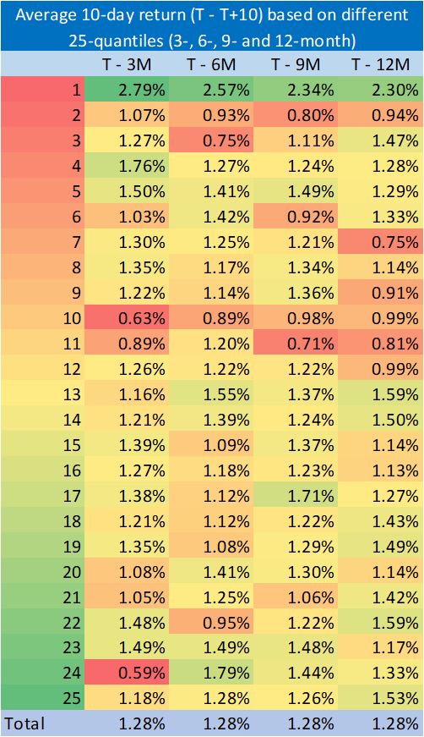
With all these previous examples and ideas, we do not claim that the momentum phenomenon does not exist, or that strategies based on it should not be used. We just want to ensure that investors don't blindly trust it and don't expect miracles from it.

Dual Momentum
In this section, we present our base ‘Dual Momentum Portfolio Calculator’, the potential advantages of dual momentum over EW, as well as the sensitivity analysis (parameter-dependency) of the dual momentum strategy.

The selectable ticker universe consists of the following parts: 11 SPDR sectors (Chaikin sectors: XLB, XLC, XLE, XLF, XLI, XLK, XLP, XLRE, XLU, XLV and XLY), the Famous-5 ETFs (6 pieces: GLD, VO, VB, VTI, QQQ and SPY + TLT as cash substitute), VNQ, DBC, SPLV, EEM, ILF, FEZ and TLT (24 ETFs altogether).

The investigated dual momentum strategy has several parameters. Among these, the following can be set in the calculator:
- Start Date and End Date: These can be set from 2000-01-04 to 2022-06-10, but it should be noted that a big part of the used ETFs were launched after 2004.
- Rebalance Period: It can be chosen from Monthly, Weekly or Daily.
- Rebalance Shift (in days): Default rebalance date is EoM or EoW, but it can be shifted by x days.
- Lookback Period: The lookback period is always understood in the unit of the rebalance period. 1 or more (up to 9) different lookback periods can be set in the calculator. In the case of more lookback periods entered, we consider the average of the relative momentums formed by each period.
- Length of Skipped Period: This is also always understood in the unit of the rebalance period. With this parameter, it is possible to ignore the immediately preceding period from the calculation of the momentum (as many researchers do in the literature by skipping the last 1 month).
- Number of ETFs Played (Top x): Using this parameter, investors can choose the maximum number of ETFs they want to keep in the basket at the same time.
- Cash/TLT/SHY: It can be set in the calculator that if a specific ETF cannot be played due to the absolute momentum rule, then the amount intended for it should be in cash, in TLT or in SHY instead.
- Return/Sharpe Ratio: It can be chosen whether the relative momentum is calculated based on the return of the past period or the Sharpe ratio.
- Threshold (%Return or Sharpe): A minimum threshold for absolute momentum calculation can be set.
- Benchmark: An x% SPY + (100% - x%) TLT virtual stock should be used as a benchmark.

In addition to the above, the elements of the ticker universe can also be selected ('Yes/No').

Chart 2 shows the UI of the calculator. It contains performance indicators by year and portfolio value chart as well. Besides that, Chart 3 contains the default values of parameters. This set of parameters will be the basis for further calculations.
Chart 2: UI of the calculator
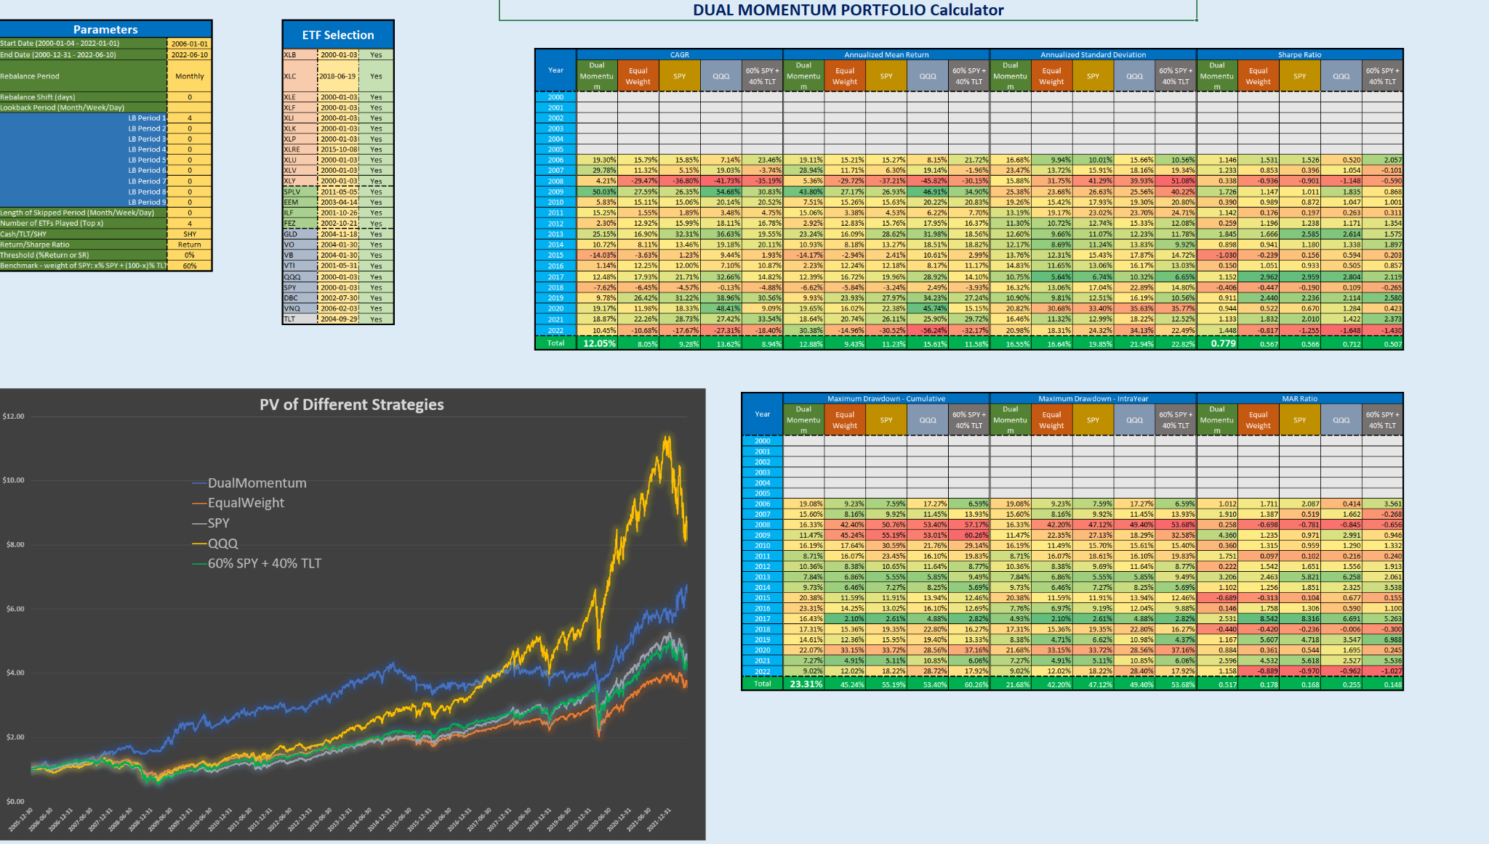

Chart 3: Default values of parameters and ticker universe
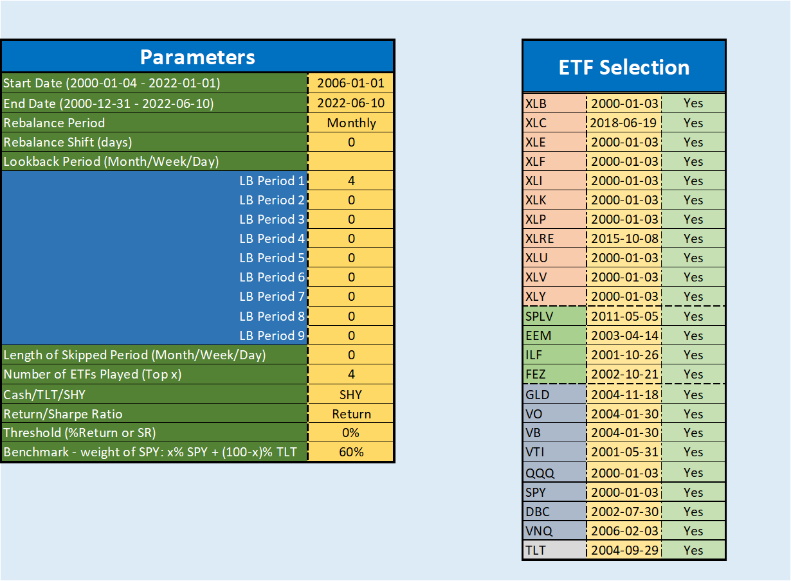
Using the previously seen parameters and the entire ticker universe, we obtained the results shown in Chart 4 and in Table 4a-b. Based on these figures, it can be concluded that:

- The Dual Momentum strategy has a CAGR of 12.05%, compared to 8.05% for the EqualWeight (EW) strategy.
- Sharpe ratio is also much better in case of the Dual Momentum strategy (0.779 vs. 0.567 in case of EW). It is not only better than the EW strategy, but also outperforms all three benchmarks (buy&hold SPY, buy&hold QQQ and 60%SPY+40%TLT) in this indicator.
- In terms of maximum drawdown, the Dual Momentum strategy is half of the EW strategy (23.31% vs. 45.24%), and approximately 40% of the benchmarks.
- The Dual Momentum strategy has only had two negative (lossmaking) years so far.
- The PV chart appears to be the smoothest in the case of the Dual Momentum strategy.

Overall, we can draw the conclusion that with this set of parameters and ticker universe, the strategy worked profitably in the past, it systematically outperformed its benchmarks, so it can even be recommended for real life trading in the future.

Chart 4: PV of different strategies
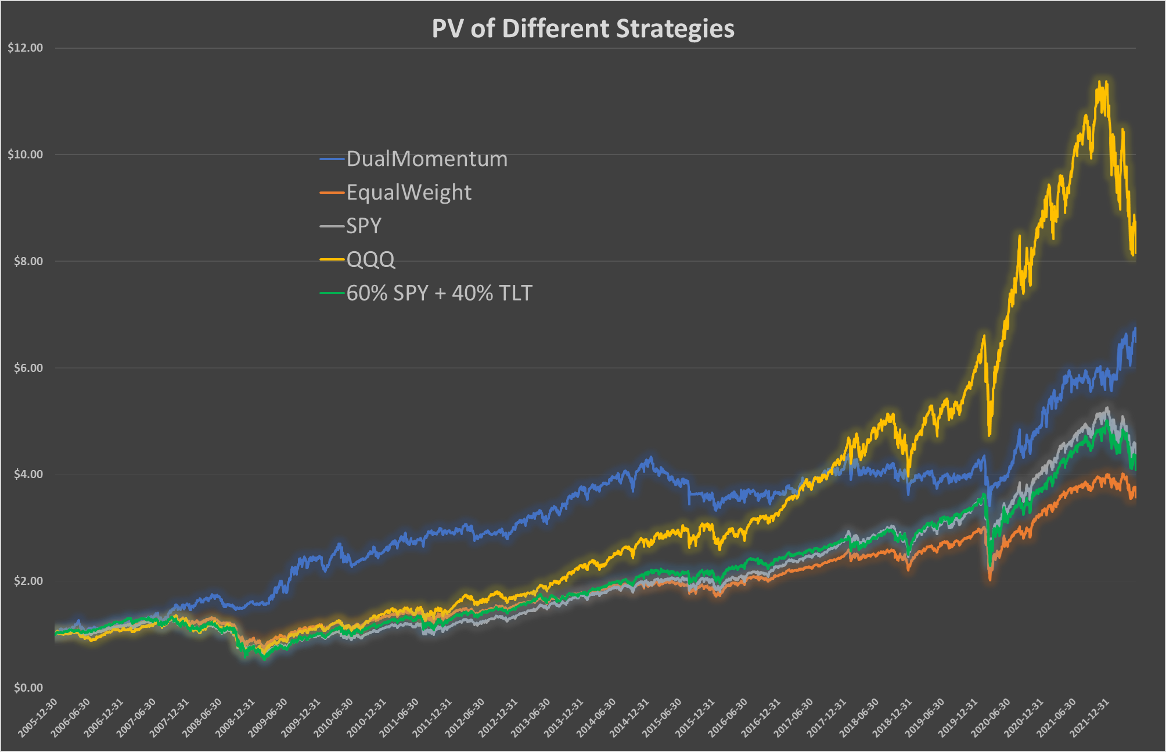
Table 4a: Performance indicators by year
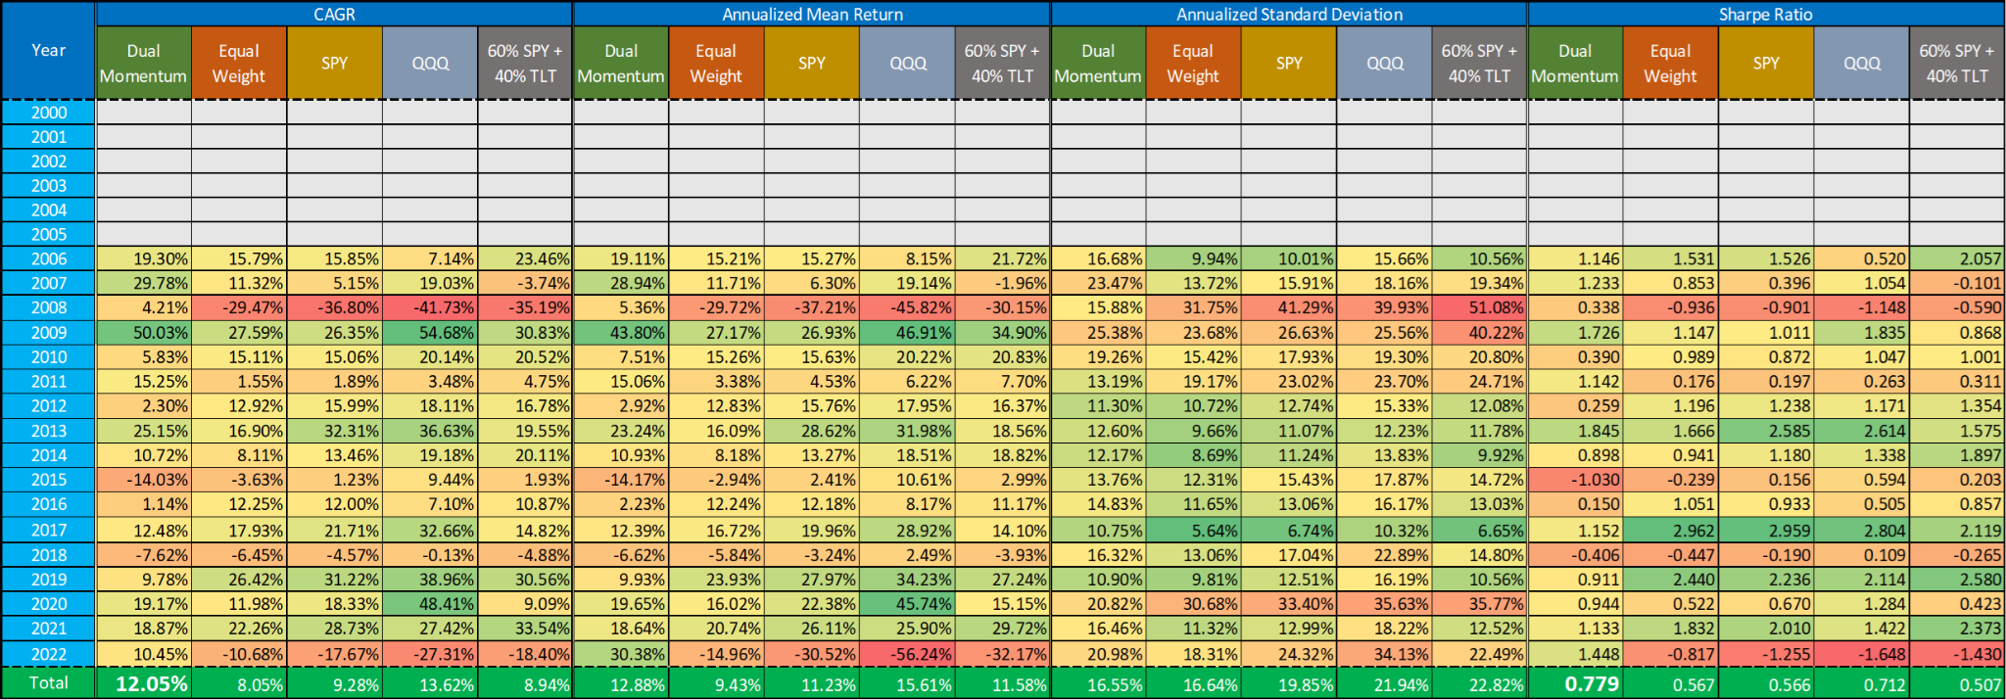
Table 4b: Performance indicators by year
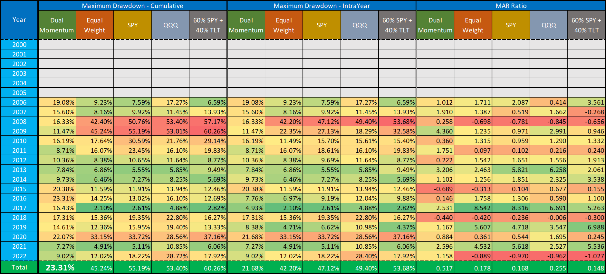

In the next part of this section, we will examine how much of the previously shown performance of the strategy is due only to the lucky choice of parameters. In other words, we perform a sensitivity test on the parameters. During this process, only one examined element of the original parameter set is changed in each step, the rest remain unchanged.

First, let's see in Table 5a how changing the rebalance period affects the performance (CAGR, Sharpe ratio, MDD). It is important to highlight here that the unit of measure of the lookback period (4) is the length of the rebalance period, i.e. 4 months in the case of monthly rebalance, 4 weeks in the case of weekly rebalance, while only 4 days of data are used to select the ticker universe in the case of daily rebalance. However, the data shows that the monthly rebalance option is the most desirable.
Table 5a: Parameter sensitivity - Rebalance period
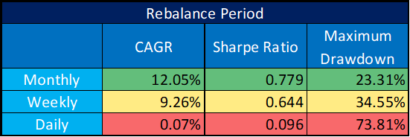

Next, let's examine whether the strategy's performance is affected by when the rebalance takes place within the month. As Table 5b shows, if the rebalance happens in the first few days or the last few days of the month, the performance is about the same. But it gets significantly worse if we leave the rebalance until the middle of the month. Based on these, it can be said that the EoM rebalancing of the strategy is a good choice, but a shift of 1-2 days is not expected to cause a significant change in performance. It is worth noting that this finding is in line with what the CXO also found when they examined the timing of the rebalance of their momentum strategy in this and this articles. Their key finding is that "and that the EW Top 3 portfolio attractively suppresses rebalance timing risk." It suggests that selecting only one or two ETFs highly increases rebalance timing risk.
Table 5b: Parameter sensitivity - Rebalance shift (in days)
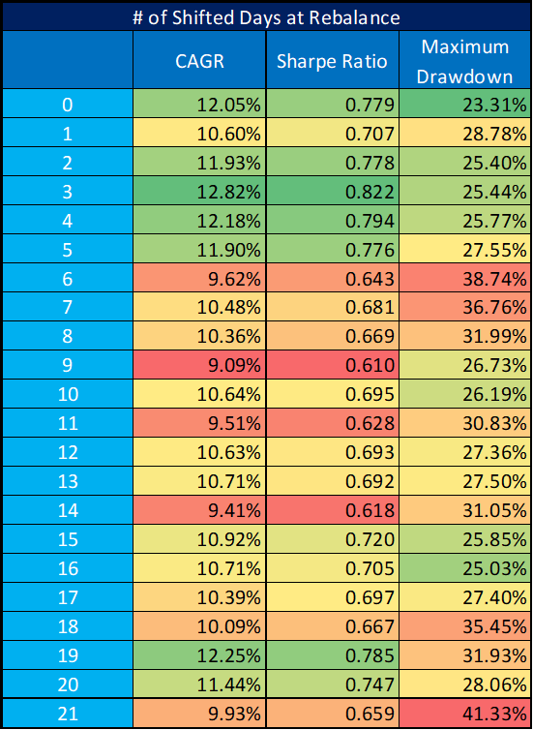
Based on Table 5c, however, the choice of the length of the lookback period significantly affects the development of the strategy's profitability. Furthermore, the 'jumping' in performance can be disturbing, i.e. that the 'best' parameters are not located in one 'group', but the better and worse results alternate back and forth (e.g. choosing 3, 4, 10 or 11 months seems good, but the intermediate ones are not). To eliminate this, it may be recommended to combine different lookback lengths. For this purpose, up to 9 different periods can be specified in the calculator (even weighted), from which the strategy calculates an average relative momentum. As Table 5d shows, this is really a good and useful feature.

Table 5c: Parameter sensitivity - Lookback period (months)
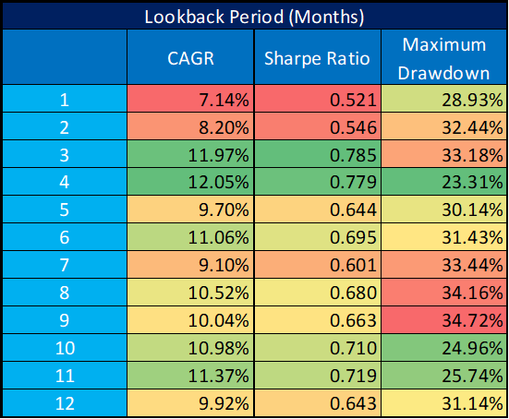

Table 5d: Parameter sensitivity - Lookback period (months) - combined
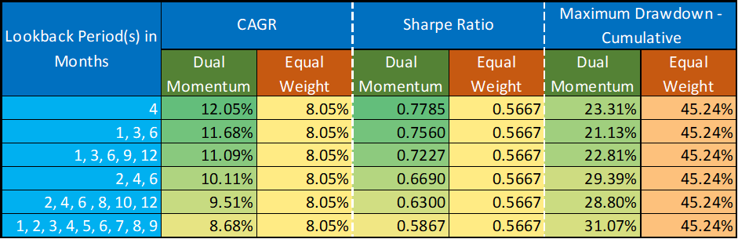

Experienced investors may legitimately feel the need to omit the immediately preceding period when calculating relative momentum (as many studies suggest). To see the effect of this, we have included a skip parameter in our calculator. However, as it can be read from Table 5e, in the case of the Dual Momentum strategy we want to use, it is better not to skip periods.
Table 5e: Parameter sensitivity - Length of skipped period
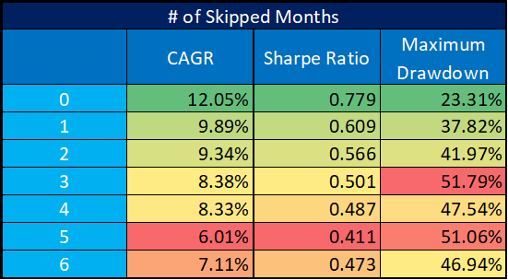

An interesting question is how many ETFs should be kept in our basket at the same time. In other words, based on the relative momentum, how many stocks should be selected when rebalancing. As Table 5f shows, choosing at least 3 ETFs is highly recommended. A maximum value is more difficult to determine, but we would definitely not recommend more than half of the universe.
Table 5f: Parameter sensitivity - Number of ETFs Played (Top x)

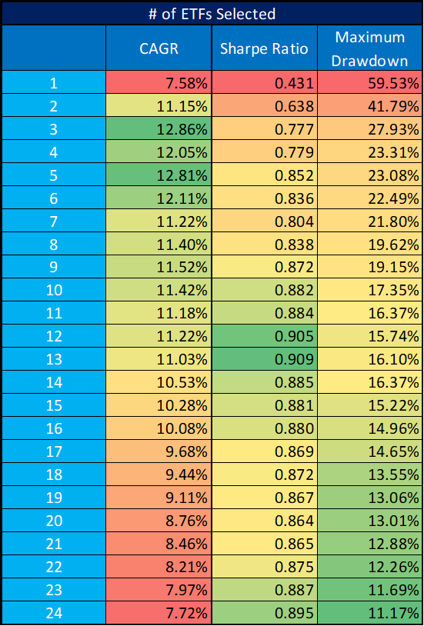

Even our basic calculator is able to take into account not only the % price change, but also the volatility of the given stock when determining the relative momentum. We can do this by calculating the relative momentum not from the % price change, but from the Sharpe ratio for the given period. Table 5g shows the results of these two methods. As performance numbers are almost identical, it is up to the investor's taste which one to choose.

Table 5g: Parameter sensitivity - Return or Sharpe ratio as relative momentum selector
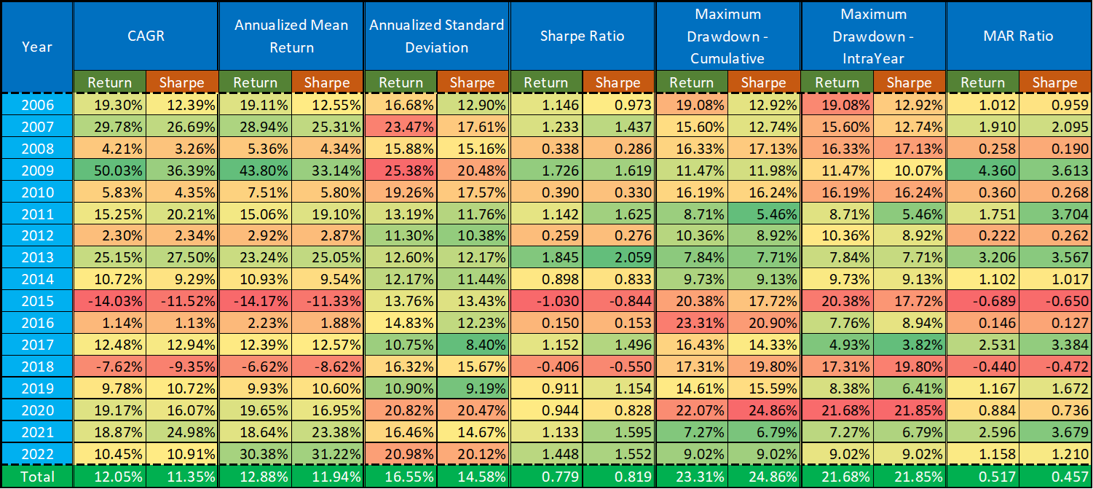

It is clear that one of the biggest effects on the performance of the strategy is the choice of the ticker universe. Table 5h below shows the results of the original, largest set ('All24') and its two reductions. The 'Chaikin' universe includes the 11 SPDR sectors, while the ‘Famous5+DBC+VNQ’ universe includes GLD, VO, VB, VTI, QQQ and SPY in addition to DBC and VNQ. It can be seen from the figures that although the performance of the former two is much better than the EW strategy, the latter far surpasses both in terms of Sharpe ratio and MDD. Table 6 contains the performance indicators of this ‘Famous5+DBC+VNQ’ ticker universe broken down by year.
Table 5h: Parameter sensitivity - Ticker universe
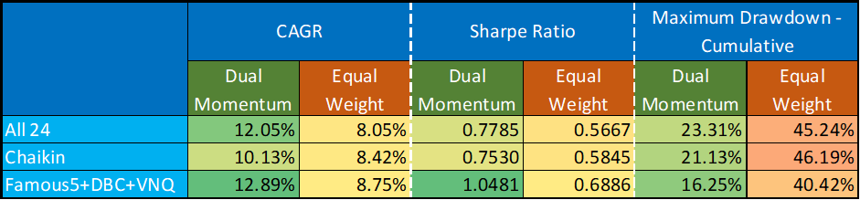

Table 6: Performance indicators of the Dual Momentum strategy using Famous5+DBC+VNQ ticker universe
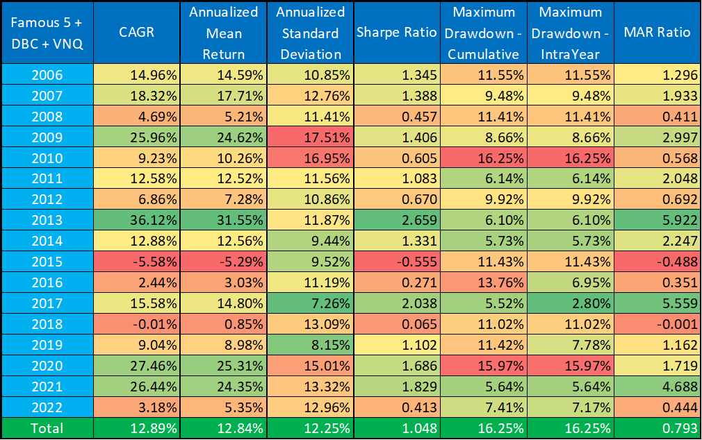

All in all, it can be said that the number of parameters of the ‘Dual Momentum strategy’ can be worrying for investors. But only a few of these parameters have a greater impact on profitability, so in our opinion the strategy can work well even without over-optimization of the parameters.

Dual Momentum with Volatility and Correlation
In this last section, we present the operation of our latest, extended calculator, some results of the expanded strategy, and finally we recommend a strategy to be played in real life.

Our recently developed ‘Dual Momentum + Volatility + Correlation + Leverage’ calculator is based on the strategy described in the ‘Asset Allocation Combining Momentum, Volatility, Correlation and Crash Protection’ article cited in the ‘Background’ chapter. This strategy can also be considered an extension of the ‘Dual Momentum strategy’ presented so far, although it appeared a little earlier.

As a first step, let's review in broad terms how this ‘Extended Dual Momentum strategy’ works:

- “To follow trend, rank funds from highest to lowest lagged total return (relative momentum).
- To suppress volatility, rank funds from lowest to highest volatility (standard deviation of daily returns).
- To enhance diversification, rank funds from lowest to highest average pairwise correlation of daily returns.
- To avoid drawdown, replace with cash any selected fund that has a negative lagged return (intrinsic or absolute momentum). “
In practice, this means that we have to provide each element of the ticker universe with three types of rank numbers: based on relative momentum, based on volatility and based on correlation. These lists are then combined using different weights (default weights are 50%, 25% and 25% respectively) to obtain a final ranking. From here, we have to select the Top x ticker and see if they can be played based on the absolute moment, or if we should rather keep the amount intended for it in cash/cash substitute.

The UI (Chart 5), structure and parameters of the calculator are almost exactly the same as discussed above, only the calculation method and results have changed. New and modified parameters are:
- Lookback Period: Due to computing capacity limits, only 3 different lookback periods can be selected at the same time.
- Weights of Ranks: Different weights must be set for the 3 lists containing the ranks to combine them, based on which the calculator can calculate the final weights.
- Market Health Leverage Indicator: It is a new feature, which tells you whether the market is currently in bullish or bearish mode. You get the signal by comparing the price of SPY to its 200-day moving average. If it is above the MA, then it is a bullish sign, otherwise it is bearish.
- Cash/TLT/SHY/TIP/XLU: It can be set in the calculator that if a specific ETF cannot be played due to the absolute momentum rule, then the amount intended for it should be in cash, in TLT, in SHY, in TIP and in XLU instead.

The ticker universe has also changed. Based on previous results, the universe played by CXO in their strategy (cited above) was combined with some other ETFs, mostly belonging to Famous5. This new universe and default parameters can be found in Chart 6.
Chart 3: UI of the calculator
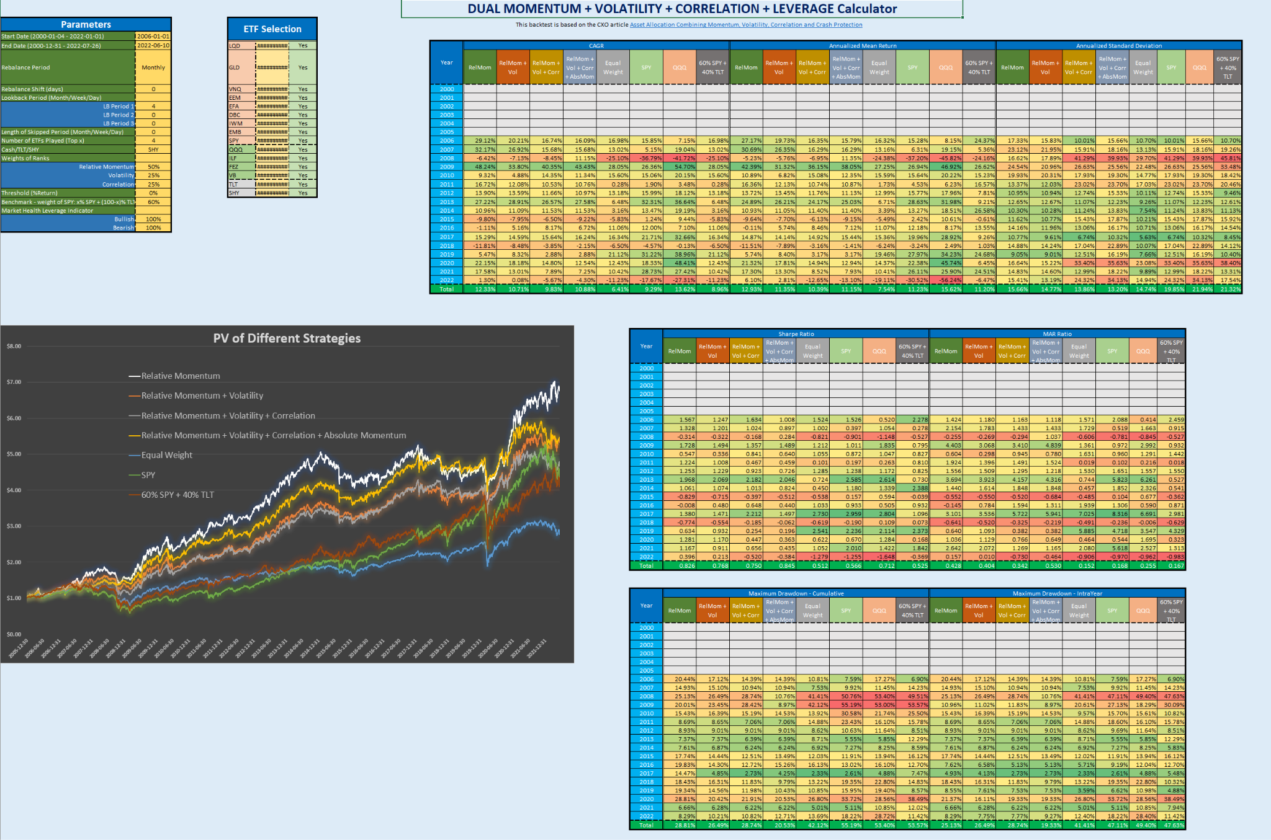
Chart 5: Default values of parameters and ticker universe
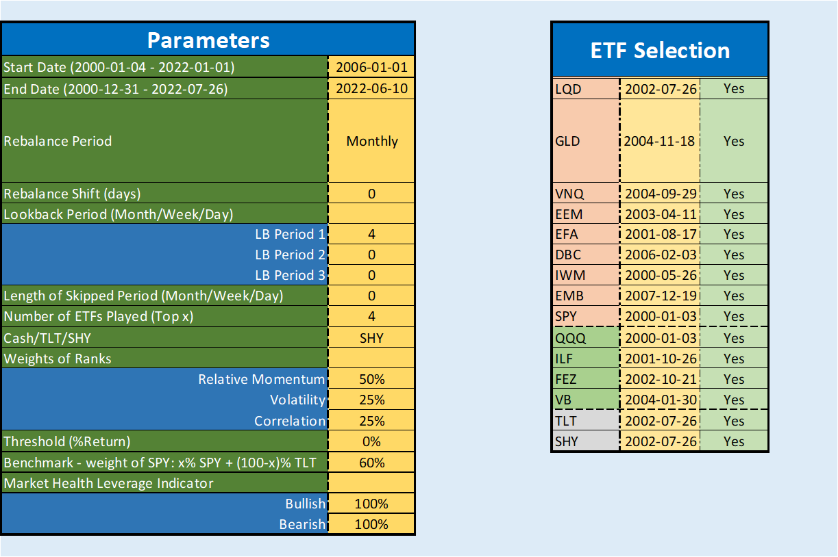

Using the previously seen parameters (which were found to be close to optimal in the previous section) and the entire ticker universe, we obtained the results shown in Chart 6 and in Table 7a-c. Based on these figures, it can be concluded that:

- The pure ‘Relative Momentum’ strategy has the highest CAGR, which is followed by the ‘Extended Dual Momentum strategy’ (Relative Momentum + Volatility + Correlation + Absolute Momentum). Both of them had 3 losing years. Adding ‘Volatility’, or ‘Volatility + Correlation’ to the pure ‘Relative Momentum’, by definition, reduces the CAGR by reducing risk. Adding absolute momentum to them reduces risk in a different way, so a higher CAGR than in the previous step can be achieved with it.
- In terms of both the Sharpe- and MAR ratios, the ‘Extended Dual Momentum strategy’, the broadest, performs best, slightly ahead of pure Relative Momentum. The performances of the benchmarks are far behind them.
- Adding ‘Absolute Momentum’ to the other selectors significantly reduces maximum drawdown.

All in all, we can draw the conclusion that adding volatility and correlation to the Dual Momentum strategy may reduce CAGR and risk at the same time. The question is about the offset. Nevertheless, it should be emphasised that in this example we worked with a near-optimal set of parameters, which may have reduced the positive return of adding new indicators. Furthermore, a change in the ticker universe can also change their effect. Overall, we recommend considering using the strategy in real life.

Chart 6: PV of different strategies

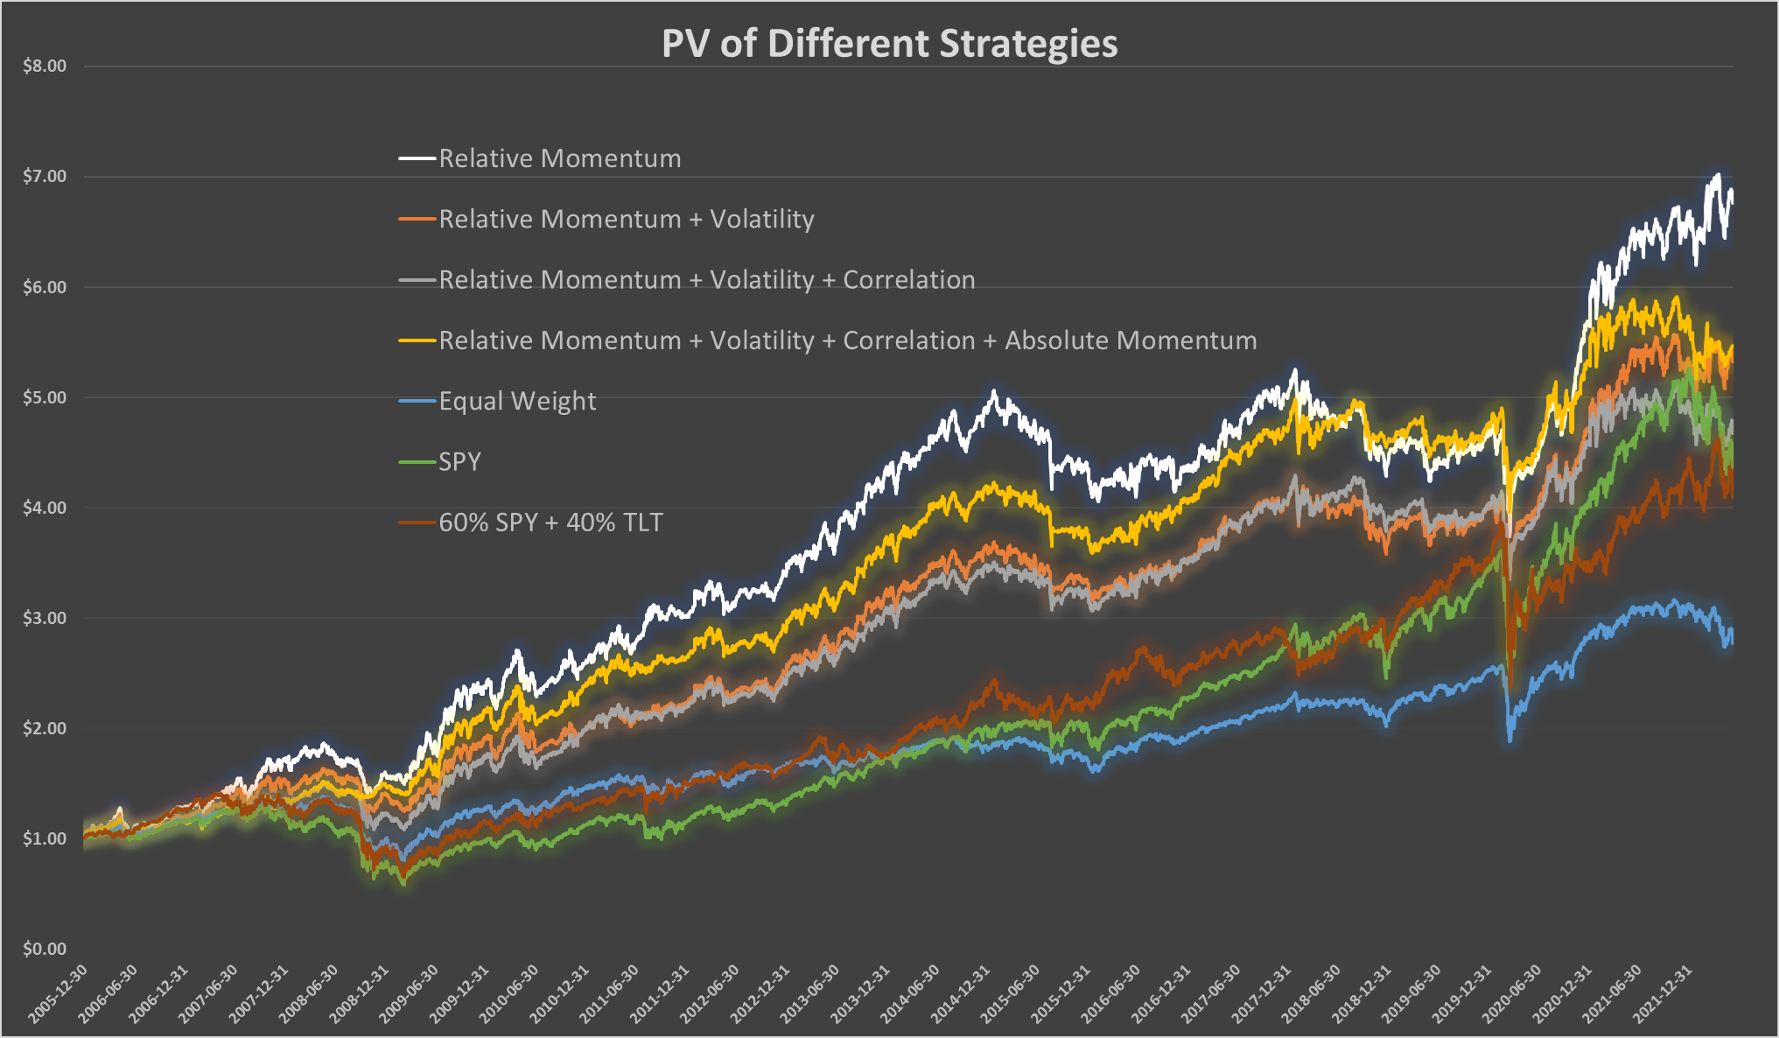

Table 7a: Performance indicators by year
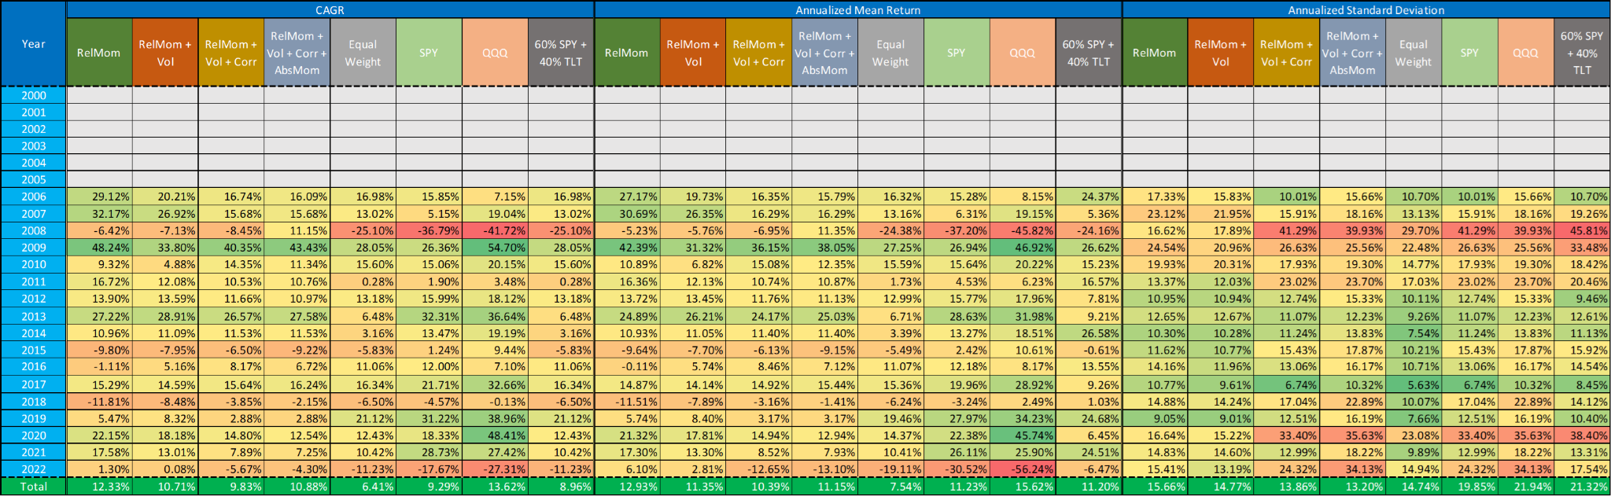
Table 7b: Performance indicators by year
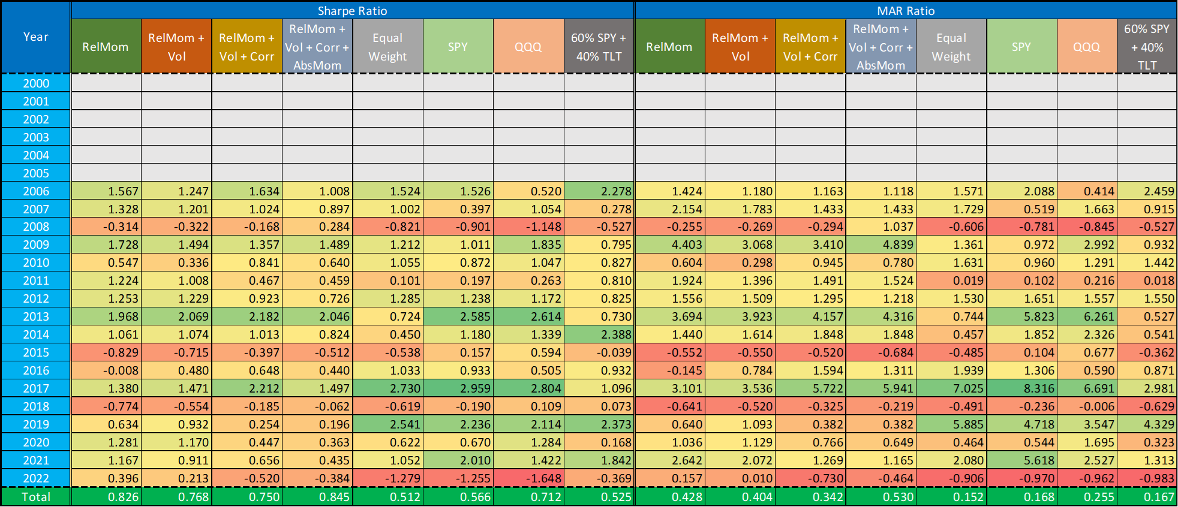
Table 7c: Performance indicators by year
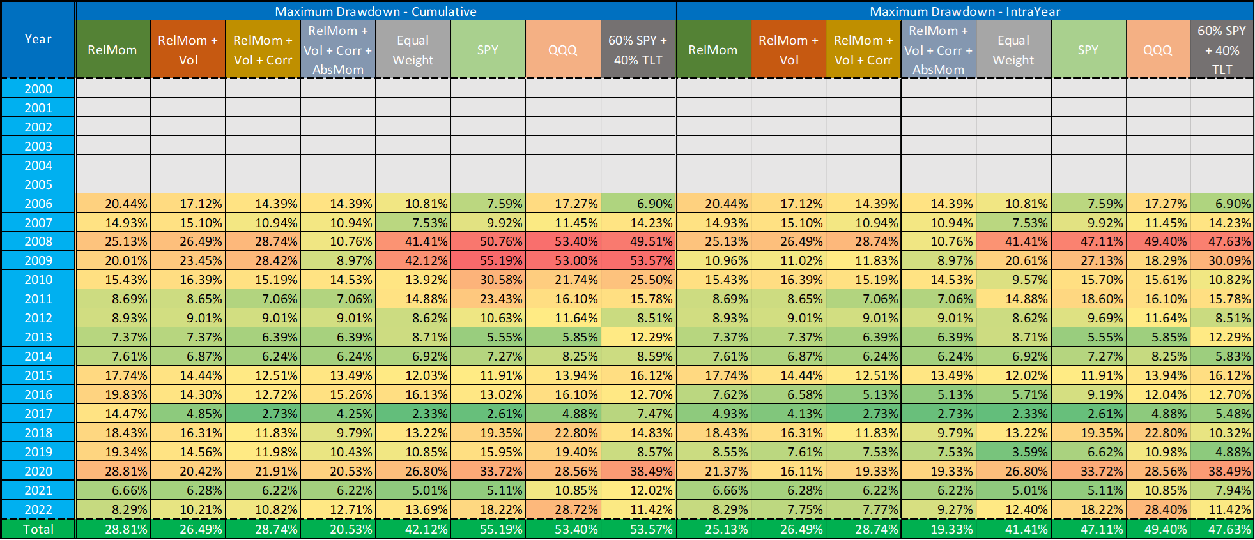
As mentioned above, the choice of ticker universe may have a significant effect on the performance of the strategy. Let's see how the numbers change if we narrow down the list of ETFs to choose from. We examine two different sub-universes: the universe of ETFs played by the CXO and the universe of ETFs selected by Mr. Charmat (Table 8). Furthermore, we examine the effect of using the 'Market Health leverage Indicator' (150% leverage on bullish and 70% leverage on bearish regimes). Number of selected ETFs has been decreased to 3 (from 4), as the number of ETFs in sub-universes also decreased significantly. Table 9 contains the CAGR, Sharpe ratio and maximum drawdown of the three ticker universes (‘All’, ‘CXO’ and ‘Mr. Charmat’) with and without leverage. Based on these figures it can be concluded that:
- In the case of all three universes, leverage naturally increases the CAGR, but also the maximum drawdown, while it decreases the Sharpe ratio.
- For all three universes, we can calculate almost the same CAGR, but in terms of both the Sharpe ratio and the MDD, Mr. Charmat's universe performed by far the best in the past (with this parameter set). Rather than CAGR, the Sharpe is the preferred performance number to look at if we want to leverage the strategy.
Summarising all this, we can say that the ‘Extended Dual Momentum strategy’ (Relative Momentum + Volatility + Correlation + Absolute Momentum) is recommended for playing in real life using Mr. Charmat's ticker universe and the above used parameter set. The development of its PV can be found in Chart 7.
Table 8: Mr. Charmat’s ticker universe
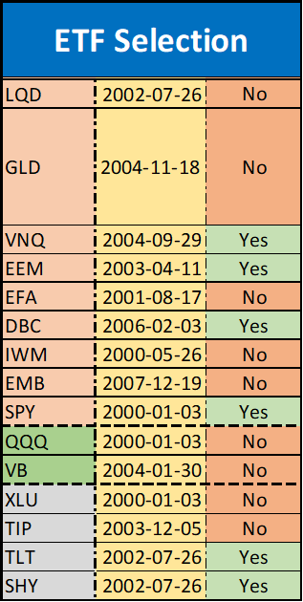
Table 9: Comparison of performance indicators by year using different ticker universes
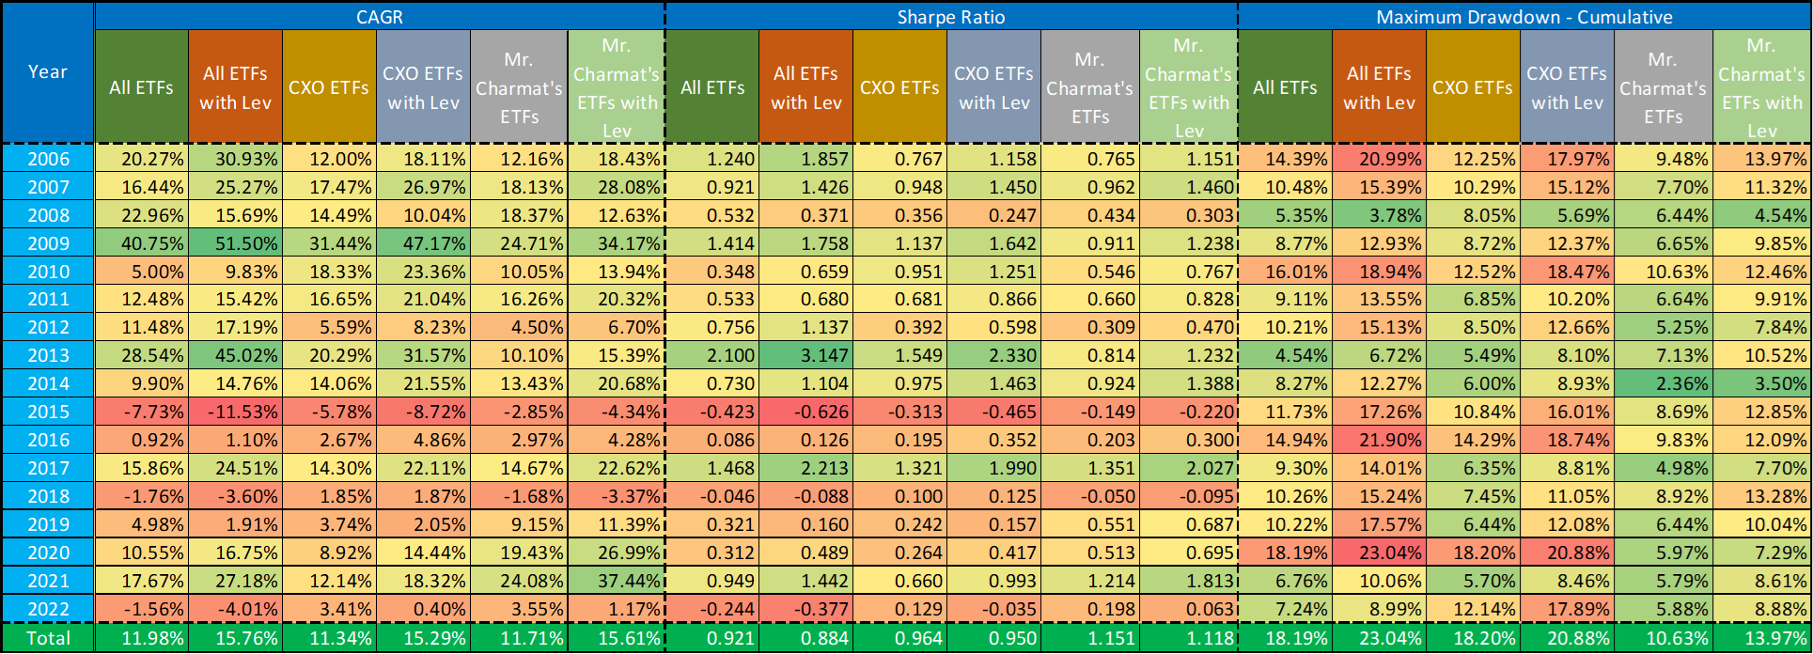
Chart 7: PV of different strategies using Mr. Charmat’s ticker universe without leverage
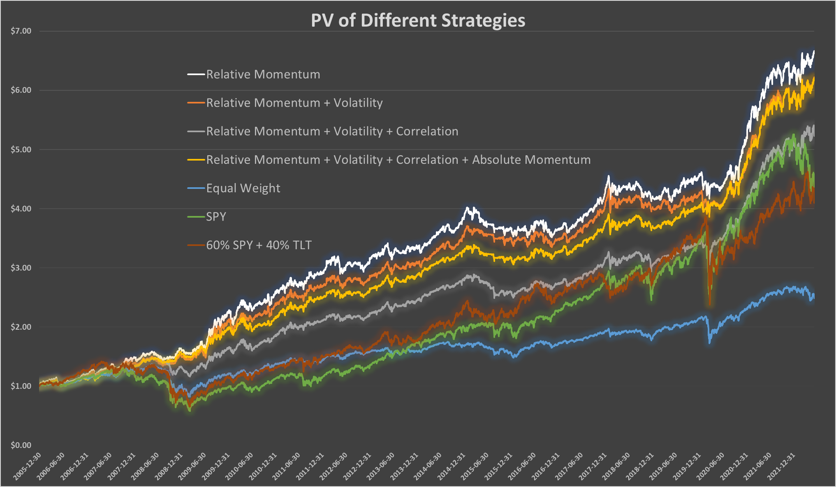

It was mentioned above that if a specific ETF cannot be played due to the absolute momentum rule, then the amount intended for it should be in cash, in TLT, in SHY, in TIP or even in XLU instead. As Table 10 shows, the choice does not have a significant effect on the performance of the strategy - using Mr. Charmat’s ticker universe.

Table 10: Parameter sensitivity - Cash substitute using Mr. Charmat’s ticker universe
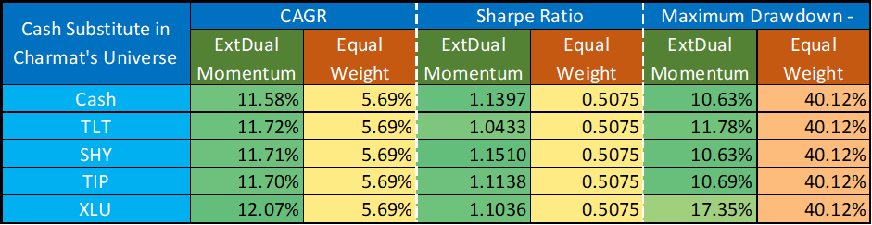

Table 11 contains the result of parameter sensitivity analysis, where the optimal monthly cycle has been examined (like in Table 5b with our previous calculator and ticker universe). Using Mr. Charmat’s ticker universe + GLD, we did not get exactly the result we expected based on the preliminary results and CXO articles.
Table 11: Parameter sensitivity - Shifted days at rebalance using Mr. Charmat’s ticker universe + GLD
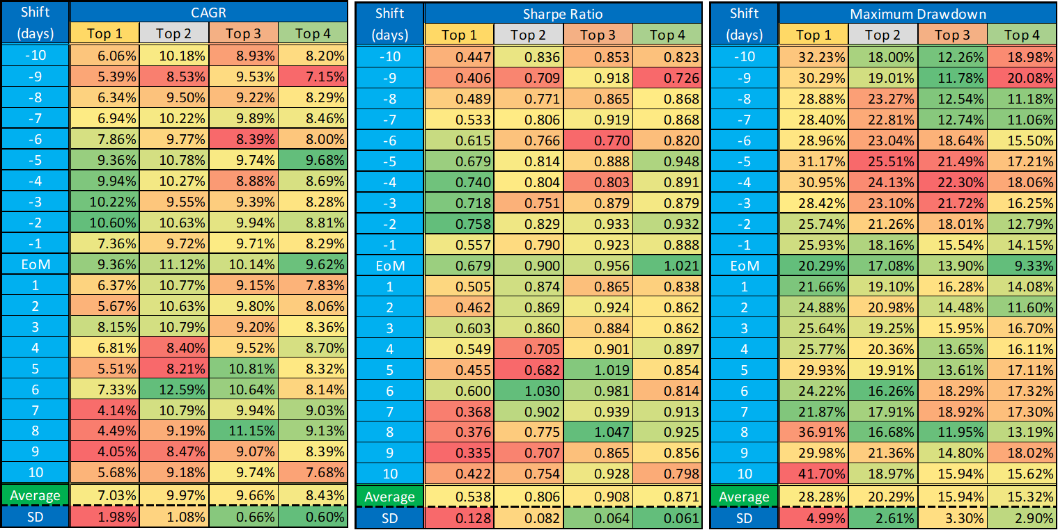

Conclusions

In this study, we took a closer look at the Dual Momentum strategy introduced by Antonacci and its improved (expanded) version. In the Background chapter, we cited four articles written by CXO regarding dual momentum and momentum itself.

The Results chapter consists of three parts. In the first part, we looked at some thought-provoking results related to some moments. We concluded that: “With all these previous examples and ideas, we do not claim that the momentum phenomenon does not exist, or that strategies based on it should not be used. We just want to ensure that investors don't blindly trust in it and don't expect miracles from it.”

In the second section, we presented our base ‘Dual Momentum Portfolio Calculator’, the potential advantages of dual momentum over EW, as well as the sensitivity analysis (parameter-dependency) of the dual momentum strategy. From the results, we could conclude that the dual momentum strategy has performed particularly well in the past, and although it has many parameters, it is only sensitive to some of them in terms of performance.

Finally, in the third part, our extended ‘Dual Momentum + Volatility + Correlation + Leverage’ calculator and the ‘Extended Dual Momentum strategy’ were presented. The numbers show that expanding the dual momentum strategy with volatility and correlation can definitely be useful. It does not primarily improve profitability, but rather can make the strategy safer without a significant decrease in CAGR.

Using Mr. Charmat's ticker universe, this ‘Extended Dual Momentum strategy’ can be a profitable strategy in real life.

https://www.cxoadvisory.com/volatility-effects/asset-allocation-combining-momentum-volatility-correlation-and-crash-protectio/
https://www.cxoadvisory.com/momentum-investing/a-few-notes-on-dual-momentum-investing/
https://www.cxoadvisory.com/momentum-strategy/
https://www.cxoadvisory.com/equity-premium/are-equity-momentum-etfs-working/

