Dr. George Antal
3D Click Limited
c/o Suite 431, 28 Old Brompton Road, London SW7 3SS

Performance analysis of Luby's Featured ETP Trade Ideas Strategy
Motivation 1
Background 2
Featured ETP Trade Ideas 2
ETP Categories 3
Results 8
Our backtests 8
Profitability of ETP Categories 12
Best and Worst Performing ETPs 20
Best and Worst Recommendations 25
Conclusions 39

Motivation

At the end of June 2019, Bill Luby expanded his weekly newsletter with a ‘Featured ETP Trade Ideas’ section. It recommends three ETPs every week. Since we have been closely following Luby's work for a long time, we launched a strategy based on this section at the end of 2019. In this study, we examine the success, playability, and reality of the recommendations based on the data of the last 3 and a half years. Are Luby's published profits real? How much is due to volatility ETPs? We also want to find answers to the questions of which holding period (1, 2, 3 or 4 weeks) is the most profitable and which ETP categories have brought the biggest profits so far.

Background

Featured ETP Trade Ideas

Bill Luby publishes his ETP ideas weekly (usually after the market closes on Wednesday) in his newsletter or in the form of bullet points. When he sends out his regular newsletter to his subscribers, it includes, in addition to new ideas, the effectiveness of the ‘strategy’ calculated by him. In these tables, the profits of positions held over various time periods are accumulated. The time periods examined by him are 1, 2, 3 or 4 weeks. That is, e.g. in the case of 3 weeks holding period, he holds 3 * 3 = 9 ETPs in his basket at the same time, thereby inducing +200% constant overleverage in his ‘portfolio’. This procedure can generate somewhat misleading results (due to the high level of overleverage), as can be seen in his tables.

In this study, we analysed his recommendations from 2019-06-26 to 2022-11-30. The following result table is copied from his 2022-10-30 newsletter.

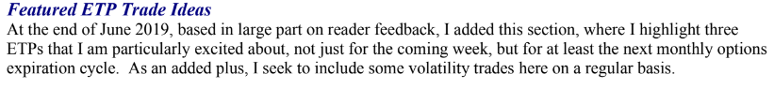
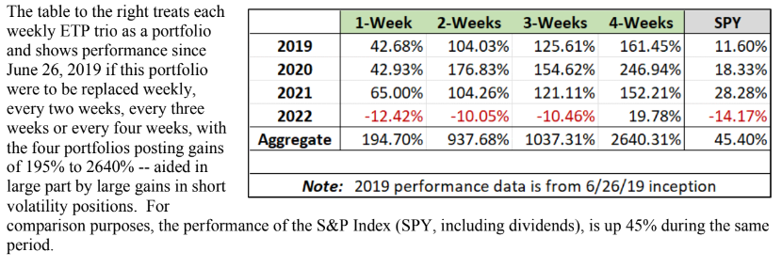

All his trading ideas are collected in an online GoogleSheet, which is updated weekly: Luby's Featured ETP Trade Ideas

In the ‘Results’ chapter, we will thoroughly examine the real profitability of the recommendations. We show how to 'cheat' with numbers without being noticed. We analyse the profitability of each ETP and ETP category separately.

Before all this, let's see which ETPs were recommended in the last three and a half years, and what categories they fall into.

ETP Categories

Market-index:
IWF - iShares Russell 1000 Growth ETF
IWN - iShares Russell 2000 Value ETF
IWO - iShares Russell 2000 Growth ETF
PBP - Invesco S&P 500 BuyWrite ETF
PUTW - WisdomTree CBOE S&P 500 PutWrite Strategy Fund
QYLD - Global X NASDAQ 100 Covered Call ETF
RYLD - Global X Russell 2000 Covered Call ETF
SDY - SPDR S&P Dividend ETF
TQQQ - ProShares UltraPro QQQ
XYLD - Global X S&P 500 Covered Call ETF

Country:
EWA - iShares MSCI Australia ETF
EWC - iShares MSCI Canada ETF
EWD - iShares MSCI Sweden ETF
EWG - iShares MSCI Germany ETF
EWI - iShares MSCI Italy ETF
EWJ - iShares MSCI Japan ETF
EWM - iShares MSCI Malaysia ETF
EWN - iShares MSCI Netherlands ETF
EWP - iShares MSCI Spain ETF
EWQ - iShares MSCI France ETF
EWS - iShares MSCI Singapore ETF
EWT - iShares MSCI Taiwan ETF
EWU - iShares MSCI United Kingdom ETF
EWW - iShares MSCI Mexico ETF
EWY - iShares MSCI South Korea ETF
EWZ - iShares MSCI Brazil ETF
EZA - iShares MSCI South Africa ETF
INDA - iShares MSCI India ETF
ASHR - X Trackers Harvest CSI 300 China A-Shares ETF
EEM - iShares MSCI Emerging Markets ETF
EIDO - iShares MSCI Indonesia ETF
EIRL - iShares MSCI Ireland ETF
FM - iShares MSCI Frontier and Select EM ETF
EPHE - iShares MSCI Philippines ETF
EPI - WisdomTree India Earnings Fund
EPU - iShares MSCI Peru ETF
GXG - Global X MSCI Colombia ETF
KSA - iShares MSCI Saudi Arabia ETF
RSX - VanEck Vectors Russia ETF
AAXJ - iShares MSCI All Country Asia ex Japan ETF
ECNS - iShares MSCI China Small-Cap ETF
EEMV - iShares MSCI Emerging Markets Min Vol Factor ETF
ILF - iShares Latin America 40 ETF
VGK - Vanguard FTSE Europe Index Fund ETF
VNM - VanEck Vectors Vietnam ETF

Commodity:
COPX - Global X Copper Miners ETF
CORN - Teucrium Corn Fund
CPER - United States Copper Index Fund
DBA - Invesco DB Agriculture Fund
DBB - Invesco DB Base Metals Fund
DBC - Invesco DB Commodity Index Tracking Fund
FTGC - First Trust Global Tactical Commodity Strategy Fund
GLD - SPDR Gold Shares
JO - iPath Series B Bloomberg Coffee Subindex Total Return ETN
GDX - VanEck Vectors Gold Miners ETF
GDXJ - VanEck Vectors Junior Gold Miners ETF
GLDI - Credit Suisse X-Links Gold Shares Covered Call ETN
LIT - Global X Lithium & Battery Tech ETF
MOO - VanEck Vectors Agribusiness ETF
PPLT - Aberdeen Standard Physical Platinum Shares ETF
REMX - VanEck Vectors Rare Earth/Strategic Metals ETF
SIL - Global X Silver Miners ETF
SILJ - ETFMG Prime Junior Silver Miners ETF
SLV - iShares Silver Trust
SLX - VanEck Vectors Steel ETF
URA - Global X Uranium ETF
VEGI - iShares MSCI Global Agriculture Producers ETF
WEAT - Teucrium Wheat Fund
XLB - Materials Select Sector SPDR Fund
WOOD - iShares Global Timber & Forestry ETF
XME - SPDR S&P Metals and Mining ETF

Energy:
CRAK - VanEck Oil Refiners ETF
FAN - First Trust Global Wind Energy ETF
FCG - First Trust Natural Gas ETF
ICLN - iShares Global Clean Energy ETF
IXC - iShares Global Energy ETF
OIH - VanEck Vectors Oil Services ETF
PSCE - Invesco S&P SmallCap Energy ETF
PXI - Invesco DWA Energy Momentum ETF
RYE - Invesco S&P 500 Equal Weight Energy ETF
TAN - Invesco Solar ETF
UNG - United States Natural Gas Fund, LP
USO - United States Oil Fund, LP
USOI - Credit Suisse X-Links Crude Oil Shares Covered Call ETNs
XLE - Energy Select Sector SPDR Fund
XOP - SPDR S&P Oil & Gas Exploration & Production ETF
XLU - Utilities Select Sector SPDR Fund

Volatility:
UVXY - ProShares Ultra VIX Short-Term Futures ETF
VXX - iPath Series B S&P 500 VIX Short-Term Futures ETN
VXZ - iPath Series B S&P 500 VIX Mid-Term Futures ETN
SVIX - -1x Short VIX Futures ETF
SVOL - Simplify Volatility Premium ETF
TVIX - VelocityShares Daily 2x VIX Short-Term ETN
ZIV - VelocityShares Daily Inverse VIX Medium-Term ETN

Finance-Banks-Insurance:
KBE - SPDR S&P Bank ETF
KIE - SPDR S&P Insurance ETF
KRE - SPDR S&P Regional Banking ETF
EUFN - iShares MSCI Europe Financials ETF
IAI - iShares U.S. Broker-Dealers & Securities Exchanges ETF
XLF - Financial Select Sector SPDR Fund

Technology:
BOTZ - Global X Robotics & Artificial Intelligence ETF
CIBR - First Trust NASDAQ Cybersecurity ETF
FDN - First Trust Dow Jones Internet Index Fund
FINX - Global X FinTech ETF
HACK - ETFMG Prime Cyber Security ETF
BLOK - Amplify Transformational Data Sharing ETF
CQQQ - Invesco China Technology ETF
EMQQ - EMQQ The Emerging Markets Internet & Ecommerce ETF
GBTC - Grayscale Bitcoin Trust
IGV - iShares Expanded Tech-Software Sector ETF
IPAY - ETFMG Prime Mobile Payments ETF
KWEB - KraneShares CSI China Internet ETF
SKYY - First Trust Cloud Computing ETF
SMH - VanEck Vectors Semiconductor ETF
SOCL - Global X Funds - Global X Social Media ETF
XLC - Communication Services Select Sector SPDR Fund
QQQJ - Invesco NASDAQ Next Gen 100 ETF

Discretionary spending:
BETZ - Roundhill Sports Betting & iGaming ETF
BJK - VanEck Vectors Gaming ETF
CHIQ - Global X MSCI China Consumer Disc ETF
ESPO - VanEck Vectors Video Gaming and eSports ETF
MJ - ETFMG Alternative Harvest ETF
PEJ - Invesco Dynamic Leisure and Entertainment ETF
RTH - VanEck Vectors Retail ETF
TRYP - SonicShares Airlines, Hotels, Cruise Lines ETF
XLY - Consumer Discretionary Select Sector SPDR Fund
XRT - SPDR S&P Retail ETF

Real estate:
REM - iShares Mortgage Real Estate Capped ETF
REZ - iShares Residential and Multisector Real Estate ETF
RWO - SPDR Dow Jones Global Real Estate ETF
SRVR - Pacer Benchmark Data & Infrastructure Real Estate SCTR ETF
VNQ - Vanguard Real Estate Index Fund ETF
VNQI - Vanguard Global ex-U.S. Real Estate Index Fund ETF
XHB - SPDR S&P Homebuilders ETF
XLRE - The Real Estate Select Sector SPDR Fund

Healthcare:
IBB - iShares Biotechnology ETF
IHI - iShares U.S. Medical Devices ETF
PJP - Invesco Dynamic Pharmaceuticals ETF
SBIO - ALPS Medical Breakthroughs ETF
XLV - Health Care Select Sector SPDR Fund
XBI - SPDR S&P Biotech ETF
XHE - SPDR S&P Health Care Equipment ETF

Bonds:
EMB - iShares J.P. Morgan USD Emerging Markets Bond ETF
HYG - iShares iBoxx $ High Yield Corporate Bond ETF
HYXU - iShares International High Yield Bond ETF
IVOL - Quadratic Interest Rate Volatility and Inflation Hedge ETF
JEPI - JPMorgan Equity Premium Income ETF
LQD - iShares iBoxx $ Investment Grade Corporate Bond ETF
TAIL - Cambria Tail Risk ETF
TIP - iShares TIPS Bond ETF
TLT - iShares 20+ Year Treasury Bond ETF

Other:
ACIO - Aptus Collared Income Opportunity ETF
BDRY - Breakwave Dry Bulk Shipping ETF
CLIX - ProShares Long Online/Short Stores ETF
COWZ - Pacer US Cash Cows 100 ETF
CWB - SPDR Bloomberg Barclays Convertible Securities ETF
DVOL - First Trust Dorsey Wright Momentum & Low Volatility ETF
FPX - First Trust US Equity Opportunities ETF
FTLS - First Trust Long/Short Equity ETF
IBUY - Amplify Online Retail ETF
IGF - iShares Global Infrastructure ETF
IJS - iShares S&P Small-Cap 600 Value ETF
INFL - Horizon Kinetics Inflation Beneficiaries ETF
ITA - iShares U.S. Aerospace & Defense ETF
IYT - iShares Transportation Average ETF
JETS - U.S. Global Jets ETF
KNG - FT Cboe Vest S&P 500 Dividend Aristocrats Target Income ETF
MOAT - VanEck Vectors Morningstar Wide Moat ETF
PAVE - Global X U.S. Infrastructure Development ETF
PFF - iShares Preferred and Income Securities ETF
PHO - Invesco Water Resources ETF
PKW - Invesco BuyBack Achievers ETF
QUAL - iShares MSCI USA Quality Factor ETF
SYLD - Cambria Shareholder Yield ETF
VIG - Vanguard Dividend Appreciation Index Fund ETF
VIGI - Vanguard International Dividend Appreciation Index Fund ETF
USMV - iShares MSCI USA Min Vol Factor ETF
VTV - Vanguard Value Index Fund ETF
XLI - Industrial Select Sector SPDR Fund

Results

Our backtests

Measuring and evaluating the performance of the ‘strategy’ recommended by Luby faces several difficulties. First of all, the prices used by Luby are not available during real-life trading, since the newsletter is sent after the market closes. He still uses these close prices (I mean in most cases when he doesn't want to cheat with the numbers). Furthermore, the ETPs he recommends often struggle with liquidity issues, which again skews the results. Finally, the biggest problem is the use of excessive over-leverage and (mostly leveraged) volatility ETPs. Due to the combination of these, the strategies would have gone bankrupt in real life long ago (due to short volatility ETPs, the PV turns negative in many cases). Despite all this, we could see what outstanding numbers Luby published. But how? We will reveal the secret soon. Stay tuned.

In order to eliminate some of the above difficulties and measure their impact, we prepared the backtest of the strategy in SQDesktop (SQ, Experiment → Luby tests 2022) using several different methods:
- Three types of prices:
  - Luby’s close price (or LubyDayClose): The price that Luby's uses most of the time. Achieving this is not possible in reality because we only receive the newsletter after the market closes.
  - Next day open price: This is the earliest tradeable price. It can be obtained by trading immediately after the newsletter arrives.
  - Next day close price: This is the most realistic price. In real-life trading, we use this too.
- Four types of holding periods:
  - 1 week;
  - 2 weeks;
  - 3 weeks;
  - 4 weeks.
- Two types of position volumes:
  - Traditional: Each week the 3 new positions are opened for one third of the current PV. Normally, this shouldn't be a problem. However, this is not a normal situation. On the one hand, in the case of longer holding periods, the leverage becomes too large, so a few bad recommendations can collectively push the PV into negative territory. On the other hand, shorting leveraged volatility ETPs can make PV negative by itself. These result in the traditional position weighting losing its meaning (resulting in negative $ volume). In other words, as soon as PV turns negative, charts and other indicators become unintelligible from then on.
  - Fixed: In this case, each new position is open for one third of the initial PV. In the case of our backtest, this is $333,333 due to the initial capital of $1M. In our opinion, this is a much safer method for high leverage and in case of frequent shorting of leveraged volatility.
- Three types of playing volatility ETPs:
  - Base: In this case, Luby's recommendation is exactly followed.
  - Replacement with VXX: In this case, all volatility recommendations are replaced with unleveraged VXX. It helps avoid whipsaws caused by shorting leveraged ETPs (like UVXY and TVIX).
  - Replacement with SPY: In this case, all volatility recommendations are replaced with unleveraged SPY. With this, the effects of volatility ETPs can be eliminated. This makes it visible what the real performance of the strategy would be without the volatile VIX assets.

It is 3*4*2*3 = 72 backtested portfolios altogether.
It is worth noting that newsletters or bullet points from Luby do not always arrive after the market closes on Wednesday. As a result, it happened that they followed each other by even 3 or 14 days. During our tests, '1 week' always means the time elapsed between two recommendations (which can be 3 or 14 days in real life).

As a first step in this section, let's take the results published by Luby again (Table 1).
Table 1: Results published by Luby on 2022-11-30
Luby’s official performance table shows that it has been profitable every year except 2022 (but even in 2022 using the 4-week holding period in which it used triple PV of the 1-week holding period). In contrast, let's look at the ugly truth.

Chart 1 and Table 1 show what the performance of portfolios created based on Luby's recommendations would look like in reality. As soon as the PV of a portfolio turns negative, the results can no longer be interpreted using the traditional position volume calculation (since the negative PV would change the long and short positions). For this reason, the crossed-out parts on the chart and in the table should be ignored and a 100% loss should be taken into account. The PV indicated by the green lines and the first 4 columns of the table would be what Luby should have published. And the PV indicated by the blue lines and the last 4 columns of the table are what anyone could achieve by strictly following the recommendations (trading at close on the next trading day). After these figures and Luby's numbers, anyone can rightly ask, 'But hey, how is it possible that these numbers are not at all related to each other???'.

The answer is clear (c-h-e-a-t-i-n-g 😱), and the source of the differences consists of two parts. First, in the case of holding periods longer than one week, the profits are ‘additively accumulated’. In other words, those numbers should be divided by the length of the period (and the volatility drag was not even taken into account then). This can even be considered a bona fide deception, because we can also find such on other websites. Secondly, what is not very fair, in our opinion, is the hindsight manipulation of the data. What does this mean in reality? When there is relative calm on the markets or there are no leveraged volatility ETPs capable of huge jumps in the basket, he uses the 'Luby close prices' without any changes. However, when the portfolio would suffer a huge loss, he waits to publish the results (only bullet points are sent to followers), and then he closes the position using the price available on another day. And only after that, tabular results are published again in the newsletter. As, for example, he did this in March 2020. Then he showed a loss of -38.02% followed by a gain of 33% in a 3 week period, which in reality was a loss of -73% and a -2.45% loss again (using 1-week holding period). In case of longer holding periods, cumulative loss would be much worse (with more than 100% MDD!!!). These are the sad facts, not just speculation or unjustified accusations… We manually extracted the data from all his spreadsheets, compared their changes to real-life numbers, and found that he misled his followers on several occasions.
It may not be by chance that Luby did not reply to my letter in which I inquired about his calculation method… (Even though I tried to be very polite.) 🙂

Overall, we wouldn't say that his recommendations are very bad or should be forgotten. We are only saying that the performance chart published by Luby should not be taken seriously at all.
In our opinion, the version we are currently playing in real life (which is more or less the same as the 'NextDayClose 2-W' column in the table) may still be profitable in the future, or at least beat the market, despite all these facts.
Chart 1: PVs of our backtests on 2022-11-30 - using traditional position volume calculation method and leveraged volatility ETPs
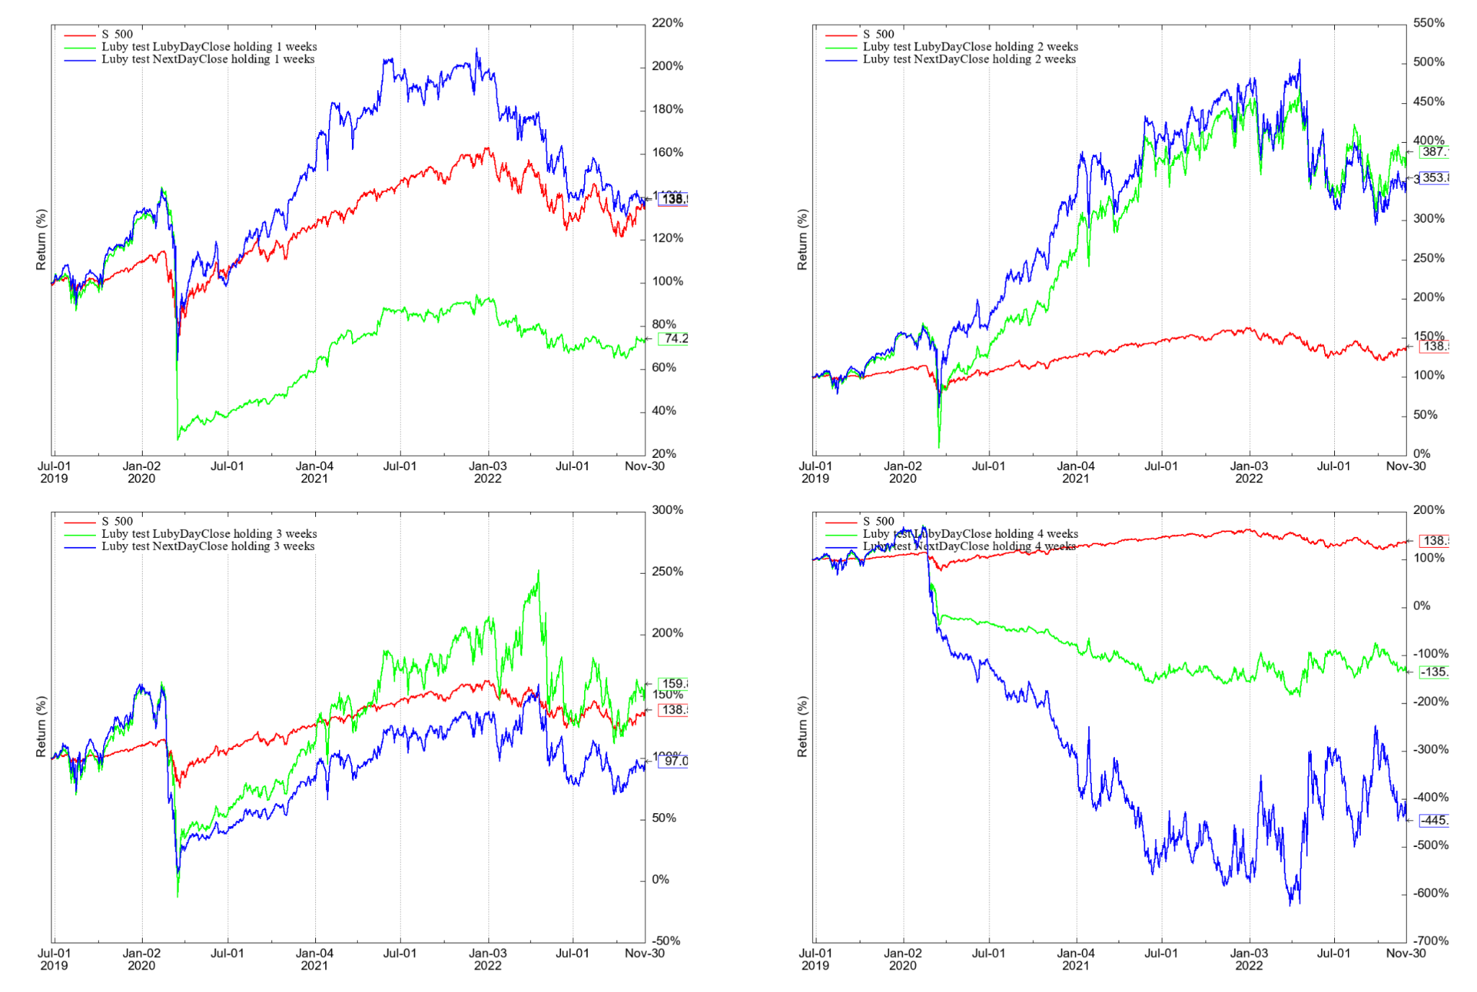

Table 2: Results of our backtests on 2022-11-30 - using traditional position volume calculation method and leveraged volatility ETPs
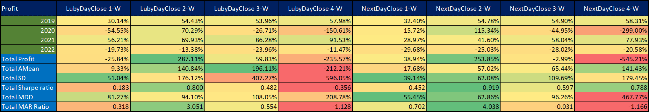
In order to avoid huge whipsaws caused by shorting leveraged volatility ETPs, we can also replace them with simple SPY, as shown in Chart2 and Table 3. With this, we can also get how much of the profits seen on the previous page came from volatility-related ETPs. It is worth noting that the two-week holding period seems to be the best in this case as well.
Chart 2: PVs of our backtests on 2022-11-30 - using traditional position volume calculation method and SPY instead of volatility ETPs
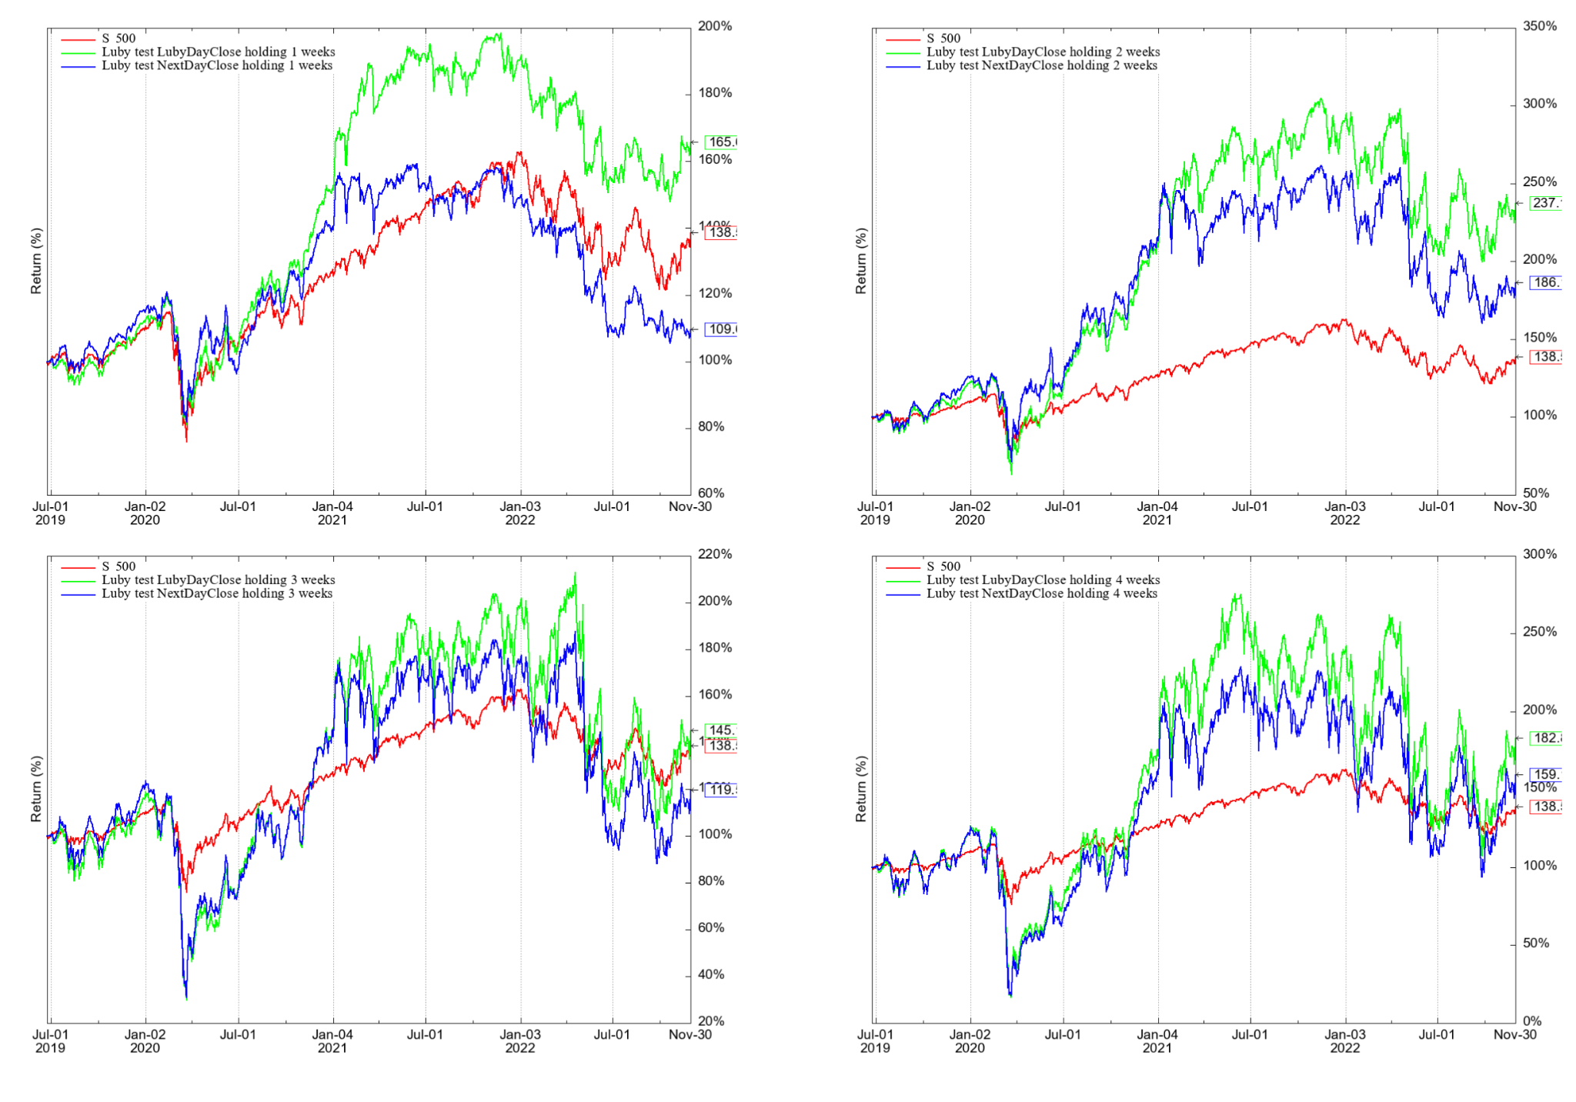
Table 3: Results of our backtests on 2022-11-30 - using traditional position volume calculation method and SPY instead of volatility ETPs
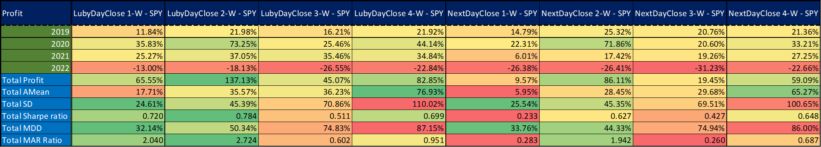

Profitability of ETP Categories

Curious investors may wonder how Luby's recommendations performed by ETP category. Has the energy sector performed the best? Or the tech? Perhaps the volatility?

In this section, we show numbers related to this topic. For this, we need to use the fixed position volume calculation method. Because from the point of view of the total $ profit, it would not be irrelevant at what PV value a recommendation arrived at - if we use the traditional position volume calculation. If we buy from a specific ETP at a low PV, then a much larger percentage profit results in a lower absolute ($) profit than a much higher PV but smaller percentage profit.

In other words, in this section, we opened all positions for $333,333, regardless of the actual PV value (therefore, even after a negative PV value, further investigations make sense).

Chart 3 contains the PV charts of the strategy using this fixed position $ volume method, different holding periods and two types of prices (Luby’s close and next day close (which is tradable)). It can be seen from these figures that even with this method, the strategy would have failed big in March 2020, but would have recovered in any case (even in the case of negative PV) afterward. What's more! In the case of a holding period longer than one week, it would not have suffered large losses even in 2022 (in contrast to the traditional method examined previously).

Henceforth, we will use this method. It is worth noting that where relative (%) profit figures are shown, the two position volume calculation methods give the same results (only the absolute profit is different). That is, it will be perfect for us to examine the profitability of each ETP category.

The results of these examinations can be seen in Table 4a-5b. First, the results obtained using Luby's close price are shown, followed by the results using the next-day close price (this is what can be achieved in reality).

Based on these figures, the following conclusions can be drawn:
- ‘Country’, ‘Other’ and ‘Commodity’ are the most recommended ETP categories (It can be seen in the ‘Sum of NoSelection’ column), while ‘Healthcare’, ‘Real estate’ and ‘Market-index’ are at the other end of the line.
- If shorter holding periods are used, there is a large difference in the case of some categories when two different prices (Luby’s and next day close) are applied. For example, if Luby's close price is applied, the amount of $ profits for one week is -$11,653, while for transactions one day later, this value is +$360,055. What a difference! In the case of longer holding periods, the strategy is less price sensitive, and the possible effects of large daily movements are better balanced. His Country category picks have average profit.
- The categories 'Volatility', 'Energy', 'Healthcare' and 'Technology' have the best cumulative and average performance. Meanwhile, accepting the recommendations for the 'Discretionary spending', 'Real-estate' and ‘Market-index’ categories was not the idea of the century. Fortunately, he rarely mentioned the latter categories (below 5% of time).
- In the 2 week versions that we focus on, a significant 50-60% of the total profit comes from the Volatility sector.
Chart 3: PVs of our backtests on 2022-11-30 - using fixed position volume calculation method and leveraged volatility ETPs
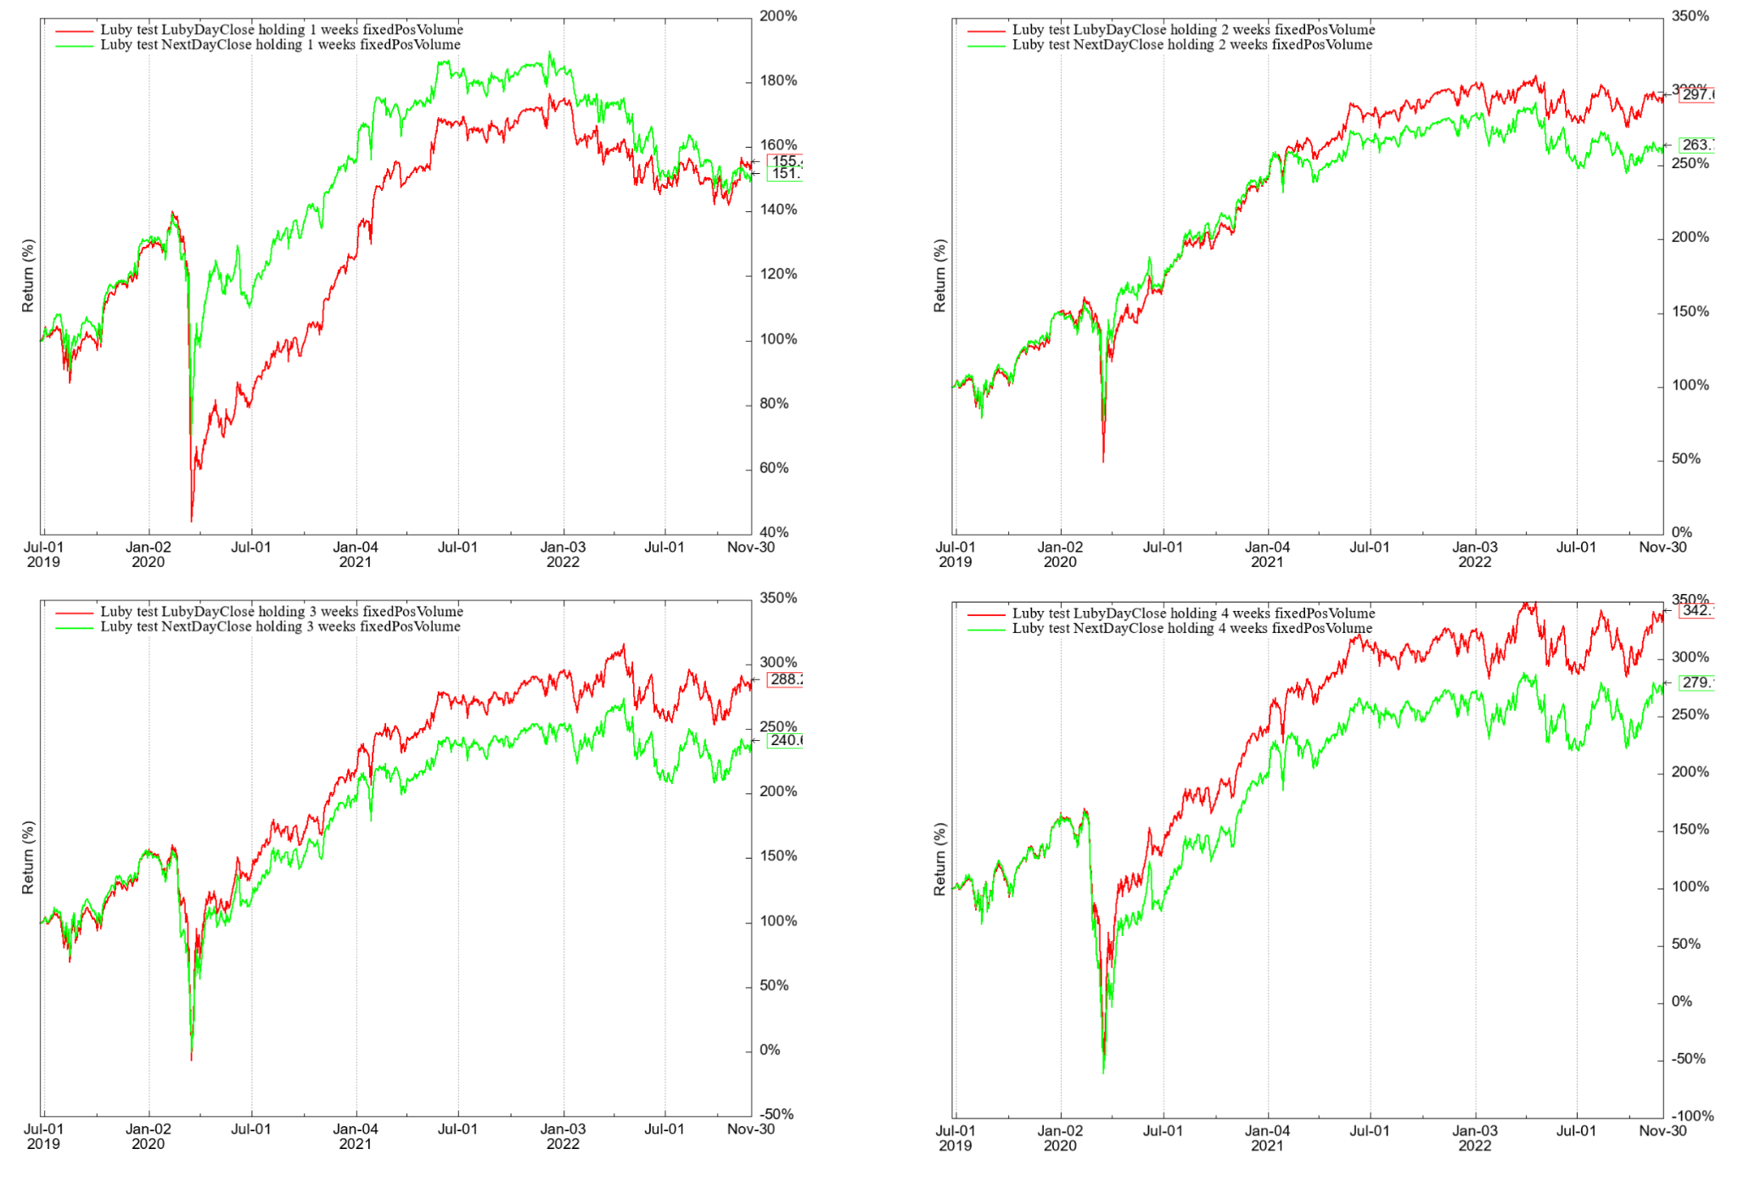

Table 4a: Dollar profits by ETP category as on 2022-11-30 - using Luby’s close price and fixed position volume calculation method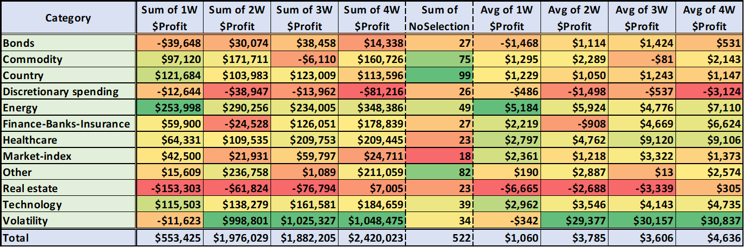

Table 4b: Distribution of total dollar profit by ETP category as on 2022-11-30 - using Luby’s close price and fixed position volume calculation method
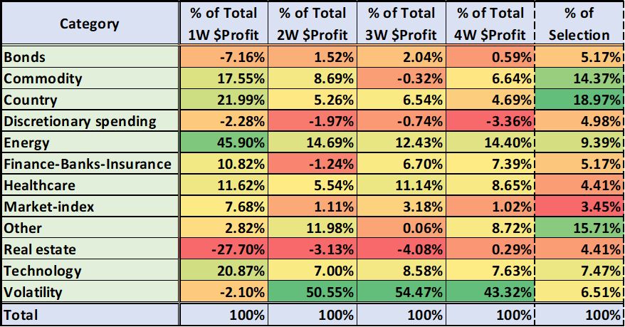
Table 5a: Dollar profits by ETP category as on 2022-11-30 - using Next day close price and fixed position volume calculation method
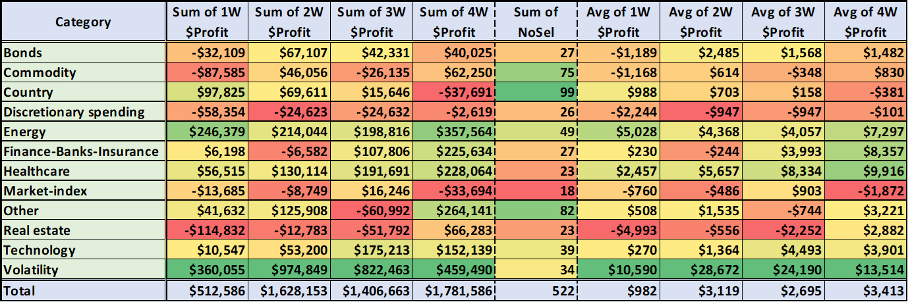

Table 5b: Distribution of total dollar profit by ETP category as on 2022-11-30 - using Next day close price and fixed position volume calculation method
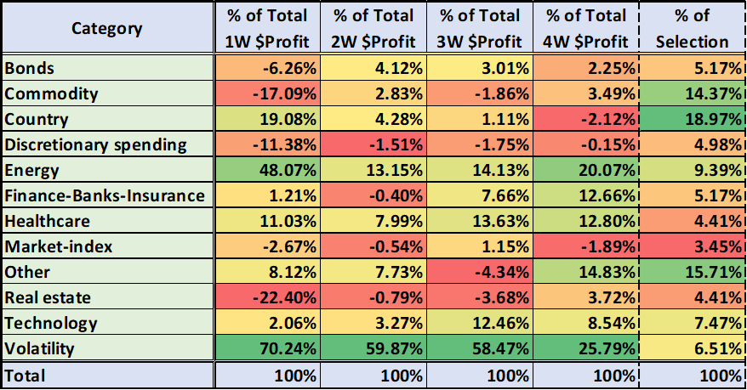

In the following charts (Chart 4a-5b) and tables (Table 6a-7b), we can see how the profit of each category would have developed if only they were taken into account from the recommendations. In other words, we now treat individual ETPs cumulatively within a category rather than additively.
Although this is only an approximate calculation, the results are in line with the previous ones.

Chart 4a: PV of Categories using Luby’s close price and 1-Week holding period - using fixed position volume calculation method and leveraged volatility ETPs
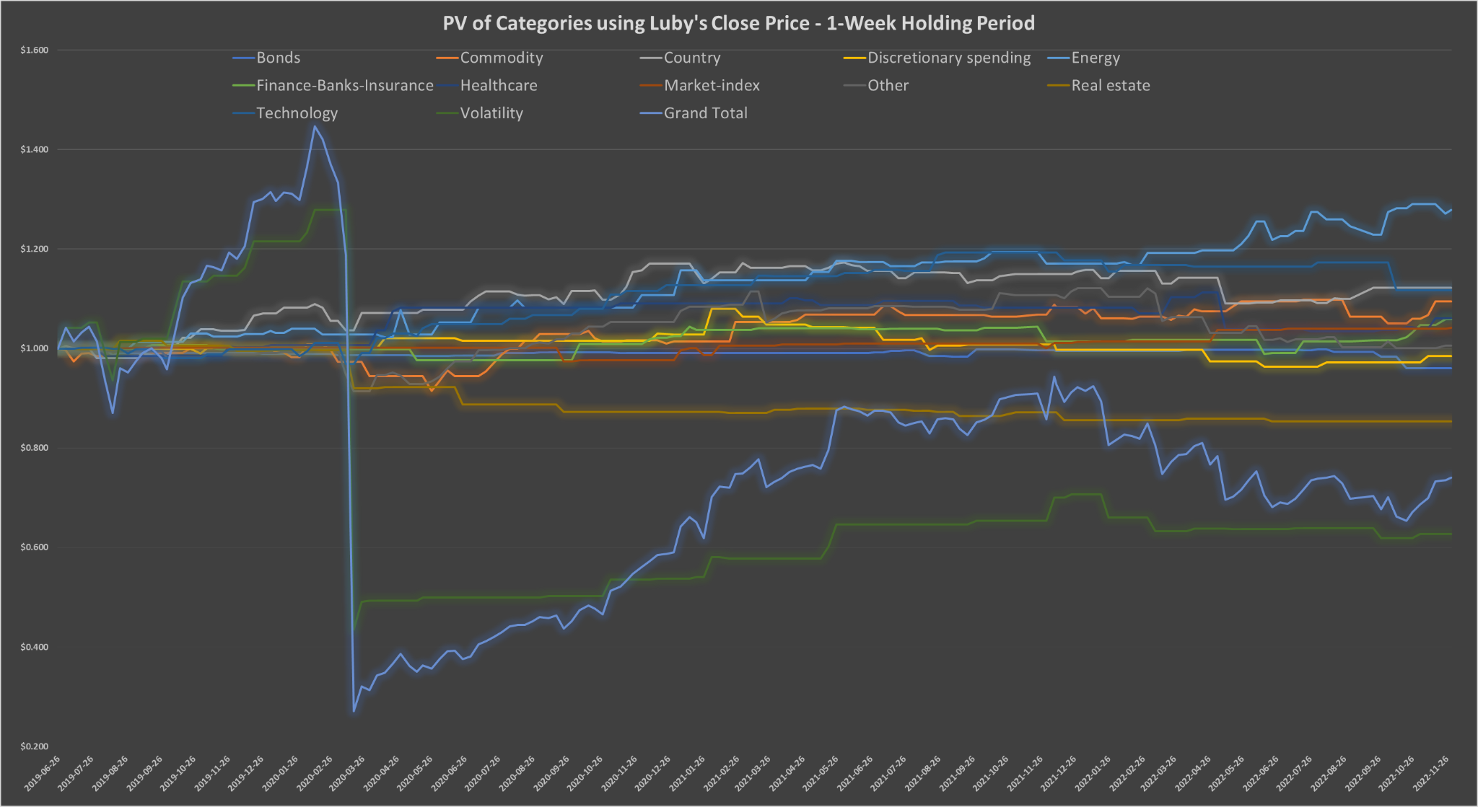
Table 6a: Total profit of Categories using Luby’s close price and 1-Week holding period - using fixed position volume calculation method and leveraged volatility ETPs - 2022-11-30
Chart 4b: PV of Categories using Luby’s close price and 2-Week holding period - using fixed position volume calculation method and leveraged volatility ETPs
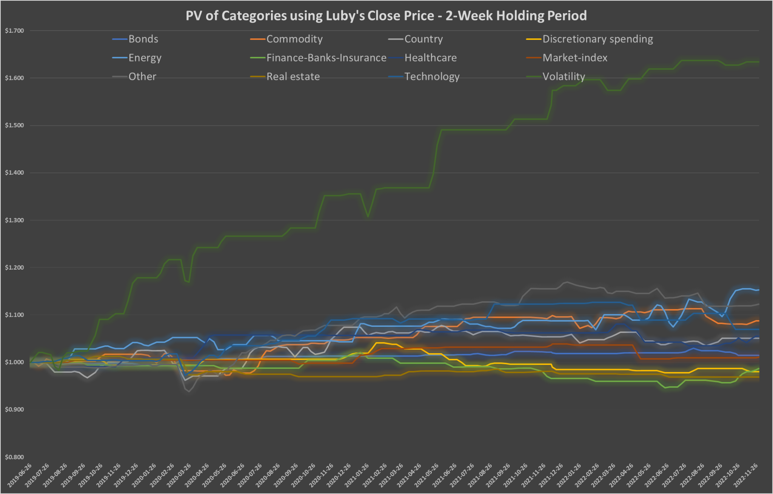
Table 6b: Total profit of Categories using Luby’s close price and 2-Week holding period - using fixed position volume calculation method and leveraged volatility ETPs - 2022-11-30
Chart 5a: PV of Categories using Next day close price and 1-Week holding period - using fixed position volume calculation method and leveraged volatility ETPs
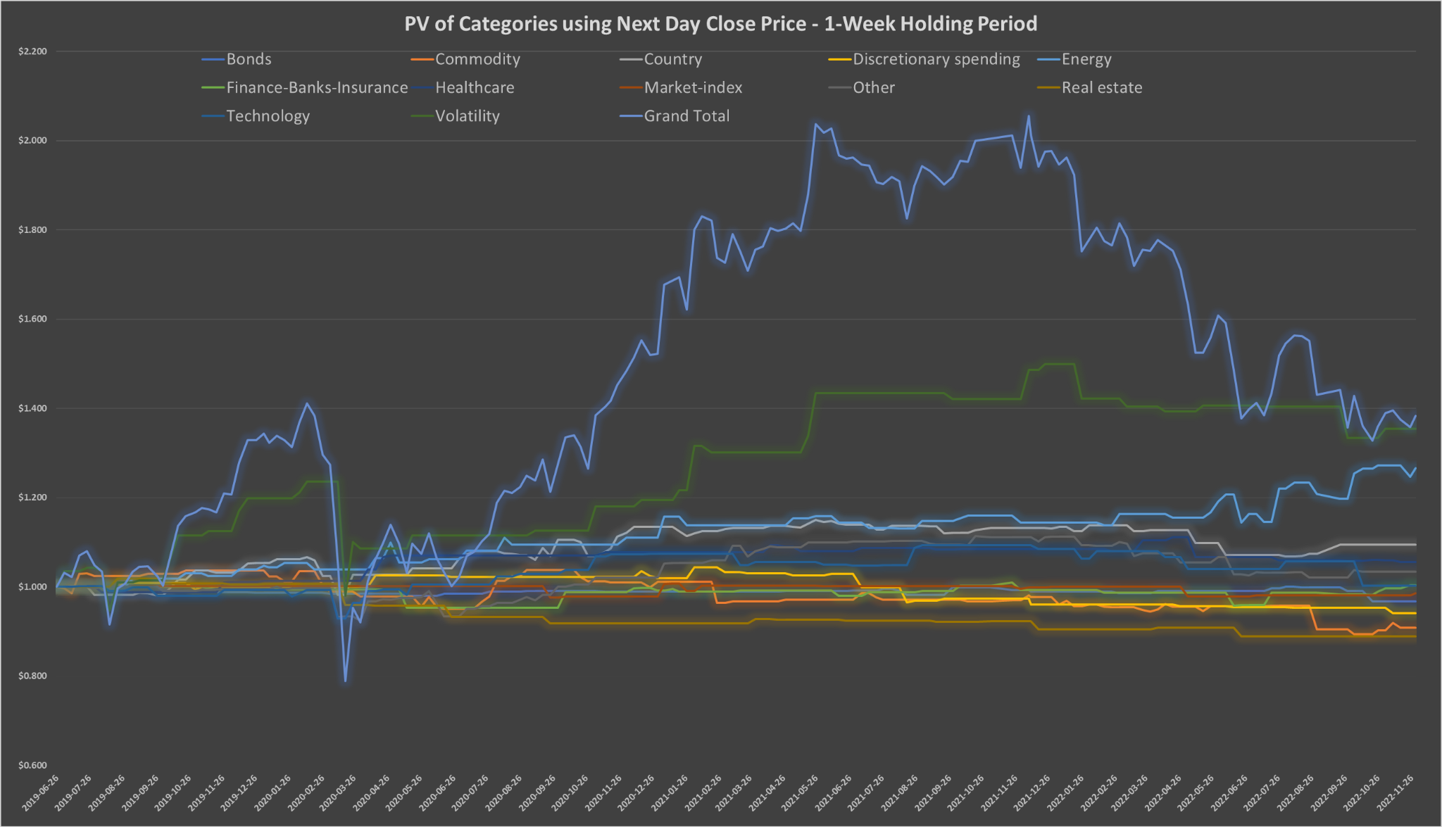
Table 7a: Total profit of Categories using Next day close price and 1-Week holding period - using fixed position volume calculation method and leveraged volatility ETPs - 2022-11-30
Chart 5b: PV of Categories using Next day close price and 2-Week holding period - using fixed position volume calculation method and leveraged volatility ETPs
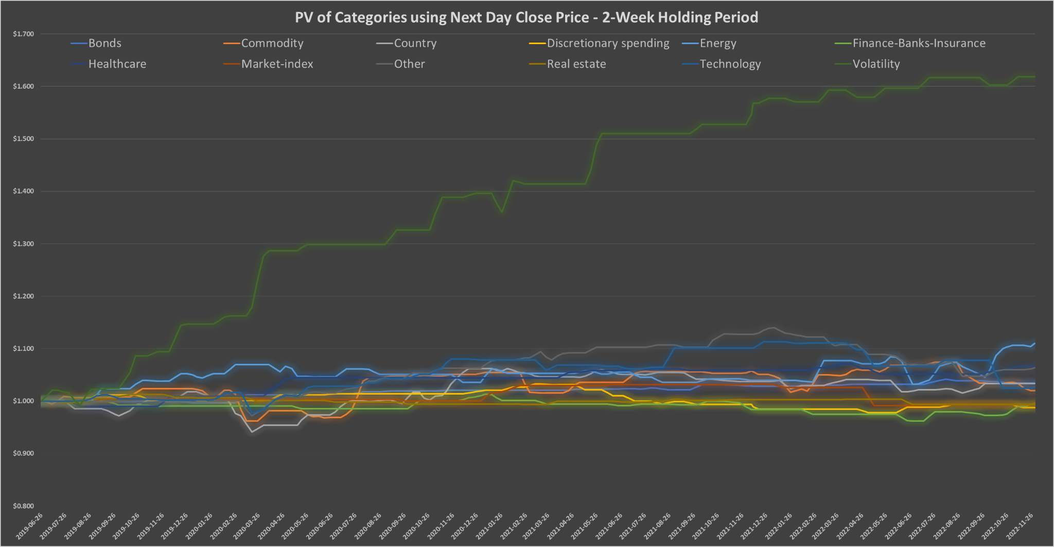
Table 7b: Total profit of Categories using Next day close price and 2-Week holding period - using fixed position volume calculation method and leveraged volatility ETPs - 2022-11-30

Best and Worst Performing ETPs

In this section, we present which ETPs were the best and worst performers overall and on average over the past three and a half years. For the sake of comparability, we again use the fixed position volume method, each position was opened for $333,333.

Until now, Luby has recommended 179 different ETPs. Of these, 32 were mentioned at least 5 times, they can be seen in Table 8. Another 70, however, were mentioned only once among the recommendations.

Table 8: Most recommended ETPs until 2022-11-30
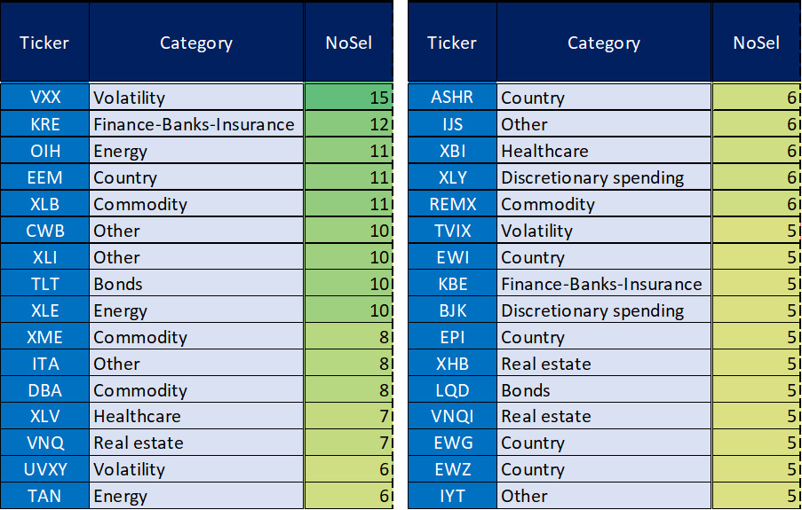

In the following the first two tables (Table 9a-b) use Luby's close price, while the next two (Table 10a-b) use the next day's close price. ETPs are sorted by their performance using a 2-week holding period.

As expected based on the previous results, the (short) volatility ETPs performed by far the best in the two-week timeframe. However, as you can see, the performance of the leveraged versions is quite fragile in the sense that they can provide quite fluctuating performance over different timeframes. See e.g. the case of TVIX. In contrast, the versions using maximum single leverage (VXX, SVIX) were much more balanced. Timing is extremely important in this category.

Competitors in the other categories performed quite mixed overall. For example, while some energy ETPs achieved excellent profits in the examined periods, there were also peers that performed very poorly. The same is true for tech ETPs and everyone else. Based on these, it would be difficult to say that the recommendations of some sectors should be given more weight than others.

Table 9a: Total dollar profits of ETPs as on 2022-11-30 - using Luby’s close price and fixed position volume calculation method

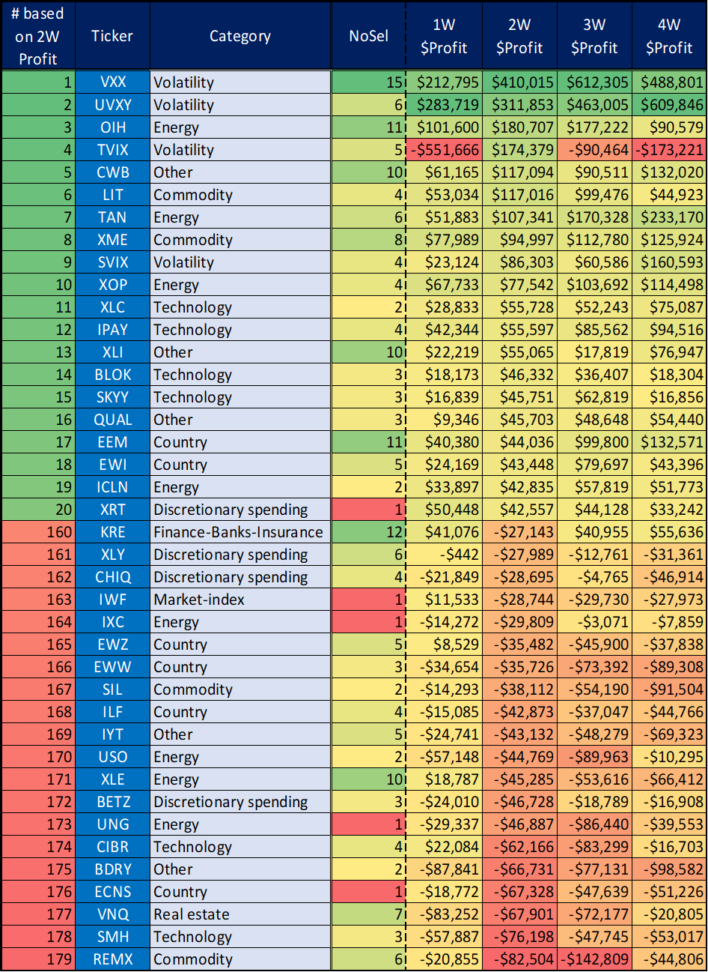
Table 9b: Average dollar profits of ETPs as on 2022-11-30 - using Luby’s close price and fixed position volume calculation method

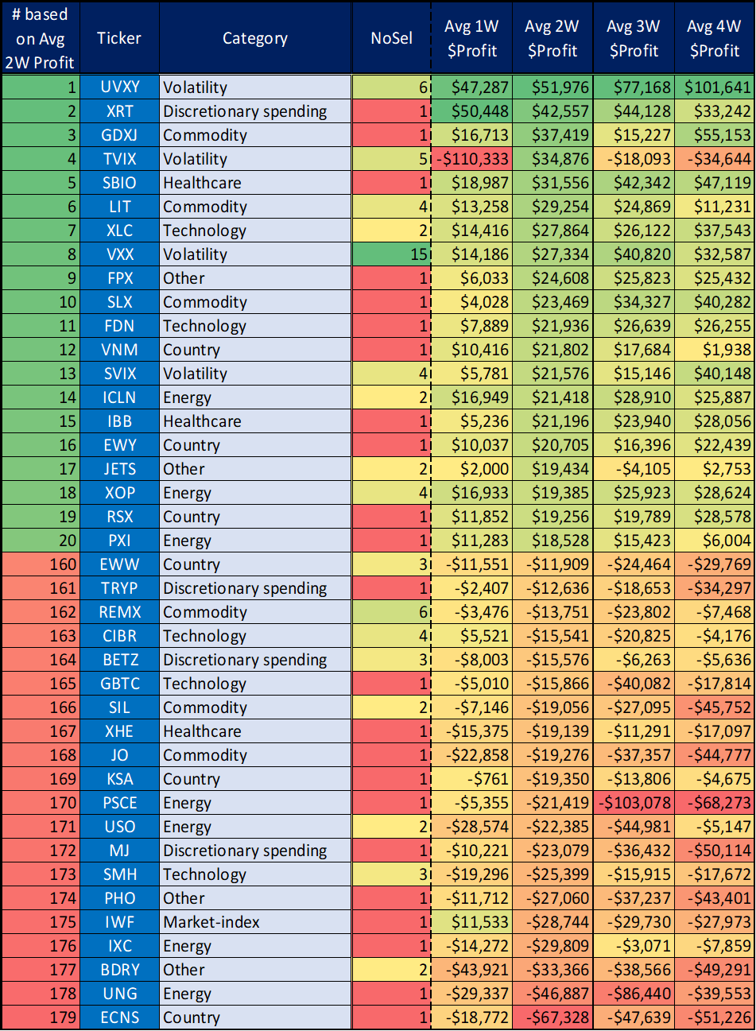

Table 10a: Total dollar profits of ETPs as on 2022-11-30 - using next day close price and fixed position volume calculation method

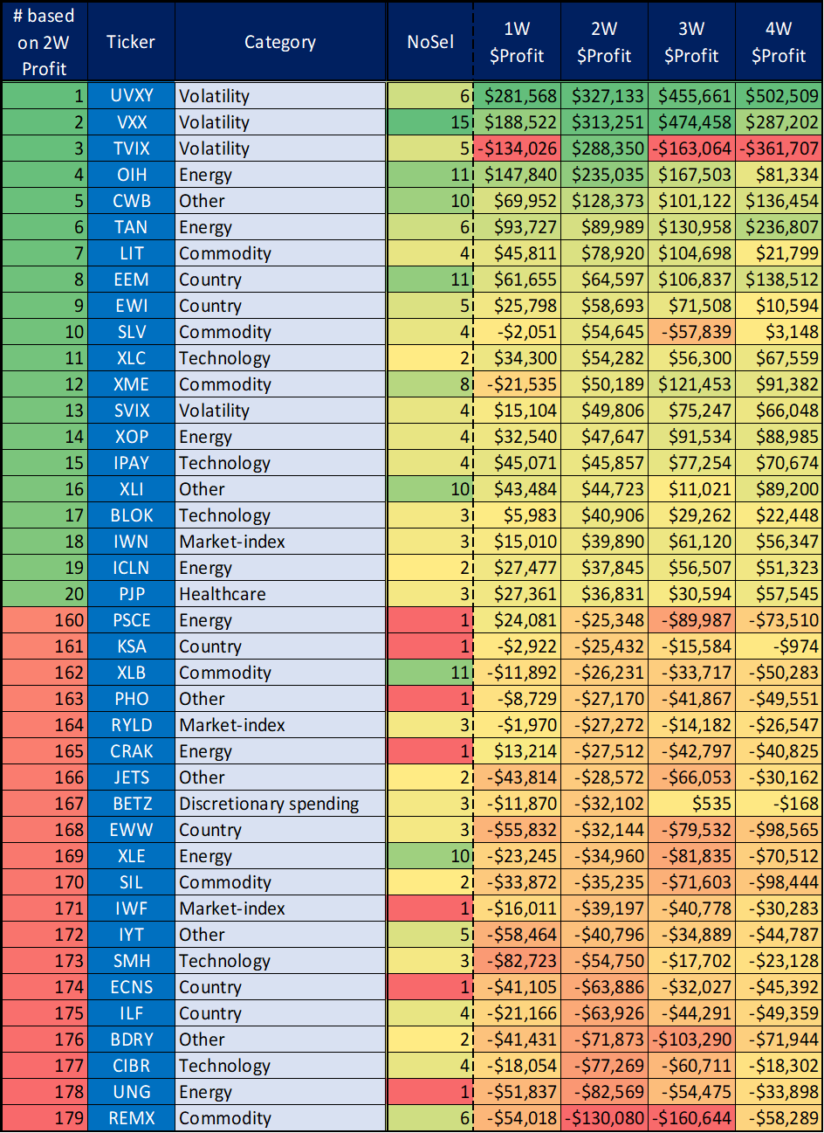
Table 10b: Average dollar profits of ETPs as on 2022-11-30 - using next day close price and fixed position volume calculation method

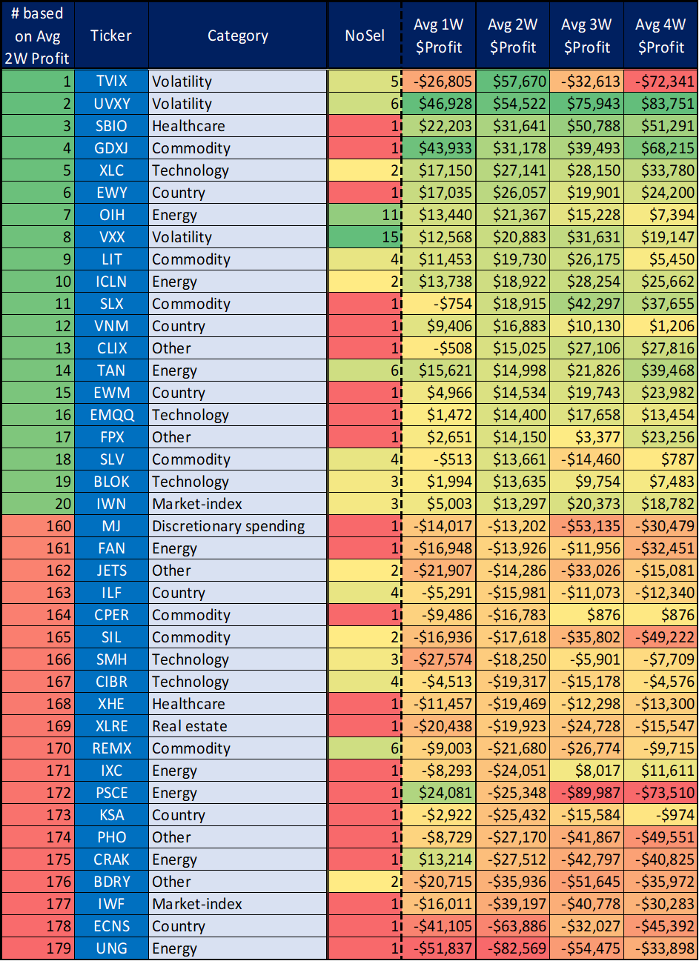

Best and Worst Recommendations

Finally, in this section, we show which recommendations have performed best and worst in the past - just for the sake of curiosity. First, we examine the joint performance of all three ETPs chosen in a given week, and then examine each proposal separately. Due to the complexity of the calculation, we only deal with holding periods of one and two weeks in this final part of the study.

As can be clearly seen in Table 11, both the average and the median joint profit are positive in the case of 1- and 2-week holding periods. Although the average is more than double due to the longer holding period, we do not see such a big difference in the case of the median. However, based on the minimum values, it can be seen that the shorter period is much more sensitive to whipsaw.

Tables 12a-13b contain the best and worst recommendations based on the joint performance of all three ETPs chosen in a given week. It can be clearly seen from the numbers that in the case of both extremes, the short volatility parts usually cause the significant movement. Furthermore, March 2020 (covid bottom) appears on both sides. In addition, these tables also show how important timing is. It really matters whether we use the close prices used by Luby, or the next day close prices available to us in reality.

Table 11: Joint performance of ETPs recommended in a given week as on 2022-11-30

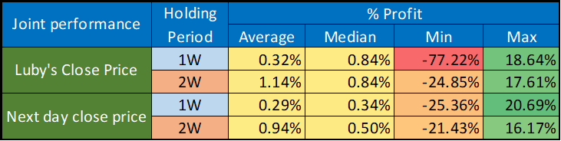

Table 12a: Best and worst 1-Week periods - using Luby’s close price

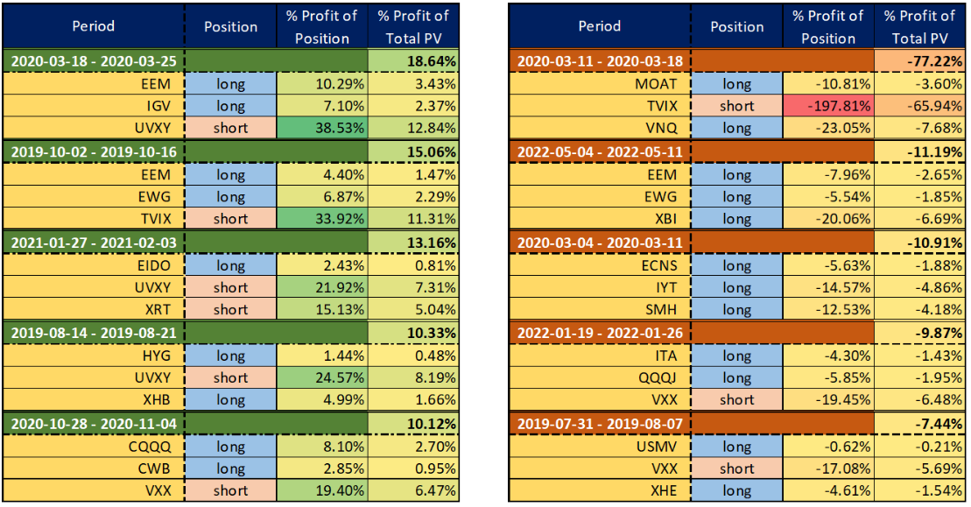
Table 12b: Best and worst 2-Week periods - using Luby’s close price

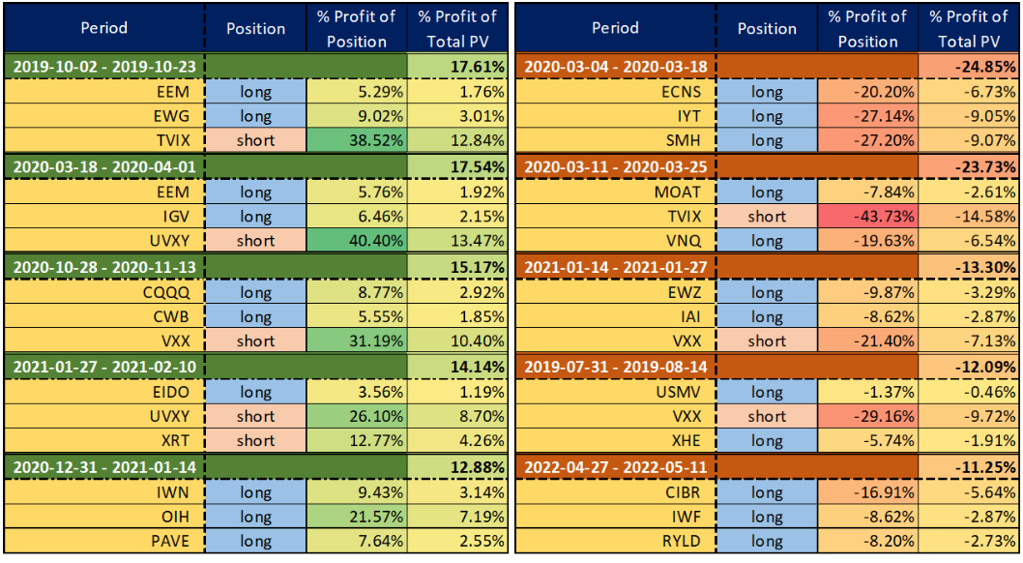
Table 13a: Best and worst 1-Week periods - using next day close price

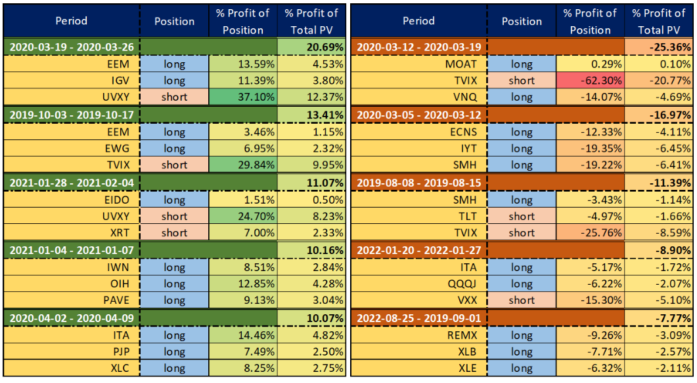
Table 13b: Best and worst 2-Week periods - using next day close price

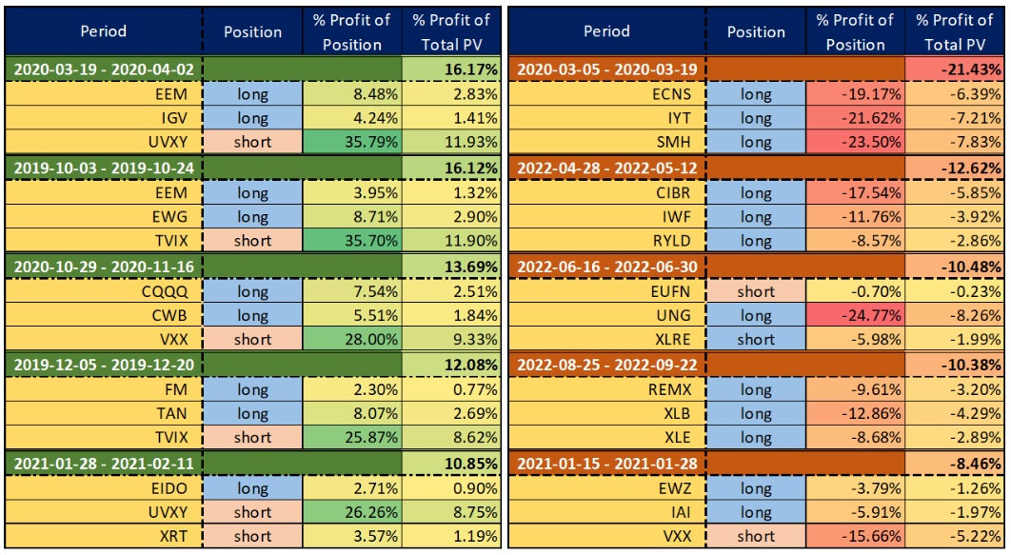
Finally, let's take a look at which of the individual recommendations were the best and worst performers over the past three and a half years. Based on Table 14, one can again recognize that the use of a two-week holding period is significantly more profitable and balanced compared to its one-week competitor.

After reviewing Table 15a-18b, no one should have the slightest doubt as to what actually drives the profitability of the strategy. When using both Luby's close price and the next day's close price, 7-9 short volatility recommendations finished in the top 10, taking both time frames into account. And although in smaller numbers, but to an even more significant extent (in terms of % change), the same ETPs are also at the top of the list of worst performers. Furthermore, these tables also show what we have said several times before: timing is very important, especially in the case of a shorter holding period.

Table 14: Individual performance of ETPs recommended until 2022-11-30
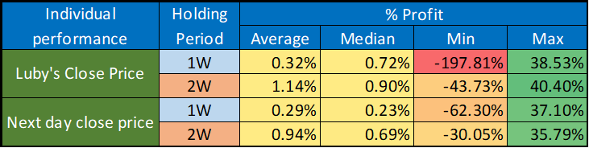

Table 15a: Best 1-Week performers - using Luby’s close price
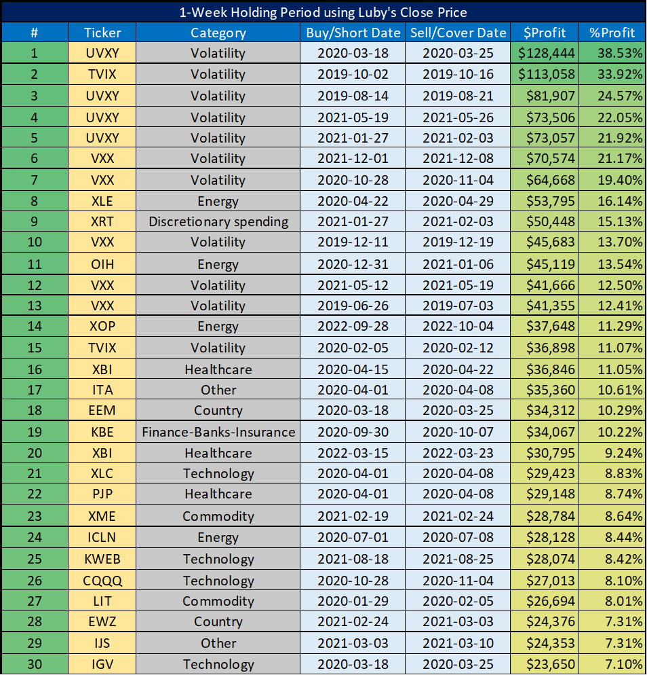
Table 15b: Worst 1-Week performers - using Luby’s close price
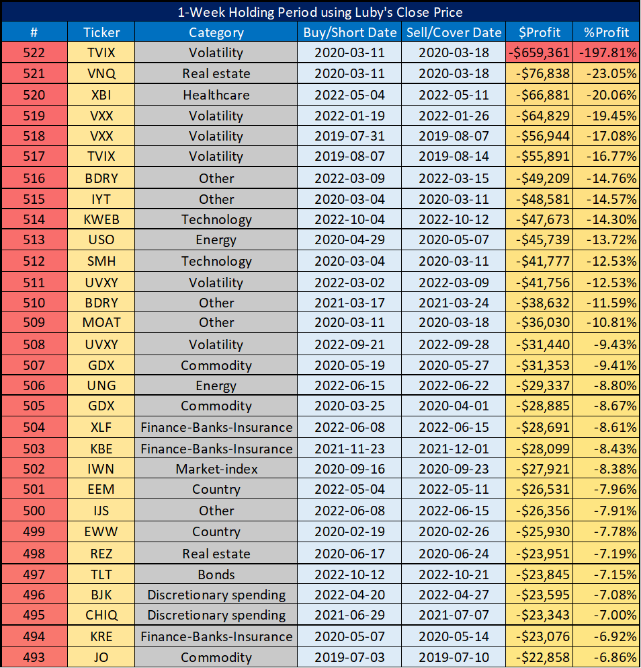
Table 16a: Best 2-Week performers - using Luby’s close price
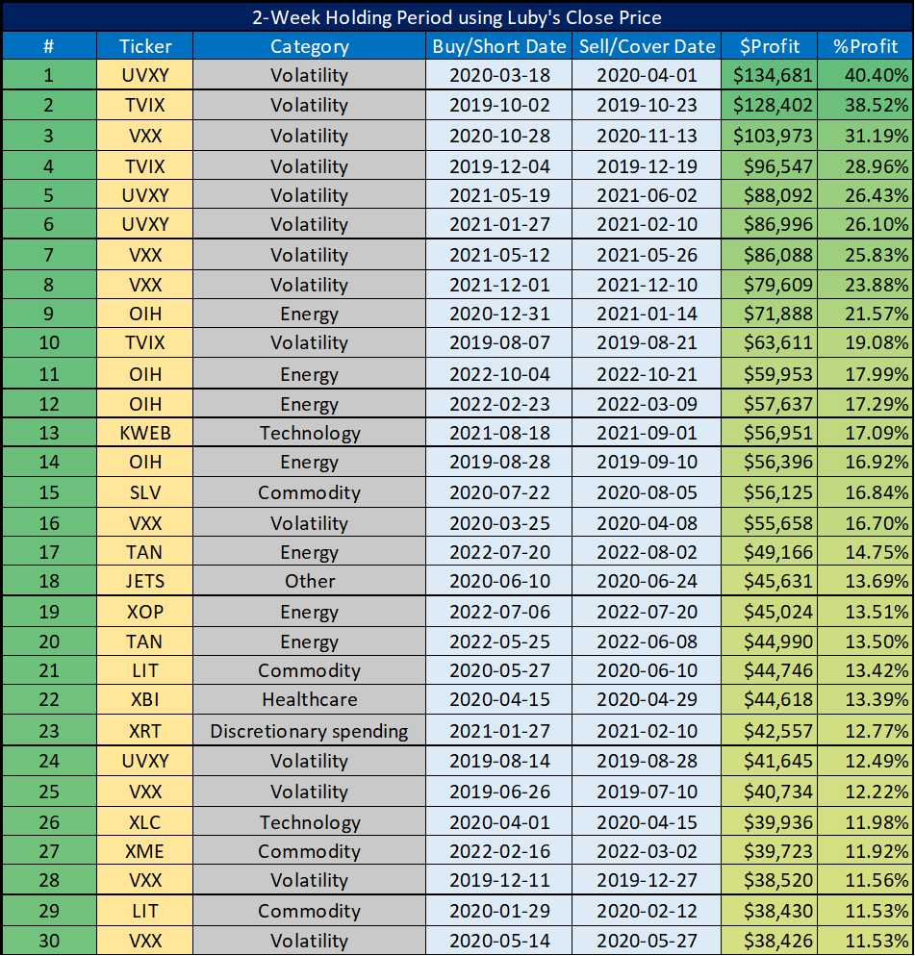
Table 16b: Worst 2-Week performers - using Luby’s close price
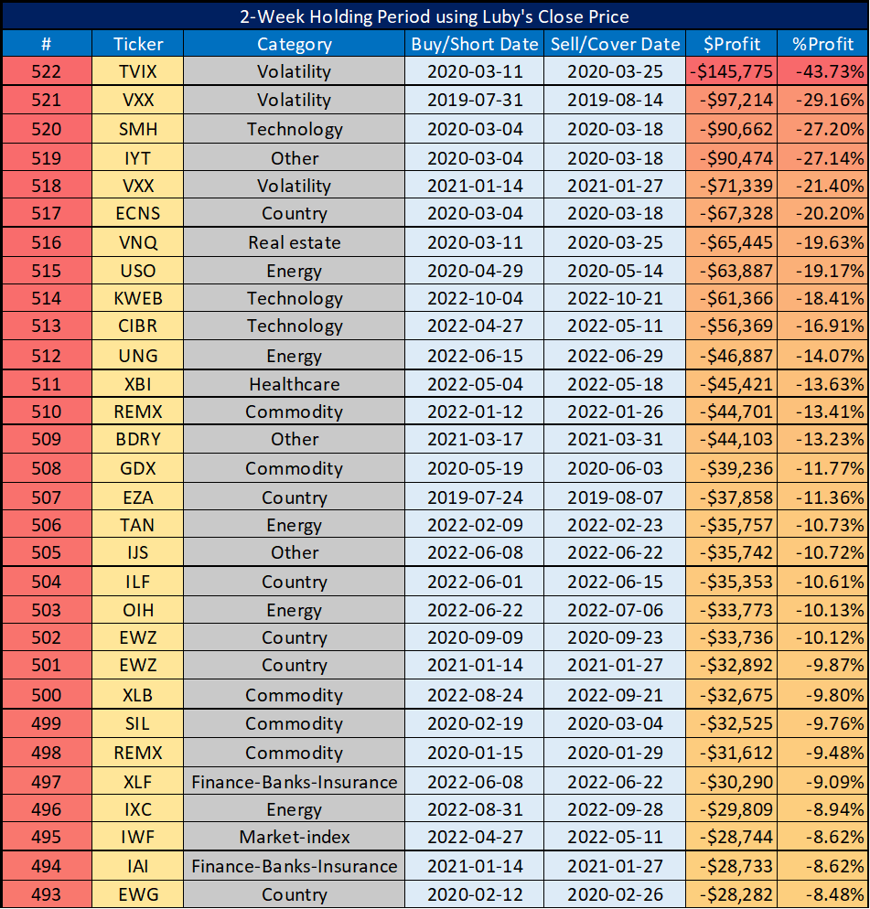
Table 17a: Best 1-Week performers - using next day close price
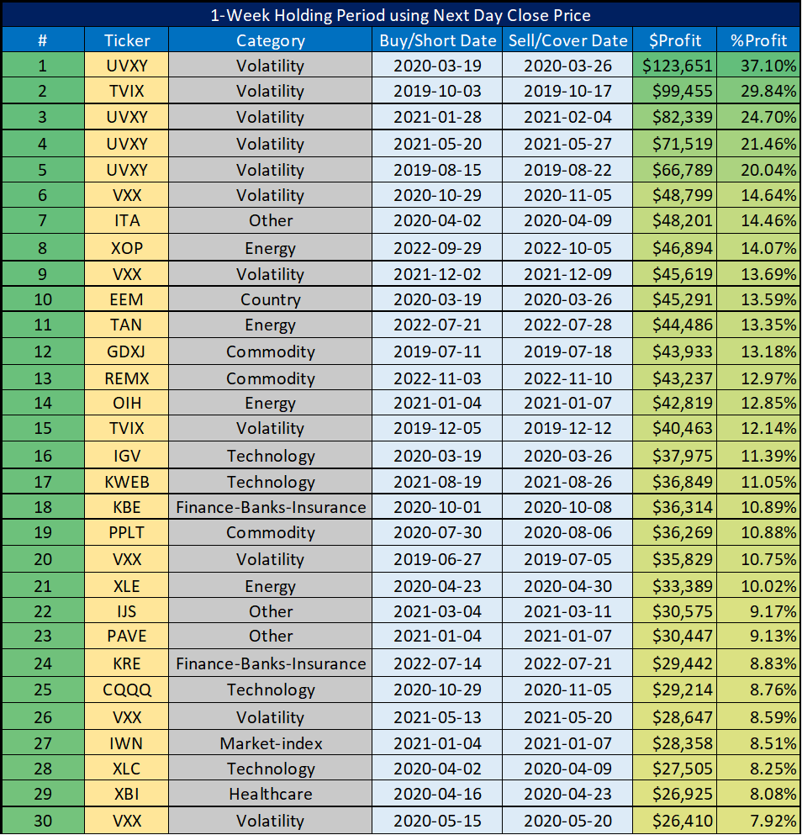
Table 17b: Worst 1-Week performers - using next day close price
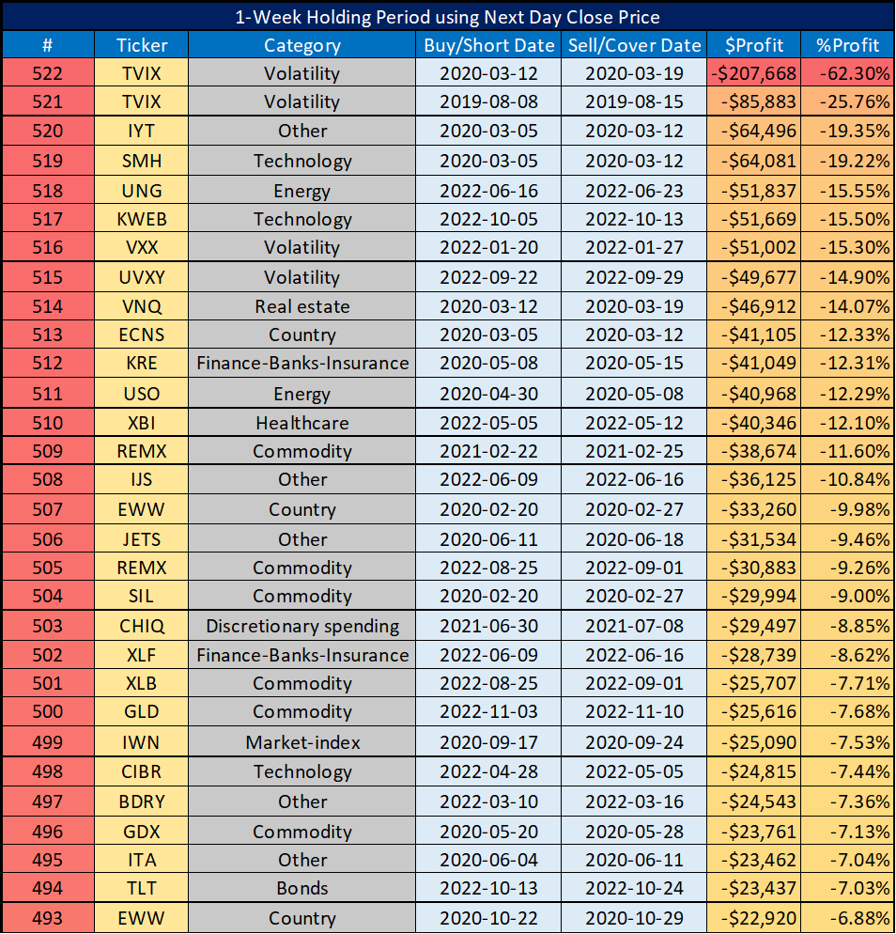
Table 18a: Best 2-Week performers - using next day close price
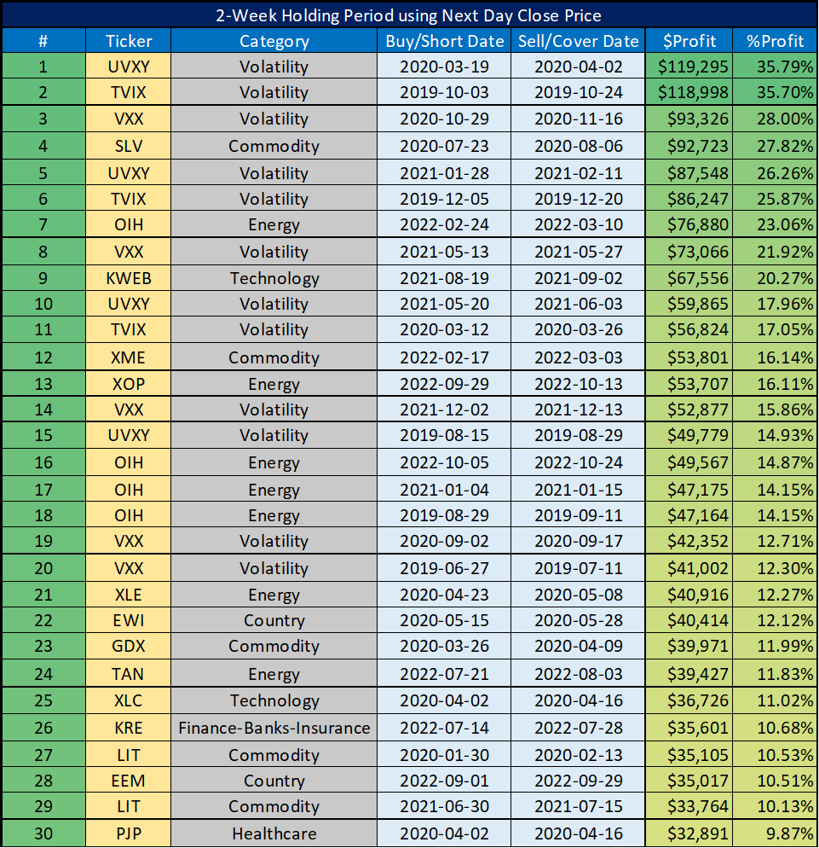
Table 18b: Worst 2-Week performers - using next day close price
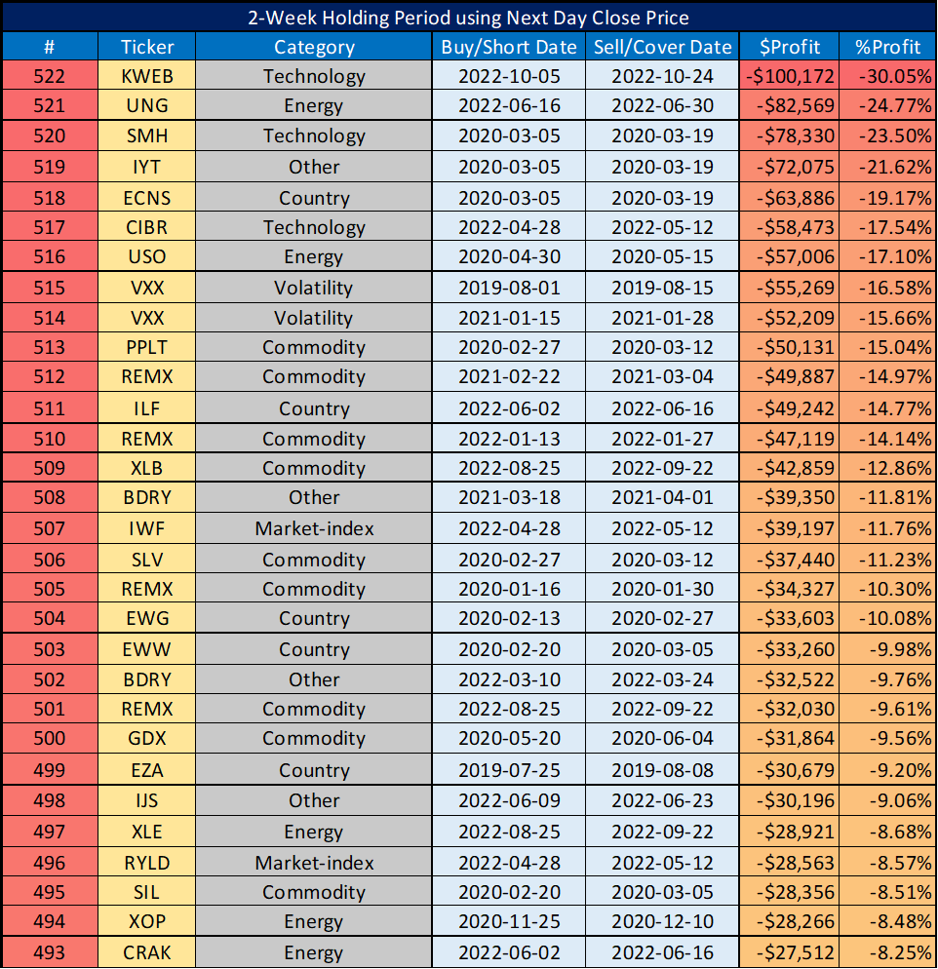

Conclusions

In this study, we dug deeper into Bill Luby's 'Featured ETP Trade Ideas'.

The key takeaways we concluded:
- The profitability figures reported by Luby in his newsletter should not be taken seriously, they are full of serious hindsight bias and misrepresentations. He should have reported a huge loss when the short TVIX tripled, but he cheated that away from his statistics.
- Shorting leveraged volatility ETPs is very dangerous for the strategy, as it can cause losses of up to 100% (see March 2020). Our remedy is to use only the non-leveraged VXX whenever he suggests a leveraged volatility ETP.
- ‘Country’, ‘Other’ and ‘Commodity’ are the most recommended ETP categories (It can be seen in the ‘Sum of NoSelection’ column), while ‘Healthcare’, ‘Real estate’ and ‘Market-index’ are at the other end of the line.
- If shorter holding periods are used, there is a large difference in the case of some categories when two different prices (Luby’s and next day close) are applied. For example, if Luby's close price is applied, the amount of $ profits for one week is -$11,653, while for transactions one day later, this value is +$360,055. What a difference! In the case of longer holding periods (2 weeks), the strategy is less price sensitive, and the possible effects of large daily movements are better balanced.
- The categories 'Volatility', 'Energy', 'Healthcare' and 'Technology' have the best cumulative and average performance. His Energy selection was good, but his Country selection was average (gave the average profit), not exceptional. Meanwhile, accepting the recommendations for the 'Discretionary spending', 'Real-estate' and ‘Market-index’ categories was not the idea of the century. Fortunately, he rarely mentioned the latter categories (below 5% of time).
- In fact, volatility ETPs are what drive the strategy's profitability (50%-60% as a rough estimate for the 2 week version).

With the above in mind, more cautious investors might think it would be wise to ignore all volatility recommendations (or even simply replace them with SPY). However, as we have seen, without them the strategy will not be very profitable (especially since the end of the post-covid market rally). Based on all of this, we continue recommending replacing all volatility recommendations with single leveraged VXX. This recommendation is worth considering if only because, according to the new rules, all volatility ETPs other than VXX fall under the rules for ‘PTP’s (see here).

Furthermore, we continue recommending using the 2-week holding period in real life. Our method so far differs from those on Chart 6 in that we do not use double leverage, but open each new position with 1/6 of the PV. This might help us avoid bigger losses and help us profitably play Luby's recommendations in the long run.

Chart 6: PVs of our backtests on 2022-11-30 - using next day close price and simple VXX instead of leveraged volatility ETPs
