Dr. George Antal

3D Click Limited

c/o Suite 431, 28 Old Brompton Road, London SW7 3SS

**Price Movement Around Earnings Announcements Based on the Success of Previous Reports**

**Motivation 1**

**Methodology 1**

**Results 3**

**Case study 8**

**Conclusions 11**

# **Motivation**

In the evaluation of publicly traded companies' performance, and consequently, their stock price dynamics, **quarterly earnings reports** play a **pivotal role**. Professionals in the stock market sphere can concur that due to their significance, these highlighted days are accompanied by substantial trading volume and significant price movements, meaning they are **highly volatile**. Consequently, **careful trading** is required around these days, while a robust strategy can unlock **substantial profit potential**.

The desire to exploit these opportunities has been on our radar for quite some time as well. Until now, we have explored the fluctuations in stock prices of companies' shares around earnings announcements **through various approaches** (primarily led by **Laszlo**). However, we are now delving into a **new concept**.

The question may have arisen in the minds of numerous investors interested in the subject: **whether a particular company's prior-quarter "earnings success," meaning its ability to deliver the analysts' expected estimated earnings figures, influences the current report's success and the price movements around the report's date**.

For instance, if a company has beaten expectations in the past two seasons, **is it likely to beat them again** this time? Moreover, **does the market already factor this in during the days leading up to the report**? In this brief study, we aim to gather evidence through simple calculations regarding these aspects.

# **Methodology**

For conducting the analysis, I utilized earnings data from the **past nine years**, covering the period **between July 2015 and May 2023**. The study included the **historical S&P 500 and Nasdaq 100 companies** (not the current snapshot) - 662 companies and **15,417 announcements** altogether.

Regarding the reports included in the analysis, I defined **two variations of 'success'** (more precisely, 2*2 variations). In the first scenario (1/A), **success is considered achieved when the reported earnings figure (EPS) exceeds the analysts' expectations**, the expected earnings per share number (the 1/B scenario represents the case where beating is not strictly necessary, matching the estimate is sufficient). In the second scenario, I strictly observed only the stock price movement. In my opinion, this conveys more information than EPS alone. It already encapsulates the impact of all additional information (such as revenue, future expectations, etc.). Therefore, I consider a report **successful if the Close-to-Close (2/A) or Close-to-Open (2/B) stock price movement right after the report (T0-return) is positive**.

We consider 2 past earnings: the previous earnings, and the earnings event before that. In both of the previously mentioned scenarios (2 and 4), we can **categorize the current report into 2*2=4 groups** (Beat-Beat, Beat-Missed, Missed-Beat, and Missed-Missed). Subsequently, after the report's release, we can further divide them into **8 groups** **based on the current success level**. We examined the **stock price changes for these groups in the 5-, 3-, and 1-day periods leading up to the report's announcement. Subsequently, we analyzed the Close-To-Open and Close-To-Close changes on Earnings T0-day. Finally, we studied the stock price fluctuations in the 1-, 3-, and 4-day periods following the post-report close**.

More precisely, following cumulative returns are used:

* Previous 5-day: From close of T-5 to Close of T0 (right before announcement);
* Previous 3-day: From close of T-3 to Close of T0 (right before announcement);
* Previous 1-day: From close of T-1 to Close of T0 (right before announcement);
* T0 Close-To-Open: From close of T0 to Open of T+1 (including the announcement);
* T0 Close-To-Close: From close of T0 to Close of T+1 (including the announcement);
* Next 1-day: From close of T+1 to Close of T+2 (from the close following the announcement);
* Next 3-day: From close of T+1 to Close of T+4 (from the close following the announcement);
* Next 4-day: From close of T+1 to Close of T+5 (from the close following the announcement).

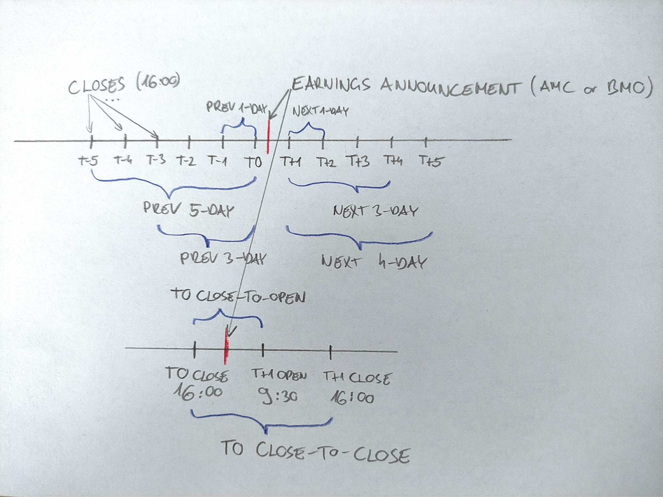

# 

# **Results**

In this section, we present the **results of our calculations**. In the following tables, **average cumulative returns** are shown for the ‘success-scenarios’ (1/A - 2/B) defined earlier separately. In all 4 cases, we calculate these average cumulative returns for the 4 and 8 groups, also defined earlier (based on the success of the preceding two and current reports).

Based on our initial assumptions, we would expect that **companies falling into the 'Success-Success' group would exhibit the most positive price movements 5, 3, and 1 days prior to the current report**. Additionally, the **Close-to-Open and Close-to-Close returns on day T0 would be significantly positive in their case**. Or, at the very least, we can observe stronger averages among those who successfully cleared the obstacle immediately preceding the current one.

Our other hypothesis is that **those stocks will have the highest performance 1, 3, and 4 days after T1 closing who have successfully performed in the current report as well as the previous ones (‘Success-Success-Success’) (according to PEAD, the Post-Earnings Announcement Drift)**.

And now, **let's see the results**! Based on the tables below (Table 1 - 5b), we can draw the following conclusions:

* In **nearly three-quarters of cases (74.85%), the reported EPS figures by companies surpass analysts' expectations**, while in an additional 6.22% of cases, they meet the expectations. Only in 18.93% of cases do they fail to clear the hurdle.
* **The 'T0 Close-to-Open' and 'T0 Close-to-Close' returns immediately following the reports are positive in only about 51.5% of cases, with an average of 0.000%** (additional information - not evident from the tables).
* The **'Distribution %' values shown for each scenario are in complete alignment** with these two previous points. However, it is worth noting that the numbers in the **'Actual success %' columns significantly differ for the Type 1 and Type 2 scenarios**. While in the Type 1/A and 1/B scenarios, we can observe that companies that previously reported success are more likely to be successful in terms of EPS in the current report, in the Type 2/A and 2/B scenarios, the values are distributed quite evenly.
* However, **in terms of average cumulative returns, there is no significant difference among the 4 scenarios**. Therefore, our conclusions regarding these returns are universal.
* **The cumulative returns for 5, 3, and 1 days prior to the report's release are positive, regardless of the success of the company's previous two reports.**
* And the most intriguing part: how do the **'T0 Close-to-Open' and 'T0 Close-to-Close'** prices change for each group? Surprisingly, once again, **no significant differences are found among them**. Moreover, if anything, those who were less successful in their previous reports might have slightly performed better (although the difference is marginal!). **With this, the first, the initial fundamental hypothesis has been contradicted**.
* Finally, let's examine how the companies perform in the **1, 3, or 4 days after T1**. The **results here are quite intricate, and no significant patterns emerge**. Perhaps an attentive reader might notice that, as expected, **companies that are successful in the current report tend to perform better in the days following the announcement compared to those that missed.** However, this outperformance is once again **marginal and not consistent across all groups**. **Thus, our second hypothesis has also been refuted.**

Table 1: Success ratio of scenarios

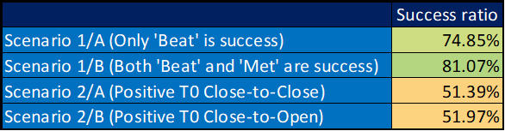

Table 2a: Preceding and T0 returns in case of Scenario 1/A: Only ‘Beat’ is success (EPS)

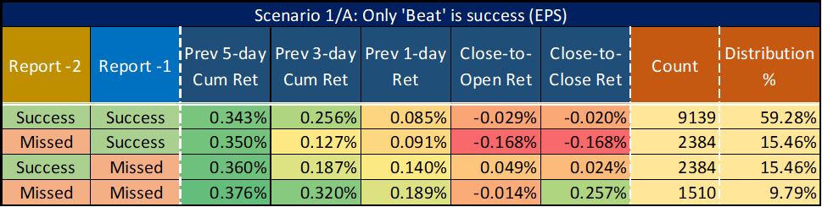

Table 2b: Post announcement returns in case of Scenario 1/A: Only ‘Beat’ is success (EPS)

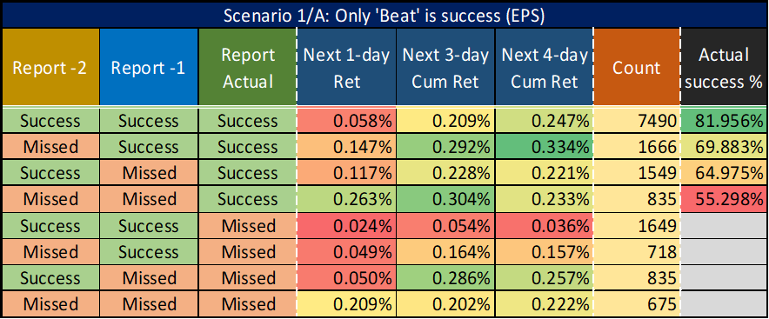

Table 3a: Preceding and T0 returns in case of Scenario 1/B: Both ‘Beat’ and ‘Met’ are success (EPS)

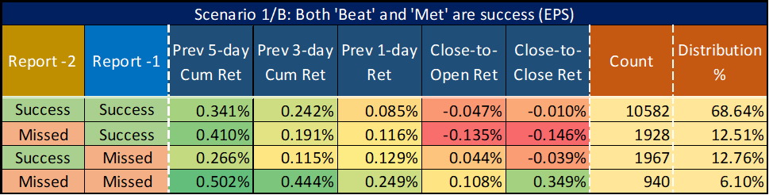

Table 3b: Post announcement returns in case of Scenario 1/B: Both ‘Beat’ and ‘Met’ are success (EPS)

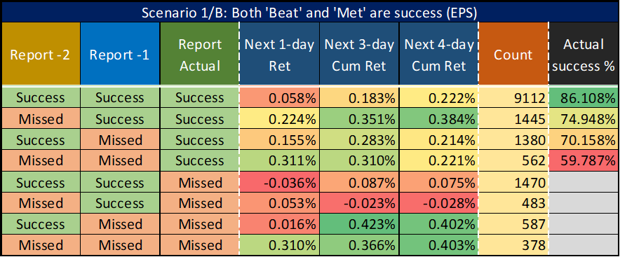

Table 4a: Preceding and T0 returns in case of Scenario 2/A: Positive T0 Close-to-Close is success (price)

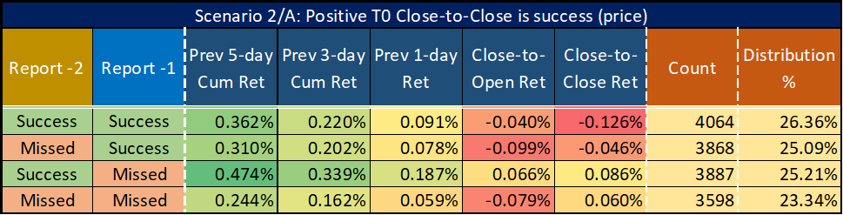

Table 4b: Post announcement returns in case of Scenario 2/A: Positive T0 Close-to-Close is success (price)

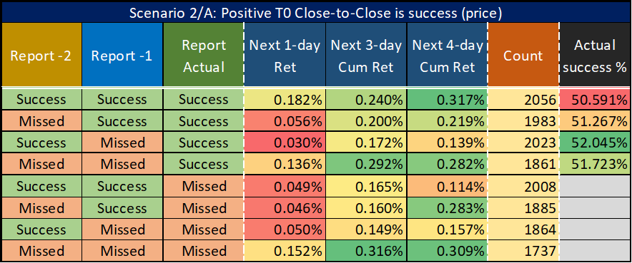

Table 5a: Preceding and T0 returns in case of Scenario 2/B: Positive T0 Close-to-Open is success (price)

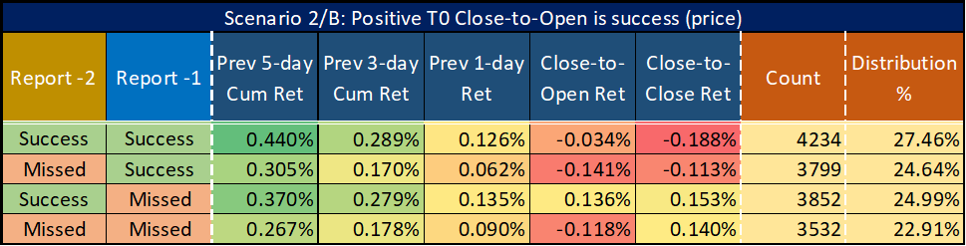

Table 5b: Post announcement returns in case of Scenario 2/B: Positive T0 Close-to-Open is success (price)

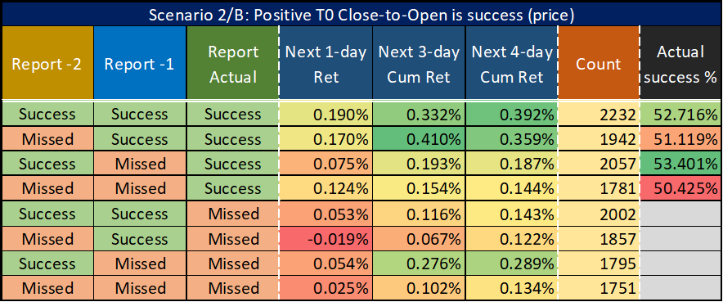

To **further substantiate the rejection of our foundational hypothesis** (that is, the notion that 'successful' companies in the past two instances will experience positive stock price movements following the current report), **we conducted an ANOVA analysis**. Single factor ANOVA, also known as one-way ANOVA, is a **statistical method** employed to **examine whether there are significant differences in the means of three or more groups**. It assesses **whether the observed variations in data can be attributed to group differences rather than being the result of random fluctuations**. By analyzing the **variability between groups and within groups**, ANOVA helps determine **whether these differences are statistically significant**, aiding in drawing conclusions about the factors contributing to observed variations.

Below (Chart 1a and 1b), you can see the results for 2 scenarios (1/B and 2/A) and 1 outcome variable each (T0 C2O and C2C return), but we obtained **similar numbers for the other cases as well**. If someone prefers not to delve into the details, they can focus solely on the **p-value**. If this value is **greater than a predetermined threshold (usually alpha = 0.05)**, then we can **reject the assumption that grouping yields significantly different means** and that we can **explain the variability in data through group classification**. In other words, **we can reject the hypothesis that there is a significant difference among the groups**. And **in the case of our results, this is exactly the situation. Thus, group membership (previous success) does not explain the expected T0 returns.**

Chart 1a: ANOVA - Scenario 1/B and T0 Close-to-Open return

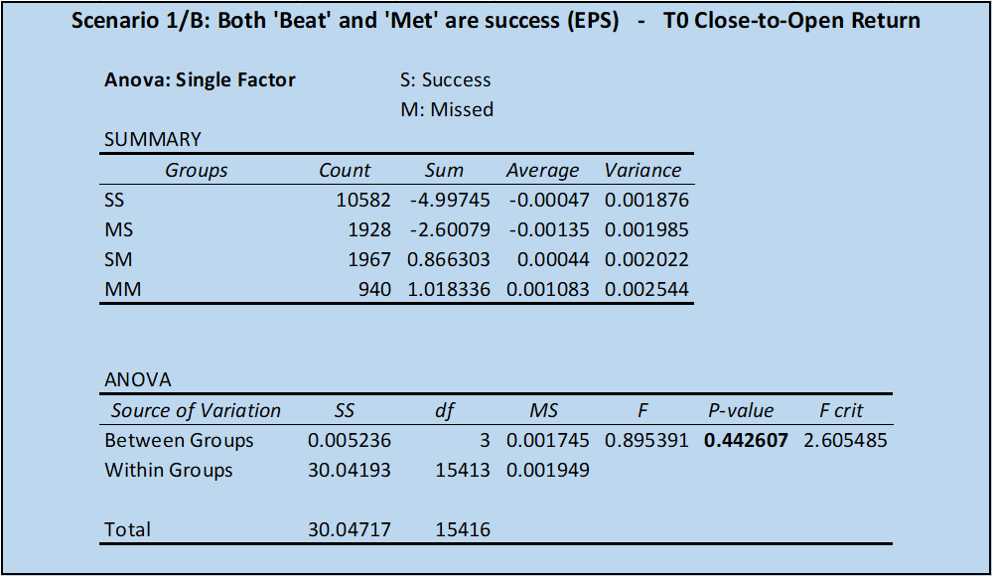

Chart 1b: ANOVA - Scenario 2/A and T0 Close-to-Close return

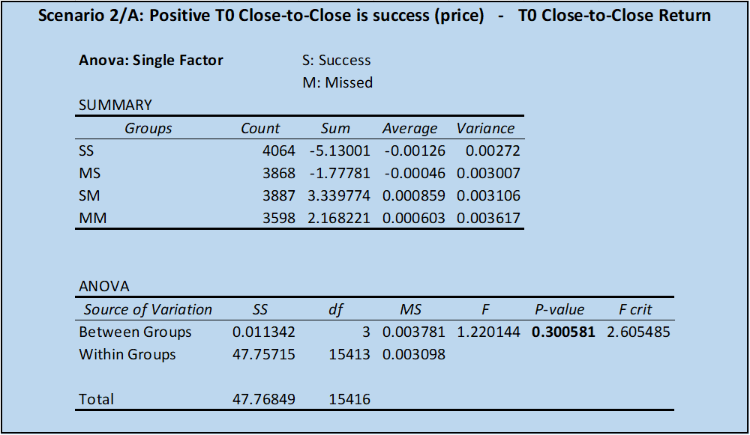

# **Case study**

For now, let's consider a concrete case study. Take a look at **one of my beloved stocks,** [**FTNT**](https://finance.yahoo.com/quote/FTNT) (with the rest being BRK.B, TSLA, and BLDR), which had its quarterly earnings report last week (2023-08-03).

“Fortinet is a **cybersecurity company** with headquarters in Sunnyvale, California. The company develops and sells **security solutions like firewalls, endpoint security and intrusion detection systems**. Fortinet has offices located all over the world.

Brothers Ken Xie and Michael Xie founded Fortinet in 2000. The company's first and main product was FortiGate, a physical firewall. The company later added wireless access points, sandbox (computer security), and messaging security. The company went public in November 2009.”[1]

Over the last few years, **the company has performed exceptionally well**. Additionally, as can be seen from the charts below[2], **its recent quarterly reports have consistently outperformed expectations**.

After taking note of these signals, what could an ordinary investor have anticipated regarding the current report? The logical anticipation would be that **the company would once again surpass expectations, resulting in a substantial increase in the stock's value.** So, **the best approach might be to make sound investments in the company's stocks before the report is released**. **Following the report's publication**, these investors might have felt **comfortable**, given that **the company exceeded the EPS and Revenue expectations once again**. Yet, to their utmost astonishment, ***the stock prices plummeted by a staggering 25% until the following day's close!***

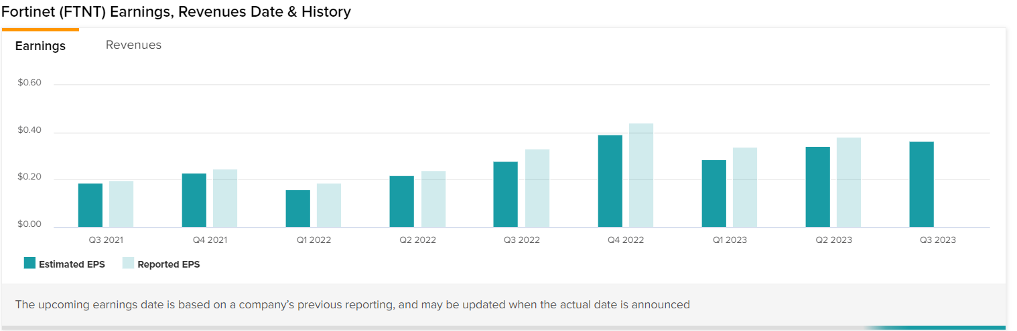

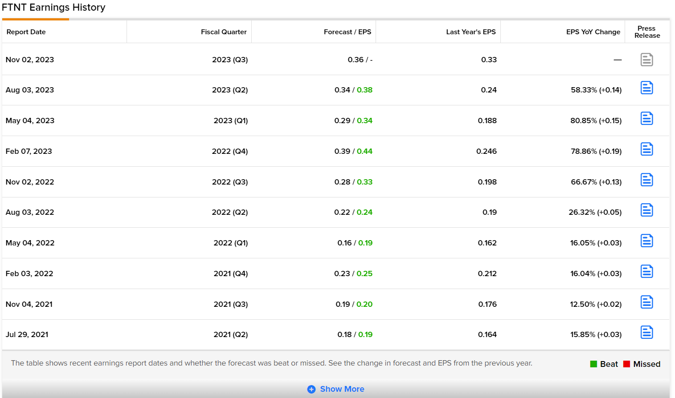

Before delving into the details of what transpired, let's examine **the market reactions to the company's previous reports**. The following table (Table 6) presents the Close-to-Open and Close-to-Close price changes following the report announcements. As you can see, the **reactions are generally quite volatile and unpredictable**. Why might this be the case? Because **experts consider not only the fulfillment of EPS and Revenue expectations from the report but also other forward-looking anticipations**. For instance, forecasts for the upcoming quarters, the anticipated market position of the company, and so forth. Thus, **our ordinary investor would have been better off considering not only the figures from past reports but also the market reactions they elicited before making his purchase**.

Table 6: FTNT - earnings reactions

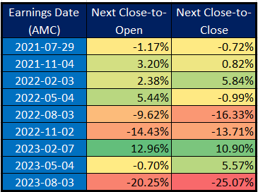

Now, let's take a look at what happened in this specific case:

“Shares of Fortinet Inc. **lost a quarter of their value** Friday **after executives at the Sunnyvale-based company warned that uncertainty in the broader economy is affecting its sales**.

The company's **billings** — which includes both current revenue and the changed in its deferred revenue — **grew by 18% year-over-year in the second quarter. That was the lowest rate in three years and the first time in two years that its quarterly billings hadn't grown by at least 30% from the same period a year earlier**.

And **Fortinet expects the slowdown to continue.** It projected that its **billings would grow by between 11% and 15% year-over-year in the third quarter**.

"We believe our billing performance reflects large enterprises' concern with the macro environment in addition to some inventory digestion after two years of 30%-plus product billing growth," CEO Ken Xie said on a conference call with analysts Thursday afternoon.

Fortinet's shares closed regular trading Friday down $18.99 each, or 25%, to $56.77 a piece. Earlier in the day, they were down as much as $19.66 each to $56.10.

The **sell-off came despite the company topping Wall Street's earnings expectations for its second quarter.**

In the just-completed period, it earned $266.3 million, or 33 cents a share. That's up from $173.4 million, or 21 cents a share, in the second quarter of 2022. Its sales jumped 25% year-over-year to $1.29 billion.

Excluding certain charges and gains, it would have earned $300.4 million, or 38 cents a share, in the second quarter this year.

On that basis, Wall Street was expecting it to earn 34 cents a share on sales of $1.3 billion.

I**n the third quarter, Fortinet expects to post an adjusted per-share profit of 35 cents to 37 cents on sales ranging from $1.315 billion to $1.375 billion. Analysts had previously forecast it would earn 36 cents a share on $1.27 billion in sales.**

But the **company lowered its outlook for full-year sales**. It now expects to post $5.35 billion to $5.45 billion in revenue for 2023. It previously forecast full-year revenue of $5.425 billion to $5.485 billion.

CEO Xie and his brother Michael founded Fortinet in 2000 and took it public in 2009. The company, which has more than 12,000 employees globally, was valued at $1.17 billion at the end of 2009.

When markets closed Thursday, it was worth $59.48 billion. But at the end of trading Friday, the company's market cap was $44.5 billion — 16% higher than where it was at the end of 2022.”[3]

**Lesson: Outperforming the expected EPS and Revenue figures on their own does not guarantee a favorable performance of the company's stock following the release of the report**.

# 

# **Conclusions**

In conclusion, **our study aimed to shed light on the relationship between the success of the previous two earnings reports and the subsequent price movements around the current report announcements**. **Despite the initial assumptions and hypotheses, the results indicate that there is no significant correlation between a company's prior-quarter earnings success and its ability to replicate that success in terms of positive return in the current report.**

The study examined various time periods leading up to and following the report announcements, analyzing different scenarios and outcome variables. **While we anticipated that certain groups, such as those with consistent prior successes, would exhibit distinctive price movements, the findings showed no consistent and statistically significant patterns across these scenarios.**

Furthermore, the analysis of the **'T0 Close-to-Open' and 'T0 Close-to-Close' price changes after the report announcements demonstrated that success in previous reports did not significantly influence the immediate post-report stock price movements.** **This finding further reinforces the idea that historical success does not guarantee future positive reactions from the market.**

**Also, the data from 2015 to 2023 doesn’t show that Post-Earnings Announcement Drift or** [**PEAD**](https://quantpedia.com/strategies/post-earnings-announcement-effect) **is alive. PEAD was a well-documented anomaly in the ‘90s, but disappeared.**

Finally, even when using **ANOVA analysis** to assess potential differences in means among different groups, we found no substantial evidence to support the notion that companies with a history of earnings success experience more positive stock price movements following the current report.

In essence, **the study reveals (through a case study of FTNT company) that while beating expectations in previous earnings reports might be a positive indicator, it is not a foolproof strategy for predicting stock price movements around current report announcements**. **Therefore, investors should exercise caution and consider a broader set of factors when making trading decisions around earnings season. The stock market's reaction to earnings announcements is influenced by a complex interplay of various variables, and relying solely on past success might not yield consistent outcomes.**

1. https://en.wikipedia.org/wiki/Fortinet
2. https://www.tipranks.com/stocks/ftnt/earnings
3. https://www.bizjournals.com/sanjose/news/2023/08/04/fortinets-stock-plunges-on-sales-warning.html?utm_source=sy&utm_medium=nsyp&utm_campaign=yh