Dr. George Antal
3D Click Limited
c/o Suite 431, 28 Old Brompton Road, London SW7 3SS

Strategic Insights from SeekingAlpha TopAnalysts:
Building a Long-Short Portfolio

Introduction 1
Background 2
Statistical Analysis 4
Detailed Analysis and Strategic Insights 5
Analysis of Outperformance Relative to SPY Using Statistical Tests 7
Use of Stop-Loss 9
Strategy Backtest Results 10
Scenario Analysis 12
Comprehensive Analysis of Strategy Scenarios 24
Conclusion 28
Appendix - QuantConnect Cloud C# code + recommendations 29

Introduction
Stock picking is a challenging endeavour, fraught with complexities that often make it difficult to discern whether success stems from genuine skill or mere luck. Determining whether a stock picker is truly adept or just fortunate can take many years, as the performance of selected stocks must be observed over an extended period, often across various market conditions. This long timeframe means that by the time a pattern emerges, market dynamics may have shifted, making past success less indicative of future performance.

Furthermore, reliance on analysts' recommendations can be equally perilous. Analysts are frequently influenced by the companies they cover, which can create conflicts of interest. These companies often have a vested interest in being portrayed positively, which may result in biassed recommendations. Consequently, short recommendations are rare, as analysts might be reluctant to issue sell ratings on companies with which they have relationships, particularly in bullish markets. Issuing a sell recommendation requires significant courage, especially when it is not directed at a company that is already visibly heading towards bankruptcy, such as a penny stock.

Given these challenges, there is a compelling case for developing a long-short strategy. This approach allows for the potential to profit not only from rising stocks but also from those expected to decline. By combining long and short positions, investors can hedge against market volatility, potentially achieving more consistent returns regardless of market direction. A well-constructed long-short strategy can thus provide a balanced approach to stock picking, mitigating some of the risks inherent in traditional long-only strategies.
In this study, a strategy based on the recommendations of analysts designated as 'Top Analysts' by SeekingAlpha will be presented. As will be evident, the strategy promises highly impressive results. However, it is crucial to keep in mind that several biases may distort these outcomes, and therefore, it is not guaranteed that similarly outstanding results can be achieved in real-world trading in the future.

Background
SeekingAlpha Pro subscribers have access to the 'Top Analyst Ideas' section. As they describe it: "This easy-to-use, PRO-only feature enables you to pinpoint the market's most compelling stocks for your specific investing strategy. Filter stock analyses from the Top 50 Seeking Alpha Analysts using criteria such as Rating, Number of Ratings, Success Rate, and Average Return. Also, screen stocks by their Sector, Industry, and Market Cap."

But who exactly qualifies as a Top Analyst?

“An Analyst qualifies to be called a "Top Analyst" if he meets all the criteria listed below.

- Only Analysts / Investing Group Leaders with at least 5 unique Actionable Recommendations on Qualified Securities in the 12 trailing months are included in the analysis.
  - Actionable Recommendations are Strong Buys / Buys / Sell / Strong Sells
  - Qualified Securities include Common/Ordinary shares, ADRs, or ETFs with a Market Capitalization greater than $20 Million USD.
  - Performance is calculated during the Holding Period, defined as the time period in which an Actionable Recommendation is active.

Recommendation Methodology:

- Strong Buy - Highest buy conviction an analyst can have. When an analyst gives this rating to a security it is added to their “pick list” and their Holding Period begins. Return for a Strong Buy rating is measured as the change in price of the Qualified Security after the Strong Buy rating is made. For purposes of Conviction Based Active Return their return is multiplied by +1.5.

- Buy - When an analyst gives this rating to a security it is added to their “pick list” and their Holding Period begins. Return for a Buy rating is measured as the change in price of the Qualified Security after the Buy rating is made. For purposes of Conviction Based Active Return their return is multiplied by +1

- Hold - When an analyst initiates coverage on a security with a hold rating it is not considered. However, when the analyst has made an Actionable Recommendation on a security and then gives a Hold recommendation the holding period ends.

- Sell - When an analyst gives this rating to a security it is added to their “pick list” and their Holding Period begins. Return for a Sell rating is measured as the change in price of the Qualified Security after the Sell rating is made. For purposes of conviction based return their return is multiplied by -1.

- Strong Sell - Highest sell conviction an analyst can have. When an analyst gives this rating to a security it is added to their “pick list” and their Holding Period begins. Return for a Strong Sell rating is measured as the change in price of the Qualified Security after the Strong Sell rating is made. For purposes of conviction based return their return is multiplied by - 1.5.

Ranking Methodology

- Analysts are ranked using the combination of the “Fundamental Law of Active Management” and their Conviction Based Active Return.
  - Fundamental Law of Active Management = Information Coefficient * √ Breadth
Information Coefficient = (2 x Proportion of predictions made correctly by the analyst) - 1
Breadth = Number of actionable recommendations made by an analyst.

  - Conviction Based Active Return = Average return of all Actionable Recommendations with Strong Buy returns are multiplied by 1.5 and Strong Sell returns multiplied by -1.5.

- Therefore, the ranking of an Analyst will depend on:
  - Security selection Skill
  - Conviction of security selection
  - How often can the analyst successfully put their skill to use.

- Only the top 15 analysts will be displayed on the page. The Top Analyst Ideas feature looks at Seeking Alpha's Top 50 Analysts.”

This brings us to a delicate issue: the selection or hindsight bias (it is difficult to determine which one is occurring in this case). We have access to the recommendations and results of those analysts who have been successful over the past year. However, we do not see the recommendations of those who were among the Top 50 analysts at the time the article was published. This hindsight clarity is highly problematic. From this perspective, the very validity of backtesting the entire strategy is questionable, as we are examining the results of recommendations that are already known to have performed well in the past. It would be far more interesting and instructive to analyse the recommendations that today’s Top 50 analysts will make over the next year, and then observe how they perform thereafter. However, this would require us to wait two years before we could obtain any results that are less distorted by bias.

It is also crucial to note at this point that the group of 50 Top Analysts is constantly changing due to the trailing measurement: some articles from a year ago are removed, while newer, more recent recommendations are included in the measurement. Based on the days we examined, it can be observed that within just 1-3 days, as many as 8-10 analysts can be replaced, and within 2 weeks, this number can increase to 20-40. In other words, scanning the site with a two-week interval, we gathered information on a total of 89 analysts instead of the expected number of around 50. In our judgement, this is more than just risky.

However, as we have no other option, let us examine just how well these retrospectively selected recommendations have actually performed. This is the focus of the following statistical analysis section.

Statistical Analysis
To assess the profitability of the SeekingAlpha 'Top Analyst Ideas' recommendations, we collected the articles of these analysts from the SeekingAlpha website on 12th July 2024, 17th July 2024, and 6th August 2024. After combining these three datasets (union), we obtained a total of 2,162 recommendations from 89 analysts for the period between 10th July 2023 and 31st July 2024. These ratings were categorised as 'Strong Buy', 'Buy', 'Sell', and 'Strong Sell'.

We examined how the stocks of the companies mentioned in the recommendations performed over various timeframes: the following 3 days, 1 week, 2 weeks, 1 month, 2 months, 3 months, 4 months, 5 months, 6 months, and 9 months (naturally, shorter intervals were measurable for all recommendations, while longer ones could only be measured for a portion of them). The results were summarised in a Google Sheet. In this section, we will summarise the findings from that data.

Table 1: Averages of % price change based on different ratings and timeframes
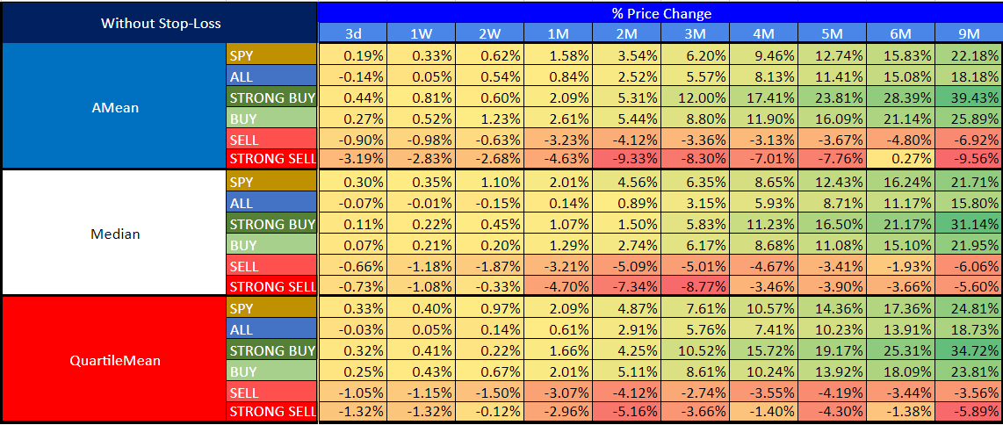

Table 2: Number of recommendations based on different ratings and timeframes
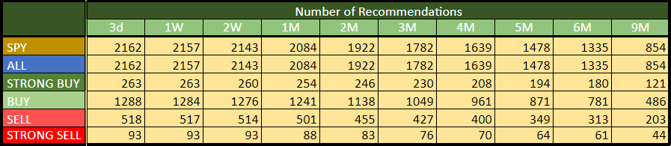

Detailed Analysis and Strategic Insights
First, let us examine the arithmetic mean, median, and quartile mean (the average of the Q1, Q2 (median), and Q3 quartiles, which is less sensitive to outliers) of the percentage price changes of the recommended companies, as shown in Table 1. Table 2 displays the number of recommendations for each type across the different timeframes. Based on this data, the following findings and conclusions can be considered statistically significant.

Arithmetic Mean Analysis:

- SPY (S&P 500 Index ETF): The arithmetic mean shows a consistent positive trend across all timeframes, peaking at a 22.18% increase over 9 months. This serves as a benchmark for comparison with the other ratings.
- Strong Buy: These recommendations perform notably well, especially over longer periods, achieving a significant 39.43% increase over 9 months. The 3-4 month range also shows strong returns (12.00% at 3 months), suggesting that this may be an optimal holding period before returns begin to slow.
- Buy: These recommendations show positive returns, with 8.80% over 3 months and 25.89% over 9 months. However, when benchmarked against SPY, Buy recommendations offer only marginally better returns (8.80% vs. SPY’s 6.20% at 3 months), raising questions about whether they are worth pursuing over simply holding SPY.
- Sell: These recommendations generally result in negative returns, with a consistent decline over time, peaking at a -6.92% loss over 9 months. This indicates that Sell recommendations are effective at identifying underperforming stocks, which could be beneficial in a short strategy.
- Strong Sell: These show even larger losses, particularly notable is the -9.56% decline over 9 months, reinforcing their value for shorting. The significant negative returns are precisely what an investor would seek in a short strategy, making these recommendations particularly useful.

Median Analysis:

- SPY: The median price change follows a similar pattern to the arithmetic mean, showing positive returns, slightly less volatile.
- Strong Buy: Median returns are lower than the arithmetic mean, particularly in the short term, suggesting variability in the performance of these recommendations. However, they still show strong positive performance, particularly in the 3-4 month range.
- Buy: The median results indicate modest but consistent positive returns, aligning closely with the arithmetic mean. Again, the comparison to SPY shows that while Buy recommendations are positive, they do not significantly outperform the benchmark.
- Sell: Median returns indicate a consistent underperformance, slightly worse than the arithmetic mean, highlighting the effectiveness of these recommendations in identifying stocks that lose value.
- Strong Sell: The median shows significant losses across all timeframes, consistent with the arithmetic mean, reinforcing their effectiveness in a short strategy.

Quartile Mean Analysis:

- SPY: The quartile mean is slightly higher than the median, indicating a generally positive skew in the distribution of returns.
- Strong Buy: Quartile mean returns are slightly lower than the arithmetic mean but still very positive, indicating that Strong Buy recommendations generally have a high success rate.
- Buy: The quartile mean is consistent with other metrics, showing steady performance, but less pronounced than Strong Buy.
- Sell: The quartile mean shows less negative impact compared to the arithmetic mean and median, suggesting some variability with a few Sell recommendations not performing as poorly.
- Strong Sell: The quartile mean shows less severe losses than the arithmetic mean, indicating that while Strong Sell recommendations typically lead to declines, the worst outcomes are likely due to a few extreme cases.

Strategic Insights:

While it’s evident that the maximum returns are observed at the 9-month mark, a closer month-by-month analysis reveals that the best average monthly returns for Strong Buy and Buy recommendations typically occur around the 3-4 month period. For example:

- Strong Buy recommendations achieve a 12.00% increase by the 3rd month, with returns continuing to grow but at a slightly decreasing rate after the 4th month.
- Buy recommendations peak around the 3-4 month period with a return of 8.80% by the 3rd month, suggesting this may be an optimal exit point before returns begin to taper off.

When comparing Buy recommendations to the SPY index, which serves as the benchmark, the data suggests that Buy ratings generally perform well, but not always sufficiently better than SPY to justify their selection:

- Over a 3-month period, Buy recommendations yield an average return of 8.80%, compared to SPY’s 6.20%. While this is better, the margin is not significant enough to clearly justify choosing Buy recommendations over simply holding SPY.
- Over longer periods, the returns on Buy recommendations continue to outpace SPY, but the differences remain modest (25.89% vs. SPY's 22.18% over 9 months).

Given these comparisons, it’s not necessarily advantageous to opt for Buy recommendations instead of SPY, especially considering potential risks and transaction costs involved in active stock picking versus a passive investment in the SPY.

In the case of Sell and Strong Sell recommendations, where the goal is to short the stocks:

- Strong Sell recommendations consistently yield significantly negative returns, reaching -9.56% over 9 months, making them highly effective for shorting.
- Sell recommendations also show negative returns, though less pronounced than Strong Sell, with a -6.92% over 9 months.
These Short ratings not only underperform compared to SPY, but they also generate negative returns, which is highly beneficial for a short strategy. This dual advantage (underperforming SPY and generating negative returns) strongly supports the integration of shorting these stocks into a long-short strategy, potentially paired with a long position in SPY.

Conclusion of Table 1:
- Strong Buy and Buy recommendations tend to perform well, particularly around the 3-4 month mark, but when benchmarked against SPY, the advantage of choosing Buy ratings over simply holding SPY is not always clear.
- Sell and Strong Sell recommendations are highly effective for shorting, offering strong negative returns that could enhance a long-short strategy, especially when combined with a long position in SPY.
- The strategic timing of exits (3-4 months) and careful selection between active (Buy) and passive (SPY) investments are crucial for optimising returns. We will examine the latter in the following section.

Analysis of Outperformance Relative to SPY Using Statistical Tests
This section examines whether the Strong Buy and Buy recommendations significantly outperform the SPY over various time frames using two different statistical tests: a two-sample t-test and a Mann-Whitney U-test (Table3). The Sell and Strong Sell recommendations were not tested, as their underperformance relative to SPY is already well-established.

Table 3: Outperformance Relative to SPY Using Statistical Tests
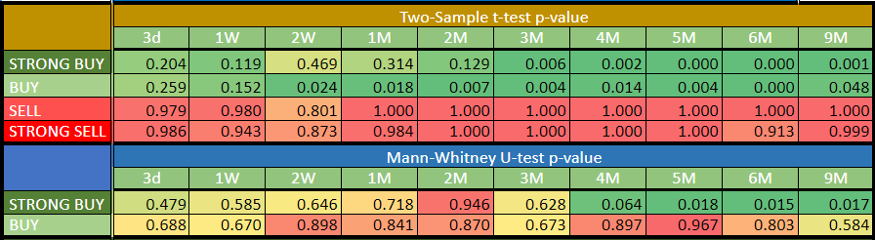

Two-Sample t-test p-value Analysis:

The two-sample t-test assesses whether the mean returns of the Strong Buy and Buy recommendations are statistically significantly higher than those of the SPY.

- Strong Buy:

  - Significant outperformance is detected starting from the 3-month mark, with p-values of 0.006 at 3 months, 0.002 at 4 months, and continuing to be highly significant through the 9-month period.
  - The p-values indicate that the Strong Buy recommendations begin to statistically significantly outperform SPY from the 3-month timeframe onwards, with very strong significance levels (p < 0.001) by 5-9 months.

- Buy:

  - The Buy recommendations show significant outperformance earlier, with a p-value of 0.024 at 2 weeks and even stronger significance as the timeframe extends (p = 0.000 by 6 months).
  - This suggests that Buy recommendations generally start to outperform SPY after about 2 weeks, with significance growing stronger over longer periods.

Mann-Whitney U-test p-value Analysis:

The Mann-Whitney U-test evaluates whether the median returns of the recommendations differ significantly from those of SPY, providing a non-parametric alternative to the t-test.

- Strong Buy:

  - The results here are less conclusive than the t-test, with the Strong Buy recommendations only showing marginal significance starting from the 4-month mark (p = 0.064) and becoming statistically significant by 5 months (p = 0.018) through 9 months (p ≈ 0.017).
  - This suggests that while the median outperformance of Strong Buy recommendations becomes evident after about 4-5 months, the results are not as strong as the mean-based t-test indicates.

- Buy:

  - The Buy recommendations do not show significant outperformance in terms of median returns, with all p-values remaining well above typical significance levels (0.05).
  - This suggests that the median performance of Buy recommendations is not significantly different from SPY, even though the mean performance might indicate outperformance.

Conclusion of Table 3:

- Strong Buy recommendations demonstrate clear statistical outperformance compared to SPY, particularly after the 3-month mark, as indicated by the two-sample t-test. The Mann-Whitney U-test also supports this outperformance from 4-5 months onwards, though with slightly less certainty.

- Buy recommendations show statistically significant outperformance starting from 2 weeks in the t-test, but this is not corroborated by the Mann-Whitney U-test, which suggests that the median performance of Buy recommendations does not significantly differ from SPY. This indicates that while the average performance of Buy recommendations may outperform SPY, the typical (median) outcome does not, highlighting variability within these recommendations.

- The findings suggest that while Strong Buy recommendations are statistically robust choices for outperformance over SPY, Buy recommendations, though potentially advantageous, may not consistently offer better returns than simply holding SPY, especially when considering median performance.

Use of Stop-Loss

We repeated the above analyses with the application of 5%, 10%, and 20% stop-losses. The results of these tests are presented in Tables 4a-c. Based on these findings, it is evident that using lower stop-loss limits clearly deteriorates the long-term average performance, while a 20% stop-loss does not significantly affect the results (though it slightly reduces them). Therefore, we do not recommend the use of stop-loss in the strategy to be developed based on these recommendations.

Table 4a: Averages of % price change based on different ratings and timeframes - using 5% stop-loss
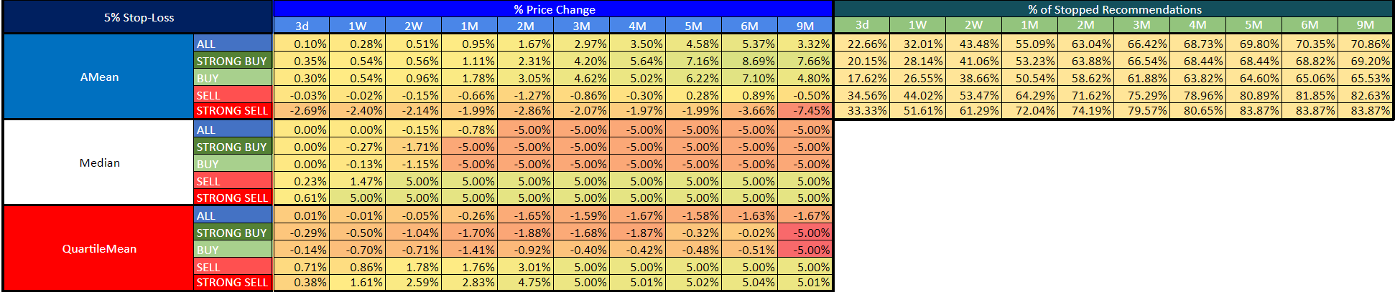
Table 4b: Averages of % price change based on different ratings and timeframes - using 10% stop-loss
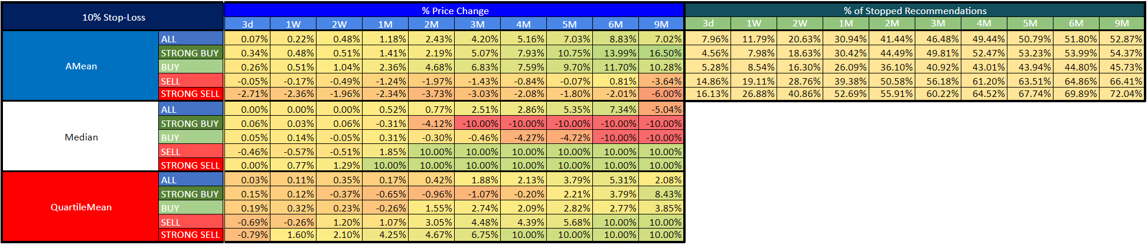
Table 4c: Averages of % price change based on different ratings and timeframes - using 20% stop-loss
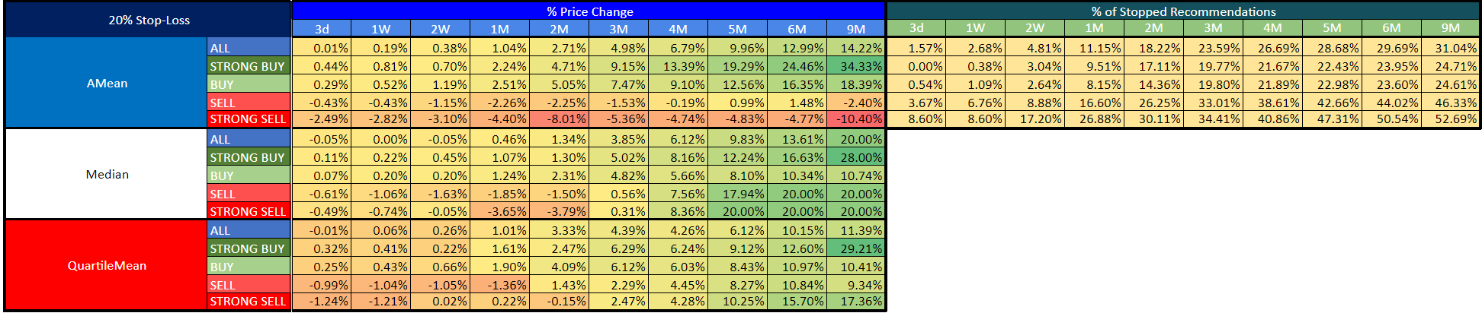

Strategy Backtest Results
Based on the results of the previous section, the objective is to develop a long-short trading strategy. As the first step in this process, we have outlined the following considerations:

- Diversity and Stock Volume: To reduce volatility, we need to ensure sufficient diversification. It is recommended that the portfolio contains at least twenty stocks at all times to maintain adequate diversity.

- Minimum Trading Volume: When considering the minimum daily trading volume, especially given that positions may need to be built and exited over several days, a threshold of $500K is suggested as a minimum. Additionally, OTC stocks and those priced below $1 should be excluded.

- Initial Portfolio Size: For the initial iteration, the base portfolio size should be set at $2 million.

- Duration of Short Positions: It is proposed that the duration for short positions should be set at around three months.

- Selection of Short Stocks: While ‘Strong Sell’ stocks demonstrate better performance than ‘Sell’ recommendations, their number is limited (only 93 stocks, with even fewer meeting the volume constraints). If ‘Sell’ recommendations need to be included, criteria for their selection must be carefully considered, given the larger pool of over 500 stocks, which may be challenging to manage effectively.

- Long Side of the Portfolio: For the long positions, consider using QQQ or SPY as the basis for the portfolio.

Based on these points, we implemented the strategy within the QuantConnect Cloud platform using the C# programming language (code provided in the Appendix). This platform enabled us to efficiently filter out unsuitable stocks (such as OTC stocks, those priced below $1, or those with insufficient daily dollar volume) and to easily explore different scenarios and parameter sets. Moreover, this approach allows for a more realistic simulation compared to using Excel or SnifferQuantDesktop, especially with factors like commissions taken into account.

One element that the current code does not consider is the borrowing fee, which can represent a significant cost when shorting stocks. However, we initially decided against including this in our implementation because, as shown in Table 5 (which lists real borrowing fees from Interactive Brokers as of 15th August 2024 for all 'Strong Sell' recommendations), the borrowing fee is typically below 1% annually in most cases. The higher values in the table are either associated with OTC stocks (which we wouldn’t include in our strategy anyway) or occur after significant price movements. In real-life trading, we would avoid shorting stocks with borrowing fees exceeding 1%.

Table 5: Borrowing fee - Interactive Brokers 2024-08-15
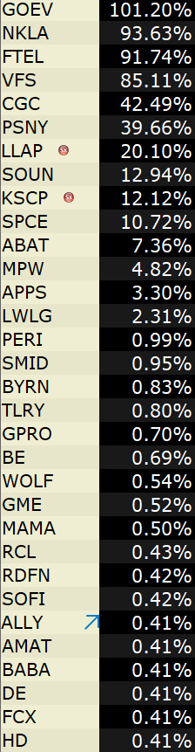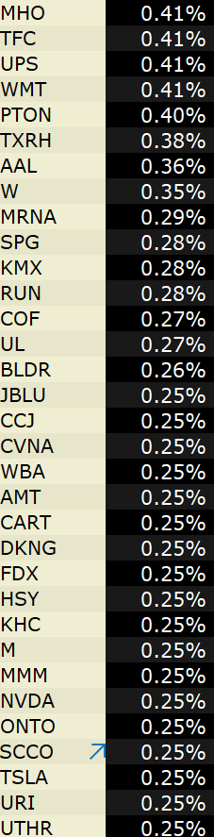

In the following, we will explore several scenarios, ranging from the simplest to the most complex. At the end of the chapter, we will summarise the results in a consolidated table. All backtests begin on 9th July 2023 and run until 15th August 2024.

Scenario Analysis
Buy&Hold SPY:
The performance of the SPY benchmark for the period:
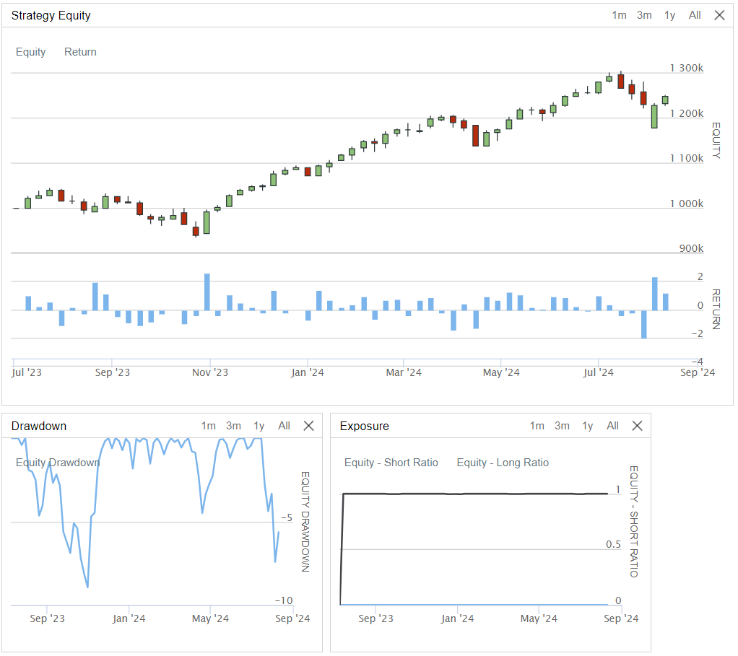
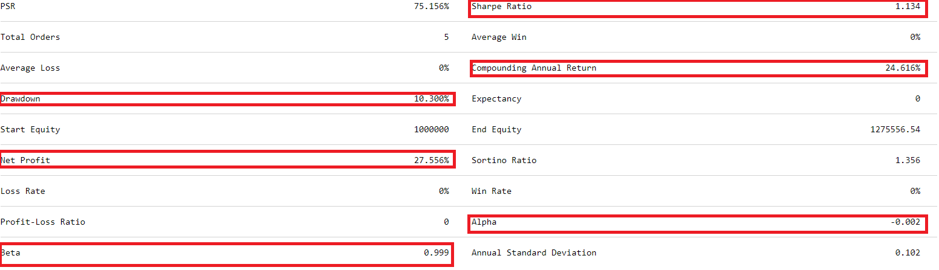
First Scenario:

Initial Portfolio Value: $2M
Strategy: Short every eligible 'Strong Sell' recommendation (i.e., those that are not OTC, have a price above $1, and a daily volume exceeding $500K). Each position is shorted for a uniform amount of $100K.
Duration: Positions are held for 3 months (91 days) and then covered.
Long Component: None (purely short strategy).
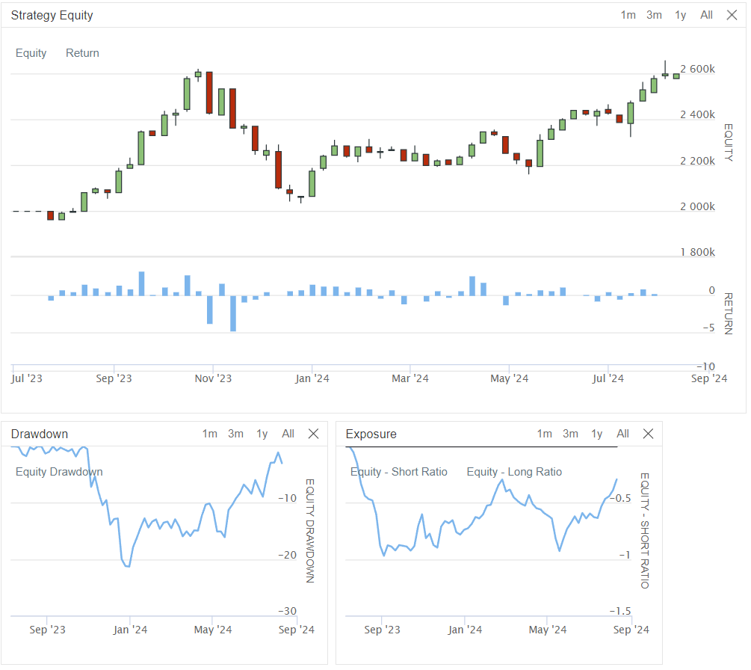
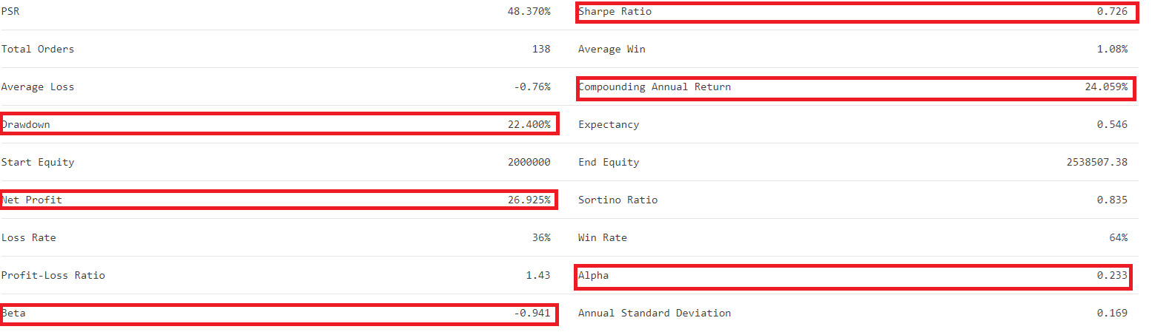
Second Scenario:

Initial Portfolio Value: $2M
Strategy: Short every eligible 'Strong Sell' recommendation (i.e., those that are not OTC, have a price above $1, and a daily volume exceeding $500K). Each position is shorted for a uniform amount of $100K.
Duration: Positions are held for 2 months (61 days) and then covered.
Long Component: None (purely short strategy).
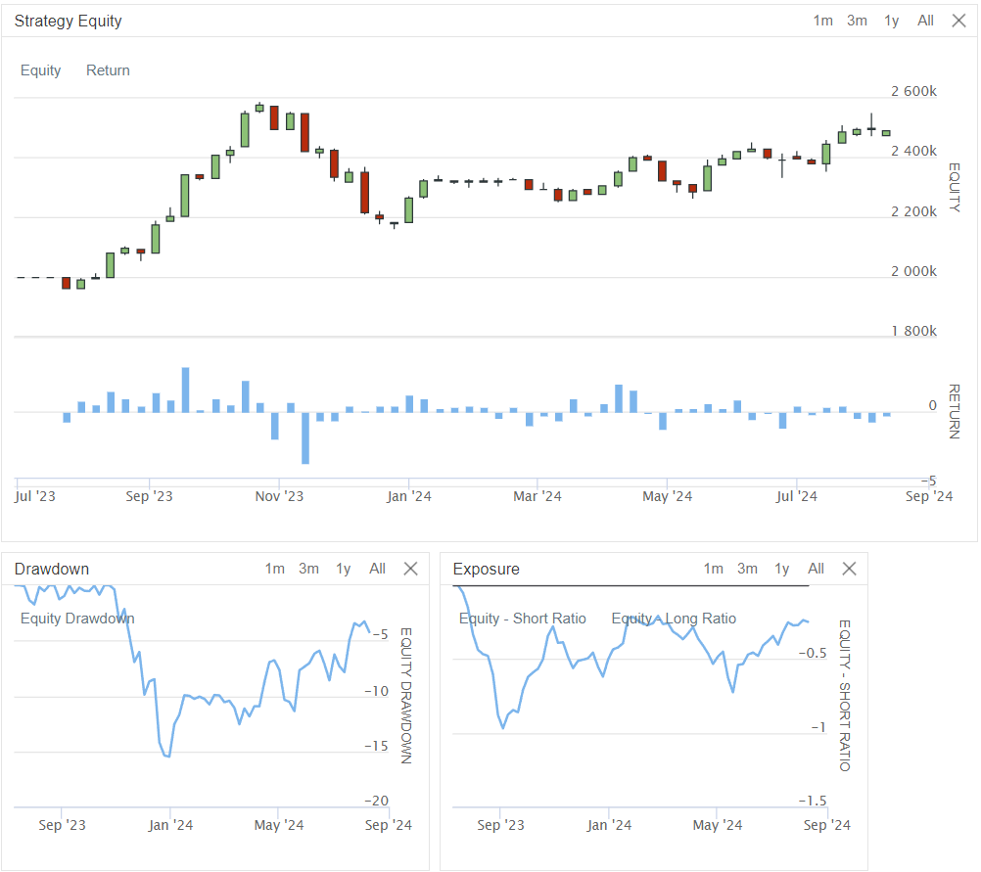
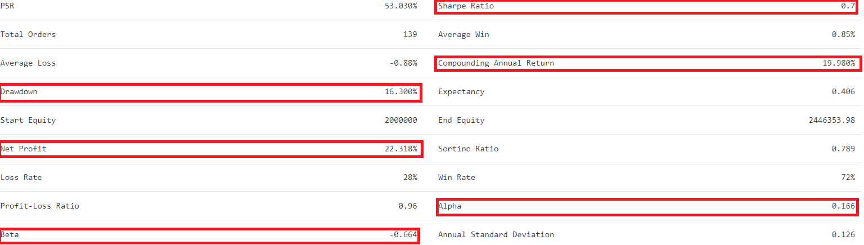
Third Scenario:

Initial Portfolio Value: $2M
Strategy: Short every eligible 'Strong Sell' recommendation. Each position is shorted for $100K.
Duration: Positions are held for 4 months (122 days) and then covered.
Long Component: None (purely short strategy).
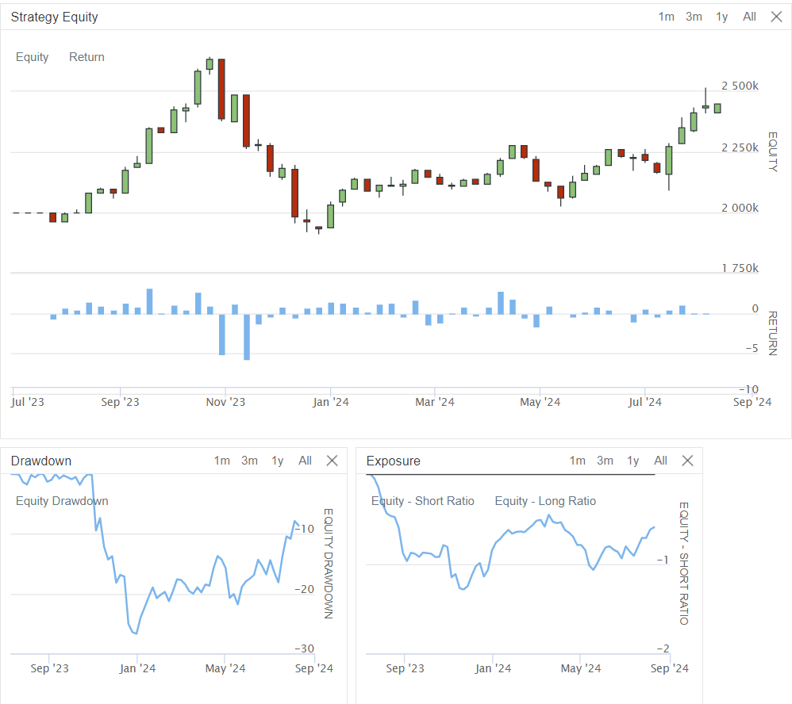
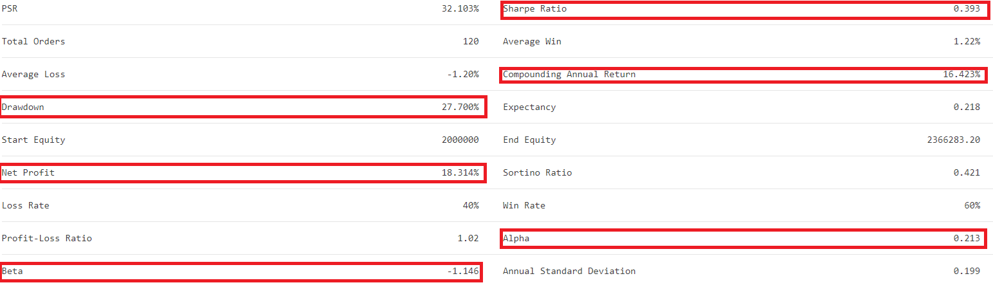
Fourth Scenario:

Initial Portfolio Value: $2M
Strategy: Short every eligible 'Strong Sell' recommendation. Each position is shorted for $100K.
Duration: Positions are held for 3 months (91 days) and then covered.
Long Component: SPY.
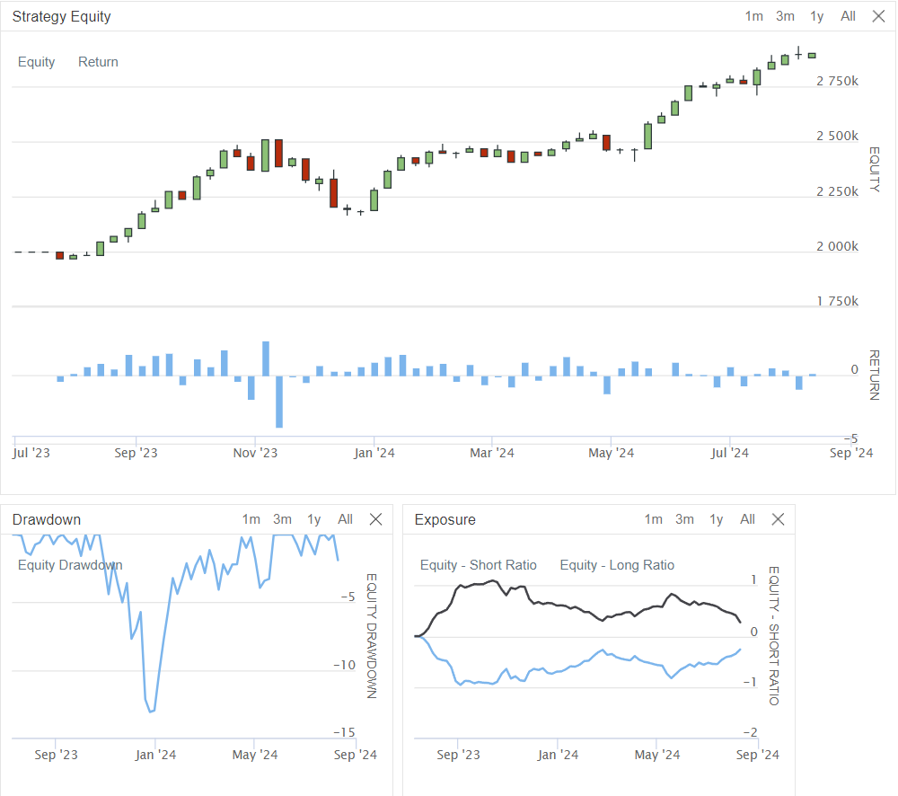
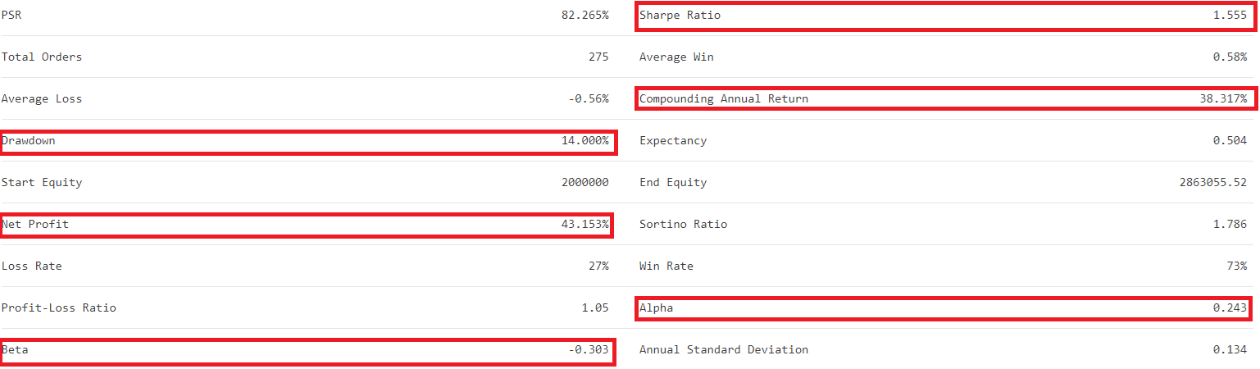
Fifth Scenario:

Initial Portfolio Value: $2M
Strategy: Short every eligible 'Strong Sell' recommendation. Each position is shorted for $100K.
Duration: Positions are held for 3 months (91 days) and then covered.
Long Component: QQQ.
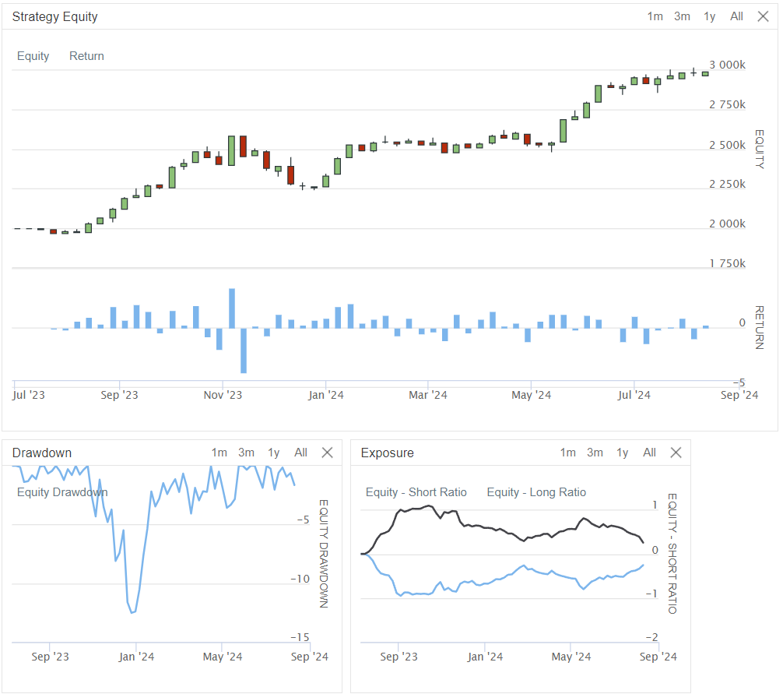
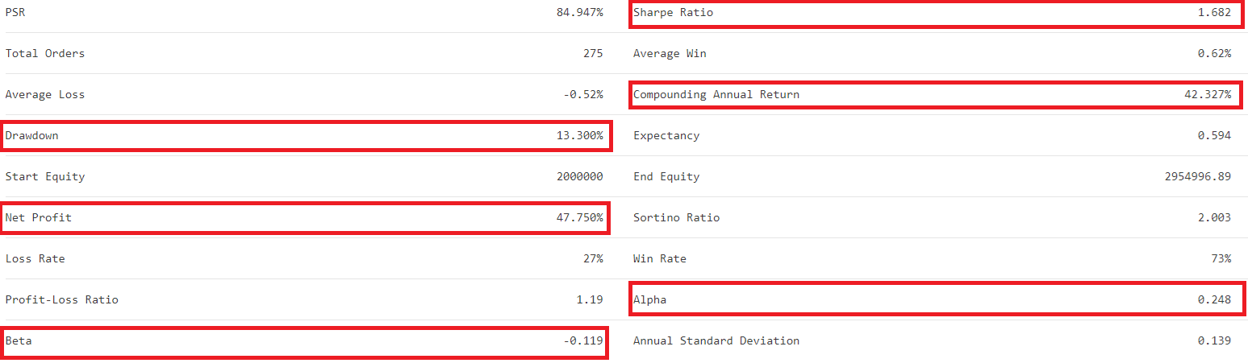
Sixth Scenario:

Initial Portfolio Value: $2M
Strategy: Short every eligible 'Strong Sell' recommendation. Each position is shorted for $100K. If there aren’t enough 'Strong Sell' recommendations to fully utilise the portfolio (i.e., the short leverage is below 100%), then we will include the next available 'Sell' recommendations, shorting each for $50K. If a new 'Strong Sell' recommendation becomes available, we will close the oldest 'Sell' short positions to make room for the new 'Strong Sell' position.
Duration: Positions are held for 3 months (91 days) and then covered.
Long Component: None (purely short strategy).
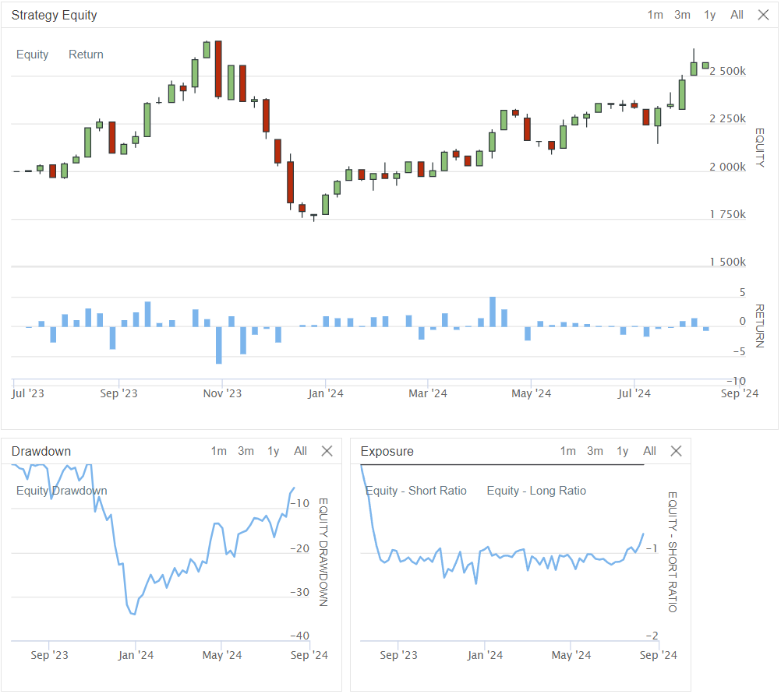
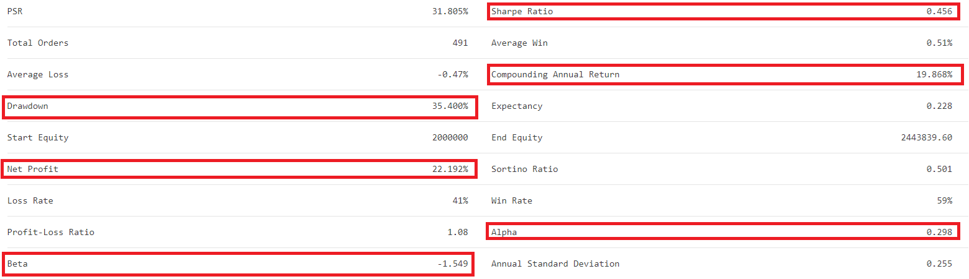
Seventh Scenario:

Initial Portfolio Value: $2M
Strategy: Short every eligible 'Strong Sell' recommendation. Each position is shorted for $100K. If there aren’t enough 'Strong Sell' recommendations, then include the next available 'Sell' recommendations, shorting each for $50K. If a new 'Strong Sell' recommendation becomes available, we will close the oldest 'Sell' short positions.
Duration: Positions are held for 3 months (91 days) in case of ‘Strong Sell’s and for 2 months (61 days) in case of ‘Sell’s and then covered.
Long Component: None (purely short strategy).
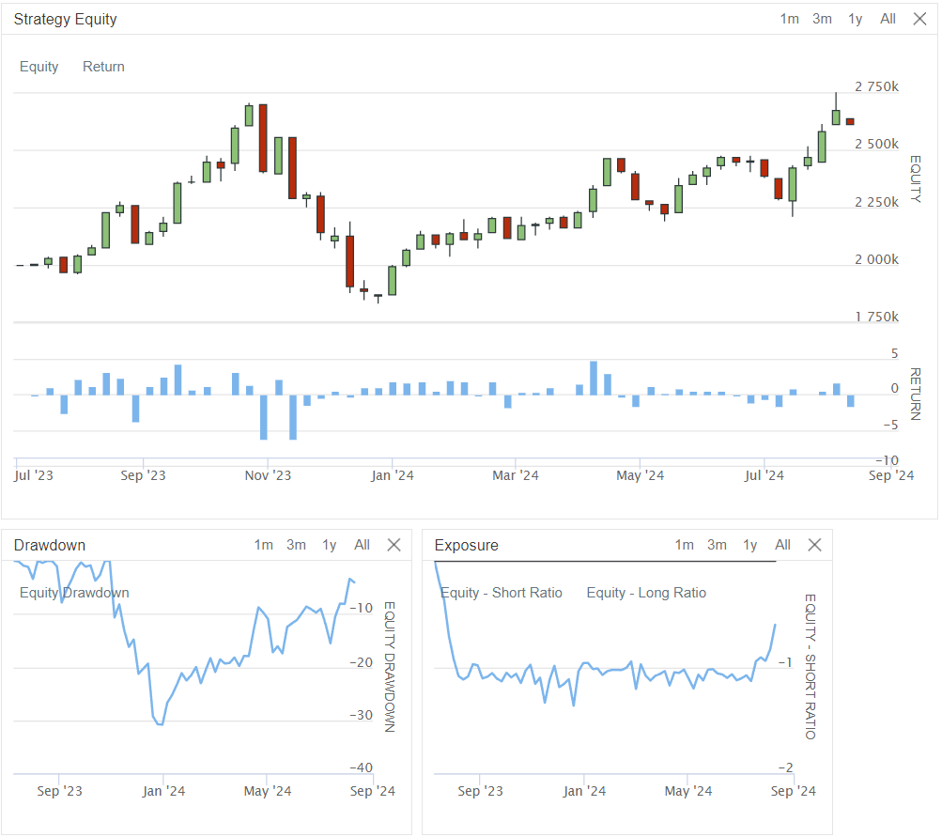
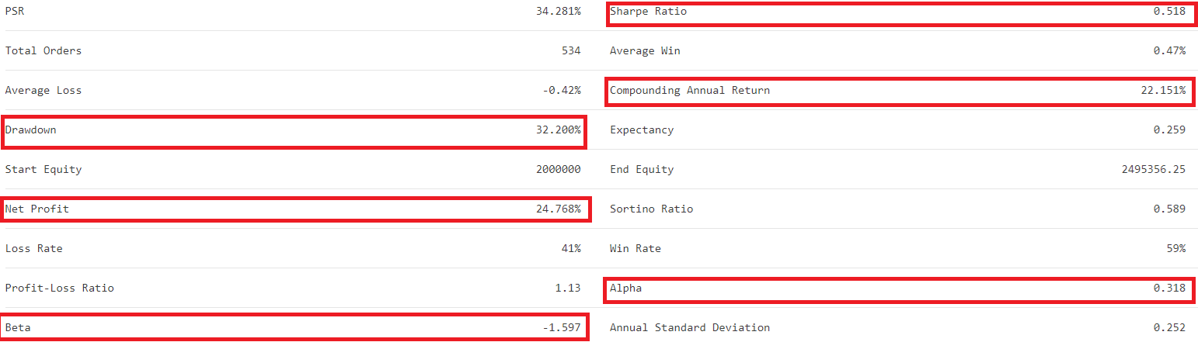
Eighth Scenario:

Initial Portfolio Value: $2M
Strategy: Short every eligible 'Strong Sell' recommendation. Each position is shorted for $100K. If there aren’t enough 'Strong Sell' recommendations, then include the next available 'Sell' recommendations, shorting each for $25K. If a new 'Strong Sell' recommendation becomes available, we will close the oldest 'Sell' short positions.
Duration: Positions are held for 3 months (91 days) in case of ‘Strong Sell’s and for 2 months (61 days) in case of ‘Sell’s and then covered.
Long Component: None (purely short strategy).
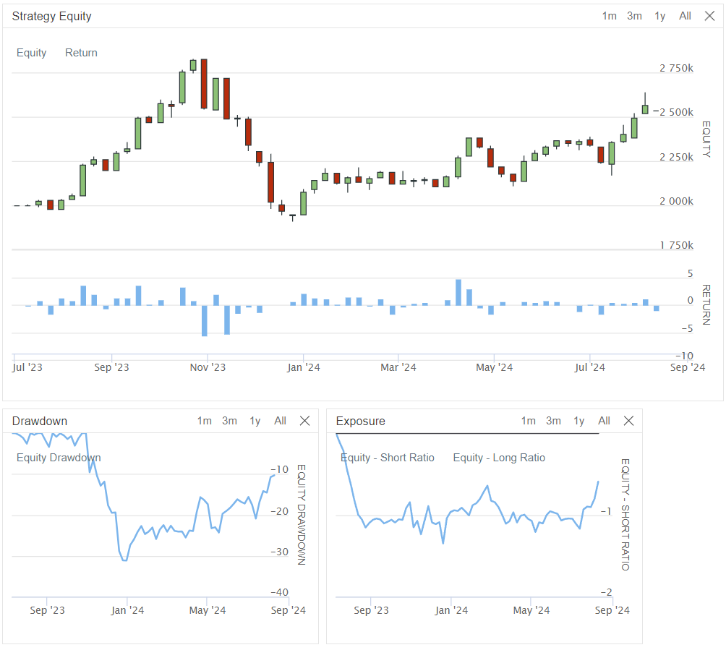
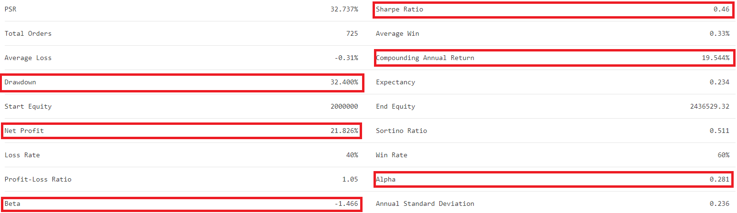
Ninth Scenario:

Initial Portfolio Value: $2M
Strategy: Short every eligible 'Strong Sell' recommendation. Each position is shorted for $100K. If there aren’t enough 'Strong Sell' recommendations, then include the next available 'Sell' recommendations, shorting each for $100K. If a new 'Strong Sell' recommendation becomes available, we will close the oldest 'Sell' short positions.
Duration: Positions are held for 3 months (91 days) in case of ‘Strong Sell’s and for 2 months (61 days) in case of ‘Sell’s and then covered.
Long Component: None (purely short strategy).
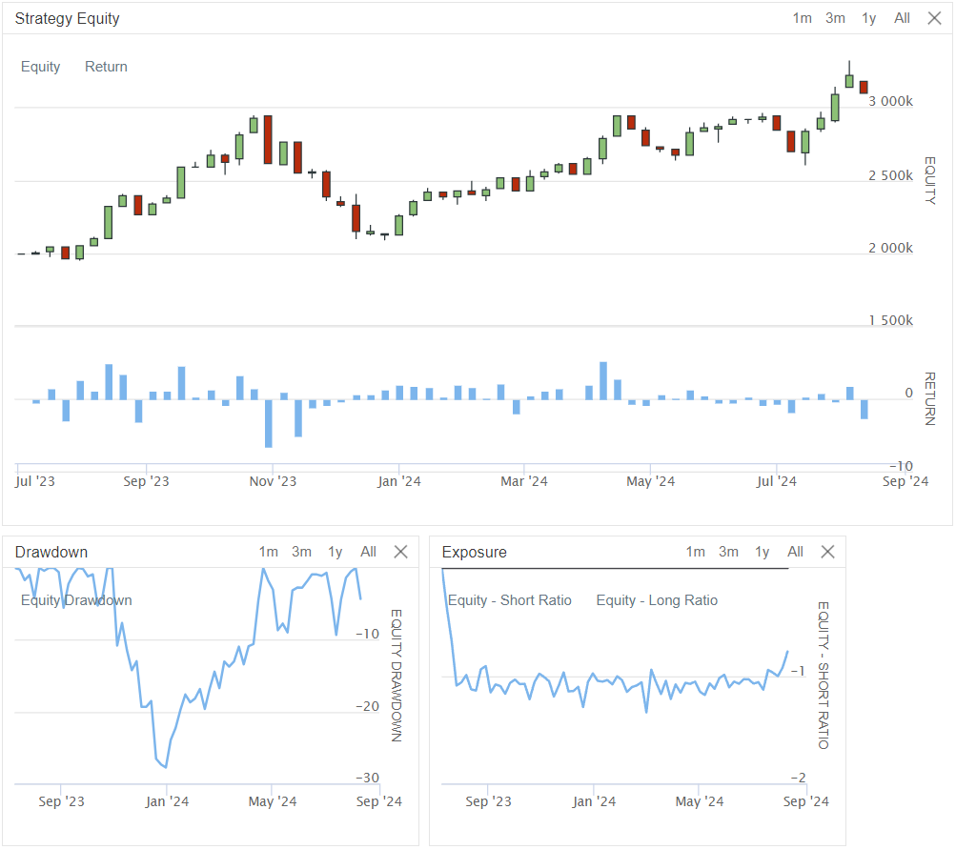
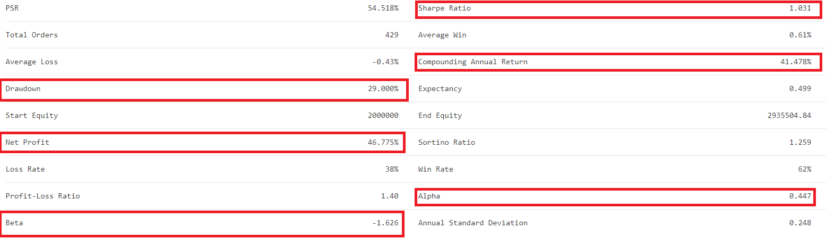
Tenth Scenario:

Initial Portfolio Value: $2M
Strategy: Short every eligible 'Strong Sell' recommendation. Each position is shorted for $100K. If there aren’t enough 'Strong Sell' recommendations, then include the next available 'Sell' recommendations, shorting each for $100K. If a new 'Strong Sell' recommendation becomes available, we will close the oldest 'Sell' short positions.
Duration: Positions are held for 3 months (91 days) in case of ‘Strong Sell’s and for 2 months (61 days) in case of ‘Sell’s and then covered.
Long Component: SPY.
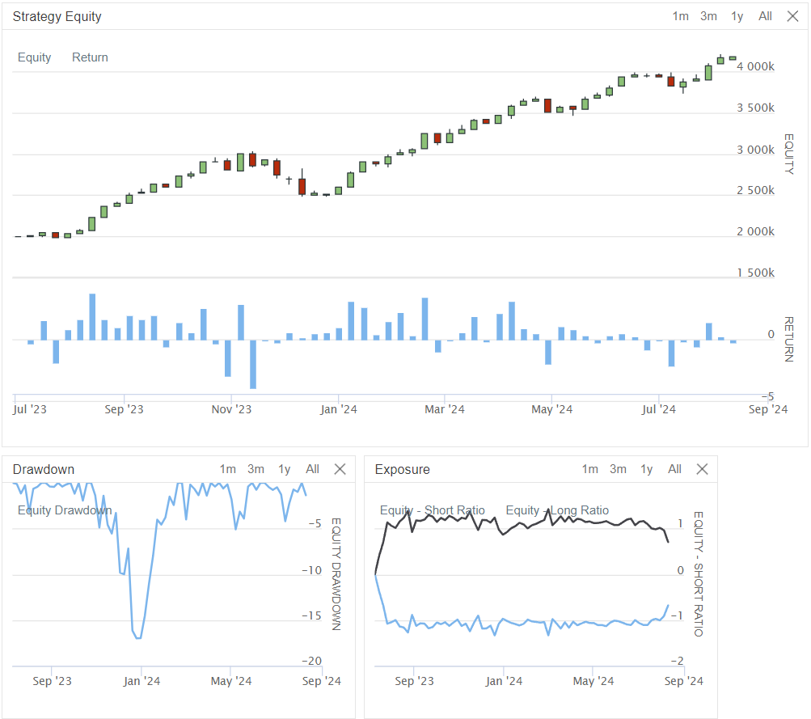
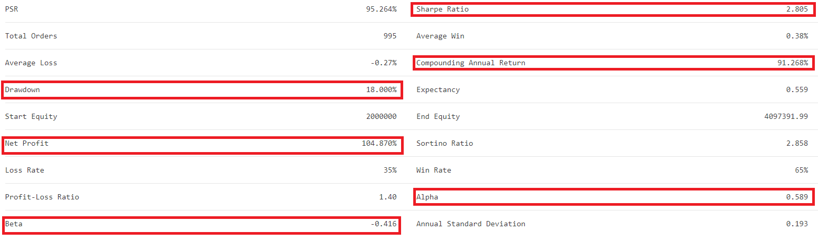
Eleventh Scenario:

Initial Portfolio Value: $2M
Strategy: Short every eligible 'Strong Sell' recommendation. Each position is shorted for $100K. If there aren’t enough 'Strong Sell' recommendations, then include the next available 'Sell' recommendations, shorting each for $100K. If a new 'Strong Sell' recommendation becomes available, we will close the oldest 'Sell' short positions.
Duration: Positions are held for 3 months (91 days) in case of ‘Strong Sell’s and for 2 months (61 days) in case of ‘Sell’s and then covered.
Long Component: QQQ.
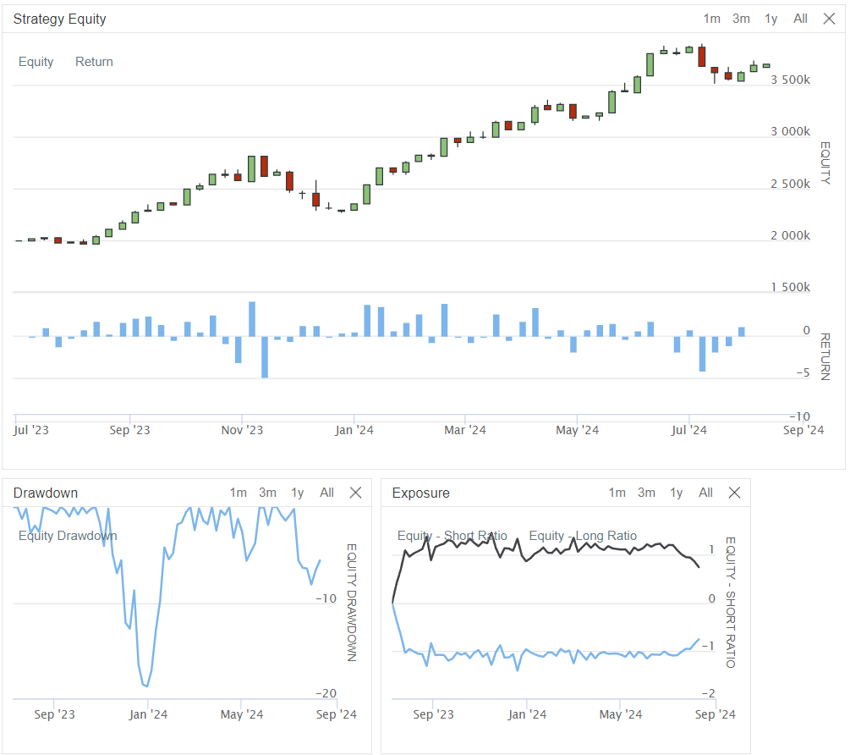
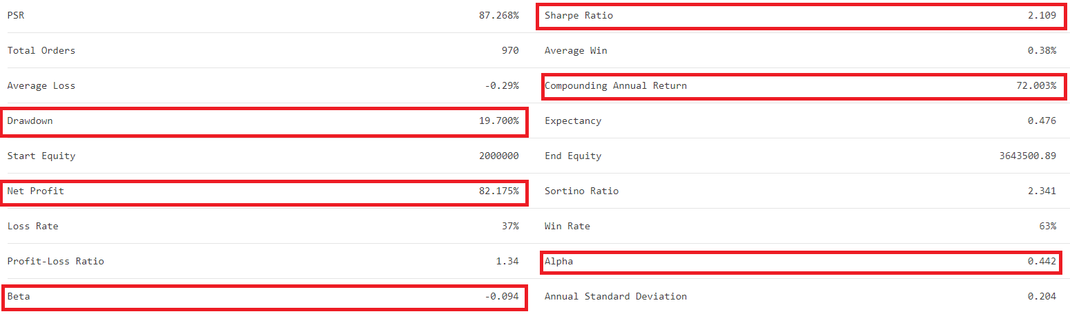

Comprehensive Analysis of Strategy Scenarios

To be clear, in the first five scenarios where I only short 'STRONG SELL' stocks, leverage does not reach 100%; it's around 50% on average due to the lack of sufficient recommendations. This can be observed in the lower right Exposure chart (in every scenario). When I expanded the strategy to include 'SELL' recommendations as well (scenarios 6-11), the average short leverage hovers around 100% (I set a leverage limit of 110% in the code for a more realistic simulation, but this is just a safety margin). In the strategies that include a long side, the leverage is set similarly to the short side. In these cases, the $2M portfolio approximately holds $2M in short positions and $2M in long positions.

Table 6 summarises the performance indicators of tested scenarios.

Table 6: Performance indicators of scenarios
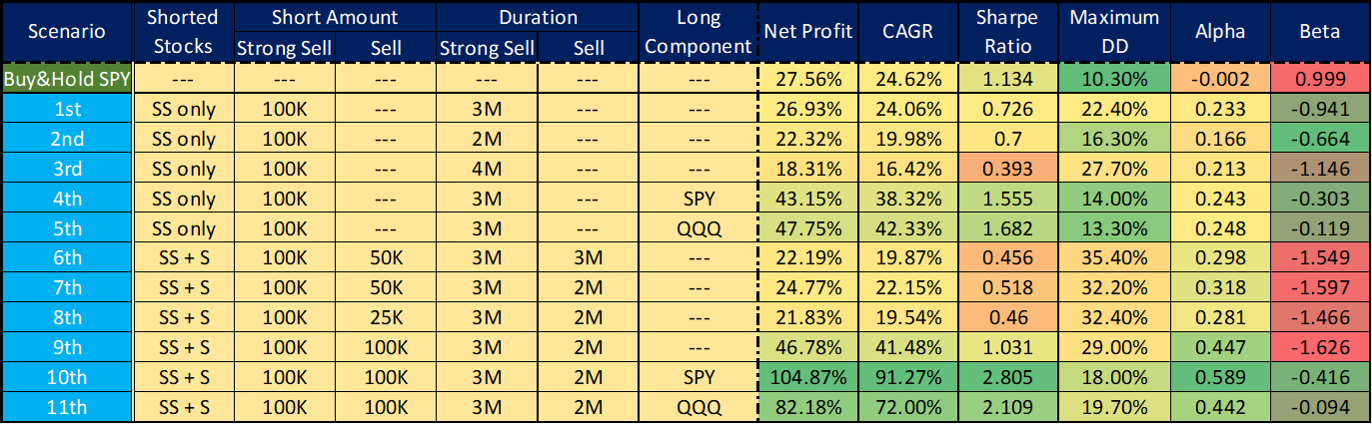

Key Observations:

- Buy & Hold SPY Benchmark:
  - The SPY buy-and-hold strategy provides a strong baseline with a Net Profit of 27.56% and a Sharpe Ratio of 1.134, indicating solid risk-adjusted returns with relatively low volatility (Maximum Drawdown of 10.30%).
- Shorting 'Strong Sell' Only:
  - Duration Impact:
    - The scenarios that involve shorting only 'Strong Sell' stocks show that the duration significantly affects performance. The 3-month duration (1st scenario) provided returns close to the SPY benchmark, but with higher volatility, as seen in the increased Maximum Drawdown (22.40%).
    - Shortening the duration to 2 months (2nd scenario) slightly reduces both returns and risk, while extending to 4 months (3rd scenario) significantly reduces returns and increases drawdown, suggesting diminishing returns with longer short positions.
  - Incorporating a Long Component:
    - Adding a long position in SPY or QQQ to the strategy (4th and 5th scenarios) substantially boosts returns and Sharpe Ratios while keeping drawdowns low. The QQQ long component, in particular, provided the highest Net Profit (47.75%) and CAGR (42.33%) among the SS-only strategies, with a well-balanced Sharpe Ratio of 1.682 and a low Maximum Drawdown of 13.30%.
- Adding 'Sell' Recommendations:
  - When 'Sell' recommendations are included alongside 'Strong Sell' positions (6th to 9th scenarios), the results are mixed.
  - Higher Allocation to 'Sell' Positions:
    - The scenario with equal allocation to both 'Strong Sell' and 'Sell' ($100K each, 9th scenario) significantly increases the Net Profit to 46.78% and a solid CAGR of 41.48%. However, this comes at the cost of increased volatility, as evidenced by a Maximum Drawdown of 29.00% and a moderate Sharpe Ratio of 1.031.
    - Lowering the allocation to 'Sell' positions ($50K or $25K) results in reduced returns and moderate drawdowns, suggesting a trade-off between risk and return depending on the allocation to 'Sell' positions.
- Best Performing Scenarios:
  - 10th Scenario (SS + S, with SPY Long): This scenario emerges as the top performer, with an outstanding Net Profit of 104.87%, a high CAGR of 91.27%, and an impressive Sharpe Ratio of 2.805. The Maximum Drawdown of 18.00% is higher than the SPY benchmark but acceptable given the significantly higher returns.
  - 11th Scenario (SS + S, with QQQ Long): The QQQ long component also delivers strong results, with an 82.18% Net Profit and a Sharpe Ratio of 2.109, although slightly lower than the SPY long counterpart. This scenario offers a good balance of high returns and relatively low drawdown (19.70%).
Consideration of Market Conditions and Bias:

It is important to highlight that these scenarios performed exceptionally well during a highly bullish market period. The ability of the short positions to yield positive results in such a market environment is notable, though it is crucial to consider the potential influence of hindsight and selection biases. These biases could have played a role in the strategy's apparent success, as the selection of 'Strong Sell' recommendations might have benefited from retrospectively identified underperformers.

Conclusion of Scenario Analysis:

The analysis clearly shows that adding a long component to a short strategy, especially using SPY or QQQ, significantly enhances overall performance while managing risk effectively. Among the tested scenarios, the 10th scenario (SS + S, with SPY Long) offers the most robust risk-adjusted returns, making it the most compelling strategy configuration.

Shorting 'Strong Sell' recommendations alone can be effective but is greatly enhanced by integrating a long position, particularly when the market's overall direction is bullish. The inclusion of 'Sell' recommendations adds complexity and potential returns but requires careful management of drawdowns and volatility. The strategic balance between the allocation to shorts and the choice of a long component is crucial for optimising performance in a long-short strategy. However, it is essential to remain cautious about the influence of hindsight and selection biases when interpreting these results. Additionally, we should not forget to mention and consider the risk of parameter over-optimization, although we made efforts to avoid or minimise this.

Although playing 'Strong Sell' and 'Sell' recommendations with equal weighting (when there is enough room for the 'Sell' positions) yields significantly better results, we still recommend considering the approach where the "lower-tier" 'Sell' recommendations are played with a lower weighting (e.g., half the amount). This approach not only enhances portfolio diversification but also potentially reduces the risk associated with over-allocating to less reliable signals. By allocating less to 'Sell' positions, the portfolio can maintain a more balanced exposure while still benefiting from the strong performance of 'Strong Sell' recommendations.
Further Investigation:

In the "short only" scenarios, one can observe a significant rise until the end of October 2023, followed by an almost equal decline until the end of December 2023, and then a slower but nearly continuous rise in 2024. This is contrary to what we might expect based on the SPY/QQQ charts.

As a first step, I examined every trade in the first scenario individually, going through the charts for each ticker during the specified period one by one. I confirmed that this phenomenon wasn’t caused by outliers. During the July-October period, SPY/QQQ/MDY/IWM dropped by an average of 10%, so the good performance of the shorts during this period is easily understood. In the end of October - end of December period, nearly all of the 30 companies involved saw a strong price increase (averaging ~+20%), so the losses on the shorts during this period are also clear. What’s more interesting is the performance of the shorts in 2024 in light of SPY/QQQ’s performance during that period. Here, it’s worth recalling the articles and analyses from this past spring/summer (SentimentTrader, Authers, Armstrong, Batnick), which discussed how SPY and QQQ reached all-time highs while the average/median companies within the indices were even in a bear market (down 20% from ATH). This was possible because the large-cap tech companies (most of the Magical7) and those involved in AI (semiconductors, etc.) saw enormous gains. In other words, it was NVDA, MSFT, and their peers that drove the indices higher, while the average companies, which the strategy shorts, were losing value (or at least not profitable). This explains how both the short side and the long SPY/QQQ side could be profitable during the given period with a few good choices.

To illustrate this, I have gathered data not only for SPY and QQQ but also for their equal-weighted counterparts, as well as for mid- and small-cap ETFs, across three different periods. Most of the shorted companies fall into these categories. The results are shown in the following table (Table 7) and chart.

Table 7: Performance of main indices during the backtested period
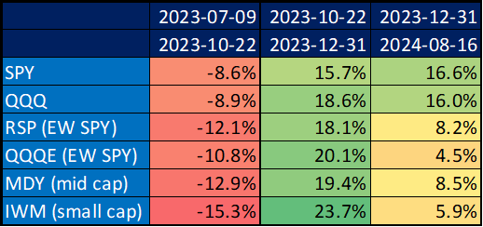

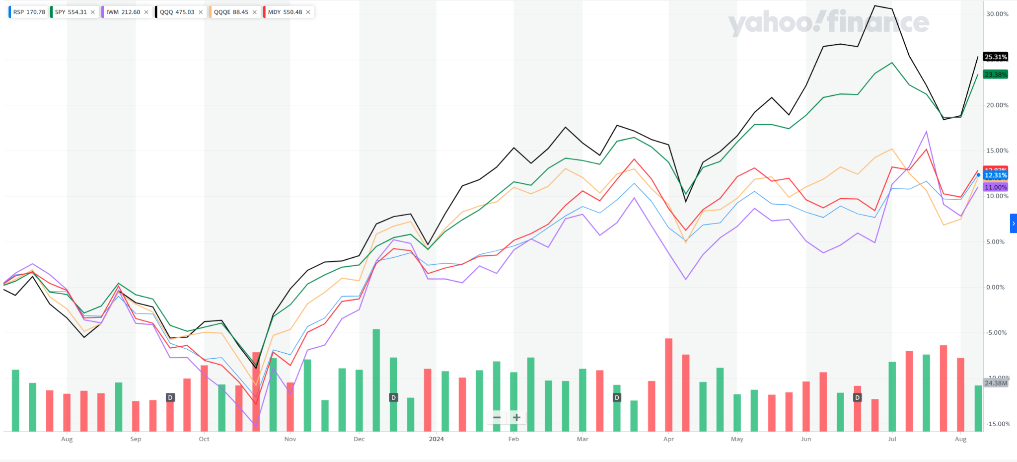

Conclusion
The primary objective of this study was to develop a long-short trading strategy based on the recommendations of analysts identified as 'Top Analysts' by SeekingAlpha. Given the inherent challenges in stock picking and the potential biases in analysts' recommendations, our goal was to determine whether a strategy focusing on shorting 'Strong Sell' and 'Sell' recommendations could be both effective and robust, particularly when combined with a long position in broad market ETFs like SPY or QQQ.

We began by analysing the statistical performance of these recommendations. Our Statistical Analysis revealed that 'Strong Buy' and 'Buy' recommendations tend to perform well, especially in the 3-4 month holding period, but their outperformance relative to SPY was not always significant. On the other hand, 'Sell' and 'Strong Sell' recommendations consistently generated negative returns, making them highly suitable for shorting. These results provided a strong foundation for developing a long-short strategy, where short positions in underperforming stocks could potentially be offset by long positions in stronger market indices.

Based on these statistical insights, we implemented a backtest using the QuantConnect Cloud platform. We tested various scenarios, starting with a simple short strategy focused exclusively on 'Strong Sell' recommendations and gradually adding complexity by including 'Sell' recommendations and long positions in SPY or QQQ.

The backtests demonstrated that while shorting 'Strong Sell' recommendations alone can be effective, the inclusion of a long component significantly enhances overall performance. Specifically, the scenario combining equal-weighted 'Strong Sell' and 'Sell' shorts with a long SPY position (the 10th scenario) delivered the highest returns and the best risk-adjusted performance. This suggests that integrating a market long position can help mitigate the risks associated with shorting, especially during bullish market conditions.

Furthermore, the analysis highlighted the importance of portfolio diversification and careful weighting of positions. While playing 'Strong Sell' and 'Sell' recommendations with equal weights yielded strong results, we recommend considering a strategy where 'Sell' recommendations are played with a lower weighting. This approach not only diversifies the portfolio but also reduces the risk of over-allocating to potentially less reliable 'Sell' signals.

In summary, the development of a long-short strategy based on SeekingAlpha's 'Top Analyst' recommendations proved to be a promising approach, particularly when the strategy includes a long component in a broad market index. The combination of strong short positions in underperforming stocks and a market long position can provide a balanced, risk-managed investment strategy. However, it's important to remain cautious of the influence of hindsight and selection biases, and ongoing adjustments may be necessary to adapt the strategy to changing market conditions. As with any strategy, real-world application should be approached with careful consideration of market dynamics, portfolio diversification, and risk management practices.

Appendix - QuantConnect Cloud C# code + recommendations
#region imports
using System;
using System.Collections.Generic;
using System.Linq;
using QuantConnect.Data;
using QuantConnect.Orders.Fees;
using QuantConnect.Scheduling;
using QuantConnect.Securities;
using QuantConnect.Securities.Equity;

#endregion

namespace QuantConnect.Algorithm.CSharp
{
public class SaShorts : QCAlgorithm
{
private Dictionary<string, List<DateTime>> _strongSellTickerDates = new Dictionary<string, List<DateTime>>();
private Dictionary<string, List<DateTime>> _sellTickerDates = new Dictionary<string, List<DateTime>>();
private Dictionary<string, ScheduledEvent> _liquidationEvents = new Dictionary<string, ScheduledEvent>(); // Scheduled liquidation events
private List<string> _tickerList = new List<string>();
private decimal _initialPV = 2000000m;
private decimal _minPrice = 1m;
private decimal _minDollarVolumeK = 500m;
private decimal _positionAmount = 100000m;
private decimal _sellPositionRatio = 0.5m; // SELL position value as a ratio of STRONG SELL
private decimal _maxShortRatio = 1.1m; // Maximum allowed short ratio
private int _strongSellHoldingPeriodDays = 91; // Holding period for STRONG SELL
private int _sellHoldingPeriodDays = 61; // Holding period for SELL
private string _longPair = "SPY"; // Set this to "SPY", "QQQ", or "" for no long pair
private decimal _currentShortValue = 0;
private decimal _currentShortRatio = 0;

// Dictionary to track the number of shares bought in the longPair for each ticker
private Dictionary<string, int> _longPairQuantities = new Dictionary<string, int>();

// HashSet to track tickers that have already been processed for the current day
private HashSet<string> _processedTickers = new HashSet<string>();

// List to track the number of shorted stocks each day
private List<int> _shortedStocksHistory = new List<int>();

// List to track executed SELL trades
private List<(string Ticker, DateTime ExecutionDate, bool IsStrongSell)> _executedSellTrades = new List<(string, DateTime, bool)>();

public override void Initialize()
{
SetStartDate(2023, 7, 9);
DateTime endDate = DateTime.Now;
SetEndDate(endDate);
SetCash(_initialPV);

// Set fee and margin model
SetSecurityInitializer(security =>
{
security.SetFeeModel(new InteractiveBrokersFeeModel());
security.SetBuyingPowerModel(new SecurityMarginModel(30m));
});

// Load the data defined in the Data.cs file
List<TD> data = Data.GetTickerData();

// Populate ticker lists and tickerDates
foreach (TD record in data)
{
if (record.Type == "STRONG SELL")
{
if (!_strongSellTickerDates.ContainsKey(record.Ticker))
{
_strongSellTickerDates[record.Ticker] = new List<DateTime>();
_tickerList.Add(record.Ticker);
}
_strongSellTickerDates[record.Ticker].Add(record.Date);
}
else if (record.Type == "SELL")
{
if (!_sellTickerDates.ContainsKey(record.Ticker))
{
_sellTickerDates[record.Ticker] = new List<DateTime>();
_tickerList.Add(record.Ticker);
}
_sellTickerDates[record.Ticker].Add(record.Date);
}
}

foreach (string ticker in _tickerList)
{
Equity equityB = AddEquity(ticker, Resolution.Daily, dataNormalizationMode: DataNormalizationMode.Raw);
_longPairQuantities[ticker] = 0;
}

if (!string.IsNullOrEmpty(_longPair))
AddEquity(_longPair, Resolution.Daily, dataNormalizationMode: DataNormalizationMode.Raw);

// Schedule clearing of the processed tickers set at the end of each trading day
Schedule.On(DateRules.EveryDay(), TimeRules.At(16, 0), () =>
{
int shortedStocks = Portfolio.Values.Count(p => p.Invested && p.Quantity < 0);
_shortedStocksHistory.Add(shortedStocks);
Log($"Processed tickers cleared at the end of day. Shorted stocks today: {shortedStocks}");
_processedTickers.Clear();

// Recalculate short value and ratio at the end of the day
_currentShortValue = CalculateCurrentShortValue();
_currentShortRatio = Math.Abs(_currentShortValue / Portfolio.TotalPortfolioValue);
});
}

public override void OnData(Slice slice)
{
// Ensure this logic only runs once per day per ticker
if (_processedTickers.Count > 0)
return; // Already processed for today

// Process STRONG SELL tickers first, always
ProcessTickers(slice, _strongSellTickerDates, _positionAmount, _strongSellHoldingPeriodDays, prioritizeStrongSell: true);

// If there is room within the short ratio, process SELL tickers with the specified position ratio
if (_currentShortRatio < _maxShortRatio)
ProcessTickers(slice, _sellTickerDates, _positionAmount * _sellPositionRatio, _sellHoldingPeriodDays, prioritizeStrongSell: false);
}

private void ProcessTickers(Slice slice, Dictionary<string, List<DateTime>> tickerDates, decimal positionAmount, int holdingPeriodDays, bool prioritizeStrongSell)
{
foreach (string ticker in tickerDates.Keys.ToList())
{
if (tickerDates[ticker].Contains(Time.Date) && !_processedTickers.Contains(ticker))
{
Security security = Securities[ticker];
decimal price = security.Price;
decimal dollarVolumeK = security.Volume * price / 1000m;

// Check if the ticker is already shorted
if (Portfolio[ticker].IsShort)
{
Log($"Skipping {ticker} as it is already shorted.");
continue;
}

if (price > _minPrice && dollarVolumeK > _minDollarVolumeK)
{
decimal newShortValue = positionAmount;
decimal newShortRatio = (Math.Abs(_currentShortValue) + newShortValue) / Portfolio.TotalPortfolioValue;

if (newShortRatio > _maxShortRatio && !prioritizeStrongSell)
continue;

if (newShortRatio > _maxShortRatio && prioritizeStrongSell)
{
// Try to free up space by liquidating SELL positions
FreeUpSpaceForStrongSell(newShortValue - (_maxShortRatio * Portfolio.TotalPortfolioValue - Math.Abs(_currentShortValue)));

// Recalculate short value and ratio after liquidation
_currentShortValue = CalculateCurrentShortValue();
_currentShortRatio = Math.Abs(_currentShortValue / Portfolio.TotalPortfolioValue);

if (_currentShortRatio >= _maxShortRatio)
{
Log($"Skipping {ticker} because the short ratio is still above {_maxShortRatio} even after freeing up space.");
continue;
}
}

int quantity = (int)(positionAmount / price);
MarketOnCloseOrder(ticker, -quantity);
Log($"Shorting {ticker} on {Time.ToShortDateString()} - Price: {price}, Volume: {security.Volume}, DollarVolume in $K: {dollarVolumeK}");

// Update the current short value and ratio after placing the order
_currentShortValue += newShortValue;
_currentShortRatio = newShortRatio;

// Track the executed SELL trade
if(quantity !=0)
_executedSellTrades.Add((ticker, Time.Date, prioritizeStrongSell));

// If longPair is set, go long the pair with the same amount
if (!string.IsNullOrEmpty(_longPair))
{
int longQuantity = (int)(positionAmount / Securities[_longPair].Price);
MarketOnCloseOrder(_longPair, longQuantity);
_longPairQuantities[ticker] += longQuantity;
Log($"Going long {_longPair} on {Time.ToShortDateString()} with {longQuantity} shares");
}

// Schedule the liquidation of this short position
ScheduledEvent liquidationEvent = Schedule.On(DateRules.On(Time.Date.AddDays(holdingPeriodDays)), TimeRules.At(15, 00), () =>
{
Liquidate(ticker);
if (!string.IsNullOrEmpty(_longPair))
{
int sharesToSell = _longPairQuantities[ticker];
MarketOnCloseOrder(_longPair, -sharesToSell);
_longPairQuantities[ticker] = 0;
}
_liquidationEvents.Remove(ticker); // Remove the event after it executes
});
_liquidationEvents[ticker] = liquidationEvent; // Store the event

// Mark this ticker as processed for today
_processedTickers.Add(ticker);
}
}
}
}

private void FreeUpSpaceForStrongSell(decimal requiredAmount)
{
DateTime today = Time.Date;

// Filter only the SELL positions that are before today and within their holding period
List<(string Ticker, DateTime ExecutionDate, bool IsStrongSell)> validSellTrades = _executedSellTrades
.Where(trade =>
!trade.IsStrongSell &&
trade.ExecutionDate < today &&
(today - trade.ExecutionDate).Days <= _sellHoldingPeriodDays)
.OrderBy(trade => trade.ExecutionDate)
.ToList();

// Iterate over the list while we still need to free up space and there are valid trades left
while (requiredAmount > 0 && validSellTrades.Any())
{
(string Ticker, DateTime ExecutionDate, bool IsStrongSell) oldestSellTrade = validSellTrades.First();
string ticker = oldestSellTrade.Ticker;

if (Portfolio[ticker].Invested)
{
decimal sellPositionValue = Portfolio[ticker].HoldingsValue;
Liquidate(ticker);
requiredAmount += sellPositionValue;
_currentShortValue += sellPositionValue; // Update the short value after liquidation
_currentShortRatio = Math.Abs(_currentShortValue / Portfolio.TotalPortfolioValue); // Update the short ratio
Log($"Liquidating oldest valid SELL ticker: {ticker} to free up space for STRONG SELL.");

// Also cancel the corresponding scheduled liquidation event
if (_liquidationEvents.ContainsKey(ticker))
_liquidationEvents.Remove(ticker);

// Also liquidate the corresponding longPair position
if (!string.IsNullOrEmpty(_longPair))
{
int sharesToSell = _longPairQuantities[ticker];
MarketOnCloseOrder(_longPair, -sharesToSell);
_longPairQuantities[ticker] = 0;
Log($"Liquidating {_longPair} for ticker: {ticker}");
}

// Remove the liquidated position from both lists
_executedSellTrades.Remove(oldestSellTrade);
validSellTrades.RemoveAt(0);
}
else
validSellTrades.RemoveAt(0); // If the position no longer exists, remove it from the validSellTrades list
}
}

private decimal CalculateCurrentShortValue()
{
decimal shortValue = 0;
foreach (SecurityHolding holding in Portfolio.Values)
if (holding.Quantity < 0)
shortValue += holding.HoldingsValue;

return shortValue;
}

public override void OnEndOfAlgorithm()
{
string shortedStocksLog = string.Join(", ", _shortedStocksHistory);
Log($"Shorted stocks history: {shortedStocksLog}");
}
}
}

using System;
using System.Collections.Generic;

namespace QuantConnect.Algorithm.CSharp
{
public static class Data
{
public static List<TD> GetTickerData()
{
return new List<TD>
{
new TD { Ticker = "MRNA", Date = new DateTime(2024,7,30), Type = "SELL"},
new TD { Ticker = "AVXL", Date = new DateTime(2024,7,29), Type = "SELL"},
new TD { Ticker = "PTON", Date = new DateTime(2024,7,26), Type = "SELL"},
new TD { Ticker = "NVAX", Date = new DateTime(2024,7,26), Type = "SELL"},
new TD { Ticker = "SSD", Date = new DateTime(2024,7,21), Type = "SELL"},
new TD { Ticker = "PLUG", Date = new DateTime(2024,7,19), Type = "SELL"},
new TD { Ticker = "GME", Date = new DateTime(2024,7,18), Type = "STRONG SELL"},
new TD { Ticker = "MPW", Date = new DateTime(2024,7,18), Type = "STRONG SELL"},
new TD { Ticker = "STR", Date = new DateTime(2024,7,17), Type = "SELL"},
new TD { Ticker = "ITW", Date = new DateTime(2024,7,16), Type = "SELL"},
new TD { Ticker = "ALX", Date = new DateTime(2024,7,16), Type = "SELL"},
new TD { Ticker = "APPS", Date = new DateTime(2024,7,15), Type = "STRONG SELL"},
new TD { Ticker = "TPC", Date = new DateTime(2024,7,14), Type = "SELL"},
new TD { Ticker = "XPEV", Date = new DateTime(2024,7,13), Type = "SELL"},
new TD { Ticker = "SQM", Date = new DateTime(2024,7,12), Type = "SELL"},
new TD { Ticker = "BL", Date = new DateTime(2024,7,11), Type = "STRONG SELL"},
new TD { Ticker = "TXG", Date = new DateTime(2024,7,10), Type = "SELL"},
new TD { Ticker = "TMDX", Date = new DateTime(2024,7,8), Type = "SELL"},
new TD { Ticker = "ANET", Date = new DateTime(2024,7,8), Type = "SELL"},
new TD { Ticker = "SMXT", Date = new DateTime(2024,7,8), Type = "STRONG SELL"},
new TD { Ticker = "AMD", Date = new DateTime(2024,7,8), Type = "SELL"},
new TD { Ticker = "BYON", Date = new DateTime(2024,7,7), Type = "SELL"},
new TD { Ticker = "RIOT", Date = new DateTime(2024,7,5), Type = "SELL"},
new TD { Ticker = "TSLA", Date = new DateTime(2024,7,5), Type = "SELL"},
new TD { Ticker = "CRSR", Date = new DateTime(2024,7,5), Type = "SELL"},
new TD { Ticker = "OLP", Date = new DateTime(2024,7,5), Type = "SELL"},
new TD { Ticker = "INTU", Date = new DateTime(2024,7,4), Type = "SELL"},
new TD { Ticker = "CVAC", Date = new DateTime(2024,7,4), Type = "SELL"},
new TD { Ticker = "SHW", Date = new DateTime(2024,7,3), Type = "SELL"},
new TD { Ticker = "TROW", Date = new DateTime(2024,7,3), Type = "SELL"},
new TD { Ticker = "BNED", Date = new DateTime(2024,7,3), Type = "SELL"},
new TD { Ticker = "SCCO", Date = new DateTime(2024,7,2), Type = "STRONG SELL"},
new TD { Ticker = "CHWY", Date = new DateTime(2024,7,1), Type = "SELL"},
new TD { Ticker = "F", Date = new DateTime(2024,7,1), Type = "SELL"},
new TD { Ticker = "CRWD", Date = new DateTime(2024,6,30), Type = "SELL"},
new TD { Ticker = "PLTR", Date = new DateTime(2024,6,28), Type = "SELL"},
new TD { Ticker = "NKE", Date = new DateTime(2024,6,28), Type = "SELL"},
new TD { Ticker = "GM", Date = new DateTime(2024,6,28), Type = "SELL"},
new TD { Ticker = "MTCH", Date = new DateTime(2024,6,27), Type = "SELL"},
new TD { Ticker = "EOSE", Date = new DateTime(2024,6,25), Type = "SELL"},
new TD { Ticker = "SEDG", Date = new DateTime(2024,6,24), Type = "SELL"},
new TD { Ticker = "HUM", Date = new DateTime(2024,6,23), Type = "SELL"},
new TD { Ticker = "VALE", Date = new DateTime(2024,6,21), Type = "SELL"},
new TD { Ticker = "NVDA", Date = new DateTime(2024,6,21), Type = "STRONG SELL"},
new TD { Ticker = "RVNC", Date = new DateTime(2024,6,20), Type = "SELL"},
new TD { Ticker = "NLCP", Date = new DateTime(2024,6,19), Type = "STRONG SELL"},
new TD { Ticker = "TSHA", Date = new DateTime(2024,6,19), Type = "SELL"},
new TD { Ticker = "YEXT", Date = new DateTime(2024,6,18), Type = "SELL"},
new TD { Ticker = "NIO", Date = new DateTime(2024,6,18), Type = "SELL"},
new TD { Ticker = "BTG", Date = new DateTime(2024,6,17), Type = "SELL"},
new TD { Ticker = "X", Date = new DateTime(2024,6,17), Type = "SELL"},
new TD { Ticker = "BIGC", Date = new DateTime(2024,6,17), Type = "SELL"},
new TD { Ticker = "COIN", Date = new DateTime(2024,6,17), Type = "SELL"},
new TD { Ticker = "MO", Date = new DateTime(2024,6,17), Type = "SELL"},
new TD { Ticker = "MNDY", Date = new DateTime(2024,6,16), Type = "SELL"},
new TD { Ticker = "RKT", Date = new DateTime(2024,6,13), Type = "SELL"},
new TD { Ticker = "MHO", Date = new DateTime(2024,6,13), Type = "SELL"},
new TD { Ticker = "SIFY", Date = new DateTime(2024,6,12), Type = "SELL"},
new TD { Ticker = "FVRR", Date = new DateTime(2024,6,12), Type = "SELL"},
new TD { Ticker = "JSAIY", Date = new DateTime(2024,6,12), Type = "SELL"},
new TD { Ticker = "FTEL", Date = new DateTime(2024,6,11), Type = "STRONG SELL"},
new TD { Ticker = "TM", Date = new DateTime(2024,6,11), Type = "SELL"},
new TD { Ticker = "NVDA", Date = new DateTime(2024,6,11), Type = "SELL"},
new TD { Ticker = "LEN", Date = new DateTime(2024,6,10), Type = "SELL"},
new TD { Ticker = "QRTEA", Date = new DateTime(2024,6,10), Type = "SELL"},
new TD { Ticker = "CMG", Date = new DateTime(2024,6,8), Type = "SELL"},
new TD { Ticker = "WING", Date = new DateTime(2024,6,7), Type = "SELL"},
new TD { Ticker = "AMT", Date = new DateTime(2024,6,7), Type = "SELL"},
new TD { Ticker = "GME", Date = new DateTime(2024,6,7), Type = "STRONG SELL"},
new TD { Ticker = "DBX", Date = new DateTime(2024,6,6), Type = "SELL"},
new TD { Ticker = "DECK", Date = new DateTime(2024,6,6), Type = "SELL"},
new TD { Ticker = "NEE", Date = new DateTime(2024,6,6), Type = "SELL"},
new TD { Ticker = "GTY", Date = new DateTime(2024,6,6), Type = "SELL"},
new TD { Ticker = "RELX", Date = new DateTime(2024,6,4), Type = "SELL"},
new TD { Ticker = "LESL", Date = new DateTime(2024,6,4), Type = "SELL"},
new TD { Ticker = "BKNG", Date = new DateTime(2024,6,3), Type = "SELL"},
new TD { Ticker = "MMM", Date = new DateTime(2024,6,3), Type = "SELL"},
new TD { Ticker = "OZK", Date = new DateTime(2024,5,30), Type = "SELL"},
new TD { Ticker = "ZIP", Date = new DateTime(2024,5,30), Type = "SELL"},
new TD { Ticker = "GME", Date = new DateTime(2024,5,30), Type = "SELL"},
new TD { Ticker = "FCPT", Date = new DateTime(2024,5,30), Type = "SELL"},
new TD { Ticker = "YELLQ", Date = new DateTime(2024,5,28), Type = "SELL"},
new TD { Ticker = "KR", Date = new DateTime(2024,5,24), Type = "SELL"},
new TD { Ticker = "FDX", Date = new DateTime(2024,5,24), Type = "SELL"},
new TD { Ticker = "GNL", Date = new DateTime(2024,5,24), Type = "SELL"},
new TD { Ticker = "NOW", Date = new DateTime(2024,5,23), Type = "SELL"},
new TD { Ticker = "BE", Date = new DateTime(2024,5,22), Type = "SELL"},
new TD { Ticker = "ANF", Date = new DateTime(2024,5,21), Type = "SELL"},
new TD { Ticker = "ISRG", Date = new DateTime(2024,5,17), Type = "SELL"},
new TD { Ticker = "PEP", Date = new DateTime(2024,5,17), Type = "SELL"},
new TD { Ticker = "PXLW", Date = new DateTime(2024,5,16), Type = "SELL"},
new TD { Ticker = "COIN", Date = new DateTime(2024,5,16), Type = "SELL"},
new TD { Ticker = "SEDG", Date = new DateTime(2024,5,15), Type = "SELL"},
new TD { Ticker = "PERI", Date = new DateTime(2024,5,15), Type = "STRONG SELL"},
new TD { Ticker = "ASC", Date = new DateTime(2024,5,15), Type = "SELL"},
new TD { Ticker = "NKLA", Date = new DateTime(2024,5,14), Type = "STRONG SELL"},
new TD { Ticker = "LWLG", Date = new DateTime(2024,5,14), Type = "STRONG SELL"},
new TD { Ticker = "SNOW", Date = new DateTime(2024,5,13), Type = "SELL"},
new TD { Ticker = "RDFN", Date = new DateTime(2024,5,13), Type = "SELL"},
new TD { Ticker = "ETSY", Date = new DateTime(2024,5,12), Type = "SELL"},
new TD { Ticker = "API", Date = new DateTime(2024,5,10), Type = "SELL"},
new TD { Ticker = "EWTX", Date = new DateTime(2024,5,10), Type = "SELL"},
new TD { Ticker = "FCX", Date = new DateTime(2024,5,10), Type = "STRONG SELL"},
new TD { Ticker = "BYRN", Date = new DateTime(2024,5,8), Type = "STRONG SELL"},
new TD { Ticker = "CMG", Date = new DateTime(2024,5,8), Type = "SELL"},
new TD { Ticker = "AAPL", Date = new DateTime(2024,5,7), Type = "SELL"},
new TD { Ticker = "GOEV", Date = new DateTime(2024,5,7), Type = "STRONG SELL"},
new TD { Ticker = "WBA", Date = new DateTime(2024,5,7), Type = "STRONG SELL"},
new TD { Ticker = "SSNC", Date = new DateTime(2024,5,3), Type = "SELL"},
new TD { Ticker = "SBUX", Date = new DateTime(2024,5,2), Type = "SELL"},
new TD { Ticker = "CYBR", Date = new DateTime(2024,5,2), Type = "SELL"},
new TD { Ticker = "AAPL", Date = new DateTime(2024,5,2), Type = "SELL"},
new TD { Ticker = "STRL", Date = new DateTime(2024,4,30), Type = "SELL"},
new TD { Ticker = "NWL", Date = new DateTime(2024,4,29), Type = "SELL"},
new TD { Ticker = "CRK", Date = new DateTime(2024,4,29), Type = "SELL"},
new TD { Ticker = "ARM", Date = new DateTime(2024,4,29), Type = "SELL"},
new TD { Ticker = "INTC", Date = new DateTime(2024,4,25), Type = "SELL"},
new TD { Ticker = "RBLX", Date = new DateTime(2024,4,25), Type = "SELL"},
new TD { Ticker = "UPS", Date = new DateTime(2024,4,24), Type = "STRONG SELL"},
new TD { Ticker = "MRNA", Date = new DateTime(2024,4,23), Type = "STRONG SELL"},
new TD { Ticker = "KOPN", Date = new DateTime(2024,4,23), Type = "SELL"},
new TD { Ticker = "PSA", Date = new DateTime(2024,4,22), Type = "SELL"},
new TD { Ticker = "CALX", Date = new DateTime(2024,4,22), Type = "SELL"},
new TD { Ticker = "SPHR", Date = new DateTime(2024,4,22), Type = "SELL"},
new TD { Ticker = "SFIX", Date = new DateTime(2024,4,21), Type = "SELL"},
new TD { Ticker = "DG", Date = new DateTime(2024,4,18), Type = "SELL"},
new TD { Ticker = "AMRN", Date = new DateTime(2024,4,16), Type = "SELL"},
new TD { Ticker = "INTU", Date = new DateTime(2024,4,16), Type = "SELL"},
new TD { Ticker = "HSY", Date = new DateTime(2024,4,16), Type = "STRONG SELL"},
new TD { Ticker = "PTON", Date = new DateTime(2024,4,15), Type = "STRONG SELL"},
new TD { Ticker = "UTZ", Date = new DateTime(2024,4,15), Type = "SELL"},
new TD { Ticker = "ELV", Date = new DateTime(2024,4,11), Type = "SELL"},
new TD { Ticker = "GPI", Date = new DateTime(2024,4,11), Type = "SELL"},
new TD { Ticker = "URI", Date = new DateTime(2024,4,10), Type = "SELL"},
new TD { Ticker = "KHC", Date = new DateTime(2024,4,10), Type = "STRONG SELL"},
new TD { Ticker = "MHO", Date = new DateTime(2024,4,9), Type = "SELL"},
new TD { Ticker = "PSNY", Date = new DateTime(2024,4,9), Type = "STRONG SELL"},
new TD { Ticker = "DUK", Date = new DateTime(2024,4,8), Type = "SELL"},
new TD { Ticker = "GRIN", Date = new DateTime(2024,4,5), Type = "SELL"},
new TD { Ticker = "JBLU", Date = new DateTime(2024,4,5), Type = "SELL"},
new TD { Ticker = "ARM", Date = new DateTime(2024,4,5), Type = "SELL"},
new TD { Ticker = "GCT", Date = new DateTime(2024,4,4), Type = "SELL"},
new TD { Ticker = "GLASF", Date = new DateTime(2024,4,4), Type = "SELL"},
new TD { Ticker = "BTI", Date = new DateTime(2024,4,4), Type = "SELL"},
new TD { Ticker = "SMR", Date = new DateTime(2024,4,4), Type = "SELL"},
new TD { Ticker = "TSLA", Date = new DateTime(2024,4,3), Type = "STRONG SELL"},
new TD { Ticker = "INVE", Date = new DateTime(2024,4,3), Type = "SELL"},
new TD { Ticker = "PCAR", Date = new DateTime(2024,4,3), Type = "SELL"},
new TD { Ticker = "LLAP", Date = new DateTime(2024,4,3), Type = "STRONG SELL"},
new TD { Ticker = "SPCE", Date = new DateTime(2024,4,2), Type = "STRONG SELL"},
new TD { Ticker = "ENVX", Date = new DateTime(2024,4,2), Type = "SELL"},
new TD { Ticker = "BLDR", Date = new DateTime(2024,4,1), Type = "SELL"},
new TD { Ticker = "CAVA", Date = new DateTime(2024,4,1), Type = "SELL"},
new TD { Ticker = "SQ", Date = new DateTime(2024,4,1), Type = "SELL"},
new TD { Ticker = "LLY", Date = new DateTime(2024,3,31), Type = "SELL"},
new TD { Ticker = "ARWR", Date = new DateTime(2024,3,30), Type = "SELL"},
new TD { Ticker = "ORIC", Date = new DateTime(2024,3,29), Type = "SELL"},
new TD { Ticker = "TDOC", Date = new DateTime(2024,3,28), Type = "SELL"},
new TD { Ticker = "ZI", Date = new DateTime(2024,3,28), Type = "SELL"},
new TD { Ticker = "EXEL", Date = new DateTime(2024,3,28), Type = "SELL"},
new TD { Ticker = "AMGDF", Date = new DateTime(2024,3,27), Type = "SELL"},
new TD { Ticker = "DELL", Date = new DateTime(2024,3,27), Type = "SELL"},
new TD { Ticker = "UUUU", Date = new DateTime(2024,3,26), Type = "SELL"},
new TD { Ticker = "VERI", Date = new DateTime(2024,3,25), Type = "SELL"},
new TD { Ticker = "RDDT", Date = new DateTime(2024,3,22), Type = "SELL"},
new TD { Ticker = "TRML", Date = new DateTime(2024,3,22), Type = "SELL"},
new TD { Ticker = "MU", Date = new DateTime(2024,3,22), Type = "SELL"},
new TD { Ticker = "DAL", Date = new DateTime(2024,3,21), Type = "SELL"},
new TD { Ticker = "ADBE", Date = new DateTime(2024,3,20), Type = "SELL"},
new TD { Ticker = "CVNA", Date = new DateTime(2024,3,20), Type = "STRONG SELL"},
new TD { Ticker = "TSLA", Date = new DateTime(2024,3,18), Type = "SELL"},
new TD { Ticker = "CCJ", Date = new DateTime(2024,3,18), Type = "STRONG SELL"},
new TD { Ticker = "PLTR", Date = new DateTime(2024,3,18), Type = "SELL"},
new TD { Ticker = "SANA", Date = new DateTime(2024,3,17), Type = "SELL"},
new TD { Ticker = "MSTR", Date = new DateTime(2024,3,17), Type = "SELL"},
new TD { Ticker = "USB", Date = new DateTime(2024,3,15), Type = "SELL"},
new TD { Ticker = "SMCI", Date = new DateTime(2024,3,15), Type = "SELL"},
new TD { Ticker = "WW", Date = new DateTime(2024,3,14), Type = "SELL"},
new TD { Ticker = "BA", Date = new DateTime(2024,3,14), Type = "SELL"},
new TD { Ticker = "DAVA", Date = new DateTime(2024,3,14), Type = "SELL"},
new TD { Ticker = "TEAM", Date = new DateTime(2024,3,13), Type = "SELL"},
new TD { Ticker = "ZIM", Date = new DateTime(2024,3,13), Type = "SELL"},
new TD { Ticker = "TM", Date = new DateTime(2024,3,13), Type = "SELL"},
new TD { Ticker = "AMD", Date = new DateTime(2024,3,13), Type = "SELL"},
new TD { Ticker = "ACAD", Date = new DateTime(2024,3,12), Type = "SELL"},
new TD { Ticker = "SOFI", Date = new DateTime(2024,3,12), Type = "SELL"},
new TD { Ticker = "RIVN", Date = new DateTime(2024,3,11), Type = "SELL"},
new TD { Ticker = "AMC", Date = new DateTime(2024,3,11), Type = "SELL"},
new TD { Ticker = "EOSE", Date = new DateTime(2024,3,11), Type = "SELL"},
new TD { Ticker = "F", Date = new DateTime(2024,3,11), Type = "SELL"},
new TD { Ticker = "SMCI", Date = new DateTime(2024,3,11), Type = "SELL"},
new TD { Ticker = "FCEL", Date = new DateTime(2024,3,8), Type = "SELL"},
new TD { Ticker = "NVDA", Date = new DateTime(2024,3,8), Type = "SELL"},
new TD { Ticker = "CHPT", Date = new DateTime(2024,3,7), Type = "SELL"},
new TD { Ticker = "VICR", Date = new DateTime(2024,3,7), Type = "SELL"},
new TD { Ticker = "RIVN", Date = new DateTime(2024,3,7), Type = "SELL"},
new TD { Ticker = "NIO", Date = new DateTime(2024,3,6), Type = "SELL"},
new TD { Ticker = "SOUN", Date = new DateTime(2024,3,6), Type = "STRONG SELL"},
new TD { Ticker = "LAZR", Date = new DateTime(2024,3,5), Type = "SELL"},
new TD { Ticker = "FSK", Date = new DateTime(2024,3,5), Type = "SELL"},
new TD { Ticker = "OCDGF", Date = new DateTime(2024,3,5), Type = "SELL"},
new TD { Ticker = "AAL", Date = new DateTime(2024,3,4), Type = "STRONG SELL"},
new TD { Ticker = "TRRVF", Date = new DateTime(2024,3,1), Type = "SELL"},
new TD { Ticker = "LFST", Date = new DateTime(2024,2,29), Type = "SELL"},
new TD { Ticker = "LECO", Date = new DateTime(2024,2,29), Type = "SELL"},
new TD { Ticker = "AAPL", Date = new DateTime(2024,2,27), Type = "SELL"},
new TD { Ticker = "SAVE", Date = new DateTime(2024,2,27), Type = "SELL"},
new TD { Ticker = "NIO", Date = new DateTime(2024,2,27), Type = "SELL"},
new TD { Ticker = "JBLU", Date = new DateTime(2024,2,27), Type = "STRONG SELL"},
new TD { Ticker = "ALT", Date = new DateTime(2024,2,27), Type = "SELL"},
new TD { Ticker = "HD", Date = new DateTime(2024,2,27), Type = "STRONG SELL"},
new TD { Ticker = "BRK.B", Date = new DateTime(2024,2,27), Type = "SELL"},
new TD { Ticker = "HUBS", Date = new DateTime(2024,2,26), Type = "SELL"},
new TD { Ticker = "SPT", Date = new DateTime(2024,2,25), Type = "SELL"},
new TD { Ticker = "VFS", Date = new DateTime(2024,2,25), Type = "SELL"},
new TD { Ticker = "DG", Date = new DateTime(2024,2,24), Type = "SELL"},
new TD { Ticker = "ALGN", Date = new DateTime(2024,2,23), Type = "SELL"},
new TD { Ticker = "RIVN", Date = new DateTime(2024,2,21), Type = "SELL"},
new TD { Ticker = "UPS", Date = new DateTime(2024,2,21), Type = "SELL"},
new TD { Ticker = "DJT", Date = new DateTime(2024,2,20), Type = "SELL"},
new TD { Ticker = "IRBT", Date = new DateTime(2024,2,20), Type = "SELL"},
new TD { Ticker = "DIT", Date = new DateTime(2024,2,19), Type = "SELL"},
new TD { Ticker = "PSA", Date = new DateTime(2024,2,19), Type = "SELL"},
new TD { Ticker = "HCAT", Date = new DateTime(2024,2,16), Type = "SELL"},
new TD { Ticker = "LSPD", Date = new DateTime(2024,2,15), Type = "SELL"},
new TD { Ticker = "AUPH", Date = new DateTime(2024,2,15), Type = "SELL"},
new TD { Ticker = "SBR", Date = new DateTime(2024,2,14), Type = "SELL"},
new TD { Ticker = "GME", Date = new DateTime(2024,2,12), Type = "SELL"},
new TD { Ticker = "FUBO", Date = new DateTime(2024,2,9), Type = "SELL"},
new TD { Ticker = "DIBS", Date = new DateTime(2024,2,9), Type = "SELL"},
new TD { Ticker = "PBT", Date = new DateTime(2024,2,9), Type = "SELL"},
new TD { Ticker = "HUBS", Date = new DateTime(2024,2,6), Type = "SELL"},
new TD { Ticker = "QLYS", Date = new DateTime(2024,2,6), Type = "SELL"},
new TD { Ticker = "TSLA", Date = new DateTime(2024,2,6), Type = "SELL"},
new TD { Ticker = "FSP", Date = new DateTime(2024,2,4), Type = "SELL"},
new TD { Ticker = "ATXS", Date = new DateTime(2024,2,4), Type = "SELL"},
new TD { Ticker = "GGR", Date = new DateTime(2024,2,3), Type = "SELL"},
new TD { Ticker = "PLUG", Date = new DateTime(2024,2,2), Type = "SELL"},
new TD { Ticker = "BE", Date = new DateTime(2024,2,1), Type = "STRONG SELL"},
new TD { Ticker = "FTCO", Date = new DateTime(2024,1,31), Type = "STRONG SELL"},
new TD { Ticker = "GOOGL", Date = new DateTime(2024,1,30), Type = "SELL"},
new TD { Ticker = "DUOL", Date = new DateTime(2024,1,30), Type = "SELL"},
new TD { Ticker = "W", Date = new DateTime(2024,1,29), Type = "SELL"},
new TD { Ticker = "CGC", Date = new DateTime(2024,1,29), Type = "SELL"},
new TD { Ticker = "WHR", Date = new DateTime(2024,1,29), Type = "SELL"},
new TD { Ticker = "INTC", Date = new DateTime(2024,1,28), Type = "SELL"},
new TD { Ticker = "AAPL", Date = new DateTime(2024,1,26), Type = "SELL"},
new TD { Ticker = "TREX", Date = new DateTime(2024,1,26), Type = "SELL"},
new TD { Ticker = "DHC", Date = new DateTime(2024,1,26), Type = "SELL"},
new TD { Ticker = "TWLO", Date = new DateTime(2024,1,25), Type = "SELL"},
new TD { Ticker = "BLUE", Date = new DateTime(2024,1,25), Type = "SELL"},
new TD { Ticker = "MAMA", Date = new DateTime(2024,1,25), Type = "STRONG SELL"},
new TD { Ticker = "YETI", Date = new DateTime(2024,1,24), Type = "SELL"},
new TD { Ticker = "SNPS", Date = new DateTime(2024,1,24), Type = "SELL"},
new TD { Ticker = "DJT", Date = new DateTime(2024,1,23), Type = "STRONG SELL"},
new TD { Ticker = "FCEL", Date = new DateTime(2024,1,23), Type = "SELL"},
new TD { Ticker = "SHOP", Date = new DateTime(2024,1,23), Type = "SELL"},
new TD { Ticker = "NLY", Date = new DateTime(2024,1,21), Type = "SELL"},
new TD { Ticker = "SAVE", Date = new DateTime(2024,1,21), Type = "SELL"},
new TD { Ticker = "LWLG", Date = new DateTime(2024,1,21), Type = "SELL"},
new TD { Ticker = "TPL", Date = new DateTime(2024,1,18), Type = "SELL"},
new TD { Ticker = "ESLT", Date = new DateTime(2024,1,18), Type = "SELL"},
new TD { Ticker = "MBLY", Date = new DateTime(2024,1,17), Type = "SELL"},
new TD { Ticker = "SOFI", Date = new DateTime(2024,1,16), Type = "STRONG SELL"},
new TD { Ticker = "MKC", Date = new DateTime(2024,1,15), Type = "SELL"},
new TD { Ticker = "YEXT", Date = new DateTime(2024,1,13), Type = "SELL"},
new TD { Ticker = "GIS", Date = new DateTime(2024,1,12), Type = "SELL"},
new TD { Ticker = "RILY", Date = new DateTime(2024,1,12), Type = "SELL"},
new TD { Ticker = "CCJ", Date = new DateTime(2024,1,12), Type = "SELL"},
new TD { Ticker = "BA", Date = new DateTime(2024,1,9), Type = "SELL"},
new TD { Ticker = "WDAY", Date = new DateTime(2024,1,9), Type = "SELL"},
new TD { Ticker = "VEEV", Date = new DateTime(2024,1,8), Type = "SELL"},
new TD { Ticker = "JOUT", Date = new DateTime(2024,1,5), Type = "SELL"},
new TD { Ticker = "FSRNQ", Date = new DateTime(2024,1,4), Type = "SELL"},
new TD { Ticker = "RIO", Date = new DateTime(2024,1,4), Type = "SELL"},
new TD { Ticker = "UTHR", Date = new DateTime(2024,1,2), Type = "STRONG SELL"},
new TD { Ticker = "TSLA", Date = new DateTime(2024,1,2), Type = "SELL"},
new TD { Ticker = "WEST", Date = new DateTime(2024,1,2), Type = "SELL"},
new TD { Ticker = "MHO", Date = new DateTime(2023,12,29), Type = "STRONG SELL"},
new TD { Ticker = "GFS", Date = new DateTime(2023,12,28), Type = "SELL"},
new TD { Ticker = "CNDT", Date = new DateTime(2023,12,27), Type = "SELL"},
new TD { Ticker = "RKT", Date = new DateTime(2023,12,26), Type = "SELL"},
new TD { Ticker = "GOOS", Date = new DateTime(2023,12,22), Type = "SELL"},
new TD { Ticker = "FSRNQ", Date = new DateTime(2023,12,22), Type = "SELL"},
new TD { Ticker = "MDB", Date = new DateTime(2023,12,21), Type = "SELL"},
new TD { Ticker = "WBD", Date = new DateTime(2023,12,21), Type = "SELL"},
new TD { Ticker = "PLUG", Date = new DateTime(2023,12,21), Type = "SELL"},
new TD { Ticker = "BUD", Date = new DateTime(2023,12,20), Type = "SELL"},
new TD { Ticker = "SMID", Date = new DateTime(2023,12,19), Type = "STRONG SELL"},
new TD { Ticker = "WLK", Date = new DateTime(2023,12,18), Type = "SELL"},
new TD { Ticker = "DASH", Date = new DateTime(2023,12,18), Type = "SELL"},
new TD { Ticker = "FOX", Date = new DateTime(2023,12,17), Type = "SELL"},
new TD { Ticker = "CDZI", Date = new DateTime(2023,12,16), Type = "SELL"},
new TD { Ticker = "RGEN", Date = new DateTime(2023,12,15), Type = "SELL"},
new TD { Ticker = "PG", Date = new DateTime(2023,12,15), Type = "SELL"},
new TD { Ticker = "MCD", Date = new DateTime(2023,12,12), Type = "SELL"},
new TD { Ticker = "TSLA", Date = new DateTime(2023,12,12), Type = "SELL"},
new TD { Ticker = "LOGC", Date = new DateTime(2023,12,12), Type = "SELL"},
new TD { Ticker = "VIRC", Date = new DateTime(2023,12,12), Type = "SELL"},
new TD { Ticker = "LCID", Date = new DateTime(2023,12,11), Type = "SELL"},
new TD { Ticker = "AMC", Date = new DateTime(2023,12,11), Type = "SELL"},
new TD { Ticker = "BW", Date = new DateTime(2023,12,10), Type = "SELL"},
new TD { Ticker = "BHVN", Date = new DateTime(2023,12,8), Type = "SELL"},
new TD { Ticker = "GDRX", Date = new DateTime(2023,12,8), Type = "SELL"},
new TD { Ticker = "AMSWA", Date = new DateTime(2023,12,7), Type = "SELL"},
new TD { Ticker = "EURN", Date = new DateTime(2023,12,7), Type = "SELL"},
new TD { Ticker = "FRO", Date = new DateTime(2023,12,7), Type = "SELL"},
new TD { Ticker = "SBR", Date = new DateTime(2023,12,7), Type = "SELL"},
new TD { Ticker = "SVC", Date = new DateTime(2023,12,7), Type = "SELL"},
new TD { Ticker = "LEV", Date = new DateTime(2023,12,6), Type = "SELL"},
new TD { Ticker = "AMAT", Date = new DateTime(2023,12,5), Type = "SELL"},
new TD { Ticker = "SPCE", Date = new DateTime(2023,12,5), Type = "SELL"},
new TD { Ticker = "UPLD", Date = new DateTime(2023,12,5), Type = "SELL"},
new TD { Ticker = "BYRN", Date = new DateTime(2023,12,5), Type = "SELL"},
new TD { Ticker = "SNOW", Date = new DateTime(2023,12,4), Type = "SELL"},
new TD { Ticker = "OB", Date = new DateTime(2023,12,4), Type = "SELL"},
new TD { Ticker = "CLX", Date = new DateTime(2023,12,3), Type = "SELL"},
new TD { Ticker = "VFS", Date = new DateTime(2023,12,1), Type = "STRONG SELL"},
new TD { Ticker = "TLS", Date = new DateTime(2023,12,1), Type = "SELL"},
new TD { Ticker = "GME", Date = new DateTime(2023,11,30), Type = "SELL"},
new TD { Ticker = "EYPT", Date = new DateTime(2023,11,30), Type = "SELL"},
new TD { Ticker = "OTTR", Date = new DateTime(2023,11,30), Type = "SELL"},
new TD { Ticker = "BLND", Date = new DateTime(2023,11,30), Type = "SELL"},
new TD { Ticker = "BHC", Date = new DateTime(2023,11,30), Type = "SELL"},
new TD { Ticker = "ABBV", Date = new DateTime(2023,11,29), Type = "SELL"},
new TD { Ticker = "RVNC", Date = new DateTime(2023,11,29), Type = "SELL"},
new TD { Ticker = "SPR", Date = new DateTime(2023,11,29), Type = "SELL"},
new TD { Ticker = "CCRD", Date = new DateTime(2023,11,28), Type = "SELL"},
new TD { Ticker = "CFG", Date = new DateTime(2023,11,28), Type = "SELL"},
new TD { Ticker = "CVS", Date = new DateTime(2023,11,28), Type = "SELL"},
new TD { Ticker = "KVUE", Date = new DateTime(2023,11,26), Type = "SELL"},
new TD { Ticker = "SLRC", Date = new DateTime(2023,11,21), Type = "SELL"},
new TD { Ticker = "MRCC", Date = new DateTime(2023,11,21), Type = "SELL"},
new TD { Ticker = "W", Date = new DateTime(2023,11,20), Type = "STRONG SELL"},
new TD { Ticker = "HLMAF", Date = new DateTime(2023,11,20), Type = "SELL"},
new TD { Ticker = "ALLG", Date = new DateTime(2023,11,18), Type = "STRONG SELL"},
new TD { Ticker = "TELL", Date = new DateTime(2023,11,17), Type = "SELL"},
new TD { Ticker = "DNMR", Date = new DateTime(2023,11,17), Type = "SELL"},
new TD { Ticker = "CHPT", Date = new DateTime(2023,11,16), Type = "SELL"},
new TD { Ticker = "PGRE", Date = new DateTime(2023,11,16), Type = "SELL"},
new TD { Ticker = "WOLF", Date = new DateTime(2023,11,15), Type = "STRONG SELL"},
new TD { Ticker = "VFS", Date = new DateTime(2023,11,15), Type = "SELL"},
new TD { Ticker = "BBY", Date = new DateTime(2023,11,15), Type = "SELL"},
new TD { Ticker = "ZNTL", Date = new DateTime(2023,11,14), Type = "SELL"},
new TD { Ticker = "FREY", Date = new DateTime(2023,11,13), Type = "SELL"},
new TD { Ticker = "M", Date = new DateTime(2023,11,13), Type = "STRONG SELL"},
new TD { Ticker = "RUN", Date = new DateTime(2023,11,13), Type = "STRONG SELL"},
new TD { Ticker = "LAW", Date = new DateTime(2023,11,12), Type = "SELL"},
new TD { Ticker = "MTC", Date = new DateTime(2023,11,11), Type = "STRONG SELL"},
new TD { Ticker = "BEAM", Date = new DateTime(2023,11,10), Type = "SELL"},
new TD { Ticker = "AAPL", Date = new DateTime(2023,11,9), Type = "SELL"},
new TD { Ticker = "BE", Date = new DateTime(2023,11,9), Type = "SELL"},
new TD { Ticker = "PLUG", Date = new DateTime(2023,11,9), Type = "SELL"},
new TD { Ticker = "FAT", Date = new DateTime(2023,11,9), Type = "SELL"},
new TD { Ticker = "LUV", Date = new DateTime(2023,11,7), Type = "SELL"},
new TD { Ticker = "LCID", Date = new DateTime(2023,11,7), Type = "SELL"},
new TD { Ticker = "VLVCY", Date = new DateTime(2023,11,7), Type = "SELL"},
new TD { Ticker = "URG", Date = new DateTime(2023,11,6), Type = "SELL"},
new TD { Ticker = "ANF", Date = new DateTime(2023,11,6), Type = "SELL"},
new TD { Ticker = "BCOV", Date = new DateTime(2023,11,3), Type = "SELL"},
new TD { Ticker = "LUMN", Date = new DateTime(2023,11,2), Type = "SELL"},
new TD { Ticker = "AAPL", Date = new DateTime(2023,11,2), Type = "SELL"},
new TD { Ticker = "PTON", Date = new DateTime(2023,11,2), Type = "STRONG SELL"},
new TD { Ticker = "UL", Date = new DateTime(2023,11,2), Type = "STRONG SELL"},
new TD { Ticker = "BCRX", Date = new DateTime(2023,11,1), Type = "SELL"},
new TD { Ticker = "TGTX", Date = new DateTime(2023,11,1), Type = "SELL"},
new TD { Ticker = "AMD", Date = new DateTime(2023,11,1), Type = "SELL"},
new TD { Ticker = "JAMF", Date = new DateTime(2023,10,31), Type = "SELL"},
new TD { Ticker = "AEHR", Date = new DateTime(2023,10,30), Type = "SELL"},
new TD { Ticker = "GPRO", Date = new DateTime(2023,10,30), Type = "STRONG SELL"},
new TD { Ticker = "PANW", Date = new DateTime(2023,10,29), Type = "SELL"},
new TD { Ticker = "MRVI", Date = new DateTime(2023,10,28), Type = "SELL"},
new TD { Ticker = "TGT", Date = new DateTime(2023,10,28), Type = "STRONG SELL"},
new TD { Ticker = "HTZ", Date = new DateTime(2023,10,27), Type = "SELL"},
new TD { Ticker = "BLZE", Date = new DateTime(2023,10,27), Type = "SELL"},
new TD { Ticker = "UONEK", Date = new DateTime(2023,10,27), Type = "STRONG SELL"},
new TD { Ticker = "CSIQ", Date = new DateTime(2023,10,27), Type = "SELL"},
new TD { Ticker = "DE", Date = new DateTime(2023,10,27), Type = "STRONG SELL"},
new TD { Ticker = "TWOU", Date = new DateTime(2023,10,26), Type = "SELL"},
new TD { Ticker = "AAOI", Date = new DateTime(2023,10,26), Type = "SELL"},
new TD { Ticker = "PEB", Date = new DateTime(2023,10,26), Type = "SELL"},
new TD { Ticker = "FNKO", Date = new DateTime(2023,10,25), Type = "SELL"},
new TD { Ticker = "NLST", Date = new DateTime(2023,10,25), Type = "STRONG SELL"},
new TD { Ticker = "NDLS", Date = new DateTime(2023,10,25), Type = "STRONG SELL"},
new TD { Ticker = "COF", Date = new DateTime(2023,10,25), Type = "STRONG SELL"},
new TD { Ticker = "DM", Date = new DateTime(2023,10,25), Type = "SELL"},
new TD { Ticker = "TDOC", Date = new DateTime(2023,10,25), Type = "SELL"},
new TD { Ticker = "SJT", Date = new DateTime(2023,10,24), Type = "SELL"},
new TD { Ticker = "BYND", Date = new DateTime(2023,10,22), Type = "STRONG SELL"},
new TD { Ticker = "HPP", Date = new DateTime(2023,10,20), Type = "SELL"},
new TD { Ticker = "TSLA", Date = new DateTime(2023,10,19), Type = "SELL"},
new TD { Ticker = "ENPH", Date = new DateTime(2023,10,19), Type = "SELL"},
new TD { Ticker = "LHX", Date = new DateTime(2023,10,19), Type = "SELL"},
new TD { Ticker = "SPCE", Date = new DateTime(2023,10,19), Type = "SELL"},
new TD { Ticker = "WST", Date = new DateTime(2023,10,18), Type = "SELL"},
new TD { Ticker = "AAPL", Date = new DateTime(2023,10,18), Type = "SELL"},
new TD { Ticker = "AVB", Date = new DateTime(2023,10,18), Type = "SELL"},
new TD { Ticker = "NKLA", Date = new DateTime(2023,10,17), Type = "SELL"},
new TD { Ticker = "MRNA", Date = new DateTime(2023,10,17), Type = "SELL"},
new TD { Ticker = "NVAX", Date = new DateTime(2023,10,17), Type = "SELL"},
new TD { Ticker = "PK", Date = new DateTime(2023,10,16), Type = "SELL"},
new TD { Ticker = "RADCQ", Date = new DateTime(2023,10,16), Type = "STRONG SELL"},
new TD { Ticker = "SMID", Date = new DateTime(2023,10,14), Type = "SELL"},
new TD { Ticker = "AAL", Date = new DateTime(2023,10,13), Type = "SELL"},
new TD { Ticker = "HRMY", Date = new DateTime(2023,10,13), Type = "SELL"},
new TD { Ticker = "JNJ", Date = new DateTime(2023,10,13), Type = "SELL"},
new TD { Ticker = "GRPN", Date = new DateTime(2023,10,12), Type = "SELL"},
new TD { Ticker = "CRT", Date = new DateTime(2023,10,12), Type = "SELL"},
new TD { Ticker = "MPW", Date = new DateTime(2023,10,11), Type = "STRONG SELL"},
new TD { Ticker = "PSNY", Date = new DateTime(2023,10,11), Type = "SELL"},
new TD { Ticker = "BTDPF", Date = new DateTime(2023,10,11), Type = "SELL"},
new TD { Ticker = "CSLR", Date = new DateTime(2023,10,11), Type = "SELL"},
new TD { Ticker = "HYLN", Date = new DateTime(2023,10,10), Type = "SELL"},
new TD { Ticker = "BBY", Date = new DateTime(2023,10,10), Type = "SELL"},
new TD { Ticker = "LCID", Date = new DateTime(2023,10,10), Type = "SELL"},
new TD { Ticker = "GT", Date = new DateTime(2023,10,10), Type = "SELL"},
new TD { Ticker = "AEHR", Date = new DateTime(2023,10,9), Type = "SELL"},
new TD { Ticker = "MYTE", Date = new DateTime(2023,10,9), Type = "SELL"},
new TD { Ticker = "MPC", Date = new DateTime(2023,10,9), Type = "SELL"},
new TD { Ticker = "OM", Date = new DateTime(2023,10,6), Type = "SELL"},
new TD { Ticker = "SOFI", Date = new DateTime(2023,10,5), Type = "SELL"},
new TD { Ticker = "NEP", Date = new DateTime(2023,10,4), Type = "SELL"},
new TD { Ticker = "ABAT", Date = new DateTime(2023,10,4), Type = "STRONG SELL"},
new TD { Ticker = "PSX", Date = new DateTime(2023,10,4), Type = "SELL"},
new TD { Ticker = "NGL", Date = new DateTime(2023,10,4), Type = "SELL"},
new TD { Ticker = "ENVX", Date = new DateTime(2023,10,3), Type = "SELL"},
new TD { Ticker = "FL", Date = new DateTime(2023,10,3), Type = "SELL"},
new TD { Ticker = "PBT", Date = new DateTime(2023,10,2), Type = "SELL"},
new TD { Ticker = "ARR", Date = new DateTime(2023,10,1), Type = "SELL"},
new TD { Ticker = "HUBS", Date = new DateTime(2023,9,30), Type = "SELL"},
new TD { Ticker = "PSQH", Date = new DateTime(2023,9,30), Type = "SELL"},
new TD { Ticker = "TLRY", Date = new DateTime(2023,9,29), Type = "STRONG SELL"},
new TD { Ticker = "ACRE", Date = new DateTime(2023,9,29), Type = "SELL"},
new TD { Ticker = "TIXT", Date = new DateTime(2023,9,28), Type = "SELL"},
new TD { Ticker = "BYLOF", Date = new DateTime(2023,9,28), Type = "SELL"},
new TD { Ticker = "CLPR", Date = new DateTime(2023,9,28), Type = "SELL"},
new TD { Ticker = "PTON", Date = new DateTime(2023,9,26), Type = "SELL"},
new TD { Ticker = "ACLS", Date = new DateTime(2023,9,26), Type = "SELL"},
new TD { Ticker = "SATL", Date = new DateTime(2023,9,26), Type = "STRONG SELL"},
new TD { Ticker = "KVYO", Date = new DateTime(2023,9,25), Type = "SELL"},
new TD { Ticker = "MAKSY", Date = new DateTime(2023,9,25), Type = "SELL"},
new TD { Ticker = "SCBFF", Date = new DateTime(2023,9,24), Type = "SELL"},
new TD { Ticker = "DASH", Date = new DateTime(2023,9,22), Type = "SELL"},
new TD { Ticker = "NOW", Date = new DateTime(2023,9,22), Type = "SELL"},
new TD { Ticker = "CART", Date = new DateTime(2023,9,22), Type = "STRONG SELL"},
new TD { Ticker = "STIXF", Date = new DateTime(2023,9,22), Type = "SELL"},
new TD { Ticker = "DOMO", Date = new DateTime(2023,9,22), Type = "SELL"},
new TD { Ticker = "PKST", Date = new DateTime(2023,9,22), Type = "SELL"},
new TD { Ticker = "DLTH", Date = new DateTime(2023,9,19), Type = "SELL"},
new TD { Ticker = "TUP", Date = new DateTime(2023,9,18), Type = "SELL"},
new TD { Ticker = "ZIM", Date = new DateTime(2023,9,18), Type = "SELL"},
new TD { Ticker = "TWKS", Date = new DateTime(2023,9,18), Type = "SELL"},
new TD { Ticker = "RCL", Date = new DateTime(2023,9,18), Type = "STRONG SELL"},
new TD { Ticker = "UAL", Date = new DateTime(2023,9,18), Type = "SELL"},
new TD { Ticker = "SPT", Date = new DateTime(2023,9,16), Type = "SELL"},
new TD { Ticker = "SCWX", Date = new DateTime(2023,9,15), Type = "SELL"},
new TD { Ticker = "LE", Date = new DateTime(2023,9,13), Type = "SELL"},
new TD { Ticker = "TGT", Date = new DateTime(2023,9,13), Type = "SELL"},
new TD { Ticker = "BAND", Date = new DateTime(2023,9,12), Type = "SELL"},
new TD { Ticker = "CGC", Date = new DateTime(2023,9,12), Type = "STRONG SELL"},
new TD { Ticker = "IMO", Date = new DateTime(2023,9,12), Type = "SELL"},
new TD { Ticker = "ROK", Date = new DateTime(2023,9,11), Type = "SELL"},
new TD { Ticker = "EXPRQ", Date = new DateTime(2023,9,10), Type = "SELL"},
new TD { Ticker = "BYND", Date = new DateTime(2023,9,10), Type = "SELL"},
new TD { Ticker = "HPQ", Date = new DateTime(2023,9,10), Type = "SELL"},
new TD { Ticker = "PIII", Date = new DateTime(2023,9,10), Type = "SELL"},
new TD { Ticker = "WBD", Date = new DateTime(2023,9,9), Type = "SELL"},
new TD { Ticker = "ORC", Date = new DateTime(2023,9,9), Type = "SELL"},
new TD { Ticker = "STBX", Date = new DateTime(2023,9,8), Type = "SELL"},
new TD { Ticker = "QCOM", Date = new DateTime(2023,9,8), Type = "SELL"},
new TD { Ticker = "AMD", Date = new DateTime(2023,9,8), Type = "SELL"},
new TD { Ticker = "DXCM", Date = new DateTime(2023,9,7), Type = "SELL"},
new TD { Ticker = "KHC", Date = new DateTime(2023,9,7), Type = "SELL"},
new TD { Ticker = "CHK", Date = new DateTime(2023,9,6), Type = "SELL"},
new TD { Ticker = "BTM", Date = new DateTime(2023,9,6), Type = "SELL"},
new TD { Ticker = "VFS", Date = new DateTime(2023,9,6), Type = "SELL"},
new TD { Ticker = "SPCE", Date = new DateTime(2023,9,5), Type = "SELL"},
new TD { Ticker = "SWKS", Date = new DateTime(2023,9,5), Type = "SELL"},
new TD { Ticker = "FFIE", Date = new DateTime(2023,9,3), Type = "SELL"},
new TD { Ticker = "PSNY", Date = new DateTime(2023,9,1), Type = "SELL"},
new TD { Ticker = "HD", Date = new DateTime(2023,9,1), Type = "SELL"},
new TD { Ticker = "TXRH", Date = new DateTime(2023,8,31), Type = "STRONG SELL"},
new TD { Ticker = "GIS", Date = new DateTime(2023,8,31), Type = "SELL"},
new TD { Ticker = "HGTXU", Date = new DateTime(2023,8,31), Type = "SELL"},
new TD { Ticker = "SNAP", Date = new DateTime(2023,8,30), Type = "SELL"},
new TD { Ticker = "ALLY", Date = new DateTime(2023,8,30), Type = "STRONG SELL"},
new TD { Ticker = "HSY", Date = new DateTime(2023,8,30), Type = "SELL"},
new TD { Ticker = "SAP", Date = new DateTime(2023,8,29), Type = "SELL"},
new TD { Ticker = "GTII", Date = new DateTime(2023,8,29), Type = "STRONG SELL"},
new TD { Ticker = "UPWK", Date = new DateTime(2023,8,27), Type = "SELL"},
new TD { Ticker = "LUV", Date = new DateTime(2023,8,26), Type = "SELL"},
new TD { Ticker = "GOEV", Date = new DateTime(2023,8,25), Type = "SELL"},
new TD { Ticker = "BABA", Date = new DateTime(2023,8,24), Type = "STRONG SELL"},
new TD { Ticker = "VFS", Date = new DateTime(2023,8,24), Type = "STRONG SELL"},
new TD { Ticker = "ONTO", Date = new DateTime(2023,8,23), Type = "STRONG SELL"},
new TD { Ticker = "AMC", Date = new DateTime(2023,8,23), Type = "SELL"},
new TD { Ticker = "RDFN", Date = new DateTime(2023,8,23), Type = "STRONG SELL"},
new TD { Ticker = "NIO", Date = new DateTime(2023,8,23), Type = "SELL"},
new TD { Ticker = "CVE", Date = new DateTime(2023,8,23), Type = "SELL"},
new TD { Ticker = "KMX", Date = new DateTime(2023,8,23), Type = "STRONG SELL"},
new TD { Ticker = "ARQ", Date = new DateTime(2023,8,22), Type = "SELL"},
new TD { Ticker = "DFS", Date = new DateTime(2023,8,22), Type = "SELL"},
new TD { Ticker = "TSLA", Date = new DateTime(2023,8,21), Type = "SELL"},
new TD { Ticker = "ZM", Date = new DateTime(2023,8,21), Type = "SELL"},
new TD { Ticker = "C", Date = new DateTime(2023,8,21), Type = "SELL"},
new TD { Ticker = "NKLA", Date = new DateTime(2023,8,21), Type = "STRONG SELL"},
new TD { Ticker = "PGRE", Date = new DateTime(2023,8,21), Type = "SELL"},
new TD { Ticker = "TFC", Date = new DateTime(2023,8,21), Type = "STRONG SELL"},
new TD { Ticker = "ETSY", Date = new DateTime(2023,8,21), Type = "SELL"},
new TD { Ticker = "MPW", Date = new DateTime(2023,8,19), Type = "SELL"},
new TD { Ticker = "MGRM", Date = new DateTime(2023,8,18), Type = "SELL"},
new TD { Ticker = "T", Date = new DateTime(2023,8,18), Type = "SELL"},
new TD { Ticker = "TORO", Date = new DateTime(2023,8,17), Type = "SELL"},
new TD { Ticker = "NRDE", Date = new DateTime(2023,8,17), Type = "SELL"},
new TD { Ticker = "WKHS", Date = new DateTime(2023,8,17), Type = "SELL"},
new TD { Ticker = "BLDR", Date = new DateTime(2023,8,17), Type = "STRONG SELL"},
new TD { Ticker = "ADP", Date = new DateTime(2023,8,17), Type = "SELL"},
new TD { Ticker = "PFMT", Date = new DateTime(2023,8,16), Type = "SELL"},
new TD { Ticker = "RUM", Date = new DateTime(2023,8,16), Type = "SELL"},
new TD { Ticker = "ADN", Date = new DateTime(2023,8,15), Type = "STRONG SELL"},
new TD { Ticker = "VOXX", Date = new DateTime(2023,8,15), Type = "SELL"},
new TD { Ticker = "UP", Date = new DateTime(2023,8,15), Type = "SELL"},
new TD { Ticker = "APPN", Date = new DateTime(2023,8,15), Type = "SELL"},
new TD { Ticker = "AI", Date = new DateTime(2023,8,15), Type = "SELL"},
new TD { Ticker = "RIOT", Date = new DateTime(2023,8,15), Type = "SELL"},
new TD { Ticker = "TWOU", Date = new DateTime(2023,8,14), Type = "STRONG SELL"},
new TD { Ticker = "NKE", Date = new DateTime(2023,8,14), Type = "SELL"},
new TD { Ticker = "CMPS", Date = new DateTime(2023,8,14), Type = "SELL"},
new TD { Ticker = "ARVLF", Date = new DateTime(2023,8,14), Type = "STRONG SELL"},
new TD { Ticker = "BL", Date = new DateTime(2023,8,13), Type = "SELL"},
new TD { Ticker = "IMPP", Date = new DateTime(2023,8,11), Type = "SELL"},
new TD { Ticker = "MULN", Date = new DateTime(2023,8,11), Type = "SELL"},
new TD { Ticker = "AMWL", Date = new DateTime(2023,8,11), Type = "SELL"},
new TD { Ticker = "FITB", Date = new DateTime(2023,8,11), Type = "SELL"},
new TD { Ticker = "DNA", Date = new DateTime(2023,8,10), Type = "SELL"},
new TD { Ticker = "CANOQ", Date = new DateTime(2023,8,10), Type = "STRONG SELL"},
new TD { Ticker = "PLUG", Date = new DateTime(2023,8,10), Type = "SELL"},
new TD { Ticker = "WMT", Date = new DateTime(2023,8,10), Type = "STRONG SELL"},
new TD { Ticker = "CANOQ", Date = new DateTime(2023,8,10), Type = "STRONG SELL"},
new TD { Ticker = "NVTAQ", Date = new DateTime(2023,8,9), Type = "SELL"},
new TD { Ticker = "CE", Date = new DateTime(2023,8,9), Type = "SELL"},
new TD { Ticker = "WEWKQ", Date = new DateTime(2023,8,9), Type = "SELL"},
new TD { Ticker = "HYZN", Date = new DateTime(2023,8,9), Type = "SELL"},
new TD { Ticker = "AAPL", Date = new DateTime(2023,8,9), Type = "SELL"},
new TD { Ticker = "AMC", Date = new DateTime(2023,8,9), Type = "SELL"},
new TD { Ticker = "NHTC", Date = new DateTime(2023,8,9), Type = "STRONG SELL"},
new TD { Ticker = "MARA", Date = new DateTime(2023,8,9), Type = "SELL"},
new TD { Ticker = "JBGS", Date = new DateTime(2023,8,9), Type = "SELL"},
new TD { Ticker = "LCID", Date = new DateTime(2023,8,8), Type = "SELL"},
new TD { Ticker = "BYND", Date = new DateTime(2023,8,8), Type = "SELL"},
new TD { Ticker = "AMD", Date = new DateTime(2023,8,8), Type = "SELL"},
new TD { Ticker = "VICR", Date = new DateTime(2023,8,8), Type = "SELL"},
new TD { Ticker = "AKYA", Date = new DateTime(2023,8,8), Type = "SELL"},
new TD { Ticker = "LLAP", Date = new DateTime(2023,8,8), Type = "SELL"},
new TD { Ticker = "NSA", Date = new DateTime(2023,8,8), Type = "SELL"},
new TD { Ticker = "YELLQ", Date = new DateTime(2023,8,7), Type = "STRONG SELL"},
new TD { Ticker = "TEAM", Date = new DateTime(2023,8,7), Type = "SELL"},
new TD { Ticker = "BHR", Date = new DateTime(2023,8,6), Type = "SELL"},
new TD { Ticker = "NKLA", Date = new DateTime(2023,8,5), Type = "SELL"},
new TD { Ticker = "INTC", Date = new DateTime(2023,8,4), Type = "SELL"},
new TD { Ticker = "NAT", Date = new DateTime(2023,8,4), Type = "SELL"},
new TD { Ticker = "FDX", Date = new DateTime(2023,8,3), Type = "STRONG SELL"},
new TD { Ticker = "BHP", Date = new DateTime(2023,8,3), Type = "SELL"},
new TD { Ticker = "DSX", Date = new DateTime(2023,8,2), Type = "SELL"},
new TD { Ticker = "STX", Date = new DateTime(2023,8,2), Type = "SELL"},
new TD { Ticker = "CHWY", Date = new DateTime(2023,8,2), Type = "SELL"},
new TD { Ticker = "SPCE", Date = new DateTime(2023,8,2), Type = "STRONG SELL"},
new TD { Ticker = "VFS", Date = new DateTime(2023,8,1), Type = "SELL"},
new TD { Ticker = "AMD", Date = new DateTime(2023,8,1), Type = "SELL"},
new TD { Ticker = "YELLQ", Date = new DateTime(2023,8,1), Type = "SELL"},
new TD { Ticker = "GPRO", Date = new DateTime(2023,8,1), Type = "SELL"},
new TD { Ticker = "ZI", Date = new DateTime(2023,8,1), Type = "SELL"},
new TD { Ticker = "RILY", Date = new DateTime(2023,8,1), Type = "SELL"},
new TD { Ticker = "WBA", Date = new DateTime(2023,8,1), Type = "SELL"},
new TD { Ticker = "AMT", Date = new DateTime(2023,7,28), Type = "STRONG SELL"},
new TD { Ticker = "LOW", Date = new DateTime(2023,7,28), Type = "SELL"},
new TD { Ticker = "TSLA", Date = new DateTime(2023,7,27), Type = "SELL"},
new TD { Ticker = "ATER", Date = new DateTime(2023,7,27), Type = "SELL"},
new TD { Ticker = "TGT", Date = new DateTime(2023,7,27), Type = "SELL"},
new TD { Ticker = "MMM", Date = new DateTime(2023,7,26), Type = "STRONG SELL"},
new TD { Ticker = "NFLX", Date = new DateTime(2023,7,26), Type = "SELL"},
new TD { Ticker = "EGIO", Date = new DateTime(2023,7,26), Type = "SELL"},
new TD { Ticker = "URI", Date = new DateTime(2023,7,26), Type = "STRONG SELL"},
new TD { Ticker = "DUOL", Date = new DateTime(2023,7,25), Type = "SELL"},
new TD { Ticker = "TSLA", Date = new DateTime(2023,7,25), Type = "SELL"},
new TD { Ticker = "TSN", Date = new DateTime(2023,7,25), Type = "SELL"},
new TD { Ticker = "DKNG", Date = new DateTime(2023,7,25), Type = "STRONG SELL"},
new TD { Ticker = "INTC", Date = new DateTime(2023,7,24), Type = "SELL"},
new TD { Ticker = "TWLO", Date = new DateTime(2023,7,24), Type = "SELL"},
new TD { Ticker = "NYT", Date = new DateTime(2023,7,24), Type = "SELL"},
new TD { Ticker = "EPR", Date = new DateTime(2023,7,23), Type = "SELL"},
new TD { Ticker = "NFLX", Date = new DateTime(2023,7,21), Type = "SELL"},
new TD { Ticker = "HIVE", Date = new DateTime(2023,7,21), Type = "SELL"},
new TD { Ticker = "AMAT", Date = new DateTime(2023,7,21), Type = "STRONG SELL"},
new TD { Ticker = "TGLS", Date = new DateTime(2023,7,21), Type = "SELL"},
new TD { Ticker = "MU", Date = new DateTime(2023,7,20), Type = "SELL"},
new TD { Ticker = "KSCP", Date = new DateTime(2023,7,20), Type = "STRONG SELL"},
new TD { Ticker = "TSLA", Date = new DateTime(2023,7,20), Type = "SELL"},
new TD { Ticker = "BLKB", Date = new DateTime(2023,7,19), Type = "SELL"},
new TD { Ticker = "AGNC", Date = new DateTime(2023,7,18), Type = "SELL"},
new TD { Ticker = "CLF", Date = new DateTime(2023,7,18), Type = "SELL"},
new TD { Ticker = "JNJ", Date = new DateTime(2023,7,18), Type = "SELL"},
new TD { Ticker = "PRLB", Date = new DateTime(2023,7,14), Type = "SELL"},
new TD { Ticker = "SPG", Date = new DateTime(2023,7,14), Type = "STRONG SELL"},
new TD { Ticker = "TDOC", Date = new DateTime(2023,7,14), Type = "SELL"},
new TD { Ticker = "DFH", Date = new DateTime(2023,7,13), Type = "SELL"},
new TD { Ticker = "RMTI", Date = new DateTime(2023,7,13), Type = "SELL"},
new TD { Ticker = "PSNY", Date = new DateTime(2023,7,12), Type = "SELL"},
new TD { Ticker = "LCID", Date = new DateTime(2023,7,12), Type = "SELL"},
new TD { Ticker = "LGIH", Date = new DateTime(2023,7,10), Type = "SELL"},
new TD { Ticker = "RADCQ", Date = new DateTime(2023,7,10), Type = "SELL"},
new TD { Ticker = "PPSI", Date = new DateTime(2023,7,10), Type = "SELL"}
};
}
}

public class TD
{
public string Ticker { get; set; }
public DateTime Date { get; set; }
public string Type { get; set; }
}
}

https://seekingalpha.com/top-performing-analysts/screeners/967aae121fc1-Top-Analyst-Ideas
https://help.seekingalpha.com/how-are-top-analysts-picked

