Dr. George Antal
3D Click Limited
c/o Suite 431, 28 Old Brompton Road, London SW7 3SS

Investigations of the SeekingAlpha TopAnalysts Short Recommendations

Past performance vs. future 2-3-month performance - 2024-10-07 1
SeekingAlpha QuantRating vs. future performance - 2024-10-07 6

In this online document, we summarize our thoughts and analyses related to the short recommendations ('SELL' and 'STRONG SELL') of SeekingAlpha Top Analysts in the form of notes.

During the development of the strategy, we prepared the following study: Strategic Insights from SeekingAlpha TopAnalysts

GoogleSheet in connection with our live strategies (and further calculations): SATopAnalysts.xlsx
GoogleDoc about our real life decisions: SeekingAlpha TopAnalystsShorts

Past performance vs. future 2-3-month performance - 2024-10-07

In this analysis, we examine to what extent the price changes prior to 'SELL' and 'STRONG SELL' recommendations predict the price changes over the next 2 and 3 months.

We analyzed 563 recommendations (exclusively 'SELL' and 'STRONG SELL') that had sufficient history (1 year prior to the recommendation and at least 3 months after it). Due to the smaller sample sizes, we treat both types of short recommendations together, as separating them is not statistically justified. It is important to note that, in many 'SELL' recommendations, the analyst may simply be suggesting the closure of a long position, often for profit-taking, rather than a call for short selling. However, we are unable to differentiate these cases, so we treat all 'SELL' recommendations as equivalent to a short.

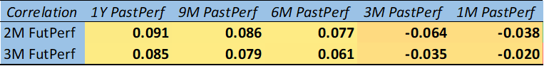

The table above presents the correlation between past price performance and future performance over 2- and 3-month periods following short recommendations ('SELL' and 'STRONG SELL'). It shows that longer-term past performance (1 year, 9 months, and 6 months) tends to have a small positive correlation with future returns. For instance, the correlation between 1-year past performance and 2-month future performance is 0.091, indicating that stocks with stronger long-term past performance may continue to perform slightly better in the short term after a short recommendation.

However, as the past performance window shortens (3 months and 1 month), the correlation becomes negative. This suggests that recent short-term performance leading up to the recommendation may not be a reliable predictor of future performance, and in some cases, there may even be a weak inverse relationship. For example, the 1-month past performance has a correlation of -0.038 with the 2-month future performance.

Interestingly, the correlations are slightly higher for the 2-month future period compared to the 3-month period, indicating that the predictive power of past performance weakens over a longer future horizon. However, it is crucial to note that these correlation coefficients are very low and close to zero, meaning the predictive strength of past performance is expected to be weak. The data suggests only minimal predictive value from past price trends for future short-term performance.
The analysis of future returns based on past performance quintiles reveals some interesting patterns for stocks under 'SELL' or 'STRONG SELL' recommendations.
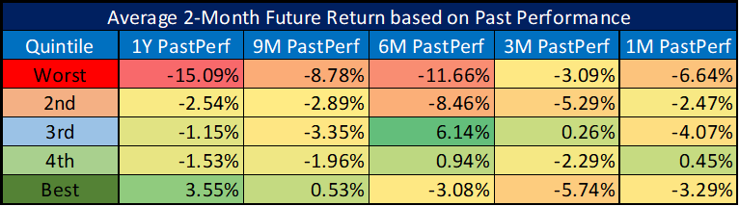
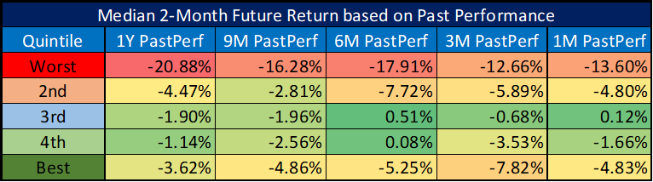
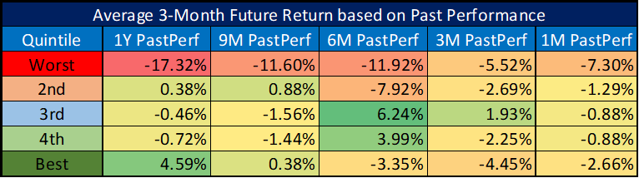
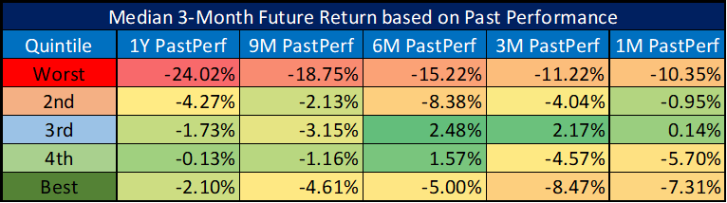
Stocks in the worst-performing quintile prior to the recommendation consistently continue to underperform in the following 2 and 3 months. For example, the worst quintile based on 1-year past performance has an average future return of -15.09% over 2 months and -17.32% over 3 months. Similarly, the median future returns for this group are equally poor, with a -20.88% median return over 2 months.
On the other hand, the best-performing stocks before the recommendation show mixed results. While we might expect strong past performance to indicate better future returns, the data reveals that even the best-performing quintile often has negative returns after the recommendation. For instance, the best quintile based on 6-month past performance has an average future return of -3.08% over 2 months and -3.35% over 3 months, both of which are negative. This indicates that good past performance doesn't necessarily translate into future gains, especially in the context of short recommendations.
The middle quintiles (2nd, 3rd, and 4th) show varied results, with some positive returns but overall no consistent trend. For instance, the 3rd quintile based on 6-month past performance exhibits positive returns of 6.14% over 2 months and 6.24% over 3 months, indicating potential outperformance in certain scenarios.
Overall, the data suggests that poor past performance is a stronger predictor of future underperformance, while strong past performance is not a reliable indicator of future returns in the case of short recommendations. Stocks that have performed poorly before the recommendation tend to continue performing badly, while stocks that performed well in the past often fail to maintain that momentum. This highlights the complexity of predicting future returns based on past performance alone, especially in a short-selling context.
What we can take away from these numbers for our discretionary decisions regarding short recommendations is that stocks which have already dropped significantly (more than 40%) over the past 9-12 months can still be shorted with confidence. There’s no need to worry too much about a rebound or that there’s no further room for decline. Additionally, it’s worth noting that stocks which have risen significantly (more than 40%) over the past 9-12 months should be approached with caution when considering short positions.
The following two figures (and their zoomed versions) are scatter plots showing the past 1-year performance against the future 2-month and 3-month performance. No reliably usable pattern can be discerned from these plots.
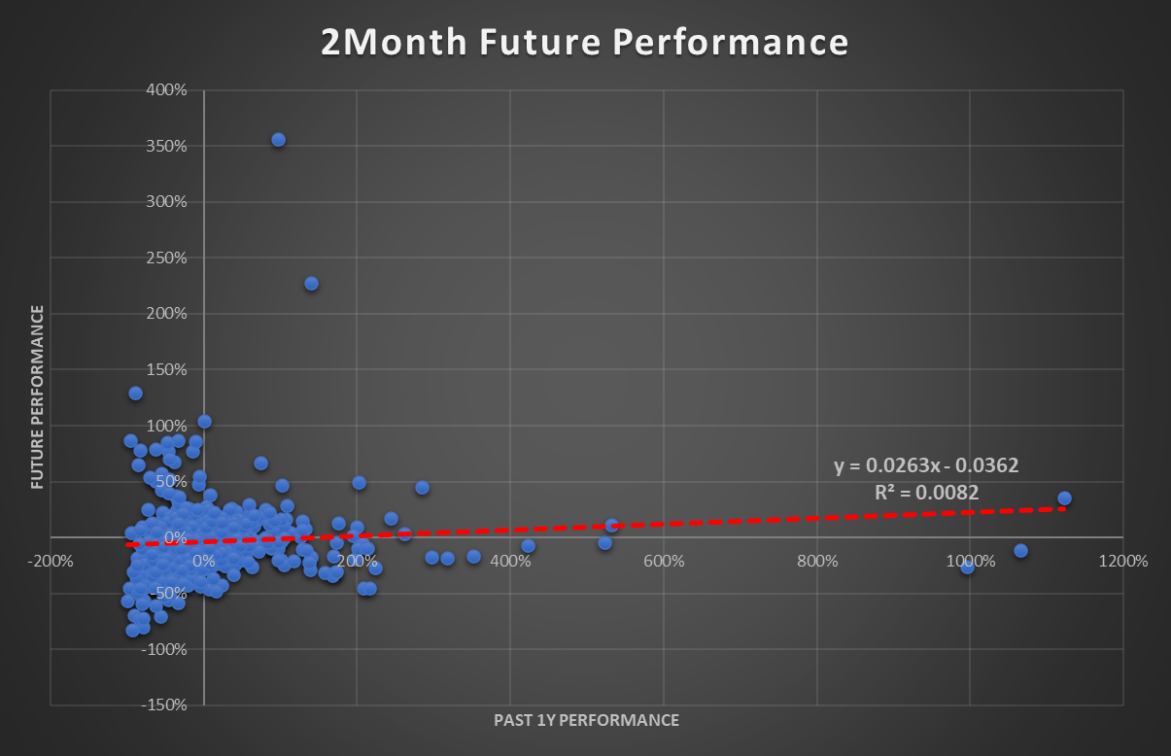
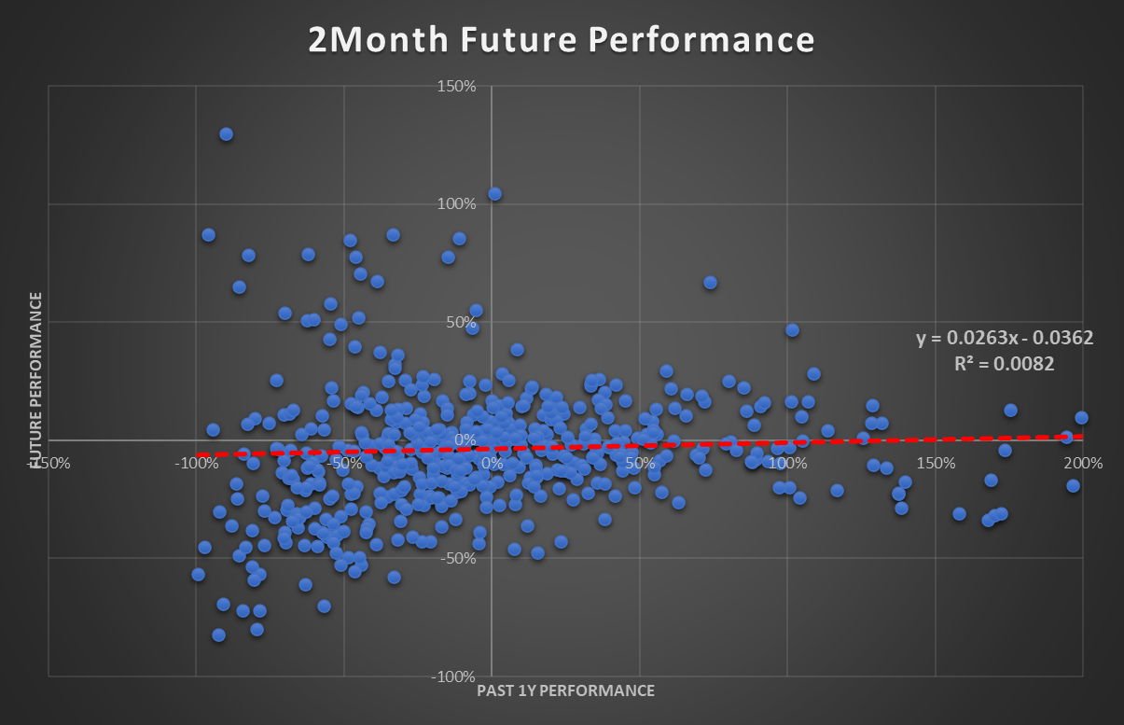
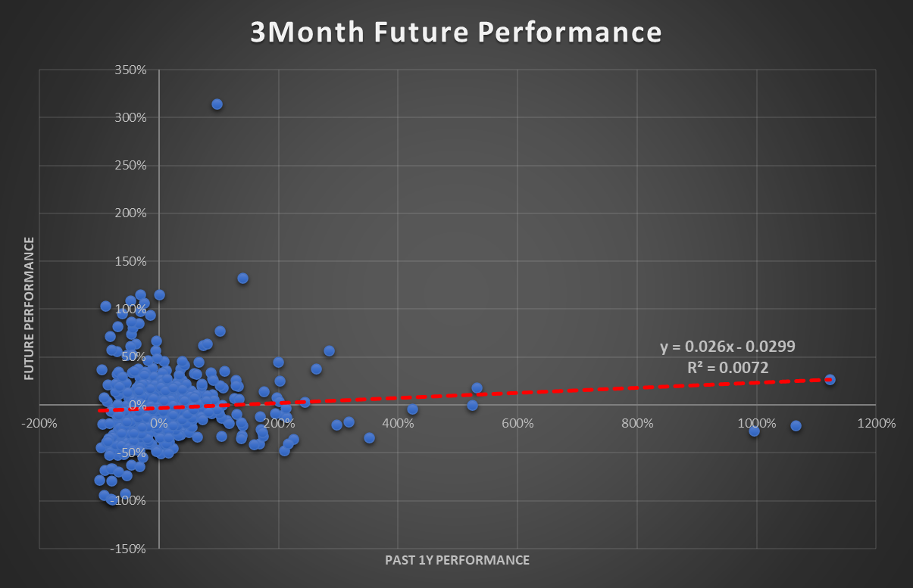
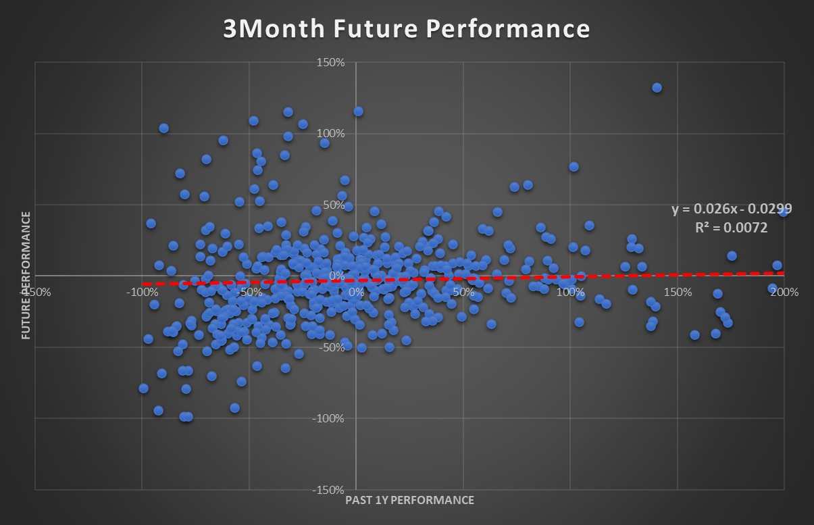

SeekingAlpha QuantRating vs. future performance - 2024-10-07

In this section, we aim to assess how much predictive power the SeekingAlpha QuantRating has when it comes to short recommendations. Unfortunately, historical QuantRating data is not available for us, so we cannot apply it to the earlier dataset. What we can do, however, is examine the performance of 44 recommendations collected during real-life trading that were received between 1 and 4 weeks ago and compare their subsequent performance with their QuantRating at the time of the recommendation. While this will obviously not provide statistically significant results, it could offer insights into how we should consider QuantRating in our discretionary decisions. Moreover, this analysis could serve as a useful foundation for further research over the long term.

The scatter plot indicates that short recommendations with a lower QuantRating (QR) tend to yield higher average short profits compared to those with higher QR values (correlation: -0.31). Moreover, if we exclude the two outliers from the data, we can observe a relatively clear negative relationship between QR and future short profit. However, it is essential to highlight several factors. First, the sample size is small, limiting the statistical significance of these findings. Second, the short profits were achieved over varying time frames between 1 and 4 weeks, making it difficult to generalize the results. Additionally, the short profits are calculated based on the prices at which we executed trades, which may differ significantly from the prices at the time the recommendation was made. Therefore, while the data suggests a potential trend, these limitations should be carefully considered when interpreting the results.
