Dr. George Antal
3D Click Limited
c/o Suite 431, 28 Old Brompton Road, London SW7 3SS

SeekingAlpha QuantRating Overview

Useful links 1
Performance charts of SA QuantRating 1
Thoughts and comments 3
AlphaPicks selection rules 3
Raw Returns of shorting Sell QR stocks 4
Summary of SA analysis papers by Mr. Charmat 5
Performance Analysis of SA QuantRatings - 2025-03-26 16

Useful links
Latest study (Past performance vs. future 2-3-month performance - 2024-10-07, SeekingAlpha QuantRating vs. future performance - 2024-10-07): Investigations of the SeekingAlpha TopAnalysts Short Recommendations

During the development of the strategy, we prepared the following study: Strategic Insights from SeekingAlpha TopAnalysts

GoogleSheet in connection with our live strategies (and further calculations): SATopAnalysts.xlsx
GoogleDoc about our real life decisions: SeekingAlpha TopAnalystsShorts

The Cross-Section of Non-Professional Analyst Skill (Michael Farrell, Russell Jame, and Tian Qiu, August 2020) (also note the CXO Cautions section here)

Quantitative Analysis and the Informativeness of Social Media Research (Yuling Guo and Russell Jame, September 2023)

Performance charts of SA QuantRating
Seeking Alpha's Quant Performance (Strong Buy): https://seekingalpha.com/performance/quant
Quant Sell Ratings: https://about.seekingalpha.com/quant-sell-ratings
Analyst Ratings: https://about.seekingalpha.com/analyst-ratings

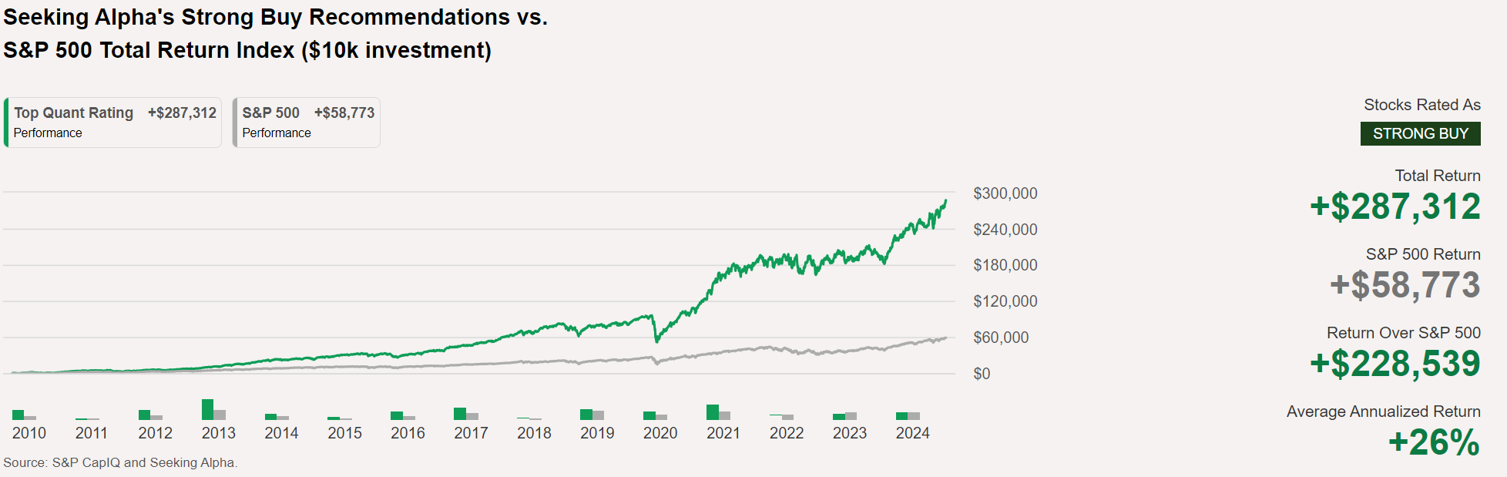
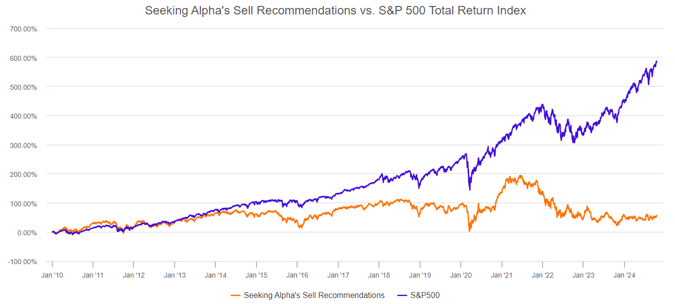
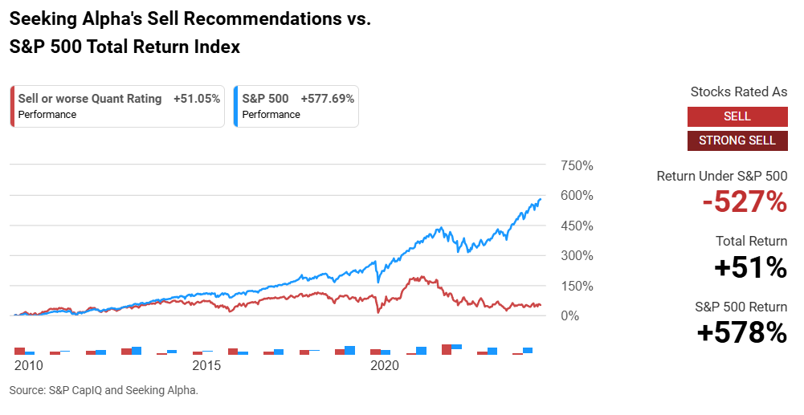
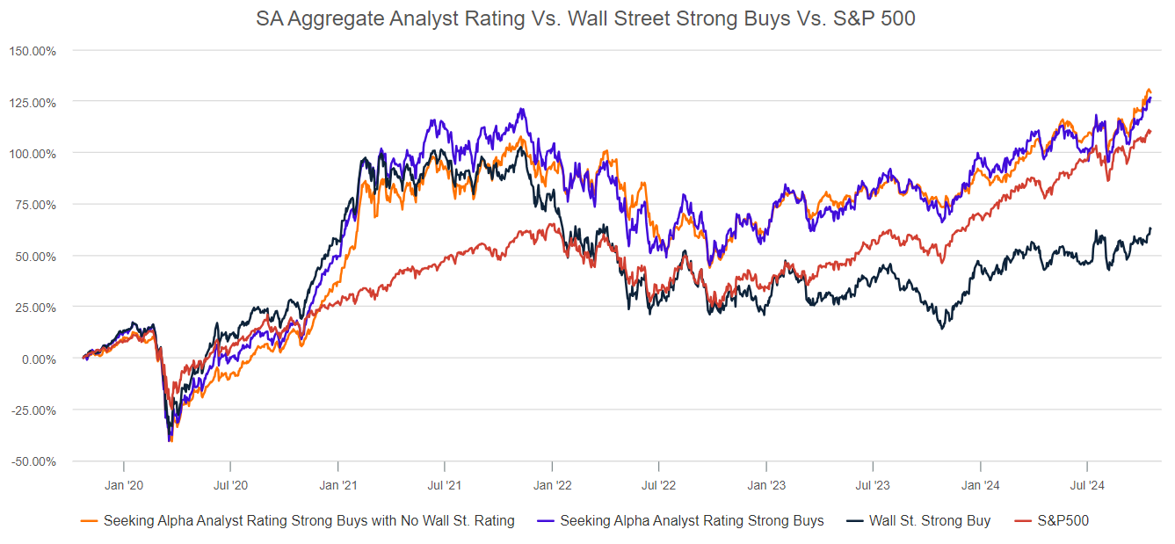

Thoughts and comments

AlphaPicks selection rules
The selection rules we know (from articles, webinars, forum posts) include:
- QuantRating of at least 4.8 and has been a "Strong Buy" for at least 75 calendar trading(!) days;
- American or Canadian or any company which is no ADR;
- Not traded OTC;
- Has not been recommended by them in the past year;
- MarketCap greater than $500M;
- Daily dollar volume greater than $10M (or not…);
- Market price greater than $10;
- Not related to REITs.
Furthermore, they consider it important that the company be among the leaders in its own sector/industry, have a good PEG (or P/E) value compared to competitors, with Growth potential of at least C, Momentum of at least C-, and an EPS Revision of at least C+. They also try to choose in such a way that no single sector has too much weight in the portfolio (Based on previous portfolio reviews, they go up to a maximum of 30%.).

“Second question being, I wonder if there is a reason why UAL, United Airlines; WFC, Wells Fargo; and Stride, LRN, all higher Quant values were skipped over by PayPal. There is a reason. So they do have higher Quant values, but we have additional parameters and criteria for Alpha Picks, one being the stock has to be a Strong Buy for at least 75 days, and none of those stocks have been a Strong Buy for 75 business days – trading days. When they do reach that, if they are still a Strong Buy, there's a possibility that they could be selected for the Alpha Picks portfolio.” https://seekingalpha.com/alpha-picks/articles/6109129-alpha-picks-stock-selection-webinar-replay-transcript

…

Raw Returns of shorting Sell QR stocks
Most of the time, the research paper mentions 6-factor Alphas as return. But that can be misleading. We have to know the raw-return, and this table shows those. (E.g. for normal “Sell” recommendations, the Alpha is negative (-0.55% per month), suggesting that shorting those stocks work, but the Raw-return is a positive 0.78%, that tells us that shorting them en masse doesn’t work.)

https://russelljame.com/quant_Ratings_9_15_23.pdf Page 44.
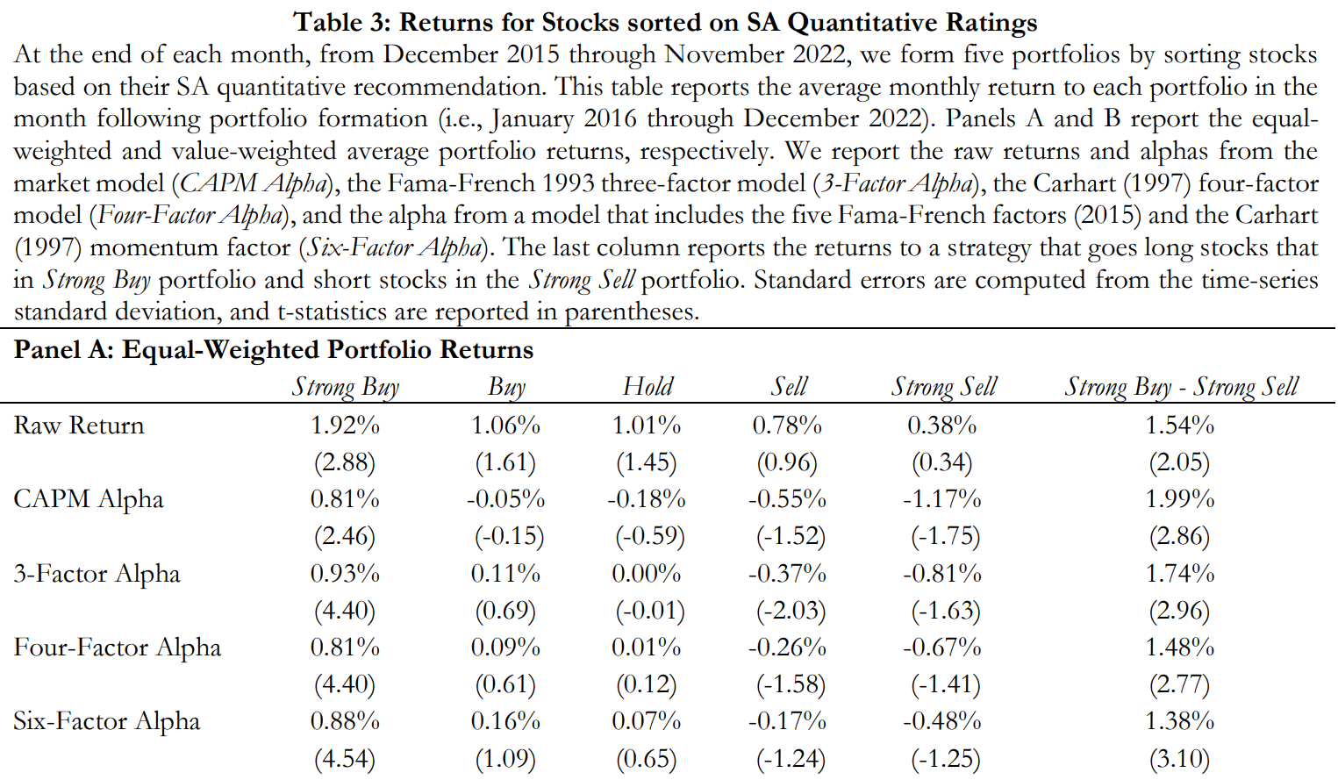

Summary of SA analysis papers by Mr. Charmat
Can investors use past performance to identify skilled.docx

The Cross-Section of Non-Professional Analyst Skill
Qiu* Michael Farrell, Russell James, and Tian
August 2020

Can investors use past performance to identify skilled contributors? If so, how much value does this create for investors? Are there other contributor characteristics, apart from past skill, that are associated with superior performance. We also document sizeable dispersion in skill among NPAs (s). Specifically, we estimate a s of 2.48% over the 63-day holding period, or 10.15% annualized.
The significant heterogeneity in NPA skill suggests that investors can improve their performance by limiting their attention to NPAs that have historically issued more informative research. Indeed, we show that conditioning on past alpha, defined as the average six-factor alpha across a contributor’s past 10 investment recommendations yields economically large benefits to
3. For example, a strategy that only follows reports written by contributors in the top quintile of past alpha earns abnormal returns of 1.78% per month which is more than double the 0.79% monthly abnormal return associated with the unconditional strategy of following all contributors.
We find that even after incorporating bid-ask spreads and a 72-hour investment delay, a trading strategy following NPAs in the top quintile of past alpha yields a statistically significant monthly return of 0.84% or roughly 10.00% annualized.
They are authored by more specialized contributors, as measured by an NPA’s tendency to either write about similar topics across all reports (Across-Report Focus) or discuss a small number of topics deeply within an report (Within-Report Focus)
The fact that neither retail nor institutional investors recognize the sizeable differences in skill across NPAs helps explain why following the recommendations of the top NPAs remains a profitable investment strategy even after incorporating trading delays of up to three day
The stronger trading profits associated with following the best NPAs is at least partially attributable to the market being far less efficient in recognizing differences in skill among NPAs. Not sure about it.
Our resulting sample includes 192,398 reports by 9,130 unique contributors for 5,080 firms.
Overall, we classify roughly 45% of reports as positive, 30% of reports as negative, and the remaining 25% of reports as neutral.
7. Neutral reports are excluded from the sample
The final sample includes 1,879 NPAs who have authored 123,120 positive or negative research reports. Conditioning on the 10 reports cutoff, the median (average) NPA has authored 25 (66) reports. 2.1

2.2 Across all the NPAs in the sample is 0.38% over a 5-day horizon and 0.68% over the 63-day horizon. Both estimates are consistent with the average contributor having economically meaningful skill in their investment recommendations. One caveat is that the analysis limits the sample to contributors with at least 10 research reports. To the extent that contributors with stronger initial performance are more likely to remain on Seeking Alpha (i.e., survivorship bias), our estimates could be biased upwards. In unreported tests, we also examine across all NPAs in the sample with less than 10 research reports. We find the mean for the five-day (63-day) holding period is 0.28% (0.56%). The estimates are lower than the corresponding estimates for NPAs with more than 10 research reports and suggest that survivorship bias likely results in moderately inflated estimates of average skill. However, survivorship bias will not impact tests focusing on out-of-sample performance (e.g., Tables 4 -7), which is the primary focus of the paper.

Table 1 reports descriptive statistics for across contributors. For the 63-day horizon, the standard deviation is 6.62% with an interquartile range of -2.21% to 3.06%.
The estimates are also measured with considerable noise. The cross-sectional average standard error over the 5-day (63-day) horizon is 1.44% (3.82%) and the average t-statistics are less than that is significantly greater than 0 over the 5-day (63-day) window, roughly double what one would expect by chance. 0.30
First, the average investor may be better off following the investment recommendations of NPAs rather than delegating their money to mutual funds managers. Second, given the sizeable dispersion in NPA ability, investors can likely earn superior returns by limiting their attention to the subset of the NPAs with a track record of excellent past performance.
P14 Specifically, the returns for days [1,63] are taken from CRSP. For day [0] returns, if the report was issued outside of trading hours, the day [0] return is the CRSP return for the trading day following the recommendation; if the report is issued during trading hours, we obtain the prevailing quote from TAQ for stock i at the time the report is published on Seeking Alpha, and we calculate the day 0 return from the quoted midpoint to the closing price.
We note that while our methodology is appropriate for quantifying contributor skill, it likely overstates the potential trading profits since it ignores trading costs and assumes investors can instantaneously process NPA research. We view these assumptions as providing a useful upper bound, and we consider more realistic assumptions in subsequent analysis.
4.2 On an average day, the long portfolio is based on 1,556 reports from the trailing 63-trading days, resulting in long positions in 451 different stocks, while the short portfolio is based on 786 reports resulting in short positions in 270 different stocks.
For example, a strategy that only follows NPAs in the top quintile generates a long-short return of 1.78% per month or more than 21% annualized. Panel C also confirms that following NPAs in the top quintile of outperforms the unconditional strategy by a statistically significant 0.99% per month.
Row 10 indicates that the results are similar if we exclude microcap stocks, defined as stocks below the NYSE percentile
One concern is that NPA research may simply “piggyback” on other major news events, making it difficult to separate the impact of the event itself from the NPA’s analysis of the event.
We address this concern using two approaches. In our first approach, we exclude SA research reports issued after trading hours (57% of the sample). Focusing on intraday reports, coupled with our calculation of intraday returns, helps isolate the price discovery associated with the SA research report, rather than any previous news. Admittedly, it is still possible that some of the return following the SA report is attributable to a delayed reaction to some underlying news event.
While this distinction has implications for understanding how NPAs add value, this subtlety is likely irrelevant to investors, since the trading profits that accrue to following an NPA’s recommendation would remain the same. Our second approach to addressing this concern is to exclude the roughly 60% of SA research report that are issued on the same day or the day after an earnings announcement, sell-side research report, or media article. The results of these two approaches are reported in Rows 12 and 13 of Table 5.
Figure 1 plots the trading profits associated with following contributors in the top quintile of for each year in the sample period (2007-2017
..10 We find that the trading profits are positive in 10 of the 11 years and are statistically significant (at a 5% level) in eight of the 11years. Further, the average magnitude is similar in the first five years of the sample (1.89%) and the last five years of the sample (1.77%), suggesting that the returns to the trading strategy have remained large despite the increasing popularity of the Seeking Alpha platform
Table 4 as a reference. Row 2 incorporates bid-ask spreads but continues to assume no investment delay. Specifically, following positive reports, investors now purchase the stocks at the ask price at the time of the report publication and sell the stock at the bid price at the end of the 63-day holding period. Similarly, following negative reports, investors sell the stocks at the bid price at the time of the report publication and repurchase the stock at the ask price at the endof the 63-day holding period. We find that incorporating bid-ask spreads reduces the long-short
14. spread from 1.78% to 1.19%, a roughly 30% decline
However, the 1.19% estimate remains
14. Our estimates incorporate 4 transactions (initiating and closing positions on both the long and short side), implying a half-spread of roughly 0.15% ((1.78% – 1.19%)/4). This estimate is very similar to the 0.16% effective half-spread reported in Boehmer et al. (2020).
transaction costs, including trading commissions and price impact. While the effects of price impact are likely to be modest for smaller retail investors, they can be substantial for larger institutional investors (e.g., Korajczyk and Sadka, 2004; and Frazzini, Israel, and Moskowitz,
2018), which may help explain why the potential trading gains are not completely eliminated by the trading of large sophisticated investors.
Farrell et al. (2020) find that many retail investors respond to SA research within 30 minutes of the release of the SA report, suggesting that these investment delays are likely to be far longer than necessary for many attentive investors
We find that incorporating a 24-hour delay reduces the trading profits by roughly 20% (from 1.19% to 0.98%). The 72-hour delay results in the trading profits falling further to 0.84%, an additional 15% decline relative to the 24-hour delay, or a roughly 50% decline relative to the baseline results. Nevertheless, the 0.84% long-short spread reported in Row 4 is still statistically significant. It is also economically sizeable as it translates to an annualized excess return of greater than 10%
Our final set of variables focus on the extent to which NPAs specialize on certain topics.. To identify topic specialization, we first encode each report as a set of weights among twenty topics, which we estimate using an unsupervised machine learning technique, Latent Dirichlet
Allocation or LDA (Blei, Ng, and Jordan, 2003). Figure 2 reports the top 10 characteristic words for each of 20 topics. We find that many of the topics are industry related. For example, Topic 4 includes words like drug, patient, trial, treatment, FDA, etc. and naturally corresponds to the pharmaceutical industry. However, we also see that there are non-industry topics. For example, Topic 19 includes words like: deal, management, acquisition, shareholder, value, board, etc. andthus captures topics related to mergers and acquisitions.
We compute two variables that are related to specialization: Within-Report and Across-Report Focus. Within-Report Focus is calculated as the standard deviation of the topics’ weights within a report, averaged across the contributor’s prior reports. To calculate Across-Report Focus, we compute the standard deviation of each topic weight across the contributor’s past reports, and then calculate the average standard deviation across each of the twenty topics.
Thus, Within-Report Focus measures a contributor’s tendency to write reports that are dedicated to a specific topic (even if the topics vary over time), while Across-Report Focus measures a contributor’s
The results confirm the findings from the previous analysis that NPA skill is highly persistent.
The point estimate indicates that a one standard deviation increase in contributor skill is associated with a 1.33% increase in the 63-day return associated with the NPA recommendation.
We do find that more engaged NPAs, as measured by Other Comments, issue more informativeness recommendations. In particular, a one-standard deviation increase in Other-Comments is associated with 0.55% greater alpha over the subsequent quarter.
This contrasts with authors who comment heavily on their own articles: a one standard deviation increase in Self-Comments is associated with a decline in alpha of 0.41%. One potential explanation for this is that self-comments are often responses to critical questions from skeptical readers, perhaps as a consequence of unclear or low-quality research reports. We also find that both focus-related variables are significantly related to returns. A one-standard deviation increase in Across-Report Focus is associated with a 0.22% increase in 63-day ahead returns, while the 5.2 The findings from Tables 6 and 7 suggest that much of the differences in skill across NPAs is not immediately impounded into prices. One plausible explanation for this finding is that investors simply do not recognize differences in NPA skill. To explore this possibility more carefully, we examine retail and institutional order imbalances following the release of SA research reports. Specifically, we estimate following regression:
we find that retail order imbalances are highly persistent and strongly negatively related to past one-week returns.
More importantly, consistent with Farrell et al (2020), we find that that retail order imbalances are strongly related to NPA recommendations (i.e., > 0). The point estimate indicates that retail order imbalances are
1.23 percentage points higher following positive reports relative to negative reports.
Specification 2 augments Specification 1 by including NPA Char. We find no evidence that retail investors respond more strongly to reports authored by more skilled contributors. None of the four NPA characteristics are significantly different from zero. The lack of a differential
6. We offer a first look at the cross-section of skill among NPAs contributing investment research on the Seeking Alpha Platform. We estimate that a substantial fraction (60%) of NPAs are skilled. More importantly, we document substantial dispersion in skill. In particular, after accounting for variability due to estimator error, we find that the dispersion in true ability among NPAs is roughly eight times as large as cross-sectional dispersion in performance across mutual fund managers.
The market does not fully recognize skill differences across NPAs. A simple transaction-based calendar time strategy that only follows the recommendations of NPAs in the top quintile of past performance generates annualized abnormal returns in excess of 10% even after incorporating bid-ask spreads and allowing for a three-day investment delay. In contrast, an analogous strategy that follows the recommendations of all NPAs does not generate significant outperformance.
Despite the sizeable trading gains associated with following only the most skilled contributors, an analysis of retail and institutional order imbalances around NPA recommendations suggests that neither group recognizes differences in contributor skill.
Our findings are consistent with much of the recent literature that suggests social media can have positive effects on financial markets and improve investment decision making. At the same time, the markets’ failure to incorporate sizeable differences in ability across NPAs suggests
Electronic copy available at: https://ssrn.com/abstract=3682490
That many of the benefits are not being fully realized. Our findings raise the question of whether social media sites, or possibly even regulators, should provide more readily available information about NPA attributes, including past performance, to help investors better recognize differences in ability.

2023 Report *
Yuling Guo and Russell Jame.
After the change, we observe a 20-fold increase in the percentage of SA
reports mentioning quant-related terms (Quant Reports). SA report recommendations also become more aligned with quant ratings. This effect is stronger for Quant Reports and reports authored by less quantitatively savvy contributors. Furthermore, both types of reports become significantly stronger predictors of future returns. We conclude that improved access to quantitative analysis enhances social media research, particularly for less sophisticated investors who likely had limited previous exposure to quantitative analysis.

For example, McLean, Pontiff, and Reilly (2022) find retail investors systematically trade against market anomalies, which suggests that they may benefit the most from greater access to quantitative research. On the other hand, simply providing investors access to additional useful information need not improve financial decision making, particularly when the information provided is relatively complex (see, e.g., Hasting, Madrian, and Skimmyhorn, 2013; and Fernandes, Lynch Jr, and Netemeyer, 2014 for a review of the financial education literature).
We begin by examining whether Quant Ratings predict returns. Our analysis uncovers a statistically and economically significant relation between Quant Ratings and returns. For example, a strategy that goes long stocks with Quant Ratings that correspond to a Strong Buy recommendation (roughly the top decile) and short stocks with Quant Ratings that correspond to a Strong Sell recommendation (roughly the bottom decile) earns an equal-weighted CAPM alpha of 1.98% per month and a six-factor alpha of 1.38% per month, both of which are statistically significant at a 1% level. The corresponding estimates for value-weighted portfolios are 1.98% and 1.21%, respectively, which suggests that the return predictability of Quant Ratings is present even in large and liquid stocks.
The return predictability is similar in both the pre-period (2016-2018) and post-period (2020-2022) indicating that Quang Ratings remained valuable even after they were disclosed on the platform. and potentially correct mispricing, including the academic publication of the anomaly (Pontiff and Mclean, 2016; and Calluzo, Moneta, and Topaluglu, 2019) and access to quantitative analysts (Birru, Gokkaya, Liu, and Markov, 2022). Our findings suggest that the introduction of Quant Ratings is another factor that helped a subset of market participants, contributors on the SA platform, issue research more aligned with anomaly mispricing. Thus, to the extent that SA research influences trading and prices (Farrell et al., 2022), SA research may now be a force that attenuates anomaly mispricing.
More than 16,000 individuals contribute at least one SA report
3, These reports are intended to provide new investment research, rather than to simply break news, and each report is subject to significant editorial review. Prior work finds that these reports contain value-relevant information that predicts returns (Chen et al., 2014) and facilitates more informative retail trading (Farrell et al., 2022).
SA does not provide the exact formula used to compute the quantitative ratings. They note that the five factor grades influence the overall quant rating, but they acknowledge that factors outside of the factor grades including firm size and measures of risk also influence the quant score
4. They also emphasize that all ratings are relative to the current sector at a given point in that time. Thus, the measures are designed to identify better performing stocks within a sector but should not be used to pick better performing sectors or for market timing. All quantitative measures are updated at a daily frequency.
For each report, we collect the following information: a report ID assigned by Seeking Alpha, report title, main text, date and time of
the article publication, author name, the ticker (or tickers) assigned to each report, and the author’s rating at publication. The author’s rating at publication includes the following categories: Strong Sell, Sell, Hold, Buy, and Strong Buy. The Strong Sell and Strong Buy labels are infrequent, and they were not used prior to December of 2018. Accordingly, we convert the author rating into a 3-point recommendation system by combining Strong Sell and Sell (hereafter: Sell) and combining Strong Buy and Buy (hereafter: Buy).
In an average year, the sample includes roughly 4,200 common stocks in the CRSP universe. Roughly 65% (2,750) of the stocks have a quantitative rating on the Seeking Alpha platform (Quant Rating), and the Quant Rating coverage has steadily improved over time. In an average year, the sample consists of 18,716 SA reports, of which close to 85% (15,710) cover stocks with an available quantitative rating. On average, about 54% of all SA reports issue a buy recommendation, 9% of SA reports issue a sell recommendation, and the remaining 37% issue a hold recommendation.
The average quant rating is 2.95 with a standard deviation of 0.89. 64% of stocks are rated as Hold, while this filter eliminates roughly 7% of all observations. Since it is possible that this filter also eliminates some correct reports
7. That may use an abbreviation for the company name, we have repeated all these tests without this filter. The results are very similar.
the remaining 36% of stocks are roughly evenly distributed across the remaining four categories (i.e., Strong Sell, Sell. Buy, and Strong Buy). The distribution of quant ratings and quant recommendations is stable over time, which is consistent with SA’s claim that quant ratings are based on relative metrics.
We note, however, that the r-squared from the model is only 9%, indicating that the overwhelming majority of the variation in Quant Ratings is unexplained by the Net Anomaly measure.
One potential explanation for the relatively low r-squared is that Quant Ratings overweight certain anomalies and underweight (or even contradict) other anomalies. To Size and Reversal. The negative loading on Size (i.e., recommending larger stocks) and the positive loading on Low Risk is consistent with SA’s claim that Quant Ratings also consider size and risk. The negative loading on Reversals, which includes one-month return reversals (Jegadeesh, 1990), is likely driven by the fact that the momentum strategies considered by SA do not follow the common academic convention of skipping the most recent one-month return.
We next examine whether Quant Ratings contain useful information for predicting stock returns. At the end of each month, from December 2015 through November 2022, we form five portfolios by sorting stocks based on their Quant Recommendation. We also consider a long-short portfolio that goes long stocks with a Strong Buy recommendation and short stocks with a Strong Sell recommendation. For each portfolio, we report the average monthly return in the month following portfolios formation (i.e., January 2016 through December 2022). We report raw-returns and alphas from the following factor models: 1) the market model (CAPM Alpha), the Fama-French (1993) three factor model (3-factor alpha), the Carhart (1997) four-factor model (4-Factor Alpha), the Fama-French (2015) five-factor model (5-factor alpha), and the Fama-French (2015) five-factor model augmented to include the Carhart (1997) momentum factor (6-factor Alpha).
Panels A and B of Table 3 report the equal-weighted and value-weighted portfolio returns.
Across all the return measures considered, we find that average portfolio returns increase with the quantitative recommendation. For example, the equal-weighted CAPM alpha increases from -1.17% for the strong sell portfolio to 0.81% for the strong buy portfolio, and the difference between the long and short portfolio of 1.99% is economically large and statistically significant. Including additional factors tends to attenuate the magnitudes. For example, the six-factor alpha falls to 1.38%, but the estimate remains highly significant. The long-short portfolio return estimates are very similar for the value-weighted portfolios, which suggests that the return predictability of quant ratings is present in larger and more liquid stocks. This finding is particularly important given the evidence that SA coverage exhibits a strong tilt towards larger companies (Farrell et al., 2022).
Figure 1 also reports the factor-loadings from the value-weighted six-factor model. Consistent with the estimates in Table 2, we find that the long-short portfolios load heavily on value stocks, momentum stocks, stocks with high profitability, and larger stocks. A comparison of the 6-factor 4. Do Quant Ratings Influence SA Research?
The results from the prior section suggest that Quant Ratings contain useful information that can potentially enhance the informativeness of SA research reports. In this section we explore whether Quant Ratings influence SA research reports.
4.1 The Frequency of “Quant” Reports
We begin by counting the number of SA reports that mention words commonly associated with SA’s new quantitative ratings (hereafter Quant Reports). Specifically, we search all SA reports for any of the following expressions: ‘quant’, factor grade', 'value grade', 'growth grade', 'profitability grade’, ‘momentum grade', or 'revisions grade'.
10. Appendix B provides excerpts from a bullish and bearish Quant Report. While anecdotal, these excerpts indicate that SA quant ratings are directly incorporated in at least some SA reports.
In contrast, in the three-year post period 1,583 reports (3.15%) are classified as Quant Reports. Although the 3.15% estimate is not particularly large in absolute terms, it represents a more than 20-fold increase relative to the pre-period estimate.
Page 15. The point estimate indicates that a one-unit increase in the quant rating is associated with a 5.50 percentage point increase in Report Rating. This estimate corresponds to an increase of roughly 13% relative to the mean of Report Rating (0.42).
Section 3 documents that quant ratings are strongly predictive of future returns. Further, the findings from Section 4 indicate that SA report recommendations became more correlated with quant ratings after the introduction of quant ratings on SA platform. Taken together, these findings point to the possibility that SA report recommendations became more predictive of future returns (i.e., more informative) following the release of the quant ratings. We investigate this possibility next.
5.1 Quant Ratings and the Informativeness of SA Research – Baseline Results.
SA reports that occur outside of trading hours, we define day [0] as the date on which an investor could have first traded on the report. For example, if a report was issued at 5 pm on Tuesday, August
1, We classify the date of the report as Wednesday, August 2, and we define the [1,5] day return as the return from Thursday, August 3 through Wednesday, August, 9. We exclude the Day [0] return to reduce the impact of potentially confounding news that could influence both the report and the Day [0] return
.15 Report Rating equals one for SA reports making a buy recommendation, zero for reports making a hold recommendation, and negative one for reports making a sell recommendation.

Chen et al. (2014) adopt a similar methodology, but they skip two days (i.e., days 0 and 1). We have repeated our tests using this approach, and we find very similar results. SA report recommendations across all periods are strongly correlated with day 0 returns. Thus, it is possible that much of the value of report recommendations is immediately incorporated into prices. Our focus is primarily on cross-sectional patterns (i.e., which reports are relatively more informative), and we find that the our main conclusions regarding cross sectional differences in informativeness are very similar when including day 0 returns.
The point estimates indicate that for Quant Reports issued in the post period, a one-unit increase in SA report recommendations (i.e., moving from a hold to a buy) is associated with 0.84% higher returns over the subsequent week, 1.85% higher returns over the subsequent month, and 2.977% higher returns over the subsequent quarter.
To estimate the relative importance of these two factors, each day we sort stocks into 25 portfolios based on the quant rating (Quant Portfolio). The typical Quant Portfolio contains 100 stocks, and the median spread between the maximum and minimum quant rating within a Quant Portfolio is 0.06. We define Quant-Style Return as the average return across all stocks in the Quant Portfolio, and we define Quant-Adjusted Return as the difference between the stock return and the Quant-Style Return.
Thus, Quant-Style Returns capture the average returns attributable to recommending a stock with as specific Quant Rating while Quant-Adjusted Return captures stock-picking ability holding the Quant Rating(essentially) constant.
The one-quarter result suggests that Quant Reports tendency to recommend stocks with higher quant ratings results in 1.72% higher returns, which accounts for roughly 60% of the total return predictability documented in Table 6. We also find that Report Rating × Post × Quant is positively related to Quant-Adjusted Returns, although the estimate loses statistical significance at the one-quarter horizon. Nevertheless, the shorter horizon results are consistent with Quant Reports having some ability to identify better performing stocks within a quant rating.
Rows 2-5 explore whether our results are robust to the inclusion of various fixed effects. First, since quant ratings are relative to a sector, in Row 2 we replace month fixed effects with sector × month fixed effects. Rows 3 and 4 include firm fixed effects and firm × report rating fixed effects. The inclusion of firm fixed effects (Row 3) helps address the concern that some firms have persistently higher return, while the inclusion of firm × report rating fixed effects addresses the concern that report informativeness is particularly strong for certain types of firms (e.g., the returns on smaller stocks following buy recommendations is particularly large, while the return following sell.?
Quant Style Returns
7. Conclusion
This paper explores whether access to quantitative research can influence and enhance social media research. Our empirical strategy exploits the introduction of quantitative ratings on the Seeking Alpha platform as a shock to the availability of quantitative research.
We first confirm that the quantitative ratings are useful. In particular, the quant ratings provided by SA are related to common academic measures of mispricing, and they strongly predict future returns. After the introduction of quant ratings, we observe a 20-fold increase in the proportion of SA reports mentioning “quant” or other quant-related words (Quant Reports). In addition, SA report recommendations become more correlated with quant ratings, particularly among Quant Reports.
Lastly, we find evidence that Quant Report recommendations are significantly more informative than pre-period reports and post-period Non-Quant Reports. A performance decomposition indicates that the superior performance of Quant Reports is at least partially attributable to the fact Quant Reports systematically recommend stocks with high quant ratings, which exhibit higher average returns.
We also find that the benefits of quantitative research are more pronounced for reports authored by less quantitatively sophisticated contributors, who presumably had more limited exposure to quantitative analysis prior to the platform design change.
Our findings have meaningful implications for policy makers, and for contributors, consumers, and designers of social media sites. For policy makers, our findings suggest that modifications in platform design on social media sites could serve as a potentially significant means of improving financial literacy, even for less sophisticated investors. For contributors, we note that the percentage of Quant Reports, while rapidly growing, is still a relatively small fraction of total reports. Thus, our evidence suggests that contributors would benefit from more regularly incorporating quantitative research into their analysis. Similarly, consumers of SA research should, all else equal, gravitate towards reports that include some quantitative analysis, and other social media platforms may potentially benefit by providing their own versions of quantitative ratings
.19 Even SA may be able to further enhance the informativeness of their site by making platform design changes that increase the salience of quant ratings. For example, SA could offer prompts for contributors to review quantitative ratings before submitting research reports or issue warning notifications to contributors when they submit a research report with a recommendation that is inconsistent with the quant ratings.

Performance Analysis of SA QuantRatings - 2025-03-26

Introduction

This study analyzes the historical performance of U.S. equities based on Seeking Alpha’s Quant Ratings (QR), using a combined universe of companies from the S&P 500 and Nasdaq 100 — approximately 550 large-cap stocks. The dataset includes daily Quant Rating values from August 2019 to March 2025, enabling a multi-year, real-world assessment of the rating system’s effectiveness.

⚠️ Important Note: Since the study is based on large-cap stocks, results may not directly generalize to small-cap equities, where market dynamics and liquidity can differ significantly.

Methodology

Each rebalance day, stocks were grouped by their Quant Rating into 5 standard bands: Strong Sell, Sell, Hold, Buy, and Strong Buy. Furthermore, we added a backtest for stock having QR > 4.7. With the backtest named ‘Total’ in which all the 550 stocks are included, we have 5+1+1 = 7 backtests for each rebalancing frequency. Using a custom strategy implemented in QuantConnect, the model:
- Selected stocks within a specified QR range,
- Rebalanced portfolios at different intervals: weekly, biweekly, and monthly,
- Tested multiple rebalance start dates (e.g., Tuesday, Friday, or with a 1-week offset),
- Altogether 8 rebalance versions were tested. In each case, 7 universes were tried, resulting in 8*7 = 56 backtests.
- Recorded daily portfolio values (PV) to analyze cumulative performance.

Rebalancing was performed using end-of-day Quant Rating data, and equal-weighted positions were opened at market close.

Results

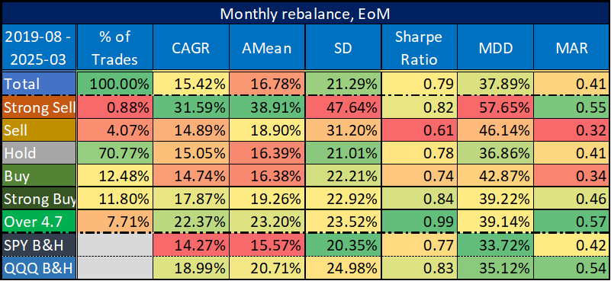
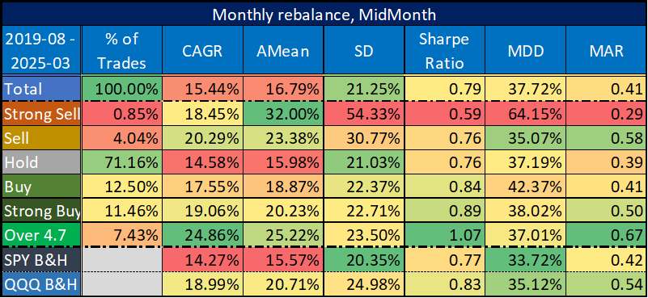
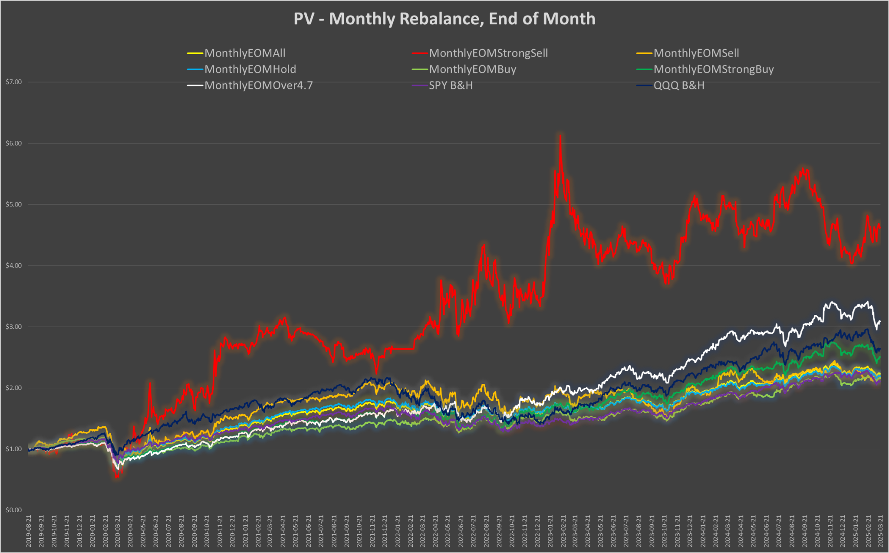
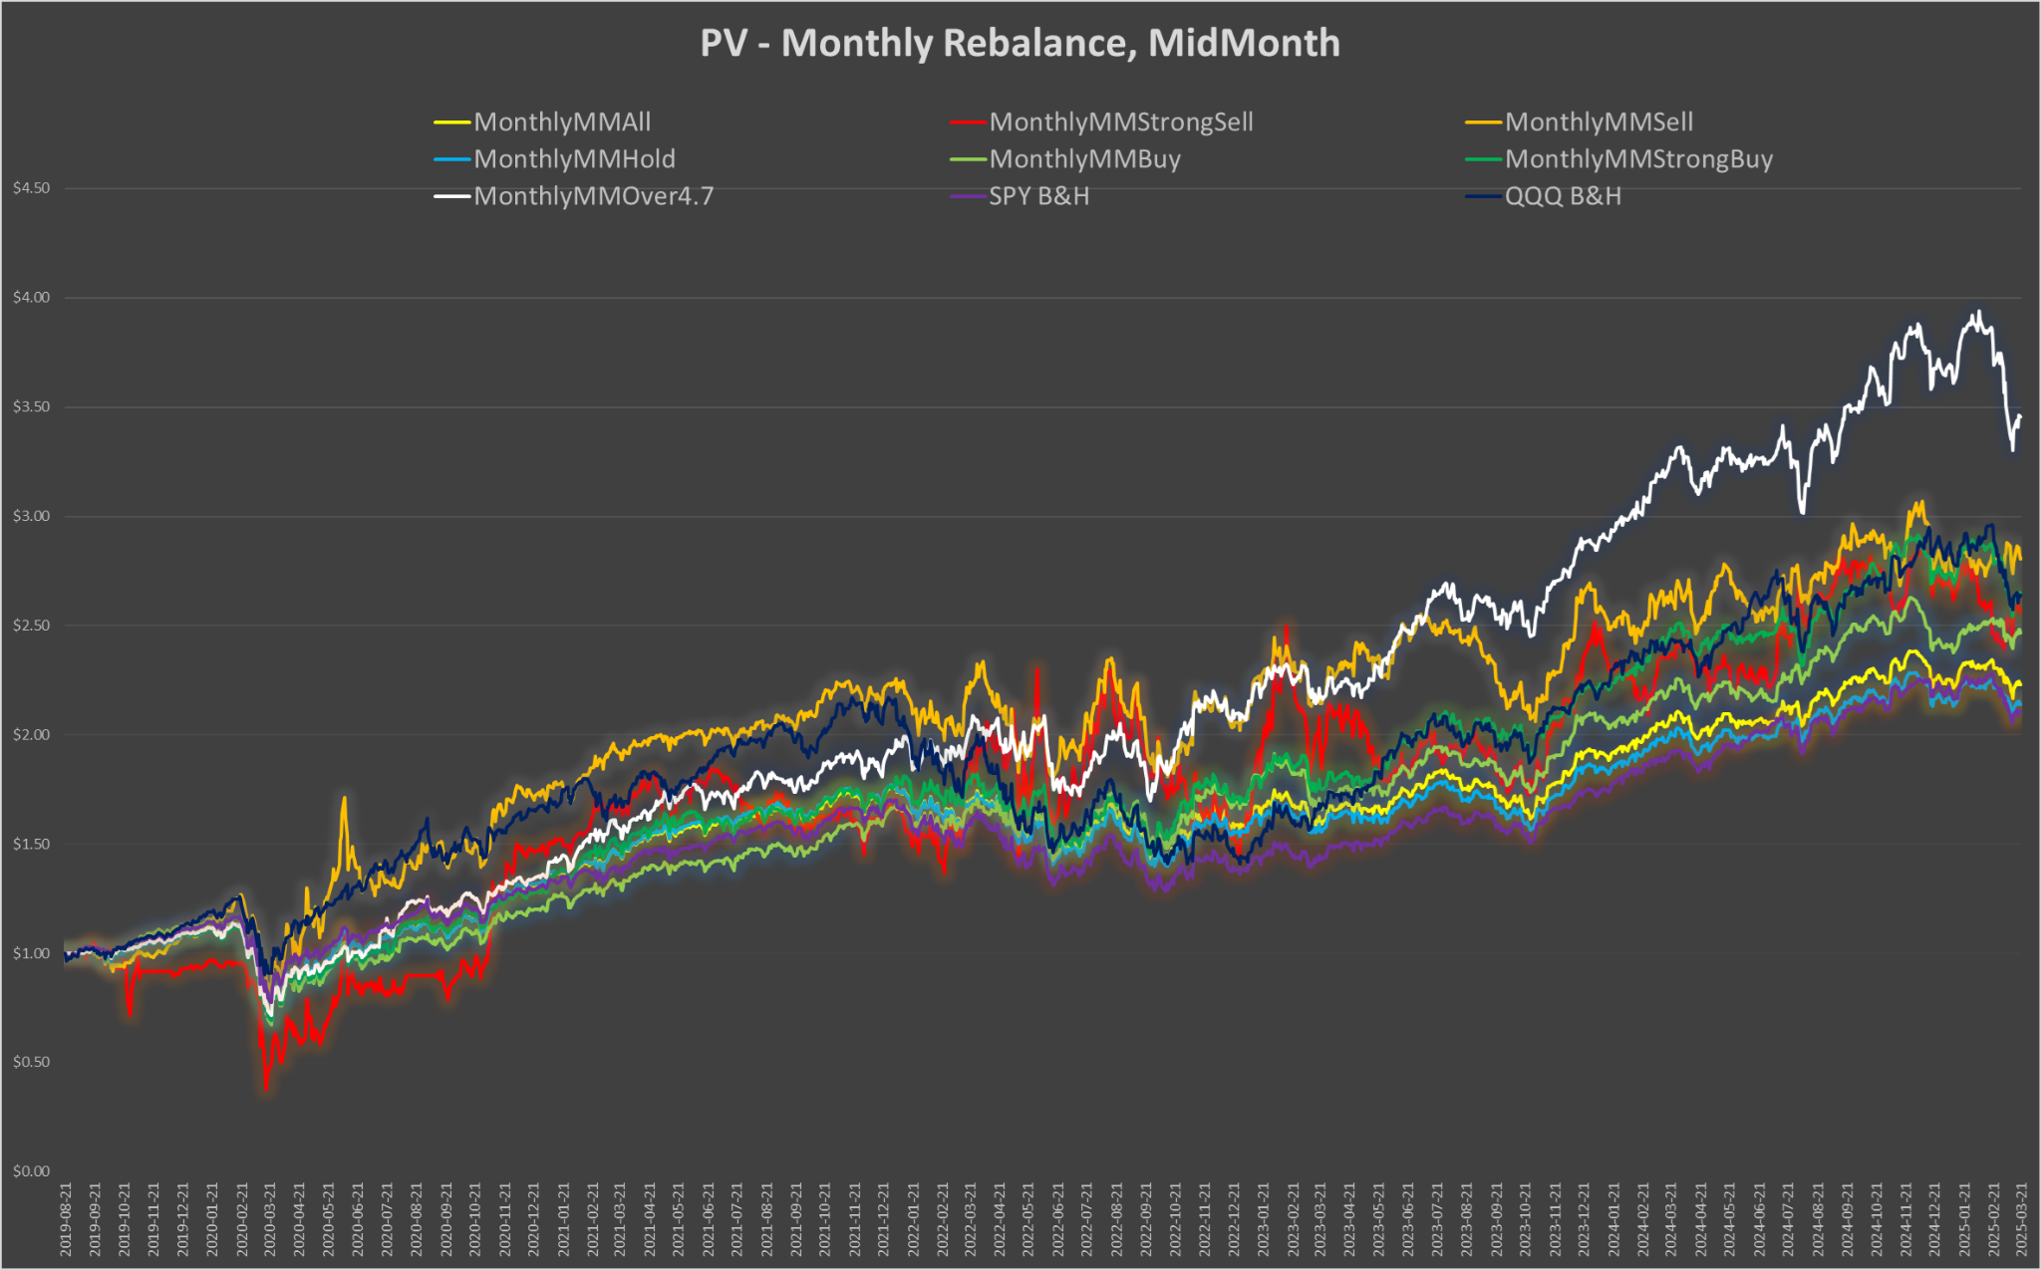
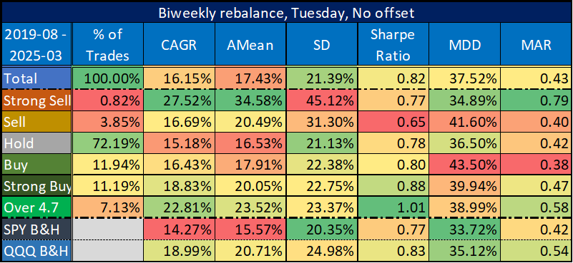
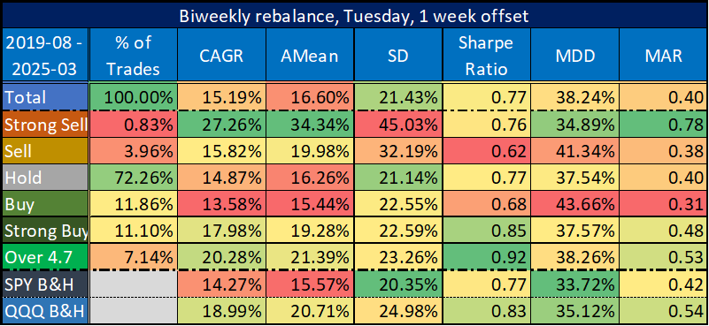
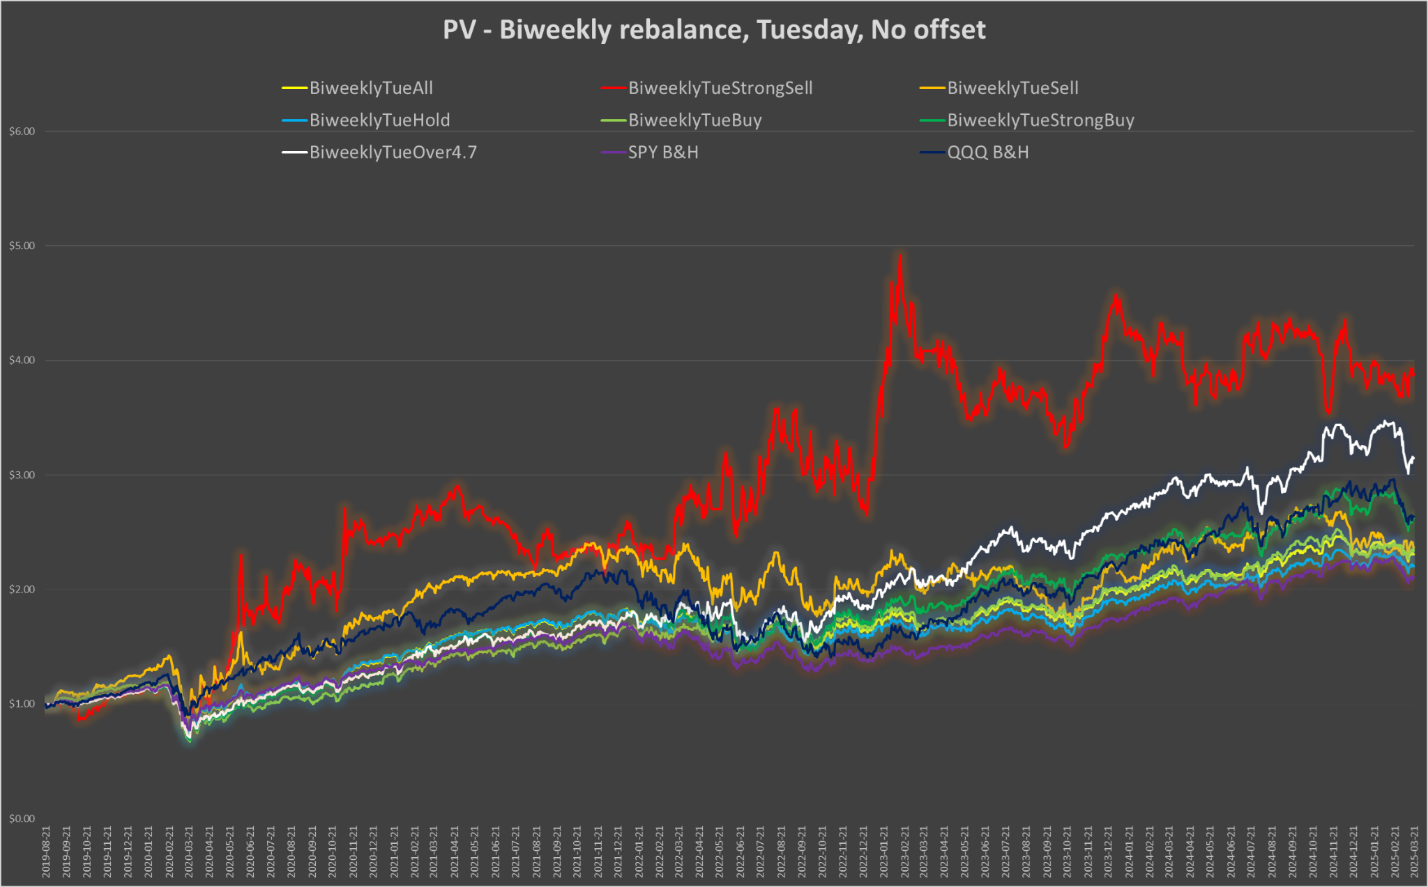
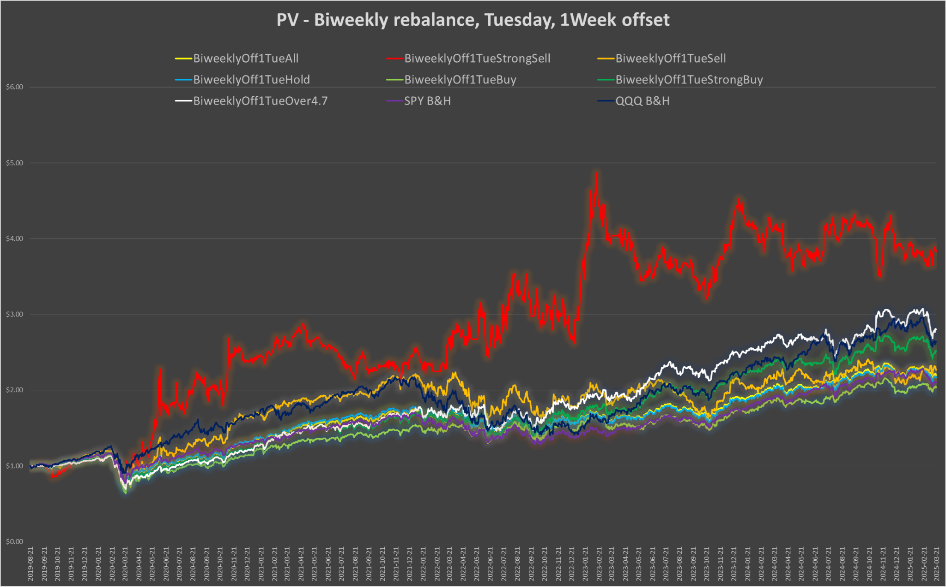
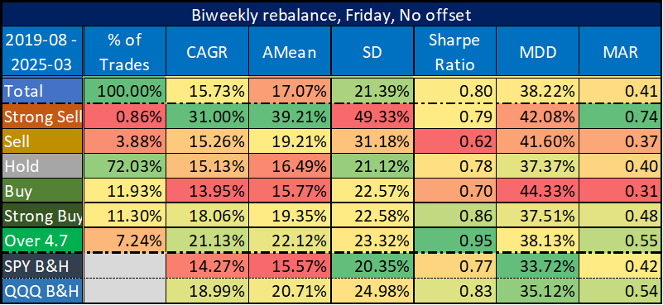
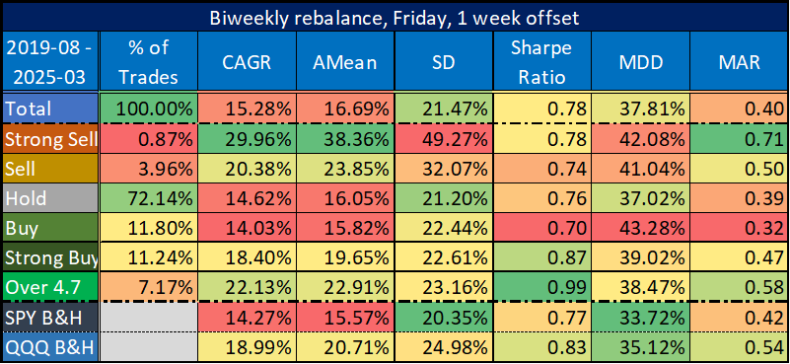
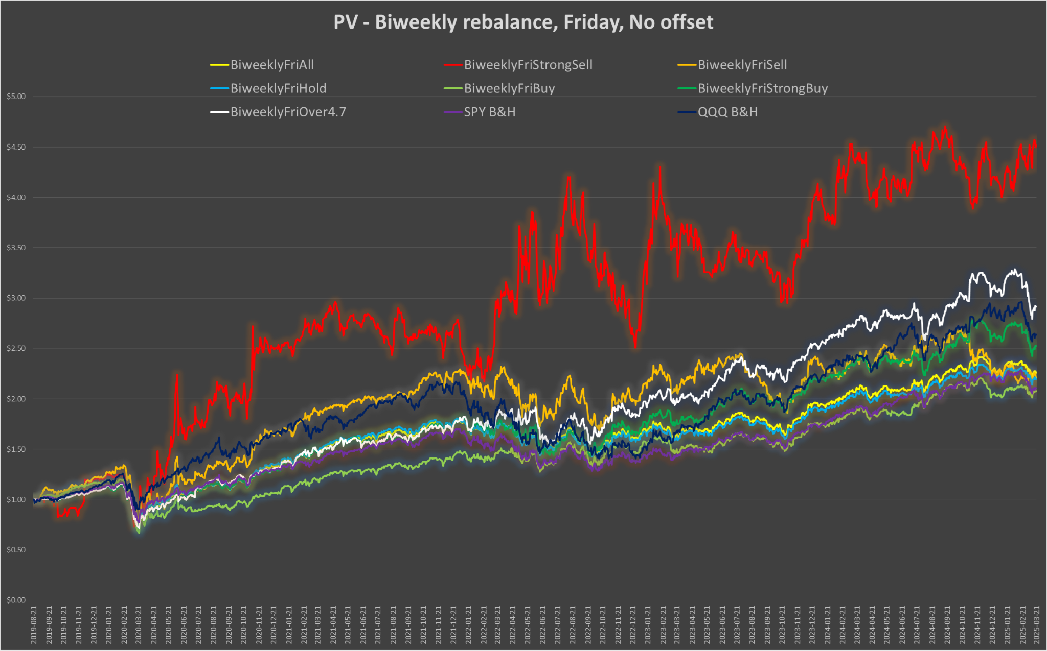
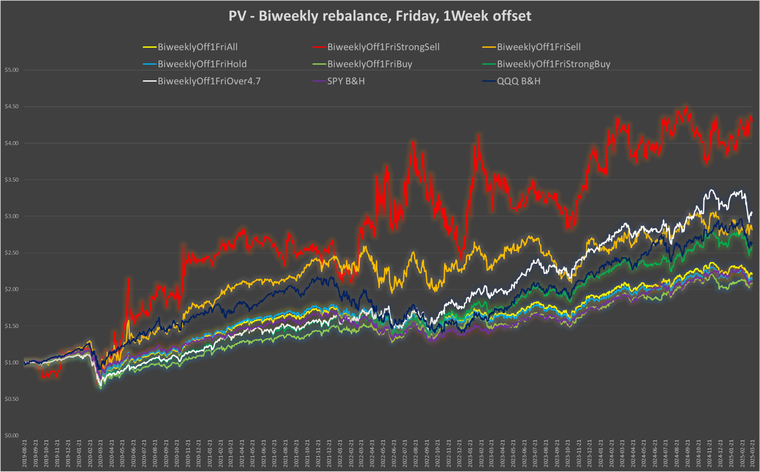
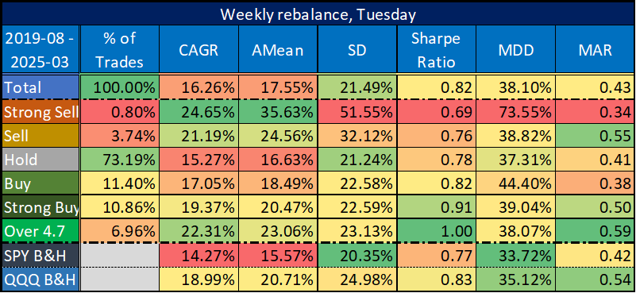
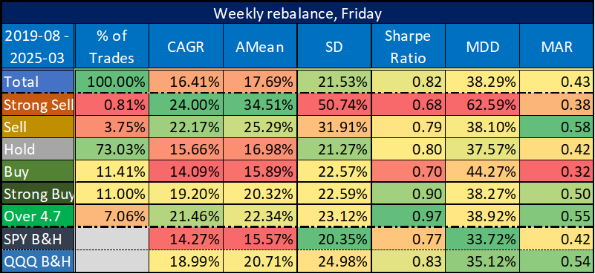
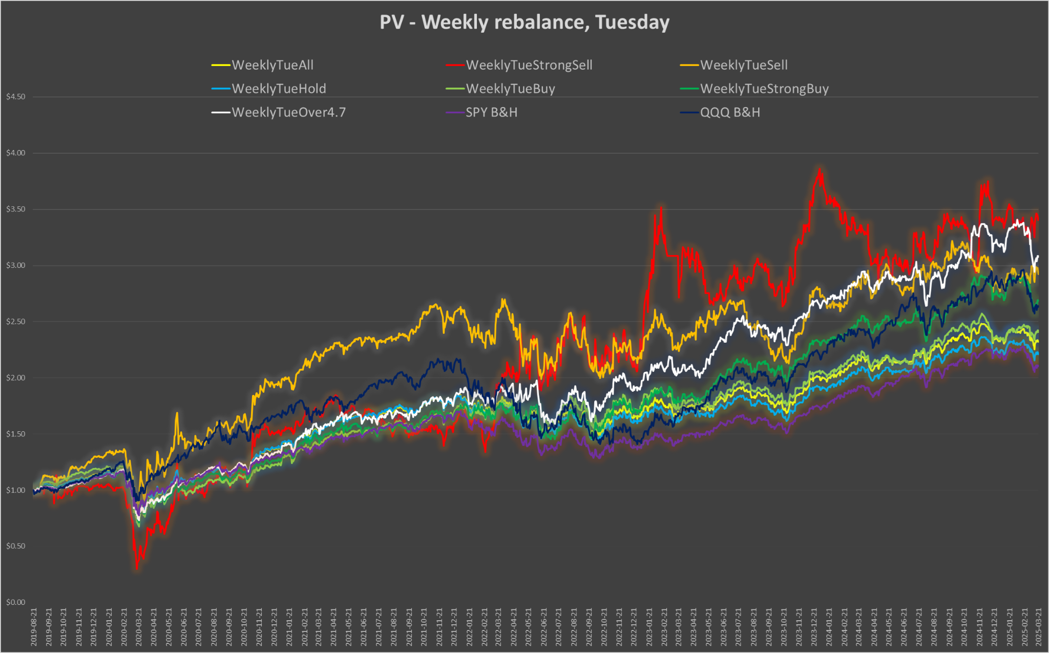
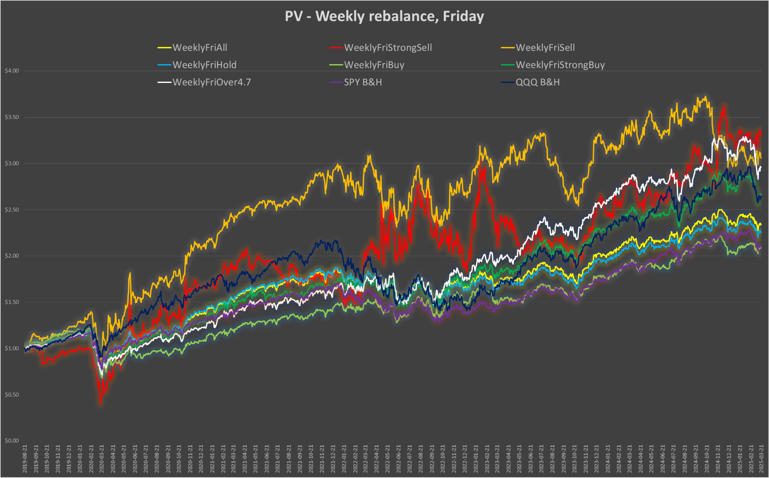

Results Overview

Despite variations in rebalance frequency or rebalance offset, overall trends remained consistent:

- Stocks with Quant Rating > 4.7 (i.e., high-end Strong Buy) consistently outperformed across all strategies, with strong CAGR and Sharpe Ratios.
- The Strong Sell group showed extremely high volatility (spikes, huge DDs), limited sample size, and inconsistent performance — indicating that both long and short positions in this segment may involve significant risk.
- Mid-range ratings (Sell, Hold and Buy) yielded moderate returns with more stability, but lower risk-adjusted performance. These categories tracked benchmarks more closely, with less potential for excess returns.
- While QQQ outperformed SPY in both return and Sharpe Ratio, the "Over 4.7" Quant Rating group still beat both benchmarks with higher CAGR and MAR, despite similar or slightly higher volatility. This highlights the potential of Quant Rating-based strategies to outperform traditional passive investing — at least within the large-cap tech-heavy universe examined.
- The patterns are in clear alignment with Seeking Alpha’s own published results, further validating the internal consistency and predictive strength of the Quant Rating system.

The robustness of the strategy was confirmed by the fact that performance patterns persisted regardless of rebalance timing or offset, highlighting the potential predictive power of high Quant Ratings.

Conclusion

This study provides strong historical evidence that Seeking Alpha’s Quant Rating can be a reliable signal for equity selection, particularly at the high end of the rating spectrum. Stocks rated above 4.7 not only delivered one of the highest returns but also offered superior risk-adjusted performance across various rebalancing regimes. Meanwhile, the Strong Sell group appeared too volatile and rare to be relied upon systematically.

The robustness of results across multiple rebalance frequencies and start dates further strengthens the case for using Quant Rating signals in systematic strategies.

However, care should be taken when interpreting these results for other market segments, especially small-cap stocks, which were not part of this universe.

Case studies: QR over 4.5 - 2025-04-07

