User Guide
Warehouse Racking system

INTRODUCTION:
3Dclick RackingMaster software is a special tool to build up Warehouse Racking systems. The program helps you to import or set up a storage and easily place, edit or move racking systems on the workspace. RackingMaster helps you to create Floorplan section drawings and export documentations during the sales and manufacturing process.
This software has been developed for WareHouse Ltd., who builds full racking sysstems around in the world. The software works and calculates based on the WareHouse racking system rules.
All rights for the racking solution is reserved for Warehouse Ltd., England.
The 3Dclick and all other brandnames and trademark are reserved by Incode International Ltd, London England.

The 3Dclick Workspace:

When you launch WareHouse Racking System from your system’s application menu or by double-clicking the program icon, the program starts with the next screen.
On RackingMaster’s User interface you can find the next fields:
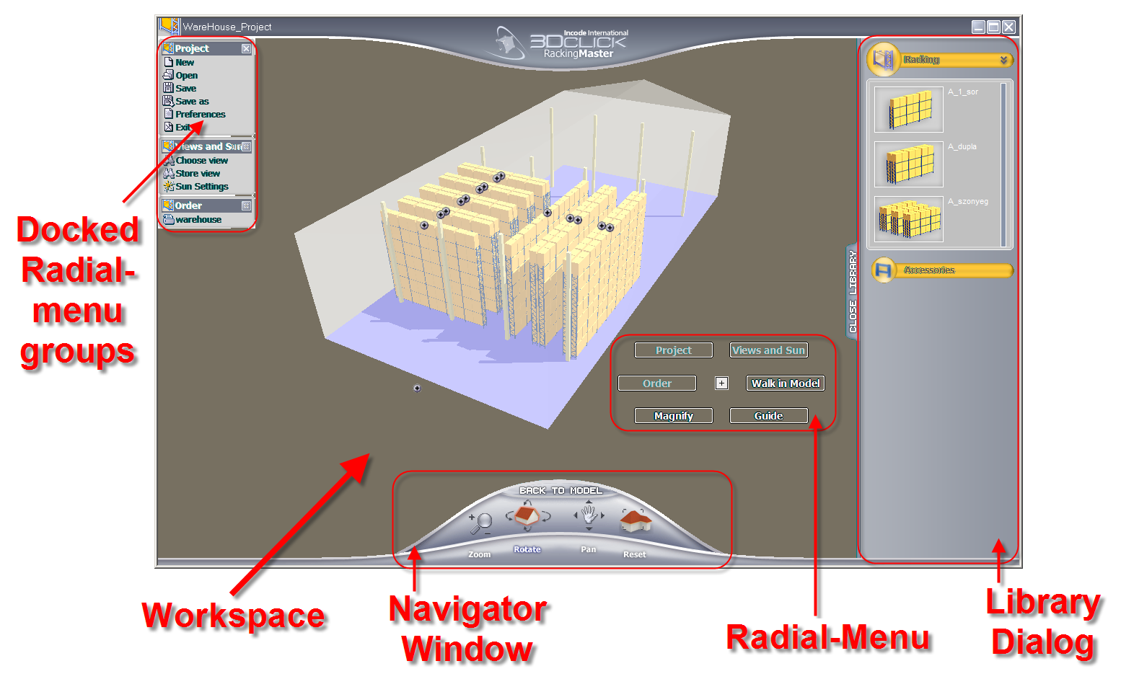

Workspace:
Here you can configure Warehouse racking systems. After the Store geometrical parameter setup, you can drag&drop a several Warehouse rackings and accessories into the storage from the right sided „Library Dialog”. The products on the workspace are available to select, modify, move and set up as groups. There are a possibility to generate sections and detailed elevation views from the rackings.
All the placed products and their accessories can be listed in a simple button-click as component calculation or as a printed layout.

Library Dialog:
You can find here the products which are placeable to the workspace. The products in the Library dialog could be drag&dropped to the workspace.
The several tab-pages contains different product types, this structure helps you to find the related product fast and easy.
The objects will be placed into the workspace with their default parameters, you can modify them in their modify dialog afterwards.

Radial-menu:
This menu contains the functions what you can use in your working process over the workspace. To reach this menu click on the left mouse button over the workspace.
The content of this menu is able to change, based on the selected elements’ type. When you select an object on the workspace you can find the available commands regarding that.
If there are no selected object, the standard project commands appear. These menu groups can be docked to the workspace. Iit helps you to put the most used commands on the screen. To dock them to the screen double-click on the header of the menugroup.
Navigate menu:
Navigate menu allows you to move, rotate the project on the workspace or helps you to walk-in the model.
The menu contains the rotation, move, zoom and reset buttons.
NOTE: Walk-in mode is visible only in perspective mode, you cannot use it in parallel view.

Magnify Window:
In the Magnify window you can zoom-in a part of the plan. One object is available to open in a new window to look at it more detailed or modify it’s parameters.
Sections and elevation views are also represented in „Magnify window”.

PROJECT handling:
At starting RackingMaster the Startup dialog box appears and prompts you to decide what to do next. From the dialog you can choose, how do you want to start Warehouse RackingMaster.

Start a new project:
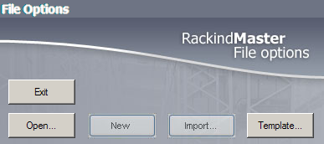
At starting the new project you have 4 options. You are able to open a saved file, import a DWG-DXF file, select a template.
The four options are different in the definition of the storage, but the further functionality (place racking systems, listing, sectioning etc.) is the same.

OPEN DWG, DXF:
Select the „IMPORT” button in the startup dialog. Select the file in the OPEN dialog and click „OK”.
The program opens the file and sets up the necessary database to build 3D storage. RackingMaster places the geometry into the workspace as building components.
The software imports only the 2D data structure, 3D blocks will be ignored.
To the perfect import process, the next layer structure has to be created in DWG:
- External Walls: Contour lines of external walls.
- Internal Walls: Internal walls’ poligons and beams contour.
- External Doors: External doors
- Internal Doors: Internal doors
- External Windows: External Windows
- Internal Windows: Internal Windows
- Structural objects: Contour poligons of the building structures, which has to be considered during the racking system configuration.
- Structural lines: Optional building parts. Structures, which have no 3D geometry, but their visibility and location help you in the planning process (e.g. grids, power points, lamps)

RackingMaster converts the data based on the next rules:
- External walls:
Closed polylines will be converted to External wall objects. The height of it is a storage height. The closed area by external wall objects will be handled as storage workspace. If there is no closed polyline, software looks for a hatch on this layer, which defines the storage interior surface.
- Internal walls:
Closed polylines will be converted to Internal wall objects as it is described above.
- External Doors:
Rackingmaster creates empty openings in the locations where external door blocks are. The empty openings width is the same as the blocks width, height of it is 2.4 m.
- Internal Doors:
Empty openings will be placed in the locations, where internal door blocks are. The empty openings width is the same as the blocks width, height of it is 2.4 m.
- External Windows:
Empty window openings will be placed in the locations, where external window blocks are. The empty openings width is the same as the blocks width, height of it is 1.5 m, parapet height is 0.9 m.
- Internal Windows:
RackingMaster creates empty window openings in the locations, where internal window blocks are. The empty openings width is the same as the blocks width, height of it is 1.5 m, parapet height is 0.9 m.

Open an existing project:
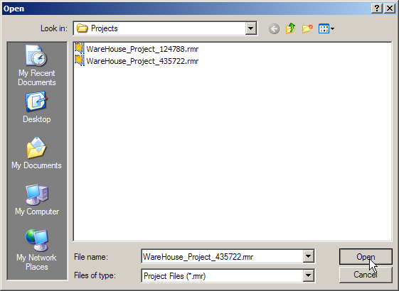
You can open a previously saved project.
Click on „OPEN” button. In the dialog, select the project file to open and click „OK”. The project opens in the last saved stage.
NOTE: If you do not want to rewrite the project, save as it with another name before you start the work (Save as).

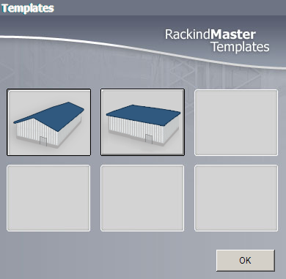
Open a Template building:
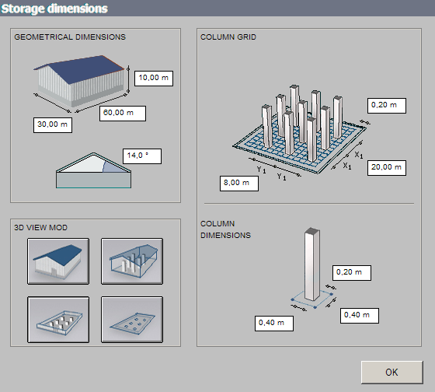
Template files help you to define a simple shape storage in RackingMaster. It is very useful if you have no drawings and the storage has a simple building structure.
Select from the basic shapes, the shape automatically placed into the workspace and a new dialog box appears. Change the parameters in the dialog to define your storage geometrical size and the other structural data. Click on „OK” button. After you fixed the parameters close the window on the top-left corner.

Save the project:
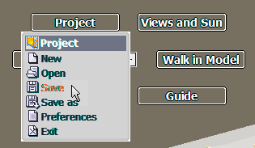
Select the „Project / Save” or „Project / Save As” menupoint from „Radial menu”. Select folder where you want to save your project and define the filename. Press „OK”, RackingMaster saves the project into the location. To make sure of the save process you can check the result with „Project / Open” menu-command.

Property window:
These settings help you to build up default parameter sets for WareHouse RackingMaster software. There are manufacturer specified defaults, these settings will be held for all projects and there are project properties, which properties employable only for the curent project.

Project properties:
Project properties helps you to define project specified properties. These setting are available only in the current project. If you want to use the settings later, it is possible to save it as settings-template.
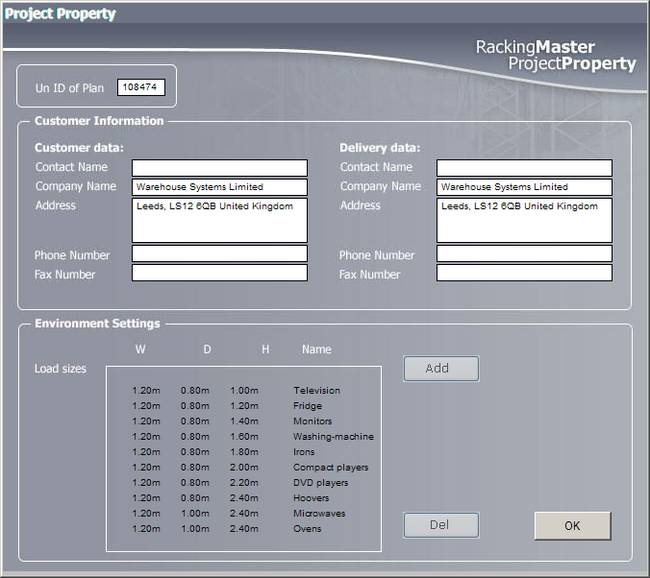
The project settings contains:
Order Num.:
Generated by RackingMaster automatically. All project get an individual number, which will be printed in all output with date together.
The Order Number rules are defined by Warehouse. These number is not editable for the user.

Customer and delivery data:
Adjustable the customer’s name, address, accessibility and the contact personn name. When the customer address and the delivery address is different, you can define delivery address and delivery contacts as well.
These data will be represented in a project and all it’s outputs. These data are not allowed to change by the user out of these settings.
Loads:
Loads properties helps to predefine the pallet types and load heights in one step for the full project. All the loads, which are defined here, will be available in all racking dialogs.
Note: Custom loads are available to create in the different racking settings, but those loads will not saved into the main database, in other racking dialog it will not be able to select, you have to define it again.

Settings for safety distances:
Here you can control the safety distances around the building components. On the workspace these distances will be held around the columns, rackings and walls. If you change the safety distances during the project phase, this will be implemented on the workspace automatically. These changes can move the rackings on the workspace. After the changes in this dialog, please check the rackings position on workspace!

Objects Placement:
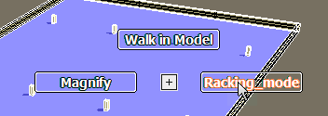
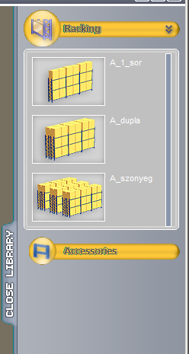
After the storage definition, you can start to place the racking system. Click on the „Racking mode” menu item in the „Radial menu”. In Racking mode the warehouse geometry cannot be selected or modified, so it is does not disturb the racking system definition.
If you want to step back to change storage geometry, select „WareHouse” menu item in „Radial menu”.

The groups of placeable product, which can be placed in the workspace, you can find in the „Library dialog” on the right. If the Library dialog is closed, please click on the „Open Library” button.
On the top you can find the Rackings. You can drag&drop them to the workspace:

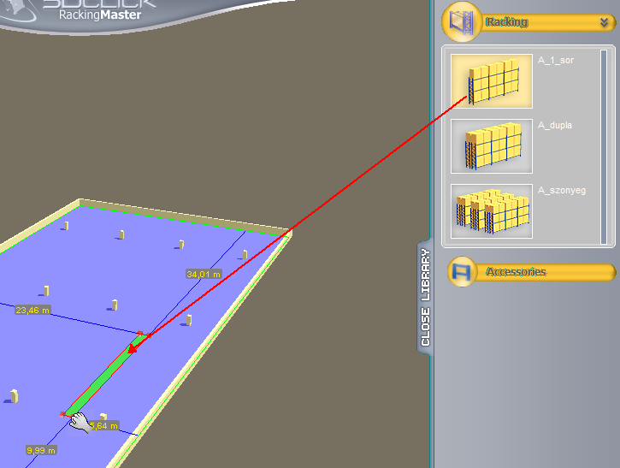
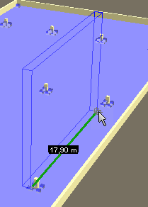
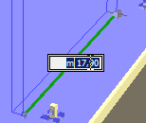
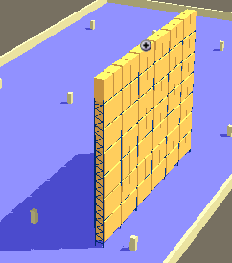
- Single- and Double Rack:
Drag the object into the workspace. The object plan symbol appears and the support measurements.
Release the mouse button over the workspace. The object will be placed into the storage. To start from the placement point define the length of the rack with the mouse.
Click on mouse button. Now you can modify the length of the rack by type an exact number into the dimension field. Click on the endpoint of rack to close the placement.
Simple or Double rack appears on the workspace. At doubble racks placement, RackingMaster places two single racks connected with acceessories.
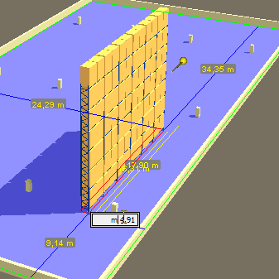
If you want to change the location of the rack, hold the mouse over it until the measurements are visible. These measurement lines show the distance of the rack from other elements. Click on one of the measurement values and edit it.
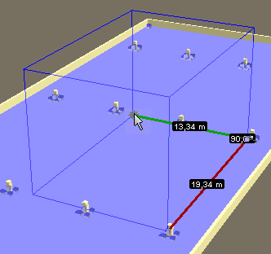
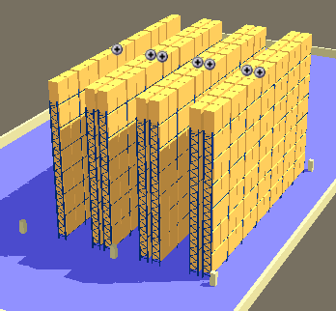
- Racking placement on surface:
Drag the object over the workspace. Release the button over the selected zero point. Define the length and directions of the racking with the mouse. The rack direction can be defined along X and Y axes.
Push the mouse button. If you want the edit the length of the rack, you can modify the values on the measurement.
Define the space depth for Racking systems. To edit the depth, use the process above.
To put the racking system into the workspace click again on the endpoint of the polyline, which define the rectangle for Racking system.
Racks appears on the workspace. The racks are independent objects, linked in a group. It is possible to move, rotate and delete them together until the ungroup command. The Rack properties able to change one by one.

The connection rules between the groupped objects has been defined in the „Project Property” windows. About the Grouping methods you can find more information in the „modifying objects” chapter.

Accessories Placement:
There are two types of accessories. Connected to other objects or stand alone accessories. The connected accessories are available to place only to Rackings, the stand alon objects are able to place only on the workspace.
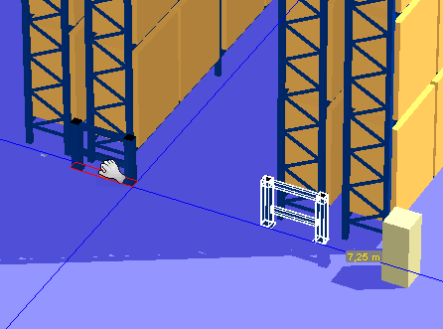
More accessories are possible to attach to a racking systems by Racking Property dialog window (column guards, corner guards…).
- Objects to connect:
These elements are able to connect to the hotspots of rackings foots. When the mouse is over the connection point, the cross on the hand will be disable, the object jump to the right position and appears.
- Objects to place on the workspace:
These objects can be connected to the storages floors hotpots or on the floor surface directly. The connection hotspots are around the columns and wall corners.
These accessories are not able to connect to the rackings. If you place them to the racking surface the program will be ignor the placement.

Dimensioning tool:
Dimensioning tool shows the distance between the placed objects on the workspace or magnifying window. It helps you to make visible the positions of the rackings and other building or racking elements in the storage.
There are two options of Dimensioning tool:
- Horizontal
- Vertical
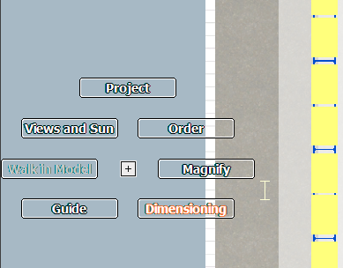
Placement of dimensions:
Select the dimensioning menu item. Click on the points on the workspace, which you want to place into the dimension chain. On the last point click twice. Select the direction of dimension line. Choose one (horizontal, vertical, slant). Dimension appears on the workspace.
At the slant dimensions the first two click defines the measurement’s direction.
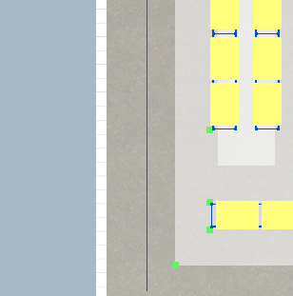
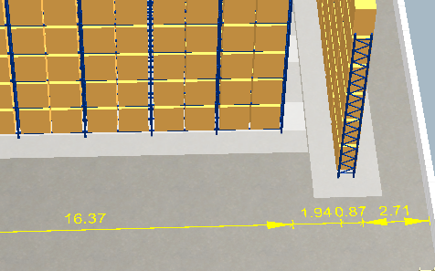

Movment of dimension:
When you change the workspace or any rackings, dimensions will be automaticaly updated.
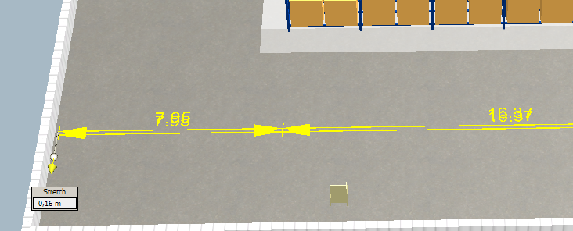
If you want to move the dimension chain, hold the cursor over the maesurement and move the edit point or type the value into the field. The dimensions are able to move only perpendicular to the dimension chain vector.

Delete Dimension:
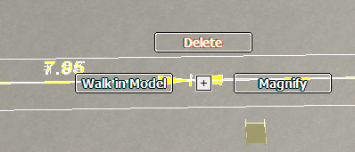
It is not possible to delete dimension points in the dimension chain, Dimension point will be deleted only in the case, if the connected object has been deleted (if you delete the rack, then all of the rack dimension point will be deleted from the connected dimensions).
To delete a dimension chain, hold the mouse over the dimension and select „Delete” menu item from the radial-menu or push „DEL” button.

Add dimension point to the placed dimensions:
Select a dimension chain. In the radial menu select „Add new point” menu item. Select the new dimension basepoint on the workspace or magnify window. The measurement and the new dimension number appears on the workspace.

Section Tool:
The tool helps you to define section and elevation views about the racking systems on the workspace.
Select section tool. Click on the workspace to define its starting point. Move mouse to define the direction and click to place the section’s secund point. Select section direction with a mouseclick.
Select parameter-dialog button of Section tool. Here you can edit the section name and section symbol type.
Hold the mouse over the section symbol and select „Open section” from the radial-menu. The section window appears.
Section window represents the cutted racks in section and elevation view.

All the sections are listed in the section dialog box (radial menu). From this dialog you can manage the section windows. You can open, delete or manage the placement on the print layout.

Modifying objects:

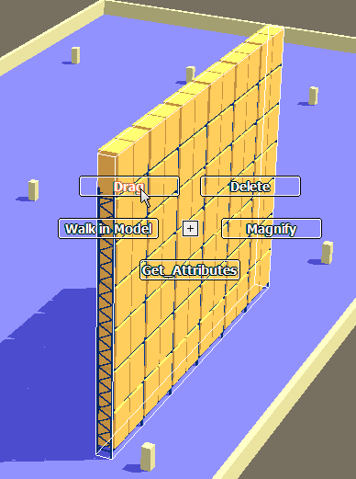
Moving objects on the workspace:
To move objects on the workspace, hold the mouse over the objects and select the „Drag” command from the radial menu. In the workspace appears a draging tool. You can snap it on 3 positions:
- In the middle: It allows you to move the object on XY surface.
- In X axis point: It alows you to move the object only along X axis.
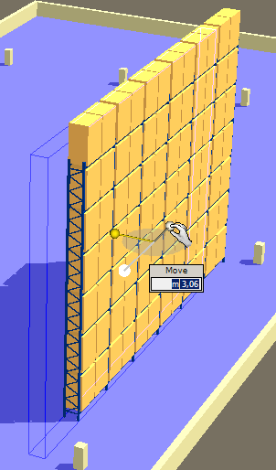
- In Y axis point: It alows you to move the object only along Y axis.
When snapped the selected movement point you can move the object by mouse. In the same time the movement distance is visible in a field on movement axis. You can define the movement by mouse or edit the values in the fields by hand. To place the elements into their new position, click on the workspace or push „Enter”.
If you want to move more objects together, select them by „Space+click” method. If you want to hold them together as a group in the future, use „Set group” command from the radial menu. To explode the groups use „Ungroup” command.

Rotating objects on the workspace:
To rotate objects on the workspace, hold the mouse over the objects and select the „Rotate” command from the radial menu. In the workspace appears the rotating tool. The warehouse objects are rotatable only around Z axis. You can snap the rotation tool or type an exact value into the rotation field. To finish the rotation click on the workspace or push „Enter”.

Deleting objects:
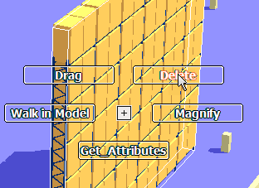
To delete object or objects from the workspace select it or them (by „Space+click”) and select „Delete” command from the radial menu or push „DEL” button on the keyboard.

Set group:
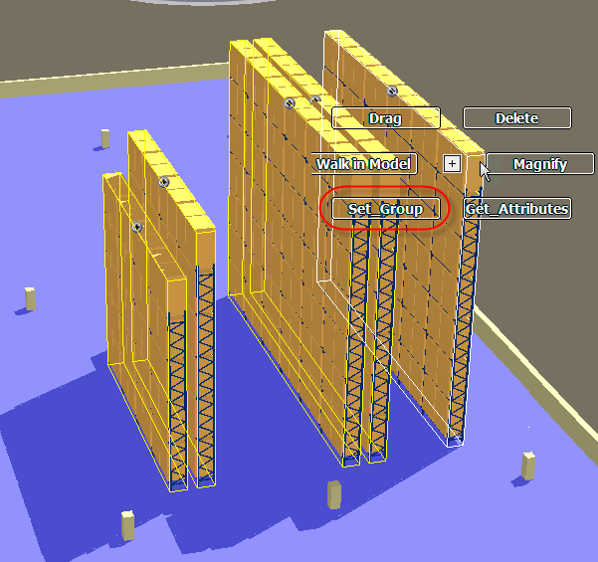
Objects linked in a group can be moved and rotated together. 3Dclick will automatically control minimal distances between rackings and increase if they are not enough.
Rackings are linked in a group automatically if you place them with surface-type or double racking method. Further objects can be linked in a group, even groups can be linked together. Use CTRL + left click to select the group and also CTRL + left click on those objects you want to link into the group. Choose the „Set group” option from the radial menu over one of the objects to link them into a group.
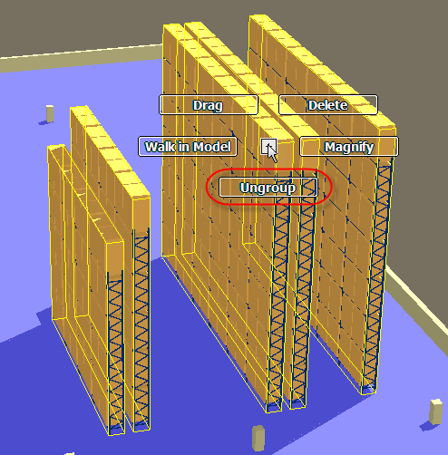

Ungroup:
After selecting the group you can click the „UnGroup” option in the radial menu. Connection between objects will be ended and they will be arranged as they were before the group created. If groups were linked into a common group and you end the common one objects will form the previously defined groups.

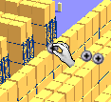
Modifying parameters of objects on the workspace:
Point to the product you want to modify. Click on the appearing parameter-dialog button. The setting window of the product appears. Changes in this window can be seen at once on the screen.

Modifying racking systems on the workspace:
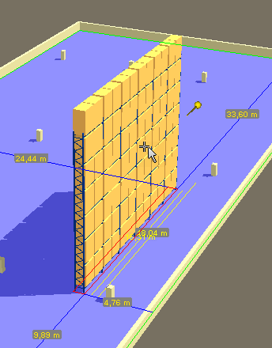
Move the mouse pointer over the racking system and a wait until dimensions and hotspots appear. By dragging the hotspots you can easily increase or decrease the length of rackings. After releasing the hotspot the racking system will be adjusted to a possible size nearest to the desired value. If you want to set the size numerically, click on the dimension with the larger value (desired length of racking). After you type the desired value the nearest possible size will be shown.

Modifying racking systems with setting dialog:
Hold the mouse pointer on a racking system until the parameter-dialog button appears. After clicking that button a setting dialog will appear. In that window you can adjust the sizes of the racking system (height, width, profile size) or the parameters of loads (height, type: EUR/UK) and also general properties, available accessories and the appearance on the plan. Changes made in the dialog will be shown on the plan at once.

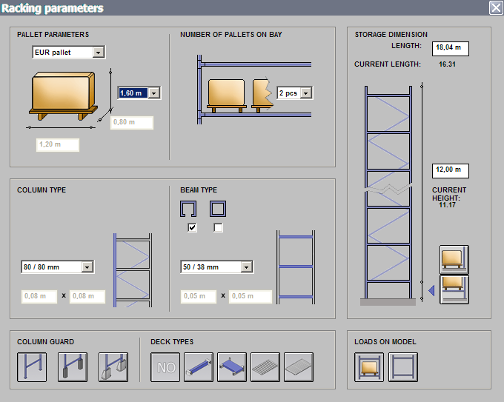
All the changes in this dialog apply to all bays of the racking, except those ones, which have been changed in „Magnify Window”. More information about the bays setting you can find in the „Magnify Window” chapter.
All changes in the dialog box can be replaced by „UNDO” command in one step.

Modifying accessories:
Accessory objects’ parameters are able to modify by their parameter dialog. Hold mouse over the accessory and push the parameter-dialog button when it has been appeared. In the settings dialog you can modify all the parameters. The object on the workspace will be automatically updated.

Pipette Tool:
With the pipette tool you can pick up settings of a racking and assign it to another one.
Actually, this settings-transfer works only on objects of the same type (e.g.: colour of racking cannot be assigned to a safety grate).
Racking system groups cannot transfer their settings, they have to be adjusted individually.

How to use pipette tool:
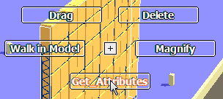
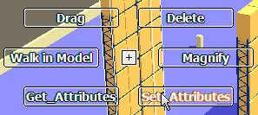
- By selecting a racking some menus appear. Among them there is the „Get attributes” menu: it gets all settings of an object which has the mouse pointer over it.
- By selecting another racking the „Set attributes” menu appears.
- With this menu you can transfer the previously got parameters into the newly pointed object.
- Parameters are stored in memory until you use the „Get attributes” menu again.

Connection between racking systems:
In the „Project property” window you can set up the minimal distance between racking systems and also the safety distance from other objects. The application will automatically control these distances in a group of objects.
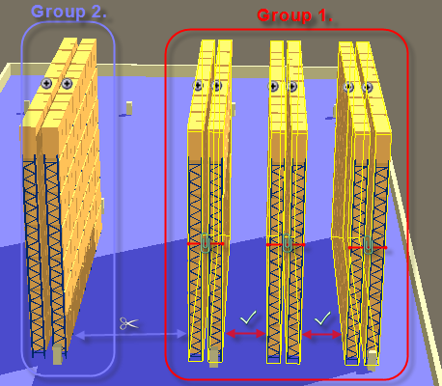
If you use the surface-type racking placing method the rackings will be installed to keep distance of a truck. If you move or modify one object of a group the program will check the safety distances and move away objects to keep the right distances.

The application will not control distances from the walls or ceiling of the hall. The user has to check these collisions visually.

If you placed single or double rackings you have to check if there are enough distances for trucks. The „minimal space” rectangles at the bottom of the objects help you by showing the half of the needed distance. If you place two rackings too close the „minimal space” rectangles will cover each other, so there is an automatic visual notice if the distances are not correct.

If you want to control safety distances between certain rackings automatically, link these ones into a group. 3Dclick will check and form minimal distances for trucks if needed.

Magnifying tool:
With the magnifying tool (MGT) you can inspect a specific object in detail.
Taking out the object from the model you can rotate it more easily, get a closer view and set parameters, as well.
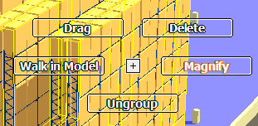
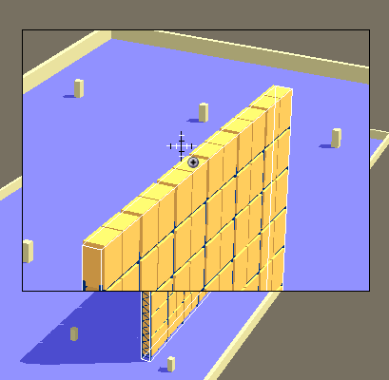
To open MGT choose the „Magnifying” option from the radial menu and point a racking.

MGT can show only one racking. A row of rackings will be shown in a separate window where you can rotate and zoom.

At the top of objects a parameter-dialog button appears. If clicked, it opens the settings dialog, which is described in Chapter „Modifying racking systems with setting dialog”.
At the bottom of each object in every bay there are dialog buttons. Click one and notice that the selected bay change to green. The pop-up dialog has two parts. In the upper you can set general parameters reflect the whole racking. In the lower you can set parameters of certain racks.
The selected racking in the MGT window is orange coloured. This helps you verify the settings of parameters. Changes made on a racking are shown in the MGT window at once. After setting the parameter of a bay you have to close the window.

On the left side of the MGT window there is a „Back to Model” button. You can get back to the workspace by clicking this button.

LAYER Handling:
In 3Dclick handle the layer visibility automaticaly. The storage and racking systems are in a different layer. Both layer is allways available, but they are editable in a separated mode.
When you use WareHouse mode, you can edit the storage parameters and place the dimension-chains. In Racking mode the storage parameters are not allow to edit, you can edit rackings and their accessories parameters.

