Running Conditions and First Steps Guide to RealDesktop

Running Conditions and First Steps Guide to RealDesktop 1
1. General software and hardware requirements 1
Minimum configuration 1
Recommended configuration 2
Supported video cards 2
2. Macromedia Flash Player requirement 3
3. Other software installation requirements 3
4. Starting the User Interface 3
5. Navigation 4
6. LibraryCatalogue 4
7. File Catalogue 5
8. New Cursors and their meanings 6

1. General software and hardware requirements

Minimum configuration
In order to run the program, you need the following configuration. Please note that the program may run slow and that not every visualization feature may run on video cards that do not support them.

- Intel Pentium4
- 256 MByte RAM
- 3D accelerated video card with at least 32 MBytes of onboard video memory (preferably cards manufactured not earlier than 3 years)
- Windows XP Professional with SP1 installed
- DirectX9c installed

Recommended configuration
In order to take full advantage of the visualization features, you need the following configuration.

- Intel Pentium4 2,8 GHz
- 512 MByte RAM
- ATI Radeon 9600 with 128 MBytes of onboard video memory
- Windows XP Professional with SP2 installed
- DirectX9c installed
- latest drivers for the VGA card

Supported video cards
We have tested our software with the following video chips. You should always ensure that you have the latest video card driver installed. The compatibility tests were performed using the latest video card drivers, namely Ati Catalyst 6.2 (www.ati.com) and nVidia ForceWare 81.98 (www.nvidia.com) driver packs, exluding Mobility models, for which the vendor provides the driver.

Important: In case the visualization is not correct on your machine, please install the driver. Older drivers are known to cause undesired visual artefacts.

NVidia

- GeForce2 MX 400 (64Mb)
- GeForce4 MX 420 (64Mb)
- GeForce4 Ti 4200 (64Mb)
- GeForce4 Ti 4200 (128Mb)
- GeForce FX 5600 (128Mb)
- GeForce FX 5700LE (128Mb)
- GeForce FX 5700 (128Mb)
- GeForce FX 5900 (128Mb)
- GeForce 6200 (128Mb)
- GeForce 6600GT (128Mb)
- GeForce 7800 GTX (256Mb)

Ati

- Radeon 9200 (128Mb)
- Radeon 9600 (128Mb)
- Radeon 9600XT (128Mb)
- Radeon 9800SE (128Mb)
- X600 Pro (256Mb)
- X700 Pro (128Mb)
- Mobility Radeon 7500 (32Mb)
- Mobility Radeon 9200 (32Mb)
- Mobility Radeon 9600 (128Mb)
- Mobility Radeon X600 (256Mb)

Intel

- Intel 82865G

2. Macromedia Flash Player requirement

The current release of RealDesktop requires the latest Macromedia Flash Player (version 8) to work under Internet Explorer. It does not matter which version of Macromedia Flash Player is installed under FireFox, but it matters which is installed under IE.
The RealDesktop installer checks whether the Flash Player 8 is installed or not. If the answer is negative the RealDesktop installer starts the Flash Player 8 installer. However, the Flash Player 8 installer processes the whole Registry or the whole hard disk drive (we do not know exactly what), but it is very busy for 10-15 seconds. During this period it may seem that the installer hangs (since it is not responsive). So be patient, it will definitely continue. When the Flash Player 8 installer finishes its work, the RealDesktop installer gets back the control and the installation is the same as before. Note that this situation only appears if the host operation system does not have Flash Player 8 under Internet Explorer installed.

3. Other software installation requirements

To demonstrate the possible usability of the 3D desktop, we assume the following applications are installed. If they are missing some of the objects may not function correctly.
- Internet Explorer or FireFox 1.5
- Skype
- Microsoft Office 2003 or OpenOffice 2.0
- Outlook or Outlook express
- Adobe Acrobat Reader

On the other hand the RealDesktop assumes that all of the listed applications are closed when the RealDesktop starts. One exception is the Skype which is assumed to be started at system boot, but minimized at RealDesktop start.

4. Starting the User Interface

When starting Realdekstop a 3D office scene appears. In this scene there are objects that you can interact with. There are two cardinal objects persistently on the scene: the two books on the shelf. It is possible to put more objects to the scene from the LibraryCatalogue book (see later). It is possible to put Document objects to the scene from the FileCatalogue book (see later). The exit from the application is available by clicking the door object, which can be found on the right side of the room. Triggering the exit will result the autosaving of the scene and the closing of the application. This indicates that the next time the user runs RealDesktop he can enjoy the modifications. It is possible to drag (move), rotate or delete objects. When dragging objects a collision detection mechanism limits the places where the object can be put.
The list of objects that are part of the workspace:
- room with walls, floor and ceiling
- a large desk in the middle of the room
- a little desk on the left
- door on the right (clicking this will exit from RealDesktop)
- a window with moving clouds
- shelves in the corner
- two books on the shelf

5. Navigation

In normal mode the camera is placed in front of the table. The user can look around by rotating the view of the camera. It is possible to achieve this by moving the mouse cursor to the left / right / top / bottom part of the scene. The camera is limited to this place. If the user feel lost it is easy to get back to the default view by pressing the HOME key on the keyboard. The rotation of the camera is limited to approximately 160 degree of field of view comparing to the default camera position.

6. LibraryCatalogue

There is a book on the shelf with an ancient cover which symbolizes the LibraryCatalogue.
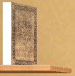
Clicking this book will trigger the LibraryCatalogue Flash object. This is a Flash user interface. It is possible to place objects to the scene from this book by ordinary drag&drop technique. The looking is similar to this shot:

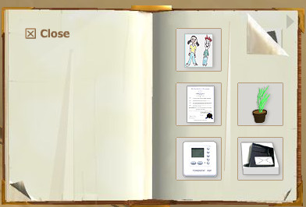

The following list summarizes the possible objects that can be dragged from the Library Catalogue. Clicking on the objects usually trigger an event, which usually starts applications.
HIFI player | Mp3 player, start, stop mp3, increase, decrease volume
Telephone | run Skype
3D Calculator | run windows calculator
Digital clock | show the time
Picture in frame | start the Internet browser (IE, FireFox)
Family photo album | do nothing, regularly change photo
Plant | start the internet browser
Lamp | turn lamplight on/off
Paper-rack | start outlook or outlook express
Climate control | start the RealDesktop preferences dialog
Document in A4 format | start wordpad

7. File Catalogue

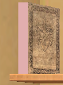

Clicking to the File Catalogue book on the self will trigger an event which starts the book to come front and open itself. It shows the file structures of the current users’s Documents&Settings folder. It does not show folders only files. It recognizes the following file formats:
1. MS Word document, *.doc
2. Powerpoint, *.ppt
3. Excell, *.xls
4. Openoffice documents, *.sxw *.odt, *.pps
5. Text, *.txt
6. Adobe Acrobat, *.pdf
7. Images, *.jpg, *.jpeg, *.bmp, *.png, *.gif

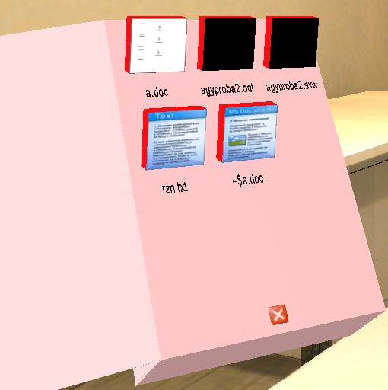

The thumbnails of the documents (if they can be extracted from the file) are mapped as textures to the items of the File Catalogue. Note that some files does not contain thumbnail information (e.g. in Microsoft Word there is a checkbox in File/Properties called “Save Preview Picture”. However, this checkbox is off by default.) It is possible to drag&drop file-s to the wall or to any of the desks in the scene. The thumbnail (if it can be extracted) will be shown there also.

8. New Cursors and their meanings

Comparing to 3DClick 3 new cursors appeared. We describe them here to make their role clear to the user.

: This is the general cursor. It replaces the old general cursor which had a crossing beside it.

 : When the RealDesktop starts an external application this cursor indicates the possibility to go back from the external application to RealDesktop. Note that triggering this will close the external application.

: This cursor indicates the rotation of a placed object.

