# ****HedgeQuant**** Framework

By Incode

2008

Table of Contents

HedgeQuant Framework 1

1. Vision, the integrated financial information system 4

2. Overview 7

3. HedgeQuant Desktop 8

The Innovative Features 9

Key Tools 13

4. HedgeQuant SQL Database 18

5. HedgeQuant Server 21

6. HedgeQuant Server Selected Portfolios 22

Community knowledge based selection 22

Tag based selection 25

Shorting strategy 27

Future Strategies 28

Note: the <” ”> sections are comments, they will be removed from the final document

*<Note that there exists (will be) a PowerPoint version of this document that shows the dynamic of the User Interface with more vividness>*

*<Improve this document by the suggestions of Mr. Charmat, Zoltan, and Robert and with the design of an artist for creating some graphics>*

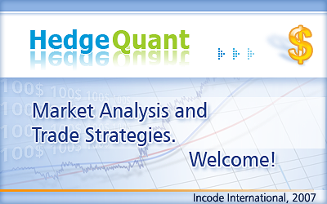

<this opening image can be replaced sometime in the future?, Brooke and Balazs should help>

## Vision, the integrated financial information system

*Solve complex screening, create 2D and 3D* charts, and monitor your personal portfolios or HedgeQuant algorithm generated portfolios real-time with HedgeQuant Desktop software.*

First of all, the aim of this tool is a long sought desire to integrate all the usable information into one easily usable interface for assisting the inventor in his decisions. The information age is upon us, there is an information overload cast from newspapers, television, radio, emails, blogs, etc... However, the technology that caused this information overload can be used to mitigate the confusion originated from it. The HedgeQuant frameworks should provide a condensed version of all the available information about the market.

Its rating tools are shaped to visualize information convergence and trends of emerging companies through a system based on

* Fundamental analysis
* Technical analysis, historical financial information
* Sentiment analysis, community knowledge and news
* Analysts rating

Secondly, behind the sleek user interface the vision contains several smart algorithms running in the background that have a significant predictive power. For example regularly (weekly) generated portfolios should facilitate as a crutch in the investing decisions.

The vision is that there are a lot of tools integrated into a common universe for watching and analyzing the market. Some of the early sketches were:

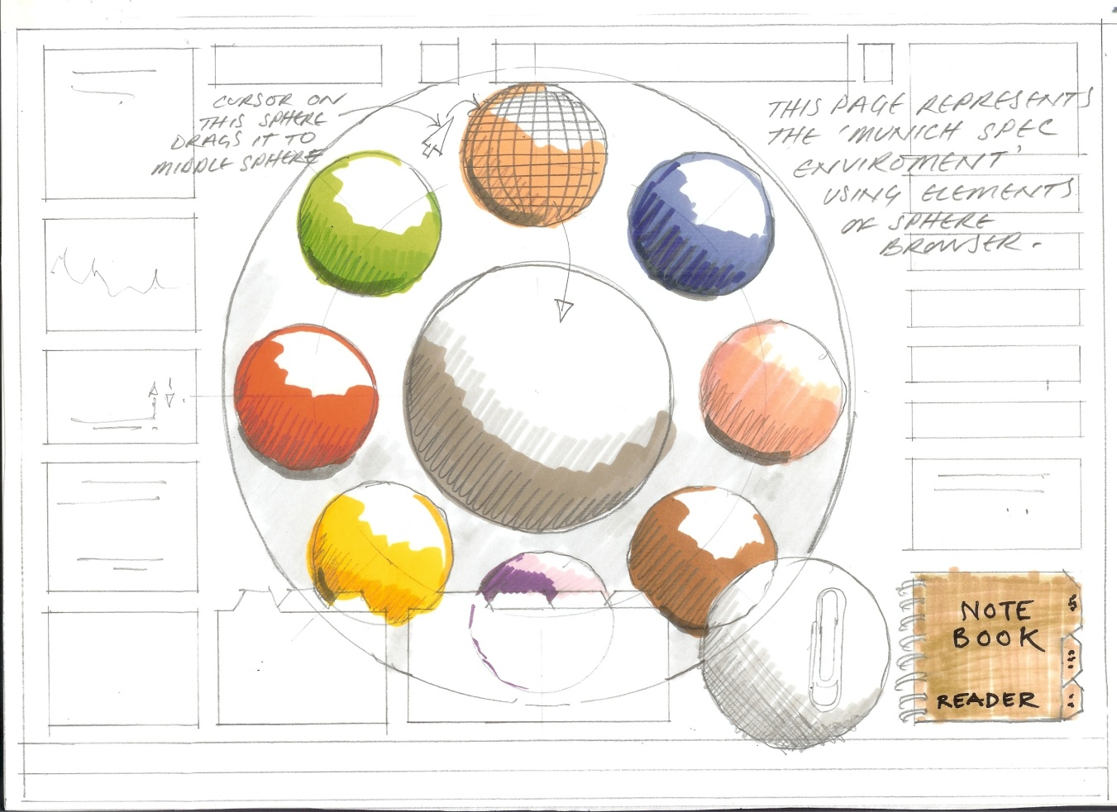

*Sketch of the envisioned framework*

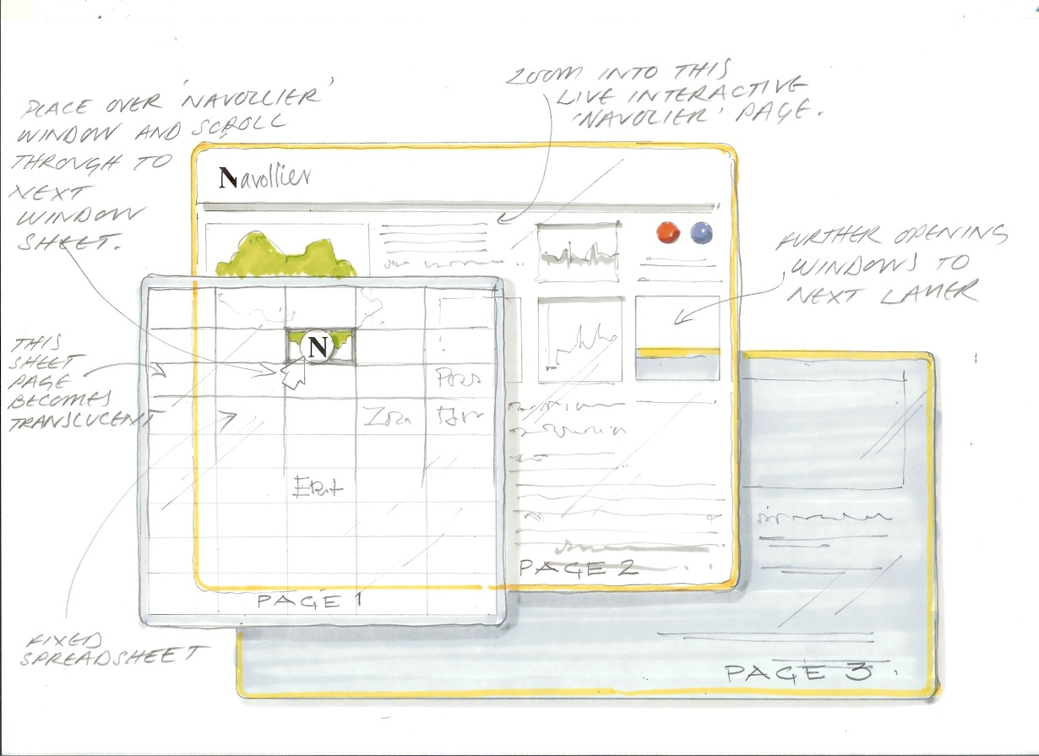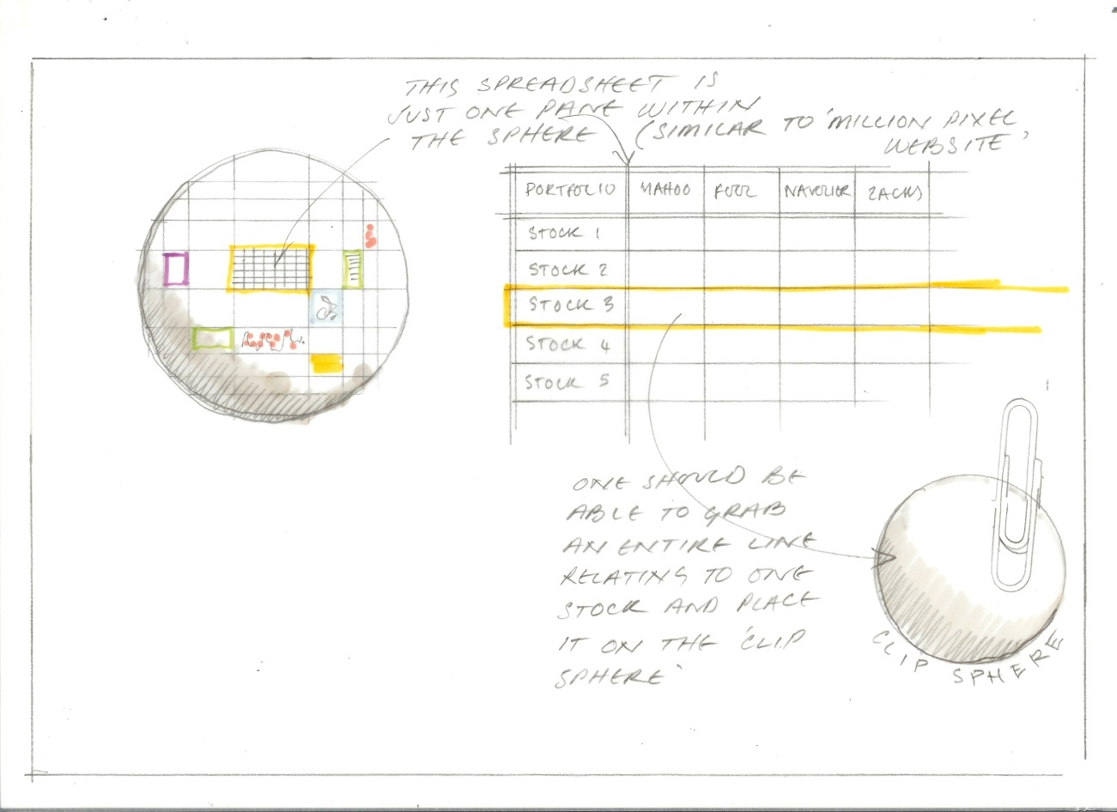  
<George: I am not sure which sketches of Brooke should we show here>

## Overview[1]

The HedgeQuant project builds and gathers a huge amount of information into a database with automatic web-crawlers and retrieves and visualizes this information to the user. The HedgeQuant framework architecture has the following components:

* **HedgeQuant Server** components, which skim specific sites and gather text information, collect datasets of information from selected sites and save it into an SQL database. These software units are installed on the high-bandwidth HedgeQuant Master Server. Components responsible for regularly crawling and interpreting important financial data, community knowledge, news, RSS and blog sites from the Internet. Smart algorithms gather and extract only the relevant data. Other software components process and analyze this information and the results of this lengthy data mining process –the generated HedgeQuant portfolios – are stored in the database.
* **HedgeQuant Database** is a fast and reliable SQL server database storing financial historical data, saved user portfolios, server generated HedgeQuant portfolios that were inferred by the smart HedgeQuant data mining components.
* **HedgeQuant Desktop Client** is installed on the desktop. It filters the huge amount of information and presents it to the sure using an innovative dynamic 3D visual representation. Very convenient to use. The investor can access every tool necessary in one application. He can understand the market processes real-time, monitor the progress of portfolios, create historical charts with a single click, can view many attributes of the stocks in a simply to use hierarchical data grid. Many aspects of the stocks can be visualized in a common framework, like fundamentals, 3rd party ratings (Navellier, Zacks, Ibd, FoolCaps, etc.).  
  Features:  
  Leverage the full visual potential of the Windows Vista WPF (Windows Presentation Foundation).  
  Automatically use the dual or quad core CPUs and the 64 bit computation architecture, so investors can create 3D charts or executing complex financial calculations faster.

## HedgeQuant Desktop

HedgeQuant Desktop is a powerful, integrated real-time market watcher, stock screener, historical data visualizer and portfolio manager. The user can define his own custom portfolio, but watching the read-only HQ server generated portfolios are also possible.

The main working area contains functionalities of portfolio selection and monitors the fine details of assets found in portfolios. Different tools that help the investor monitoring the market or gathering information are placed around in smaller floating interactive windows and widgets.   
The tools are transparent if they are not used, so they don't hide important information that happens in another window under them. The different tools that are active end visible can be configured by the user and this setting is persisted.

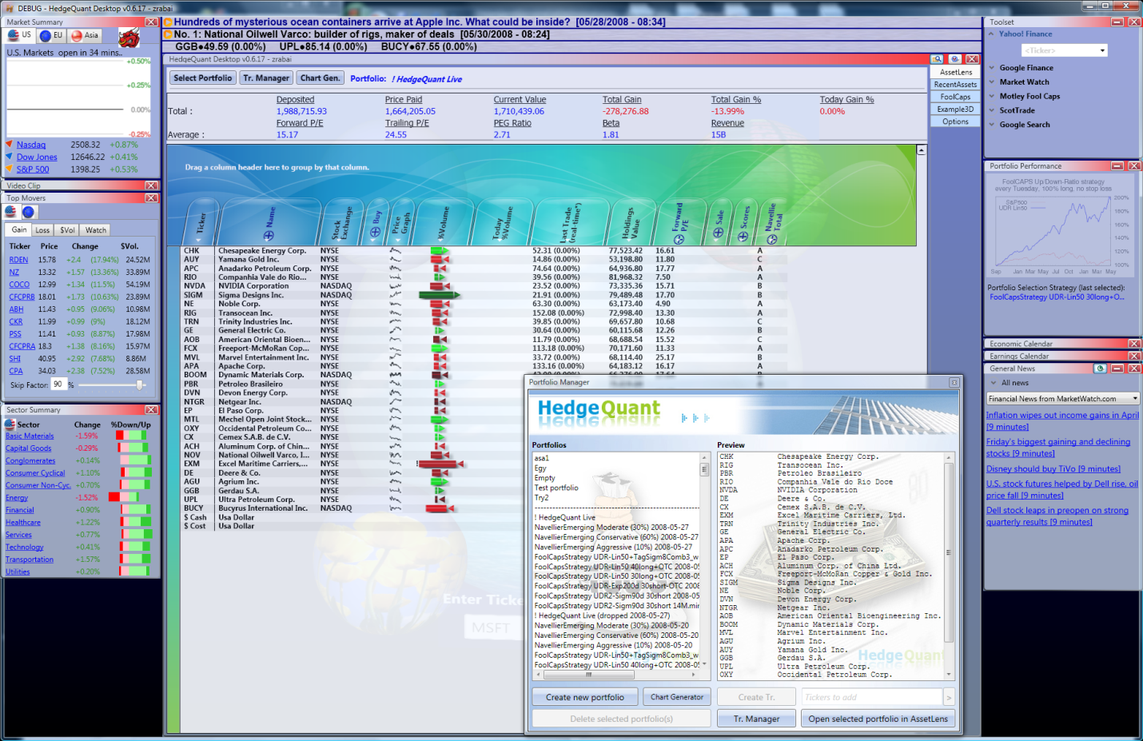

*HedgeQuant Desktop in action*

### The Innovative Features

*Zoomable User Interface (ZUI): The graphical user interface (GUI) is based on a graphical environment where users can change the scale of the viewed area in to see more. detail or less*

* **The Zoomable User Interface** is very convenient tool to zoom and pan the  
  main working area and the various small panels around the main area. Instead of the conventional pixel-based rendering, the software applies vector-based rendering that allows for high-fidelity scaling of complex drawings and text. The user can zoom arbitrarily into any areas of the desktop and still see crystal crisp images.

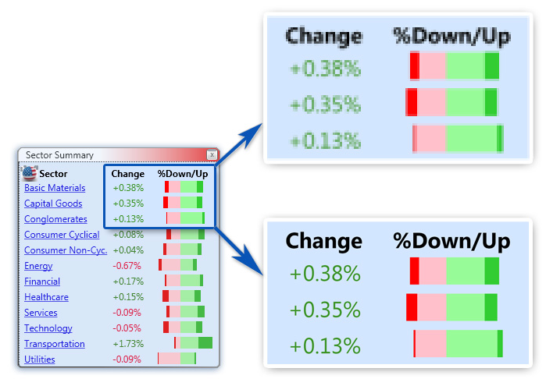

*Pixel-based vs. vector-based rendering after zooming in*

* **Discrete LOD:** In addition to vector based zooming, the ZUI is capable to even change the content for the different zooming levels. This is called Level of Detail (LOD) technique. For example zooming closer to a simple 2D chart reveals a very detailed, complex 3D charts in a deeper level.
* **Continuous change of detail (CCOD):** the discrete LOD can be changed with a continuous one. So instead of the abrupt visual jump that occurs between the change from LOD 0 to LOD 1, a smooth transition occurs. The animation effect uses keyframe animation inside the panels. A great example for this gradually visible behaviour is the Market Summary panel.

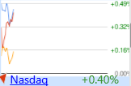  
Market Summary: minified

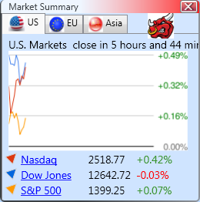

Market Summary: default view

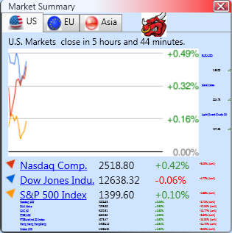

Market Summary: magnification started

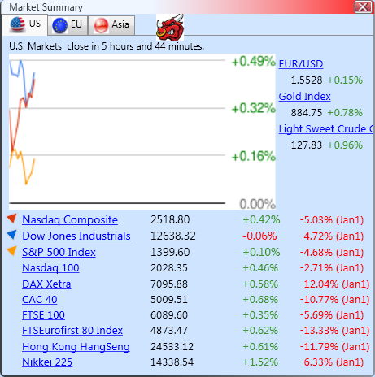

Market Summary: magnified

* **Powerful hierarchical data grid** that can group different, but coherent information together in a group. It solves one of the most difficult problems of information visualization; issues in which the user is faced to 500 different attributes of a company in one row of a table. Overlook the 500 different columns is a challenge even to the most experienced user. The hierarchical data grid defines different layers of columns, so the top layer contains only few 5-7 super-columns. These super-columns can contain children columns which can be made visible by zooming onto the parent column. In the example that can be seen on the next figures, the Sales super-column can be expanded or shrank any time to columns Revenue, EBIDTA and Total Cash. The hierarchy of columns, these parent child relationships can be customized by the user and saved as user settings. For example new groups can be created.

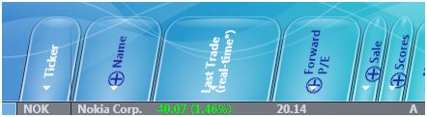

*Figure 3: A row of AssetLens: the Sale super-column is closed*

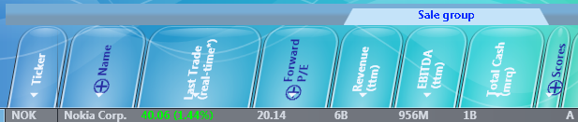

*Figure 4: Pixel A row of AssetLens: the Sale super-column is opened*

<Brooke can create some sketches here. For example we need arrows to show the dynamic, because it is too static images>

### Key Tools

* HQ Desktop has a **3D background** that contains 5 clickable spheres. The clicks open the corresponding tabpages in the main tabpage window. We believe that 3D user interface is not only a frill, but really handy tool. One can pack more information to the user interface if the panels can be rotated sideways in 3D for example. So we pursue this aim.

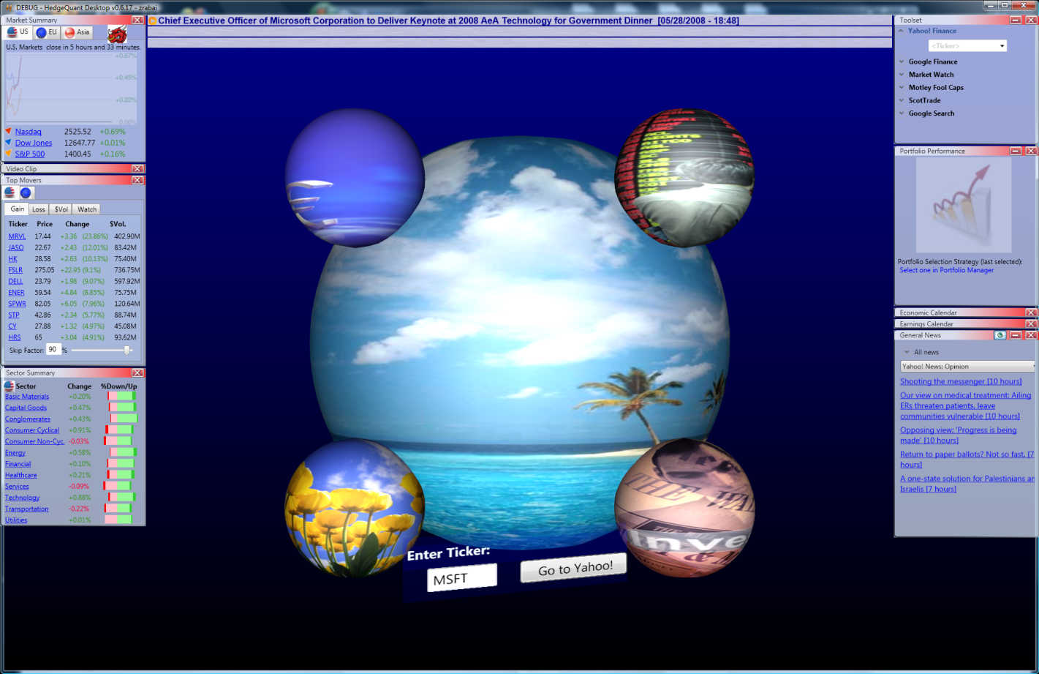  
3D background

Another frill is that by typing a ticker into a rotating 3D panel textbox can directly lead the user to the associated page on yahooFinance.  
<Mr. Charmat mentioned that Brooke has some chart here, rubber. More information is coming.>

* **AssetLens tabpage** contains functionalities of portfolio selection and monitors the fine details of assets found in portfolios.  
    
  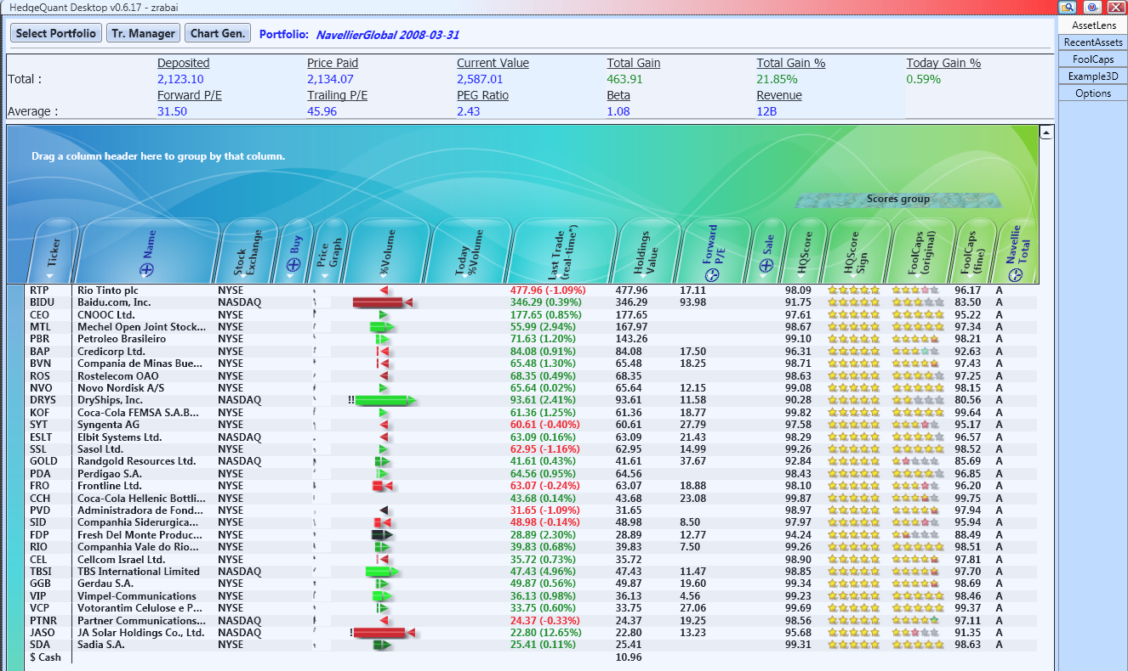

AssetLens tabpage

Information datasets are reformatted to be accessed, manipulated from here. Relevant information is processed with multiple criteria and automated input of stock tickers and output of results fed into comprehensive suite of visualisation tools to make visible the patterns, trends, the coherent rating.   
Dynamic 2D and 3D widgets/gizmos were developed that are embedded in the datagrid cells to display trends. The underlying detailed information is accessible through scrolling (LOD). These widgets are:

- Animated and static charts

- Animated icons

- Flashing alerts

- Pie charts* (3D target colouring with 3D button sphere., tools to rate relevancy,

- Tag tool to visualize trends*: colour and font size is driven by the tag’s relevancy   
 (examples are the volume gizmo, FoolCaps stars)

* **Recent Assets** contains basically the same information as AssetLens, but here the user can insert stocks without putting them into a specific portfolio.
* 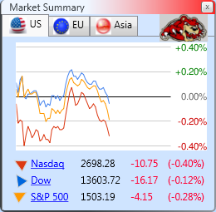**Different tools** that help the investor monitoring the market or gathering information are placed around in smaller windows. The tools are transparent if they are not used, so they don’t hide important information that happens in another window under them. The different tools that are active and visible can be configured by the user and this setting is persisted.
* **Visualizing the market indexes real time** is a useful aid in every financial application. Main indicators of USA, European and Asian market can be monitored in the Market Summary panel. Rendering chart of the market indexes is very common in finance applications. In HedqeQuant this is a minor thing. The power of HedgeQuant is that the user can follow the real-time performance of his personal portfolio, not just the main market indexes, or just the individual stocks that other tools give.
* **Chart generation for portfolios.** Multiple portfolios can be selected for charting. Filters can be added. Individual stocks and market indexes can be added too. Other parameters are the smoothing level and logarithmic scale can be selected.

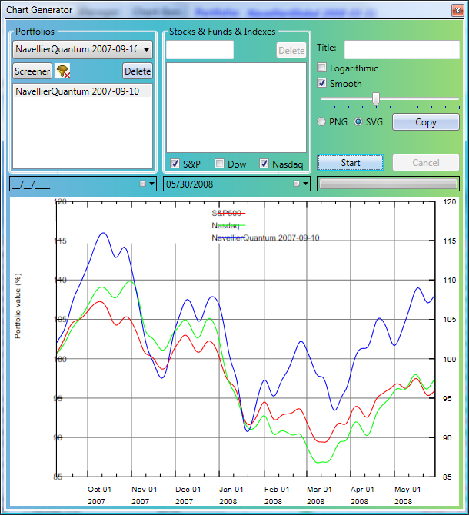

Chart generation

* **Screening\*** makes it possible for example to select companies which are associated with the tag China, but aren’t associated with the tag Banking. These so called Boolean operators can be used with sectors, industries and tags for example. Other filters for the screening functionality.
  1. Average Daily Liquidity
  2. Average Market Capitalization
  3. Prices:
     1. Close Price
     2. OpenPrice
     3. ClosePrice
     4. HighPrice
     5. LowPrice
     6. MeanPrice
  4. Tags
  5. Sector
  6. Industry
  7. Company
  8. Stock Exchange
  9. Ticker
  10. Revenue

The aim of this document is not a complete user’s guide so don’t detail their functionalities of other tools, merely mention them here:

* **Sector Summary**
* **Economic Calendar**
* **Earnings Calendar**
* **Bloomberg Videos**
* **Top Movers**
* **Portfolio Performance Chart**
* **General News**
* **Blogs and News Viewer\***Automatic scrolling of RSSs, blogs in separate window. Retrieve information from the server that built a relational database of news items
* **Sniping Tool\***

It is a grasping hand concept which retrieves bits of information, tagging them, structure them in a modular way and reformat them providing resumes, clipboards, can be forwarded to a note book or to the clip sphere. For example if a stock ticker is clipped it goes automatically through a rating process.

## HedgeQuant SQL Database

It is operated with the industry standard Microsoft SQL Server 2005. The SQL database 2.1GB and contains historical price data from 2006-01-01. However, it can be extended to cover more years by the cost of more storage space in the future.

<the list of tables will be removed from the final document>

The following tables exist:

1. AssetType
2. Company
3. Company_Sector_Relation
4. Currency
5. FoolPitch
6. FoolSecurityRate
7. FoolUser
8. FoolUserStat
9. FoolVote
10. Fund
11. FundQuote
12. HistoricalDoubleItem
13. HQUser
14. IbdGrade
15. NavellierScreen
16. NavellierStockGrade
17. Portfolio
18. PortfolioItem
19. Sector
20. Sector_Sector_Relation
21. ServerManagement
22. Stock
23. StockExchange
24. StockIndex
25. StockIndexQuote
26. StockQuote
27. StockSplitDividend
28. StockTickerRename
29. TableID
30. Tag
31. Tag_Company_Relation
32. ZacksGrade

## HedgeQuant Server

It is a Windows Server 2008 machine with 2GB RAM. Currently (2008-05-30) it runs the following services, crawlers:

1. FoolRate crawler (daily)
2. IbdRate crawler (daily)
3. ZacksRate crawler (daily)
4. YahooData crawler (daily) (for number of shares, Beta, Revenue, EBITDA, NetIncome, TotalCash, PEG, ForwardNetIncome)
5. YahooQuote crawler (daily) (for high/low/open/close/adjusted daily close prices)
6. Navellier Grade crawler (daily)
7. Navellier Portfolio crawler (weekly) (for Global, Quantum and Emerging portfolios)
8. FoolVote crawler (weekly)
9. HQStrategy Computation (weekly), create many HQ portfolios
10. Sql database backup (weekly)

<don’t be too specific and we want to hide that we use FoolCaps, so substitute the previous list by this>

1. crawler of 3rd party rating agencies (for example Zacks) (daily)
2. fundamental data crawler (daily) (for number of shares, Beta, Revenue, EBITDA, NetIncome, TotalCash, PEG, ForwardNetIncome)
3. historical price crawler (daily) (for high/low/open/close/adjusted daily close prices)
4. our smart portfolio suggestion strategies (weekly)
5. Sql database backup (weekly)

*HedgeQuant portfolio selection strategies are designed to maximize the profit while maintaining significant stability. Our innovative algorithms leverage the widest available information source, the Internet.*

## HedgeQuant Server Selected Portfolios

We rely on different methods, different strategies. These strategies votes for different portfolios that are combined in the final step of the algorithm. This integration can be customized according to the market conditions. Similarly to famous newsletters, we create new portfolios every week. Complex calculations and predictions are performed on HedgeQuant server usually at Monday nights. HedgeQuant Portfolios are saved to the HedgeQuant database from where it is achievable to every HedgeQuant Desktop user.

Our portfolio selection strategies can be customized to consider many parameters of the strategy or restrictions on the selectable companies. For example one strategy picks the best 30 stocks for long trading (excluding stocks under 400,000$ average daily volume considering the last 3 months; under 2$ close price; or under 10$ for biotech companies). OTC stocks could be allowed or restricted.

We have developed a back-testing framework. Back-testing can be customized to include many parameters. It can back-test a portfolio without stop loss or with stop loss either.

### Community knowledge based selection

When we speak about community knowledge we refer to getting to know the opinion of large number of people: a crowd. We use their decision to estimate the importance of stocks. We integrate the knowledge of experts, investors, casual traders, even ordinary persons who have never traded on the stock market.

One can say that the stock market in itself is a community that estimates the future price of the stocks with some precision. However, no one (except Fama and other EMH followers) can argue for that this estimation is efficient. Every now and then irrational stock market bubbles and crashes occur.

The Wall Street community is not a large community in itself (comparing to our domain, the Internet). The bulk of the investments (80%) are made by institutions, pension funds, hedge funds, and a few wealthy individuals. So, in this sense the stock market only aggregates the knowledge of a great bunch of people. (a couple of hundred fund managers maybe). There is a lack of diversity hence the herd mentality we are contemplating now. They drive the prices of the stocks; they determine whether it is a bull or a bear market today.

In this sense we use a broader spectrum of people (thousands) and integrate their knowledge. Suppose that we have more people who are similarly accurate in predicting the stock prices than the previous smaller group. The good news is that only incorporating more people the accuracy of the prediction significantly improves.

On the other hand, we have another advantage on our side. This larger group is more diverse and they may be aware of more information about the company than those few fund managers who are trading with the stocks. Mr. Smith knows for example that in the recent months the parking zone of the Holiday Inn in the neighbourhood is always full. Mr. Smith cannot find a parking place for his car easily day after day. He may be upset about it. However, he has valuable information. Mrs. Smith buys a new washing machine and she knows that the product is fabulous. According to Peter Lynch, she is better buying some stocks of the company.

If we assume that the prices of the stock is driven by a function F() with 500 parameters, our task is to estimate the y = F(x_1, x_2, ... x_500) function. Parameters x_i can be P/E ratios, sales growth, etc. A Wall Street expert is aware no more than 10 dimensions of the domain in his estimation. It is easy to see that he can and probably will miss some important dimensions. These dimensions can be found in the estimation of Mr. Smith in spite of that regular people regards only 3-4 dimensions of the domain.

However experts tend to ignore dimensions that the rest of us take. For example regular Joe notices that the food of a restaurant is the best around (he tasted it) and he notices that the car park in front of his house is always full, because the restaurant is in the neighbourhood. This is the dimension that Joe regards, but the expert will not.

It is possible (it can be proven if some conditions are met ) that if we select the best 10 individual agents (Computer simulation of Scott Page), that will perform worse than random averagely smart 10 agents.The best 10 problem solvers are similar. They are good to find the solution for the same part of the domain.An easy to follow example is finding gold-chests on the field by digging. If there are many hidden chests in the North part of the field (70% of the gold is there), and the best problems solvers are all good to find gold in the soil at North. However, none of them is good to find gold in the mud in the South. The group of 10 experts performs the very same as one individual expert. However, random 10 treasure-finders can also find the gold at the South. This is the main idea behind the viability of the predictive power of a mixed community.

### Independent stock graders

Integrating the knowledge of large diverse groups is the main idea of the HedgeQuant Community based portfolio generation. However, we would like to use the decisions of experts, so this strategy does not diverge totally from the fundamentals of the company, since those experts are likely to base their decisions on fundamental and technical analysis. In this sense, we use second-hand fundamental-technical data. As 3rd party opinions, we use the Zacks, Ibd and Navellier grading system as underlying components. We thoroughly back tested their performance.

Our system leverages the web, the Internet as the information source for the community base strategy. We integrate the advices of experts we periodically crawl selected community network sites, RSS pages, blogs and news channels. Based on that knowledge we select those companies in our “long” strategy that the community likes most or in our “short” strategy that the community estimates as worst.

This is a totally new concept that has never been used and our back-testing shows that it works.

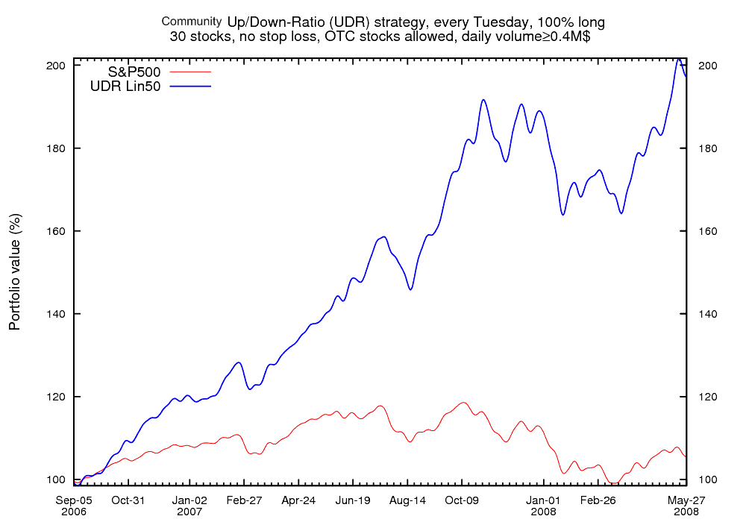

*Figure : Community knowledge strategy vs. S&P500*

### Tag based selection

Our tag based strategy is evolved from noticing that different sectors and industries create significant momentum if they are favourized. This is similar in concept to buying a house in the city. If the prices of the houses are on the rise in that specific neighbourhood, the houses which are close will gain significant price too. If a company performs well, it is also worth looking around in the neighbourhood.

We have further investigated the idea and found that when we find macro trends - like the whole Transportation sector is rising - there are more granular micro trends inside that category, for example the Water Transportation subsector which is rising with even more pace. Going further, it can be observed that inside that subsector, there are micro niches industries (Dry Bulk Shipping) that are likely to outperform the market even more.

Therefore, the official sector/subsector categorization is substituted by a more general tags based categorization of the companies. This is another, but better way of slice and dice the market.

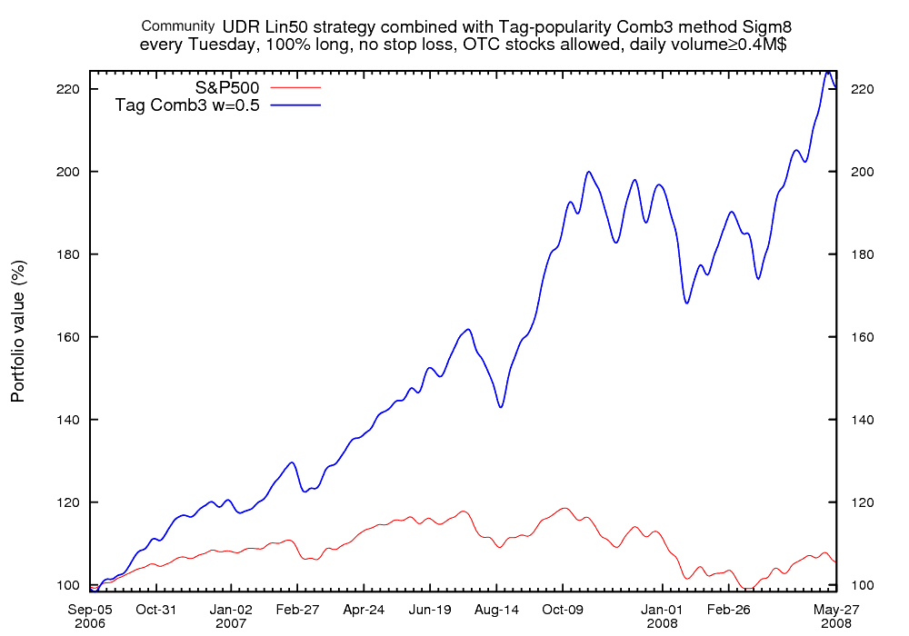

*Figure : Tags strategy vs. S&P500*

The Internet is a huge information source of tag and company relations. We intend to expand our tag database regularly with sophisticated data extraction algorithms. When a new product is released (e.g. iPhone) and it appears on the news portals or on blogs, it is automatically inserted into our database.

Our tag based strategy estimates the positive and negative popularity of tags. Based on that the tags gains a rank, a weight, so virtually the tags can be ordered by its goodness. However, we need to create stock portfolios, not tags portfolios. So, in the next step the companies are weighted based on the weight of the tags they belong.

Note that the tags strategy is better to be combined with another strategy, because in itself it is not a reliable indicator for the performance of the stock. There are cases when every company of the tag is relatively good, like Russia or Dry Bulk shipping, but it is also possible that the importance of a tag is based only on a performance of one or two company, like Finland and. In this last cases betting for every company in the tag in not optimal. However, this trivial case is handled by our Tags strategy, but there can be more complex situations in which combining the Tags strategy with another one proves beneficial.

### Shorting strategy

In this financially volatile market hedging is very important. Until now we have concentrated on making portfolios of buying good stocks. However, in case of a bear market even stocks of a potentially good company tend to fall. Therefore, we suggest sacrificing some part of the portfolio fund to short stocks. The shorting strategy will be based on those techniques that were found successful for longing, namely the Community knowledge and the Tags approach. Our first shorting strategy will use only stocks, not options.

## 

### Future Strategies

We seem to achieve very good results so far, but we constantly improve our portfolio selection with other potentially efficient strategies.

#### Trading with options*

We see great potential in options trading. Options can be used for long or for short trading. Algorithm of options trading can be potentially complex. The main direction of the development in 2008 is positioned around this topic.

#### Newsflow based selection strategy*

This is a forward looking strategy. We would like to monitor and use the newsflow in our strategy. An academic [paper](http://papers.ssrn.com/sol3/papers.cfm?abstract_id=923911) that was highlighted by CXO Advisory reports 21.1% annual returns before transaction costs based on analyzing the negative sentiment in financial news coverage utilizing a "standardized level of negativity based on word counts and the Harvard psychosocial dictionary." This result that stocks are tradeable on news is consistent with another study that stocks with news exhibit significant momentum. The implication is that it takes the market a significant amount of time to react or overreact to news.

The author found less drift with "good news" and more drift with "bad news," and the drift effect is higher for low priced and small market cap stocks.

<Mr. Charmat: “we should redesign this”. Ok, advices are welcomed.>

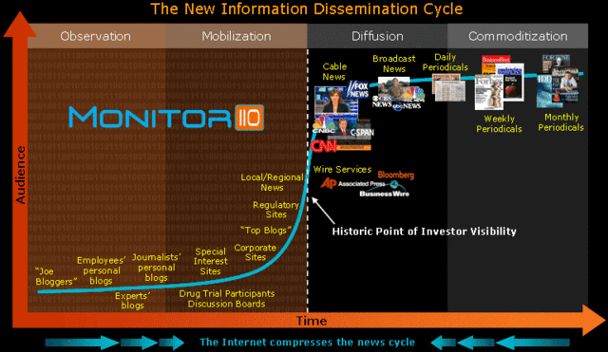

*Figure : Newsflow timeline: the number of well-informed people*

#### Selection based on selected experts*

We plan to implement this strategy too. However, take note that the community knowledge is proved to be superior to the average experts.

#### Selection based on selected fundamentals*

We plan to implement this strategy too. However, take note that the community knowledge strategy builds on the decision of the crowd. Members of the crowd can use the fundamentals of the company in their decision. Since our main Community strategy aggregates the knowledge of the individuals, the fundamentals of the company are implicitly included in the outcome of our main community strategy. In this sense we already use the company fundamentals, but we work on a different, a higher layer.

However, working purely and directly with fundamental data is still useful. HedgeQuant mining aggregates, synthesizes and optimizes selected strategies. It filters stocks for up to 30 primary indicators based on momentum; none of them being on their own sufficient to be reliable predictive indicators.

Main Fundamental protocols:

Recent quarter’s earnings, earning trends, past 3 quarters, earning/share, expected Product pipeline, cash flow trend, bottom line growth, fundamental analysis rating of analysts, business competitive advantage, management innovation, product cycle change, product pipeline....

Main Market timing indicators:

Technical strength/price break out, insider buying, overall momentum score, volume trend , liquidity trend, sector trend , option availability , filtered multi protocols and pure stochastic indicators.

1. * means: implemented in the future