**Beware the Wrath of VXX**

This should be a statement of the obvious, but a week doesn’t go by that I don’t see someone extolling the virtues of [VXX](http://finance.yahoo.com/q?s=vxx&ql=1) as a *free lunch* (so perhaps it’s worthwhile to beat this dead horse once more)…

Below is a graph of VXX since inception in 2009:

[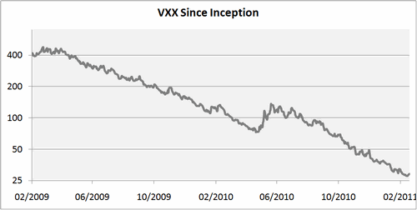](http://marketsci.files.wordpress.com/2011/02/20110211-01.gif)

For two years, VXX has been on a march towards zero. For those keeping score that’s a -93% return since inception, and on first blush, looks free lunch sexy for shorts.

**But VXX’s death march is a result of market fundamentals that are by their nature temporary, and *when* (not *if*) big volatility/backwardation returns, the wrath of VXX will devour the shorts whole**.

Below is the [S&P 500 VIX Short-term Futures TR Index](http://www.bloomberg.com/apps/quote?ticker=SPVXSTR:IND), which VXX tracks, back to 12/2005 (giving us 3+ years additional data):

[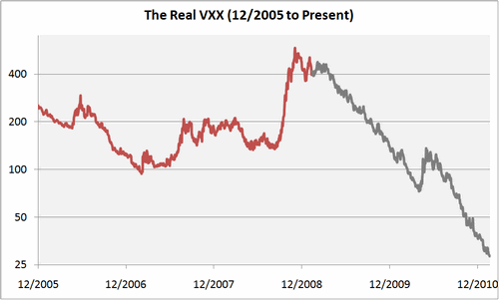](http://marketsci.files.wordpress.com/2011/02/20110211-02.gif)

The period since the ETF VXX launched is in grey and all prior data is in red. It’s clear from this second graph that VXX was the beneficiary of *very* fortuitous timing.

Note the spike that would have occurred in VXX during the financial crises in late 2008 – **that’s a 300% gain (loss) for longs (shorts) in the space of 3 months**.

The point of this post is not that trading VXX short is bad. I take short VXX (or more accurately, long [XIV](http://finance.yahoo.com/q?s=xiv&ql=1)) positions in my own vol trading.

The point is that VXX is not a free lunch, and that when volatility and the VIX term structure inevitably turn, shorts need to be prepared to *quickly* let go of this beloved trade.

**According to Michael, there are basically two ways to trade these products (straight long/short):**

1. **One is by following the VIX futures term-structure (TS).**

: following the VIX futures term-structure.

As the chart below shows, most of the time the term-structure acts as a strong tailwind in favor of either trading short volatility (ex. short VXX/long XIV) or long.

I would go so far as to say I think it’s wrong to think of these ETF products as VIX tracking at all. The impact of the futures term-structure is almost always the real driver of returns over a longer periods, not the underlying VIX index (i.e. beta).

Even during times like now when the VIX is spiking, **backwardation is still a big (if not the biggest?) contributor to the corresponding spike in VXX** (as opposed to beta).

[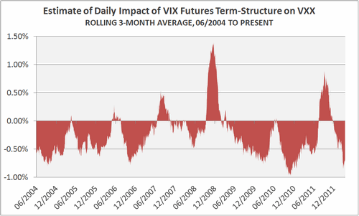](http://marketsci.files.wordpress.com/2012/04/20120411-01.gif)

The chart shows my estimate of the average daily impact that the VIX futures term-structure had on VXX over the previous 63-days (3 months). You can more or less flip these results for XIV.

For example, if the chart reads +0.5%, that means the term-structure boosted VXX (regardless of changes in the VIX) by 0.5% per day over that 3 months (or about 251% annualized).

Geek note: I’m using “term-structure” loosely to mean roll yield, time decay, and all other factors not directly related to immediate changes in the VIX itself.

**I don’t want to share the math on this one because I think this is one of the competitive advantages of**[**my model**](http://www.marketsci.com/strategy.VT.html), but you could get in the ballpark simply comparing the first/second month futures contracts.

**The Strategy**

**Keeping it really simple, let’s assume we bought VXX at the close when the values in the chart above were positive, and bought XIV when the values in the chart were negative. This is just a proof of concept**, so I’m ignoring transaction costs/slippage.

[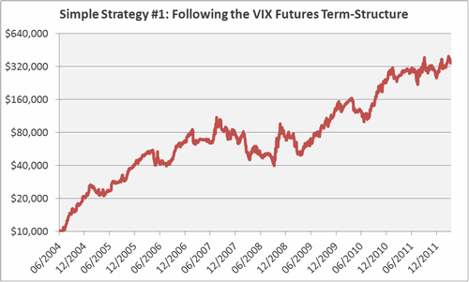](http://marketsci.files.wordpress.com/2012/04/20120411-02.gif)  
[logarithmically-scaled, growth of $10,000]

This strategy is overly simple, but would still have put up impressive numbers: a 57% annualized return with **only 8 trades per year, since 06/2004**.

How could he have only 8 trades a year? (see the previous chart, 2 charts earlier, there is a trade when we cross the 0 line)

But flat performance from 2006 to 2010 (almost 4 years) (with -50% DD). My suggestion was: hedge it with short ZIV. We do it. (but that decreases the profit too) (btw. We delay the decision by 2 days… just to be clear)

There’s clearly some low hanging fruit to improve results (like stop losses), but I think it proves the point nicely that simply following the VIX futures term-structure, and ignoring what’s happening with the underlying VIX, is a workable strategy.

**Strategy 2**

As I’ve [shown before](http://marketsci.wordpress.com/2011/03/01/random-thoughts-re-trading-volatility-etfs-part-1/), timing the VIX index itself is easy (albeit useless):

[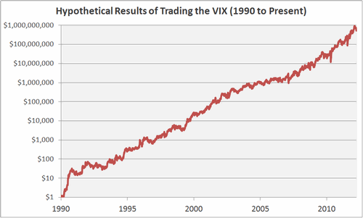](http://marketsci.files.wordpress.com/2012/04/20120411-03.gif)

In the graph above I’ve assumed we could buy/short the VIX index at the close when the 10-day EMA of the VIX closed under/over the 10-day SMA. An EMA is a faster moving average than an SMA, so this is a mean-reversion strategy. (that is mean reversion!!!! So VIX is MR!!!)

The graph shows that the VIX is uber predictable.

The problem of course is that back here in the real world the VIX futures term-structure acts as such a strong head/tailwind on volatility ETPs that it effectively becomes the most important driver of returns, not movements in the VIX itself.

But what if we traded these ETPs by timing the VIX, but only taking those trades where the term-structure put the trade in our favor?

**The Strategy**

Go long VXX/XIV at the close when the 10-day EMA of the VIX closed under/over the 10-day SMA, AND the average daily impact of the term-structure was greater/less than zero, otherwise move to cash.

See [this post](http://marketsci.wordpress.com/2012/04/11/strategy-1-for-trading-volatility-etps-term-structure-following/) for more on estimating the average daily impact of the term-structure. Strategy results from 06/2004 (frictionless):

[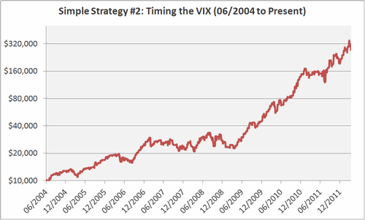](http://marketsci.files.wordpress.com/2012/04/20120411-04.gif)  
[logarithmically-scaled, growth of $10,000]

Despite its simplicity, this strategy would have put up impressive numbers: a 53% annualized return **with less than 1 trade per week and a max drawdown of -33%. The same problem: 3 years no performance.**

**But flat performance from from 2007 t0 2009( two years and a half)**

Like the strategy I presented in my [last post](http://marketsci.wordpress.com/2012/04/11/strategy-1-for-trading-volatility-etps-term-structure-following/), there’s clearly some low hanging fruit to improve on these results (like stop losses (I don’t think it works: playing the equity curve didn’t help, stop loss will not help either.), but the smoothness of the equity curve through very different volatility regimes demonstrates nicely that timing the VIX while respecting the VIX futures term-structure is an effective strategy.

As I talked about [previously](http://marketsci.wordpress.com/2012/04/10/saddling-up-to-the-keyboard-again-with-a-bit-of-volatility-talk/), I use a mix of both types of strategies.

Following the term-structure (ex. strategy #1) ensures **I always have some exposure to which way the winds of the VIX futures term-structure are blowing. And timing the VIX (strategy #2) tells me when the market is particularly ripe for a trade so that I can up my risk exposure.**

Still: the combination is also a MR strategy. Beware.

ms

. . . . .

1. [1](http://marketsci.wordpress.com/2012/04/12/strategy-2-for-trading-volatility-etps-timing-the-vix/#comment-6308)**Jared** on [April 12, 2012](http://marketsci.wordpress.com/2012/04/12/strategy-2-for-trading-volatility-etps-timing-the-vix/#comment-6308) said:

Great posts, Michael.

1. [4](http://marketsci.wordpress.com/2012/04/12/strategy-2-for-trading-volatility-etps-timing-the-vix/#comment-6311)**eber terandst** on [April 12, 2012](http://marketsci.wordpress.com/2012/04/12/strategy-2-for-trading-volatility-etps-timing-the-vix/#comment-6311) said:

Great work !.  
Question: where did you get the historical data for the term structure ?  
Thanks  
eber

* + [5](http://marketsci.wordpress.com/2012/04/12/strategy-2-for-trading-volatility-etps-timing-the-vix/#comment-6317)**MarketSci** on [April 12, 2012](http://marketsci.wordpress.com/2012/04/12/strategy-2-for-trading-volatility-etps-timing-the-vix/#comment-6317) said:

Hello Eber – this post from the Intelligent Investor Blog can help with historical data for the first and second month VIX futures:

<http://investing.kuchita.com/2011/08/21/vxx-data-since-vix-futures-avilable-march-2003/>

Note that for my estimate of (what I loosely call) the “term-structure”, **I’m extrapoloating from the actual ETP and VIX prices. (very incorrect, but we do it properly from the VIX futures)** But using the VIX futures themselves (like the blogger does in the link above) is going to give you a very similar result.

michael

1. [6](http://marketsci.wordpress.com/2012/04/12/strategy-2-for-trading-volatility-etps-timing-the-vix/#comment-6315)**Jeff Pietsch** on [April 12, 2012](http://marketsci.wordpress.com/2012/04/12/strategy-2-for-trading-volatility-etps-timing-the-vix/#comment-6315) said:

Although the results look impressive I get the feeling the environment over the past couple of years has been very hospitable to this trade and it would be dangerous to assume past will match future.

The returns from 2004-2008 are only about 16% annualized, with the bulk of the gains coming during the huge bull market beginning in 2009. Since 2009 the market has been tightly coupled to central bank liquidity. It goes up remarkably smooth when central bank liquidity programs are running and is highly mean-reverting when negative shocks are encountered when QE programs are running. If you’re trading the VIX EMA/SMA mean reversion in a bull market you are basically betting on QE to cause mean reversion after a negative shock happens. I get the feeling this environment is not sustainable and when the liquidity games stop this trade will become much less profitable and much more dangerous both because of the increased return volatility and not being able to detect the regime change until much later.

So, he says that MR will disappear. I agree. Fundamentally, I like VIX FT strategies (in any form)

I think if you look at your data and instead buy SPY at the times you would have bought XIV you’d get significant excess returns there as well, although not as much because VIX has natural ~3x leverage built in.

Michael uses a strictly quantitative strategy and follow it blindly we saw the trouble this approach can bring with YK.

Luby and Pietsch are connected with macro market sentiments and fundamentals.

[7](http://marketsci.wordpress.com/2012/04/12/strategy-2-for-trading-volatility-etps-timing-the-vix/#comment-6318)**MarketSci** on [April 12, 2012](http://marketsci.wordpress.com/2012/04/12/strategy-2-for-trading-volatility-etps-timing-the-vix/#comment-6318) said:

RE to Jeff: couple of thoughts:

First, the mean-reversion in the VIX is clearly not tied to QE. See the first chart in this post. Note how the strong tendency towards MR in the VIX has existed since its first quote in 1990.

The improved performance 2009+ has nothing to do w/ an increase in MR, **it has everything to do with consistently contangoed VIX futures, which to your point, one could argue is a result of QE.**

All straight long/short volatility ETP plays are going to be less productive when the direction of the term-structure is unclear, and without a doubt, I don’t think anyone could expect big returns all the time.

Having said that, annualized returns for this simple strategy pre 2009 are in the neighborhood of 24% (I’m not sure where you’re getting 16%). Couple that with the fact that this is an overly simplified strategy without the slightest bit of sophistication, and I think it’s pretty safe to say it has wings (at least in my humble opinion).

P.S. I disagree re: trading SPY. That would be a straight MR play and usually is less productive. For better or worse, the primary driver of the strategy I’ve detailed in this post isn’t MR, it’s the term-structure.

michael

* + - [9](http://marketsci.wordpress.com/2012/04/12/strategy-2-for-trading-volatility-etps-timing-the-vix/#comment-6320)**MarketSci** on [April 12, 2012](http://marketsci.wordpress.com/2012/04/12/strategy-2-for-trading-volatility-etps-timing-the-vix/#comment-6320) said:

RE to JZ: there’s no “leverage”. Jeff means that these products are more volatile than the S&P 500.

That’s why I always say that “returns are an illusion” – they’re just a function of exposure/leverage/volatility. It’s much more important to look at the smoothness of the equity curve and volatility-adjusted measures (Sharpe Ratio, Ulcer Index, etc.)

michael

1. [10](http://marketsci.wordpress.com/2012/04/12/strategy-2-for-trading-volatility-etps-timing-the-vix/#comment-6322)**Eugenio** on [April 13, 2012](http://marketsci.wordpress.com/2012/04/12/strategy-2-for-trading-volatility-etps-timing-the-vix/#comment-6322) said:

Very nice strategy, I’ve developed something very similar.  
Do you have more statistics to share? volatilty, sharpe, sortino ratios?  
have you tried to assume trading and borrowing costs to see what would be the impact on performance?  
Thanks Eugenio

* + [11](http://marketsci.wordpress.com/2012/04/12/strategy-2-for-trading-volatility-etps-timing-the-vix/#comment-6324)**MarketSci** on [April 13, 2012](http://marketsci.wordpress.com/2012/04/12/strategy-2-for-trading-volatility-etps-timing-the-vix/#comment-6324) said:

Hello Eugenio – I don’t trade this strategy, it’s just an illustration, but I trade something conceptually similar. I didn’t bother with my usual statistical breakdown b/**c I would never suggest anyone trade the strategy as is (especially without stop losses),** but if you did: annualized return = 53%, annualized SD = 37%, Sharpe Ratio = 1.4, max DD = -33%, winning months = 68%, days in market = 50%

Trading costs would be negligible assuming a decent sized account (**less than 1 trade per week)**. There are no borrowing costs because these are ETPs sans margin.

michael

**Suggestion: mix Connor with Term structure following. These are FT. MR is dangerous. Do you want to play that?**

**In my own trading I mix a term-structure following approach with one timing the underlying VIX itself**

Note that I’m using “term-structure” loosely to mean roll yield, time decay, and all other factors not directly related to immediate changes in the VIX itself.

Most of the time the TS acts as a strong tailwind in favor of either trading short volatility (ex. short VXX/long XIV) or long volatility.

The downside of this approach is that when volatility turns, these products will move against you incredibly fast. As I’ve [shown before](http://marketsci.wordpress.com/2011/10/05/vxx-devours-the-shorts-whole/), the relatively smooth march to zero that we’ve seen in VXX over the last years is the exception not the norm.

Successfully surfing the TS requires (a) constantly measuring the TS bias and scaling up/down position size as it strengthens/weakens, and (b) employing reasonably tight stops to protect against the inevitable jump in volatility when it happens.   
George: I don’t think it works, but we may backtest a -20% stop loss.

**The second approach to trading volatility ETFs is timing the VIX itself, while respecting the TS bias.**

As I’ve [shown before](http://marketsci.wordpress.com/2011/03/01/random-thoughts-re-trading-volatility-etfs-part-1/), timing the VIX is easy. The problem is of course that these volatility ETFs don’t track the VIX very well because of the aforementioned TS bias.

Was the VIX due a turn north? Sure. But the TS was acting as such a strong head wind that it was going to take a BIG increase in VIX to make that a profitable play.

Having said all of that, I do think it makes sense to time the VIX in the direction of the TS bias.

For example, if you are predicting a falling VIX and the TS is biased towards short volatility, take the position (ex. long XIV). **But if the TS is biased towards long volatility, sit on the sidelines (or at least reduce position size)**.

Let’s establish when the TS are biases toward long volatility.

and what are the best conditions to be in Backwardisation.

The downside of this approach is missed opportunities. It means (a) a lot more time in cash, and (b) never being the first to capitalize on big changes in volatility (because there tends to be a lag between “regime changes” in volatility and a corresponding shift in the VIX futures TS).

**My own approach has been a combination of the two.**

I allocate a % of my portfolio to surfing the TS bias (approach #1) and a % to timing the VIX while respecting the TS bias (approach #2).

So he is thinking in term of portfolio management, by position sizing.

As I hope I made clear enough, these strategies were meant to be illustrative and are NOT ready for actual trading.

**Protective stops**

**The most important element both strategies were missing was protective stops.**

The nature of these ETPs means that your trade is less likely to move against you in tiny increments (like a dripping faucet) assuming that you stay on the right side of the VIX futures term-structure.

But at some point you will be on the wrong side of the trade when the VIXjumps (which overshadows the effect of the term-structure) and your position will move against you very quickly.

That’s especially true when you’re short volatility (ex. long XIV) because the VIX is much more prone to spiking up than down.

**This “spiky” nature of the volatility ETPs means that protective stops are even more important than with most conventional assets**.

I considered different ways to illustrate that point statistically, but I think a simple chart of XIV back to 2004 makes a better case than a number ever could. **Note all of the crashes over just the last 8 years.**

[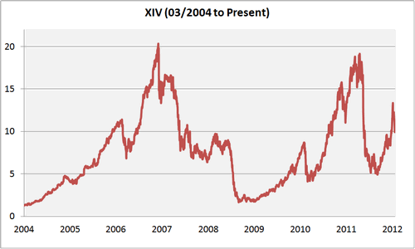](http://marketsci.files.wordpress.com/2012/04/20120416-01.gif)

Comments about stop loss from what I think is Bill Luby

1. [5](http://marketsci.wordpress.com/2012/04/16/trading-volatility-etps-obey-thy-stops/#comment-6352)**xls5929** on [April 17, 2012](http://marketsci.wordpress.com/2012/04/16/trading-volatility-etps-obey-thy-stops/#comment-6352) said:

Do you really gain anything from stops in a strategy like this? A nosedive isn’t predictable, so once it hits, the damage is done. A slow bleeding droop or a series of smaller droops are also unpredictable and once they hit, the damage is done.

Trying to protect this type of strategy with stops simply kills off some of the upswing by closing positions before they’ve had a chance to run. The tighter the stop, the more upswing is killed off.

As described above, one way out is to simply risk a small enough part of your capital so you can survive.

[Reply](http://marketsci.wordpress.com/2012/04/16/trading-volatility-etps-obey-thy-stops/?replytocom=6352#respond)

* + [6](http://marketsci.wordpress.com/2012/04/16/trading-volatility-etps-obey-thy-stops/#comment-6355)**MarketSci** on [April 17, 2012](http://marketsci.wordpress.com/2012/04/16/trading-volatility-etps-obey-thy-stops/#comment-6355) said:

Hello xls5929: when you’re talking about equity plays, especially ones that are based on OB/OS (ex. buying stocks on dips), I think that’s often true. Better to play small rather than use stops.

But IMHO these products are different because **when volatility spikes up causing the term-structure to shift, moves in the ETP become magnified. You’re getting hit twice: once from the move in the VIX and again from the backwardation.** As the graph above shows, during crises, things get out of control pretty quickly. **I don’t think “riding it out” makes sense here** like it might with an straight equity play.

Just my $0.02.

michael

[Reply](http://marketsci.wordpress.com/2012/04/16/trading-volatility-etps-obey-thy-stops/?replytocom=6355#respond)

* + - [7](http://marketsci.wordpress.com/2012/04/16/trading-volatility-etps-obey-thy-stops/#comment-6361)**xls5929** on [April 18, 2012](http://marketsci.wordpress.com/2012/04/16/trading-volatility-etps-obey-thy-stops/#comment-6361) said:

You might want to try various stop schemes and see what happens. I’ve been playing with a strategy similar to what you’ve described, and so far, any stop scheme reduces the overall profitability with a minimal effect on drawdowns. In fact, the reduced-profits makes the overall method more risky.  
George: no need to backtest then.

* + - [8](http://marketsci.wordpress.com/2012/04/16/trading-volatility-etps-obey-thy-stops/#comment-6362)**MarketSci** on [April 18, 2012](http://marketsci.wordpress.com/2012/04/16/trading-volatility-etps-obey-thy-stops/#comment-6362) said:

Hello xls5929 – my assessment was based on have already done a lot of analysis of the issue for my own trading.

Out of curiousity – how far back are you backtesting? If you’re only looking at the VXX since launch in 2009, you’re going to miss some very volatile moments in recent history. You can go all the way back to 03/2004 using VIX futures to simulate VXX (and/or back to 2006 using Bloomberg data).

michael

* + - [9](http://marketsci.wordpress.com/2012/04/16/trading-volatility-etps-obey-thy-stops/#comment-6370)**xls5929** on [April 18, 2012](http://marketsci.wordpress.com/2012/04/16/trading-volatility-etps-obey-thy-stops/#comment-6370) said:

Michael,

I couldn’t find a “reply” selection under your post, so I put it here.

I estimated the data from the futures data, back to March 2004 (I haven’t checked out your Excel files, but I will when I can…..thanks by the way) . However, during my estimating process, I discovered how iffy the calculation can be. When I tried to extend that calculation to estimate Open/Hi/Lo data (for stops calcs), I was even more uncomfortable. My point is, I trust the actual Open/Hi/Lo/Close data far more than the estimated data. I consistently keep that in mind when I’m testing any type of strategy.

Anyway, to keep things simple, I’ll use your second graph (cumulative profits) in the Strategy #2 post. You stated that the return was around 53%/yr and the max drawdown was 33%. Correct me if I’m wrong, but isn’t that without stops. My version of a similar strategy may have a different return and drawdown, but it also is without stops. When I try various stops schemes, the return drops while the max drawdown is reduced only a small amount. I am aware of the possibility of another Flash Crash or 1987-nosedive where stops may or may not work anyway, so my current solution is to back the percent-of-capital down to an acceptable level, just in case.

Bill (probably easier to keep track if you continue to use xls5929)

* + - [10](http://marketsci.wordpress.com/2012/04/16/trading-volatility-etps-obey-thy-stops/#comment-6374)**MarketSci** on [April 18, 2012](http://marketsci.wordpress.com/2012/04/16/trading-volatility-etps-obey-thy-stops/#comment-6374) said:

I think reducing allocation is a perfectly fine approach. You’re just limiting exposure (and potential returns).

Just one additional thought: **there is limited data to consider** (b/c of how new these products are**) and backtests** **are always by their nature curve fit**.

**So if I could create a strategy that wasn’t significantly negatively impacted by stop losses (i.e. if the backtest was just a little worse), I would still use them because that limited data and curve fitting guarantees that “next time” will be very different than “this time”.**

At least he is conscious of it. That is a new way of thinking!

**In my case, I use multiple stop losses and scale down positions as positions move against me**. That way if “next time” is like “last time” and the VIX bounces back, the negative impact of those stop losses is limited. But if “next time” isn’t like “last time” damage to the portfolio is limited.

There’s no right answer here…just my $0.02.

michael

* + - [11](http://marketsci.wordpress.com/2012/04/16/trading-volatility-etps-obey-thy-stops/#comment-6377)**xls5929** on [April 19, 2012](http://marketsci.wordpress.com/2012/04/16/trading-volatility-etps-obey-thy-stops/#comment-6377) said:

Michael,

I think I might have figured out an important difference in our methods. In your Strategy #2 post, **you mention your trading frequency as “…less than 1 trade per week….**”. My method is based on daily trades, which is why the daily Open/Hi/Lo is also important. **I think I can see how a stop strategy at your frequency may not be as punishing as it is at a daily frequency. I’ll have to think about that some more.**

xls5929

I know that Michael read assiduously CXO.

I noticed that at the very beginning of the implementation of his strategy in November 2011 he went on cash for almost 2 months.

[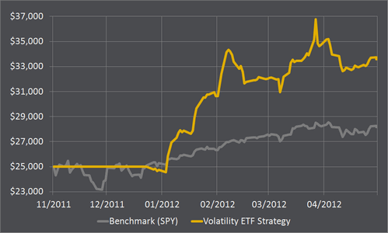](http://marketsci.files.wordpress.com/2008/12/equity-vt3.gif)

(Impressive performance **so far,** + 30% with a drawdown of only 11 %.)

I think, he is using the following strategy,

<http://www.cxoadvisory.com/20683/volatility-effects/shorting-vxx-with-crash-protection/>

We should backtest it from 2004.

Excellent that you find the article. I concur with you. It is a monthly FT. I like VIX FT strategies.

[12](http://marketsci.wordpress.com/2012/04/16/trading-volatility-etps-obey-thy-stops/#comment-6357)**brekekex** on [April 18, 2012](http://marketsci.wordpress.com/2012/04/16/trading-volatility-etps-obey-thy-stops/#comment-6357) said:

Michael,

As an alternative (or supplement) to stops I think it can make sense to fully or partially hedge a long XIV position with a long VXZ position. Not a perfect solution, as when XIV starts to fall, VXZ will increase with a lower percentage. And of course, the VXZ position slowly reduces the total gains on XIV. On the other hand, the pair responds similarly to overnight and intraday moves, so overnight gaps are less of an issue.

We could vary the weight of the ZIV as an edge, for example.

Have we tested the XIV edged with the ZIV Since 2004? I cannot remember.

Andras

[Reply](http://marketsci.wordpress.com/2012/04/16/trading-volatility-etps-obey-thy-stops/?replytocom=6357#respond)

* + [13](http://marketsci.wordpress.com/2012/04/16/trading-volatility-etps-obey-thy-stops/#comment-6358)**MarketSci** on [April 18, 2012](http://marketsci.wordpress.com/2012/04/16/trading-volatility-etps-obey-thy-stops/#comment-6358) said:

Hello Andras – thanks for the smart thoughts – sort of analogous to shifting to a position in XVIX or XVZ (with more weight on the short front month position). **Not a trade I would want on all the time, but certainly would make sense in times of market stress**. Michael

<http://etfdb.com/2011/examining-vix-etf-performance-during-a-sell-off/>

E-TRACS Daily Long-Short VIX ETN ([XVIX](http://etfdb.com/etf/XVIX/))

This ETN from UBS is unique in that the underlying index includes both long and short exposure to VIX–specifically a 100% long position in mid-term VIX futures and a 50% short position in short-term VIX futures contracts. The short position positions XVIX to benefit from the structural inefficiencies in the VIX futures markets, while the long position allows for exposure to volatility that may not be impacted as adversely by contango. XVIX rebalances exposure on a daily basis.

The methodology behind XVIX makes this product very unique from the others highlighted above in terms of risk/return profile. The combination of long and short exposure to similar asset classes results in a relatively low volatility–a feature the other inverse VIX ETNs do not share. XVIX might be useful for those looking to add non-correlated assets to their portfolio, as the movements in the underlying benchmark will generally exhibit very little correlation to stocks or bonds [[Examining VIX ETF Performance During A Sell-Off](http://etfdb.com/2011/examining-vix-etf-performance-during-a-sell-off/)].

Not really goon in 2 years:

<http://stockcharts.com/h-sc/ui?s=XVIX&p=D&yr=2&mn=0&dy=0&id=p73663258846>

### Deciphering the VIX:HV Ratio

**24apr12**

I’ve been researching how I might use the relationship between the VIX and the historical volatility of the S&P 500 (HV) in my own [volatility trading](http://marketsci.wordpress.com/my-strategies/).

For the uninitiated, the VIX (which is an estimate of future volatility) is closely tied to recent past volatility of the S&P 500, as the graph below demonstrates. Here I’ve shown the VIX on the y-axis versus the 21-day standard deviation of the S&P 500 (i.e. historical volatility) on the x-axis.

[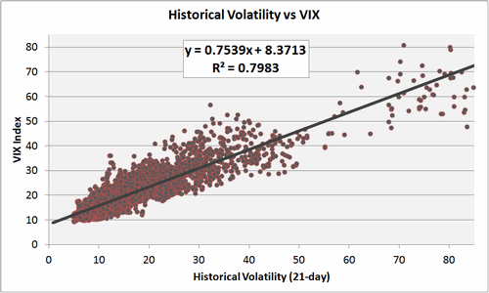](http://marketsci.files.wordpress.com/2012/04/20120424-01.gif)  
[HV = annualized 21-day std. dev. of the natural log of daily S&P 500 changes * 100]

Note three things: (a) how the relationship is roughly linear, (b) the slope is less than 1.0 (m=0.7539), and (c) the large y-intercept (b = 8.3713).

That means that when historical volatility (HV) is low, the ratio of the VIX to HV tends to be high. But when HV is high, the ratio will be near or even less than 1.0.

That also means that simply comparing the VIX to historical volatility is meaningless without considering whether HV is high or low.

To illustrate, the graph below shows historical volatility (x-axis) versus the VIX:HV ratio (y-axis).

. . . . .

[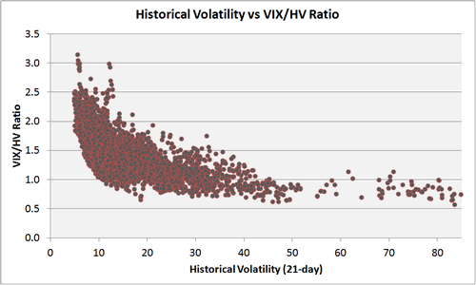](http://marketsci.files.wordpress.com/2012/04/20120424-02.gif)  
[HV = annualized 21-day standard deviation of the natural log of daily changes * 100]

Note how when HV is low, the VIX:HV ratio tends to be high, but as HV increases, the VIX:HV ratio approaches and eventually falls below 1.0.

**Why is all this important?**

Pundits often make hay about the VIX:HV ratio as if it had predictive value all by itself. It doesn’t.

**What does have predictive value is comparing the VIX to where you would expect the VIX to be at that level of historical volatility.**

In a follow up post I’ll dive deeper into the topic by using this observation to predict next-day changes in the S&P 500, the VIX, and volatility ETPs VIX and XIV.

1. [1](http://marketsci.wordpress.com/2012/04/24/deciphering-the-vixhv-ratio/#comment-6430)[**Elliott**](http://www.seasoninvestments.com/) on [April 30, 2012](http://marketsci.wordpress.com/2012/04/24/deciphering-the-vixhv-ratio/#comment-6430) said:

, I’ve often thought that it would be useful to look at this ratio in combination with a time variable. Intuitively, it seems like the longer this ratio “hangs out” in the extremes, the more likely it is that the ratio will mean revert in the near future. So seeing this ratio at 2.0 may not be a big deal, but seeing that it has been at 2.0 or greater for the past X trading days might make it much more relevant. Haven’t had time to test this theory but something to noodle on.

[Reply](http://marketsci.wordpress.com/2012/04/24/deciphering-the-vixhv-ratio/?replytocom=6430#respond)

* + [2](http://marketsci.wordpress.com/2012/04/24/deciphering-the-vixhv-ratio/#comment-6431)**MarketSci** on [April 30, 2012](http://marketsci.wordpress.com/2012/04/24/deciphering-the-vixhv-ratio/#comment-6431) said:

Hello Elliott – I got a little sidetracked, but I’ll be back on this topic this week. I appreciate the thoughts above – will run the numbers and include in my follow up post if it bears fruit. michael

No follow up posts so far but apparently Michael went on holiday... !

### VXX/XIV Performance in Advancing & Declining Markets

Obviously declining markets are good for VIX ETN [VXX](http://finance.yahoo.com/q?s=VXX) and advancing markets bad (and vice-versa for [XIV](http://finance.yahoo.com/q?s=XIV)), but in this post I want to do a better job quantifying that.

Below I’ve colored red all S&P 500 declines of more than 5% since 03/2004 (which is as far back as we can [estimate VXX/XIV](http://marketsci.wordpress.com/2012/04/18/free-historical-vxx-data/)).

George: I think it compares the decline from the value 1 month earlier. If not, the chart is wrong.

[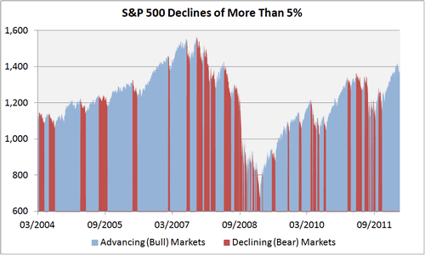](http://marketsci.files.wordpress.com/2012/04/20120423-01.gif)

Next I’ve shown the daily performance of VXX during those advancing (blue) and declining (red) markets (you can more or less flip these results for XIV).

[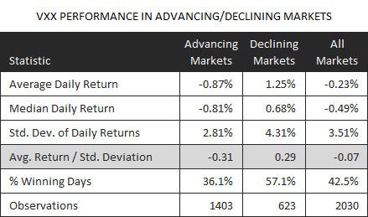](http://marketsci.files.wordpress.com/2012/04/20120423-02.gif)

And for good measure, the results of two hypothetical (frictionless) portfolios. The first (blue) only trades VXX during advancing markets, and the second (red) only during declining markets.

George: Can this be fake? Not traded. If there is -5% drop of SPY today, there is no chance we could buy VXX yesterday. So, this is correlation, not forecasting.

[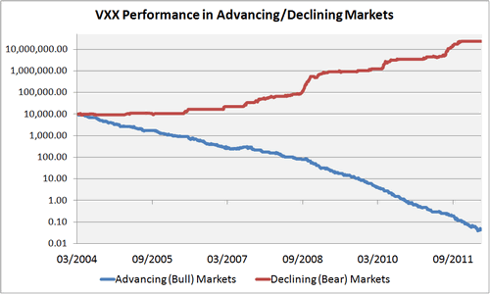](http://marketsci.files.wordpress.com/2012/04/20120423-03.gif)  
[growth of $10,000, logarithmically-scaled]

The fact that VXX goes down in advancing markets and up in declining ones isn’t the surprise. The surprise (at least to me) is how “symmetrical” that observation is.

I expected VXX’s performance in declining markets to be more inconsistent because most of these declines were small enough that, with the exception of the 2007-08 and 2011 bear markets, VIX futures stayed mostly contangoed (which is a drag on VXX returns).

But by comparing the stats in the table above we see that (adjusted for volatility) VXX’s outperformance in advancing markets was just as strong as it’s underperformance in declining ones.

Even after removing the 2007-08 market crash, that observation holds.

That makes a small case for trading VXX/XIV by timing the broader stock market (something I’ve poopooed in the past).

One last thought: notice the skew in the results for declining markets (i.e. average VXX returns are much larger than median returns) indicating gains during declines are the result of a smaller number of big days.

It’s more difficult to be right about a long VXX position in declining markets, but the payoff for being right is greater. That’s because the VXX tends to increase in spikes, but decrease in increments (the opposite of equities).

**Key takeaway: despite the mostly negative (positive) impact of the VIX futures term structure, the performance of VXX (XIV) is, on average, equally positive (negative) in advancing markets as it is negative (positive) in declining ones.**

Happy Trading,  
ms

. . . . .

1. [4](http://marketsci.wordpress.com/2012/04/23/vxxxiv-performance-in-advancing-declining-markets/#comment-6411)**Andrew** on [April 24, 2012](http://marketsci.wordpress.com/2012/04/23/vxxxiv-performance-in-advancing-declining-markets/#comment-6411) said:

I would think a more trade-friendly approach would be some kind of moving avg crossover to cue the decline. Then, the signals you’re getting saying whether we’re in a bull/bear are actionable at that moment in time versus seeing it was a 5% dip after the fact.

[Reply](http://marketsci.wordpress.com/2012/04/23/vxxxiv-performance-in-advancing-declining-markets/?replytocom=6411#respond)

* + [5](http://marketsci.wordpress.com/2012/04/23/vxxxiv-performance-in-advancing-declining-markets/#comment-6413)**MarketSci** on [April 24, 2012](http://marketsci.wordpress.com/2012/04/23/vxxxiv-performance-in-advancing-declining-markets/#comment-6413) said:

Hello Andrew – that would be true if the point of the post was to create a strategy, but it wasn’t. The point of the post was to show the mechanics of how these ETPs operate. michael

[Reply](http://marketsci.wordpress.com/2012/04/23/vxxxiv-performance-in-advancing-declining-markets/?replytocom=6413#respond)

1. [6](http://marketsci.wordpress.com/2012/04/23/vxxxiv-performance-in-advancing-declining-markets/#comment-6412)**Mrkt_Rwnd** on [April 24, 2012](http://marketsci.wordpress.com/2012/04/23/vxxxiv-performance-in-advancing-declining-markets/#comment-6412) said:

These are so misunderstood, I’m glad to see you writing about them Michael.

[The following strategy seems interesting, could we backtest it from 2004.](http://www.cxoadvisory.com/19884/volatility-effects/what-happens-when-vxx-moves-the-wrong-way/)

<http://www.cxoadvisory.com/19884/volatility-effects/what-happens-when-vxx-moves-the-wrong-way/>

George: I like it.